Installing Git on Windows, MacOS, and Linux
In this guide we will teach you how to download and install Git on your preferred operating system. Although the process is mostly the same on Windows, MacOS, and Linux, there are a few platform-specific differences that we will discuss.
Before we begin the tutorial, it is important to understand the distinction between Git and GitHub. Git is the version control software used on your computer that allows you to track changes to files and projects. GitHub is a cloud-based hosting platform that allows you to store Git repositories online.
In the installation process, we will be installing Git and the two most common ways of interacting with it:
- Git Bash- This is a command line interface (CLI) that allows you to interact with Git using the command line. Bash is actually an acronym that stands for Bourne Again Shell, which is the successor of the original Unix command line shell created by Stephen Bourne.
- Git GUI- This is a graphical user interface (GUI) that some people find easier to use than command line tools to interact with Git using graphical menus and buttons rather than commands.
By the end of this guide, you will have Git installed, a way or ways to interact with it, and be ready to create and manage repositories at the local level.

Windows Installation

Step 1: Download Git
The first thing you need to do is open your preferred browser and navigate to this link to download Git from the official webpage: https://git-scm.com/download/win .
You need to download the version of Git that is appropriate for your architecture. For your convenience, you can run the command below in PowerShell to confirm what architecture your computer is running. (You can find PowerShell by clicking the search bar on the bottom left and searching the term `Power`.)
Get-CimInstance Win32_OperatingSystem | Select-Object OSArchitecture
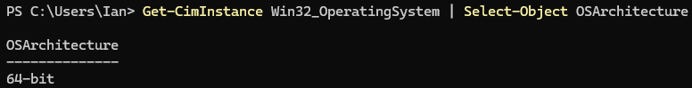
This command will either return 64-bit like in my case or ARM64 if you have an ARM processor. If your output looks like mine, you will select the option that is circled in the image below. Otherwise, if it says ARM64 select the option below the circled option.
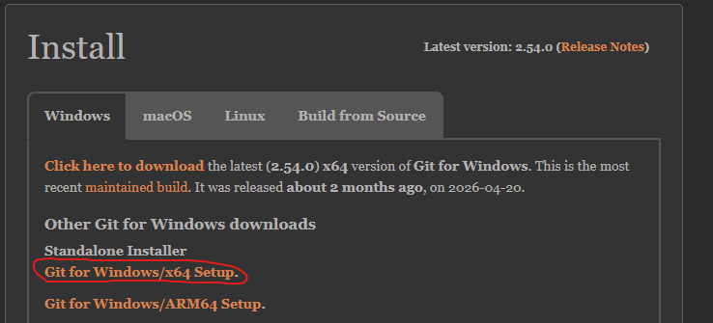

Step 2: Run the Installer
Find where you downloaded the installer and double click it to launch. If you are prompted by Windows to allow the installer to make changes to your computer, you need to give it permission by selecting “Yes”.

Step 3: Configuring the Installation Options
Below are a series of screenshots showing the options you should select for installing Git. Some of the images have no explanation because they are relatively straightforward (such as agreeing to the privacy agreement). There will be explanations for less straightforward options!
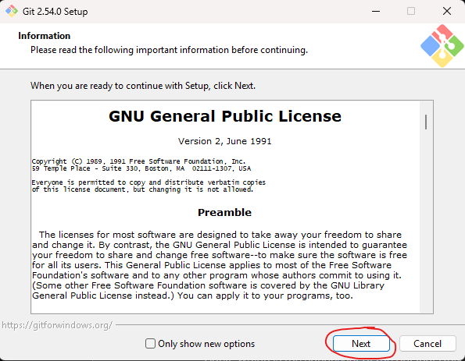
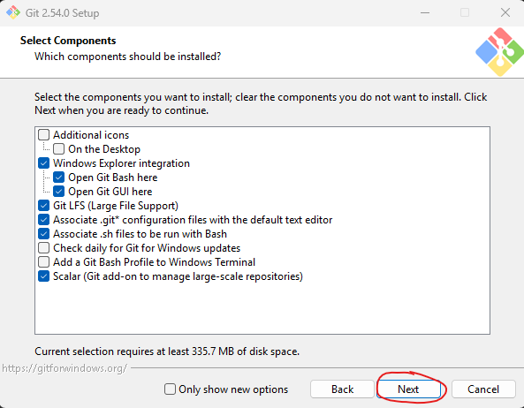
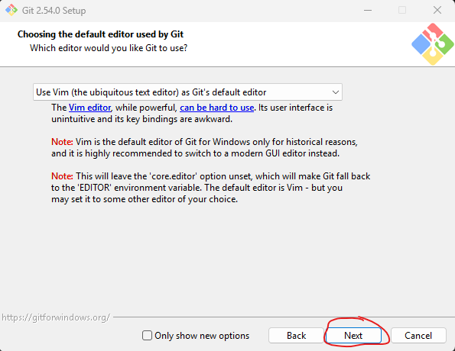
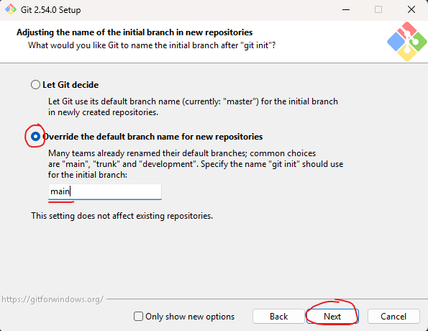
We are going to make a change on this page by selecting the override the default branch name for new repositories. The default is to let Git decide, but we want to make this change for simplicity’s sake. If you let Git decide, when creating repositories your default branch would be “master” instead of “main”, but when creating repositories from Git Hub like we will be later, the default branch will be “main” by default. By making this change, we can ensure that our default branch is “main” regardless of how we create our repository.
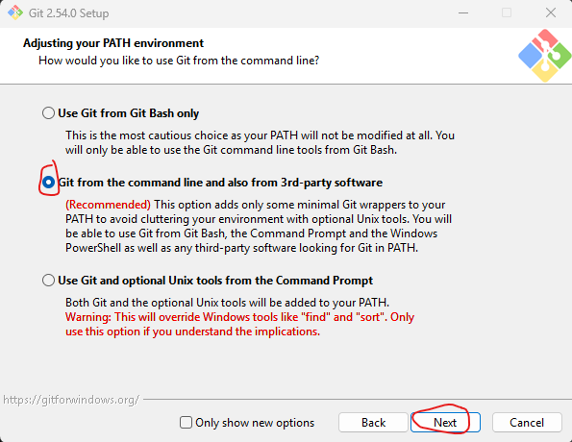
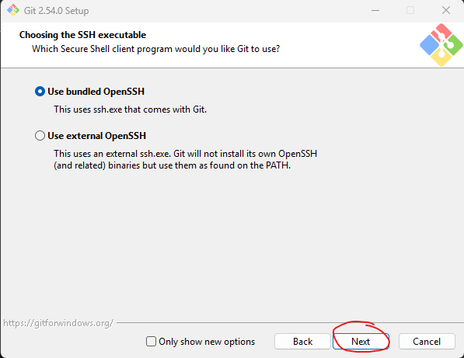
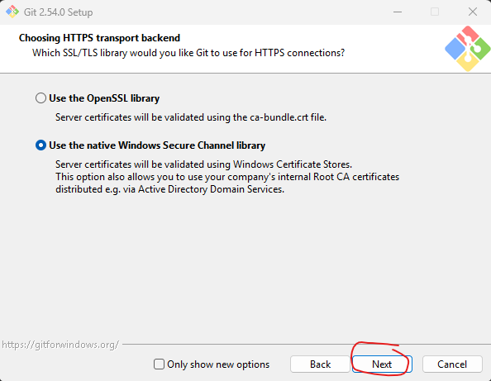

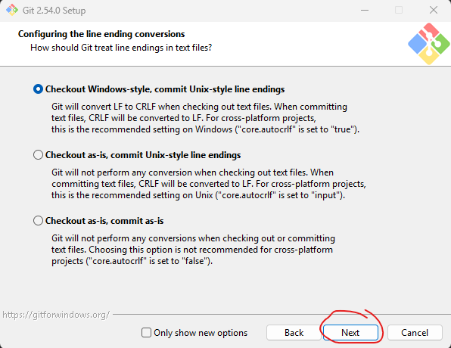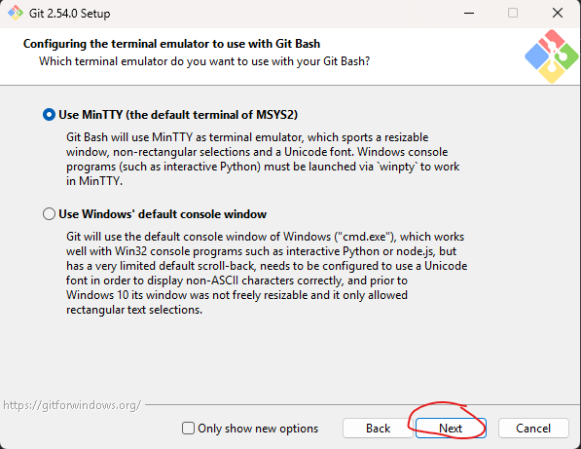
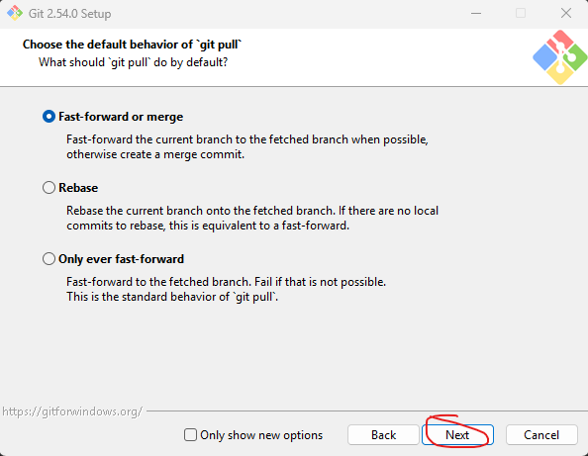
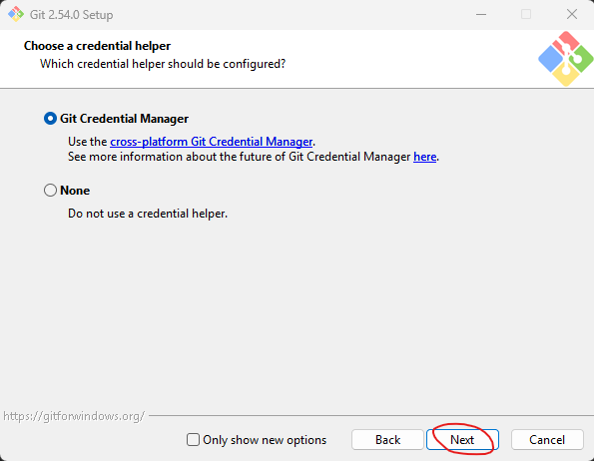
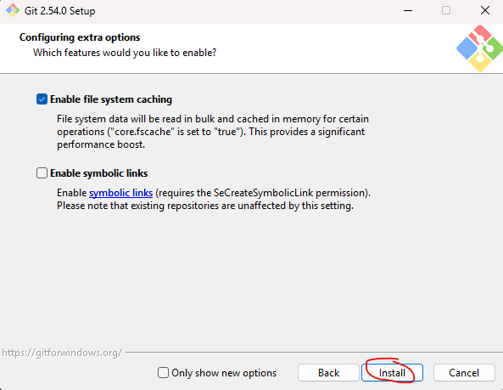
After you click install, you will need to wait until the installer has finished. You have successfully installed Git if you see this window at the end. You may click finish.
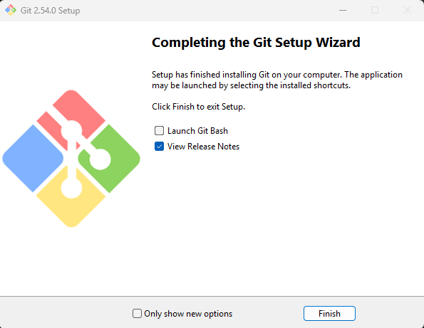
Skip to the Verifying Installation Section!

Linux Installation

Step 1: Ensure Package Installer is Updated and Download Git
We will be downloading Git from the command line on Linux as it is the easiest way to do so.
Navigate to your command line and use this command to both update your package installer as well as install Git.
sudo apt update && sudo apt install git
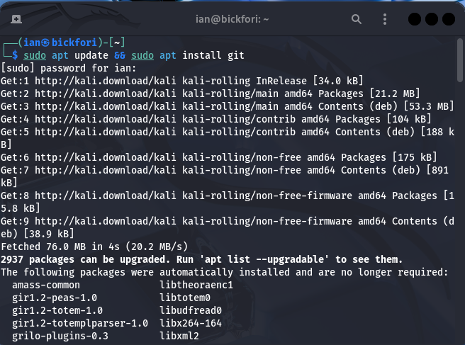
There can type “y” whenever it prompts you to for permission to do something during the installation. It may also ask you if it is allowed to restart some services that are affected by the installation, to which you should select yes as well.
As long as there are no errors in the installation, this is the only step we need to do for the Linux version.
Skip to the Verifying Installation Section!

MacOS Installation

Step 1: Check if Git is Installed
On newer versions of MacOS, Git is actually installed by default. You can check this by running the command within the Mac terminal:
git --version

Step 2: Install Git if Needed
If Git is not installed, terminal will prompt you to download the developer tools for Mac. You can select yes and install it this way if you choose.
Alternatively, you can click on the link from the Windows guide, navigate to the Mac installation options, and then download it from there selecting the same options as in the Windows guide where applicable.

Verification of Installation
To verify your installation of Git, you need to navigate either to CMD (Windows), command line tool of choice in Linux, or Terminal in MacOS and run this command:
git --version
If you see the word git followed by a version number, you know that you have Git installed.
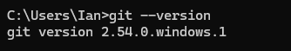

Configuring Your Git Username and Email Address
Before we do anything with Git, we need to make sure that Git knows who we are! Why does this matter? Well, we know that Git has the ability to see the commit history of a repository by showing who has changed what and when. To make this possible, we need to tell Git who we are, so it knows who to attribute changes to. This becomes much more important when we start working with remote repositories in later sections; so just ensure it is an email account that you can access!
Think of this information as being your digital signature attached to every commit you make, giving you the credit for the work that you have completed. This further allows team members if you are on a team project be able to reach out to the author of some work found in the team project!
To start the process of changing our configuration we need to open Git Bash. To do so, right click anywhere on your desktop. If you are using Windows 10 or earlier, the option for “Open Git Bash Here” should already be available. If you are using Windows 11, you need to select the option for “Show More Options” and then you will be able to see the “Open Git Bash Here” option.
For the remainder of the guide, we will mostly be working with Git on Windows as that is my operating system of choice. However, the commands are the same regardless of operating system and anything that does not work the same way as it does in Windows, a quick ChatGPT inquiry will fix! This is done to alleviate the amount of redundant content and streamline learning, not operating system bias.

Setting Your Username
Once we have opened a Git Bash terminal, we will find ourselves at the dreaded command line. Fret not, it’s not as scary as it may seem if you have never worked at the command line before.
The command for changing your username configuration is:
git config --global user.name “John Doe”
All you need to do now is change the John Doe to your actual name, and you want to make sure to include the quotes. To check to see if your name was configured correctly, use the same command but leave out the name and quotes like this:
git config --global user.name
This is what your console should look like:
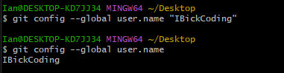

Setting Your Email
Next, configuring your email address is just as straightforward as the username step. This time we will replace the user.name to user.email as such:
git config --global user.email john.doe@example.com
All you need to do is once again replace the email with your corresponding email address! Check once again that it has been configured correctly by running the same command without the email address and quotes!

What’s Next?
Now that we know what Git is, a basic understanding of how Git works, and Git knows who we are; we are finally ready to make our first repository and start tracking changes to our files!

