Learning Objectives
By the end of this guide, learners will be able to:
- Explain how Git uses references to identify and locate objects within a repository.
- Describe what HEAD represents and how Git uses it to track the current location in history.
- Differentiate between symbolic and direct references.
- Describe how branches function as moveable pointers to commits.
- Explain how creating a branch does not duplicate repository data.
- Differentiate between lightweight tags and annotated tags.
- Explain how tags are used to mark specific points in Git history.
- Navigate between commits using Git references.
- Explain what a detached HEAD state is.
- Explain what may cause a detached HEAD state.
- Identify the risks and limitations of working from a detached HEAD state.
- Safely create, preserve, and recover work created while in a detached HEAD state.
- Build a stronger mental model of Git as a system of objects and references.

Introduction
As we learned in the previous guide, Git is built on the foundation of pointers and objects. A git repository has three core objects: blobs, trees, and commits. These three objects work together to represent file contents, directories, and snapshots of the repository.
Commits then use pointers to form a Directed Acyclic Graph (DAG), which represents the complete history of a repository. Since each commit knows its own parent commit, Git is able to travel backwards through the history of the project.
But how does Git know which point in the repository’s history we are currently working from within that DAG? A Git repository may contain hundreds to thousands of commits, so Git needs a way to know how to identify a specific point in the commit history. The answer is references!

What Are References?
A reference is simply a human-readable name that points to a Git object. We can observe this in a repository that has one branch named “main”. The reference “main” stores the hash identifier of the latest commit object in that line of development.
An important distinction is that “main” is not the commit, but rather a pointer to the commit. Let’s look at a real example.
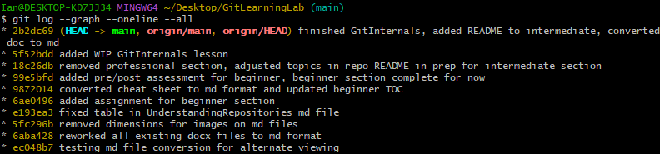
The above image is the commit history of this repository that I am currently working on. On the first line after the command `git log --graph --oneline --all` we can see the latest commit: 2b2dc69. Next to it, we see something called HEAD main. We will go over what HEAD is very soon, but for now let’s focus on the part that says main. The reference “main” points to the commit 2b2dc69, as it is the latest commit on this line of development. If I were to stop this guide here, and make another commit we would see the reference for main shift to the new commit’s hash identifier.
As previously mentioned, references store the hash identifier of the Git object they point to. Where do we store these references? We store references in the “refs” directory, which is found in the hidden `.git` directory that we have covered before.
Inside this directory, we have several other sub-directories including heads and tags. The “heads” directory contains references to local branches and the “tags” directory stores references to tags. More on this later.

Branches Are Just Pointers
A common misbelief is that each branch is a separate copy of the files from a repository. Instead, branches are just pointers to a commit and do not create copies of the files every time you create a new branch. Creating a new branch just creates a new label or reference to a given commit.
For instance, if we had a single branch named “main” that had a linear repository history of A B C, the current reference that “main” stores is the hash identifier of commit C. The workflow would look like:
A B C
“main” C
Now, let’s say we want to create an experimental branch named “feature” where we can test new features that we want to add to “main”, but only when the feature is complete. We can create and switch to this branch using the command `git switch -c feature`. With this command, we have now created a new label or reference called “feature” that points to the hash identifier of commit C and swapped to this branch. Both “main” and “feature” are references to the same commit currently. The workflow would look like:
A B C
“main” C
“feature” C
Now let’s pretend that we are working on that feature. It took us 3 commits worth of work to finish that darned feature. We will aptly name those commits D, E, and F. Right now, the “feature” reference points to the hash identifier of commit F and the “main” reference still points to the hash identifier for commit C. The workflow would look like:
A B C D E F
“main” C
“feature” F
If we have a working version of the feature and we want “main” to now point to the same commit as the feature line of development, we will merge the two branches at commit F.
This is called a fast-forward merge, because the two branches never diverged. The “main” branch was behind the “feature” branch and now fast-forwarded to the point in the repository’s history where the “feature” branch is, which would be commit F.
The reference “main” would now point to commit F, as would “feature”. No files were copied, no history would be duplicated, but only a new pointer from “main” to the hash identifier for commit F. Finally, the workflow would look like:
A B C D E F
“main” F
“feature” F
Finally, as explained before you can actually see these references if you open the .git/refs/heads directory, and look to see what is stored in the files for both “main” and “feature”. In this example, both files opened in notepad would have the hash identifier of commit F. Below is an image of this repository’s `.git/refs/heads/main` file, which contains the latest commit’s hash identifier:
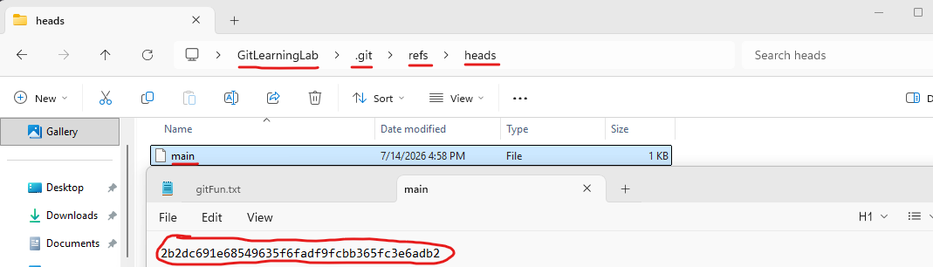

How Branches Move
Going back to a simpler workflow of a repository with a single branch named “main”, let’s quickly go over another important behavior of Git. If branches are pointers, who updates the pointer when new changes are made? Well Git does of course!
Git updates the branch reference to point to the new commit automatically whenever you commit new changes. The branch moves forward to the newly created commit because the reference changes to the new commit’s hash identifier inside of the `.git/refs/heads` directory.

