Introduction to Version Control and Git
Before we begin working with Git, we should first understand what version control is and why it matters. You may have heard the terms version control and source control used interchangeably in conversation, but are they the same thing? Although the two terms are closely related, there are some subtle differences between the two.
Have you ever had to work on an important school project with a partner? You probably shared the project through email, Google Drive, or even a USB thumb drive if you are old enough. As each person made changes, the file was passed back and forth until the project was complete.
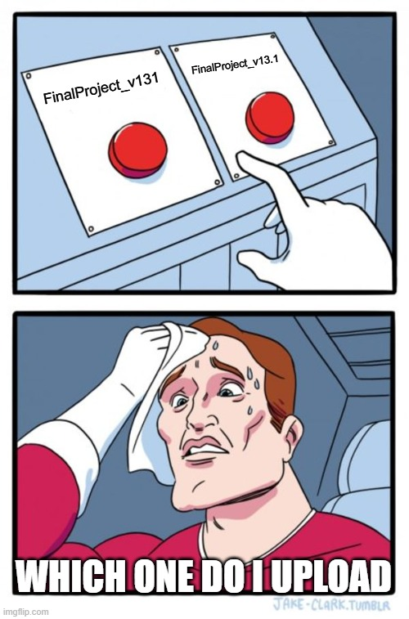
To avoid overwriting each other's work, you may have created new versions of the file. Each time you created a new version of the file, you probably added the day’s date to end of the file name. If you were really “cool” like me, you added the version number at the end instead. Each file name becomes some variation of `FinalProjectv2.docx` incrementing the number at the end each time. Before long, it becomes very difficult to remember which file contains the latest changes and which version should be submitted by the end of the project.
Version control systems were created to solve this problem as they automatically track changes made to files, maintain a history of those changes, make collaboration easy, and allow you to have access to your files anywhere that you have internet access. In this course, we will teach you how version control works, how Git implements these concepts, and why it has become an essential skill/tool in the world of modern software development.

Version Control vs Source Control
Now that we have a general understanding of the problem that version control systems were designed to solve, we can talk about the question I posed earlier: Are version control and source control the same thing?
The answer is yes and no. They are not exactly the same, but they are often used interchangeably. You can think of this relationship as similar to when somebody who is less tech oriented says that the internet in your building is down when they are referring to the Wi-Fi not working. The internet, a global interconnection of thousands of miles of infrastructure is not down, but certainly your connection to it via the Wi-Fi in the building may be down. However, when we hear this, we understand what that person is saying even if that’s not what they technically just said.
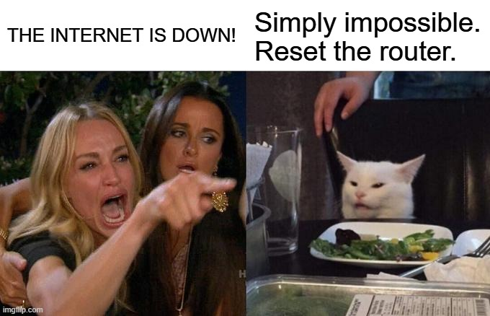

Version control is the broader concept of the two. It refers to any system that tracks changes to files overtime, allowing users to inspect those changes via a file’s history, restore previous versions of a file if needed, and easily collaborate with others typically through a remote repository (although this can be done via shared storage on the same network). Another important distinction is that these files can be anything you want. They can be images, documents, config files, source code, or anything else that you please.
Source control is a specific type of version control that focuses on the source code of a project. Modern software development projects often involve large teams working on the same files at the same time from the source code, so source control systems provide tools for tracking code changes, resolving conflicts, and more. Simply put, source control is basically version control but for specific use cases.
In modern software development, the distinction between the two is less important due to tools like Git existing that allow us to manage much more than just source code. For this reason, many developers will use the term interchangeably and I may even accidentally do it from time to time in these guides (I’m human too!).

Why Git Matters
In this course, we chose to use Git as our main tool for learning version control. Git is not the only version control system available, but it is one of the most widely used ones in the software development industry.
We also use GitHub to host this course. GitHub is one of the most popular platforms for storing and sharing Git repositories, and it helps make collaboration and access to projects easier. Git and GitHub work seamlessly with one another and thus made our choice even easier.
Git works well for both individuals and teams, is widely supported across the software development industry, and introduces the core concepts of version control. Because of this, Git is an excellent starting point for this course.


Benefits for Individuals
As a student or a solo developer, you may think that Git is unnecessary. This is a common misconception, as the benefits of using a version control system are still present even for a solo developer.
Git allows you to track changes over time. This creates a trackable history of your work, which makes it easy to see what changed and when. If you were to ever delete something important or make a mistake, you can easily restore yourself to a previous version of your project. This also makes it safer for you to experiment. You can try new ideas without having to worry about permanently deleting work.
Git helps keep workflows and projects organized and allows you to work across multiple devices either through a locally shared storage, or even through the internet when using cloud hosted services such as GitHub.

Benefits for Teams
Git really shines when used in a team setting. Git allows multiple people to work on the same project at the same time. You no longer need to wait for your partner to give you back a working file for the project. Instead, you could be working on the project at the same time which boosts efficiency.
You can still see a clear record of who changed what and when, for transparency of changes made to files. You can change the settings to make it so that the team lead must approve changes made to files only after they have reviewed them. Finally, one of the more important benefits is being able to share files with teammates that are not located in the same building, state, country, etc.
Think of Git like a shared Google Doc, but instead of just being able to share a text document you instead can share a multitude of different files with much more control.


