Making Commits and Tracking Changes

Learning Objectives:
At the completion of this lesson, learners will be able to:
- Explain the Git workflow.
- Differentiate between the Working Directory, Staging Area, and Repository.
- Stage files using git add.
- Create commits using git commit.
- View commit history using git log.
- Explain how Git tracks changes over time.

Introduction
To remind you where we last left off, we created a folder named GitPractice. Inside this folder, we used git init to create a repository. We then used the command line to create 2 files and a folder in the repository. When we used git status, we saw that the files were being detected but had not been added or committed.
In this lesson, we will work all the way through the Git Mental Workflow Model that we went over in one of the first lessons of the Beginner section. To refresh, the model flows as such:
Working Directory Staging Area Commits.
The reason this is important to recap, is because each step of this model has an action or actions that must be done prior to moving to the next step.

The Working Directory
The working directory contains the files that you are actively creating or editing. All work to files is done in the working directory, fitting name huh? As we have discovered though, Git may notice that something has changed in the files but it is not yet tracking those changes. To be able to get to the next step in the workflow model, we must add the files to the staging area.

The Staging Area
To add files to the staging area, we will simply use the command git add -A. This command will add all changes to the repository to the staging area. There are variations of this command that you can use instead of the “-A” argument (these will allow you to add just a single file, all files within just a folder, etc.), but in most cases “-A” will suffice.
To move files from the staging area to the next step in the workflow model, we need to commit our changes.

Commits
To finally commit our work that we have done, we will use the command git commit -m “initial commit”. This command tells git to commit the files that are in the staging area with the message (-m is the argument for writing a commit message) initial commit. Once we have done this, not only is Git tracking the files that we have created and edited, it also just took a snapshot of how the files look at this exact point in time for us to reference later.

Hands-On Guided Exercise

Step 1: Add files
Let’s take the work from the previous tutorial and add the files to the staging area. To do this, open the folder named GitPractice from the previous tutorial, then right click in the empty space and select “Open Git Bash Here”. To add the files to the staging area, use the command git add -A.
Once we have done this, use the git status command to review what has changed! Instead of the status telling us that we have untracked files, git is now tracking these files and instead telling us that we have 3 new files to be committed.
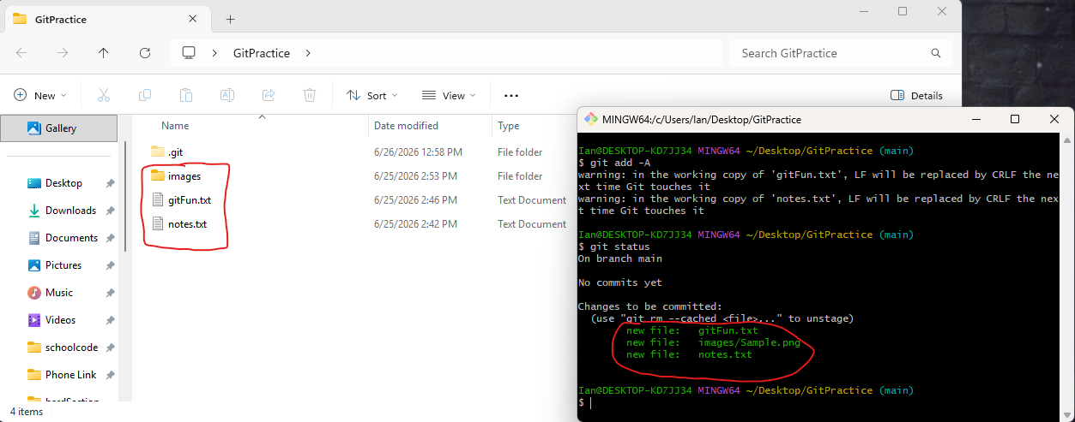

Step 2: Commit the Files
To commit the files, we will use the command we went over earlier and use git commit -m “enter message here”. For this message, since it is our first commit, it is customary to use the commit message “initial commit”. After your first commit, typically your commit message is a very short description of the changes you have made.
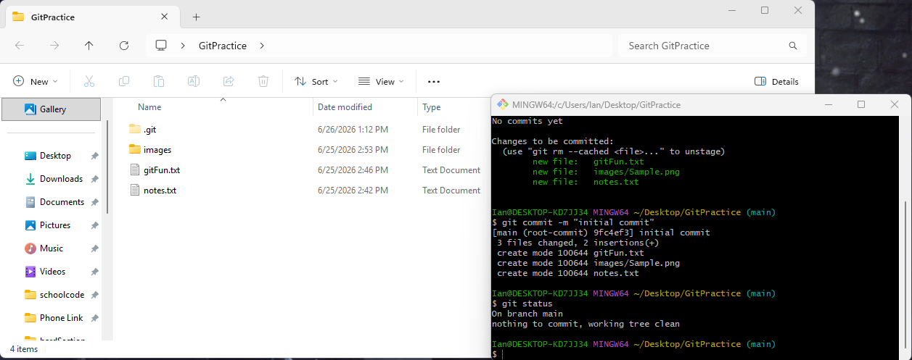
After we have committed, you will get output that gives you a quick summary of the actions that were done in this commit. The output tells you the commit ID, commit message, how many files were changed, how many files were created, how many files were deleted, how many changes within the files, and a summary of all files that were committed. If you check git status, you can see that there is nothing to commit, no untracked files, and the working tree is clean (working tree clean just means there are no new changes to stage).

Step 3: Check the Commit History
To check the commit history and see the changes that have been made to the repository over time, you can use the command git log. This will give you details about every commit that has been done to repository, along with the commit hash, author, date, and the commit message. For this repository, it is a little boring because we have made one commit. But for a repository that has had a lot of commits, such as the one hosting this course, it is quite extensive. Below is an image of this course:
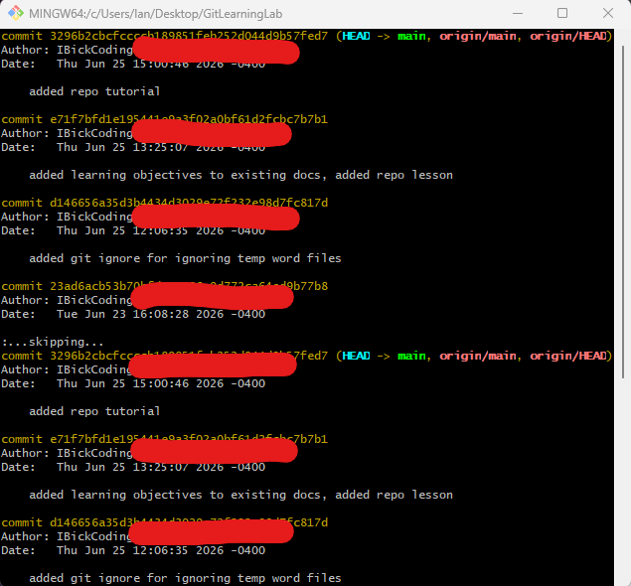

How Git Tracks Changes Over Time
Does Git store copies of files every time you change it? If that were the case repositories would very quickly grow to a ridiculous size and would be impractical.
However, Git is clever with how they take their snapshots of files. Instead of storing the entire file in its current state at each commit, Git instead keeps track of the differences between versions of the file at different commits. This way, Git is able to piece together what a file looks like at a given commit by referencing the differences between the version of the file at the current commit against an earlier commit. These differences are often referred to as "diffs", and this is an oversimplified explanation of the internals of Git but works for our current understanding.
Essentially, every time you make a commit, Git is checking to see if files were changed, if they were, it saves the “diffs”. For example, in a repository with the files 1stFile.txt and 2ndFile.txt, the internals of Git kind of look like this:

Commit 1
1stFile.txt
2ndFile.txt
↓
Edit 1stFile.txt
↓
Commit 2
1stFile.txt changed, saves the diff
2ndFile.txt unchanged
↓
Edit 2ndFile.txt
↓
Commit 3
1stFile.txt unchanged
2ndFile.txt changed, saves the diff

