Learning Objectives:
By completing this guide, learners will be able to:
- Explain why a developer may want to rewrite history.
- Identify where rewriting history may improve repository quality.
- Explain the difference between rewriting private history and rewriting public history.
- Modify the most recent commit within a repository.
- Change commit messages after a commit has been created.
- Use interactive rebase to modify multiple commits.
- Explain how interactive rebase rewrites commit objects.
- Reorder commits using interactive rebase.
- Combine multiple commits into one commit.
- Rename commit messages.
- Remove commit objects.
- Explain why rewritten commit objects will have different hashes from the original commit object.
- Explain why force pushing is required after rewriting remote history.
- Apply best practices when rewriting shared repository history.
- Determine when history should and should not be rewritten.

Introduction
We have learned in previous guides that commits are immutable objects, meaning that once a commit object has been created, its contents cannot be modified. We know that a commit object contains metadata that indicates the author, message, timestamp, parent commit, and tree. Changing any of these values will create a new commit.
Since a commit’s hash identifier is generated from the contents of the commit object, any change to the metadata of the commit will result in a different hash, even if the actual file changes contained by the commit remain the same. It is through this idea that we can “rewrite” commit history by creating new commits that take the place of old commits in history.

Why Rewrite History?
A logical question to ask is why you would even want to rewrite history. As I do in these guides, let’s take a scenario to break down why it may be useful to rewrite history.
Let’s assume that you are a developer working on the front-end of a website. On this front-end, we have several buttons that perform different actions. The specific functionality of these buttons is not important. What matters is that another developer’s work depends on your changes, so the feature needs to be completed quickly.
As you are working, you are attempting to make this button function as you designed them to. When you are working on them locally, you notice that they work as intended. However, once you commit and push them to your remote repository that is connected to the website’s deployment workflow, you notice that the buttons do not function as they did locally. Sometimes this happens because the environment is different, there are different dependencies, missing files, etc. But the important thing to note is that the buttons do not function as needed.

You decide, as the good programmer you are, to immediately work on fixing the buttons. You are confident that your solution will make the buttons function as intended and push the new fix up to the remote repository. Again, the buttons don’t function as intended. Once again, you decide to try and fix the buttons. Finally, you notice the issue that is causing the buttons not to work. You have a git ignore file that is excluding a key file that is necessary for the buttons to function. You remove the file from the git ignore and push your changes to the remote repository.
Your button finally works! However, you have created quite a messy commit history in the wake of the button dilemma. You have commits that look like “added all needed buttons to main page of website”, “fixed buttons”, “fixed buttons again”, “fixed buttons, but for real this time”. Instead of having four separate commits for adding the buttons to the main page of the website, we can instead consolidate them into one commit with the original message but the functionality of the last commit. Furthermore, we can leave out unnecessary debugging attempts in the project’s history.

The Golden Rule of Rewriting History
NEVER REWRITE HISTORY THAT OTHER PEOPLE ARE ALREADY DEPENDING ON. This is the most important rule to consider when trying to decide whether rewriting commit history is appropriate. As we know, a commit hash identifies the content of a commit object. Since a commit object contains a reference to its parent commit, changing any commit in the chain will also change the hash of every single commit that comes after it.
If you rewrite a commit, Git does not modify the original commit as if it were time traveling. Instead, it creates a new commit with a new hash identifier, which is now the commit that is referenced in the rewritten history. Everyone else may still have the old commit history, but you now have a new commit history. This creates two different versions of the commit history, which can cause the histories to diverge unintentionally.

Diverged commit histories become a problem because other teammates may have commits based on the old history, pulling the changes may now require complicated merges, and force pushing the changes to the remote repository may overwrite someone else’s work. This is all stuff we want to avoid as it causes unnecessary chaos that could be prevented.

Methods of Rewriting History
Now that we understand why rewriting history works, the dangers associated with it, and a rough idea of when to do it, we can look at the various ways we can rewrite history.
Common methods of rewriting history include:
- Amending commits
- Squashing Commits through interactive rebasing
- Reordering commits
- Dropping commits
- Resetting history

Amending Commits
Amending commits is the simplest form of rewriting commit history. A use case for amending a commit is when you have a typo in your last commit message and would like to fix it, such as “added buttns to main web page”.
To fix this typo, we would use the command `git commit --amend -m “added buttons to main web page”`. This will create a new commit object to replace the old commit object with the corrected message.
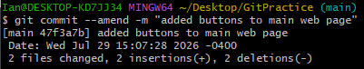
Additionally, if you forgot to stage a file in your previous commit that you have not pushed yet, you can add the changes to the staging area using `git add {filename}` and then `git commit --amend` to include them in the previous commit.

Squashing Commits
Squashing commits is the process of taking two or more commits and combining them into one commit. A use case for something like this is when you are working on a feature and you notice that you are creating a lot of small commits that belong to the same feature.
An example of this would be creating a log-in feature, where you have commits such as “added login page”, “added login button”, “fixed login button”, “added text fields for login”. All of these can be summed up into one commit that has a message of “added login feature”.
The commits in this example before squashing them would look like: A B C D. After squashing the commits, your commit history would look like A E, which looks far cleaner for the single feature that was added.
To do this, we will need to use the command `git rebase -i HEAD~{number of commits you want to squash together}`. This will open an editor with the last n commits where n is the number of you specified. The commit that appears on top you will keep as “pick”, and the rest you will change the wording to “squash”. You can see an example of this in the image below.
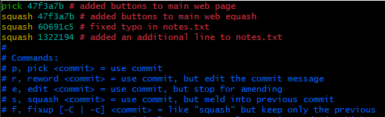
Next, press the escape button and then type “:wq” (w stands for write and q means to quit the editor.) to close this editor and a new editor will appear.
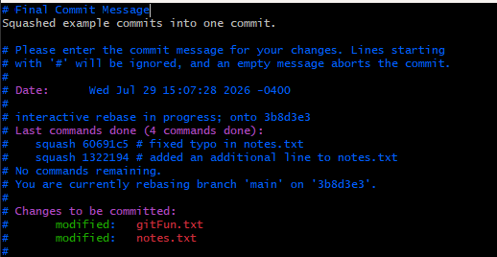
Here you will see the commit messages of all the commits that you are squashing. You can delete everything regarding commit messages and add a new commit message or keep one of the old ones. In this case, I wrote a new commit message. When you are finished, press the escape button again and type “:wq” again to write and quit the editor.

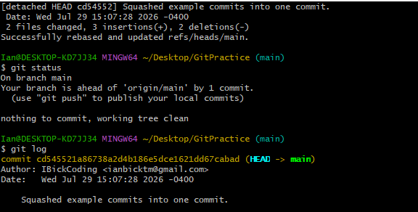
We will finally get the above output, that says that the rebase was successful. If we run `git status` now, we can see that our branch is 1 commit ahead of the remote branch. If we check `git log` we can see that the commit that has not been pushed yet is the squashed commit with the new message.

Reordering Commits
Reordering commits is done through interactive rebasing too. The command remains the same as squashing ` git rebase -i HEAD~{number of commits to reorder}`. To reorder commits, you would just move the content from one line that is below another to a new position above. Since Git executes from top to bottom, any commit above another will appear first in commit history. To exit the editor, press escape and type “:wq” to write and quit.
It is important to note that if you try reordering commits that affect the same line within a file and Git is not able to apply them cleanly, Git may encounter conflicts and pause the rebase until you resolve them.

Dropping Commits
Dropping commits can also be done through interactive rebasing. Dropping a commit just removes the commit from the commit history. The command still remains the same as both squashing and reordering. To drop a commit, replace the word in front of the commit you want to remove with the word “drop”. Then press the escape button and type “:wq” to write and quit.

Resetting History
Resetting history is the process of moving a branch reference to point to a past commit in the commit history. For instance, if we want to reset the branch to an older commit that is 2 commits behind the most recent, we would use the command `git reset --hard HEAD~2`. If we had a repository history that looked like A B C D and used this command, our history would now look like A B. Commits C and D are not permanently lost, but they are now unreachable from typical branch navigation techniques. If we wanted to recover them, we would have to use `git reflog`. This command is covered in a previous guide.

Force Pushing
If you choose to rewrite history on commits that have yet to be pushed to the remote repository and have only existed in your local repository, we are golden. However, if you choose to rewrite history that has already been pushed to a remote repository, we run into issues.
When you try to push your rewritten commit history to the remote repository in the latter option, the push will fail. This is because Git notices the repositories’ histories are not the same. You have a new history, but your remote repository has the old history. If we choose to rewrite the remote repository after weighing the risks, how can we push our changes?
You can do this with the command `git push {remote} {branch} --force`. This tells Git that you are aware of the issue it is trying to raise, but that you want it to force the push anyway. Essentially, you are telling Git “Replace the remote repository’s history with mine.”

Dangers of Force Pushing
If we have a team that is working on a project, the history of the project looks like:
A B C D
Then we have someone on the team that rewrites the history by squashing commits C and D and then force pushes the new history to the remote repository. We now have a history that looks like:
A B E
If we have another team member that tries to push a new commit to the remote repository, Git can no longer add the new changes because the commits are based on different versions of history.
In this specific example, the issue would not be that difficult to fix because Commit E contains the changes from both Commit C and Commit D. The team member may still be able to recover their work by rebasing their changes onto the new history. But if we were to drop Commit D rather than squashing it with Commit C, resolving the conflict becomes much more complicated if the changes made in the new commit being added depended on the changes made in Commit D.

