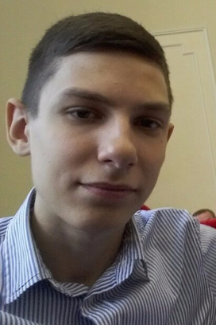**Igor Bordan**

**Address:** Odessa, Sil's'kohospodars'kyi Ln, 5

**Phone:** +38 (067) 7379851

**E-mail:** bordan.igor15@gmail.com

**Web-Site:** <https://ibordan.github.io/PersonalWebApplication/>

**LinkedIn**: <https://www.linkedin.com/in/igor-bordan/>

**Date of birth:** 16.07.2000

**Age:** 18

**Objective:** Have finished school with an average score of 9.7, very diligent.

**Summary:** In general, I'm a developer, who work with Web technology. I study on a speciality "Computer Sciences", I finish the 2nd course. I have experience in programming languages such as Python, C/C++, SQL. Worked with data structures. Currently working on a course project in PHP and MySQL.

**Skills:** HTML5, CSS3, Sass, JavaScript, jQuery, Gulp, npm, Git, Photoshop.

**Education:**

# Odessa National Polytechnic University (September 2017 – Present)

Higher education I'm getting at the Odessa National Polytechnic University, ICS faculty, department of information systems. At the university I took an active part in various activities such as programming competitions, conferences, etc.

**Languages:** Ukrainian (Native),Russian (Native), English (A2).

**Additional information:**

I have ability to work well and to quickly learn new software product, language or technology.

Also, I’m conscientious in work and I have creativity and desire to work and earn. Besides, I do sports.