Instructions for Authors of JMIR

Here are some quick links to how your manuscript should look at the time of submission. Components are detailed in the expected format of your manuscript. Please also refer to Instructions for Authors of JMIR for more information related to submissions, and Guide to JMIR Online Interface (PPT to come) for help with using our online system.

Authors’ information/metadata
Heading/heading styles
Type of Paper
Length of paper
Title
Keywords
Trial registration
Introduction
Methods
Results
Discussion
Other components
Figures
Tables
Footnotes
Textboxes
Multimedia Appendices
CONSORT-EHEALTH
Acknowledgements (previously Authors’ Contributions)
Conflicts of Interest
Abbreviations
URLs
Field codes/citation formatting
References:
Formatting
Published works
Journal
Book
Web
Conference proceedings
Website URLs

Original Paper
Enter information for authors (including designations, affiliations, correspondence, contributions) in the online metadata form. Do not use periods after initials, and include degree designations and affiliations for all authors. Trial registration numbers are also filled in on the metadata forms online.

PAFH-KM: A Knowledge Model to Guide Development of Ontologies and Data Standards for Physical Activity Prescription for Improved Health and Fitness Outcomes

Abstract
Background: Precise understanding of health consequences from varied forms of physical activity is essential for clinicians to prescribe physical activity interventions, for health-care organizations to store patient data, and for researchers to compute over intervention/outcome data. In the past five years, research into physical activity ontologies has gained traction, with most efforts aimed at personal applications like goal setting and training. However, a significant gap exists in linking these ontologies with physiological outcomes, establishing dose-response relationships for clinical use, and integrating with broader medical concepts.
Objective: This paper begins by examining existing ontologies and vocabulary systems that characterize physical activity, fitness, and health. Following this brief review, we propose a Physical Activity, Fitness, and Health Knowledge Model (PAFH-KM) as a standard approach for linking currently disparate vocabularies referencing physical activity fitness and health outcomes.
Methods: We reviewed vocabulary terms related to physical activity at NCBO BioPortal, ACSM Guidelines for Exercise Testing and Prescription, the 2008 and 2018 Physical Activity Guidelines for Americans, and the Compendium of Physical Activities. Utilizing concepts from these sources, we created the Physical Activity, Fitness, and Health Knowledge Model (PAFH-KM).
Results: PAFH-KM integrates several disparate physical activity and fitness vocabulary sources across our novel five root ontologies. Inclusion of conceptual domains from extant vocabularies enables discreet annotation and quantification of complex and varied physical activity types, conditions, and dosages--linking these with fitness tests and health phenotypes/trajectories.
Discussion: The PAFH-KM potentiates integration of vast and varied mHealth data streams for: collection, storage, query and interpretation of data from multiple physical activity, fitness, and health monitoring devices; standardized import into electronic health records; meta-analyses of historical physical activity studies across disciplines; semantic mapping across other health and medical vocabularies/ontologies; and economic analyses of direct and indirect costs/consequences of various lifestyles.
Conclusion: PAFH-KM provides a modular, evolvable framework upon which evolving ontologies to describe this data can be created, integrated, and extended.

Keywords: Physical Activity, Exercise, Ontology, Phenotype, Conceptual Model

Introduction
Despite documented evidence of the many health benefits of physical activity [1,2], sedentary lifestyles have become pervasive in many developed countries. The World Health Organization has identified physical inactivity as the fourth greatest risk for non-communicable diseases in 2019 [3] Surveillance data indicate that in 2012, 31% of adults worldwide did not perform enough physical activity to meet the minimum recommendations to achieve health benefits [4] and 8.3% of deaths in the United States are attributable to inadequate levels of physical activity (Carlson et al. 2018). This figure dropped to 27.5% in 2022 for adults, but remains high at 81% for adolescents [5]. The associated health and economic consequences related to this high level of physical inactivity are profound. If all inactive people worldwide became active, more than 5 million deaths could be averted each year [6] resulting in a potential reduction in direct and indirect medical costs of nearly $200 billion US dollars across China, India, the United Kingdom, and the United States [7].
The magnitude and scope of this global health concern has prompted the promotion and assessment of physical activity to become a diverse field of inquiry with correspondingly varied terminology and measurement tools. For the past 40 years, public health organizations including the American College of Sports Medicine (ACSM), Centers for Disease Control and Prevention, American Heart Association, U.S. Surgeon General, and the World Health Organization have developed different evidence-based physical activity recommendations to inform and encourage the public to be physically active [1,8–15]. At the same time, advances in technology have prompted the explosive growth of fitness and health sensors to enable individuals and clinical researchers to objectively quantify physical activity behaviors [16–20].
Despite widespread acceptance of these guidelines and tools, a multi-faceted communication breakdown between public health professionals, clinicians, and the public has hampered the prescription of physical activity in routine clinical practice [21–24][21]. Dissemination of physical activity guidelines to physicians and the public can vary across different geographic [25,26] and cultural regions [27], ambiguously include issues such as diet and smoking [28,29], and differ in interpretation and application [30,31]. Furthermore, current guidelines lack the detail needed for physicians to prescribe physical activity safely in a dose-response manner similar to pharmacotherapy [32–35][32]. To appropriately provide individual prescriptions, clinicians must query a patient for information including physical activity history and fitness level [36,37][36], but these data are not computable or easily stored in electronic health records. Meanwhile, a consistent quantification scheme for physical activity is important to communicate aspects such as type (e.g., muscle-strengthening, flexibility), dosage (e.g., intensity, frequency), and capacity (e.g., equipment, environment), among others. Despite existing efforts to standardize these descriptions, the growing demand for better management of personal physical activity and the increasing variety of available exercises have introduced more factors to consider [38–40]. Health and activity data collected by patients’ wearable devices have the ability to address this challenge, but inconsistent outcomes, proprietary algorithms, and concerns with data privacy limit the integration of device data into the healthcare system [41].
Standardized vocabularies and ontologies can simplify complex language into coding systems to guide clinical decisions and communication between physicians and patients. Recent efforts, like Kim et al. (2019), developed a physical activity ontology to improve data interoperability. However, it lacks clinician-specific descriptors like intensity, frequency, and population-based adaptations [42]. Similarly, Chatterjee and Prinz (2022) focus on personal physical activity tracking but overlook medical implications [43]. Most current ontologies are tailored for personal fitness use, not for clinicians to prescribe and quantify physical activity [44–48].
Currently, no unifying vocabulary or ontology exists to describe the knowledge domains of physical activity, fitness, and health outcomes for physical activity prescriptions. The objectives of this study were, therefore, to 1) comprehensively review existing vocabularies and semantic ontologies that include physical activity terminology, 2) organize the knowledge base created from this review, synthesizing essential elements into a knowledge model, the Physical Activity, Fitness, and Health Knowledge Model (PAFH-KM), from which ontologies related to physical activity, fitness, and health can be constructed, 3) Demonstrate the application of these ontologies in annotating data from activity monitoring devices and medical records to enhance interoperability across diverse vocabularies used in different health and fitness systems, and 4) improve granularity for population health aggregation and public health interventions.

Material and Methods

Review of Physical Activity Vocabularies and Ontologies
We identified physical activity terminology in existing guidelines, the scientific literature, and biomedical ontologies. We used the seminal vocabulary defined by Caspersen et al [49]. to build the primary conceptual domains of inquiry: physical activity, physical fitness, and exercise. We then searched in Medical Subject Headings (MeSH) to identify the related MeSH terms. Title word searches were performed with a query syntax in PubMed (http://www.ncbi.nlm.nih.gov/pubmed) that consisted of these conceptual terms AND clinical practice guidelines (e.g. practice guideline, guideline, standards, statement, position stand, recommendation, and consensus) OR semantic ontologies (e.g. ontology, taxonomy). In parallel, we conducted a systematic review in the National Center for Biomedical Ontologies (NCBO) Bioportal (http://bioportal.bioontology.org/) for references to the primary conceptual domains [50].
The two searches were conducted in September 2013 and were limited to articles, guidelines, or ontologies written in the English language and specified for humans. An additional search was conducted in September 2024 to fill in new ontologies and guidelines to augment the existing knowledge model. Search results were further refined to physical activity recommendations applicable to all individuals and not specific populations or disease conditions. Three authors (ML,CC, and HF) reviewed the search results and employed an iterative process to extract concepts and terminology hierarchies necessary to define the physical activity, fitness, and health knowledge domains.

Knowledge Model Development
Once primary components were extracted, a conceptual knowledge model was created using concept mapping (CMAP) software (Institute for Human and Machine Cognition CMAP Tools, v6.04). Three observable dynamics drove the design requirements for PAFH-KM:
- The primary framework of the PAFH-KM must describe ontologies to characterize the physical activity, fitness, and health dose-response relationship to enable prescription of physical activity as a standard clinical intervention that can be cataloged using biomedical data standards.
- Integration of current vocabularies must include an experimental context to prescribe exact doses of physical activity to achieve fitness and health outcomes in discrete measurable units.
- Proposed ontologies must enable annotation of data obtained in clinical and real-world settings such as data streams emerging from mHealth devices used by individuals to capture physical activity and related fitness and health responses.

Annotation of Physical Activity Data
To demonstrate the utility of the PAFH-KM, we used its primary components to annotate three example physical activity data sets selected to represent the diverse fields of physical activity inquiry. The data sets included: 1) a clinician’s notes for a patient requesting physical therapy, 2) activity monitor outputs recorded during a graded exercise tolerance test for an exercise science research study, and 3) mHealth data obtained by an individual interested in self-quantification of physical activity. All data sets were simulated as theoretical examples and were not obtained for other clinical or research purposes.

RESULTS

Review of Physical Activity Vocabularies and Ontologies
The database search resulted in an initial return of 691 scientific articles and guidelines. Following title and abstract review, 30 were considered in the scope of the original query [2,9,11–15,49,51–68]. “Physical Activity” as a search phrase was also found in eight ontologies in the NCBO BioPortal [50]. The different contextual representations of physical activity extracted from these ontologies were used in conjunction with the relevant articles and guidelines to develop the primary domains for the PAFH-KM.
Knowledge domains identified for the PAFH-KM focused on the characterization of the physical activity dose-response relationship, a necessary component to quantifiably assess health outcomes related to engagement (and repetitive engagement) in physical activities [2,13]. Specific domain areas were categorized as either “dose” or “response” variables. For each variable, a hierarchy was constructed to delineate the term parent/child relation as well as related sibling terms. As a representative example of this methodology, Table 1 highlights the diversity of the phrase “Physical Activity” as it occurs in the context of the 2008 Physical Activity Guidelines for Americans [2] and the selected NCBO ontologies.

Description of the PAFH-KM
Figure 1 depicts a dose-response characterization of the multi-ontological knowledge model that encapsulates essential elements of physical activity, fitness, and health knowledge domains around which ontologies can begin to be built. The independent “Dose” variables (X axis) include specific ontologies to describe the physical activity type, the condition under which the activity occurs, and the time duration (or number of repetitions) of activity bouts. When these variables are multiplied by the physical activity frequency with which they occur, a temporal physical activity dosage pattern emerges. The “Response” variables (Y axis) are separated into detailed ontologies of physiological health and fitness. The physiological health ontology characterizes adaptations of biological systems that are affected by a specific physical activity dose. The fitness performance ontology, on the other hand, measures the ability of an individual to perform a specific task. Lastly, units of measurement for both dependent and independent variables are described via a measurement method ontology. This ontology characterizes technologies and units used to quantify physical activity, fitness, and health.

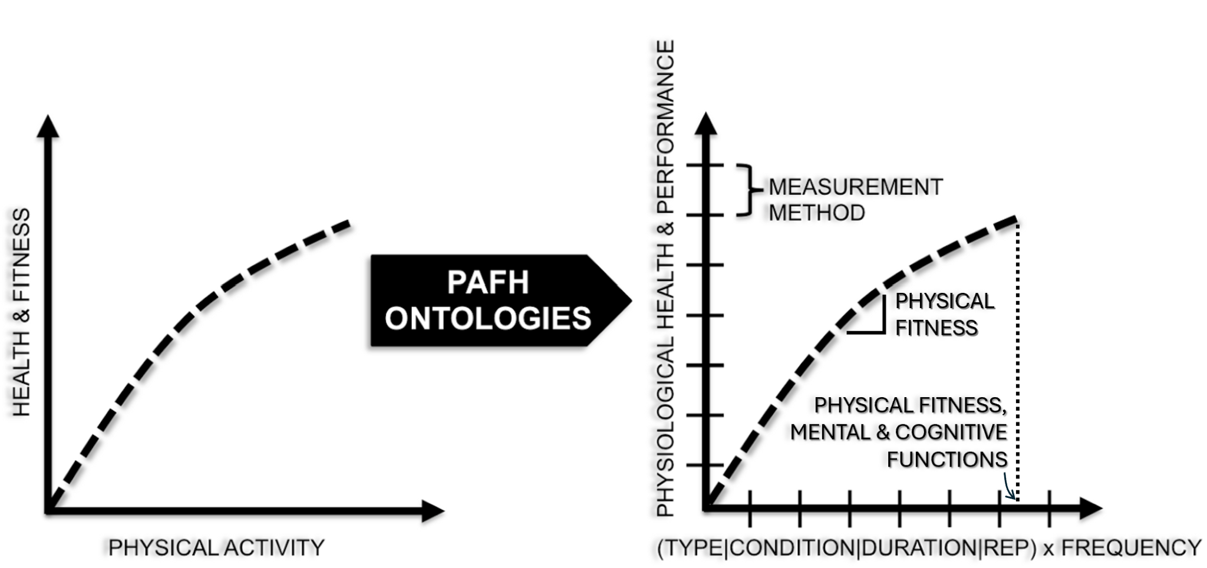
Figure 1. Elements of PAFH-KM characterizing the physical activity dose-response relationship

Using the foundation of the physical activity dose relationship, four primary root class ontologies were created: Physical Activity Ontology, Physical Fitness Ontology, Mental and Cognitive Functions Ontology, Physiological Health Ontology, and the PAFH Measurement Method Ontology. These ontologies were further characterized by their hierarchical relationships and representative knowledge domains (Figure 2). Many of the vocabularies for propagating these ontological components are largely completed and need merely to be harmonized and semantically integrated. Other sub-ontologies are less well characterized, and need to be created de novo. A description of the components of these knowledge domains including example classes/instances follows.
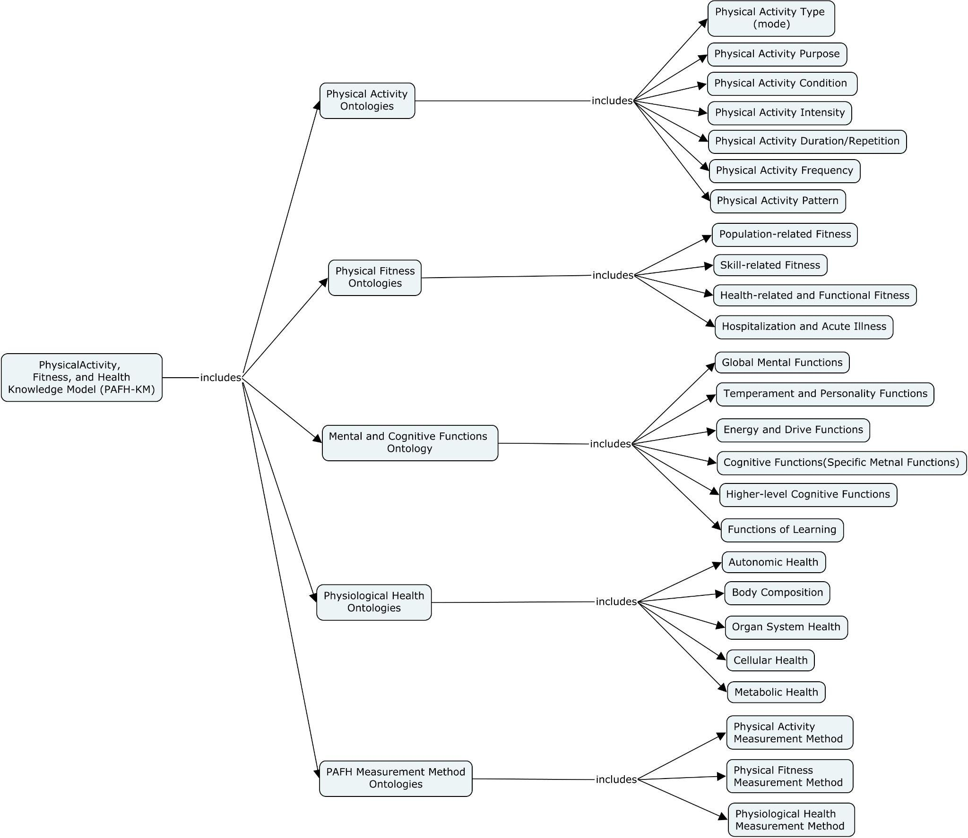
Figure 2. Base ontologies and their locations in the PAFH-KM.

Description of the Physical Activity Ontology
The Physical Activity Ontology combines elements of a physical activity dose: Type, Purpose, Condition, Intensity, Duration/Repetitions, Frequency, and Pattern with which each of these occur. The Physical Activity Type portion of the ontology describes the type or mode of physical activity being performed. Activity types were extracted from foundational references including: the Compendium for Physical Activities [67,69][67], the American Time Use Survey [68], the Activities of Daily Living (ADL) [70,71][70], the Barthel Index [72], and the International Classification of Functioning Disability and Health (ICF) [52]. Examples of classes and their respective instances within this ontology include: “Aerobic Activity”: “running”, “Muscle-Strengthening Activity”: “weightlifting”, “Balance Activity”: “Tai Chi”, “Flexibility Activity”: “Yoga”. This portion of the ontology is being built such that instances can belong to more than one class. For example, hiking can be part of “Aerobic Activity” and “Bone-Strengthening Activity” classes.
The Physical Activity Purpose portion of the Physical Activity Ontology defines the intent behind physical activities, whether for daily living, recreation, or competition. Foundational references include the Compendium of Physical Activity [67,69]and the Activities of Daily Living (ADL) [71]. Even for the same activity, different purposes can involve varying patterns and health impacts. For example, “walking” for daily living may be slower and less intense, while “walking” for recreation could involve brisker, more sustained movement, leading to different cardiovascular benefits. Example classes include “Basic Activities of Daily Living” like walking to the bathroom, “Instrumental Activities of Daily Living” such as walking for grocery shopping, “Leisure or Recreation” like walking as a part of a hike, and “Competition” such as race walking. These distinctions highlight how the purpose influences both activity patterns and health outcomes.
The Physical Activity Condition portion of the Physical Activity Ontology describes both intrinsic and extrinsic conditions under which an activity is pursued and completed. Foundational references for this ontology include ACSM Guidelines for Exercise Prescription [13], the Compendium of Physical Activities [67,69], the Physical Activity Guidelines for Americans [2], International Classification of Functioning Disability and Health (ICF) [73], and knowledge elicited from subject matter experts. Intrinsic conditions include pre-existing physical fitness, mental and cognitive functions, and physiological health, all of which will be detailed in other ontologies in sections to follow. Extrinsic conditions include Environmental Conditions and Equipment/Assistance Conditions. Examples of classes and their respective instances within the physiological condition portion of this ontology include: “immune status”: “immunocompromised”, “hydration status”:“dehydrated”, “functional limitation”:“fractured tibia”. Examples of classes and their respective instances within the environmental condition portion of the ontology include: “precipitation status”:“snowing”, “altitude”:“high (>2400 meters)”, “outdoor temperature”:“ >23°C”. Examples of classes and their respective instances within the equipment/assistance conditions portion of the ontology include: “protective gear”: “knee braces”, “mobility aids”: “crutches”.
The Physical Activity Intensity portion of the Physical Activity Ontology describes the intensity of physical activity doses. Intensity is defined as the magnitude of effort required to perform an activity and can be expressed in either “absolute” or “relative” terms [15]. Similarly, the Physical Activity Duration/Repetitions portion of the Physical Activity Ontology describes the length of time and/or the number of reps used to gauge the duration of a bout of activity. The Frequency and Pattern portion of the Physical Activity Ontology is used to describe the number of times a bout of activity is performed expressed as the number of sessions per time interval [15]. Foundational references for these portions of the Physical Activity Ontology include the ACSM Guidelines for Exercise Prescription [13], and Physical Activity Guidelines for Americans [2,15][2]. Example classes and their respective instances within the absolute and relative intensity portion of this ontology include: “staging intensity”: “40-50% of max heart rate”, “load intensity”: weightlifting at “85% 1RM”, “speed intensity”: running at “70% max speed”, “rate of energy expenditure”:“kilocalories/min”, and “rating of perceived exertion”:“very hard”.
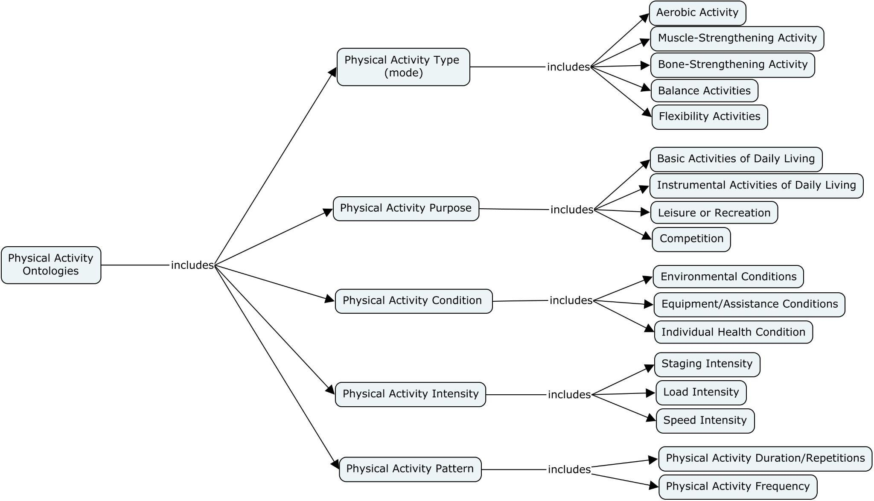
Figure 3. Physical Activity ontologies and their locations in the PAFH-KM.

Description of the Physical Fitness Ontology
Building on the early work of Caspersen et al. [49] suggesting utilization of evaluation procedures to determine specific types of fitness, the Physical Fitness Ontology aims to unambiguously describe components of physical fitness by splitting descriptors of Skill-related Fitness from Health-related Fitness. Both sections of the Physical FitnessOntology describe the pre-existing fitness levels and fitness response to physical activity, quantified in terms of ability to complete a physical fitness task with specified constraints. The Physical Fitness Ontology includes Population-related fitness, Skill-related fitness, Health-related functional fitness, and Hospitalization and acute illness. Foundational references for this ontology include the ACSM Guidelines for Exercise Prescription [13], the Physical Activity Guidelines for Americans [2,15][2], and knowledge elicited from subject matter experts.
The Population-Related Fitness portion of the Physical Fitness Ontology emphasizes the diverse demographic and contextual factors influencing fitness and physical activity. Foundational references for this ontology include the ACSM Guidelines for Exercise Prescription (American College of Sports Medicine ), the 2024 Compendium of Physical Activities for older adults (Willis et al. 2024) and Wheelchair Activities (Conger et al. 2024), National Institute of Aging (Exercise and Physical Activity: Getti...), and expert knowledge (Eckstrom et al. 2020; Brawley et al. 2003). Age influences both participation in physical activity and fitness outcomes, with younger individuals generally having greater capacity for vigorous activity and older adults often benefiting from modifications to accommodate age-related physiological changes. Disability may limit participation due to physical or cognitive barriers but also shapes fitness outcomes based on the level of adaptation provided. Gender affects participation through physiological differences, such as muscle mass or endurance, and societal norms, while influencing fitness outcomes through varying responses to training. Location impacts participation by providing or restricting access to activity opportunities (e.g., facilities, safe spaces) and affects fitness outcomes through environmental conditions such as altitude, temperature, or pollution levels. Examples of categories and their instances include: Age: "65+ years", Disability: "Paraplegia", Gender: "Post-menopausal female", and Location: "High altitude".
The Skill-Related Fitness portion of the Physical Fitness Ontology emphasizes components of fitness that contribute to performance in physical activities requiring specialized skills. Foundational references for this ontology include Activities of Daily Living (Edemekong et al. 2024) , CDC's Community Design Guidelines (CDC 2024), and expert insights. Key factors include Agility, which influences the ability to change direction quickly during activity; Balance, critical for maintaining stability during static or dynamic tasks; Coordination, affecting the ability to execute movements with precision and synchronization; Power, reflecting the capacity to exert force rapidly; Reaction Time, determining how quickly an individual responds to stimuli; Speed (encompassing acceleration and velocity), essential for rapid movement; and Endurance, supporting sustained activity over time. Examples of categories and their instances include: Agility: "Able to change direction 180° within 2.5 seconds during a 10-meter sprint", Balance: "Maintaining stability on a single leg for 30 seconds with eyes closed", Coordination: "HaExecuting precise bimanual tasks such as threading a needle within 15 seconds", Power: "Generating a vertical jump height of 60 cm", Reaction Time: "Reacting to a visual cue in under 0.25 seconds", Speed: "Reaching a maximum sprinting velocity of 10 m/s over a 50-meter dash", and Endurance: "Maintaining a constant pace of 12 km/h for 43 km in a marathon". These categories outline key dimensions of skill-related fitness that influence physical performance across various contexts.
The Health-Related and Functional Fitness portion of the Physical Fitness Ontology addresses the functional capacity of bodily systems as they relate to maintaining physical fitness and performing daily activities. Foundational references for this ontology include the Activities of Daily Living (Edemekong et al. 2024), International Classification of Functioning, Disability, and Health (ICF) by WHO (International Classification of Funct...), and ACSM Guidelines for Exercise Prescription (American College of Sports Medicine ). Key components include Musculoskeletal Functions, critical for performing tasks such as lifting or walking (e.g., "Grip strength exceeding 30 kg in males for functional independence"), Neurological Functions, enabling motor coordination and balance during activity (e.g., "Ability to maintain upright posture for 60 seconds without support"), Circulatory Functions, supporting sustained physical activity through efficient blood flow (e.g., "Resting heart rate between 60–100 bpm to meet aerobic demands"), Sensory Functions, facilitating safe interaction with the environment (e.g., "Peripheral vision sufficient for detecting obstacles at 90 degrees"), Voice and Speech Functions, enabling communication for social and occupational functioning (e.g., "Speech intelligibility above 90% in everyday contexts"), Cardiovascular Functions, crucial for delivering oxygen during activity (e.g., "VO2 max above 40 mL/kg/min for moderate exercise capacity"), Respiratory Functions, supporting endurance by maintaining oxygen exchange (e.g., "Forced expiratory volume in 1 second >80% of predicted value for aerobic activity"), and Digestive, Metabolic, and Endocrine Systems Functions, ensuring energy availability for sustained activity (e.g., "Fasting blood glucose <100 mg/dL to prevent exercise intolerance").
Hospitalization and acute illness often lead to declines in physical fitness and activity due to immobilization, muscle deconditioning, and systemic effects of illness. Recovery can be prolonged, impacting strength, endurance, and overall mobility. Since this is a broad and well-known topic among the audience, this paper won’t go into detail, but these factors are important to consider in understanding long-term physical function.

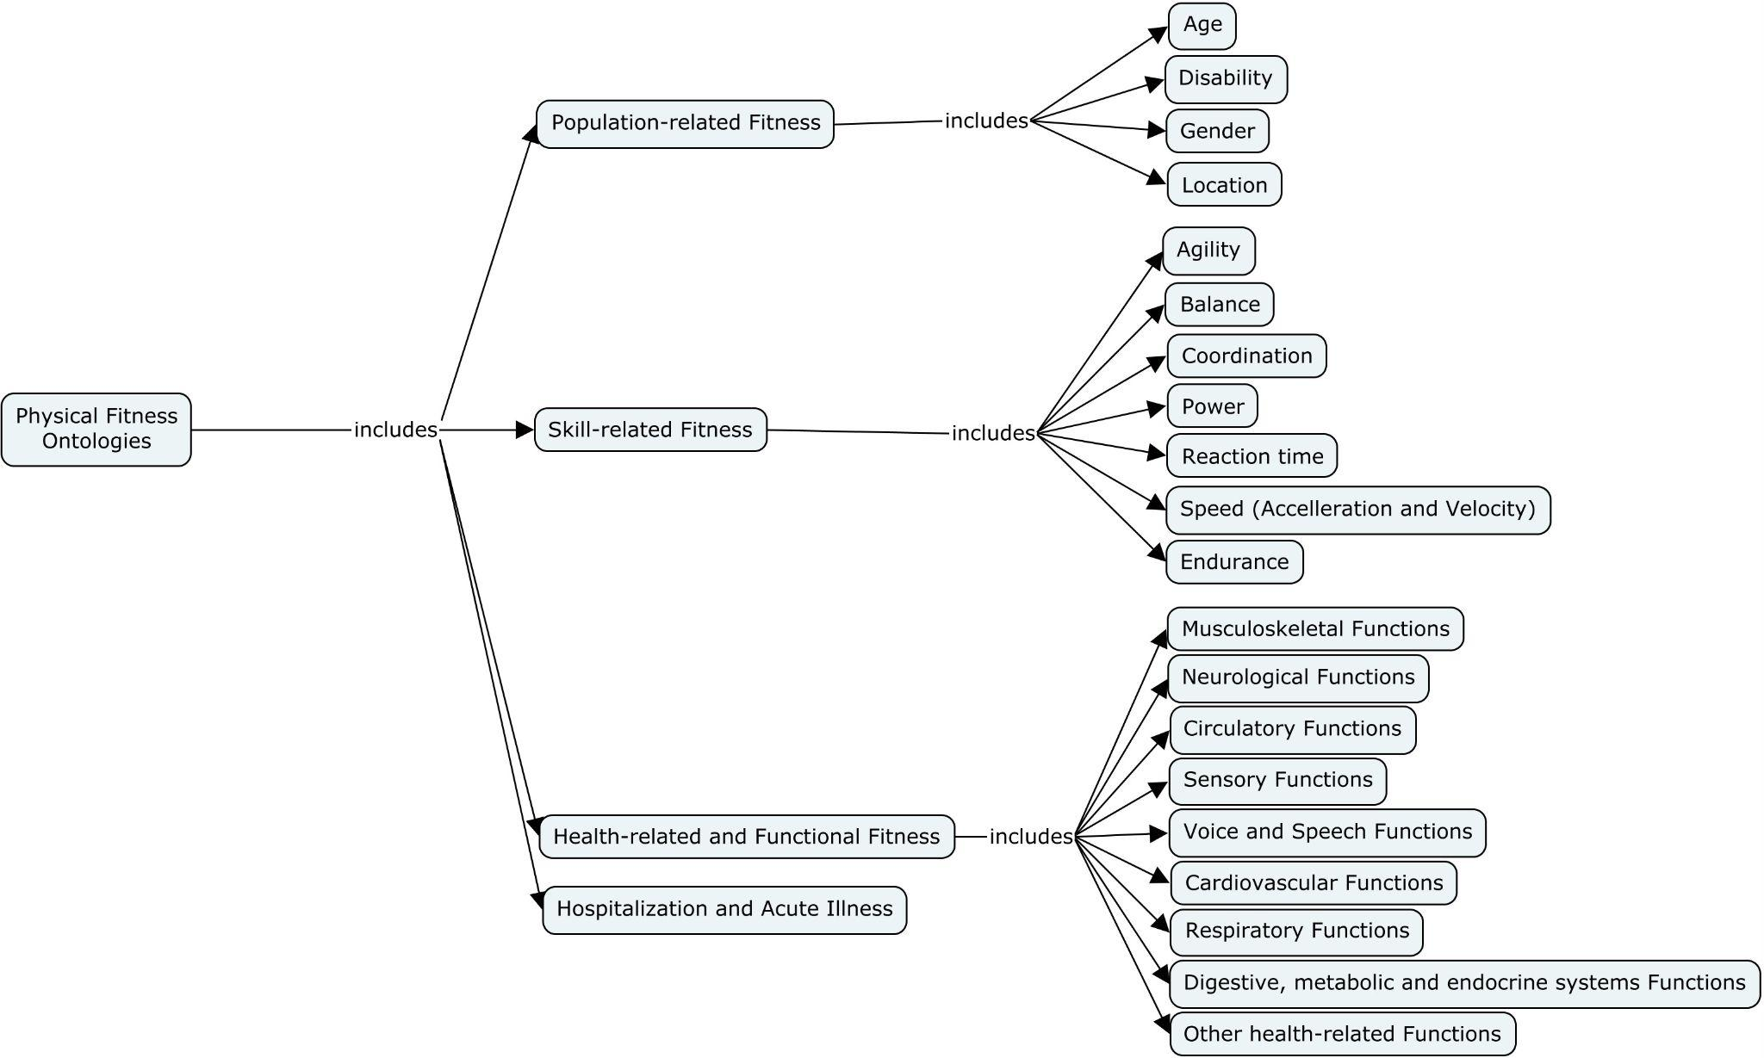
Figure 4. Physical Fitness ontologies and their locations in the PAFH-KM.

Description of Mental and Cognitive Functions Ontology

The Mental and Cognitive Functions Ontology provides a comprehensive framework for understanding the mental processes and cognitive capacities that influence engagement, performance, and adaptation in prescribed physical activity. This section presents results across six key domains: Global Mental Functions, Temperament and Personality Functions, Energy and Drive Functions, Cognitive Functions (Specific Mental Functions), Higher-Level Cognitive Functions, and Functions of Learning. Each domain encompasses mental attributes and processes that shape individuals’ capacity to initiate, sustain, and adapt to physical activity, supported by foundational ontologies and theoretical frameworks. The following subsections outline the contributions of each domain to physical activity participation and performance, with examples relevant to exercise adherence, motor performance, and training adaptation.

Global Mental Functions in the Mental and Cognitive Functions Ontology regulate cognitive stability, adaptability, and physiological responses to physical activity. Foundational references include the Mental Functioning Ontology (Hastings and Schulz 2012; Hastings et al. 2014; Hastings et al. 2012; Ceusters and Smith 2010), International Classification of Functioning, Disability, and Health (ICF) by WHO (International Classification of Funct...), and frameworks such as Cognitive Load Theory (Sweller 1988), Executive Function Model (Miyake and Friedman 2012), Self-Regulation Theory (Baumeister and Vohs 2007), Yerkes-Dodson Law (1908) on arousal and performance (Classics in the History of Psychology...), BDNF Model (Bathina and Das 2015), and Polyvagal Theory (Porges 1995). Consciousness affects situational awareness and self-regulation, influencing decision-making and injury risk in fatigued or stressed individuals. Orientation supports spatial awareness and task execution, essential for activities requiring precise movement, like gymnastics. Intellectual functions enhance cognitive endurance and learning efficiency, aiding skill acquisition and strategic thinking in sports. Emotional stability fosters stress resilience and consistent motivation, reducing performance anxiety and burnout. Stress response regulates physiological reactivity and recovery efficiency, with the Yerkes-Dodson Law showing how moderate stress enhances performance, while excessive stress impairs it. Arousal and alertness influence reaction speed and motor readiness, aligning with Polyvagal Theory on balancing engagement and precision. Rest and recovery support neural consolidation and physical repair, with the BDNF Model highlighting their role in skill retention and adaptation. Examples of categories and their instances include: Consciousness: "Full alertness during endurance training"; Orientation: "Spatial positioning in gymnastics routines"; Emotional Stability: "Regulating anxiety before competition"; Stress Response: "Adaptive physiological reactions to high-intensity exercise"; Rest and Recovery: "Sleep-dependent memory consolidation for movement skills".

Temperament and Personality Functions in the Mental and Cognitive Functions Ontology highlight affective traits and motivational drives shaping cognitive function and physical activity. Foundational references include the Emotion Ontology (Hastings et al. 2014; Hastings et al. 2012; Hastings et al. 2011; Liakata et al. 2012), International Classification of Functioning, Disability, and Health (ICF) by WHO (International Classification of Funct...), Big Five Personality Traits (Costa and McCrae 1999), Reinforcement Sensitivity Theory (Gray 1982), Grit Theory (Duckworth et al. 2007), and Self-Determination Theory (Deci and Ryan 2012). Extraversion enhances social engagement and activity preference, promoting participation in team sports and high-intensity workouts. Agreeableness supports cooperative behavior and exercise adherence, fostering motivation in group training. Psychic Stability strengthens emotional regulation and stress resilience, aiding performance in endurance and competitive settings. Openness to Experience boosts cognitive flexibility and adaptability, encouraging engagement in varied or novel activities. Optimism sustains goal persistence and perceived effort, reinforcing long-term commitment to training. Confidence enhances self-efficacy and performance consistency, enabling individuals to push their physical limits. Mental Toughness drives perseverance under fatigue, essential for endurance and high-intensity challenges. Examples include Extraversion: "frequent participation in team sports such as soccer and basketball"; Agreeableness: "high adherence to partner-based workouts with ≥80% attendance in paired training programs"; Psychic Stability: "lower cortisol reactivity and sustained pacing in ultra-endurance events like marathons and Ironman triathlons"; Mental Toughness: "maintaining peak output under pressure in high-stress competitions such as combat sports and CrossFit finals."

Energy and Drive Functions portion of the Mental and Cognitive Functions Ontology highlights the physiological and psychological mechanisms that sustain motivation, endurance, and regulatory control in physical activity. Foundational references include the Emotion Ontology (Hastings et al. 2014; Hastings et al. 2012; Hastings et al. 2011; Liakata et al. 2012), International Classification of Functioning, Disability, and Health (ICF) by WHO (International Classification of Funct...), Cognitive Science and Neuropsychological Frameworks (Sweller 1988; Miyake and Friedman 2012; Baumeister and Vohs 2007), and Neuroscientific and Behavioral Frameworks (Classics in the History of Psychology...; Bathina and Das 2015; Porges 1995). Energy Level influences both physical endurance and task persistence, determining an individual's capacity to sustain prolonged exertion (e.g., "VO2 max > 40 ml/kg/min supports sustained aerobic activity"). Motivation drives exercise adherence and performance intensity, impacting goal-setting and persistence (e.g., "Self-determined motivation predicts >150 min/week of moderate exercise"). Appetite regulates nutritional intake and exercise metabolism, shaping energy availability for performance (e.g., "Leptin and ghrelin balance modulates post-exercise feeding behavior"). Impulse Control affects risk-taking in sports and exercise consistency, influencing behavior in high-stakes settings (e.g., "Lower impulsivity correlates with long-term exercise adherence"). Cognitive Endurance supports sustained focus and mental resilience during prolonged activity (e.g., "Higher working memory capacity correlates with endurance task persistence"). Habit Formation reinforces exercise routine stability and automaticity of movement patterns, enhancing long-term participation (e.g., "Daily physical activity habits predict >80% adherence rates in structured training programs"). Pain Tolerance and Sensitivity modulates exercise intensity thresholds and injury resilience, shaping engagement in endurance and resistance training (e.g., "Elite endurance athletes exhibit higher pain tolerance in cold-pressor tests").

Cognitive Functions (Specific Mental Functions) in the Mental and Cognitive Functions Ontology encompass perceptual, motor, emotional, and executive processes critical for cognitive performance and physical activity. Foundational references include the Mental Functioning Ontology (Hastings and Schulz 2012; Hastings et al. 2014; Hastings et al. 2012; Ceusters and Smith 2010), Emotion Ontology (Hastings et al. 2014; Hastings et al. 2012; Hastings et al. 2011; Liakata et al. 2012), and Cognitive Atlas Ontology (Miller et al. 2010; Bilder et al. 2009; Poldrack et al. 2011; Kittur and Kraut 2008). Attention enhances focus and reaction speed (e.g., Stroop Test <500ms improves decision-making in fast sports). Memory supports skill retention and strategy execution (e.g., N-back accuracy >85% aids tactical adaptation). Psychomotor functions integrate cognition with movement (e.g., reaction time <250ms enhances agility in combat sports). Motor planning facilitates precise movement execution (e.g., Purdue Pegboard scores correlate with gymnastics performance). Emotional functions regulate stress and performance anxiety (e.g., high emotional regulation reduces pre-competition anxiety). Perceptual functions process spatial and sensory input (e.g., superior visual-spatial skills aid tactical awareness in combat sports). Thought functions drive decision-making and adaptability (e.g., fast cognitive flexibility aids strategic play in team sports). Sensory integration coordinates multimodal sensory inputs (e.g., better vestibular function predicts balance in gymnastics).

The Higher-Level Cognitive Functions portion of the Mental and Cognitive Functions Ontology encompasses advanced cognitive processes essential for goal-directed behavior and adherence to prescribed physical activity. Foundational references include the Mental Functioning Ontology (Hastings and Schulz 2012; Hastings et al. 2014; Hastings et al. 2012; Ceusters and Smith 2010), Cognitive Atlas Ontology (Miller et al. 2010; Bilder et al. 2009; Poldrack et al. 2011; Kittur and Kraut 2008), and the International Classification of Functioning, Disability, and Health (ICF) (International Classification of Funct...). These functions align with Embodied Cognition Theory (Wilson 2002) in proprioceptive influence on movement control, and the Temporal Processing Framework (Buhusi and Meck 2009) in time perception affecting exercise scheduling and consistency. Organization and Planning support structured physical activity routines and goal-setting (e.g., individuals with strong planning skills are more likely to follow long-term exercise programs, improving adherence rates). Time Management ensures consistency in physical activity engagement (e.g., effective scheduling of workouts increases weekly exercise compliance in rehabilitation settings). Cognitive Flexibility facilitates adaptation to changing routines and exercise modifications (e.g., patients recovering from injury benefit from cognitive flexibility when adjusting to altered physical activity regimens). Proprioception enhances body awareness and movement efficiency, crucial in rehabilitation and injury prevention (e.g., improved proprioception in older adults reduces fall risk through balance training). Other Higher-Level Cognitive Functions integrate cognitive domains to sustain engagement in structured activity programs (e.g., individuals with better executive function are more likely to sustain engagement in home-based physical therapy exercises).

The Functions of Learning portion of the Mental and Cognitive Functions Ontology emphasizes the processes that facilitate knowledge acquisition, retention, and application in physical activity contexts. Foundational references for this ontology include Bloom’s Taxonomy (Bloom 1968), Piaget’s Theory of Cognitive Development (Piaget 1936), Vygotsky’s Sociocultural Theory (Vygotsky 1978), Kolb’s Experiential Learning Theory (Sims 1983), and Constructivist Learning Theory (Hein 1991). Purposeful Sensory Experiences enhance perceptual learning by refining sensory processing and motor responses (e.g., proprioceptive training improves movement precision in rehabilitation). Basic Learning involves fundamental cognitive processes necessary for skill acquisition and adaptation (e.g., repetitive motor drills reinforce muscle memory in balance training). Applying Knowledge translates learned concepts into real-world execution, fostering skill transfer and problem-solving (e.g., applying biomechanical principles optimizes exercise technique for injury prevention). These learning functions play a crucial role in structured physical activity, shaping engagement, skill progression, and overall cognitive-motor integration.

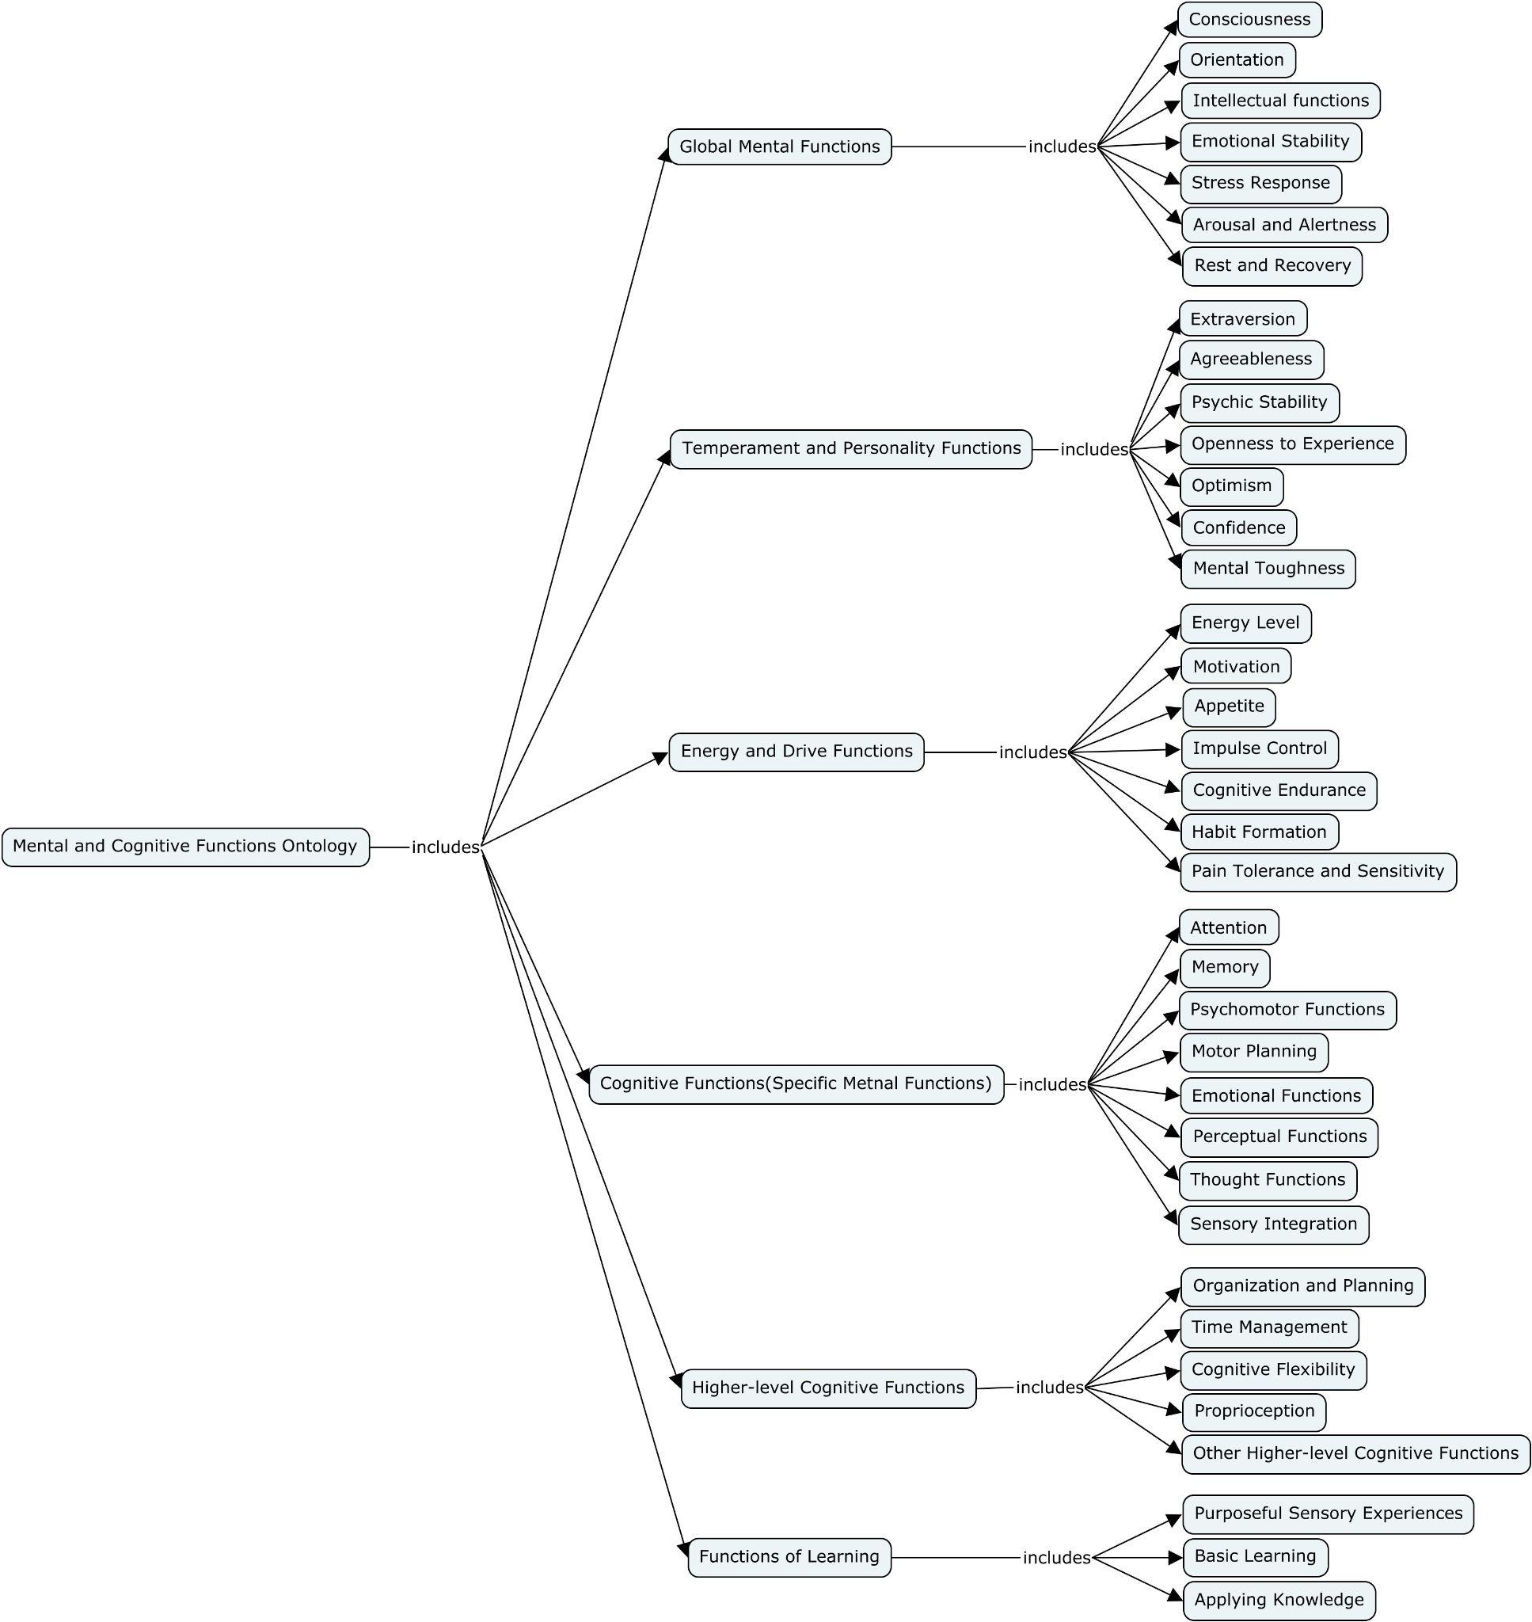
Figure 5. Mental and Cognitive Functions ontologies and their locations in the PAFH-KM.

Description of Physiological Health Ontology
The Physiological Health Ontology, seeks to describe the discrete physiologic responses, both acute and chronic, to varied combinations of physical activity doses. Foundational references for this ontology include the ACSM Guidelines for Exercise Prescription [13] and the 2008 Physical Activity Guidelines for Americans [2]. This ontology includes Autonomic Health, Body Composition, Organ System Health, Cellular Health, and Metabolic Health.
The Autonomic Health portion of the Physiological Health Ontology focuses on the regulation of involuntary physiological processes critical for maintaining internal stability and responding to external demands. Foundational references for this ontology include the International Classification of Functioning, Disability, and Health (ICF) by WHO (International Classification of Funct...) and clinical guidelines for autonomic function assessment (Low et al. 2013). This section encompasses the Sympathetic Nervous System, which drives "fight-or-flight" responses by increasing heart rate, blood pressure, and energy mobilization (e.g., "Resting heart rate >80 bpm in sympathetic overactivation"), the Parasympathetic Nervous System, which promotes "rest-and-digest" processes by reducing heart rate and facilitating recovery (e.g., "Heart rate variability >30 ms indicating robust parasympathetic activity"), and Homeostasis, the dynamic balance between these systems that maintains physiological stability (e.g., "Core body temperature within 36.5–37.5°C under varying environmental conditions"). These categories define the essential regulatory mechanisms that underpin physiological health and adaptability to stress.
The Body Composition portion of the Physiological Health Ontology focuses on the functional characteristics of different tissue types that contribute to physical health and performance. Foundational references for this ontology include the ACSM Guidelines for Exercise Prescription (American College of Sports Medicine ). This section includes Adipose Tissue Function, which regulates energy storage and hormone release, and can benefit from physical activity via reduced fat mass and improved metabolic health; Muscle Tissue Function, which supports movement and strength, with activity increasing muscle mass, strength, and metabolic efficiency; and Bone Tissue Function, which provides structural support and mineral balance, with weight-bearing exercise enhancing bone density and reducing the risk of osteoporosis. Examples of classes and their respective instances include: Adipose Tissue Function: "Body fat percentage >25% (indicative of obesity)", Muscle Tissue Function: "Skeletal muscle mass index <7.0 kg/m² (indicative of sarcopenia)", and Bone Tissue Function: "Bone mineral density T-score ≤ -2.5 (indicative of osteoporosis)".
The Organ System Health portion of the Physiological Health Ontology focuses on the functional integrity and interactions of major organ systems that sustain physiological processes and overall health. Foundational references for this ontology include the International Classification of Functioning, Disability, and Health (ICF) by WHO (International Classification of Funct...), clinical guidelines for system-specific health (Clinical Practice Guidelines ), and expert literature (Boron and Boulpaep 2016). This section includes the Cardiovascular System, which enhances aerobic capacity and endurance as physical activity improves cardiac output and lowers blood pressure; the Respiratory System, which supports gas exchange during exercise, with aerobic training improving ventilatory efficiency and lung function; the Digestive System, which benefits from increased gut motility and nutrient absorption to meet energy demands of activity; the Endocrine System, where exercise enhances hormone regulation, improving insulin sensitivity and glucose metabolism; the Renal System, which maintains hydration and electrolyte balance during activity, with exercise reducing proteinuria and supporting kidney function; and the Lymphatic and Immune System, which promotes recovery and strengthens immunity with moderate activity while excessive exercise may temporarily suppress it. Examples of classes and their respective instances include: Cardiovascular System: "Blood pressure >140/90 mmHg (hypertension)", Respiratory System: "Forced expiratory volume in 1 second (FEV1) <80% of predicted value (indicative of obstructive lung disease)", Digestive System: "Gastric pH >4 (indicative of hypochlorhydria)", Endocrine System: "HbA1c ≥6.5% (diagnostic of diabetes)", Renal System: "Glomerular filtration rate <60 mL/min/1.73m² (chronic kidney disease)", and Lymphatic and Immune System: "Lymphocyte count <1,000/µL (lymphopenia)". These examples highlight measurable indicators of organ system health relevant to clinical and physiological contexts.
The Cellular Health portion of the Physiological Health Ontology focuses on key cellular processes that maintain homeostasis, support tissue function, and prevent disease progression. This section includes Mitochondrial Function, which supports cellular energy production through oxidative phosphorylation; Oxidative Stress Response, which involves mechanisms to counteract reactive oxygen species (ROS); Apoptosis, a regulated process of programmed cell death critical for tissue renewal and disease prevention; and DNA Health, which encompasses genomic stability and repair mechanisms. Examples of classes and their respective instances include: Mitochondrial Function: "ATP production rate <2.5 µmol/min/mg protein (indicative of mitochondrial dysfunction)", Oxidative Stress Response: "Elevated malondialdehyde (MDA) >3 µmol/L (indicative of oxidative damage)", Apoptosis: "Caspase-3 activity >20% above baseline (indicative of increased apoptotic signaling)", and DNA Health: "DNA damage marker γH2AX >1.5-fold increase (indicative of genomic instability)".
The Metabolic Health portion of the Physiological Health Ontology focuses on the efficiency and balance of biochemical processes essential for maintaining energy homeostasis, growth, and repair. This section includes Carbohydrate Metabolism, where physical activity increases glucose uptake and glycogen storage to fuel exercise; Lipid Metabolism, where activity enhances fat breakdown and transport, reducing lipid levels and improving energy balance; Protein Metabolism, which supports muscle repair and growth, with exercise stimulating amino acid turnover and protein synthesis; and Hormonal Regulation, where physical activity optimizes endocrine signaling, improving insulin sensitivity, stress hormone balance, and overall metabolic efficiency. Examples of classes and their respective instances include: Carbohydrate Metabolism: "Fasting blood glucose >126 mg/dL (indicative of diabetes)", Lipid Metabolism: "Triglycerides >150 mg/dL (indicative of dyslipidemia)", Protein Metabolism: "Blood urea nitrogen (BUN) >20 mg/dL (indicative of impaired protein catabolism)", and Hormonal Regulation: "Thyroid-stimulating hormone (TSH) >4.0 mIU/L (indicative of hypothyroidism)". These examples highlight measurable parameters that define metabolic health and its role in physiological stability.

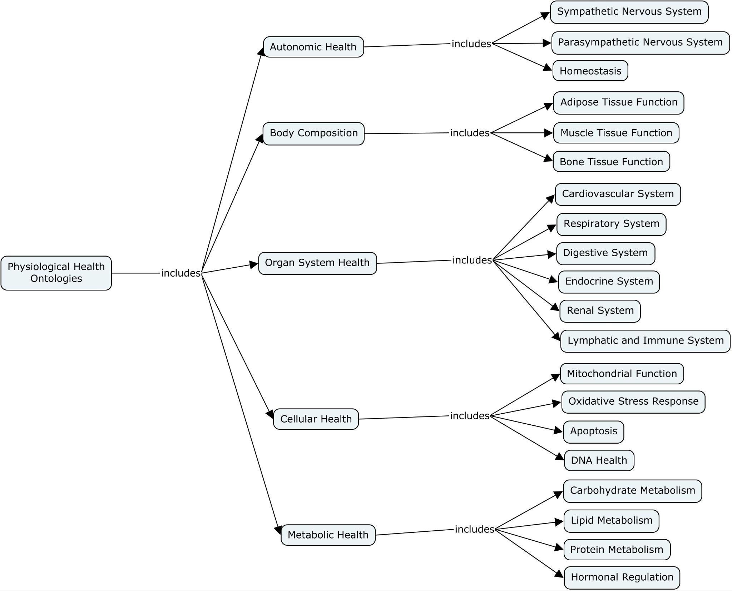
Figure 6. Physiological Health ontologies and their locations in the PAFH-KM.

Description of Measurement Method Ontology
The Measurement Method Ontologies describes the technologies, methods, and units used to quantify physical activity, fitness, and health [74]. Foundational resources for this ontology were obtained from a systematic review of literature describing activity monitoring and fitness assessment equipment. Examples of technologies could range from a thermometer to measure temperature, with units expressed in terms of degrees Celsius, to an indirect calorimeter to measure indirect energy expenditure in terms of kilocalories per minute.
This section includes three broad categories, measurement method for Physical Activity, Physical Fitness, and Physiological Health. The Physical Activity Measurement Method centers around quantifying the Relative Intensity of Physical Activity section, to quantify physical activity intensity in relation to an individual's capacity. Examples of these measurements include Percentage of Oxygen Uptake Reserve (VO2R), which measures the percentage difference between resting and maximal oxygen uptake to prescribe individualized aerobic training intensities; Heart Rate Reserve (HRR), which calculates the difference between resting and maximum heart rate to determine target zones for cardiovascular training; Oxygen Consumption (VO2), which quantifies oxygen use during activity as a marker of intensity; Heart Rate (HR), which serves as a direct, scalable measure of activity intensity; and Metabolic Equivalents (METs), which standardize activity intensity relative to resting metabolic rate. Examples of classes and their respective instances include: Percentage of Oxygen Uptake Reserve: "40–59% VO2R for moderate-intensity aerobic exercise," Heart Rate Reserve: "50–70% HRR for improving cardiovascular fitness," Oxygen Consumption: "1.5 L/min during light activity," Heart Rate: "120 bpm during moderate activity," and Metabolic Equivalents: "3–6 METs for moderate physical activity." These metrics provide precise tools for tailoring physical activity prescriptions to individual fitness levels.
The Physical Fitness Measurement Method section encompasses standardized tests and metrics used to evaluate various dimensions of physical fitness. This section includes Cardiorespiratory Fitness, assessed through methods like VO2 Max testing and Submaximal Exercise Testing to determine aerobic capacity and endurance; Body Composition Testing, which evaluates the proportions of fat, muscle, and bone using techniques such as Body Mass Index (BMI), Anthropometric Measurements, Bioelectrical Impedance (BIA), Dual-Energy X-ray Absorptiometry (DEXA), and Skinfold Measurements; Muscular Strength Testing, which measures maximal force output using methods such as One-Repetition Maximum (1RM), Repetitions to Fatigue, and Handgrip Strength Test; Muscular Endurance Testing, which evaluates sustained muscle performance through tests like the Push-up Test and Sit-up Test; and Flexibility Testing, which assesses joint range of motion using tools like the Sit-and-Reach Test and Goniometry. Examples of classes and their respective instances include: Cardiorespiratory Fitness: "VO2 Max of 45 mL/kg/min indicating high aerobic fitness," Body Composition Testing: "BMI of 25–29.9 indicating overweight," Muscular Strength Testing: "1RM of 100 kg for bench press," Muscular Endurance Testing: "30 consecutive push-ups without fatigue," and Flexibility Testing: "Sit-and-Reach score of 20 cm indicating average hamstring flexibility." These methods provide objective data for assessing fitness levels and tailoring physical activity programs.
The Physiological Health Measurement Method section includes standardized tests and metrics to evaluate key physiological markers relevant to overall health and fitness. This section includes Blood Pressure Measurement, used to assess cardiovascular risk and monitor hypertension, Cholesterol and Lipid Testing, which evaluates lipid profiles to identify dyslipidemia and cardiovascular risk, Spirometry, which measures lung function to detect respiratory conditions such as obstructive or restrictive lung disease, and Blood Glucose Testing, which assesses fasting glucose levels to diagnose and monitor diabetes or insulin resistance. Examples of classes and their respective instances include: Blood Pressure Measurement: "Systolic pressure of 140 mmHg indicating hypertension," Cholesterol and Lipid Testing: "LDL cholesterol >160 mg/dL indicating high cardiovascular risk," Spirometry: "Forced expiratory volume in 1 second (FEV1) <70% indicating obstructive lung disease," and Blood Glucose Testing: "Fasting glucose level of 126 mg/dL indicating diabetes." These methods provide critical insights into physiological health and inform tailored interventions for improving overall fitness and well-being.

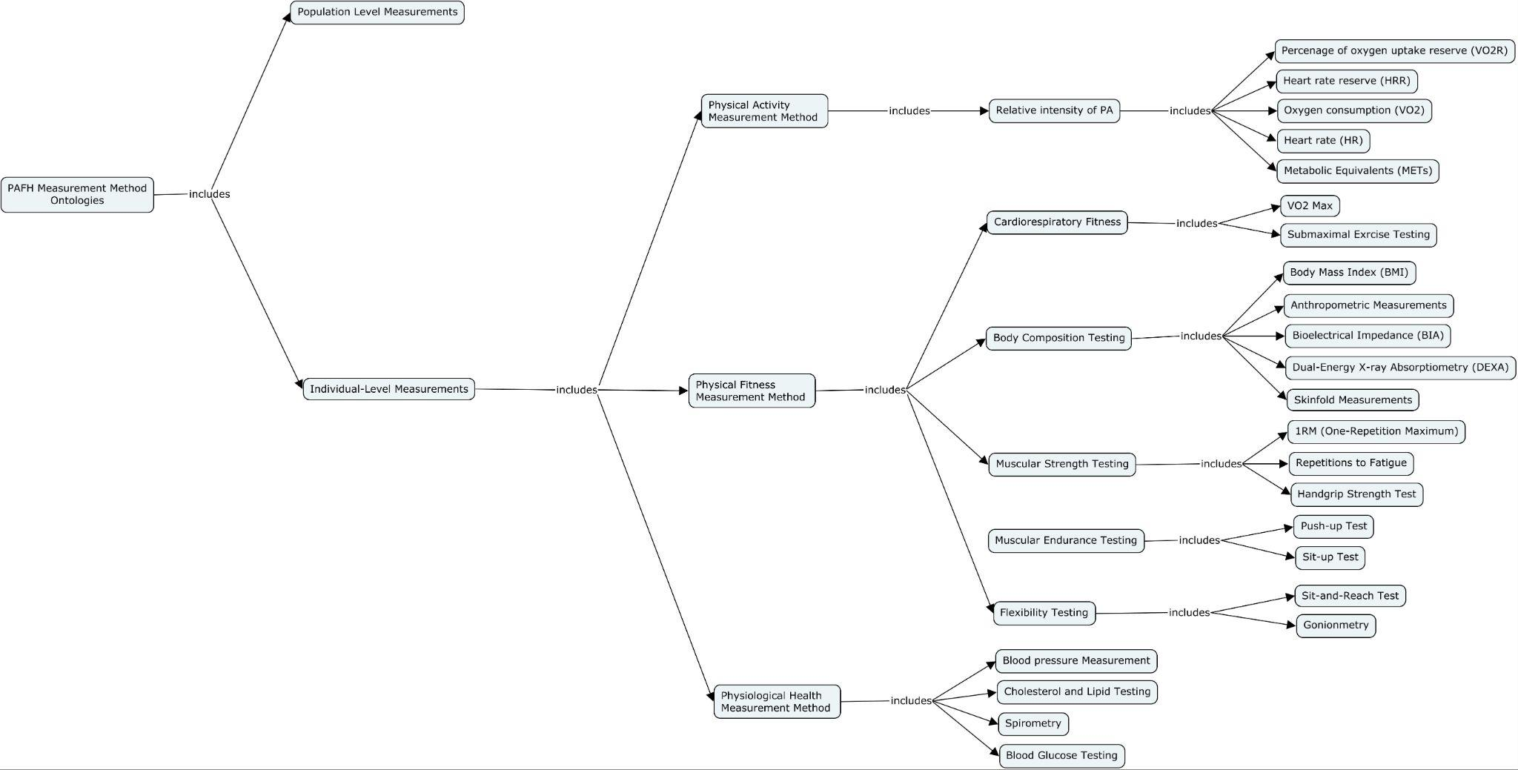

Figure 6. Measurement Method ontologies and their locations in the PAFH-KM.

Annotation of Physical Activity Data
Figure 3 demonstrates the ability of the PAFH-KM ontologies to semantically tag a clinician’s notes.
Figure 4 illustrates heart rate and triaxial acceleration data recorded by an activity monitor during a Bruce protocol clinical exercise tolerance treadmill test [75]. From these data, physical activity duration (exercise time), relative physical activity intensity (rating of perceived exercise (RPE) marked on a 6-20 scale [76]), absolute physical activity intensity (energy expenditure derived from acceleration and heart rate data [77]), and physical activity conditions (treadmill speed and incline associated with the stage of the protocol) can be delineated using the PAFH-KM ontologies. In addition, activity monitor metadata including sensor sensitivities and amplitude limits can be captured via the Measurement method ontologies to enable standardization of units between activity monitor models.
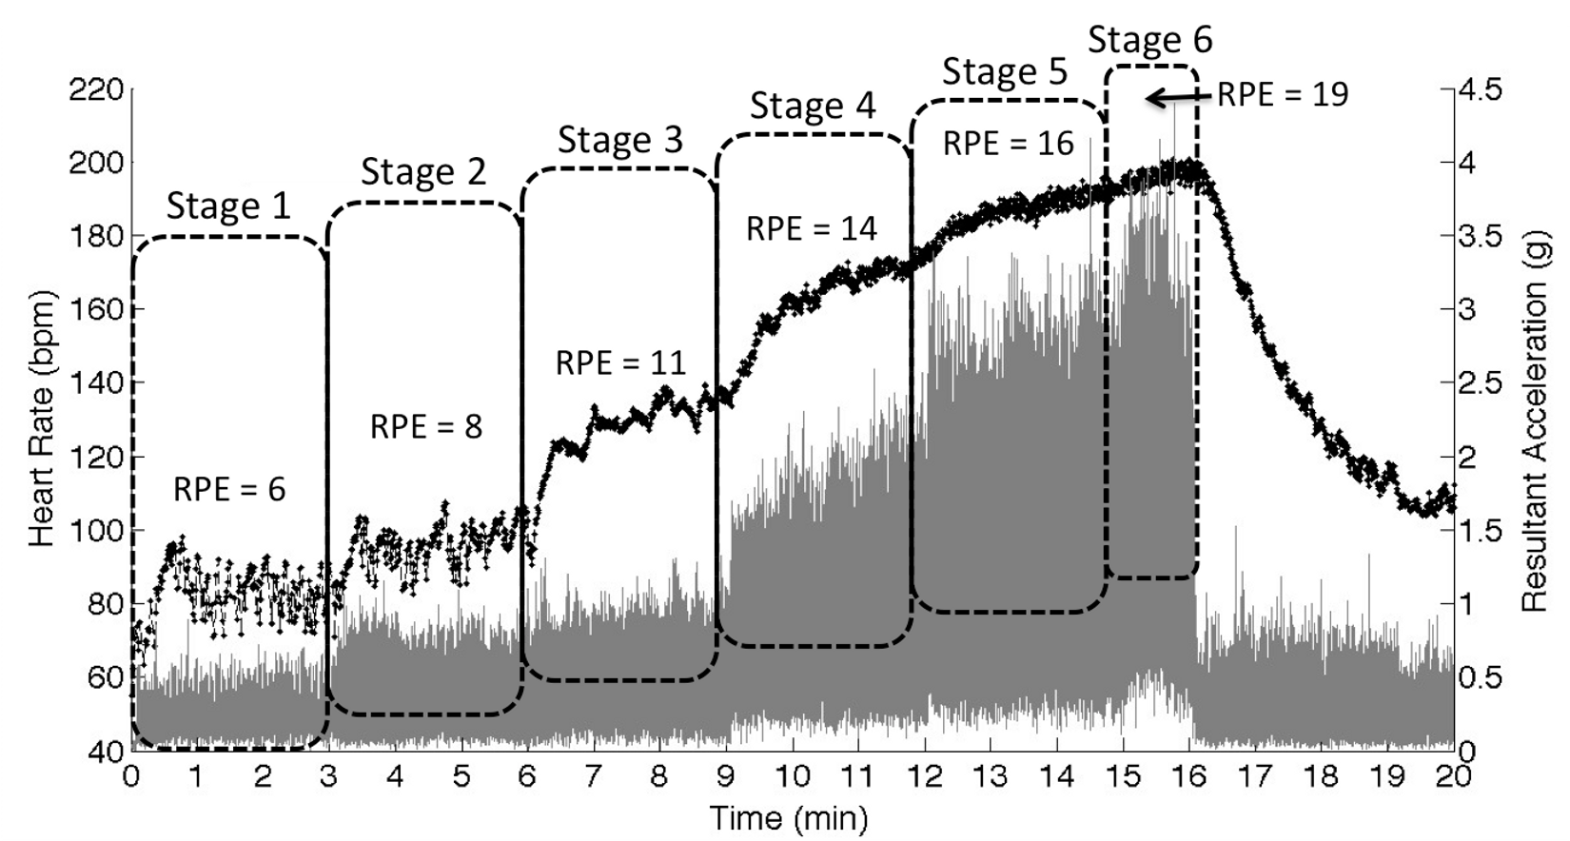
Figure 4. Example of triaxial acceleration (gray) and heart rate (black) activity monitor data obtained during a Bruce protocol clinical exercise tolerance treadmill test. Stages of the test protocol associated with increases in treadmill speed and grade delineate the physical activity conditions. Ratings of perceived exertion (RPE) for each stage indicate the individual’s relative physical activity intensity while increases in heart rate reflect absolute intensity. Measures of physiological health including resting heart rate and heart rate recovery can also be extracted from the raw heart rate data.

Figure 5. Highlights self-quantified physical activity data captured using the Move App.

Discussion

Principal Results
In response to the global impact of physical inactivity, the fields of physical activity, fitness, and health research have expanded at a rapid pace, yet tools and platforms to semantically integrate these knowledge domains into biomedical data standards for modern healthcare systems have failed to develop concurrently. In this study, we extracted existing terminology from knowledge resources including physical activity guidelines, scientific literature, and biomedical ontologies to develop primary conceptual domains describing physical activity, fitness, and health. We then proposed a conceptual model, the PAFH-KM, as a foundation to build ontologies to enable semantic representation of the physical activity, fitness, and health dose-response relationship. Lastly, we used simulated examples to highlight the utility of the PAFH-KM to annotate clinical, research, and personal data streams, an important advance to facilitate communication between public health professionals, physicians, and individuals interested in self-monitoring physical activity.
Current physical activity vocabularies are diverse in scope and present discordant levels of detail. Recent ACSM guidelines (American College of Sports Medicine ; Garber et al. 2011) harmonized their terminology for fitness assessment and prescription with US federal recommendations [2] leaving many seminal definitions of physical activity, physical fitness, and exercise intact [49]. This unification has provided a basis for consistent communication of concepts between policy makers, exercise scientists, and the public. ACSM further expanded concepts around the quantification of physical activity intensities and recommendations directed toward special needs populations – making the information more relevant for many kinds of people and activities [13]. These guidelines, however, do not map to operational vocabularies that characterize activity types, information needed to define physical activity interventions in the context of randomized clinical trials [78]. Physical activity types and intensities have been categorized within the Compendium of Physical Activities (Ainsworth et al. 2011; Willis et al. 2024; Conger et al. 2024; Herrmann et al. 2024), which is the current gold standard for characterizing physical activity types and their metabolic equivalents (METs). The Compendium has been extended to include responses from the American Time Use Survey (Tudor-Locke et al. 2009; American Time Use Survey — 2022 Resul...). The Compendium lists 823 types of physical activity and serves to assign MET intensities in survey research; however, it is derived from population level data. Pande, et al have shown that the MET equivalents may not accurately describe actual metabolic expenditures in individuals due to variations in age, disease state, etc, however, and contains limited descriptors of environmental and physiological conditions, which can impact a person’s ability to perform an activity [15]. The PAFH-KM is designed to describe real-time streaming MET intensities for individuals. Collectively, these knowledge resources provide a foundation to conceptually describe physical activity, fitness, and health, but they have not been designed to enable semantic mapping and logical inference. There is, therefore, a need for tools and platforms capable of semantic annotation of natural language of physical activity histories and prescriptions to permit integration of these data into health care systems and the electronic medical record.
Unified ontologies and vocabularies provide an important framework to characterize the physical activity dose-response knowledge domains and integrate this information into biomedical data structures. Pharmacotherapy’s success as an intervention method is in part because its dose-response relationship is understood at the molecular level [32]. This precision enables scientists to advance the field in discrete quantifiable units while allowing clinicians to prescribe exact dosages to achieve measurable health outcomes. Physicians, however, lack the same depth of knowledge and precision to prescribe personalized physical activity interventions. We have developed the PAFH-KM as a semantic knowledge representation framework to construct formal ontologies to describe physical activity, fitness, and health in a manner that can be queried and computed to improve prescription of physical activity. This formal structure will permit integration of the PAF-KM into existing ontologies thus enabling semantic queries that join physical activity dose and fitness and health response data with other knowledge bases.
The conceptual model presented in the PAFH-KM serves as a necessary bridge between disparate sources of physical activity data and the structured knowledge environments of biomedical systems. By formalizing the physical activity–fitness–health relationship into semantically interoperable components, the model enables consistent characterization of dose-response mechanisms in a way that can be incorporated into electronic health records, research databases, and policy frameworks. This structured representation is particularly important for advancing research and clinical applications that rely on meta-analyses or federated queries. For example, the PAFH-KM makes explicit the "what," "how," and "under what conditions" an activity was performed, drawing on the principles of measurement ontology (Shimoyama et al.) to facilitate cross-study comparisons. Such precision is critical for evaluating interventions across different demographic groups, activity types, and physiological conditions—ultimately allowing for more refined and generalizable conclusions about the health benefits of physical activity.
Annotation of exemplar data streams—spanning clinician-recorded assessments, laboratory-based physiological measurements, and self-tracked metrics from wearable devices—demonstrates the utility of the PAFH-KM to support communication and data integration across settings. Through shared terminology and structured metadata, the model enables clinicians to interpret self-reported or sensor-derived physical activity data in the context of established fitness benchmarks, while also helping individuals contextualize their behavior relative to public health guidelines or clinical recommendations. Moreover, consumer health technologies such as smartphones and wearables can serve as data collection interfaces that continuously feed into ontology-enabled systems, promoting real-time personalization of care and fostering engagement between patients and providers. In this way, the PAFH-KM not only enables semantic interoperability but also lays the groundwork for longitudinal monitoring and adaptive physical activity prescriptions across diverse real-world environments

Making physical activity more fair and with care
The PAFH-KM framework advances the principles of both FAIR and CARE in structuring physical activity knowledge. By organizing activity, fitness, and health data into well-defined, interoperable semantic units, the model enhances Findability and Accessibility for both human and machine agents. Ontological representations ensure that physical activity information—whether sourced from clinical assessments, research datasets, or self-tracked devices—is Interoperable across systems and contexts, and Reusable for secondary analyses such as meta-studies, public health surveillance, and personalized feedback systems. This is critical for building a connected infrastructure that supports consistent interpretation and data-driven decision-making across research, clinical, and consumer domains.
Equally important, the PAFH-KM reflects the CARE principles by foregrounding Collective Benefit—enabling knowledge infrastructures that can improve public health without excluding underrepresented or marginalized groups. Its modular structure allows communities and individuals to maintain Authority to Control how their activity data is described, shared, and used, particularly when these data reflect culturally specific movements, lived experiences, or localized conditions. The framework embeds Responsibility by promoting transparency in how physical activity concepts are defined and applied, and encourages Ethics in reuse by supporting annotation schemes that protect privacy and contextual integrity. In uniting FAIR's technical rigor with CARE's ethical imperatives, the PAFH-KM offers a blueprint for responsible innovation in physical activity research and digital health

Limitations and Next Steps
This study presents an initial knowledge model—rather than a fully implemented ontology—with the goal of guiding future formalization and data integration efforts. As such, the current PAFH-KM comprises four levels of hierarchical detail across most conceptual domains. While this structure supports clarity and usability, it limits the model’s granularity in capturing highly specific physical activity attributes or health outcomes. Future work will involve expanding these levels to enable more detailed classification and tailored health recommendations.
Additionally, the present model is not yet instantiated with empirical data. Although we have structured the terms and relationships to support eventual integration with clinical, research, and self-tracked data, the current work represents a conceptual foundation rather than an operational system. The development of the corresponding ontology and the linking of structured data will be essential next steps to realize the vision of a robust, semantically rich physical activity–health knowledge base. We view this model as the necessary groundwork to support evidence-based reasoning, decision support tools, and interoperable data commons in the future.
Looking ahead, one of the primary goals of expanding this knowledge model into a fully instantiated ontology is to enable its integration into clinical and public health decision support systems. Such systems could offer context-aware physical activity guidance tailored to individual needs, capabilities, and desired outcomes—whether for managing chronic disease, improving functional capacity, or promoting mental well-being. By linking semantically structured physical activity data with health indicators and outcomes, the ontology could support clinicians in prescribing more precise, evidence-informed interventions, while also empowering individuals to understand and act on their own activity data within a personalized care framework.
In addition, the ontology can be promoted for use in specific research domains, such as exercise oncology, pediatric physical activity, rehabilitation science, and population health monitoring. These fields often require domain-specific refinements to terminology, measurement methods, and intervention design—refinements that a modular, extensible ontology can support. With sufficient instantiation, the ontology could further serve as a training ground for artificial intelligence and machine learning models, providing a structured dataset to identify new dose-response relationships, uncover underexplored contextual variables, and generate predictive tools for activity planning and outcome forecasting. In this way, the PAFH-KM and its future instantiations will help guide and accelerate the next generation of physical activity and exercise science.

Comparison with Prior Work
There are a good number of research that looked at how physical activity ontologies can be used to guide personal training. However, to the best of our knowledge, our model is the first that focuses on the support prescription of physical activity, and it bridges significant gap between the health outcomes of the physical activity and the physical, physiological, mental and cognitive conditions that limit the feasibility of conducting certain physical activities, and enabled precise, personalize and prescriptive

Conclusions

Acknowledgements
Please include all authors’ contributions, funding information, financial disclosure, role of sponsors, and other acknowledgements here. This description should include the involvement, if any, in review and approval of the manuscript for publication and the role of sponsors. Omit if not applicable.

Conflicts of Interest
Disclose any personal financial interests related to the subject matters discussed in the manuscript here. For example, authors who are owners or employees of Internet companies that market the services described in the manuscript will be disclosed here. If none, indicate with “none declared”.

Abbreviations
JMIR: Journal of Medical Internet Research
RCT: randomized controlled trial

Multimedia Appendix 1
Multimedia appendices are supplementary files, such as a PowerPoint presentation of a conference talk about the study, additional screenshots of a website, mpeg/Quicktime video/audio files, Excel/Access/SAS/SPSS files containing original data (very long tables), and questionnaires. See https://jmir.zendesk.com/hc/en-us/articles/115003396688 for further information. Do not include copyrighted material unless you obtained written permission from the copyright holder, which should be uploaded together with your Publication Agreement form as supplementary file.

The Multimedia Appendices must be uploaded online, accompanied by a caption. CONSORT-EHEALTH checklists are always uploaded as Multimedia Appendices. Although this is primarily intended for randomized trials, the section of the checklist describing how an intervention should be reported is also relevant for manuscripts with other evaluation designs.
Before submission, authors of RCTs must fill in the electronic CONSORT-EHEALTH questionnaire at http://tinyurl.com/consort-ehealth-v1-6 with quotes from their manuscript (if you wish to comment on the importance of the items from the checklist for reporting, please also rate each item on a scale between 1-5). BEFORE you press submit, please generate a pdf of the form with your responses and upload this file as supplementary file entitled CONSORT-EHEALTH V1.6.

References
1. Global recommendations on physical activity for health. Geneva: World Health Organization; 2010. Available from: https://pubmed.ncbi.nlm.nih.gov/26180873/
2. 2008 Physical Activity Guidelines for Americans. U.S. Department of Health and Human Services (HHS); 2008. Available from: https://www.health.gov/paguidelines
3. Global health risks : mortality and burden of disease attributable to selected major risks. World Health Organization; 2009. Available from: https://www.who.int/publications/i/item/9789241563871 [accessed Oct 23, 2024]
4. Hallal PC, Andersen LB, Bull FC, Guthold R, Haskell W, Ekelund U, Lancet Physical Activity Series Working Group. Global physical activity levels: surveillance progress, pitfalls, and prospects. Lancet Elsevier BV; 2012 Jul 21;380(9838):247–257. PMID:22818937
5. WHO. Global status report on physical activity 2022. World Health Organization; 2022. Available from: https://www.who.int/publications/i/item/9789240059153 [accessed Oct 24, 2024]
6. Lee I-M, Shiroma EJ, Lobelo F, Puska P, Blair SN, Katzmarzyk PT, Lancet Physical Activity Series Working Group. Effect of physical inactivity on major non-communicable diseases worldwide: an analysis of burden of disease and life expectancy. Lancet Elsevier BV; 2012 Jul 21;380(9838):219–229. PMID:22818936
7. Nike, Inc. DESIGNED TO MOVE. Available from: https://www.sportsthinktank.com/uploads/designed-to-move-full-report-13.pdf
8. US Health and Human Services. 2008 Physical Activity Guidelines Advisory Report. 2008. Available from: https://odphp.health.gov/our-work/nutrition-physical-activity/physical-activity-guidelines/previous-guidelines/2008-physical-activity-guidelines/advisory-report [accessed Oct 23, 2024]
9. Haskell WL, Lee I-M, Pate RR, Powell KE, Blair SN, Franklin BA, Macera CA, Heath GW, Thompson PD, Bauman A. Physical activity and public health: updated recommendation for adults from the American College of Sports Medicine and the American Heart Association: Updated recommendation for adults from the American college of sports medicine and the American heart association. Med Sci Sports Exerc Ovid Technologies (Wolters Kluwer Health); 2007 Aug;39(8):1423–1434. PMID:17762377
10. Physical activity and cardiovascular health. NIH Consensus Development Panel on Physical Activity and Cardiovascular Health. JAMA American Medical Association (AMA); 1996 Jul 17;276(3):241–246. PMID:8667571
11. Office of the Surgeon General United States Public Health Services. Physical activity and health : a report of the Surgeon General. 1996; Available from: https://stacks.cdc.gov/view/cdc/11223 [accessed Oct 23, 2024]
12. Fletcher GF, Balady G, Blair SN, Blumenthal J, Caspersen C, Chaitman B, Epstein S, Sivarajan Froelicher ES, Froelicher VF, Pina IL, Pollock ML. Statement on exercise: benefits and recommendations for physical activity programs for all Americans. A statement for health professionals by the Committee on Exercise and Cardiac Rehabilitation of the Council on Clinical Cardiology, American Heart Association: A statement for health professionals by the committee on exercise and cardiac rehabilitation of the council on clinical cardiology, American heart association. Circulation Ovid Technologies (Wolters Kluwer Health); 1996 Aug 15;94(4):857–862. PMID:8772712
13. American College of Sports Medicine. ACSM’s Guidelines for Exercise Testing and Prescription. ACSM_CMS. Available from: https://www.acsm.org/education-resources/books/guidelines-exercise-testing-prescription [accessed Oct 23, 2024]
14. Goodman JM, Thomas SG, Burr J. Evidence-based risk assessment and recommendations for exercise testing and physical activity clearance in apparently healthy individuals. Appl Physiol Nutr Metab Canadian Science Publishing; 2011 Jul;36 Suppl 1(S1):S14–32. PMID:21800940
15. Piercy KL, Troiano RP, Ballard RM, Carlson SA, Fulton JE, Galuska DA, George SM, Olson RD. The Physical Activity Guidelines for Americans. JAMA American Medical Association (AMA); 2018 Nov 20;320(19):2020–2028. PMID:30418471
16. Van Remoortel H, Giavedoni S, Raste Y, Burtin C, Louvaris Z, Gimeno-Santos E, Langer D, Glendenning A, Hopkinson NS, Vogiatzis I, Peterson BT, Wilson F, Mann B, Rabinovich R, Puhan MA, Troosters T, PROactive consortium. Validity of activity monitors in health and chronic disease: a systematic review. Int J Behav Nutr Phys Act Springer Science and Business Media LLC; 2012 Jul 9;9(1):84. PMID:22776399
17. Zainudin MNS, Sulaiman MN, Mustapha N, Perumal T. Monitoring daily fitness activity using accelerometer sensor fusion. 2017 IEEE International Symposium on Consumer Electronics (ISCE) IEEE; 2017. p. 35–36. doi: 10.1109/isce.2017.8355540
18. Yuan B, Kamruzzaman MM, Shan S. Application of motion sensor based on neural network in basketball technology and physical fitness evaluation system. Wirel Commun Mob Comput Wiley; 2021 Jan;2021(1). doi: 10.1155/2021/5562954
19. Farrokhi A, Farahbakhsh R, Rezazadeh J, Minerva R. Application of Internet of Things and artificial intelligence for smart fitness: A survey. Comput Netw Elsevier BV; 2021 Apr;189(107859):107859. doi: 10.1016/j.comnet.2021.107859
20. Gupta N, Jilla S. Digital Fitness Connector: Smart Wearable System. 2011 First International Conference on Informatics and Computational Intelligence IEEE; 2011. p. 118–121. doi: 10.1109/ici.2011.70
21. Barnes PM, Schoenborn CA. Trends in adults receiving a recommendation for exercise or other physical activity from a physician or other health professional. NCHS Data Brief 2012 Feb;(86):1–8. PMID:22617014
22. Purcell K, Taylor J, West K, Haynes A, Hassett L, Sherrington C. Promotion of physical activity by health professionals in a sample of six public hospitals: A cross sectional study. Health Promot J Austr Wiley; 2024 Jan;35(1):176–187. PMID:37039303
23. Brannan M, Bernardotto M, Clarke N, Varney J. Moving healthcare professionals - a whole system approach to embed physical activity in clinical practice. BMC Med Educ Springer Science and Business Media LLC; 2019 Mar 15;19(1):84. PMID:30876426
24. Berra K, Rippe J, Manson JE. Making physical activity counseling a priority in clinical practice: The time for action is now. JAMA American Medical Association (AMA); 2015 Dec 22;314(24):2617. doi: 10.1001/jama.2015.16244
25. Patel A, Schofield GM, Kolt GS, Keogh J WL. Perceived barriers, benefits, and motives for physical activity: two primary-care physical activity prescription programs. J Aging Phys Act Human Kinetics; 2013 Jan;21(1):85–99. PMID:22832475
26. Brawley L, Rejeski W, King A. Promoting physical activity for older adults: the challenges for changing behavior. Am J Prev Med Elsevier; 2003 Oct 1;25(3):172–183. PMID:14552942
27. Kohl HW 3rd, Craig CL, Lambert EV, Inoue S, Alkandari JR, Leetongin G, Kahlmeier S, Lancet Physical Activity Series Working Group. The pandemic of physical inactivity: global action for public health. Lancet Elsevier BV; 2012 Jul 21;380(9838):294–305. PMID:22818941
28. WHO. Global Strategy on Diet, Physical Activity and Health. World Health Organization; 2004. Available from: https://www.who.int/publications/i/item/9241592222 [accessed Oct 23, 2024]
29. United Nations. 2011 High Level Meeting on the Prevention and Control of Non-communicable Diseases. United Nations; 2011 Aug 10; Available from: https://www.un.org/en/ga/ncdmeeting2011/ [accessed Oct 23, 2024]
30. Blair SN, LaMonte MJ, Nichaman MZ. The evolution of physical activity recommendations: how much is enough? Am J Clin Nutr 2004 May;79(5):913S–920S. PMID:15113739
31. Canning KL, Brown RE, Jamnik VK, Salmon A, Ardern CI, Kuk JL. Individuals underestimate moderate and vigorous intensity physical activity. PLoS One Public Library of Science (PLoS); 2014 May 16;9(5):e97927. PMID:24835105
32. Lee I-M. Dose-response relation between physical activity and fitness: even a little is good; more is better: Even a little is good; More is better. JAMA American Medical Association (AMA); 2007 May 16;297(19):2137–2139. PMID:17507351
33. Aune D, Norat T, Leitzmann M, Tonstad S, Vatten LJ. Physical activity and the risk of type 2 diabetes: a systematic review and dose-response meta-analysis. Eur J Epidemiol Springer Science and Business Media LLC; 2015 Jul;30(7):529–542. PMID:26092138
34. Dunn A, Trivedi M, O’Neal H. Physical activity dose-response effects on outcomes of depression and anxiety. Med Sci Sports Exerc Centre for Reviews and Dissemination (UK); 2001 Jun 1;33(6):S587–97;discussion609–10. PMID:11427783
35. Sattelmair J, Pertman J, Ding EL, Kohl HW 3rd, Haskell W, Lee I-M. Dose response between physical activity and risk of coronary heart disease: a meta-analysis: A meta-analysis. Circulation Ovid Technologies (Wolters Kluwer Health); 2011 Aug 16;124(7):789–795. PMID:21810663
36. Phillips EM, Kennedy MA. The exercise prescription: a tool to improve physical activity. PM R Wiley; 2012 Nov;4(11):818–825. PMID:23174544
37. Gibson AL, Wagner DR, Heyward VH. Advanced fitness assessment and exercise prescription. 9th ed. Champaign, IL: Human Kinetics; 2024. Available from: https://books.google.com/books?hl=en&lr=&id=Z_vxEAAAQBAJ&oi=fnd&pg=PR1&dq=physical+activity+prescription+fitness+&ots=tzC6W_E1L6&sig=x-CCMkVsbSBt5HUF6kU3X7dDTC8 ISBN:9781718221628
38. Bailey DP, Boddy LM, Savory LA, Denton SJ, Kerr CJ. Choice of activity-intensity classification thresholds impacts upon accelerometer-assessed physical activity-health relationships in children. PLoS One Public Library of Science (PLoS); 2013 Feb 18;8(2):e57101. PMID:23441234
39. Wei L, Ahmadi MN, Biswas RK, Trost SG, Stamatakis E. Comparing Cadence vs. Machine learning based physical activity intensity classifications: Variations in the associations of physical activity with mortality. Scand J Med Sci Sports Wiley; 2024 Sep;34(9):e14719. PMID:39252407
40. Abel M, Hannon J, Mullineaux D, Beighle A. Determination of step rate thresholds corresponding to physical activity intensity classifications in adults. Journal of Physical Activity and Health journals.humankinetics.com; 2011;8(1):45–51. Available from: https://journals.humankinetics.com/view/journals/jpah/8/1/article-p45.xml
41. Personal Data for the Public Good: New Opportunities to Enrich Understanding of Individual and Population Health - Final Report of the Health Data Exploration Project. California Institute for Telecommunications and Information Technology (Calit2); Robert Wood Johnson Foundation; 2014. Available from: http://hdexplore.calit2.net/wp-content/uploads/2015/08/hdx_final_report_small.pdf
42. Kim H, Mentzer J, Taira R. Developing a Physical Activity Ontology to support the interoperability of physical activity data. J Med Internet Res JMIR Publications Inc.; 2019 Apr 23;21(4):e12776. PMID:31012864
43. Chatterjee A, Prinz A. Personalized recommendations for physical activity e-coaching (OntoRecoModel): Ontological modeling. JMIR Med Inform JMIR Publications Inc.; 2022 Jun 23;10(6):e33847. PMID:35737439
44. Braun M, Carlier S, De Backere F, De Paepe A, Van De Velde M, Van Dyck D, Marques MM, De Turck F, Crombez G. Content and quality of physical activity ontologies: a systematic review. Int J Behav Nutr Phys Act Springer Science and Business Media LLC; 2023 Mar 13;20(1):28. PMID:36907890
45. Ontology-Based Physical Exercise Recommender System for Underweight Using Ontology and Semantic Web Rule Language.
46. Hoda M, Montaghami V, Al Osman H, El Saddik A. ECOPPA: Extensible context ontology for persuasive physical-activity applications. Proceedings of the International Conference on Information Technology & Systems (ICITS 2018) Cham: Springer International Publishing; 2018. p. 309–318. doi: 10.1007/978-3-319-73450-7_30ISBN:9783319734491
47. Villalonga C, den Akker H op, Hermens H, Herrera LJ, Pomares H, Rojas I, Valenzuela O, Banos O. Ontological modeling of motivational messages for physical activity coaching. Proceedings of the 11th EAI International Conference on Pervasive Computing Technologies for Healthcare New York, NY, USA: ACM; 2017. doi: 10.1145/3154862.3154926
48. Carlier S, Braun M, De Paepe A, Crombez G, De Backere F, De Turck F. The design of an ontology-driven mHealth behaviour change ecosystem to increase physical activity in adults. Lecture Notes of the Institute for Computer Sciences, Social Informatics and Telecommunications Engineering Cham: Springer International Publishing; 2022. p. 452–468. doi: 10.1007/978-3-030-99194-4_28ISBN:9783030991937
49. Caspersen CJ, Powell KE, Christenson GM. Physical activity, exercise, and physical fitness: definitions and distinctions for health-related research. Public Health Rep 1985 Mar;100(2):126–131. PMID:3920711
50. NCBO BioPortal Search for Quoted Phrase. Physical Activity. 2013. Available from: http://bioportal.bioontology.org/search?query=activity&commit=Search
51. Pate RR, Pratt M, Blair SN, Haskell WL, Macera CA, Bouchard C, Buchner D, Ettinger W, Heath GW, King AC. Physical activity and public health. A recommendation from the Centers for Disease Control and Prevention and the American College of Sports Medicine. JAMA American Medical Association (AMA); 1995 Feb 1;273(5):402–407. PMID:7823386
52. Garber CE, Blissmer B, Deschenes MR, Franklin BA, Lamonte MJ, Lee I-M, Nieman DC, Swain DP, American College of Sports Medicine. American College of Sports Medicine position stand. Quantity and quality of exercise for developing and maintaining cardiorespiratory, musculoskeletal, and neuromotor fitness in apparently healthy adults: guidance for prescribing exercise: Guidance for prescribing exercise. Med Sci Sports Exerc Ovid Technologies (Wolters Kluwer Health); 2011 Jul;43(7):1334–1359. PMID:21694556
53. Fletcher GF, Balady GJ, Amsterdam EA, Chaitman B, Eckel R, Fleg J, Froelicher VF, Leon AS, Piña IL, Rodney R, Simons-Morton DA, Williams MA, Bazzarre T. Exercise standards for testing and training: a statement for healthcare professionals from the American Heart Association: A statement for healthcare professionals from the American heart association. Circulation Ovid Technologies (Wolters Kluwer Health); 2001 Oct 2;104(14):1694–1740. PMID:11581152
54. Jacobson DM, Strohecker L, Compton MT, Katz DL. Physical activity counseling in the adult primary care setting: position statement of the American College of Preventive Medicine. Am J Prev Med Elsevier BV; 2005 Aug;29(2):158–162. PMID:16005814
55. Keller P, Vollaard N, Babraj J, Ball D, Sewell DA, Timmons JA. Using systems biology to define the essential biological networks responsible for adaptation to endurance exercise training. Biochem Soc Trans Portland Press Ltd.; 2007 Nov;35(Pt 5):1306–1309. PMID:17956337
56. Khusainov R, Azzi D, Achumba IE, Bersch SD. Real-time human ambulation, activity, and physiological monitoring: taxonomy of issues, techniques, applications, challenges and limitations. Sensors (Basel) MDPI AG; 2013 Sep 25;13(10):12852–12902. PMID:24072027
57. Marcus BH, Williams DM, Dubbert PM, Sallis JF, King AC, Yancey AK, Franklin BA, Buchner D, Daniels SR, Claytor RP, American Heart Association Council on Nutrition, Physical Activity, and Metabolism (Subcommittee on Physical Activity), American Heart Association Council on Cardiovascular Disease in the Young, Interdisciplinary Working Group on Quality of Care and Outcomes Research. Physical activity intervention studies: what we know and what we need to know: a scientific statement from the American Heart Association Council on Nutrition, Physical Activity, and Metabolism (Subcommittee on Physical Activity); Council on Cardiovascular Disease in the Young; and the Interdisciplinary Working Group on Quality of Care and Outcomes Research: What we know and what we need to know: A scientific statement from the American heart association council on nutrition, physical activity, and metabolism (subcommittee on physical activity); Council on cardiovascular disease in the young; And the interdisciplinary working group on quality of care and outcomes research. Circulation Ovid Technologies (Wolters Kluwer Health); 2006 Dec 12;114(24):2739–2752. PMID:17145995
58. Mudd LM, Rafferty AP, Reeves MJ, Pivarnik JM. Physical activity recommendations: an alternative approach using energy expenditure. Med Sci Sports Exerc 2008 Oct;40(10):1757–1763. PMID:18799985
59. Norton K, Norton L, Sadgrove D. Position statement on physical activity and exercise intensity terminology. J Sci Med Sport Elsevier BV; 2010 Sep;13(5):496–502. PMID:20005170
60. O’Donovan G, Blazevich AJ, Boreham C, Cooper AR, Crank H, Ekelund U, Fox KR, Gately P, Giles-Corti B, Gill JMR, Hamer M, McDermott I, Murphy M, Mutrie N, Reilly JJ, Saxton JM, Stamatakis E. The ABC of Physical Activity for Health: a consensus statement from the British Association of Sport and Exercise Sciences. J Sports Sci Informa UK Limited; 2010 Apr;28(6):573–591. PMID:20401789
61. Oja P, Bull FC, Fogelholm M, Martin BW. Physical activity recommendations for health: what should Europe do? BMC Public Health 2010 Jan 11;10:10. PMID:20064237
62. Budreviciute A, Damiati S, Sabir DK, Onder K, Schuller-Goetzburg P, Plakys G, Katileviciute A, Khoja S, Kodzius R. Management and prevention strategies for non-communicable diseases (NCDs) and their risk factors. Front Public Health Frontiers Media SA; 2020 Nov 26;8:574111. PMID:33324597
63. Mazzeo RS, Tanaka H. Exercise prescription for the elderly: current recommendations. Sports Med 2001;31(11):809–818. PMID:11583105
64. Strath SJ, Kaminsky LA, Ainsworth BE, Ekelund U, Freedson PS, Gary RA, Richardson CR, Smith DT, Swartz AM, American Heart Association Physical Activity Committee of the Council on Lifestyle and Cardiometabolic Health and Cardiovascular, Exercise, Cardiac Rehabilitation and Prevention Committee of the Council on Clinical Cardiology, and Council. Guide to the assessment of physical activity: Clinical and research applications: a scientific statement from the American Heart Association: A scientific statement from the American heart association. Circulation Ovid Technologies (Wolters Kluwer Health); 2013 Nov 12;128(20):2259–2279. PMID:24126387
65. Turbett P, Society of Pediatric Nurses. Position statement on exercise and physical activity. J Pediatr Nurs Elsevier BV; 2006 Feb;21(1):80–83. PMID:16428018
66. American College of Sports Medicine Position Stand. The recommended quantity and quality of exercise for developing and maintaining cardiorespiratory and muscular fitness, and flexibility in healthy adults. Med Sci Sports Exerc 1998 Jun;30(6):975–991. PMID:9624661
67. Ainsworth BE, Haskell WL, Herrmann SD, Meckes N, Bassett DR Jr, Tudor-Locke C, Greer JL, Vezina J, Whitt-Glover MC, Leon AS. 2011 Compendium of Physical Activities: a second update of codes and MET values. Med Sci Sports Exerc 2011 Aug;43(8):1575–1581. PMID:21681120
68. Tudor-Locke C, Washington TL, Ainsworth BE, Troiano RP. Linking the American Time Use Survey (ATUS) and the Compendium of Physical Activities: methods and rationale. J Phys Act Health Human Kinetics; 2009 May;6(3):347–353. PMID:19564664
69. Herrmann SD, Willis EA, Ainsworth BE, Barreira TV, Hastert M, Kracht CL, Schuna JM Jr, Cai Z, Quan M, Tudor-Locke C, Whitt-Glover MC, Jacobs DR Jr. 2024 Adult Compendium of Physical Activities: A third update of the energy costs of human activities. J Sport Health Sci Elsevier BV; 2024 Jan;13(1):6–12. PMID:38242596
70. Spector WD, Katz S, Murphy JB, Fulton JP. The hierarchical relationship between activities of daily living and instrumental activities of daily living. J Chronic Dis Elsevier BV; 1987;40(6):481–489. PMID:3597653
71. Edemekong PF, Bomgaars DL, Sukumaran S, Schoo C. Activities of daily living. StatPearls Treasure Island (FL): StatPearls Publishing; 2024. PMID:29261878
72. Sinoff G, Ore L. The Barthel activities of daily living index: self-reporting versus actual performance in the old-old (> or = 75 years). J Am Geriatr Soc 1997 Jul;45(7):832–836. PMID:9215334
73. Kostanjsek N. Use of The International Classification of Functioning, Disability and Health (ICF) as a conceptual framework and common language for disability statistics and health information systems. BMC Public Health 2011 May 31;11 Suppl 4:S3. PMID:21624189
74. Shimoyama M, Nigam R, McIntosh LS, Nagarajan R, Rice T, Rao DC, Dwinell MR. Three ontologies to define phenotype measurement data. Front Genet Frontiers Media SA; 2012 May 28;3:87. PMID:22654893
75. Bruce RA, Kusumi F, Hosmer D. Maximal oxygen intake and nomographic assessment of functional aerobic impairment in cardiovascular disease. Am Heart J Elsevier BV; 1973 Apr;85(4):546–562. doi: 10.1016/0002-8703(73)90502-4
76. Borg GA. Perceived exertion. Exerc Sport Sci Rev Ovid Technologies (Wolters Kluwer Health); 1974;2(1):131–153. PMID:4466663
77. Brage S, Brage N, Franks PW, Ekelund U, Wareham NJ. Reliability and validity of the combined heart rate and movement sensor Actiheart. Eur J Clin Nutr Springer Science and Business Media LLC; 2005 Apr;59(4):561–570. PMID:15714212
78. Johnston MV. Desiderata for clinical trials in medical rehabilitation. Am J Phys Med Rehabil Ovid Technologies (Wolters Kluwer Health); 2003 Oct;82(10 Suppl):S3–7. PMID:14502032

