*uc_Eating:*

*Ontology for unambiguous characterization of eating and food habits*

Kimiya Taji

Department of Food Science and Technology

University of California Davis

Davis, CA

[khtaji@ucdavis.edu](mailto:khtaji@ucdavis.edu)

Matthew Lange, PhD

Department of Food Science and Technology

University of California Davis

Davis, CA

mclange@ucdavis.edu

*Abstract*— **The uc_Eating ontology seeks to create a standardized unambiguous characterization system for modeling human food habits and eating processes. The creation of a computational knowledge base allows for the assessment, identification and characterization of eating patterns. Enabling individuals to use the model across multiple scenarios. Simultaneously, these ontologies provide an infrastructure for annotating the relationships between food consumption and eating behaviors creating a foundation for the characterization of human eating processes.**

*Introduction*

1.1 billion adults worldwide are considered overweight and 312 million are medically diagnosed as obese [1]. Obesity, a growing epidemic is becoming the largest public health obstacle in the world. While food no longer only encompasses a means for fuel it also contributes to improve performance amongst an array of activities. Individuals who consume multiple small meals a day compared to infrequent large meals happen to promote an increased energy intake allowing for the utilization of foods in sports or other physical activities [2]. Aside from the frequency and timing of food consumed many cultural factors concomitantly transpire. Various influences throughout life affect the food choices individual’s make, impacting various attributes to health [3]. Food consumption practices allow for the sharing of culture that brings people together. However, in the last decade American adult participation in social media climbed from seven to sixty five percent of the population [4]. Therefore, altering the food habits and consumption patterns of users. Yet, while modern science clearly demonstrates alterations in human eating behaviors and patterns contribute to disease progression, to date they have received very limited attention in the world of ontological research. Recognizing the importance that eating behaviors and patterns play in both disease progression and health improvement. The uc_Eating ontology seeks to create a standardized unambiguous characterization system for modeling human food habits and eating processes. Different behaviors of eating are identified to help establish a conceptual model for better understanding how various processes interact. Hierarchies are utilized in order to show the detailed relationships between entities within each process demonstrated in Figure 1. The characterization for human eating patterns allow for multiple uses such as Google’s micro-moments, which characterize specific in-the-moment occurrences that elicit different responses [5]. It is important to classify diverse micro-moments to characterize the resulting eating behaviors. Other uses include, creating inference patterns to personalize health condition assessments such as obesity [6]. According to the eating pattern ontology developed by Sojic et al. “an eating pattern ontology can create personalized profiles across several obesity-related knowledge-domains structured into dedicated modules in order to support inference about health condition, physical features, behavioral habits associated with a person, and relevant changes over time” [6]. Thus, providing the implications necessary to build a useful ontology. Within the National Center for Biomedical Ontology, classifications of eating behaviors exist within a very limited range of specifications. For example, the Gene Ontology characterizes eating behavior as the “reduction of food intake in response to dietary excess” providing little regard to the actual processes that coincides [7]. Our goal is to create a further specified interpretation of those eating behaviors.

# Design and methods

Open world assumptions of semantic web ontology languages (OWL) provide a means for capturing the diverse array of behaviors and concomitant responses. Simultaneously, ontologies provide an infrastructure for annotating the relationships between food consumption and eating behaviors, providing a foundation for the characterization of human eating processes. The use of the program Protégé, provides necessary tools in order to create and characterize a useable ontology. In doing so, a myriad of specific behaviors are classified within each co-occurrent processes that interconnect demonstrated in Figure 2. All of which contain several subclasses used to identify multiple areas of the hierarchy. To begin, identification of base classes consisting of different biological behaviors conspired. All human food consumption originates from breastfeeding. Breastfeeding provides the basis to model various biological eating processes that transpire. Captured in the uc_Eating ontology, breastfeeding enables the characterization of other eating patterns such as, regulated eating behavior, snacking behavior, eating influenced by the environment etc. The pattern begins with the age of the baby and how often milk is consumed or pumped. Subsequently, FIL (feedback inhibition of lactation) decreases milk production therefore ceasing breastfeeding. The termination of breastfeeding thus leads to the consumption of various non-colostrum foods consumed throughout life. Therefore, giving rise to various food habits and patterns adapted from internal and external stimuli. The differentiation of behaviors and processes stayed crucial in the comparison of how individuals behave amongst various scenarios. Behaviors may be seen as occurrences that are self-induced whereas processes are incidents that can be out of the individuals’ control. The base class “meal eating behavior” characterizes numerous types of meals that are consumed by individuals including, celebratory meal, post-workout meal, feasting meal, religious meal, and holiday meal behaviors. Identified in Figure 2, various processes and behaviors of eating patterns allow for the construction of a concise functioning model. Part of human nature involves the ability to make decisions on what to eat based on the environmental and social influences. Compensatory meal behaviors involve food consumed to compensate for sleep, stress, physical activity and for other foods consumed. Characterizing environmental influences, as entities help create a full understanding of one’s eating patterns. Other sub classes include “snacking behavior, regulated eating behavior, eating behavior concomitant with other behaviors and eating influenced by external and internal stimuli”. The entity “eating concomitant with other behavior” exhibits various activities that one can engage in whilst eating such as eating while laughing, exercising, reading, crying, talking and etc. The base class “snacking behavior” consists of different timed snacks that take place comprising of, after school, late-night, mid-day, and morning snacking behaviors. Assessing various behaviors such as snacking allows for the determination and specific identification of eating patterns that occur. Regulatory eating behaviors are included to help the understanding why people consume various types of foods. The base class of “regulated eating” comprises of subclasses identified as ethically regulated eating behavior, health oriented eating behavior, hunger oriented eating behavior, and religious regulated eating behavior. Each behavior remains perceived as a single fixed occurrent or regarded as co-occurrents. Multiple entities interact with each other such as micro-moments, concomitant eating behaviors and eating influenced by internal stimuli. Micro-moments remain characterized by specific in-the-moment occurrences that can elicit diverse responses. In relation to eating, people make decisions of what to eat, when to eat, and where to eat based on micro-moments. The class of “eating influenced by external stimuli” also connects to the micro-moments where all aspects of the environment, media and culture come into play. Although occurrences are occasionally recognized individually, the uc_Eating ontology helps create a clear and concise model for identification of behaviors amongst individuals. Deciding which foods to consume vary by individual contingent on countless attributes, recognized by the uc_Eating ontology.

# Conclusion

The consumption of food is studied vastly amongst anthropologists, biologists and various scientists. Determining influential attributes that affect eating patterns is a key component to better understand physical health and help disease progression. Consumption of various foods constitutes a large role in the health of individuals and influences longevity. The identification for the consumption of various meals assessed by Glanz et. al states, “Value times expectancy’ affects the decision to act” [8]. Identification, characterization and assessment help create an accurate representation of various eating patterns consumed. Decisions on food consumption are dependent on the value of reward and expected results due to the consumption. It is vital that connections between eating processes present the interplay between all of the necessary characterizations. Multiple processes that affect the consumption of food are characterized to ensure that almost all areas of what constitutes eating are classified. The consumption of food contains an array of influences that affect which eating processes take place. The unambiguous characterizations of these processes that occur create a useful tool that can be applied across multiple scenarios.

Figure 1

##### Macintosh HD:Users:Kimi:Desktop:Screen Shot 2016-05-23 at 1.14.11 PM.png

Figure 2

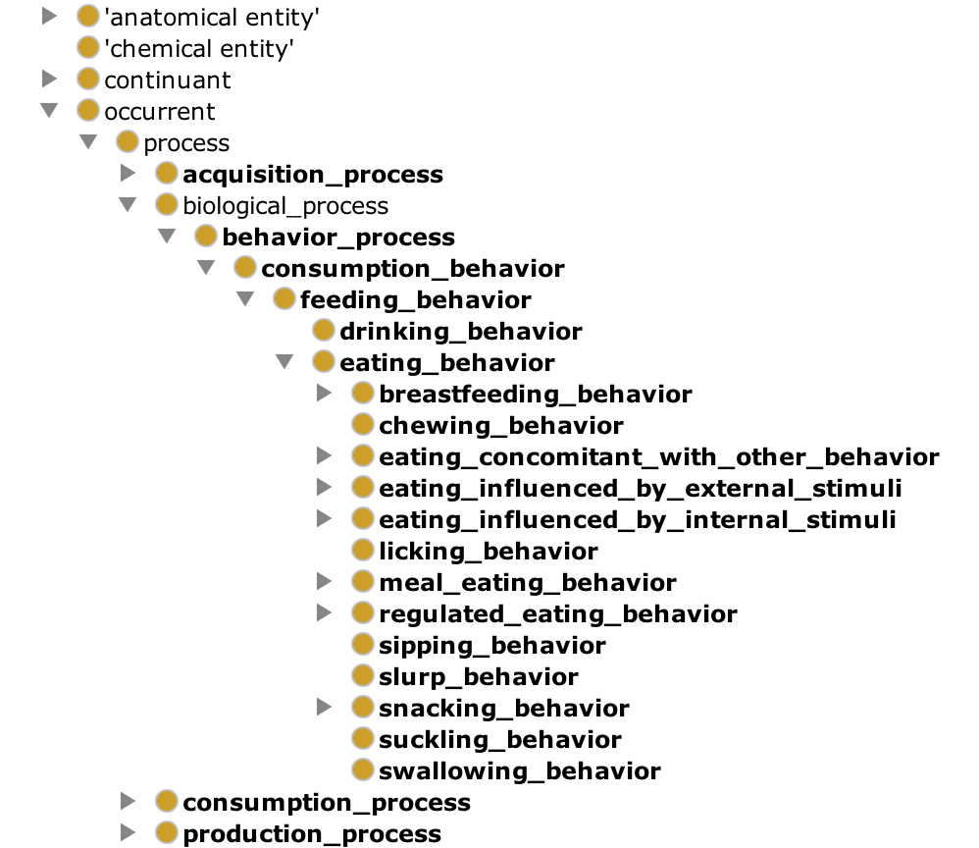

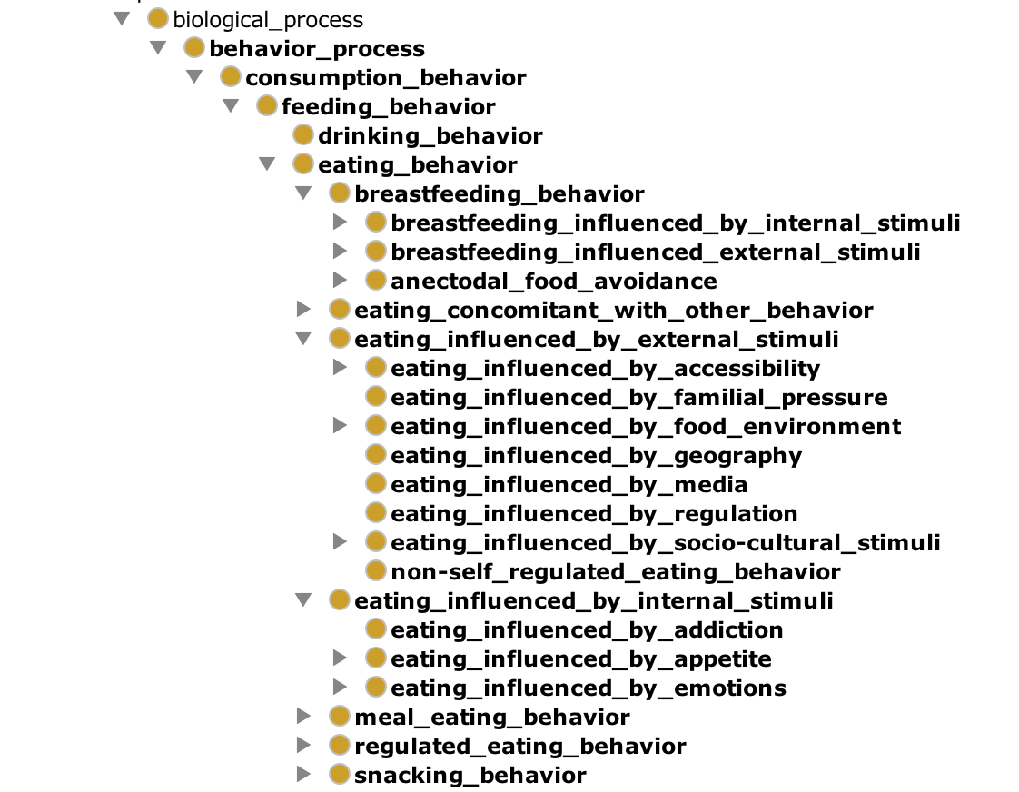

References

1. Hossain, P., Kawar, B., & Nahas, M. E. (2007). Obesity and Diabetes in the Developing World — A Growing Challenge. *New England Journal of Medicine N Engl J Med,* *356*(3), 213-215. doi:10.1056/nejmp068177.
2. Hawley, J. A., & Burke, L. M. (1997). Effect of meal frequency and timing on physical performance. *British Journal of Nutrition Br J Nutr,* *77*(S1). doi:10.1079/bjn19970107I
3. Nestle, M., Wing, R., Birch, L., DiSogra, L., Drewnowski, A., Middleton, S., Sigman-Grant, M., Sobal, J., Winston, M. and Economos, C. (1998), Behavioral and Social Influences on Food Choice. Nutrition Reviews, 56: 50–64. doi: 10.1111/j.1753-4887.1998.tb01732.
4. Perrin, A. (2015). Social Media Usage: 2005-2015. Retrieved May 15, 2016, from <http://www.pewinternet.org/2015/10/08/social-networking-usage-2005-2015/>
5. Micro-Moments. (n.d.). Retrieved May 15, 2016, from https://www.thinkwithgoogle.com/micromoments/intro.html
6. Sojic, A., Terkaj, W., Contini, G., & Sacco, M. (2016). Modularising ontology and designing inference patterns to personalise health condition assessment: The case of obesity. *Journal of Biomedical Semantics J Biomed Semant,* *7*(1). doi:10.1186/s13326-016-0049-1
7. Gene Ontology | NCBO BioPortal. (n.d.). Retrieved May 15, 2016, from <http://bioportal.bioontology.org/ontologies/GO/?p=properties>
8. Glanz, K., Basil, M., Maibach, E., Goldberg, J., & Snyder, D. (1998). Why Americans Eat What They Do. *Journal of the American Dietetic Association,* *98*(10), 1118-1126. doi:10.1016/s0002-8223(98)00260-0