# Exercise 1

## Question 1

Create an ER diagram of this library system. Give appropriate cardinality information.

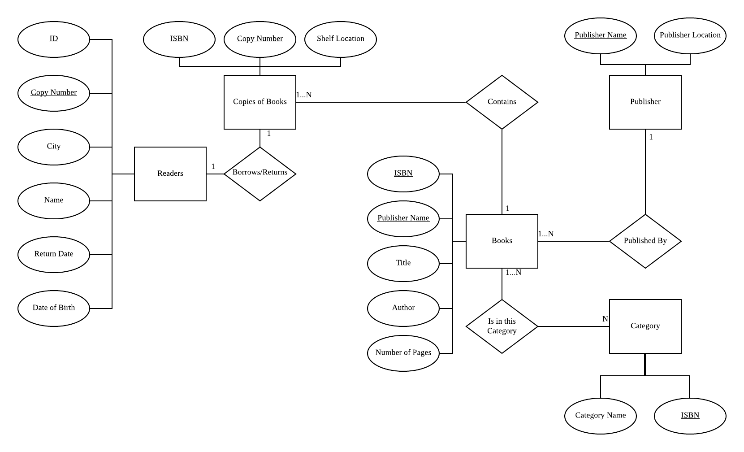

## Question 2

Translate the diagram into relations.

* Readers (ID, Copy Number, City, Name, Return Date, Date of Birth)
* Copies_Of_Book (ISBN, Copy Number, Shelf Location)
* Books (ISBN, Publisher Name, Title, Author, Number of Pages)
* Publisher (Publisher Name, Publisher Location)
* Category (ISBN, Category Name)

