**Replication**

**Game Design Document**

Group 6

Kayden, Ahmad, Jun Shen, Shi Ze, Yu Heng

# **High Concept**

“Replication” is a **Sci-Fi 2D Turn-based RPG** where you are a rogue clone fighting your way through mutants and guards with the help of unlockable abilities and items to escape a facility owned by a shady corporation.

# **Features**

* 2D Top-Down World Exploration
* Turn-Based Battle System
* Abilities for player to use if they defeat enemies
* Use items for defence, attack and heals during battle
* Vending Machine to exchange currency (GeneCoin) for items to use in battle

# 

# **OVERVIEW**

# **Player Motivation**

Fight through mutated clones and soldiers of R-Corp to reach the final boss and escape the facility.

# **Genre**

* Dungeon Crawler
* Sci-fi
* Top-Down 2D RPG
* Turn-Based RPG

# **Target Audience**

* Fans of Dungeon Crawlers & Roguelikes
* Turn-Based RPG Players
* Sci-Fi Enthusiasts

# **Unique Selling Point**

* Copy your Enemy’s Attacks when you defeat them
* Text-based Sprites aesthetic
* Amazing Dark Sci-Fi Soundtrack

# **Target Platform**

* Windows, MacOS, Linux (DESKTOP)

# **Design Goals**

Discovery - Exploring different areas of the map can gain you currency (GeneCoins) or extra dialogue, making players feel rewarded

Challenge - Strategic Thinking to decide what is the correct move (Fight, ability, items, flee?) to determine the best outcome to win and survive

Fantasy - Makes the player feel like he is in an actual sci-fi facility, escaping clones and finding out what happened

# 

# **GAMEPLAY**

# **Objective**

Fight enemies through battle, collect GeneCoins for items and solve puzzles to navigate through the crumbling R-Corp facility.

# **Core Mechanics**

* Damage Enemies
* Use items for advantages in games
* Copy your enemies’ abilities in battle
* Exploration of the world
* Puzzles for rewards and progress

# **Gameplay Flowchart**

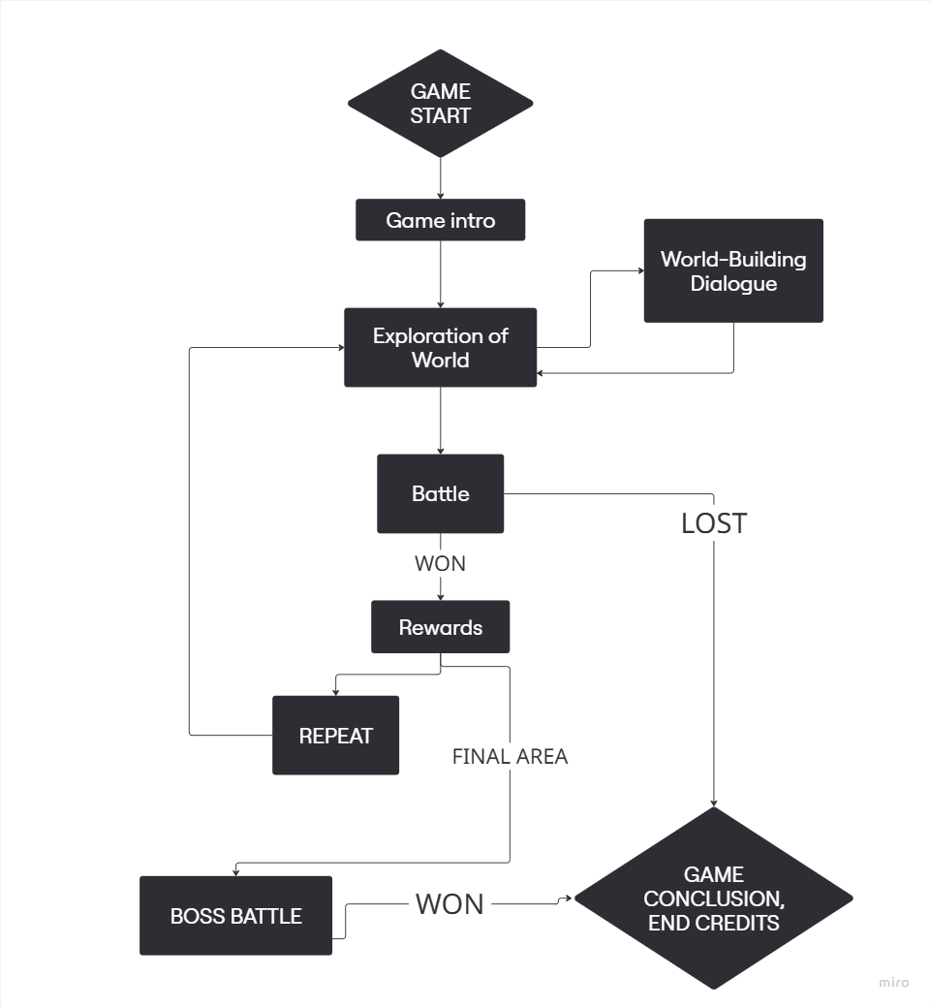

# **Story**

* I**NTRO/BACKSTORY**
  + In the 50th century, war breaks out among some of humanity’s biggest countries.
  + Genetically enhanced supersoldiers and clones appear early on in the war, leading to an arms race for them. R-Corp, a powerful paramilitary and biotech company, spearheads the development of such supersoldiers.
  + Pedro, a soldier fatally wounded in combat, is selected to be the base for a new generation of supersoldiers. During the enhancement process, he becomes amnesiac.
* **BODY (WHAT HAPPENS DURING THE GAME)**
  + While Pedro is in his prison cell, a massive riot breaks out among the test subjects, leading to a site-wide lockdown.
  + After some time, his cell door malfunctions and opens up, giving him a chance to escape. He fights through the various test subjects and guards as he makes his way to the site’s command center to override the lockdown..
  + Upon reaching there, he is confronted by Nikolai Warden, the head of security. He defeats him, and uses his keycard to end the lockdown and unlock the exits.
* **ENDING**
  + Pedro successfully escapes the site, steals a military truck, and drives off into the sunset.

# **Characters**

* Pedro
* Protagonist
* Tough and gritty
* Nikolai Warden
* Antagonist
* Arrogant, has a superiority complex

# **INTERFACE**

# **User Controls**

WASD/Up-Down-Left-Right-Arrows - Movement in WORLD

SPACE - Interaction of objects in WORLD, Continue to next dialogue line

1/2/3/4 - Options for battle during player turn

1 - Fight

2 - Items

3 - Abilities

4 - Flee

# **ARTWORK**

# **CHARACTERS**

Player

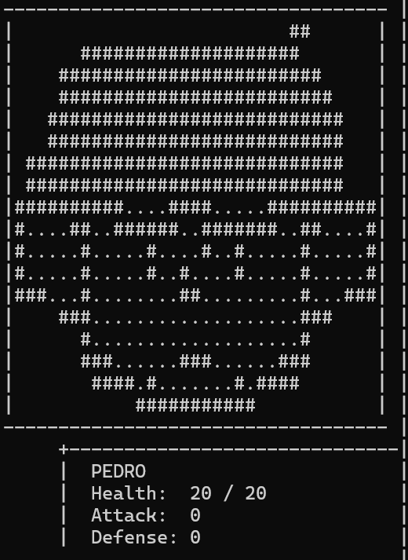

Enemy (Mutant)

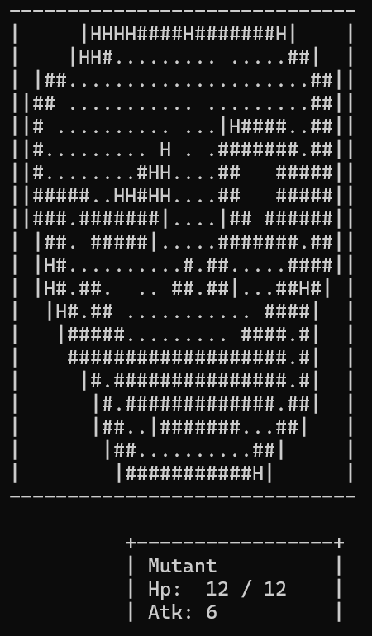

Enemy (Healer)

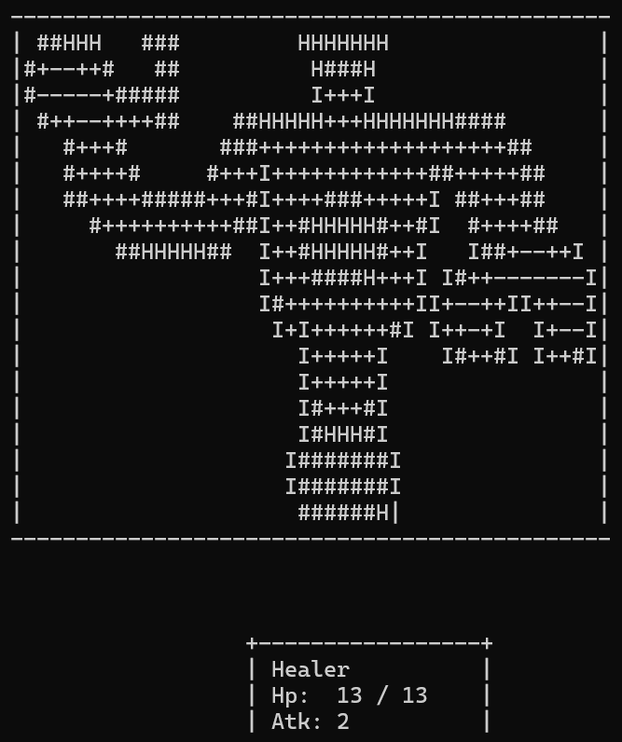

Enemy (Guard)

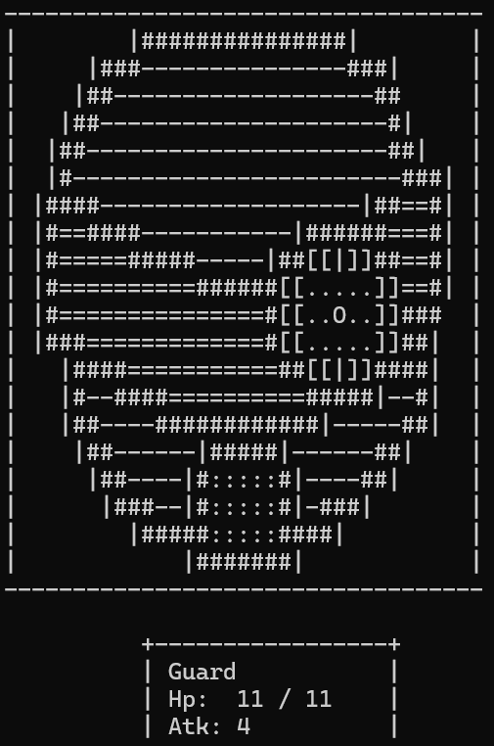

Enemy (Nikolai)

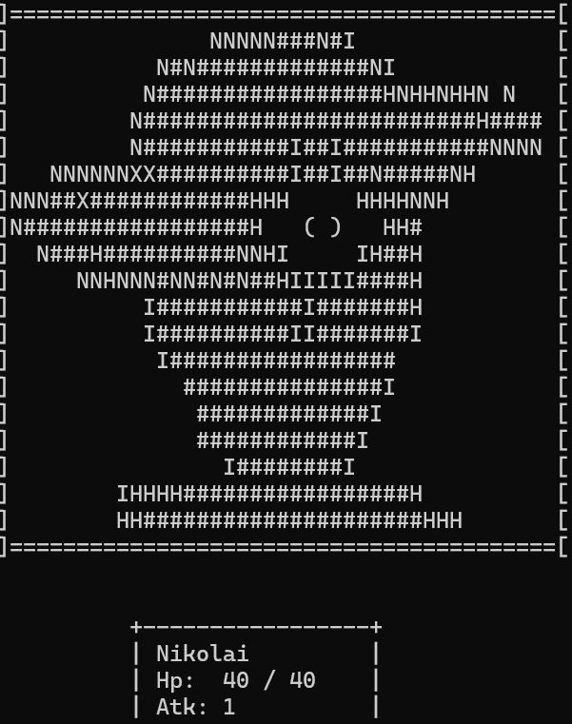

# **WORLD**

* World exploration
* 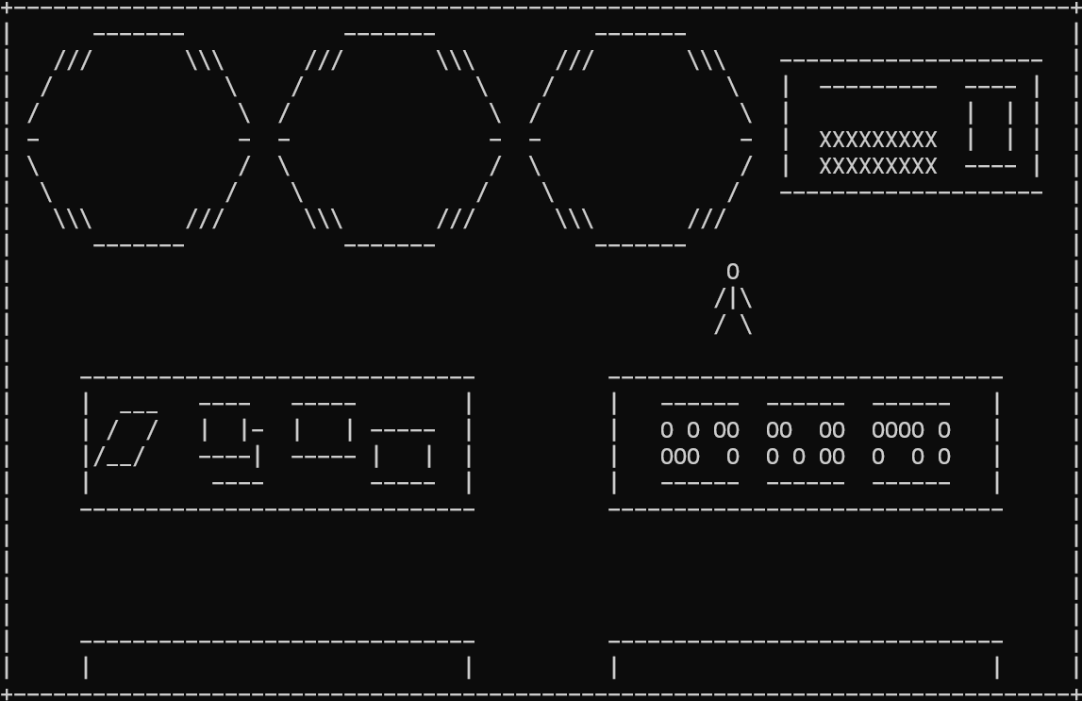
* Dialogue
* 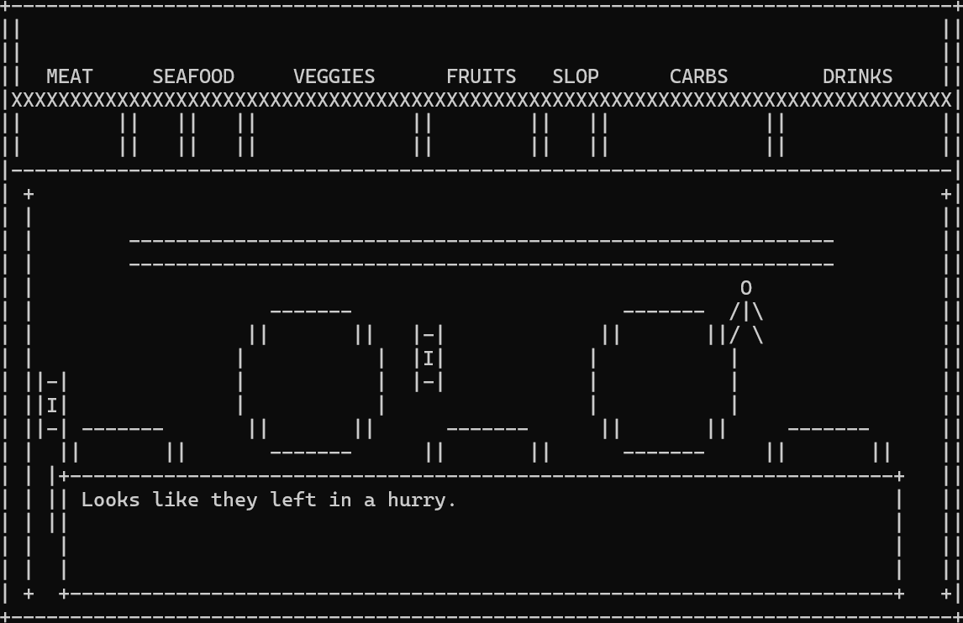
* Vending Machine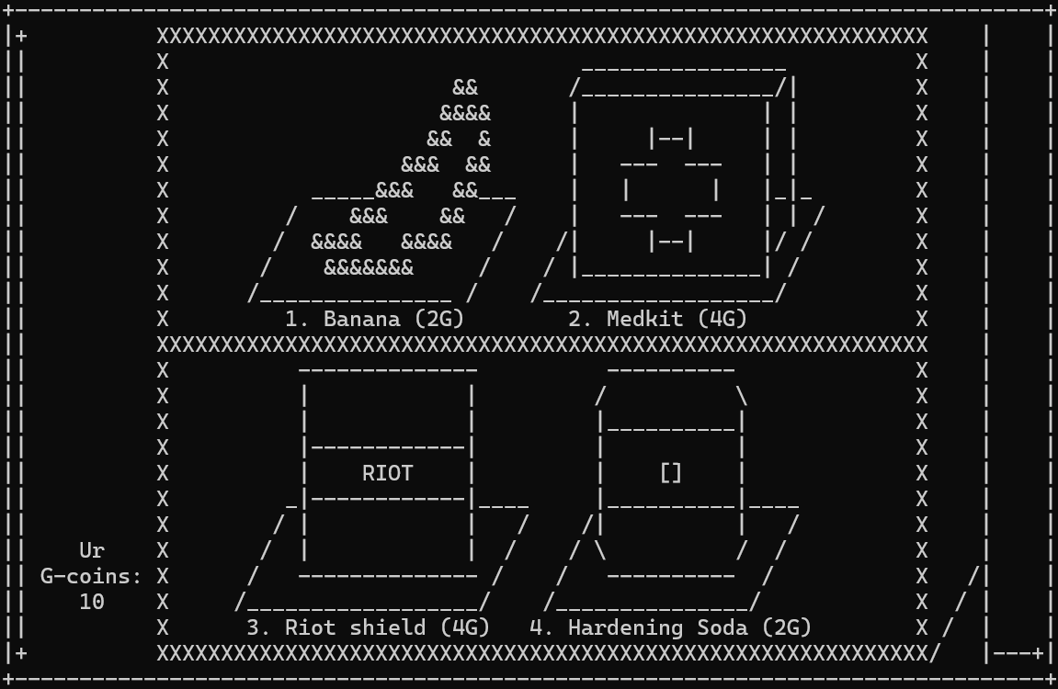
* Notes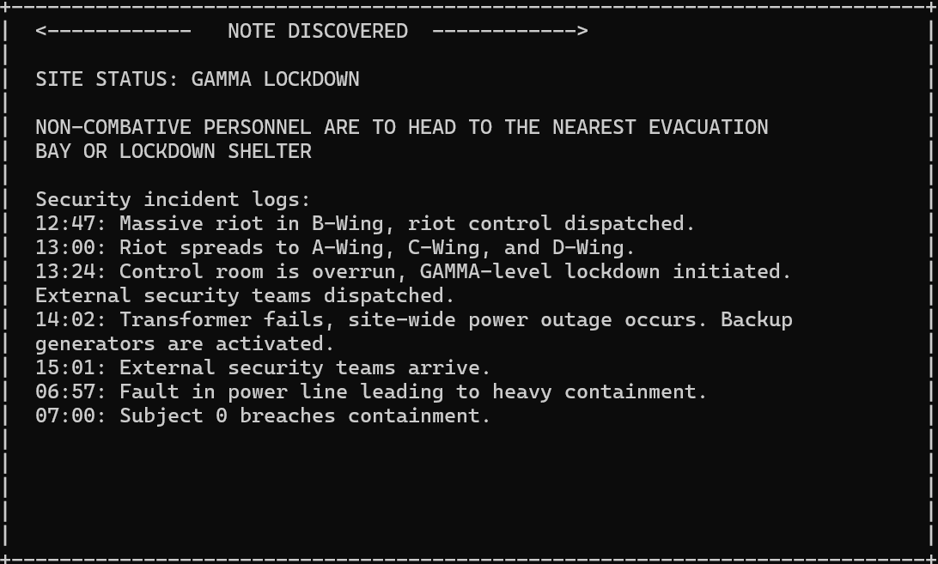

# **BATTLE**

* “Player was attacked!”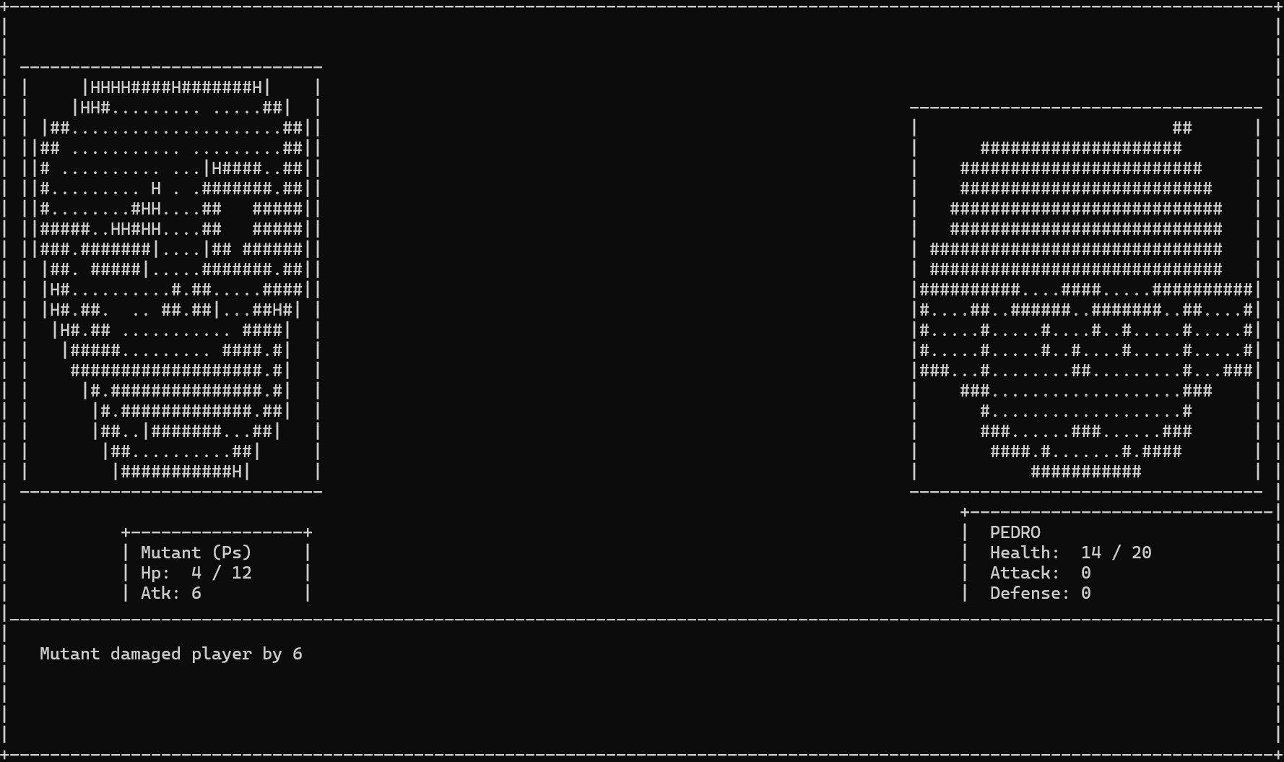
* Abilities screen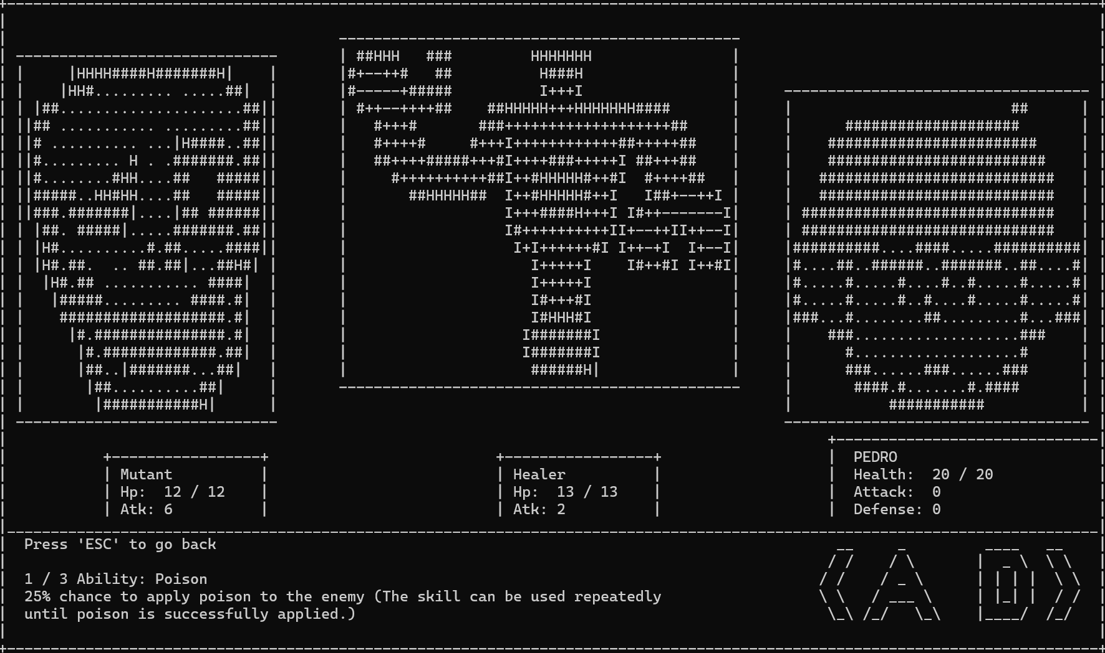
* Items screen