System Design Document (SDD)
  - Architecture, integrations, data flow and diagrams
Working reconstruction | 17 October 2026 | Not independently verified as supervisor-approved
Basis: PROJECT_SOURCE_OF_TRUTH_v1 (working baseline), existing architecture diagrams, and project-owner-provided Codex QA reports. Historical evidence and latest reported outcomes are distinguished; inspect the live repository and approved proposal before sign-off.

1. Logical system architecture
The Angular single-page application communicates with the ASP.NET Core Web API. The API coordinates application/domain services and SQL Server persistence. The backend calls the Python FastAPI model service for seven-day LSTM inference. Open-Meteo supplies recent operational weather observations; ERA5 is the historical model training/evaluation source.
Public browser → Angular → ASP.NET Core API → SQL Server / Python FastAPI (LSTM v1). Open-Meteo observations feed preprocessing and inference. Seven daily forecast values are stored and returned through the API.

2. Forecast inference pipeline
- Open-Meteo supplies the latest operational observations (rainfall, temperature and relative humidity).
- The forecasting service prepares 30 consecutive days × 3 features using the trained model preprocessing/scaler.
- Python FastAPI loads saved TensorFlow/Keras LSTM v1 and predicts the next seven dates × 3 weather values.
- ASP.NET Core receives inference results and persists a ForecastRun and its seven daily records in SQL Server.
- Angular requests the latest forecast from the API and renders the results; the recommendation API uses the persisted forecast.
- Historical seasonal-planning logic is separate from seven-day LSTM forecasting and uses historical climate plus crop-calendar evidence.

3. Core software modules
- Frontend: Angular application; public forecast dashboard, seasonal planning, account and role-protected views.
- API: ASP.NET Core; authorization, forecast, recommendation, seasonal-planning and admin/officer endpoints.
- Backend layering: Api, Application, Domain and Infrastructure projects.
- AI microservice: Python FastAPI with TensorFlow/Keras model artifact, scaler and metadata.
- Database: SQL Server storing users/roles, forecast runs/records and relevant application data.
- External source: Open-Meteo for operational historical weather observations; ERA5 for historical training/evaluation.
- Do not include private SQL server address, usernames, passwords or connection strings in handover documents.

4. Selected reported endpoints
- GET /health — backend health check.
- GET /api/forecasts/latest — latest stored forecast.
- POST /api/admin/forecasts/operational — authorized operational forecast generation.
- POST /api/recommendations/evaluate — evidence-aware crop assessment.
- POST /api/seasonal-recommendations/by-date-range — historical seasonal crop candidates.
- POST /api/seasonal-recommendations/by-crop — crop-to-period guidance.
- GET /api/auth/me — authenticated role/user context.
- Paths are based on previous Codex reports; check actual code before final sign-off.

5. Security, role policy and scientific limitations
- Public, Registered User, Agricultural Officer and Administrator roles are distinct; privileged self-registration is prohibited.
- Officer validation is read-only/review-focused; local feature flag may be enabled for testing, but no authorized live Officer validation has yet been evidenced.
- Recommendation history and climate-risk indicators remain conditional and require approved-scope verification.
- Seven-day forecast does not justify full-season suitability scores. QA-001 remains PARTIAL; soil is optional.
- Security dependency patch to System.Security.Cryptography.Pkcs 9.0.21 and zero vulnerable packages was reported; a non-blocking FastAPI/Starlette deprecation warning remains.

6. Architecture diagrams (existing working images)

Logical system architecture
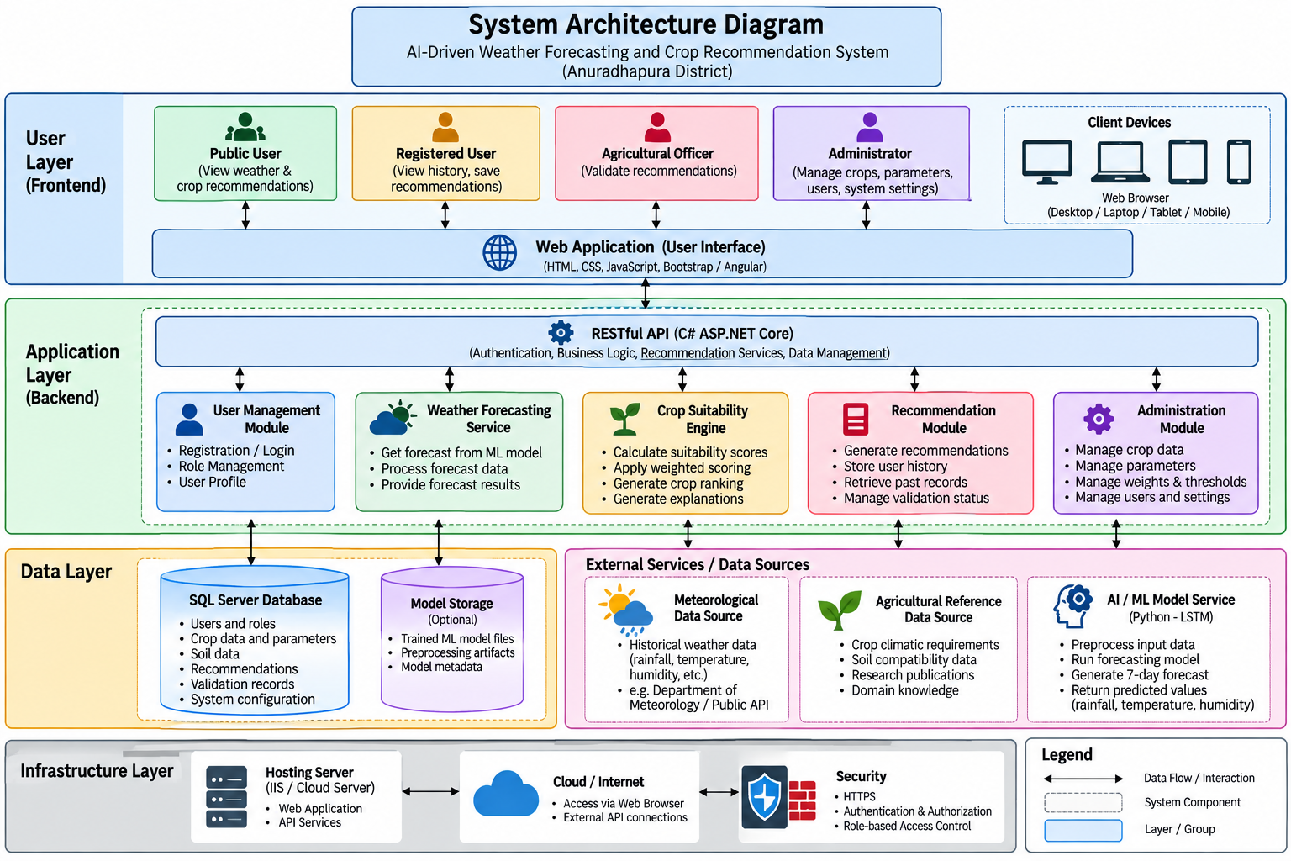
Existing diagram — draft/design reference; reconcile labels with current code and approved version.

System context
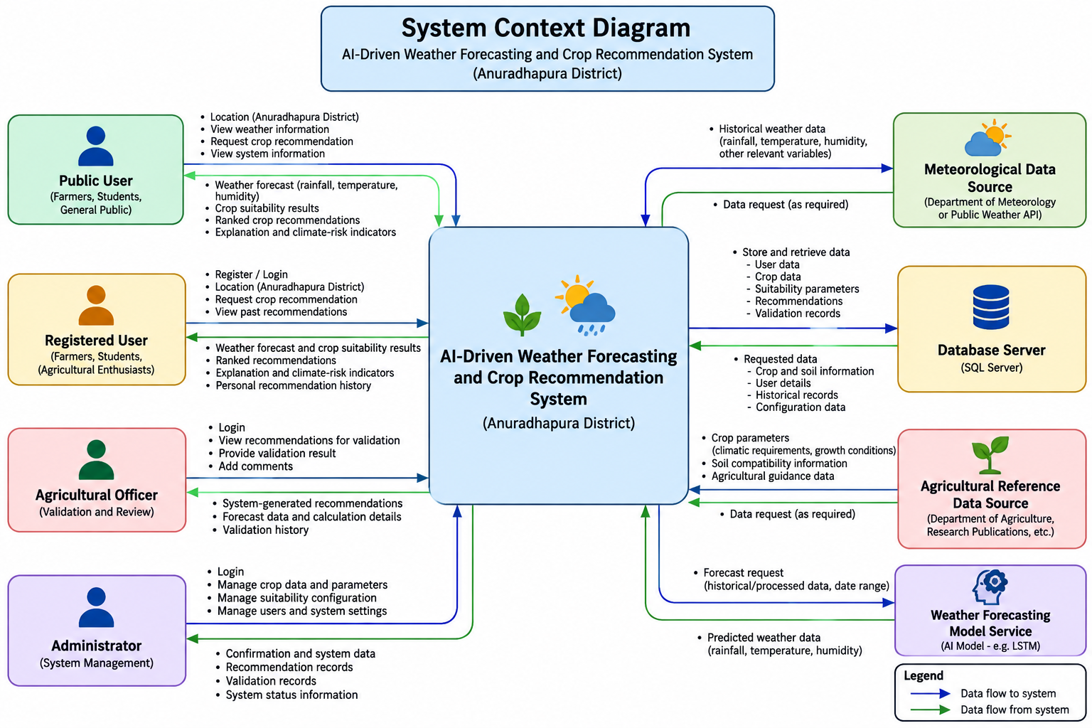
Existing diagram — draft/design reference; reconcile labels with current code and approved version.

Deployment architecture
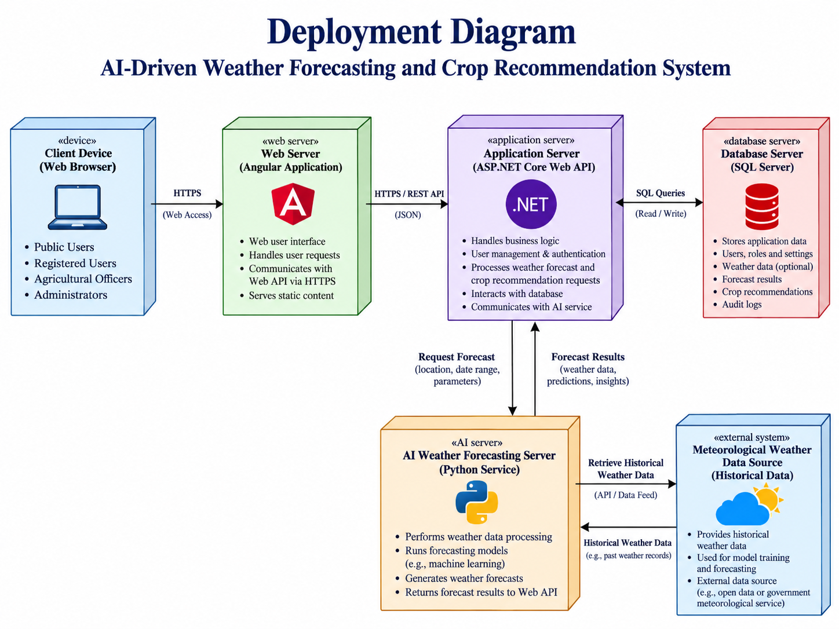
Existing diagram — draft/design reference; reconcile labels with current code and approved version.

Data flow
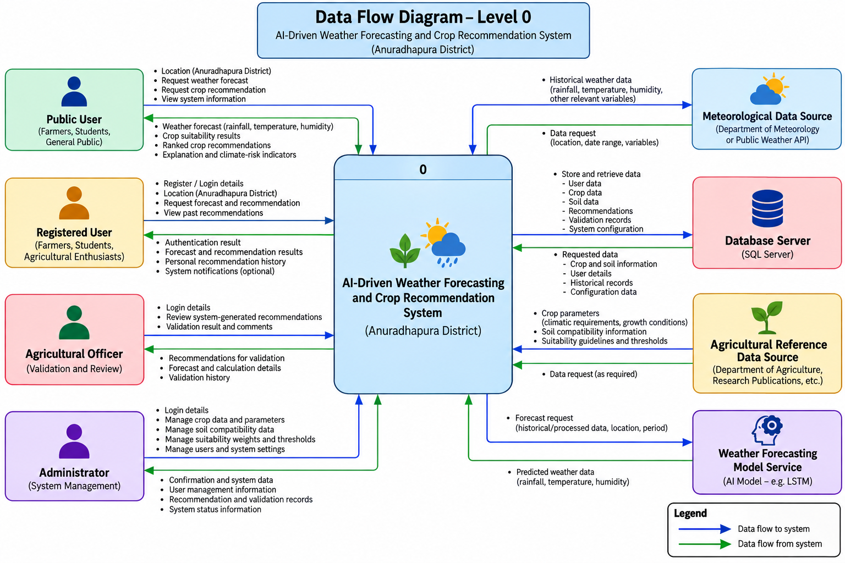
Existing diagram — draft/design reference; reconcile labels with current code and approved version.

Database entity relationship
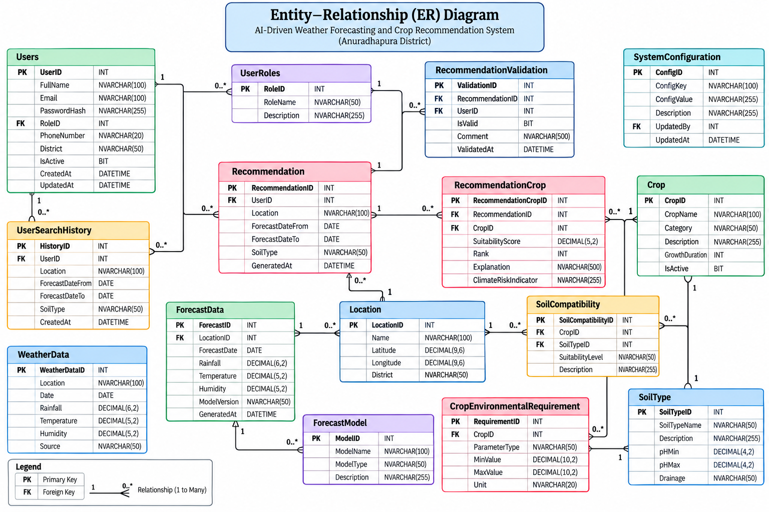
Existing diagram — draft/design reference; reconcile labels with current code and approved version.

Use case overview
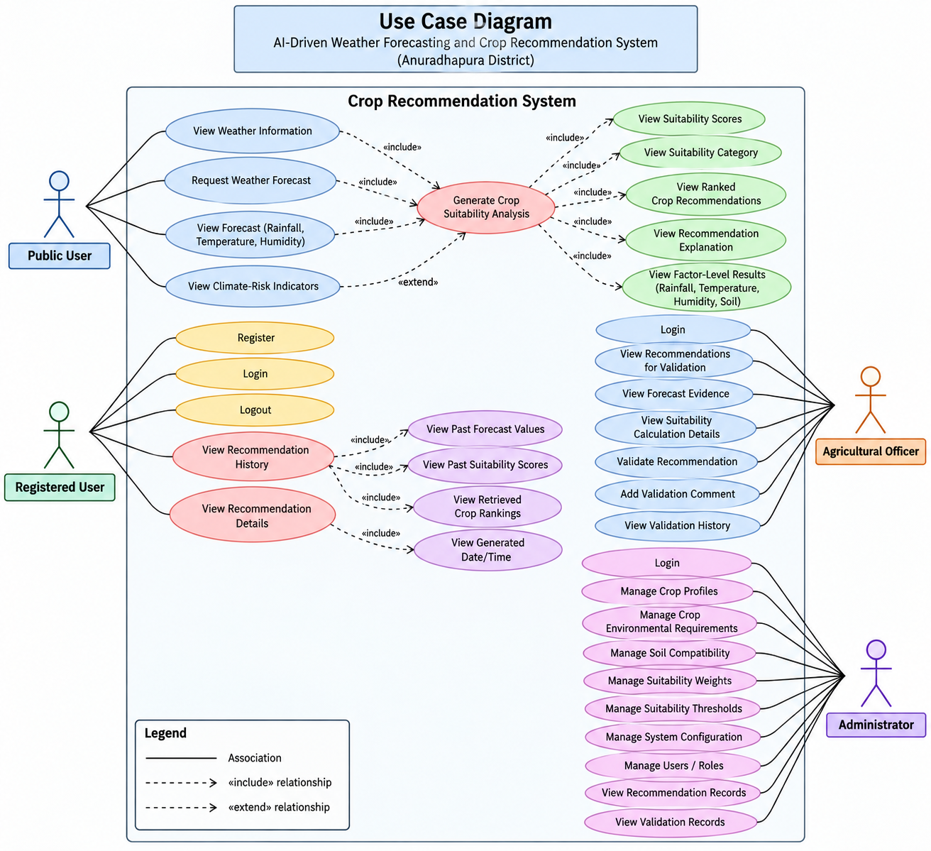
Existing diagram — draft/design reference; reconcile labels with current code and approved version.

7. Remaining design and implementation verification
- Reconcile approved PRD/SRS and Chapters 1–4 against implemented routes, feature flags, diagrams and actual acceptance tests.
- Complete authorized Agricultural Officer live validation using safe test records.
- Obtain agricultural expert/supervisor decision on missing crop-specific seven-day rainfall/RH criteria; retain PARTIAL status until validated.
- Confirm conditional history, climate risk and language requirements before implementing or claiming completion.
- Complete final dissertation Chapters 5–8 with model comparison, QA evidence and limitations.

