**Appendix 1**

**AGENDA**

1. Opening, adoption of the Agenda and meeting arrangements
2. Review progress made by the ICCAT GBYP and Phase 6 programme
3. Review of historical and new information on biology and stock structure
   1. Review life history assumptions such as fecundity, maturity, mortality schedules
   2. Review stock structure and mixing rate information
      1. Review status of ICCAT electronic tagging data base and the response to the letter from the SCRS Chair
      2. Review/compile inventory of composition data (genetics, microconstituent) by fleet and area and year
      3. Determine preliminary stock definitions
   3. Review/develop movement matrices (probability of occurrence in a region, amongst 8 box model regions, by stock, month of the year, and size class)
   4. Review progress on age-length keys
      1. Evaluate performance of various ALK approaches and cohort slicing
      2. Develop preliminary age-length keys for each stock
      3. Review potential for developing age-stock-length keys
4. Review of Task I and Task II statistics
   1. Review Task I statistics to be used for the 2016 update projections
   2. Review CPC submissions of metadata describing the quality of the submitted statistics
   3. Review progress by CPCs on their submissions of Task II size data to include the actual size samples used to estimate the catch at size and using the new weight/length conversions
   4. Review and make final revisions to Task II by validating and integrating the catch at size

statistics with new information from farms, harvesting and stereoscopic cameras, and other

sources of information.

1. Evaluate indices available for use in next assessment (including the index criteria table)
   1. Review currently used indices and updates for 2016 species group meeting
   2. Review of new indices of potential use in 2017 assessment
   3. Review of progress towards combined CPUE indices
2. Review of assessment methods
   1. Review current models and proposed enhancements
   2. Review new models under consideration for 2017 assessment
   3. Review status of the ICCAT Software Catalogue
3. GPYP Core Modelling and MSE Group
   1. Review of activities relative to MSE/MP development
   2. Review, discuss and complete the technical specifications for the MSE/MP
   3. Recommend Task I and Task II statistics, abundance indices and other information to be used for the MSE/MP
4. Other matters
   1. Biometrics for farmed fish
   2. Observer coverage
5. Recommendations
6. Adoption of the report and closure

**Appendix 2**

**LIST OF PARTICIPANTS**

***CONTRACTING PARTIES***

**ALGERIA**

**Ferhani,** Khadra

Centre National de Recherche et de Développement de la Pêche et de l'Aquaculture (CNRDPA), 11 Boulevard Colonel Amirouche, BP 67 Tipaza Bou Ismail

Tel: +213 24 32 64 10, Fax: +213 24 32 64 10, E-Mail: ferhani_khadra@yahoo.fr; dpmo@mpeche.gov.dz

**CANADA**

**Carruthers,** Thomas

335 Fisheries Centre, University of British Columbia, Vancouver Columbia V2P T29

Tel: +1 604 805 6627, E-Mail: t.carruthers@oceans.ubc.ca

**Hanke,** Alexander

Scientific, St. Andrews Biological Station/ Biological Station, Fisheries and Oceans Canada, 531 Brandy Cove Road, St. Andrews New Brunswick E5B 2L9

Tel: +1 506 529 4665, Fax: +1 506 529 5862, E-Mail: alex.hanke@dfo-mpo.gc.ca

**Maguire,** Jean-Jacques

1450 Godefroy, Quebec G1T 2E4

Tel: +1 418 688 3027, Fax: E-Mail: jeanjacquesmaguire@gmail.com

**Melvin,** Gary

Biological Station - Fisheries and Oceans Canada, Department of Fisheries and Oceans, 531 Brandy Cove Road, St. Andrews, New Brunswick E5B 2L9

Tel: +1 506 529 5874, Fax: +1 506 529 5862, E-Mail: gary.melvin@dfo-mpo.gc.ca

**EUROPEAN UNION**

**Álvarez-Berastegui**, Diego

SOCIB - Sistema de Observación Costera de las Islas Baleares, Parc Bit, Naorte, Bloc A 2ºp. pta. 3, 07121 Palma de Mallorca, Spain

Tel: +34 971 43 99 98, Fax: +34 971 43 99 79, E-Mail: dalvarez@socib.es

**Arrizabalaga,** Haritz

AZTI - Tecnalia /Itsas Ikerketa Saila, Herrera Kaia Portualde z/g, 20110 Pasaia Gipuzkoa, Spain

Tel: +34 94 657 40 00, Fax: +34 94 300 48 01, E-Mail: harri@azti.es

**Bonhommeau,** Sylvain

IFREMER - DOI, B.P. 60 - Rue Jean Bertho, 97822 Le Port, Reunion, France

Tel: +262 554 723; +262 693 801 100, Fax: +262 420 340, E-Mail: sylvain.bonhommeau@ifremer.fr

**Cort,** José Luis

Ministerio de Economía y Competitividad, Instituto Español de Oceanografía, C.O. de Santander, Apartado 240; Promontorio de San Martín S/N, 39080;39004 Santander Cantabria, Spain

Tel: +34 942 291 716, Fax: +34 942 27 5072, E-Mail: jose.cort@st.ieo.es

**Goñi,** Nicolas

AZTI-TECNALIA, Herrera Kaia Portualdea z/g, 20110 Pasaia, Spain

Tel: +34 946 574000, E-Mail: ngoni@azti.es

**Gordoa,** Ana

CEAB - CSIC, Acc. Cala St. Francesc, 14, 17300 Blanes Girona, Spain

Tel: +34 972 336101, E-Mail: gordoa@ceab.csic.es

**Lino,** Pedro Gil

Instituto Português do Mar e da Atmosfera - I.P./IPMA, Avenida 5 Outubro s/n, 8700-305 Olhão, Portugal

Tel: +351 289 700520, Fax: +351 289 700535, E-Mail: [plino@ipma.pt](mailto:plino@ipma.pt)

**Navarro Cid,** Juan José

Grupo Balfegó, Polígono Industrial - Edificio Balfegó, 43860 L'Ametlla de Mar Tarragona, Spain

Tel: +34 977 047700, Fax: +34 977 457 812, E-Mail: jnavarro@grupbalfego.com

**Reglero,** Patricia

Centro Oceanográfico de las Islas Baleares, Instituto Español de Oceanografía, Muelle de Poniente s/n, 07015 Palma de Mallorca Islas Baleares, Spain

Tel: +34 971 13 37 20, E-Mail: patricia.reglero@ba.ieo.es

**Rodríguez-Marín,** Enrique

Ministerio de Economía y Competitividad, Instituto Español de Oceanografía, C.O. de Santander, Promontorio de San Martín s/n, 39004 Santander Cantabria, Spain

Tel: +34 942 291 716, Fax: +34 942 27 50 72, E-Mail: rodriguez.marin@st.ieo.es

**Rouyer,** Tristan

Ifremer - Dept Recherche Halieutique, B.P. 171 - Bd. Jean Monnet, 34203 Sète, France

Tel: +33 (0)4 42 57 32 37; +33 (0)7 82 99 52 37, Fax: E-Mail: tristan.rouyer@ifremer.fr

**JAPAN**

**Butterworth,** Douglas S.

Emeritus Professor, Department of Mathematics and Applied Mathematics, University of Cape Town Rondebosch, 7701 Cape Town, South Africa

Tel: +27 21 650 2343, Fax: +27 21 650 2334, E-Mail: doug.butterworth@uct.ac.za

**Itoh,** Tomoyuki

Chief of Temperate Tuna Group, Bluefin Tuna Resources Division, National Research Institute of Far Seas Fisheries, Fisheries Research and Education Agency, 5-7-1 Orido, Shizuoka Shimizu 424-8633

Tel: +81 54 336 6000, E-Mail: itou@fra.affrc.go.jp

**Kimoto,** Ai

Bluefin Tuna Resources Division, National Research Institute of Far Seas Fisheries, Fisheries Research and Education Agency, 5-7-1 Orido, Shizuoka Shimizu 424-8633

Tel: +81 54 336 6000, E-Mail: aikimoto@affrc.go.jp

**Kitakado,** Toshihide

Associate Professor, Faculty of Marine Science, Tokyo University of Marine Science and Technology, Department of Marine Biosciences, 5-7, Konan 4, Minato-ku, Tokyo, Japan 108-8477

Tel: +81 3 5463 0568, Fax: +81 3 5463 0568, E-Mail: kitakado@kaiyodai.ac.jp

**Rademeyer,** Rebecca

Marine Resource Assessment and Management Group, Department of Mathematics and Applied Mathematic - University of Cape Town7701 Rondebosch, South Africa

E-Mail: rebecca.rademeyer@gmail.com

**Uozumi,** Yuji

Visiting Scientist, Bluefin Tuna Resources Division, National Research Institute of Far Seas Fisheries, Fisheries Research and Education Agency, 5-7-1 Orido, Shizuoka Shimizu 424-8633

Tel: +81 54 336 6000, E-Mail: uozumi@japantuna.or.jp; uozumi@affrc.go.jp

**MAURITANIA**

**Habibe,** Beyahe Meissa

Institut Mauritanien de Recherches Océanographiques et des Pêches - IMROP, B.P. 22, Cite IMROP Villa Nº 8, Nouadhibou

Tel: +222 2242 1047, Fax: +222 574 5081, E-Mail: beyahem@yahoo.fr; bmouldhabib@gmail.com

**MEXICO**

**Ramírez López,** Karina

Jefe de Departamento de Modelación y Pronósticos Pesqueros - DGAIPA-INAPESCA, Instituto Nacional de Pesca - SAGARPA, Av. Ejército Mexicano No.106 - Colonia Exhacienda, Ylang Ylang, C.P. 94298 Boca de Río Veracruz

Tel: +52 22 9130 4520, Fax: +52 22 9130 4518, E-Mail: kramirez_inp@yahoo.com; kramirez_lopez@yahoo.com.mx

**MOROCCO**

**Abid,** Noureddine

Responsable du programme de suivi et d'étude des ressources des grands pélagiques, Center Régional de L'INRH á Tanger/M'dig, B.P. 5268, 90000 Drabed Tanger

Tel: +212 53932 5134, Fax: +212 53932 5139, E-Mail: abid.n@menara.ma; noureddine.abid65@gmail.com

**Ben Mhamed,** Abdelouahed

Ingénieur en Modélisation statistique à l'INRH, Laboratoire Approches et Méthodologies, INRH, Institut National de Recherche Halieutique, Boulevard Sidi Abderrahman Ain Diab, 20000 Casablanca

Tel: +212 614 592 144; +212 613 384 845, Fax: E-Mail: a.benmhamed@mail.com;a.benmhamed@gmail.com; ben.mhamed.abdelouahed@gmail.com

**TUNISIA**

**Zarrad,** Rafik

Institut National des Sciences et Technologies de la Mer, BP 138 Mahdia 5199

Tel: +216 972 92 111, Fax: +216 73688602, E-Mail: rafik.zarrad@instm.rnrt.tn

**UNITED STATES**

**Ailloud,** Lisa

Virginia Institute of Marine Science, College of William & Mary, PO Box 1346 Gloucester Point, VA 23062

Tel: +1 240 253 3958, E-Mail: lailloud@vims.edu

**Bravington,** Mark

CSIRO MARINE LAB, Castray Esplanade, Tas 7000 Hobart, Australia

Tel: +61 438 315 623, E-Mail: Mark.bravington@csiro.au;Mark.Bravington@data61.csiro.au

**Díaz,** Guillermo

NOAA-Fisheries, Southeast Fisheries Science Center, 75 Virginia Beach Drive, Miami Florida 33149

Tel: +1 305 898 4035, E-Mail: guillermo.diaz@noaa.gov

**Hoenig,** John

Professor of Marine Science, Department of Fisheries Science, Virginia Institute of Marine Science, PO Box 1346

(1375 Greate Rd), Gloucester Pt. VA 23185

Tel: +1 804 815 2912, E-Mail: hoenig@vims.edu

**Kerr,** Lisa

Gulf of Maine Research Institute, 350 Commercial Street, Portland ME 04101

Tel: +1 207 228 1639, E-Mail: lkerr@gmri.org

**Lam,** Chi Hin (Tim)

Large Pelagics Research, University of Massachusetts, P O Box 3188, Gloucester, Massachusetts MA01931

Tel: +1 978 238 8208, Fax: +1 978 283 0297, E-Mail: tim.lam@umb.edu; tagtuna@gmail.com

**Lauretta,** Matthew

NOAA Fisheries Southeast Fisheries Center, 75 Virginia Beach Drive, Miami Florida 33149

Tel: +1 305 361 4481, E-Mail: matthew.lauretta@noaa.gov

**Lutcavage,** Molly

Director, Large Pelagics Research Center, University of Massachusetts, Boston, PO Box 3188, Gloucester MA 01931

Tel: +1 603 767 2126, E-Mail: molly.lutcavage@umb.edu

**Porch,** Clarence E.

Chief, Sustainable Fisheries Division, Southeast Fisheries Science Center, National Marine Fisheries Service, 75 Virginia Beach Drive, Miami Florida 33149

Tel: +1 305 361 4232, Fax: +1 305 361 4219, E-Mail: clay.porch@noaa.gov

**Richardson,** David

US Dept of Commerce/NOAA Fisheries, 28 Tarzwell Driave, Narragansett RI 02882

Tel: +1 401 782 3222, Fax: +1 401 782 3201, E-Mail: david.richardson@noaa.gov

**Secor,** David

University of Maryland Center for Environmental Science, P.O. Box 38, MD Solomons 20688

Tel: +1410 326 7229, Fax: +1 410 326 7210, E-Mail: secor@cbl.umces.edu

**Thomson,** Robin Barbara

Stock Assessment Modeller, Commonwealth Scientific and Industrial Research Organisation Marine and Atmospheric Research(CSIRO), CSIRO MARINE LAB Castray Esplanade, Tas 7000 Hobart, Australia

Tel: +61 3 6232 5133, Fax: +61 3 6232 5000, E-Mail: robin.thomson@csiro.au

***OBSERVERS FROM NON-GOVERNMENTAL ORGANIZATIONS***

**FEDERATION OF MALTESE AQUACULTURE PRODUCERS – FMAP**

**Deguara,** Simeon

Research and Development Coordinator, Federation of Maltese Aquaculture Producers - FMAP, 61, St. Paul Street, VLT 1212 Valletta, Malta

Tel: +356 21223515 /21226268, Fax: +356 21241170, E-Mail: simeon.deguara@um.edu.mt

**THE OCEAN FOUNDATION**

**Boustany,** Andre M.

Duke University, Nicholas School of the Environment Box 90328, Durham NC 27708, United States

Tel: +1 831 402 1364, E-Mail: andre.boustany@duke.edu

**Miller,** Shana

The Ocean Foundation, 1320 19th St., NW, 5th Floor, Washington, DC 20036, United States

Tel: +1 631 671 1530, E-Mail: smiller@oceanfdn.org

**UNIVERSITY OF NORTH CAROLINA**

**Braun,** Amy

University of North Carolina at Chapel Hill, Department of Geography, CB 3220 Chapel Hill, NC, 27599, United States

Tel: +1 919 923 1068, Fax: +1 919 962 1537, E-Mail: ambraun@live.unc.edu

**Havice,** Elizabeth

University of North Carolina Chapel Hill, Department of Geography Carolina Hall CB 3220, Chapel Hill, NC-27599-3220, United States

Tel: +1 919 962 3414, E-Mail: havice@email.unc.edu

***SCRS CHAIRMAN***

**Die,** David

SCRS Chairman, Cooperative Institute of Marine and Atmospheric Studies, University of Miami, 4600 Rickenbacker Causeway, Miami Florida 33149, United States

Tel: +1 305 421 4607, Fax: +1 305 421 4221, E-Mail: ddie@rsmas.miami.edu

**\*\*\*\*\***

**ICCAT Secretariat**

C/ Corazón de María 8 – 6th floor, 28002 Madrid – Spain

Tel: +34 91 416 56 00; Fax: +34 91 415 26 12; E-mail: info@iccat.int

**Neves dos Santos,** Miguel

**De Bruyn,** Paul

**Kell,** Laurence

**Palma,** Carlos

**Ortiz,** Mauricio

**GBYP PROGRAM**

**Di Natale,** Antonio

**Pagá,** Alfonso

**Tensek,** Stasa

**Appendix 3**

**LIST OF DOCUMENTS AND PRESENTATIONS**

|  |  |  |
| --- | --- | --- |
| **Reference** | **Title** | **Authors** |
| SCRS/2016/115 | A summary of bluefin tuna electronic and conventional tagging data | Guénette S., Hanke A., and Lauretta M. |
| SCRS/2016/118 | Update on the bluefin tuna catches from the tuna trap fishery off southern Portugal (NE Atlantic) between 1998 and 2015 | Lino P.G., Rosa D., and Coelho R. |
| SCRS/2016/122 | Simple update of the standardized bluefin CPUE of Japanese longline fishery in the Atlantic up to 2016 fishing year | Kimoto A., and Itoh T. |
| SCRS/2016/123 | Revision of Task II size data of bluefin tuna catch by Japanese longline from the 1970s to present | Itoh T. |
| SCRS/2016/124 | Report of Japan's scientific observer program for tuna longline fishery in the Atlantic Ocean since 2013 fishing year |  |
| SCRS/2016/128 | Comparative analysis of origin assignments for bluefin tuna sampled within ICCAT GBYP | Brophy D., Arrizabalaga H., Fraile I., Haynes P., Kitakado T., and Hanke A. |
| SCRS/2016/129 | Structures de taille de *Thunnus thynnus* capturé par les thoniers algériens | Ferhani K, and Bensmail S. |
| SCRS/2016/130 | Contribution of the Gulf of Mexico population to US Atlantic bluefin tuna fisheries in 2015 | Barnett B.K., Secor D.H., and Allman R. |
| SCRS/2016/131 | Possible consequences of the use of Atlantic Bluefin tuna population biometrics in the algorithm of stereo cameras | Gordoa A. |
| SCRS/2016/132 | Updated Bluefin CPUE and catch structure from the Balfegó Purse Seine Fleet in Balearic Waters from 2000 to 2016 | Gordoa A. |
| SCRS/2016/133 | Age-length keys availability for Atlantic bluefin tuna captured in the eastern management area | Quelle P., Rodriguez-Marin E., Ruiz M., and Gatt M. |
| SCRS/2016/134 | Expanded comparison of age estimates from paired calcified structures from Atlantic bluefin tuna | Rodriguez-Marin E., Quelle P., Ruiz M., Busawon D., Golet W., Dalton A., and Hanke A. |
| SCRS/2016/135 | A summary of bluefin tuna electronic and conventional tagging data | Hanke A., Guénette S., and Lauretta M. |
| SCRS/2016/136 | Standardized CPUE of bluefin tuna (*Thunnus thynnus*) caught by Moroccan traps for the period 1986- 2015 | Abid N., and Ben Mhamed A. |
| SCRS/2016/137 | Acoustic-based fishery-independent abundance index of juvenile bluefin tunas in the Bay of Biscay: 2015 and 2016 surveys | Goñi N., Onandia I., Lopez J., Arregui I., Uranga J., Melvin G.D., Boyra G., Arrizabalaga H., and Santiago J. |
| SCRS/2016/138 | ICCAT GBYP P-Sat tagging: the first five years | Tensek S., Di Natale A., and Pagá García A |
| SCRS/2016/139 | Report on revised trap data recovered by ICCAT GBYP between Phase 1 and Phase 6 | Pagá Garcia A., Palma C., Di Natale A., Tensek S., Parrilla A., and de Bruyn P. |
| SCRS/2016/140 | A peculiar situation for YOY of bluefin tuna (*Thunnus thynnus*) in the Mediterranean Sea in 2015 | Di Natale A., Tensek S., Celona A., Garibaldi F., Oray I., Pagá García A., Quilez Badía G., and Valastro M. |
| SCRS/2016/141 | Studies on eastern bluefin tuna (*Thunnus thynnus*) maturity – Review of old literature | Di Natale A., Tensek S., Pagá García A. |
| SCRS/2016/142 | Bluefin tuna weight frequencies from selected market and auction data recovered by GBYP | Di Natale A., Tensek S., Die D., Porch C., Bonhommeau S., Takeuchi Y., Melvin G., Mielgo Bregazzi R., de Bruyn P., and Palma C. |
| SCRS/2016/143 | Bluefin tuna (*Thunnus thynnus*) growth derived from conventional tag data | Pagá Garcia A., Tensek S., and Di Natale A. |
| SCRS/2016/144 | Simulation testing a multi-stock model with age-based movement | Carruthers T., and Kell L. |
| SCRS/2016/145 | Issues arising from the preliminary conditioning of operating models for Atlantic bluefin tuna | Carruthers T., and Kell L. |
| SCRS/2016/146 | Resolution of age at maturity and reproduction in Atlantic bluefin tuna: historical evidence and new insights from endocrine-based biomolecular approaches | Heinisch G., Correiro A., and Lutcavage M.E. |
| SCRS/2016/147 | Improving growth estimates for western Atlantic bluefin tuna using the AMSFc approach | Ailloud L.E., Lauretta M.V., Hoenig J.M., Hanke A.R., Golet W.J., Allman R., and Siskey M.R. |
| SCRS/2016/148 | Update of CPUE bluefin tuna *Thunnus thynnus* (l. 1758) caught by Tunisian purse seines in the Central Mediterranean | Rafik Z., and Missaoui H. |
| SCRS/2016/149 | Morphometric relationships of fattening bluefin tuna (*Thunnus thynnus*) caught in the Central Mediterranean in 2013 and 2014 | Rafik Z., and Missaoui H. |
| SCRS/2016/150 | Overview of the bluefin tuna data recovery in GBYP Phase 6 | Di Natale A., Pagá Garcia A., and Tensek S. |
| SCRS/2016/151 | The impact of massive fishing of juvenile Atlantic bluefin tunas on the spawning population (1949-2010) | Cort J.L., and Abaunza P. |
| SCRS/2016/152 | Statistical catch at length assessment methodology for Atlantic bluefin tuna | Butterworth D.S., and Rademeyer R.A |
| SCRS/2016/153 | Aerial surveys of bluefin tuna in the western Mediterranean Sea: an operational fishery-independent abundance index for juvenile fish? | Rouyer T., Bonhommeau S., Fromentin J.-M., and Brisset B. |
| SCRS/2016/154 | Analysis of the length–weight relationships for the Atlantic bluefin tuna, *Thunnus thynnus* (L.) | Cort J.L., and Estruch V.D. |
| SCRS/P/2016/032 | A genetic traceability tool for differentiation of Atlantic bluefin tuna (*Thunnus thynnus*) spawning grounds | Rodríguez-Ezpeleta N., Díaz-Arce N., Alemany F., Deguara S., Franks J., Rooker J.R., Lutcavage M., Quattro J., Oray I., Macías D., Valastro M., Irigoien X., and Arrizabalaga H. |
| SCRS/P/2016/033 | Using SatTagSim to provide transition matrices for Movement Inclusive Models | Galuardi B, Cadrin S.X., Arregui I., Arrizabalaga H., Di Natale A., Brown C.,Lam C.H., and Lutcavage M.E. |
| SCRS/P/2016/034 | Herring Acoustic Surveys: A new fishery independent abundance index (1994 - 2014) for Atlantic bluefin tuna in the Gulf of St Lawrence | Melvin G., Munden J., and Finley M. |
| SCRS/P/2016/035 | Review of BCD information (2008 to 2016) as a complement to improve Task I | Palma C. |
| SCRS/P/2016/036 | Guidelines towards a “fully revised” catch-at-size/age estimation | Palma C. |
| SCRS/P/2016/037 | Bluefin tuna larvae in the Gulf of Mexico: an overview of available oceanographic conditions during the past 20 years | Domingues R., Goni G., Bringas F., Walter J., Muhling B., and Lindo D. |
| SCRS/P/2016/038 | Incorporating stock mixing into the assessment and long-term expectations of Atlantic bluefin tuna | Kerr L.A., Cadrin S.X., Secor D.H., and Siskey M. |
| SCRS/P/2016/039 | Review progress made by the ICCAT GBYP and Phase 6 programme | Di Natale A., Tensek S., and Pagá García A. |
| SCRS/P/2016/040 | Close-Kin Mark-Recapture for Eastern ABFT: Summary of scoping study for ICCAT | Davies C., Bravington M., and Thomson R. |
| SCRS/P/2016/041 | Indices of larval bluefin tuna (*Thunnus thynnus*) in the western Mediterranean Sea (2001-2014) | Ingram Jr. G.W., Álvarez-Berastegui D., Reglero P., Balbín R., García A., and Alemany F. |
| SCRS/P/2016/042 | Genetic close kin pilot project for West Atlantic bluefin tuna | Walter J., Lauretta M., Porch C., Grewe P., Bravington M., Davies C., McDowell J., Graves J., and Kaplan D. |
| SCRS/P/2016/043 | A recruitment index for Atlantic bluefin tuna independent from the fishery | Reglero P., Balbin R., Ortega A., Mourre B., Alvarez-Berastegui D., Abascal F., Blanco E., Medina A., de la Gándara F., Juzá M., Kernec M., Tintoré J., and Alemany F. |

|  |  |  |
| --- | --- | --- |
| SCRS/P/2016/049 | Improving age composition estimates using hybrid Age Length Keys | Ailloud L.E., Hoenig J.M, Lauretta M.V. |

**Appendix 4**

**LIFE-HISTORY INPUTS DISCUSSED FOR MSE**

The material presented in this Appendix was developed by a few members of the life-history subgroup and presented during the plenary session, however there was insufficient time to fully review the material in plenary and it was not formally adopted.

* Table 8.2 in DRAFT ANNEX FOR ATLANTIC BLUEFIN MSE SPECIFICATIONS_JULY 2016.pdf
* Natural mortality rate at age
* Maturity at age

**A. Areas with potential spawning for MSE**

The quarters and areas with probability of spawning activity were classified in two categories (yes and no) using the criteria of average value quarter SST >20ºC assuming 20ºC is the minimum temperature for the larvae to survive (SCRS/P/2016/043). Average temperatures per quarter were estimated from monthly SST NOAA NASA AVHRR Oceans Path-finder on a grid of 5x5º cells. Areas and quarters with positive probability of spawning activity might be overestimated due to the size of the geographical areas considered.

|  |  |  |  |  |
| --- | --- | --- | --- | --- |
| **Area** | **Q1** | **Q2** | **Q3** | **Q4** |
| GOM | yes | yes | yes | yes |
| W. Alt | yes | yes | yes | yes |
| GSL | no | no | no | no |
| C. Atl | yes | yes | yes | yes |
| E. Atl | yes | yes | yes | yes |
| NE. Atl | no | no | no | no |
| W. Med | no | no | yes | no |
| E. Med | no | no | yes | yes |

**B. Stock-Recruitment**

Recent modeling exercises have attempted to incorporate mixing rates into the assessments for eastern and western stocks of bluefin tuna (SCRS_P_2016_038_Kerr_et_al.pdf). It was noted that when the estimates of spawning stock biomass and recruitment for the western stock were separated from eastern fish, the former seemed to show increasing recruitment with increasing SSB in recent years.  The Group agreed that while there is high uncertainty in the estimates for the most recent years of both SSB and recruitment, should this trend continue in future assessments it may prove informative in elucidating the spawner recruit relationship for WBFT.

**Egg production modeling for assessment purposes**

In addition, The Group discussed and agreed that the total number of eggs produced by the spawning stock *S* is the product of the number of females in each age class during the spawning season *Na*and the average number of eggs produced per female *Ea*, summed over all ages:

*S*=*Ea Na*

Egg production for both stocks was expected to be similar between the East and West, and to vary with age (as agreed in Tenerife). There was considerable discussion regarding the meaning of various terms. For example, when assessment scientists use the term maturity what they often mean is the relative fraction of the population that is spawning, whereas the term maturity used in a physiological sense refers to the stage when viable gametes are produced and the animal has the potential to be reproductively active (regardless of whether they actually do reproduce). In order to avoid further confusion, the Group discussed the quantity that is ultimately needed for the operating model and the assessment: the relative egg production of each age/size class (or equivalent measure of spawning capacity at age).

The number of eggs per female is the product of the number of spawning events *n* and the average number of eggs produced per spawning event (batch fecundity) *f*:

*Ea*= *na fa*

For stock assessment purposes, it is not generally necessary to know the absolute number of eggs produced, but rather the relative change in egg-production with age. Thus, the values for *n* or *f* may be expressed relative to their maximum values (for example, *n* may be interpreted as the relative fraction of each age class that spawns).

The dependence of batch fecundity on age has not been determined for Atlantic Bluefin Tuna, although there is evidence that batch fecundity per gram of body weight is fairly constant at about 58 eggs gr-1 regardless of fish size (e.g., Medina *et al*., 2002, Corriero *et al*., 2005; Knapp *et al*., 2015The relationship between the number of spawning events and age is poorly known for BFT and there was considerable discussion regarding the best proxy for this quantity. One approach is to assume that all mature fish spawn the same number of times per year regardless of their age (i.e., that they spawn with the same frequency and stay on the spawning grounds for the same amount of time). In that case, the maturity vector *m* (calculated from histology and endocrinal work could serve as the proxy for number of spawners (*n*)*.* This, together with the previous assertion that batch fecundity is proportional to body weight, implies mature biomass as a proxy for egg production:

*mB*=*mawaNa*

In other words, one is assuming mature fish produce eggs in direct proportion to their body mass. The assessment for the Eastern Atlantic similarly used mature biomass as a proxy for egg production and it was pointed out that this approach can be regarded as a limit in the sense that it attributes the greatest possible impact to younger mature fish.

Another possible alternative is to infer the contribution of each age class from the frequency of occurrence of each age class on the spawning grounds relative to the frequency in the overall population *p*:

*pB*=*pawaNa*

Variations of this approach were used for the Western Atlantic population (assuming most spawning occurs in the Gulf of Mexico), in which case the relative contribution of younger fish was much less than expected based on maturity alone. It was pointed out that there is some evidence from PSAT data in the Gulf of Mexico and observations of fish movement patterns in the Mediterranean that younger fish may have shorter resident times in the spawning grounds than older fish. A preliminary review of purse seine catches on the Mediterranean spawning grounds also suggested that the contribution of younger mature fish might be less than expected based on maturity alone. However, further analyses were required to account for possible biases owing to the effects of size selection by the fishery. In any case, proxies obtained from relative age frequencies on the spawning ground could potentially be regarded as another limit in the sense that they attribute the least possible impact to younger mature fish by assuming they do not spawn outside the putative spawning grounds.

Two other alternatives were identified that may be intermediate between the ‘limits’ (*pB* and *mB*) discussed above. One of these was based on the observation that the estimates of spawning potential from a close-kin genetic tagging study of Southern Bluefin Tuna showed that younger fish contributed substantially less to the spawning stock than was expected based on the histologically-based maturity vector. It was pointed out that there are important differences between BFT and SBT, as well as the environments they live in. Thus, rather than use the SBT vector directly, it was proposed to use the relative difference between the close-kin and histologically-based SBT vectors as a correction factor for BFT:

$${}^{adj}B=\sum_{a}{m_{a}w_{a}N_{a}}\frac{E_{a}^{}\left[SBT, genetics\right]}{E_{a}^{}\left[SBT, histology\right]}$$

This adjustment essentially assumes that the basic physiological processes that might cause younger fish to contribute proportionately less than older fish are similar for BFT and SBT (rather than making the more restrictive assumption that the animals are identical).

**Establishing hypotheses about the contribution of each age to spawning**

The latest stock assessments of ABFT made assumptions about the relative contribution of each age group to the spawning output of the population. The assumed vectors are different for the eastern and western stock (Table LH1).

The only tuna where the contribution of different age groups to population spawning output has been directly measured is Southern Bluefin tuna. These estimates were derived from the close kin analysis (Bravington *et al*. 2014). Estimates of this contribution show that it departs significantly from the assumption that spawning output can be approximated by the weight of the spawner (Figure LH1). Estimates differ significantly from the assumption that weight of spawner is a good measure of spawning contribution. Close-kin results strongly suggest that older fish contribute relatively more to the spawning output of the population than what it would otherwise be expected because of their weight.

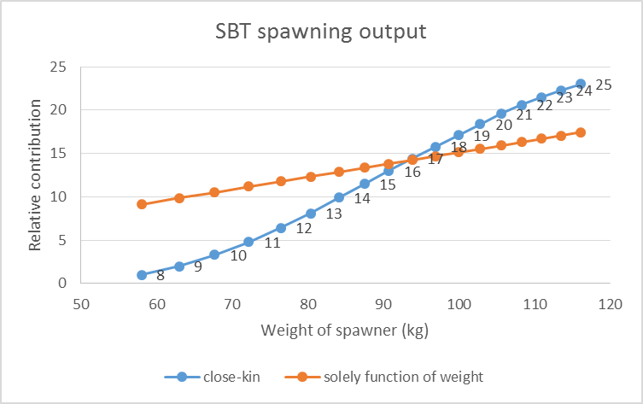

**Figure LH1.** Relative contribution of southern bluefin tuna to population spawning output as a function of weight. Labels on line correspond to age of each spawner. Blue line corresponds to estimates from close-kin analyses. Orange line corresponds to assumption that relative contribution can be solely calculated from the weight of the spawner (redrawn from Bravington *et al*., 2014)

After further discussion the Group agreed in plenary to develop two alternative vectors to condition the operating model. One uses the latest results of the endocrine studies (reference needed) which suggest that ABFT start maturing at age 3 and are all mature by age 5. The second vector was developed by using the vector estimated for SBT by Bravington *et al*. (2014) and shifting it so that the youngest ABFT contributing to the spawning output would be assumed to be fish of age 4 rather than fish of age 8 like in SBT.

These 2 alternative vectors were compared with the maturity vectors used in the previous stock assessment. The resulting 4 vectors show that option 1 developed herein is relatively close to the vector assumed for eastern stock of ABFT. Option 2 is more aligned than the vector assumed for western stock of ABFT, however, option 2 assumes a gradual change in the contribution rather than a knife-edge shift (**Figure LH2**). Previous studies of size composition of ABFT in the GOM are consistent with the vector in option 2 (Diaz, 2011).

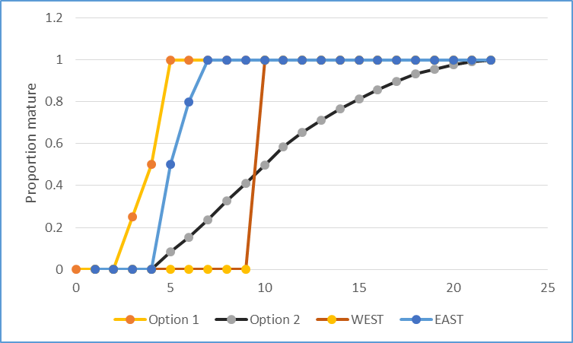

**Figure LH2.**  Proportion mature at age as a proxy for the relative contribution of ABFT to the total population spawning output.

To evaluate the consequences of these assumptions on the calculation of spawning biomass it is useful to calculate the SSB on the basis of the simple product of %mature x biomass of mature fish. The biomass of mature fish in equilibrium would be the product of Numberage x Weightage. Assuming that Numberage of a fully exploited stock can be expressed as Nage = Nage-1 e -2M. This assumes that F=M on a fully exploited stock. Calculations were made with the Mage and Weightage values included in MSE model specifications document.

When these calculations are done for the four vectors it is clear that the ages that contribute the most to population spawning output are different (**Figure LH3**). When such contributions are done cumulatively it is more apparent that the current Eastern stock assumption is very similar to option 1 and the western stock assumption to option 2, except that option 2 acknowledges some contribution of fish age less than 9 (**Figure LH 4**).

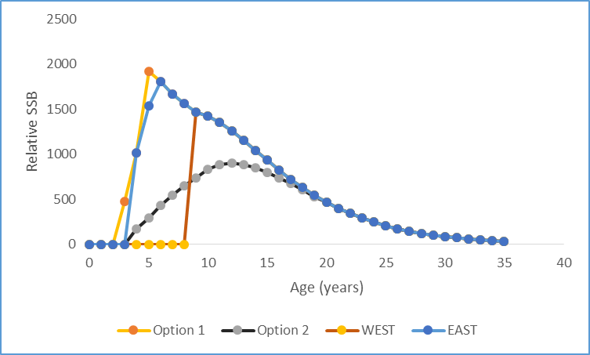

**Figure LH3.** Relative spawning stock biomass as a function of age for a fully exploited stock. Each line represents a different assumption about the relative contribution of each fish as a function of age.

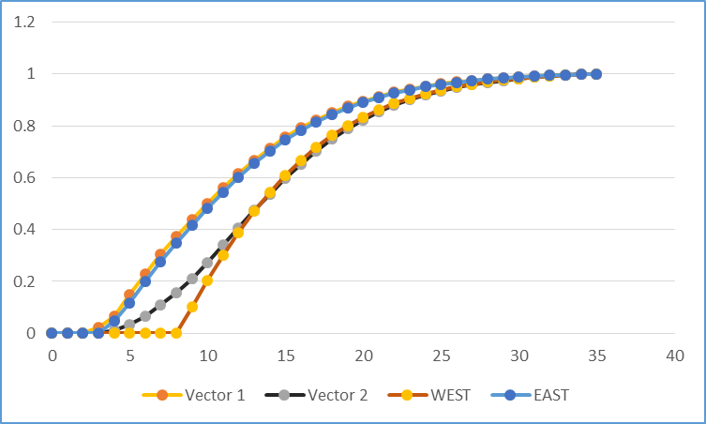

**Figure LH4.** Cumulative relative spawning stock biomass as a function of age for a fully exploited stock. Each line represents a different assumption about the relative contribution of each fish as a function of age.

**Table LH1.** Maturity vectors used to represent the proportion of any age group that will contribute to the spawning biomass. East and West rows correspond to assumptions made in the latest ICCAT stock assessment for each of the two ABFT stocks. Option 1 and Option 2 are the vectors proposed for the conditioning of the MSE GBYP operating model.

|  |  |  |  |  |  |  |  |  |  |  |  |  |  |  |  |  |
| --- | --- | --- | --- | --- | --- | --- | --- | --- | --- | --- | --- | --- | --- | --- | --- | --- |
| **Age** | **0** | **1** | **2** | **3** | **4** | **5** | **6** | **7** | **8** | **9** | **10** | **11** | **12** | **13** | **14** | **15** |
| **East** | 0 | 0 | 0 | 0 | 0.5 | 1 | 1 | 1 | 1 | 1 | 1 | 1 | 1 | 1 | 1 | 1 |
| **West** | 0 | 0 | 0 | 0 | 0 | 0 | 0 | 0 | 0 | 1 | 1 | 1 | 1 | 1 | 1 | 1 |
| **Option 1** | 0 | 0 | 0 | 0.5 | 1 | 1 | 1 | 1 | 1 | 1 | 1 | 1 | 1 | 1 | 1 | 1 |
| **Option 2** | 0 | 0 | 0 | 0 | 0.08 | 0.15 | 0.24 | 0.33 | 0.41 | 0.5 | 0.58 | 0.65 | 0.71 | 0.82 | 0.86 | 0.9 |

**References**

Bravington M.V., P.M. Grewe and C.R. Davies. 2014. Fishery independent estimate of spawning biomass of southern bluefin tuna through identification of close-kin using genetic markers. FRDC report 2007/034 CSIRO, Australia. 150 p.

Corriero, A., Karakulak, S., Santamaria, N., Deflorio, M., Spedicato, D., Addis, P., Desantis, S., Cirillo, F., Fenech-Farrugia, A., Vassallo-Agius, R., de la Serna, J.M., Oray, Y., Cau, A., Megalofounou, P., De Metrio, G., 2005. Size and age at sexual maturity of female bluefin tuna (*Thunnus thynnus* L. 1758) from the Mediterranean Sea. J Appl Ichthyol 21, 483–486.

Cort J.L., Estruch V.D., Santos M.N., Di Natale A., Abid N.,de la Serna J.M. 2015. On the Variability of the Length–Weight Relationship for Atlantic Bluefin Tuna, *Thunnus thynnus* (L.), Reviews in Fisheries Science & Aquaculture, 23:1, 23-38, DOI: 10.1080/23308249.2015.1008625

Díaz G. 2011. A revision of western Atlantic bluefin tuna age of maturity derived from size samples collected by the Japanese longline fleet in the Gulf of Mexico (1975-1980). Collect. Vol. Sci. Pap. ICCAT, 66: 1216-1226.

Gordoa, A., Sanz, N., & Viñas, J. 2015. Individual spawning duration of captive Atlantic bluefin tuna (*Thunnus thynnus*) revealed by mitochondrial DNA analysis of eggs. *PloS one*, *10*(8), e0136733.

Heinisch G, Corriero A, Medina A, Abascal FJ, de la Serna JM, et al. (2008) Spatial-temporal pattern of bluefin tuna (*Thunnus thynnus* L. 1758) gonad maturation across the Mediterranean Sea. Marine Biology 154: 623–630.

Heinisch, G., Rosenfeld, H., Knapp, J.M., Gordin, H., Lutcavage, M.E., 2014. Sexual maturity in western Atlantic bluefin tuna. Sci. Rep. 4. doi:10.1038/srep07205

Izquierdo MS, Fernández-Palacios H, Tacon AGJ. Effect of broodstock nutrition on reproductive performance of fish. Aquaculture. 2001; 197:25-42.

Knapp, J.M., Aranda, G., Medina, A., Lutcavage, M., 2014. Comparative assessment of the reproductive status of female Atlantic bluefin tuna from the Gulf of Mexico and the Mediterranean Sea. PloS One 9, e98233.

Medina, A., Abascal, F. J., Megina, C. and García, A. (2002), Stereological assessment of the reproductive status of female Atlantic northern bluefin tuna during migration to Mediterranean spawning grounds through the Strait of Gibraltar. Journal of Fish Biology, 60: 203–217. doi:10.1111/j.1095-8649.2002.tb02398.x

Neilson, J.D., Campana, S.E., 2008. A validated description of age and growth of western Atlantic bluefin tuna (*Thunnus thynnus*). Can J Fish Aqua Sci 65, 1523–1527.

Ortega, A. and G. Mourente, G. 2010. Comparison of the lipid profiles from wild caught eggs and unfed larvae of two scombroid fish: northern bluefin tuna (*Thunnus thynnus* L., 1758) and Atlantic bonito (*Sarda sarda* Bloch, 1793). Fish Physio. & Biochem. 36:461-471.

Reglero, P., Tittensor, D. P., Álvarez-Berastegui, D., Aparicio-González, A., Worm, B. 2014. Worldwide distributions of tuna larvae: revisiting hypotheses on environmental requirements for spawning habitats. Mar Ecol Prog Ser 501:207-224.

Richardson, D.E., Marancik, K.E., Guyon, J.R., Lutcavage, M.E., Galuardi, B., Lam, C.H., Walsh, H.J., Wildes, S., Yates, D.A., Hare, J.A. 2016. Discovery of a spawning ground reveals diverse migration strategies in Atlantic bluefin tuna (*Thunnus thynnus*). Proc. Natl. Acad. Sci. 201525636. doi:10.1073/pnas.1525636113

**Appendix 5**

**AGE-LENGTH KEY AND STOCK KEY SMALL WORKING GROUP REPORT**

In order to be consistent with the recommendations and work plan of the 2015 Bluefin tuna Working Group, their report on the feasibility of producing an ALK was used as a template to guide the discussions. The Group also recognized that 4 papers and 1 presentation provided at this year’s meeting would be informative (SCRS/2016/133, SCRS/2016/134, SCRS/2016/143, SCRS/2016/147 and SCRS/P/2016/049). The material presented in this Appendix was developed by members of the age-length subgroup and presented during the plenary session, however there was insufficient time to fully review the material in plenary and it was not formally adopted.

The 2015 Working Group’s recommendations/evaluation below was amended with actionable items as noted following each point:

1. Verify that all ages used same protocol and that we are tracking cohorts properly:
   1. The currently accepted (Busawon *et al.* 2014, Secor *et al.,* 2014) aging protocol counts the number of opaque bands and assigns the age according to this number.[***The biological database includes a field that indicates if the new protocol was used in ageing. Prior to the next meeting, the group will confirm with each contributor that the entries are correct for years prior to the introduction of the protocol (SCRS/P/2016/049),).***]
   2. In an assessment that works on calendar years to correctly track cohorts it is necessary to assign the fish correctly to the year it was born. [***The protocol for assigning a fish to the year it was born was confirmed to be as described in c) below. It was also agreed that a correction should be done to account for the type of section shape used for the reading: V or Y type, where one year should be added to the readings of V sections (Secor et al., 2014)]***
   3. To do so we propose a rule that if the fish is caught between January 1 and the assumed time of the opaque band formation (June 1) then 1 year is added to the age. The timing of opaque band formation was inferred from monthly formation of edge type in bluefin tuna fin spines (Cort 1990, Luque *et al*., 2014) and band formation from chemical tagging in southern bluefin tuna (*Thunnus maccoyii*) (Clear *et al*., 2000). Both sources coincide in opaque bands forming annually in summer. [***Recent chemical analyses of opaque and translucent zones of Atlantic bluefin tuna otoliths (Siskey et al. 2015) also show that opaque zones are apparent (distinguishable from the edge) by June 1.The database includes the direct age estimate and the adjusted age based on the this protocol and it was confirmed that the adjusted age was correctly applied by all investigators.***]
   4. For future otolith reads we recommend measuring the width of the translucent band and continuing to determine if the timing of opaque band formation in otoliths can be more precisely determined. [***This depends on data that do not exist for each otolith and hence cannot be accomplished in the short term.***]
2. Evaluate the suitability of the existing information to use the ALKs:
   1. Identify and verify any outlier age-length pairs (Otolith readers) [***Prior to generating eastern and western ALKs from both otolith and spine samples, the outliers in length for a given age were removed when they were further than 3 standard deviations from the mean. As a consequence, approximately 50 western observations and one eastern observation were removed.***]
   2. Are all bins filled, define appropriate size bin? [***The Group agreed that the resolution of the ALK should not be coarser than that used in slicing and that ALKs would be developed at several resolutions and evaluated. Six methods were proposed for dealing with an absence of observations (i.e. gaps in the key). These approaches are: 1) Hybrid key (SCRS/P/2016/049), 2) Gap fill using data form other years, 3) Inverse key, 4) follow Butterworth’s ALK method (SCRS/2016/152) 5) follow an approach integrating several methods and 6) Smooth ALK. The group was not in favour of borrowing data from another stock region because of the potential for differences in probability in age-at-length between the two stocks (which forward ALKs are based on), which can result from differences in annual recruitment strengths (see SCRS/P/2016/049)There was also a preference for an approach that did not involve reliance on a growth model. Finally, it was thought that the use of a plus group in the assessment may allow one to overcome gaps at older ages. These approaches will be evaluated intersessionally, however an interim ALK (as described below) will be made available for use in the MSE operating model (LA).***]
   3. Are sample sizes sufficient for the EastWest ***Recent years data have been added to the database (East: 2800 fish over years 2005-2013; West: 3400 over years 2009-2015). The existence of GBYP data for the western management zone, that were not included in the Biological Database, was noted and efforts will be made to include them (ERM). Bubble plots of year by age were produced to determine if the data was sufficient for detecting cohort progression. In the eastern bubble plot (Figure 1) it was possible to detect some cohort progression whereas in the west there was no strong evidence (Figure 2***]
   4. Are sufficient years represented and is there trend over year, evaluate mean age at length. [***Approximately 5 annual ALKs could be constructed using data from the west. The east has approximately 5 years. The adequacy of the annual ALKs (whether sample sizes are sufficient) is yet to be determined (LA). The 2016 ages should be available for the 2017 assessment.]***
   5. Are samples representative of the fishery? [***This was assessed by comparing the catch at size from each stock (east, west, Mediterranean) with the length composition of the relevant samples (Figures 3*** *to* ***5). In all cases the sampling covered the size range of the catch, though the eastern samples were closer to being collected in proportion to the size distribution of the catch. Two catch at size options were provided for the Mediterranean and the length distribution of the sample matched that of the catch at size that include data from caging operations. It still remains to be verified that the distribution of samples from smaller western fish (100 to 110 cm) is correct.]***
   6. Do we need a ‘rule’ to deal with holes in the ALK? [***As described in b) above, there are several alternatives for dealing with holes. The approach will be contingent on the seriousness of the gaps and the performance of the various ALK approaches (LA).***]
3. Does the new aging data provide new information on growth [***The new data in addition to tagging data were used to generate a new growth model for the western stock (SCRS/2016/147). There was no new model provided for the east, although the group was informed about two recent publications with same results on this topic (Cort et al., 2014; Luque et al., 2014). The group considered that before the new Richards model could be accepted, it should be refit after outlier removal and removal of age 1 and 2 fish as these could introduce a bias because of under-representation of slowing-growing fish (LA). It was recommended that the east also adopt a model fit using a Richards curve to be consistent with the west. However, since the von Bertalanffy growth estimates for each stock (Restrepo et al. (2010) and Cort (1991)) are very similar to one another, there is no reason to suspect much difference between the Richards models fitted to eastern and western samples. Given that the east has few older fish it was recommended that the model is fit with priors on shape parameters. The intent is for the new models for the east and west to be used whenever slicing is required.***]
   1. Do we need to re-estimate Restrepo *et al.* (2010) , Cort (1991) and Cort *et al*., 2014 growth curves to be consistent with the new aging protocols and the substantial new age-length data. [***The ageing data that produced the Restrepo et al. (2010) and Cort (1991) growth curves used old ageing protocols and involved modal progression. Recent analyses using more data under the new protocols match the Restrepo et al. (2010) fit but also indicate that the Richards model is free of residual bias for the older ages.***
   2. Re-estimate Restrepo *et al.* (2010) growth curves (cohort progression or without)?
4. 2-3 step evaluation of which method replicates known ages (To be completed for Species group meetings) [***The group recognized that steps 4 and 5 represent a reasonable approach for evaluating the ALKs once produced. These comparisons can be accomplished in time for the Species Working Group Meeting (LA).***]
   1. Use Restrepo *et al.* (2010) and Cort (1991) and run cohort slicing on known age-length info;
   2. Fit growth curve to new direct aging data, use cohort slicing to generate ages from the same lengths;
   3. Use ALK to generate ages;
   4. Compare Age comp with known ages to test the three methods.
5. Estimate full CAA with slicing and ALK to evaluate (To be completed for Species group meetings):
   1. CAA from slicing and Restrepo *et al.* (2010) and Cort (1991) (continuity CAA);
   2. CAA from slicing and new growth curves;
   3. CAA from ALKs

In addition to the work and decisions indicated above, the group considered how spines would inform the key (SCRS/2016/134). It was felt that spine age could be included in a key when an otolith was not available, however spine age was not suitable for fish older than 13 y and there were moderate concerns over using spine age for fish between 7 and 13 years of age.

**Diagnostics and quality control**

Prior to the 2017 data preparatory meeting the biological database will be summarized so that the completeness of the data and the availability of ages for annual keys can be assessed. Also, checks for inconsistencies in age assignment by lab will be checked using the relationship to the new Richards growth curve. Lastly, the effect on the ALK of using lengths estimated from weights or snout length will be evaluated.

**Preliminary age-length key comparisons**

Following a review of related diagnostics, preliminary ALKs were developed for both the east and western stocks. Catch at age matrices were created for the western stock using 3 approaches and included in the 2014 BFT western VPA. Retrospective analyses yielded estimates of Mohn's Rho calculated for both F and recruitment on 10 year retrospective peels. These performance statistics were used to assess the effect of the 3 approaches on cohort progression. The three approaches considered were as follows:

1. Use a hybrid key (SCRS/P/2016/049) for each year with direct ages. Gaps are filled using cohort slicing. For all other years, cohort slicing is applied to the catch at size data. The growth model used to perform the cohort slicing was based Restrepo *et al*. (2010).
2. Apply a pooled key to all the catch at size data.
3. Apply cohort slicing to all the catch at size data using the growth model described 1.

**Results**

For the pooled key, convergence of the VPA was a problem and the retrospective pattern was bad (**Figure 6**). Relative to cohort slicing, the hybrid method had very little retrospective pattern until the transition to years where no or few direct ages were available (**Figure 7**). The pattern coincided with the change in method but also because the von Bertalanffy curve used in cohort slicing was not a good fit to the age-length data. There was some concern that the retrospective issue was also a function of other features which can’t be disentangled from the effect of the age assignment method.

Estimates of Mohn’s Rho show that the hybrid method was less biased over the most recent 5 years (**Table 1**, **Figure 8**). Performance over the most recent 10 years was much worse. This could be indicative of the influence of more years of ALK providing a differential cohort or growth signal relative to the assumptions of age-slicing. The pooled key was the worst performing key for both 5 and 10 year peels. For both recruitment and SSB, the hybrid method had higher bias; however, the bias decreased with the shorter (5 year) retrospective span.

Some considerations for future analyses were:

1. Retest with the addition of the most recent years of ageing data.
2. Use a Richards’s model throughout.
3. Explore other age assignment methods described above (e.g. combined forward and inverse key).
4. Compare slicing using the Richards and von Bertalanffy growth models.
5. Explore the sensitivity to gap filling (i.e. explore alternative bin widths and sample size thresholds).

**Stock specific age-length key**

The possibility of constructing stock specific ALKs was not assessed. The availability of stock origin information across all ages and by area could be more properly assessed by the small working group on stock mixing which compiled all available mixing information.

**Recommendations**

1. The GBYP has collected otoliths and spines that have not been aged. It is recommended that in the short term gaps be identified in the ALK and that these be filled by ageing those GBYP samples that will fill the gaps (e.g. **Tables 2** and **3**).
2. It was noted that many institutions have conducted Bluefin tuna sampling programs which could yield samples not part of the GBYP or Biological Sampling databases. It is recommended that a request for these data be circulated.
3. It is recommended that all the biological data be included in the Biological Database. To that end, an Excel workbook can be provided to each investigator to facilitate data transfer.

**References**

Ailloud L.E., Lauretta M.V., Hoenig J.M., Hanke A.R., Golet W.J., Allman R., and Siskey M.R. 2016. Improving age composition estimates using hybrid Age Length Keys. SCRS/2016/147

Busawon, D. S., Neilson, J. D., Andrushchenko, I., Hanke, A., Secor, D. M., and Melvin, G., 2014. Evaluation of Canadian sampling program for bluefin tuna, results of natal origin studies 2011-2012 and assessment of length-weight conversions. *Col. Vol. Sci. Pap. ICCAT*, 70 (1): 202-219

Cort, J. L., 1990. Biología y pesca del atún rojo, *Thunnus thynnus* (L.), del mar Cantábrico. *Publicaciones Especiales Inst. Esp. Oceanog.,* Num. 4: 272 p.

Cort, J.L., 1991. Age and growth of the bluefin tuna (*Thunnus thynnus*) of the Northeast Atlantic. *Col. Vol. Sci. Pap. ICCAT*, 35 (2): 213-230

Cort, J. L., Arregui, I. Estruch, V., and Deguara, S., 2014. Validation of the growth equation applicable to the eastern Atlantic bluefin tuna, *Thunnus thynnus* (L.), using *L*max, tag-recapture and first dorsal spine analysis. *Reviews in Fisheries Science & Aquaculture*, 22: 3, 239–55

Butterworth D.S., and Rademeyer R.A. 2016. Statistical catch at length assessment methodology for Atlantic bluefin tuna. SCRS/2016/152

Luque, P., Rodriguez-Marin, E., Ruiz, M., Quelle, P., Landa, J., Macias, D., and Ortiz de Urbina, J. M., 2014. Direct ageing of *Thunnus thynnus* from east Atlantic and western Mediterranean using dorsal fin spines. *J. Fish Biol*., 84, 1876-1903

Pagá Garcia A., Tensek S., and Di Natale A. 2016. Bluefin tuna (*Thunnus thynnus*) growth derived from conventional tag data. SCRS/2016/143

Quelle P., Rodriguez-Marin E., Ruiz M., and Gatt M. 2016. Age-length keys availability for Atlantic bluefin tuna captured in the eastern management area. SCRS/2016/133

Restrepo, V. R., Díaz, G. A., Walter, J. F., Neilson, J., Campana, S. E., Secor, D., and Wingate, R. L., 2010. Updated estimate of the growth curve of western Atlantic bluefin tuna. *Aquat. Living Resour*. 23, 335-342

Rodriguez-Marin E., Quelle P., Ruiz M., Busawon D., Golet W., Dalton A., and Hanke A. 2016. Updated comparison of age estimates from paired calcified structures from Atlantic bluefin tuna. SCRS/2016/134

Secor, D. H., Busawon, D. S., Gahagan, B., Golet, W., Koob, E., Neilson, J. D., and Siskey, M., 2014. Conversion factors for Atlantic bluefin tuna fork length from measures of snout length and otolith mass. *Col. Vol. Sci. Pap. ICCAT*, 70 (2): 364-367

Siskey M.R., Lyubchicha V., Lianga D., Piccoli P.M., Secor D.H. 2016. Periodicity of strontium: Calcium across annuli further validates otolith-ageing for Atlantic bluefin tuna (*Thunnus thynnus*). Fish Res  
177: 13-17.

**Table 1.** Mohn statistics for Mean squared error, Mean absolute error (a measure of error) and Mohn bias from 10 year and 5 year retrospective peels for the three methods of obtaining catch at age.

|  |  |  |  |  |  |  |
| --- | --- | --- | --- | --- | --- | --- |
| 10 years | Recruits |  |  | SSB |  |  |
|  | MSE | MAE | BIAS | MSE | MAE | BIAS |
| Slicing | 3.36E+09 | 0.421 | 0.04 | 38414041 | 0.214 | -0.132 |
| Pooled | 3.02E+10 | 0.407 | -0.226 | 2.79E+09 | 0.368 | -0.363 |
| Hybrid | 3.03E+09 | 0.46 | 0.128 | 39929636 | 0.245 | -0.232 |
|  |  |  |  |  |  |  |
| 5yrs | Recruits |  |  | SSB |  |  |
|  | MSE | MAE | BIAS | MSE | MAE | BIAS |
| Slicing | 1.04E+09 | 0.359 | -0.121 | 30407307 | 0.164 | -0.117 |
| Pooled | 1.35E+10 | 0.342 | -0.342 | 1.19E+09 | 0.221 | -0.207 |
| Hybrid | 6.95E+08 | 0.266 | -0.092 | 24094263 | 0.157 | -0.128 |

**Table 2.** Summary of age-length data (otoliths and spines) available for the East Atlantic/Mediterranean. Gaps in data are highlighted in gray.

**EAST ATLANTIC/MED:**

|  |  |  |  |  |  |  |  |  |  |
| --- | --- | --- | --- | --- | --- | --- | --- | --- | --- |
| **size bin** | **2005** | **2006** | **2007** | **2008** | **2009** | **2010** | **2011** | **2012** | **2013** |
| **20** | 25 | 0 | 0 | 0 | 8 | 30 | 20 | 0 | 0 |
| **40** | 11 | 1 | 21 | 0 | 0 | 3 | 23 | 0 | 0 |
| **60** | 89 | 36 | 40 | 73 | 4 | 2 | 57 | 5 | 0 |
| **80** | 57 | 3 | 26 | 88 | 47 | 72 | 105 | 6 | 0 |
| **100** | 52 | 8 | 18 | 39 | 44 | 16 | 229 | 26 | 0 |
| **120** | 7 | 2 | 6 | 40 | 29 | 5 | 123 | 41 | 0 |
| **140** | 10 | 23 | 2 | 2 | 18 | 12 | 95 | 20 | 0 |
| **160** | 8 | 14 | 29 | 27 | 12 | 50 | 41 | 21 | 0 |
| **180** | 19 | 5 | 26 | 45 | 20 | 32 | 87 | 21 | 0 |
| **200** | 46 | 1 | 6 | 41 | 4 | 54 | 110 | 80 | 9 |
| **220** | 58 | 0 | 2 | 15 | 2 | 16 | 94 | 29 | 8 |
| **240** | 6 | 0 | 0 | 1 | 0 | 8 | 26 | 16 | 4 |
| **260** | 0 | 0 | 0 | 0 | 0 | 0 | 6 | 3 | 0 |
| **280** | 0 | 0 | 0 | 0 | 0 | 0 | 2 | 1 | 0 |
| **300** | 0 | 0 | 0 | 0 | 0 | 0 | 0 | 0 | 0 |
| **320** | 0 | 0 | 0 | 0 | 0 | 0 | 0 | 0 | 0 |
| **340** | 0 | 0 | 0 | 0 | 0 | 0 | 0 | 0 | 0 |
| **360** | 0 | 0 | 0 | 0 | 0 | 0 | 0 | 0 | 0 |
| **380** | 0 | 0 | 0 | 0 | 0 | 0 | 0 | 0 | 0 |

**Table 3.** Summary of age-length data (otoliths and spines) available for the West Atlantic. Gaps in data are highlighted in gray.

**WEST ATLANTIC**

|  |  |  |  |  |  |  |  |  |  |  |  |  |  |  |  |  |  |  |
| --- | --- | --- | --- | --- | --- | --- | --- | --- | --- | --- | --- | --- | --- | --- | --- | --- | --- | --- |
| **size bin** | **1974** | **1975** | **1976** | **1977** | **1978** | **1996** | **1997** | **1998** | **1999** | **2000** | **2001** | **2002** | **2009** | **2010** | **2011** | **2012** | **2013** | **2014** |
| **20** | 0 | 0 | 0 | 0 | 0 | 0 | 0 | 0 | 0 | 0 | 0 | 0 | 0 | 0 | 0 | 0 | 0 | 0 |
| **40** | 0 | 24 | 0 | 0 | 0 | 0 | 1 | 2 | 0 | 0 | 0 | 0 | 0 | 0 | 0 | 0 | 0 | 0 |
| **60** | 0 | 53 | 0 | 1 | 0 | 1 | 4 | 12 | 4 | 1 | 0 | 0 | 0 | 0 | 19 | 3 | 1 | 16 |
| **80** | 0 | 7 | 7 | 3 | 0 | 4 | 11 | 5 | 7 | 2 | 0 | 0 | 0 | 0 | 46 | 24 | 4 | 64 |
| **100** | 0 | 5 | 4 | 1 | 0 | 0 | 2 | 11 | 9 | 3 | 0 | 0 | 0 | 3 | 89 | 109 | 40 | 37 |
| **120** | 0 | 4 | 8 | 4 | 0 | 0 | 6 | 8 | 1 | 0 | 0 | 0 | 2 | 10 | 55 | 88 | 45 | 13 |
| **140** | 1 | 1 | 6 | 5 | 0 | 0 | 4 | 4 | 0 | 0 | 0 | 0 | 10 | 0 | 75 | 61 | 16 | 13 |
| **160** | 1 | 0 | 1 | 1 | 0 | 4 | 6 | 1 | 0 | 0 | 0 | 1 | 4 | 53 | 65 | 60 | 69 | 7 |
| **180** | 0 | 1 | 0 | 0 | 0 | 34 | 0 | 0 | 0 | 0 | 2 | 12 | 7 | 124 | 270 | 45 | 29 | 23 |
| **200** | 0 | 4 | 1 | 0 | 1 | 11 | 0 | 0 | 0 | 0 | 2 | 7 | 7 | 112 | 67 | 100 | 62 | 60 |
| **220** | 0 | 26 | 13 | 6 | 17 | 17 | 0 | 0 | 0 | 0 | 1 | 20 | 18 | 59 | 95 | 41 | 104 | 100 |
| **240** | 0 | 19 | 12 | 4 | 62 | 3 | 0 | 0 | 0 | 0 | 0 | 12 | 32 | 71 | 100 | 69 | 74 | 88 |
| **260** | 0 | 8 | 13 | 1 | 16 | 1 | 0 | 0 | 0 | 0 | 0 | 2 | 26 | 23 | 93 | 66 | 91 | 61 |
| **280** | 0 | 2 | 2 | 0 | 1 | 0 | 0 | 0 | 0 | 0 | 0 | 0 | 5 | 7 | 24 | 16 | 42 | 18 |
| **300** | 0 | 0 | 0 | 0 | 0 | 0 | 0 | 0 | 0 | 0 | 0 | 0 | 0 | 0 | 0 | 0 | 1 | 1 |
| **320** | 0 | 0 | 0 | 0 | 0 | 0 | 0 | 0 | 0 | 0 | 0 | 0 | 0 | 0 | 0 | 0 | 0 | 0 |
| **340** | 0 | 0 | 0 | 0 | 0 | 0 | 0 | 0 | 0 | 0 | 0 | 0 | 0 | 0 | 0 | 0 | 0 | 0 |
| **360** | 0 | 0 | 0 | 0 | 0 | 0 | 0 | 0 | 0 | 0 | 0 | 0 | 0 | 0 | 0 | 0 | 0 | 0 |
| **380** | 0 | 0 | 0 | 0 | 0 | 0 | 0 | 0 | 0 | 0 | 0 | 0 | 0 | 0 | 0 | 0 | 0 | 0 |

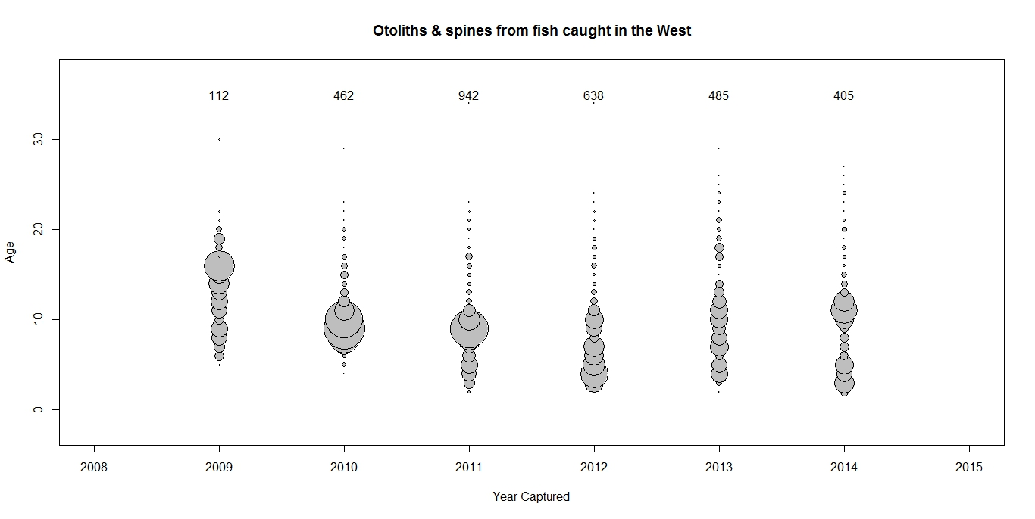

Figure 1. Bubble plot representing the direct ages form spines and otoliths collected in the west.

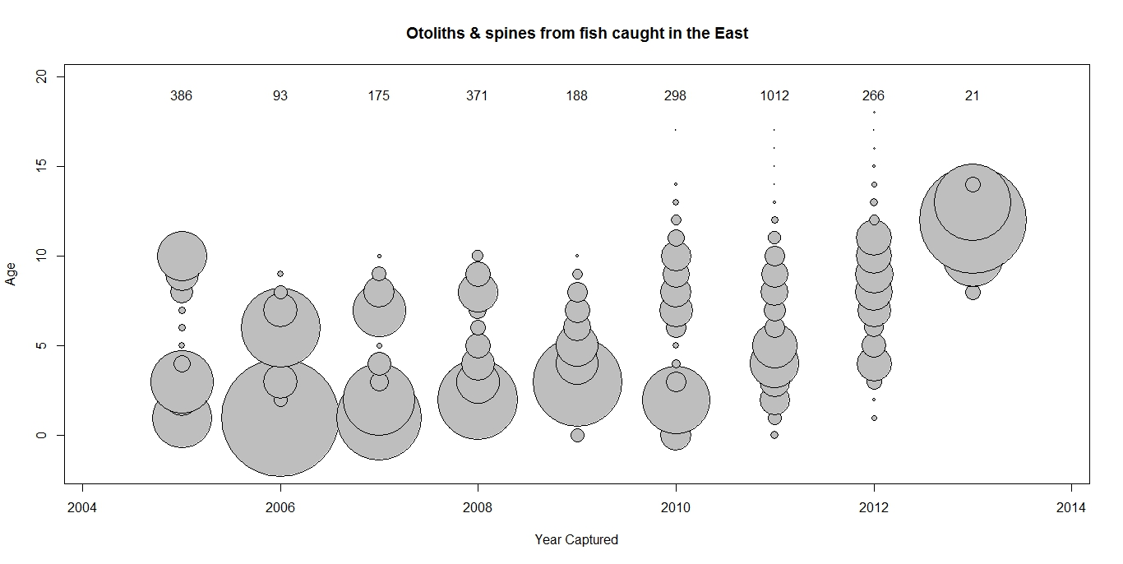

Figure 2. Bubble plot representing the direct ages form spines and otoliths collected in the east.

**Figure 3.** A comparison of catch at size (2005-2013) in the western management zone with the distribution of the samples collected from the same area (2009-2015).

**Figure 4.** A comparison of catch at size (2005-2013) in the eastern management zone with the distribution of the samples collected from the same area (2005-2014).

Figure 5. A comparison of catch at size (2005-2013) in the Mediterranean management zone with the distribution of the samples collected from the same area (2005-2014).

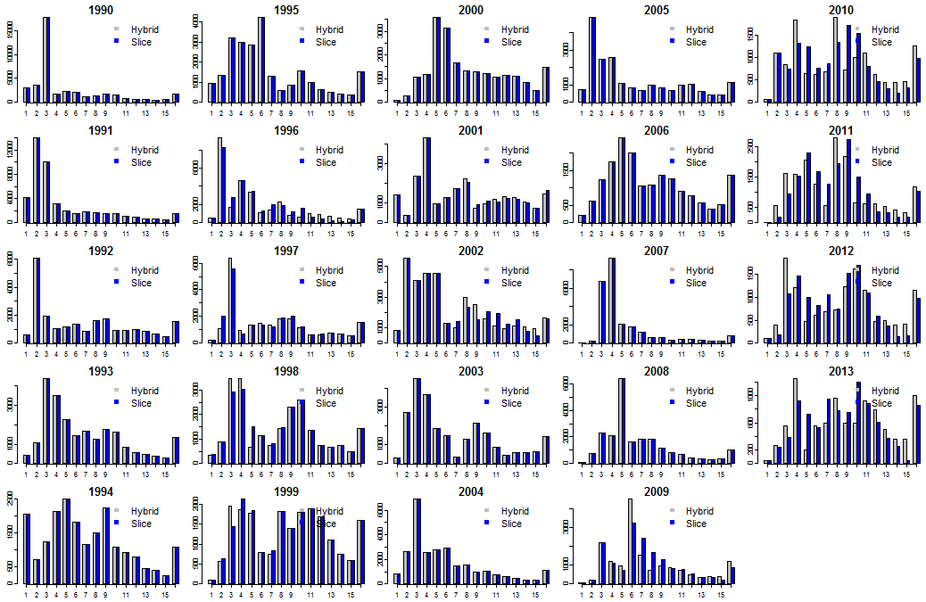

**Figure 6.** Comparison of CAA obtained from the hybrid method versus age-slicing for WBFT for years 1990-2013, where the CAA differs between slicing and the hybrid method when annual ALK information is available (primarily 2009-2013).

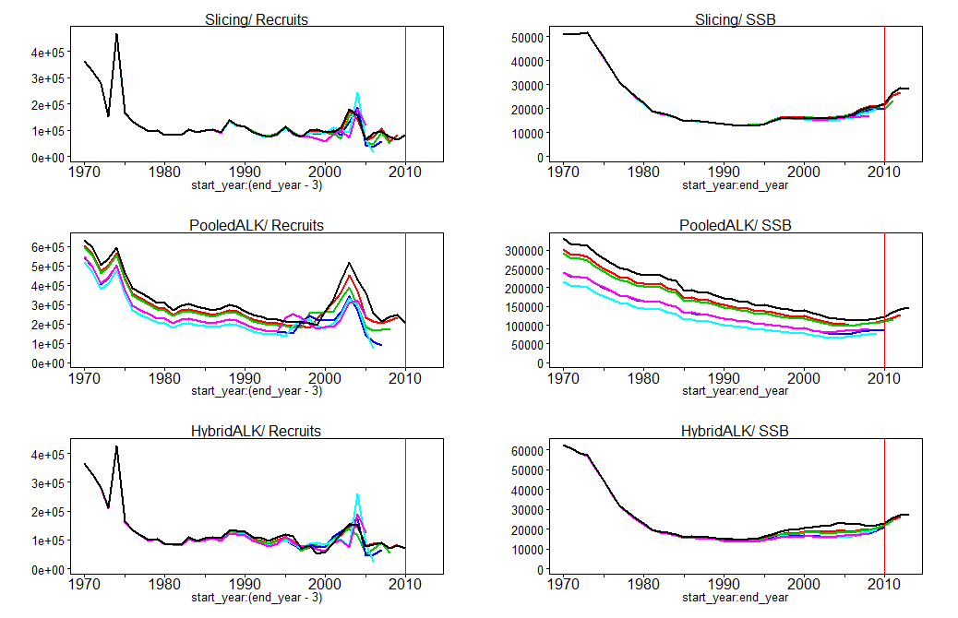

**Figure 7**. Retrospective VPA results between the three methods of obtaining CAA for WBFT. The red line indicates the year (2010) that most ageing data enters in the models for the hybrid method.

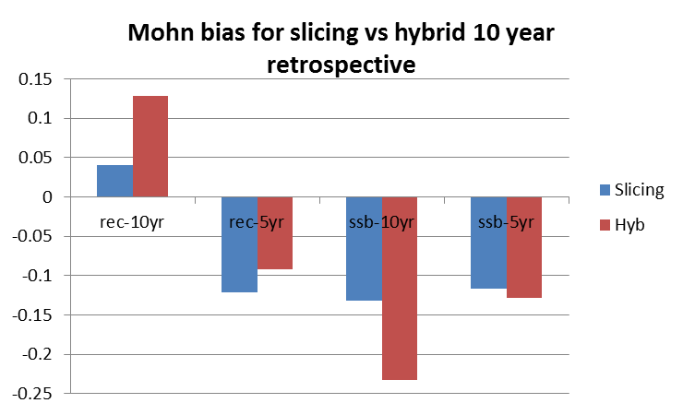

**Figure 8**. Mohn retrospective bias for 10 year vs 5 year retrospectives comparing slicing to the hybrid method of obtaining CAA.