**DISCUSSION ON THE AREA STRATIFICATION IN THE NORTH ATLANTIC FOR BLUEFIN TUNA MIXING MODEL**

A. Kimoto[1], Y. Takeuchi1 and T. Itoh1

*SUMMARY*

*Currently there is an ongoing work to develop a new model incorporating mixing for Management Strategy Evaluation (MSE) framework under the ICCAT GBYP. The area stratification is the fundamental to the model development. In some studies, the area stratification presented in the mixing workshop in 2001 or its modified one were referred as if SCRS already authorized it. However according to the mixing workshop report, the area division was not fully agreed, and seemed to focus only on the east- or west-ward directed migration. In addition, that presented area division differs from the one used for the Japanese longline indices in the northeast Atlantic. Since 2001, more new biological knowledge became available through variety of studies, and the fishing pattern by Japanese longline has been changed. This document provides possible new area stratification, while the current management boundary between the East and the West Atlantic is retained. It is the right time for the full re-examination of this area division with accumulated knowledge in the light of both biological and fisheries aspects.*

*KEYWORDS*

*Bluefin tuna, stock assessment, mixing, area stratification*

Since 1980 Atlantic Bluefin tuna has been separately managed with the management boundary of the 45W. However, through tagging studies and later by otolith micro constituent analyses, and genetic studies (well summarized in the bluefin meeting on biological parameters review, Anon. 2014), it has been frequently noted that these two stocks are not geographically distinct and rather mixed in the North Atlantic. In the independent advice on the scientific basis of management for Atlantic bluefin tuna conducted by the National Research Council, the Committee recommended to include mixing of Atlantic bluefin tuna between eastern and western fishing grounds in the new stock assessment (NRC. 1994). The ICCAT bluefin tuna working group (WG) also noted the importance of incorporating the mixing into the stock assessment. The WG also emphasized that it would take some time to complete the process of model development, verification and robustness testing. In the model development, one of critical agenda would be the area stratifications.

Currently there is an ongoing work to develop a new model incorporating mixing for Management Strategy Evaluation (MSE) framework under ICCAT Atlantic wide research programme for Bluefin Tuna (GBYP). As described above, the area stratification is the fundamental to the model development. It is a solid fact that the Gulf of Mexico and Mediterranean Sea as two spawning areas should naturally be distinguished. The WG needs to carefully examine spatial (and if necessary temporal) stratifications especially in the northeast Atlantic. This is because that region is the current main fishing area for Japanese longline vessels. The catch effort data of the fleets are the source of Japanese longline abundance indices that are probably the most important data for the new stock assessment model of Atlantic bluefin tuna as well as current stock assessment. In order to achieve their ambitious goal, collaboration and cooperation between the task leader and scientists at WG are necessary. This work would also help to improve assessment models and the scientific advice on stock status.

There can be several candidates for the area division in the central North Atlantic. Japanese longline indices used their unique area stratification which reflects their fisheries characteristics (Figure 1). In 2001, the ICCAT SCRS workshop on Bluefin mixing (Anon. 2002) was held, area division was discussed and a figure (Figure 2) was put in the report. The MAST model (Taylor *et al*. 2011, Figure 3) referred the area division of the mixing workshop. Kerr *et al*. (2015) further revised the area division (Figure 4) based on the division used by MAST model. Data preparatory meeting in March 2015 (Anon. 2015b) discussed and proposed its further revision (Figure 5) primary intended for electronic tag data reporting format for future stock assessment based on Kerr’s study.

The area division in Figure 2 in the mixing workshop report (Anon. 2002) or its modifications listed above differs from one used for the Japanese standardized CPUEs in the East Atlantic (east of 45W, Figure 1). Future use of different area division there inevitably needs to be also applied for the area division of Japanese longline CPUE standardization there. As the area definition of Japanese longline in the East Atlantic is optimized for its fishing area and season, application of different area division to Japanese longline in that area should carefully be examined if it is warrant.

Before detailed examination is done, it would be very useful to note that, although the six areas very frequently referred from the mixing workshop report was often recognized as if SCRS already authorized it, according to the mixing workshop report (see footnote[2]), the area division was presented by some interested parties as their preference, and was not fully agreed by the WG except the Gulf of Mexico and Mediterranean. Since then, more new biological knowledge became available through variety of studies. In addition, the fishing pattern by Japanese longline has been changed (Kimoto *et al*. 2011b). These new and updated information should be incorporated into the consideration of the area stratification. It is the right time for the full re-examination of this area division.

With the new knowledge accumulated during 15 years since the workshop, the explanations for each boundary are not fully supported now. At the workshop the area division seemed to focus only on the east- or west-ward directed migration. For the stratum 3 in Figure 2, we have more electronic tags' results, and bluefin catch are observed continuously across 30W by Japanese longline since 1990 (Figure 6). Tag release/recovery information might be limited to this area, thus it is not clear if this separated area is worthwhile to keep.

With regards to the strata 4 or 5 in Figure 2, the mixing workshop report unfortunately did not provide the reason of separation. In the east of 45W, two Japanese indices were provided in the north or south of 40N, which have been used in the stock assessment (Anon. 2015a). Japanese fishery characteristics were fully considered for the 40N boundary and each area stratification (Kimoto *et al*. 2015). Japanese longliners developed the current main fishing ground off Iceland early 1990 (Kimoto *et al*. 2011b). Since then they start to fish bluefin in August in the northeast Atlantic. The fishing area in the northeast Atlantic shifts towards west in Oct-Dec (40°-60°N) and in January. After operating in the West Atlantic in winter, then come back to the area close to Mediterranean in spring. Thus we provide two CPUEs in the north/south 40N, their main seasons are Aug- Feb (north or 40N) or March-July (south of 40N). The boundary between strata 4 and 5 would be better to shift southwards, if separated these strata are necessary.

Taking into account above information, possible new area stratification can be suggested while the current management boundary between the East and the West Atlantic is retained. This suggested area division can fully incorporate the characteristics of Japanese longline fisheries (fishing area and season) for bluefin tuna in the North Atlantic for its abundance indices. Furthermore it matches information of the distribution pattern of bluefin tuna revealed through archival tagging studies. It is recommended to revise the area stratification with new and updated information collected after the workshop in 2001, in the light of both biological and fisheries aspects.

In the stock assessment for the east Atlantic Bluefin tuna, the results relied on the two Japanese CPUEs. If the currently proposed area stratification in Figure 5 needed to be kept for future Atlantic Bluefin stock assessment and its management strategy evaluations (MSE), the trends of the CPUEs possibly be affected and we may face with inconsistencies to the current stock assessments. The WG would need carefully review the currently proposed 8 area stratifications before the WG engage new stock assessment and MSE.

**References**

Anon. 2002. Report of the 2010 ICCAT Workshop on Bluefin Mixing (Madrid, Spain, September 3 to 7, 2001). ICCAT, Col. Vol. Sci. Pap., 54(2): 261-352.

Anon. 2014. Report of the 2013 Bluefin Meeting on Biological Parameters Review (Tenerife, Spain - May 7-13, 2013). ICCAT, Col. Vol. Sci. Pap., 70(1): 1-159.

Anon. 2015a. Report of the 2014 Atlantic Bluefin Tuna Stock Assessment Session (Madrid, Spain - September 22-27, 2014). ICCAT, Col. Vol. Sci. Pap., 71(2): 604-691.

Anon. 2015b. Report of the 2015 ICCAT Bluefin Data Preparatory Meeting (Madrid, Spain - March 2-6, 2015).

Kerr L. A., Cadrin S. X., Secor D. H., and Taylor N. 2011. Evaluating the effect of Atlantic bluefin tuna movement on the perception of stock units. ICCAT, Col. Vol. Sci. Pap., 71(4): 1660-1682.

Kimoto A., Itoh T., and Miyake M., P. 2011a. Updated Standardized bluefin CPUE from the Japanese longline fishery in the Atlantic up to 2009. ICCAT, Col. Vol. Sci. Pap., 66(2): 956-983.

Kimoto A., Itoh T., and Miyake M., P. 2011b. Overview of the Japanese longline fishery for bluefin tuna in the Atlantic Ocean, up to 2009. ICCAT, Col. Vol. Sci. Pap., 66(3): 1116-1135.

Kimoto A., Takeuchi Y., and Itoh T. 2015. Updated standardized bluefin CPUE from the Japanese longline fishery in the Atlantic to 2014 fishing year. 71(2): 1059-1097.

NRC (National Research Council). 1994. An Assessment of Atlantic Bluefin Tuna. National Academy Press: Washington, D.C. 148 pp.

Taylor N. G., McAllister M. K., Lawson G. L., Carruthers T, and Block B. A. 2011. Atlantic Bluefin Tuna: A Novel Multistock Spatial Model for Assessing Population Biomass. PLoS ONE., 6(12).

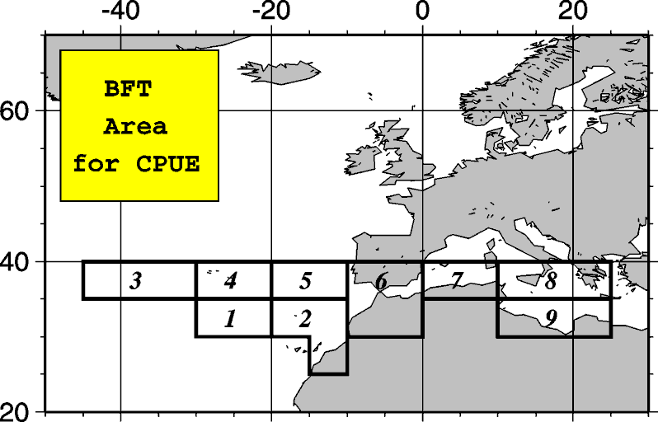

Figure 1. Area stratification used in the CPUE standardization for the West and the Northeast (north of 40N) Atlantic (left panel, Kimoto *et al*. 2015), and East Atlantic (south of 40N and Mediterranean) (right panel, Kimoto *et al*. 2011a).

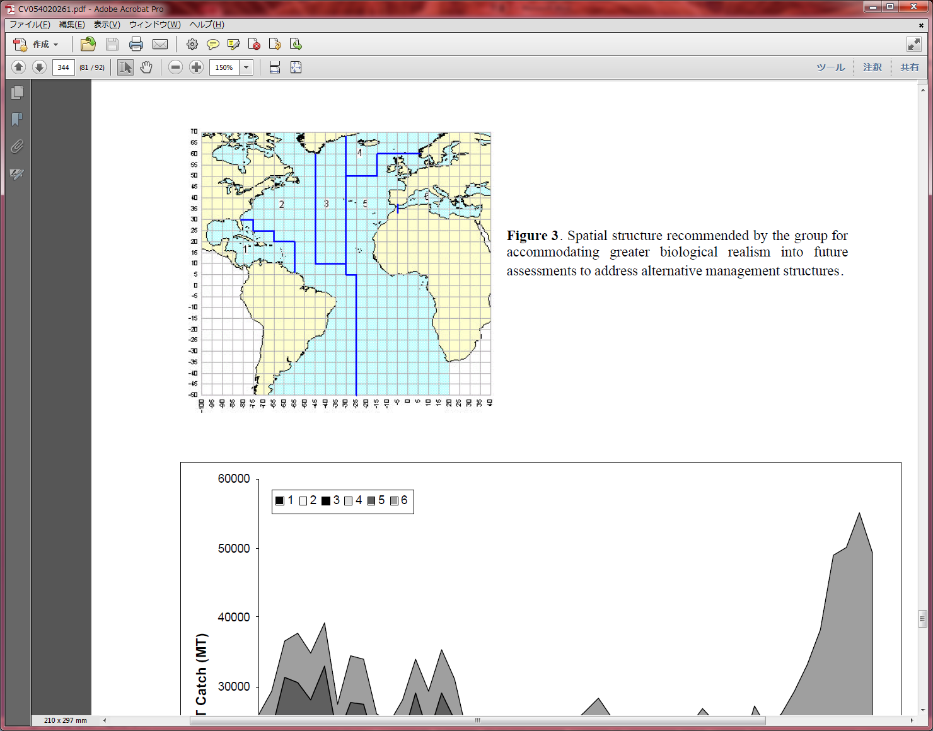

Figure 2. The area stratification for bluefin mixing model presented in the ICCAT workshop on bluefin mixing in 2001 as the preference of some interested parties (Anon. 2002.).

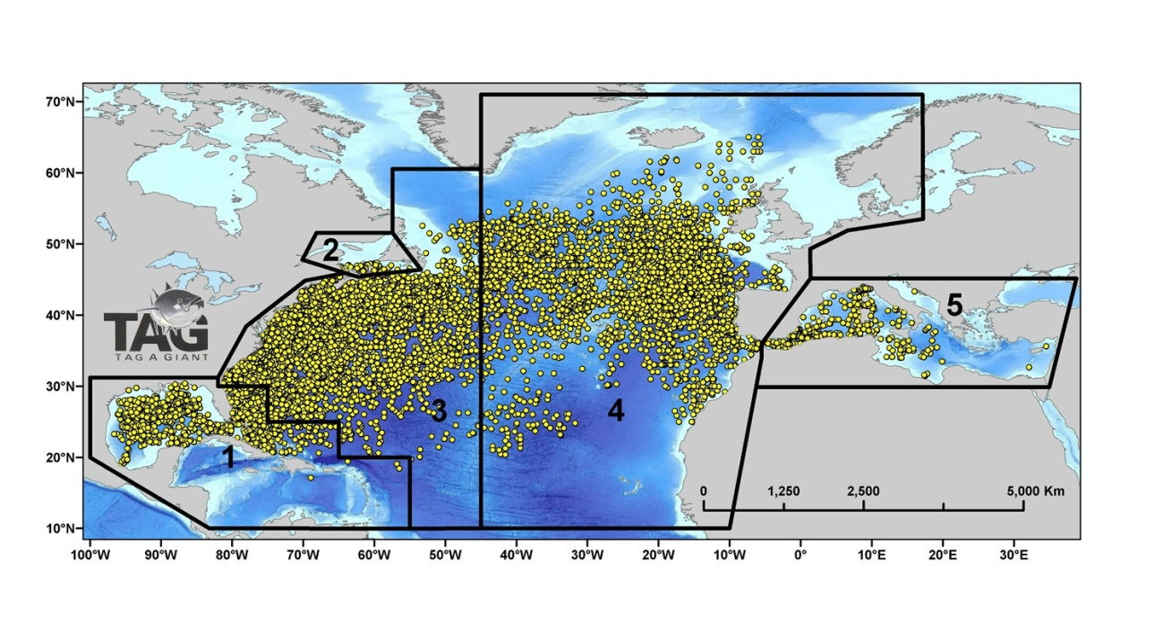

Figure 3. The area stratification for bluefin mixing model used in MAST model (Taylor *et al*. 2011).

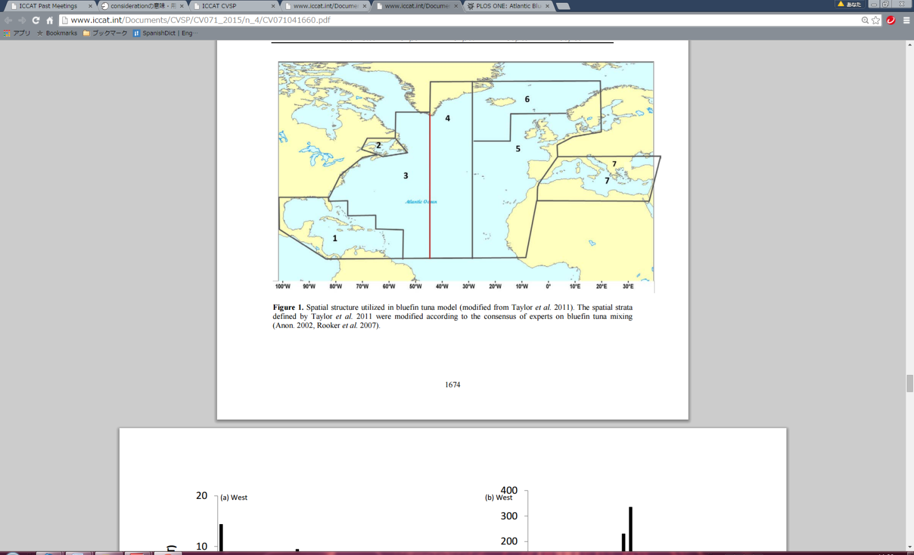

Figure 4. The area stratification for bluefin mixing model used in Kerr et al. 2011.

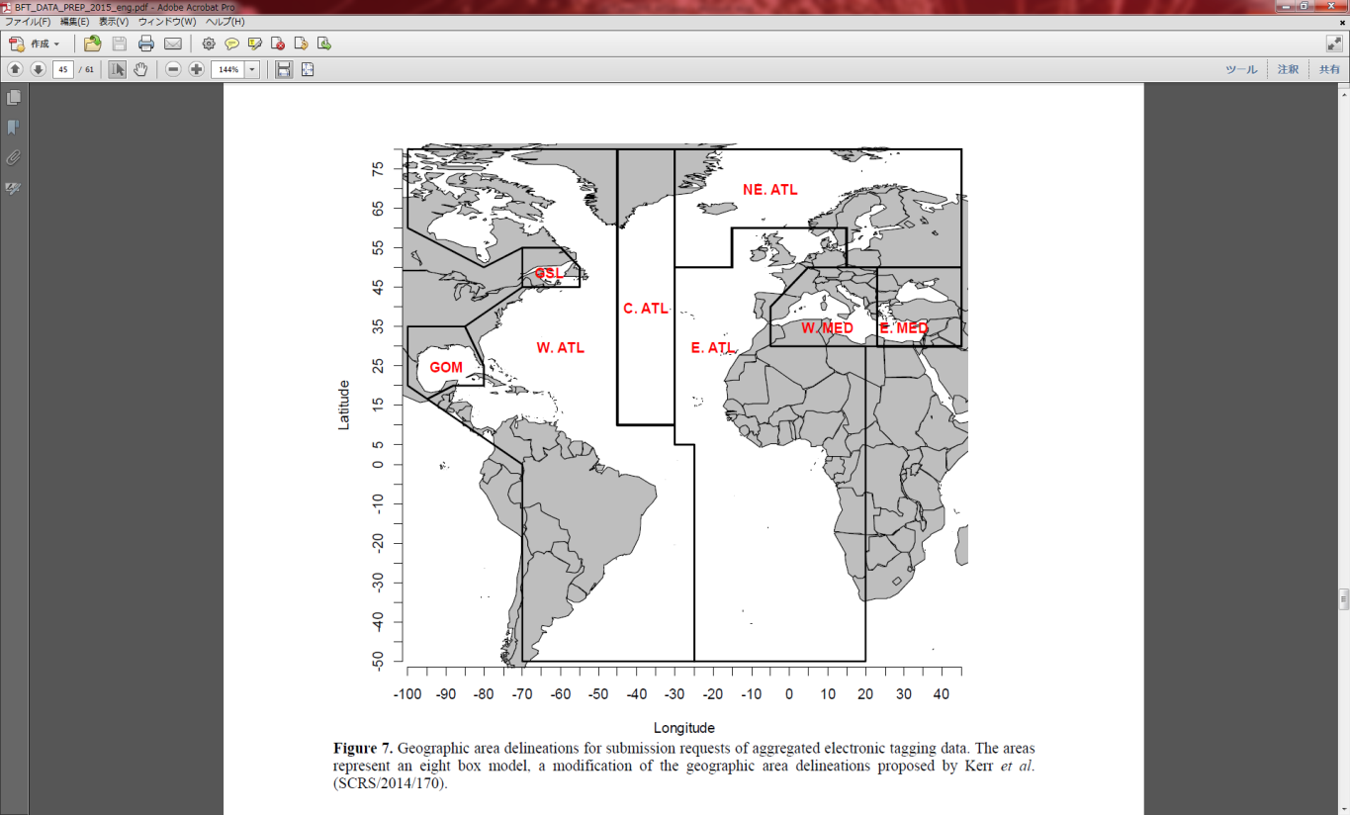

Figure 5. The area stratification for submission requests of aggregated electronic tagging data suggested at the bluefin data preparatory meeting in March 2015 (Anon. 2015b).

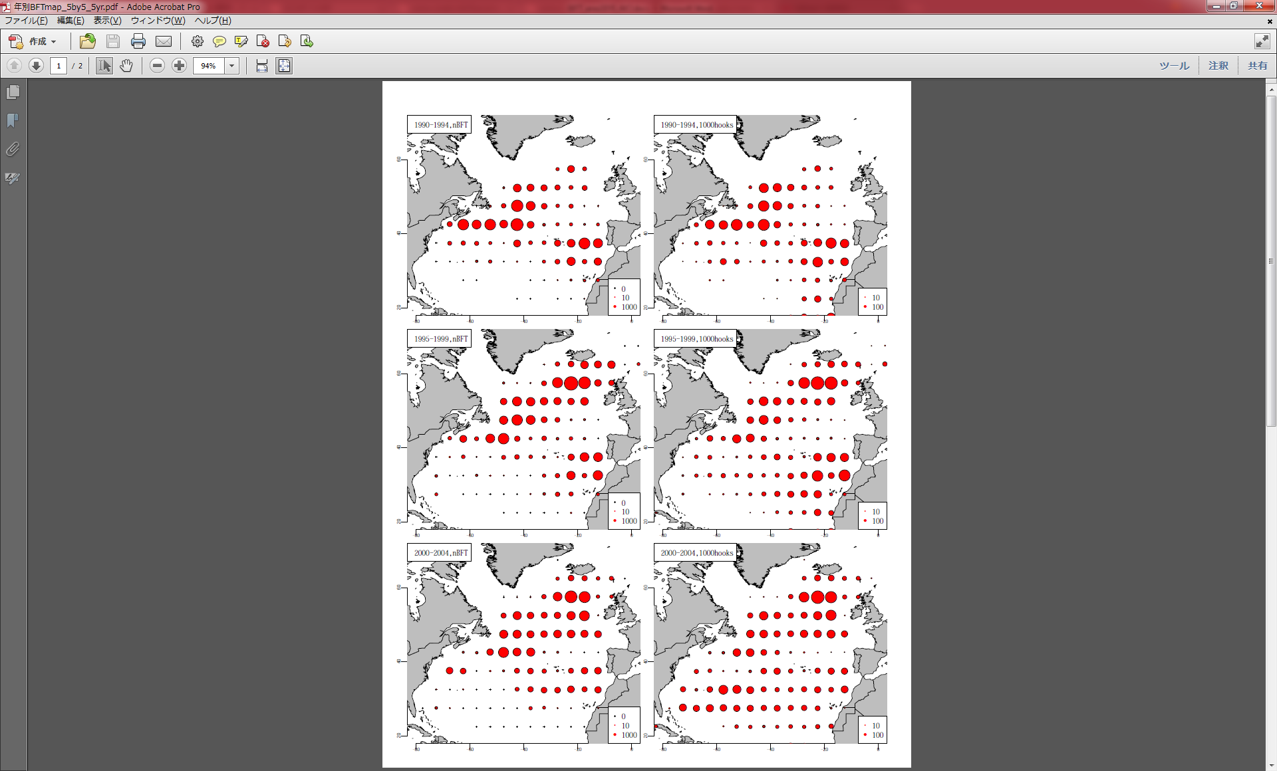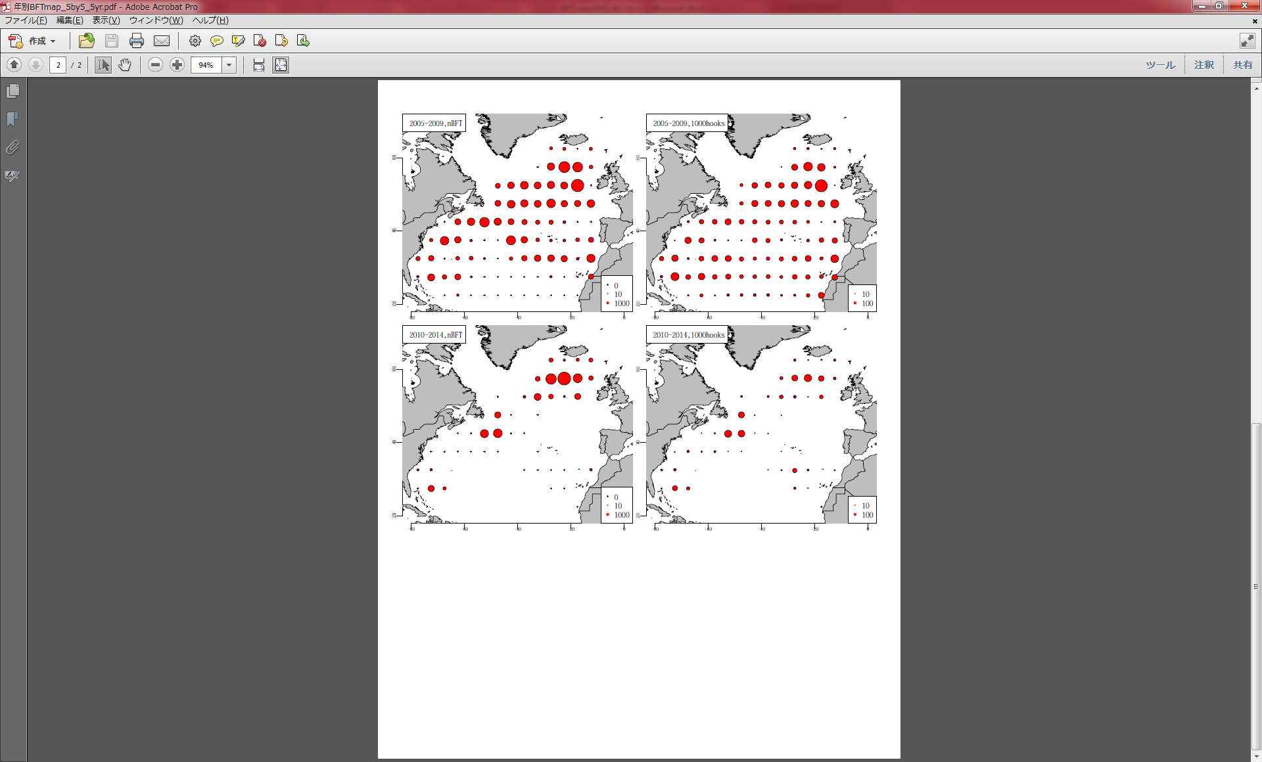

Figure 6. Historical distribution of bluefin tuna catch (in numbers) and effort (in 1000 hooks) for Japanese longline since 1990.

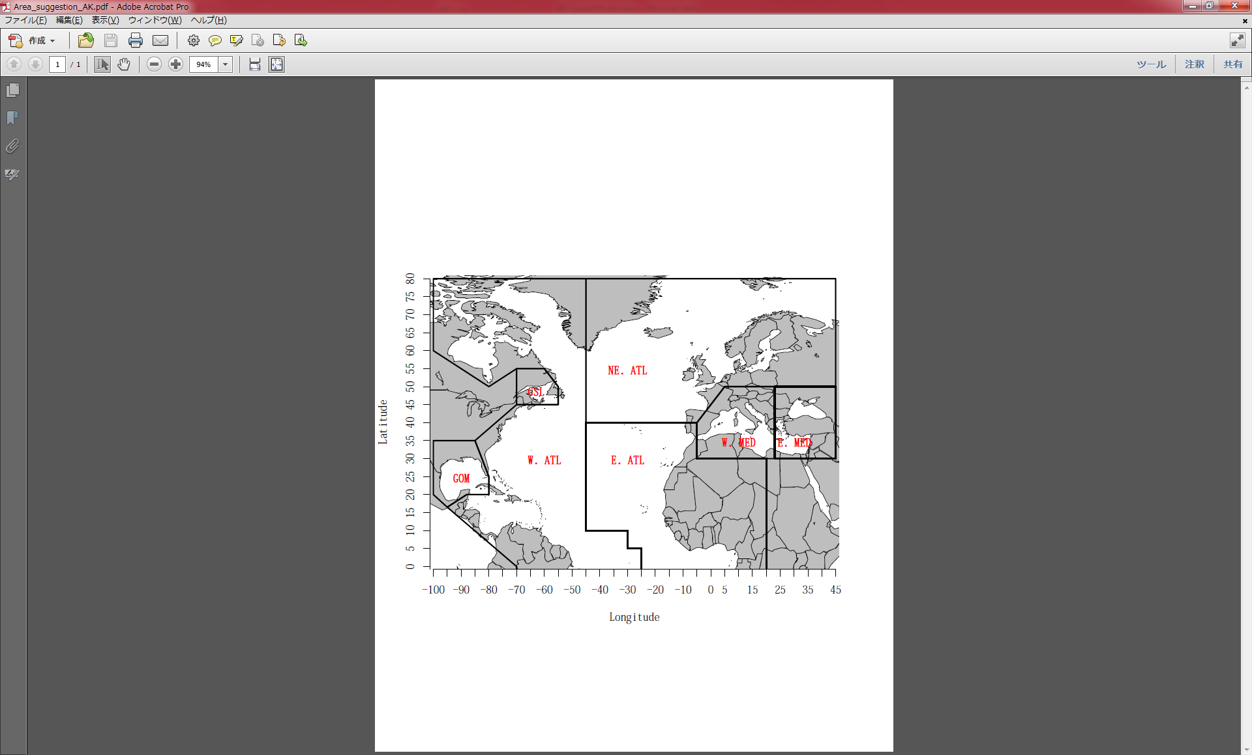

Figure 7. A possible new area stratification for the bluefin mixing model suggested in this document .

1. NRIFSF. 5-7-1, Orido, Shimizu, Shizuoka, 424-8633. Japan. aikimoto@affrc.go.jp
2. Mixing Workshop Report (Anon. 2002): in the pages 278 and 279. “A consensus was more difficult to reach regarding the appropriate spatial divisions, but it was agreed that the number of divisions should probably not exceed five or six, from the viewpoint of practicality given the current data availability. Several interested parties then presented their preferences and the common features were incorporated into six strata. All agreed that the Gulf of Mexico (spatial stratum 1, which includes the Straits of Florida and Caribbean Sea) and Mediterranean Sea (spatial stratum 6) should be distinguished. The current operational East/West management boundary was retained except that it was shifted northwards in the vicinity of Brazil to include the unique oceanographic features of the region and associated large catches during the 1960's as part of the western zone. A distinct Central Atlantic zone including the region off the Flemish Cap (spatial stratum 3) was also specified in recognition of the fact that few of the fish tagged in the west with electronic tags moved beyond 30 degrees west. Spatial stratum 4 includes the Northeastern Atlantic region from south of Iceland extending northeastward to include waters off the Norwegian coast; while stratum 5 includes the remainder of the Eastern Atlantic. The group identified the spatial structureas a starting point for use in organizing data for preliminary model development and parameterization research. ”.