DRAFT ANNEX
Version 19-5: July 30 2019

SPECIFICATIONS FOR MSE TRIALS FOR BLUEFIN TUNA IN THE NORTH ATLANTIC
CONTENTS

1. BASIC CONCEPTS AND STOCK STRUCTURE 3
I) Spatial definitions 3
Baseline 3
Alternative low priority future options 4
II) Stock mixing 4
Baseline 4
2. PAST DATA AVAILABLE 4
I) Raw data 4
II) Analysed data 8
III) Assumptions 11
3. BASIC OPERATING MODEL DYNAMICS 15
I) Overview 15
II) Equations 15
The following selections apply for the Base Case OM: 20
Alternative options 21
III) Fleet structure and exploitation history 21
Base Case 21
Alternative options 21
4. MANAGEMENT OPTIONS 21
I) Spatial strata for which TACs are set 22
Base Case 22
Alternative options 22
II) Management period length for the setting of TACs 22
Base Case 22
Alternative options 22
III) Upper limits on TACs 22
IV) Minimum extent of TAC change 23
Base Case 23
Alternative options 23
V) Maximum extent of TAC change 23
Base Case 23
Alternative options 23
VI) Technical measures 24
5. RECRUITMENT AND DISTRIBUTION SCENARIOS IN THE OPERATING MODEL 24
I) Western stock 24
II) Eastern stock 24
III) Future regime shifts 25
Western stock 25
Eastern stock 25
Base Case 25
IV) Possible future spatial distributional changes (movement) 25
6. FUTURE CATCHES 25
Base Case 25
Alternative options 26
7. GENERATION OF FUTURE DATA FOR INPUT TO CANDIDATE MANAGEMENT PROCEDURES 26
I) Base Case suggestions 27
West 27
East+Med 27
II) Alternative options 27
III) Relationships with abundance 28
IV) Statistical properties 28
Base Case 28
Alternative options 28
Other aspects 28
8. PARAMETERS AND CONDITIONING OF OPERATING MODELS 29
I) Fixed parameters 29
II) Estimated parameters 29
III) Characterising uncertainty 34
Base Case 34
Alternative options 34
9. TRIAL SPECIFICATIONS 35
A. Interim Reference set 35
B. Robustness trials 36
10. PERFORMANCE MEASURES/STATISTICS 38
I) Summary measures/statistics 38
II) Summary plots 39
III) Level of reporting 39
Base Case 39
Alternative options 39
i. Spatial strata 41
Alternative low priority future options 41
ii. Stock mixing 41
Possible alternative options 41

BASIC CONCEPTS AND STOCK STRUCTURE

This first item intends to cover only the broadest overview issues. More detailed technical specifications are included under subsequent items.

In this document the term ‘Stock’ refers to fish originating from a natal spawning region either in the Mediterranean (East Stock) or the Gulf of Mexico / Slope Sea (West Stock). Hence ‘Eastern’ and ‘Western’ may be used to describe fish according to their stock of origin, for example ‘Eastern fish’ are fish that spawn in the Mediterranean.

In this document the term ‘area’ refers to the traditional East and West management areas (‘East Area’ and ‘West Area’).

The term ‘strata’ refers to seven smaller spatial definitions (described in Figure 1.1).

The two management areas are delineated by 45 degrees west in the North Atlantic. The West area includes strata 1-3, the East area includes strata 4-7.

The model is divided in to four time-steps per year (quarters): (1) Jan-Mar, (2) Apr – Jun, (3) July – Sept, (4) Oct-Dec. The term spatio-temporal strata refers to one of the seven spatial stratum in a particular year and quarter (e.g. stratum 6, quarter 3 in 1981).

Eastern fish (of the East Stock) can migrate to the West Area (management area) and Western fish (of the West Stock) can migrate to the East Area (management area). However, it is assumed that no Eastern fish enters the Gulf of Mexico and no Western fish enters the Mediterranean.

Spatial definitions
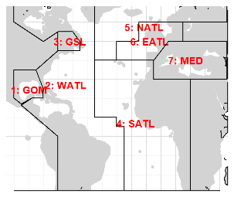
Figure 1.1. The seven spatial strata.

Baseline

The 7-stratum model of Figure 1.1 (the reported electronic tagging data and the stock of origin data do not have sufficient resolution to divide the Mediterranean stratum).

Alternative low priority future options

The MAST model (Taylor et al. 2011) which has strata similar to Figure 1.1, but where strata 4-6 are merged into a single East Atlantic stratum.

Stock mixing

B
A

Figure 1.2. Mixing hypotheses suggested by Anon, (2014) and Arrizabalaga et al. (2019).
(A) A two stock model with no sub-stock structure.
(B) A two stock model with sub-stock structure.
(C) A complex 2+ stock model.
C

Baseline

A two-stock model similar to Figure 1.2A but adhering to the spatial structure of Figure 1.1. The mixing proportions are determined by the stock of origin data (genetics and otolith chemistry).

PAST DATA AVAILABLE

Table 2.5 provides an overview of the data that may be used to condition operating models for Atlantic bluefin tuna. The table indicates those data that have been gathered, those that are currently available and those that have already been used in conditioning operating models.

Raw data

Operating models are fitted to the fishery, tagging and survey data that are currently available (Table 2.5, field ‘Used in OM’). Currently, the operating model is fitted to ICCAT Task II landings data scaled upwards to annual Task I landings.

The ICCAT catch-at-size dataset was used to estimate gear selectivity for each of the baseline fleet types. The operating models incorporate 17 fishing fleets, as described in Table 3.1.

The pop-off satellite (PSAT) archival tag data from several sources (NOAA, DFO, WWF, AZTI, UNIMAR, IEO, UCA, FEDERCOOPESCA, COMBIOMA, GBYP, IFREMER, Stanford University) have been compiled by NOAA (M. Lauretta) and used to estimate movements among spatial strata. Tag tracks were provided by the seven spatial strata. These are converted to strata-quarter records by the following rule: for each tag, its strata position in a quarter is assigned as the strata in which the tag spent the most days during that quarter (Fig 2.1A).

In the model developed for movement, quarterly transitions between strata depend on stock (Eastern or Western) and age class (ages 1-4, 5-8, and 9+). Only tags that have either corresponding weight or length data can be assigned an age class (by cohort slicing) and can be used by the model. Similarly, only those tags that have entered either the Gulf of Mexico or the Mediterranean can be assigned a stock of origin. All other tags are removed and not used in the conditioning of operating models. The exception are tags released by AZTI in the Bay of Biscay, which are assumed to correspond to be of Eastern Stock of origin. By November 2018 data from 1,307 tags were available for the model, however only #### of these tags could be used for to provide transition information as the others lacked either age-class assignment or stock of origin assignment. This resulted in a total of 598 quarterly electronic tag transitions, or around 1/5 of all quarterly transitions, being used by the model (Fig 2.1B).

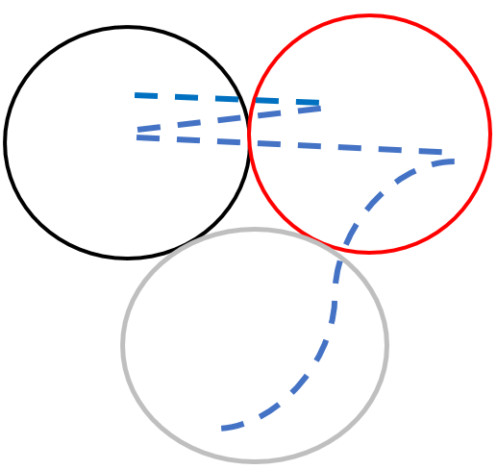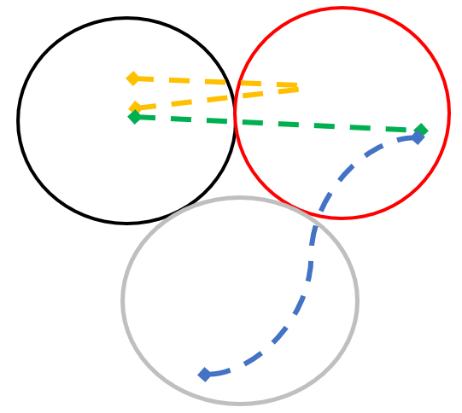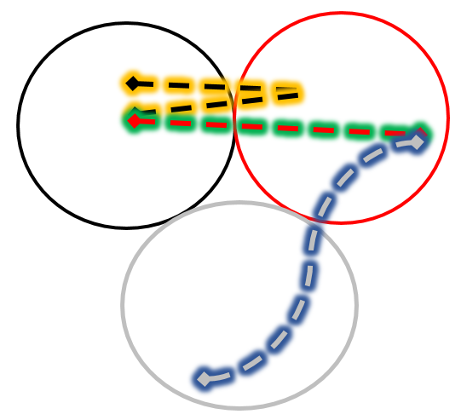
B
C
A

Figure 2.1A. Electronic tag data was used to inform quarterly transitions. This figure explains how each tag was allocated to an strata (represented as black, red, and gray circles) and quarter. The blue dashed line in (A) represents one electronic tag track. In (B) this track is spliced into quarters (here the track is split into different quarters through different colours 1=yellow, 2=green, 3=blue). Then (C) the track for each quarter was allocated to a spatio-temporal strata (a spatial strata, quarter, age class). This was done by counting the days (days are represented as dashes in these figures) the tag spent in each spatio-temporal strata; the strata where the tag spent the most days in a quarter was determined to be the location for the tag in that quarter.

All age classes
Age class 1
Age class 2

Age class 3

Figure 2.1B. Observed electronic tag transitions among spatial strata by stock and quarter. These are tags present in a particular stratum (row) that move to a stratum (column) in the following quarter. The solid line represents strata available to the Western Stock (i.e. excludes the MED), the dashed line represents strata available to the Eastern Stock (i.e. excludes the GOM). The shaded diagonal cells highlight tags that did not move strata from one quarter to the next. Age class 1 consists of 1-4 year olds; age class 2 consists of 5-8 year olds; age class 3 consists of 9+ year olds. These transitions are derived from 1307 individual tags.

Catch data provide scale to stock assessments. It follows that spatial stock of origin data are necessary to estimate the relative magnitude of the various stocks in a multi-stock model (to correctly assign catches to stock). Currently the model uses stock of origin data derived from the otolith microchemistry and genetic research of AZTI, UMCES, GBYP, and DFO (Table 2.5 and Table 2.6A-D).

There is uncertainty in regard to the stock of origin of bluefin tuna catches in the South Atlantic that were reported prior to 1970. For the Base Case, these are dealt with in the same way as all other catches: they are assigned to the strata of Figure 1.1 by uprating Task II catches (that are reported spatially) to the annual Task I catch data.

Analysed data

The operating models are also fitted to standardized CPUE indices (Table 2.1) and a range of fishery-independent indices (Table 2.2). These fishery-independent indices include a Western larval index in the Gulf of Mexico (Lamkin et al., 2014) an Eastern larval index in the western Mediterranean (Ingram et al. 2015) and two aerial surveys in the Mediterranean (French Aerial survey: Rouyer et al 2018).

In order to predict observed catch at size from model predicted catch at age, operating models made use of an inverse age-at-length key (probability of length class given age). These keys are developed from the base-case stock assessment growth curves for Eastern and Western stocks and a coefficient of variation (variability in length at age) determined by the growth model of Allioud et al. (2017).

Table 2.1. The standardized CPUE indices used to fit the operating models (many of which are used in stock assessments previously conducted by ICCAT). Many of these indices are available after 2016 but the operating model only uses data to 2016 due to the unavailability of CATDIS uprated catch data for more recent years at the time of model conditioning. The right-most column indicates the fishing fleets used to assign selectivity to each CPUE index; the fishing fleets are described in Table 3.1.
Flag | Gear | Details | Fleet (selectivity) assigned
Spain | Baitboat | 1952-2006, Q3, E Atl | 3: BBold
Spain / France | Baitboat | 2007-2014, Q3, E Atl | 3: BBold
Morocco / Spain | Trap | 1981-2011, Q2, SE Atl | 12: TPold
Morocco / Portugal | Trap | 2012-2016, Q2, SE Atl | 13: TPnew
Japan | Longline | 1975-2009, Q2, SE Atl | 2: LLJPN
Japan | Longline | 1990-2009, Q4, NE Atl | 2: LLJPN
Japan | Longline | 2010-2016, Q4, NE Atl | 2: LLJPN
US (66cm - 114cm) | Rod and reel | 1993-2016, Q3, W Atl | 15: RRUSAFS (62.5 – 112.5cm)
US (115cm - 144cm) | Rod and reel | 1993-2016, Q3, W Atl | 15: RRUSAFS (112.5 – 137.5cm)
US (177cm+) | Rod and reel | 1993-2016, Q3, W Atl | 16: RRUSAFB (162.5 – 387.5cm)
US (<145cm) | Rod and reel | 1980-1992 (gap in 1984), Q3, W Atl | 15: RRUSAFS (37.5 – 137.5cm)
US (195cm+) | Rod and reel | 1983-1992, Q3, W Atl | 16: RRUSAFB (187.5-387.5cm)
US | Longline | 1987-1991, Q2, GOM | 1: LLOTH
US | Longline | 1992-2016, Q2, GOM | 1: LLOTH
Japan | Longline | 1974-1980, Q2, GOM | 2: LLJPN
Japan | Longline | 1976-2009, Q4, W Atl | 2: LLJPN
Japan | Longline | 2010-2016, Q4, W Atl | 18: LLJPNnew
Canada GSL | Rod and reel | 1984-2016, Q3, GSL | 14: RRCAN
Canada SWNS | Rod and reel | 1988-2016, Q3, W Atl | 14: RRCAN

Table 2.2. Fishery-independent indices used in the fitting of operating models.
Type | Details | Infers:
French aerial survey | 2000-2003, 2009-2016 (gap in 2013), Q3, Med | Vulnerable biomass according to the RRUSAFS selectivity
Western Med Larval survey | 2001-2015 (gaps in 2006-2011), Q2, Med | SSB
Aerial survey – GBYP* | 2010-2015 (gaps in 2012, 2014, and 2016), Q2, Med | SSB
Canadian acoustic survey | 1994-2016, Q3, GSL | SSB
USA Larval survey | 1977-2016 (gaps in 1979-1980, and 1985), Q2, GOM | SSB
* Only the Balearic component is used (because there are problems with consistency regarding patchy or low biomass inference in other regions surveyed)

In order to initialize the spatial-seasonal operating model at a plausible distribution of vulnerable biomass, a so-called “master index” was derived. This index allows a standardized effort to be derived for the catch series of any fleet simplifying the estimation of fishing mortality rates (for more detail see SCRS/2019/XXX). The only role of the master index is to initialize the model and it effectively plays no role in the likelihood.

The default master index (‘Assess-Tag’) was derived using electronic tagging data and East / West area trends estimated by the most recent Stock Synthesis assessments.

The electronic tagging data of known stock of origin p (fish that have been in either the Gulf of Mexico or the Mediterranean) were aggregated by quarter s, stratum-from a, stratum-to k, into a matrix T. Each row of this matrix was normalized to form a Markov movement matrix V such that the values summed to 1:

$V_{p, s, a,k}=\frac{T_{p, s, a,k}}{\sum_{k}{T_{p, s, a,k}}}$ (2.1)

For each stock, an even initial spatial distribution was repeatedly multiplied though this quarterly movement matrix until it stabilized on an asymptotic quarterly distribution D_{p,s,a.}

Then using the estimates of historical spawning stock biomass B from the most recent East and West Stock Synthesis stock assessments (assuming that the area trends of assessments reflect the stock trends), a predicted spawning biomass by season and stratum $\hat{B}$was calculated:

${\hat{B}}_{p, s, a,y}=D_{p, s, a}B_{p,y}$ (2.2)

This was summed over the two stocks (Eastern and Western) to get total biomass $\overline{B}$ that was assumed proportional to the master index I (red line Figure 2.2):

$I_{s,a,y}^{Assess-Tag}≈{\overline{B}}_{s, a,y}=\sum_{p}{{\hat{B}}_{p, s, a,y}}$ (2.3)

Other approaches to index derivation were used to demonstrate that it has little impact on final model estimates (SCRS/2019/XXX) including derivation by GLM and assuming a flat, constant trend over time and space (Figure 2.2).
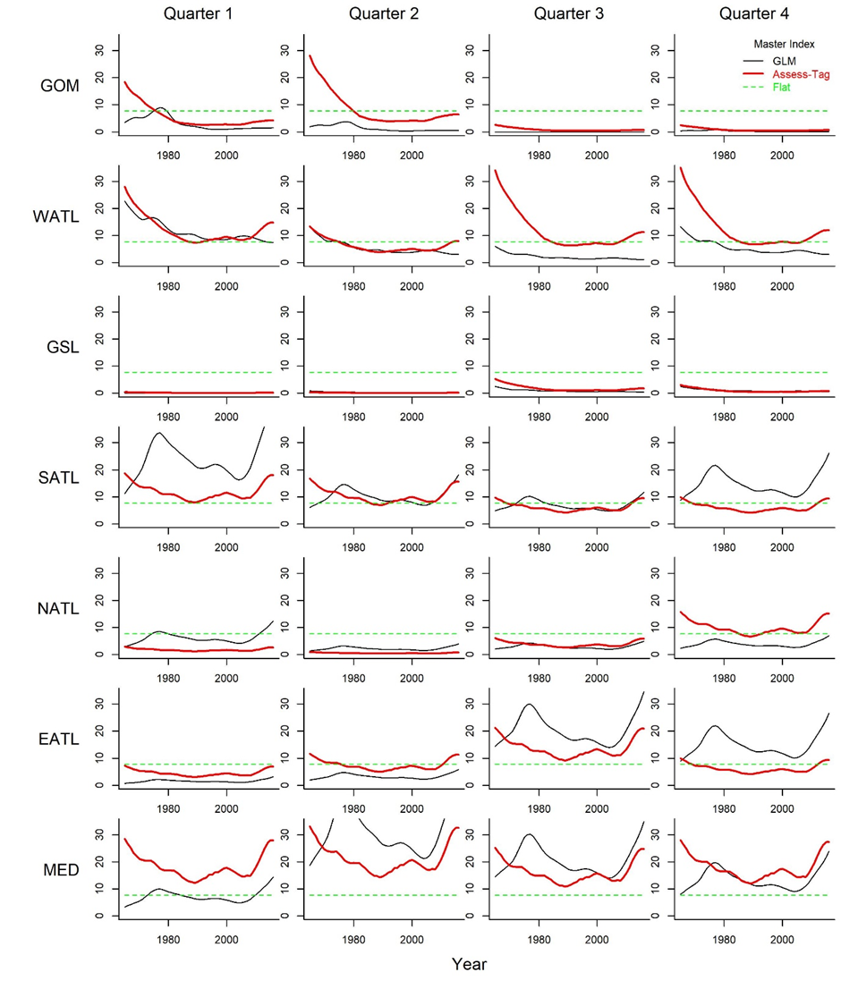

Figure 2.2. The seasonal / spatial master indices derived by various methods including by generalized linear modelling (GLM, Carruthers 2018) and ‘Assess-Tag’ described above and in (SCRS/2019/XXX). The master index is used as a way to initialize the model and has essentially no other role in model fitting. The default index used in OM conditioning is Assess-Tag described above but results have been shown to be invariant to the choice of master index (SCRS/2019/XXX). The magnitude of all points are relative and have an arbitrary mean value that is the green dashed line.

Assumptions

The following are the default assumptions made in the model. Some of them may be relaxed in the robustness trials.

The age-length key is static and not adjusted according to fishing mortality rate and length selectivity of fishing.

CPUE indices are considered to be proportional to vulnerable (i.e. selectivity-weighted) biomass.

Larval indices are assumed to be proportional to spawning stock biomass in the stratum in which they were collected in contrast to stock-wide spawning stock biomass (for scenarios where the two are not proportional). Non-larval fishery-independent indices may mirror fleet selectivities or are assumed to be proportional to spawning stock biomass.

Fish found in the GOM stratum are assumed to be all Western Stock fish (i.e. the model assumes that close to zero Eastern Stock fish move to the GOM). Fish found the MED stratum are all assumed to be Eastern Stock fish.

Table 2.5. Overview of data that may (includes all available years, not just those used in conditioning) be used to inform operating models for Atlantic bluefin tuna (available online here). Cells shaded green reflect sources for which data are available (‘Collab’, the Technical Team TT, or the ICCAT secretariat) and whether data that are available have also been used in conditioning preliminary operating models (‘used in OM?’). Conventional tags are used only in defining the stock specific areas of the GOM and Mediterranean.
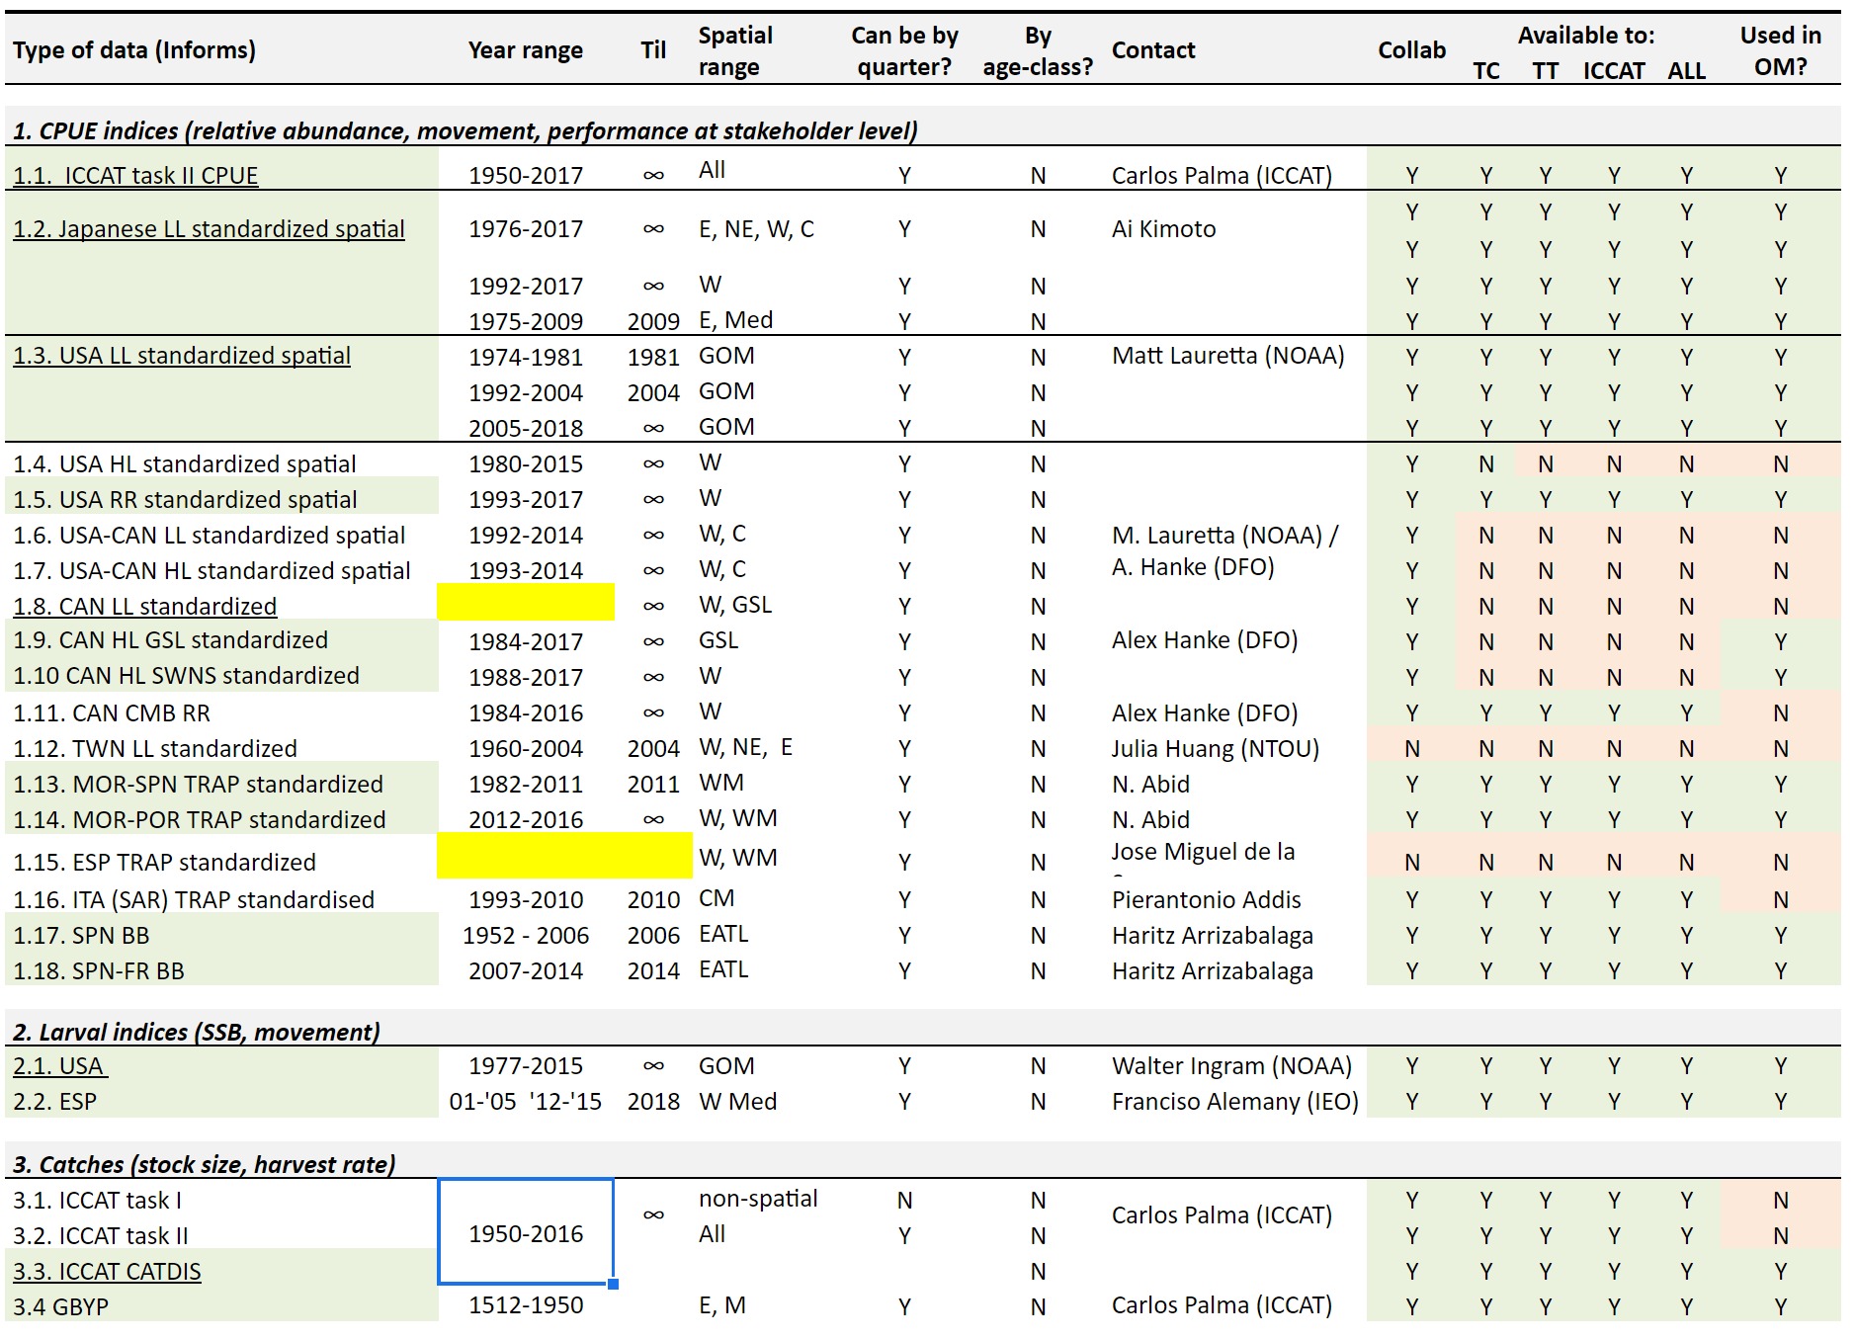

Table 2.5 continued.
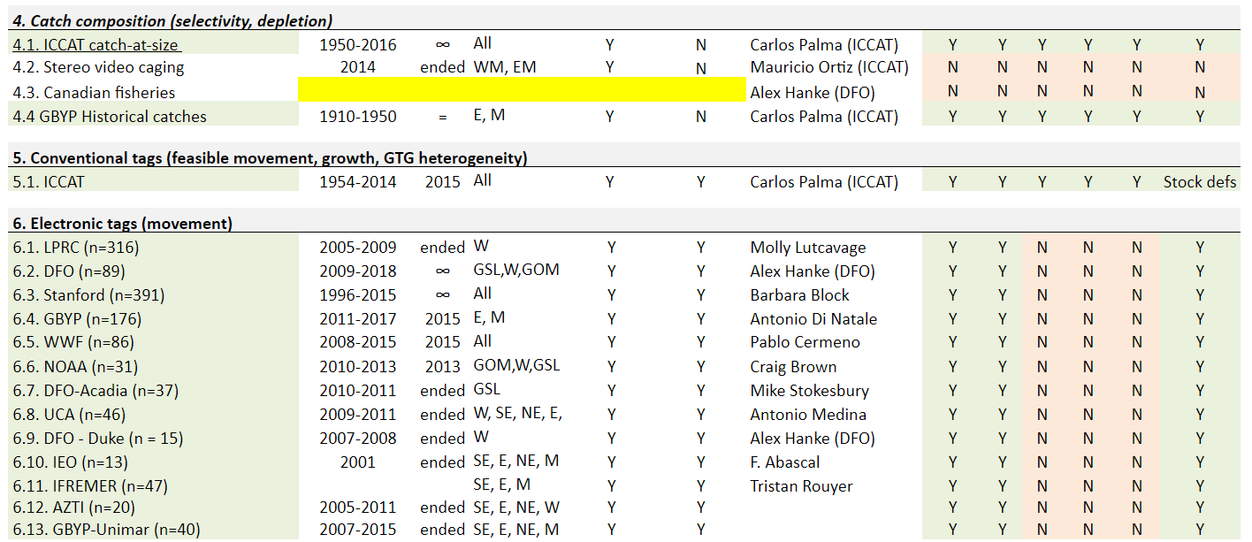
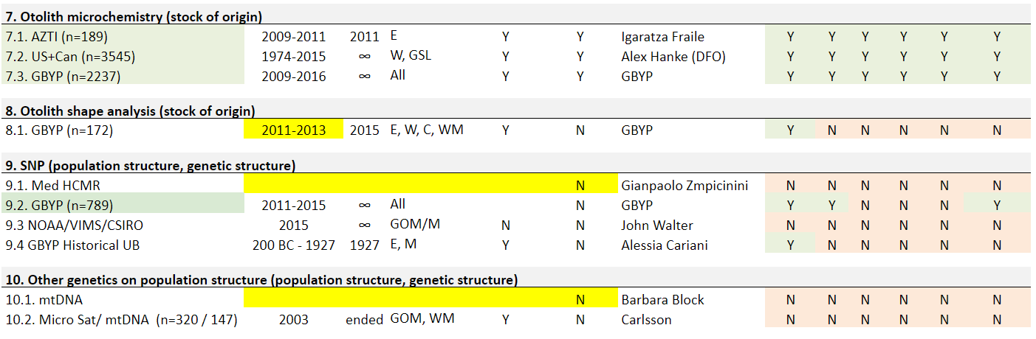
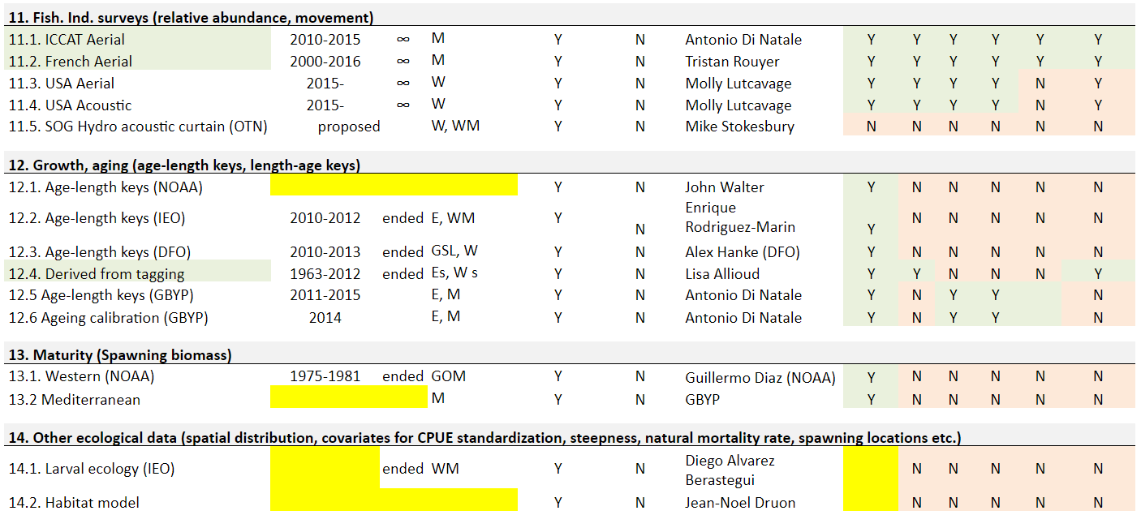

Table 2.6A. Summary of the observed assignment scores from otolith microchemistry and genetics datasets (labelled ‘Probability Eastern Origin’ from dataset ‘Joint East West Mixing Data 15042019.csv’). Each point in those datasets consists of an observed assignment score, i.e. the assigned probability (between 0% and 100%) of that point being of Eastern origin. The table summarises (median, 5th and 95th percentiles) the observed assignment scores in each spatial strata. A mixture model is applied to these data (SCR/2018/133) to generate stock-of-origin “pseudo-observations” that are used in the conditioning of the operating models..

Table 2.6B. The sample size of stock of origin data by type (otolith micro-chemistry and genetics) and the 7 spatial strata. Note that data are available for the Gulf of Mexico and the Mediterranean but these were not used directly in the operating model but were used to identify a western and eastern stock signature for interpreting the assignment data in a mixture model (Carruthers and Butterworth 2018).

Table 2.6C. Seasonal-spatial coverage of the otolith chemistry assignment data (that have covariate information regarding age class and quarter; from dataset ‘Joint East West Mixing Data 15042019.csv’). Orange shaded cells represent quarter-strata for which there are no stock of origin data available for the mixture model approach (i.e. no otolith chemistry data were available for these spatio-temporal strata).

Table 2.6D. Seasonal-spatial coverage of the genetics assignment data (that have covariate information regarding age class and season; from dataset ‘Joint East West Mixing Data 15042019.csv’). Orange shaded cells represent quarter-strata for which there are no stock of origin data available for the mixture model approach (i.e. no genetic data were available for these spatio-temporal strata). Note that data are available for the Gulf of Mexico and the Mediterranean but these were not used in the operating model.

BASIC OPERATING MODEL DYNAMICS

Overview

The current operating model (modifiable multi-stock model, ‘M3’ v5.0) is based on conventional age-structured accounting (e.g. Quinn and Deriso 1999, Chapter 8) which is common to stock assessment models such as Stock Synthesis 3 (Methot and Wetzel 2013), CASAL (Bull et al. 2012), Multifan-CL (Fournier et al. 1998) and iSCAM (Martell 2015).

The standard age-structured equations are complicated somewhat by the quarterly temporal structure, in which age incrementation and recruitment occur in a particular quarter. In this version of the model, spawning occurs for all stocks in quarter 2 (spawning in the Mediterranean for the Eastern stock and Gulf of Mexico and West Atlantic strata for the Western stock is thought to occur after a period of movement early in the year).

Equations

Numbers of individuals N, for stock s, in a model year y, in the first quarter m=1, age class a, and stratum r are calculated from individuals that have moved $\vec{N}$, in the previous year, final quarter (m=4)of the same age class, subject to combined natural and fishing mortality rate Z:

$N_{s,y,m=1,a,r}={\vec{N}}_{s,y-1,m=4,a,r}∙ e^{-Z_{s,y-1,m=4,a,r}}$ (3.1)

Where total mortality rate is calculated from annual natural mortality rate M, divided by the fraction of the year represented by the quarter t_{m} (i.e. 0.25), and fishing mortality rate F (per quarter), summed over all fleets f:

$Z_{s,y,m,a,r}={t_{m} M}_{s,a}+\sum_{f}{F_{s,y, m,a,r,f}}$ (3.2)
Fishing mortality rate at age is derived from fishing mortality rate by length class F_{l} and the conditional probability of fish being in length class l, given age a (an inverse age-length key, LAK):

$F_{s,y,m,a,r,f}=\sum_{l}{F_{l,y,m,l,r,f}}∙{LAK}_{s,a,l}$ (3.3)

The fishing mortality rate at length is calculated from an index of fishing mortality rate I (calculated from dividing the value of the catch for that fleet by the value of the ‘master index’ in that year-quarter-stratum – a simple way to preserve scale), an estimated catchability coefficient q, a quarter and strata specific deviation F_{D} (constrained to mean 1) a quarter, strata and year specific deviation F_{A} (constrained to mean 1), and a length selectivity function s, by fleet:

$F_{l,y,m,l,r,f}=q_{f}∙I_{y,m,rf}∙F_{D,m,r}∙F_{A,y,m,r}∙s_{f,l}$ (3.4)

For most fleets, selectivity is calculated by a double-normal equation using the mean length L_{l} for a length class l:

$s_{f,l}=\left\{\begin{matrix}2^{-{\left(\frac{L_{l}-l_{max,f}}{{σ_{f,A}}^{2}}\right)}^{2}} & L_{l}≤l_{max,f} \\ 2^{-{\left(\frac{L_{l}-l_{max,f}}{{σ_{f,D}}^{2}}\right)}^{2}} & L_{l}>l_{max,f}\end{matrix}\right.$ (3.5)

where l_{max,f} is the fleet-specific length at maximum vulnerability, and σ_{f,A} and σ_{f,D} are parameters controlling the width of the ascending and descending limbs of the selectivity, respectively. Large values of σ_{f,D} approximate a ‘flat topped’ logistic selectivity.

To ensure numerical stability and prevent the estimation of unrealistic values, the length at maximum vulnerability l_{max} and the two standard deviation parameters, σ_{A} and σ_{D} were derived from estimated parameters θ_{lmax}, θ_{A} and θ_{D}, respectively, and the longest length class L_{nl} (mean length of the maximum length class):

lmax=ρL+(ρU-ρL )Lnl∙120+1920∙eθlmax1+eθlmax (3.6)

$σ_{A}=2 l_{max}∙\left(\frac{e^{θ_{A}}}{1+e^{θ_{A}}}\right)$ (3.7)

σD=(ρU-ρL )Lnl∙eθD (3.8)

The ρ terms are the upper (ρ_{U}) and lower bounds (ρ_{L}) (lengths) for the truncation of the length selectivity function and are half a length increment (12.5cm) wider than the highest and lowest observed length categories for each fleet, respectively.

These parameterizations allow for unbounded estimation of the θ parameters. Each of these parameters has an extremely weak prior prescribed which allows the model to converge in extreme cases where there is little or no data to inform a parameter. For example, if data suggest there is asymptotic (near logistic) selectivity, l_{max} tends to L_{nl} and there are no data above this length class to estimate the descending limb parameter $θ_{D}$.

In general, age or length structured models are much better informed by the data if at least one fleet selectivity either has the descending limb parameters fixed or can be assumed to have the form of a logistic (‘flat topped’) ogive. Without such a constraint, the declining frequency of older/longer classes can be attributed to either mortality rates or dome-shaped selectivity and this parameter confounding can lead to poorly defined estimation and numerical instability during fitting. In this case at least one fleet is assumed to have a 2-parameter logistic form for its selectivity function:

$s_{f,l}=\frac{1}{1+e^{{\left(l_{inf,f}-L_{l}\right)}/{σ_{S,f}}}}$ (3.9)

where l_{inf} is the inflection point (the length at 50% vulnerability) and σ_{S} is a slope parameter controlling how steeply selectivity increases with length. Similarly to the 3-parameter double-normal function, there is a reparameterization to ensure numerical stability during fitting:

linf=ρL+(ρU-ρL )Lnl∙120+1720∙eθlinf1+eθlinf (3.10)
σS=(ρU-ρL )Lnl∙0.005+0.11∙eθS1+eθS (3.11)

Again, the estimation of the θ parameters can be unbounded but the inflection point.

All selectivity θ parameters are assigned a vague normal prior with mean 0.

In the spawning quarter ms, and spawning strata rs, ages advance by one and recruitment occurs.
The model includes a plus group which is the final age class n_{a}:

$N_{s,y,ms,a,r}=\left\{\begin{aligned}{\vec{N}}_{s,y,ms-1,a-1,r}∙ e^{-Z_{s,y,ms-1,a-1,r}} \\ {\vec{N}}_{s,y,ms-1,a-1,r}∙ e^{-Z_{s,y,ms-1,a-1,r}}+{\vec{N}}_{s,y,ms,a,r}∙ e^{-Z_{s,y,ms,a,r}}\end{aligned} \begin{matrix}1<a<n_{a} \\ a=n_{a}\end{matrix}\right.$ (3.12)

Recruitment is calculated based on stock-wide spawning stock biomass and recruits enter the model in proportion to spawning stock biomass in the spawning strata (Gulf of Mexico and West Atlantic for the West stock, the Mediterranean for the East stock) in the spawning season (quarter 2 for both stocks). The model does not force all the SSB back to the spawning stratum at the spawning time. It is not possible to estimate recruitment for only those fish that exist in the spawning stratum in the spawning season as that leads to numerical instability and can result in unrealistic estimates of recruits per spawner.
Recruitment (fish in their first year) is calculated from a Beverton-Holt stock recruitment relationship with fixed steepness:

$N_{s,y,ms,1,rs}=exp⁡\left(ε_{R,s,y}-σ_{R,s}^{2}/2\right)∙\frac{\frac{4}{5}∙{h_{s}∙R}_{0,s}{∙SSB}_{s,y}}{\frac{1}{5}{∙SpR}_{s}∙ R_{0,s}∙\left(1-h_{s}\right)+\left(h_{s}-0.2\right)∙{SSB}_{s,y}}$ (3.13)

where ε_{R} is a random normal deviate with variance $σ_{R}^{2}$ and $σ_{R}^{2}$/2 is the bias correction to ensure that on average over years, recruitment strengths have a mean of 1.

Spawning stock biomass SSB, is calculated from moved stock numbers in the previous year, and quarter prior to spawning quarter ms, weight of individuals at age w, and the fraction of individuals mature at age m:

${SSB}_{s,y}=\sum_{a}{\sum_{r}{{\vec{N}}_{s,y,ms-1,a,r}∙ e^{-Z_{s,y,ms-1,a,r}}}}∙w_{s,a}∙m_{s,a}$ (3.14)

where weight is calculated from length at age l:

$w_{s,a}=α_{s}∙l_{s,a}^{β_{s}}$ (3.15)

and the fraction mature at age is assumed to be a logistic function of age with parameters for the age at 50% maturity γ, and slope ϑ:

$m_{s,a}=1/{\left(1+e^{{\left(γ_{s}-a\right)}/{ϑ_{s}}}\right)}$ (3.16)

Stock numbers for quarters that are not the first quarter of the year and are not the spawning quarter are calculated:

$N_{s,y,m,a,r}={\vec{N}}_{s,y,m-1,a,r}∙ e^{-Z_{s,y,m-1,a,r}}$ (3.17)

In each quarter, before mortality and recruitment, fish are moved according to an age-class-specific Markov transition matrix mov that represents the probability of a fish moving from statum k to stratum r at the end of the quarter m:

${\vec{N}}_{s,y,m,a,r}=\sum_{k}{N_{s,y,m,a,k}∙{mov}_{s,m,a,k,r}}$ (3.18)

The movement matrix is calculated from a log-space matrix lnmov and a logit model to ensure each row (k) sums to 1:

${mov}_{s,m,a,k,r}={e^{{lnmov}_{s,m,a,k,r}}}/{\sum_{r}{e^{{lnmov}_{s,m,a,k,r}}}}$ (3.19)

Size/age stratification for movement models will initially be attempted for three age groups: 1-4, 5-8 and 9+ years (this will be kept the same for the Western Atlantic and the Eastern Atlantic/Mediterranean, but should be re-evaluated for the East as future data become available).

Due to the relatively incomplete coverage (over stocks, quarters and spatial strata) of electronic tagging data to be able to explicitly inform individual movements to/from each strata, a parsimonious gravity modelling approach was used to estimate movement (e.g. MAST Taylor et al. 2011, Carruthers et al. 2010). For a movement matrix of dimension n_{strata} x n_{strata}, rather than estimating a parameter for each possible transition (which would result in (n_{strata} -1) x n_{strata} parameters), the gravity model estimates only the attractivity g of each strata (n_{strata}-1 parameters) identically for all strata of departure. Unmodified, this is simply a spatial distribution model, mixing all tagged fish in every time step and redistributing them by fractions over all strata. There is however evidence of stock viscosity, where fish remain in the same strata over several time steps. This is particularly the case for spawning strata in spawning seasons, for example. The gravity model incorporates a single additional parameter per movement matrix (resulting in n_{strata} parameters per movement matrix) that is added to the positive diagonal (probability of staying in the same strata, i.e. when the ‘from strata’ k is the same as the ‘to strata’ r) to make fish more likely to stay in proportion to the attractivity of that strata:

${lnmov}_{s,m,2,k,r}=\left\{ \begin{matrix}g_{s,m,2,r} & k≠r \\ g_{s,m,2,r}+e^{v_{m,2}} & k=r\end{matrix}\right.$ (3.20)

In this equation, the subscript “2” refers to the second movement age-class (ages 5-8). Since the lnmov variables are used in a logit model to determine fractional probabilities across all strata, the estimation is indeterminate if all g terms are freely estimated. To solve this, the first strata in each row of the g terms is fixed at 0 (e.g. g_{s,m,2,k,1} = 0). This means that for each stock s, season m and age class a, the movement matrix (n_{strata} x n_{strata}) requires the estimation of n_{strata} parameters (n_{strata} -1 g parameters and one v parameter). The g and v parameters are assigned weak normal priors with mean 0 (with very low weight). Previous studies (Carruthers et al. 2011) have demonstrated that the simplified gravity modelling approach is estimable from spatial abundance indices alone, which means that the estimation will not fail for spatio-temporal strata that are sparse in terms of electronic tagging data.

For the two other movement age classes (a=1 and a=3), the g parameters and v parameters are calculated as penalized deviations from the age class 2 parameters. This allows the model to borrow information across the age classes easily when data are sparse (e.g. if data are available for age class 2 only, age classes 1 and 3 use age class 2 parameters; if age class 1 data only are available, age classes 2 and 3 borrow age class 1 parameters). For example, for age class 1:

$g_{s,m,1,r}=g_{s,m,2,r}+θ_{G,s,m,1,r}$ (3.21)

Note that due to data sparsity it is not possible to estimate stock-specific viscosity v. It is still possible for East and West stocks to have radically different spatial distributions as determined by the g terms, but their seasonal propensity to stay in a given stratum is linked for the two stocks.

Movements from a stratum k to a stratum r that are considered to be implausible (e.g. from the Eastern Mediterranean to the Gulf of Mexico) are assigned a large negative number (essentially zero movement) in the corresponding cells in these movement matrices. For each stratum k, from which individuals can move, one value is assigned zero and all other possible movements are assigned an estimated parameter ψ (since rows must sum to 1, there is one less degree of freedom):

${lnmov}_{s,m,a,k,r}=\left\{\begin{matrix}1e^{-10} \\ 0 \\ Ψ_{s,m,k,r}\end{matrix} \begin{matrix}no movement from k to r \\ first assigned possible movement from k to r \\ other possible movements from k to r\end{matrix}\right.$ (3.22)

Compared with spatially aggregated models, initialization is more complex for spatial models, particularly those that need to accommodate seasonal movement by age and may include regional spawning and recruitment. The equilibrium unfished age structure / spatial distribution cannot be calculated analytically. For any set of model parameters it is necessary to determine these numerically by iteratively multiplying an initial guess of age structure and spatial distribution by the movement matrix. The solution used here is to iterate the transition equations above given a fishing mortality rate averaged over the first five years of model predictions, until the spatial distribution of stock numbers converges for each of the quarters.

Prior to this iterative process an initial guess at the spatial and age structure of stock numbers $\hat{N}$ is made based on the movement matrix and natural mortality rate at age M:

${\hat{N}}_{s,m,a,r}={\overline{R}}_{s}∙e^{-\sum_{1}^{a-1}{M_{s,a}}}∙\sum_{k}{\frac{1}{n_{r}}{∙mov}_{s,m,a,k,r}}$ (3.23)

In the years 1864 to 1964, the model does not predict catches from estimates of fishing mortality rate and instead this historical ‘spool-up’ phase removes catches from the model without error. These historical catches are reconstructed for each age-class and spatio-temporal strata (SCRS/2019/XXX). This is intended to account for meaningful landings prior to 1965 that are not accompanied by sufficient length composition data to estimate fleet selectivities in a conventional statistical catch-at-length model that is applied for the years 1965 – 2016.

Stock numbers for historical years (e.g. 1864-1964) are calculated using the same equations as model years (e.g. 1965 – 2016). The exception is that rather than using effort data, selectivities and an inverse age-length key, fishing mortality rate at age is derived from mean historical catches and the assumption is made that these are taken without error in the middle of the time step with natural mortality rate occurring both before and after fishing:

$F_{i=1,m,a,r,f}=\left\{\begin{matrix}-log\left(1-\frac{{\overline{C}}_{m,a,r,f}}{{\hat{N}}_{s,m,a,r}e^{-\left({t_{m} M}_{s,a}\right)/2}}\right) & i=1 \\ -log\left(1-\frac{{\overline{C}}_{m,a,r,f}}{{\vec{N}}_{s,y-1,n_{m},a,r }e^{-\left({t_{m} M}_{s,a}\right)/2}}\right) & i>1, m=1 \\ -log\left(1-\frac{{\overline{C}}_{m,a,r,f}}{{\vec{N}}_{s,y,m-1,a,r}e^{-\left({t_{m} M}_{s,a}\right)/2}}\right) & i>1, m>1\end{matrix}\right.$ (3.24)

where i=1 is the first year and calculates fishing mortality rates from asymptotic numbers $\hat{N}$.

Under MSE projections (after 2016), total allowable catches (TAC) by East-West management area are allocated according to a fleet-specific allocation A_{f} and the predicted seasonal-spatial-age composition of catches ${\hat{V}}_{s,y,m,a,r,f}$

$C_{s,y,m,a,r,f}=\left\{\begin{matrix}{{\hat{V}}_{s,y,m,a,r,f,west} ∙A_{f,west} ∙TAC}_{y,west} & r≤3 \\ {{\hat{V}}_{s,y,m,a,r,f,east} ∙A_{f,east} ∙TAC}_{y,east} & r≥4\end{matrix}\right.$ (3.25)

where

${\hat{V}}_{s,y,m,a,r,f,west}=\frac{{\vec{N}}_{s,y,m,a,r}∙F_{y,m,a,r,f}}{\sum_{m}{\sum_{a}{\sum_{1}^{3}{{\vec{N}}_{s,y,m,a,r}∙F_{y,m,a,r,f}}}}}$ (3.26)

${\hat{V}}_{s,y,m,a,r,f,east}=\frac{{\vec{N}}_{s,y,m,a,r}∙F_{y,m,a,r,f}}{\sum_{m}{\sum_{a}{\sum_{4}^{7}{{\vec{N}}_{s,y,m,a,r}∙F_{y,m,a,r,f}}}}}$ (3.27)

It is possible for MPs to prescribe catches that are higher than the available stock numbers (are not possible). When catches are equivalent to a harvest proportion U, greater than a maximum harvest proportion U_{max}: $C_{s,y,m,a,r,f}>U_{max}∙ {\vec{N}}_{s,y,m,a,r}$ the catch is redistributed into quarter-age-strata (m, a, r) in order of the magnitude of $\hat{V}$ up to a maximum harvest rate of U_{max} (the default value is 90%). This means that, for example, the catch taken will likely start to drop below the TAC specified for MPs that lead to continued stock declines.

The following selections apply for the Base Case OM:

Beverton-Holt with fixed steepness (see Section 9A for a detailed account of the stock-specific recruitment assumptions).
Recruitment calculated from stock-wide SSB. Recruits are subsequently placed in the MED strata (Eastern stock) or in the GOM or WATL strata in proportion to the relative SSB in each of those strata (Western stock).
Gravity movement model used to calculate a Markov movement matrix by quarter, stock and age class (e.g. Carruthers et al. 2011).

Alternative options

Recruitment calculated from spawning strata SSB
Markov movement matrix by quarter and stock (note: the gravity model chosen for the Base Case is a specific case of the more general Markov model).

Fleet structure and exploitation history

Table 3.1. Fishing fleets included in the operating model, based on the selectivities of fleets active historically in the Atlantic.
No. |  | Name | Gear | Flag | Stratum/Quarter | Start | End
1 |  | LLOTH | LL | All except Japan | All | 1960 | 2016
2 |  | LLJPN | LL | Japan | All | 1960 | 2009
3 |  | BBold | BB | EU.Spain, EU.France | Bay of Biscay | 1960 | 2006
4 |  | BBnew | BB | EU.Spain, EU.France | Bay of Biscay | 2007 | 2016
5 |  | PSMEDold | PS | All except EU.Croatia | Med, No Quarter2 | 1960 | 2008
6 |  | PSMEDoldQ2 | PS | All except EU.Croatia | Med, Quarter2 | 1960 | 2008
7 |  | PSMEDnew | PS | All except EU.Croatia | Med | 2009 | 2016
8 |  | PSNOR | PS | Norway | ATE | 1950 | 2016
9 |  | PSHRV | PS | EU.Croatia | Med | 1991 | 2016
10 |  | PSWold | PS | USA, Canada | ATW | 1960 | 1984
11 |  | PSWnew | PS | USA, Canada | ATW | 1985 | 2016
12 |  | TPold | TP | EU.Spain, Morocco, EU. Portugal | St. Gibrartar | 1950 | 2011
13 |  | TPnew | TP | EU.Spain, Morocco, EU. Portugal | St. Gibrartar | 2012 | 2016
14 |  | RRCAN | RR | Canada | ATW, GSL | 1960 | 2016
15 |  | RRUSAFS | RR | USA | ATW | 1960 | 2016
16 |  | RRUSAFB | RR | USA | ATW | 1960 | 2016
17 |  | OTH | other | other | other | 1960 | 2016
18 |  | LLJPNnew | LL | Japan | All | 2010 | 2016

Base Case

A 17-fleet model based on the definitions of Table 3.1.

Alternative options

A proposal for alternatives may need to be developed and reviewed in the future.

MANAGEMENT OPTIONS

Notes:
- The following section is included to provide some suggestions on possible structures to Candidate MP (CMP) developers of management options to be included in the CMPs. The suggestions offered are illustrative – clearly they will need to be discussed with stakeholders as the process develops.
- As above, for convenience they have been set out in Base Case and alternative option form. It is recommended that many of the choices for the final CMP options be made later in the process, so that they can be informed by results from trials which show the pro/con trade-offs amongst such options.
- The specifics of future CMPs will be left to their developers to determine based on the results of their application to the finalised trials. However, those candidates need to take account of the broad desired characteristics/limitations set out below.
- HCRs need not to explicitly include reference points
- In March 2019 Panel met and began setting their recommendation on what their objectives would be for the MSE. They also provided some guidance on preferences for some management options. This advice will be incorporated below where applicable.

Spatial strata for which TACs are set

Base Case

Conventional West and East/Mediterranean regions (Figure 1.1):

West: strata 1-3 (GOM, WATL, GSL)
East: strata 4-7 (SATL, NATL, EATL, MED)

Alternative options

Various possibilities exist. For example, separating out central Atlantic strata.

A more complex 10 strata option could separate both the central Atlantic and the Caribbean (CAR):
West: strata 1-4 (GOM, CAR, WATL, GSL).
East+Med: strata 5-10 (SCATL, NCATL, NEATL, EATL, SEATL, MED).

However, it is suggested that consideration of such more complex options be postponed to a “second round”.

Management period length for the setting of TACs

The management period is the number of years a TAC is set before the management procedure is used again to calculate a new TAC. The length of the management period must be set when implementing a CMP, managers should be consulted on desirable management period lengths to make certain the period length is suitable for other management actions needed beyond TAC setting (e.g. fleet allocation planning, consultations, etc.). Panel 2 has indicated they would prefer to see a 3-year management cycle, similar to what is currently used in Bluefin Tuna management plans (Anon. 2019).

Base Case

Every three years both a West Area TAC and an East+Med Area TAC are set.

Alternative options

- Every two years
- Every four years

Upper limits on TACs

The “upper limits on TAC” allows CMP developers to put restrictions on the maximum level the TAC can achieve in the running of the CMPs.

Base Case

No upper limit

Alternative options

West e.g. 5 000, 6 000 tons
East +Med e.g. 30 000, 40 000 tons

Minimum extent of TAC change

The “minimum extent of TAC change” allows the CMP developer to avoid having small changes in TAC between management periods by setting a value and implementing the TAC change only if the extent of the change is at least equal to the set value. Managers might find this desirable to avoid having “trivial” increases or decreases being incorporated in management recommendations. This restriction should be used only if it is requested by managers; otherwise it should be kept at no minimum as is the case in the base case below.

Base Case

No minimum.

Alternative options

West e.g. 200, 300 tons
East +Med e.g. 1 000, 2 000 tons

Maximum extent of TAC change

The “maximum extent of TAC change” allows CMP developers to limit the maximum allowed increase or decrease in TAC between management periods. This may help to achieve TAC stability between consecutive management periods. CMP developers can also incorporate a “maximum extent of TAC change” in the actual design of their CMP, so there are two ways to incorporate this type of constriction. Panel 2 has provided several values of maximum extent of TAC change they would like to see (Anon 2019). The values they would like to see are 20%, 30%, 40%, and outcomes where no restriction in TAC is implemented.

Base Case

West No restriction
East +Med No restriction

Alternative options

West 20%, 30%, 40%
East + Med 20%, 30%, 40%

Note that developers of candidate CMPs should consider including options which:
- Override such restrictions on the maximum extent of TAC reduction if abundance indices drop below specified thresholds.
- Allow for greater TAC increases (in terms of tonnage) if a TAC has had to be reduced to a low level and indices confirm subsequent recovery.

Technical measures

No “technical measures” are currently being implemented in the MSE. Size restrictions might be considered on a fleet and/or spatial stratum basis. However, for a “first round” it is suggested that these not be included explicitly, but instead be considered to be implemented implicitly through the selectivity prescriptions for future catches by the various fleets which are set out under Section 6 below.

RECRUITMENT AND SPATIAL DISTRIBUTION SCENARIOS IN THE OPERATING MODEL

See also Section 9 of this document for additional detail on specified trials.

For both stocks, estimated historical recruitment ends four years before the end of the historical time period (i.e. recruitment estimation ends in 2012), after which it is considered that recruitment is poorly estimated. Consequently, stochastic recruitment projections start in 2013.

Recruitment deviations are estimated in two-year time blocks (i.e. the same deviation in the two years). This is necessary because the model is fitted to length-composition data (without age composition data). Due to variability in growth there are multiple age classes in each length class and, therefore, adjacent cohorts have poorly informed relative strengths. In traditional statistical-catch-at-length models this often leads to strong negative correlation between adjacent years in estimates of annual recruitment deviations, a poorly defined estimation problem and numerical instability of parameter estimation.

Western stock

Functional forms fitted to assessment outputs for the years 1965+
- Beverton-Holt with steepness h fixed to 0.6 until 1974, then h fixed to 0.9 as of 1975. Two values of R₀ (unfished recruitment) are estimated, one for each time period (mimics the hockey-stick approach after 1975 used in past assessments).
- Beverton-Holt with steepness h fixed to 0.6. A single value of R₀ is estimated.

Eastern stock

Functional forms fitted to assessment outputs for the years 1965+
- Beverton-Holt with h = 0.98. Two values of R₀ (unfished recruitment) are estimated, for the the periods 1950-1987 and 1988+ respectively.
- Beverton-Holt with steepness h fixed to 0.7. A single value of R₀ is estimated (to include scenarios where recruitment overfishing could occur to test a CMP’s ability to react adequately to this).

Note that, for the Eastern Stock, 1965-1987 represents “low” recruitment and 1988+ “high” recruitment. For the Western Stock a) represents “xx” recruitment and b) represents “xx” recruitment.

Future regime shifts

Western stock
- None
- After 10 years of projection, there is a change back to the to pre-1974 stock-recruitment relationship (applicable only to OMs with a change in 1975).

Eastern stock
- None
- After 10 years there is a change back to the 1965-1987 relationship (applicable only to OMs with a change in 1988).

Statistical properties of recruitment deviations:

Base Case

For historical years, recruitment deviations (also called “residuals”) are estimated in two-year blocks, as noted earlier, starting from a lognormal prior with standard deviation σ_{R} = 0.5 (a common value obtained from the RAM legacy database) and without correlation between the blocks.

For future projection years, annual recruitment deviations for each stock are simulated from lognormal distributions with variance and autocorrelation from the historical residuals for that stock, estimated post model conditioning (not within model fit) for greater numerical stability.

For future projection years and for each stock separately, annual variance in recruitment deviations $σ_{R,1}^{2}$ and annual lag-1 autocorrelation in recruitment deviations γ_{R,1} can be derived analytically from 2-year blocked estimates of variance $σ_{R,2}^{2}$and ‘lag-1’ γ_{R,2} autocorrelation by inverting the relationships:

$σ_{R,2}^{2}= σ_{R,1}^{2}\left(1+γ_{R,1}\right)/2$ (5.1)

$γ_{R,2}=γ_{R,1}\left(1+γ_{R,1}\right)/2$ (5.2)

Possible future spatial distributional changes (movement)

Plausible options for future distributional changes (in relative terms) in response to changes in abundance and to possible environmental changes will be considered in a “second round”.

FUTURE CATCHES

Base Case

- Future catches will be taken to equal future TACs (up to a maximum harvest proportion $U_{max}=$90% in each stratum-quarter).
- The allocation of future catches amongst fleets will be set equal to the average decided by the Commission for the period 2017-2020 (Table 6.1 below).
- The spatial distribution (Section 1) of these future catches will be set equal to the average over 2014-2016 (last three years of model-estimated spatio-temporal catch distribution).
- The selectivity function for each fleet for the most recent period for which this is estimated in the conditioning of the operating model in the trial concerned will be taken to apply for all future years.
- TAC and catches are fixed into projection model (2017 and after) based on realized catches for 2017-2019 and TACs as reflected in Rec 17-06, 17-07, and 18-02.

Table 6.1. Recent allocations (tons) by fleet

No | Fleet | Area (East, Med, West) | Country | 2017 | 2018 | 2019 | 2020
1 | LLOTH | Med | all others except Japan | 1183.78 | 1809.659 | 2068.915 | 2310.203
1 | LLOTH | East | all others except Japan | 303.1159 | 344.9436 | 471.8561 | 548.7152
1 | LLOTH | West | all others except Japan | 224.7676 | 323.0225 | 323.0225 | 323.0225
2 | LLJPN | East | Japan | 1910.61 | 2279 | 2528 | 2801
2 | LLJPN | West | Japan | 345.8273 | 407.48 | 407.48 | 407.48
4 | BBnew | East | France and Spain in Bay of Biscay | 867.1738 | 1063.048 | 1176.124 | 1298.459
7 | PSMEDnew | Med | All PS except Croatia in Med | 13883.7 | 16293.17 | 18652.74 | 20837.71
8 | PSNOR | Med | Norway | 47.14 | 97.78229 | 224.7112 | 282.0643
9 | PSHRV | Med | Croatia | 586.6341 | 687.6733 | 760.8197 | 839.9537
11 | PSWnew | West | USA,Canada | 0 | 0 | 0 | 0
13 | TPnew | East | Spain,Morocco and Portugal | 3362.447 | 4141.503 | 4616.081 | 5118.636
14 | RRCan | West | Canada | 344.1203 | 414.1369 | 414.1369 | 414.1369
15 | RRUSAFS | West | USA | 197.5411 | 254.5472 | 254.5472 | 254.5472
16 | RRUSAFB | West | USA | 597.1076 | 856.4611 | 856.4611 | 856.4611

Alternative options

Clearly many are possible, but are probably best delayed until a “second round”. Were substantial changes to eventuate during a period when a CMP was in operation, this would in any case likely necessitate re-tuning and re-testing or a modified CMP.

The impacts of possible IUU catches should perhaps be considered under robustness trials (see Section 9 below).

GENERATION OF FUTURE DATA FOR INPUT TO CANDIDATE MANAGEMENT PROCEDURES

Note that these are for use as input to CMPs, so need to be chosen carefully from a set of those highly likely to be regularly (i.e. annually) available. This is because the application of a CMP relies on these data being available in this way, so difficulties can (and have in other cases) obviously arise should they fail to do so. Though any CMP proposed should include a rule to deal with the absence of just one future value from an input series, any more than that would require re-tuning and re-testing of a modified CMP, ideally this is avoided given the associated extra costs.

Consideration is also needed of the “delays” associated in such data becoming available for input to an CMP. When a TAC is set for year y, the last year of finalised data at the time of setting the TAC is y-2 for surveys and CPUE indices and y-3 for catch data. For years y-2 and y-1 the catch is assumed to be equal to the TAC.

TAC implementation year = y
Commission decision year = y-1
SCRS advice year = y-1
CPUE/Independent last data year = y-2
Therefore CPUE/independent data would have to be finalized up until year y-2 and provided to SCRS meeting that takes place in Sept of year y-1.

Base Case suggestions

West
- Gulf of Mexico larval index of spawning stock biomass
- US RR 66-114 cm index of vulnerable biomass
c) JLL_W CPUE index of vulnerable biomass
d) Canadian Acoustic survey

East+Med
- JLL_NEA CPUE index of vulnerable biomass
- Western Mediterranean larval index of spawning stock biomass
- GBYP aerial survey of spawning stock biomass
- Juvenile aerial survey Gulf of Lion index of juvenile fish (2-4 year olds)

These indices are generated based on the simulation-specific post-model fit of the operating model to the indices, including lognormal error and autocorrelation in residuals. These generated indices must maintain the same methods for their construction in future years; changes to how the indices are constructed would not be allowed during an accepted MP’s period of use.

Some CMPs may use annual catch (removals) observations in addition to the simulated indices. As the base case, simulated annual catch data are assumed to have been observed with error and a log-normal CV of 2.5% (95% of observations are within +/- 5% of the true catch that was taken).

While not all of the indices are being used for projections, this does not imply that they should be discontinued or not updated and reviewed by the SCRS BFT species group. It will also be important to have these updated indices for model re-conditioning when the MSE is re-run (which would be done at a set interval to be determined by the Commission).

Alternative options

Many additions or alternatives are possible. The reasons behind the initial suggestions above are lengthy periods of continuity (though admitting a concern about the decrease in spatial coverage of the JLL_NEA index over time) and fishery-independence. Accordingly, the East + Med might be extended to include trap or baitboat indices.

Including additional indices of abundance will increase the workload (see below), so might be better postponed to a “second round”.

Catch-at-length series could also be considered for inclusion as CMP inputs, but raise further technical complications regarding the specification of how they are generated, so are likely best deferred from consideration until a “second round”.

A ‘perfect information’ observation error model (suitable for CMP testing) that includes essentially no observation error or autocorrelation in indices, or observation error in catches.

A ‘bad’ observation error model that is the same as the base-case but includes the estimated non-linearity in indices with biomass, and a 10% lognormal CV in annual catch data.

Relationships with abundance

For base case trials, abundance indices will be taken to be linearly proportional to the appropriate component of the underlying model biomass in the stratum/strata concerned.

Possible alternatives to this are considered under Robustness trials (see Section 9 below).

Statistical properties

Base Case

- Residuals are taken to be lognormally distributed;
The standard deviation of the log recruitments (σ) is invariant over time.
- The values of σ will be estimated post model fit
- No Autocorrelation of residuals
- The conditioning results will be inspected for model mis-specification regarding the fit to the series concerned; if so the bias identified will be modelled to continue into the future in a “plausible” way.

Alternative options
- Fix σ values for all trials based on a central trial from the Reference set (see Section 9 below).
- If additional CPUE indices to those initially suggested are included, residuals need to be examined for correlation, with this being taken into account in generating future values.

Other aspects

Note that consideration should at some stage also be given to new data types that are only now becoming available (e.g. genetic tagging). These will not at this stage have been collected over a sufficient length of time to be able to serve as CMP inputs, but the overall testing process can be used to provide insight into their potential future utility.

PARAMETERS AND CONDITIONING OF OPERATING MODELS

Fixed parameters

Table 8.1. The parameters that are fixed (user specified)
Parameter | Number of parameters | Symbol
Steepness | ≥ n_{stocks} | h
Maximum length | n_{stocks} | Linf
Growth rate | n_{stocks} | Κ
Age at length zero | n_{stocks} | t₀
Natural mortality rate at age | n_{ages} ∙ n_{stocks} | M
Selectivity of at least one fleet | 2-3 | Θ
Maturity at age | n_{ages} ∙ n_{stocks} | mat

Table 8.2. Parameter values of Base Case and alternative options
Parameter | Western stock |  | Eastern stock
Steepness  (Bev. -Holt) | 0.6 changing to 0.9 in 1975  0.6 |  | 0.98  0.7
Type | Richards growth (Ailloud et al., 2017) |  | von Bert. Growth (Cort, 1991)
A2 | 34
L1 (cm) | 33.0
L2 (cm) | 270.6 |  | Linf (cm) 318.8
K | 0.22 |  | K 0.093
p₀ | -0.12 |  | t0 -0.97
Natural mortality rate at age (Eastern and Western)
1 2 3 4 5 6 7 8 9 10 11 12 13 14 15+
High 0.38 0.30 0.24 0.20 0.18 0.16 0.14 0.13 0.12 0.12 0.11 0.11 0.11 0.10 0.10
Low 0.36 0.27 0.21 0.17 0.14 0.12 0.11 0.10 0.09 0.09 0.08 0.08 0.08 0.08 0.07
Selectivity of at least one fleet |  | Fleets #13 ‘TPnew’ and #14 ‘CAN RR’ are assumed to be logistic (Table 3.1)
Spawning fraction
Age class  Younger  Older (East)  Older (West) | 1 2 3 4 5 6 7 8 9 10 11 12 13 14+  0 0 0 0.25 0.5 1 1 1 1 1 1 1 1 1  0 0 0 0.15 0.3 0.45 0 .6 0 .75 0.9 1 1 1 1 1  0 0 0 0 0 0 0 0.01 0.04 0.19 0.56 0.88 0.98 1

Estimated parameters

The majority of parameters estimated by the model relate to movement probabilities and annual recruitment deviations (Table 8.3).

Table 8.3. The parameters estimated by the model. The example is for a bluefin tuna operating model of 7 strata (Figure 1.1), 4 quarters, 17 fleets, 52 years and 3 movement age classes.
Parameter | Number of parameters
Unfished recruitment (recruitment level 1) | 2 ∙ n_{stocks} | 4
Length at modal selectivity | n_{fleets} -2 | 15
Ascending precision of selectivity | n_{fleets} -2 | 15
Descending precision of selectivity | n_{fleets} -2 | 15
Recruitment deviations | (n_{years} / 2 - 2) ∙ n_{stocks} | 48
Fleet catchability (q) | n_{fleets} | 17
F deviation (FD) | n_{quarters} ∙ n_{strata} | 28
Annual F (FA) deviation | n_{quarters} ∙ n_{strata}∙ ( n_{years} -1) | 1428
Movement | n_{strata}∙ n_{quarters} ∙ n_{stocks} ∙ n_{mov-ages} | 144
 | Total | 1714

Table 8.4. Prior probability distributions for model parameters with mean μ and standard deviation σ, and lower and upper bounds LB and UB, respectively.
Parameter | Prior | Likelihood component
All operating models
Unfished recruitment | log-uniform(LB = 11.5, UB = 16.5) | -lnL_{rec}
All Selectivity parameters (θ) | lognormal(μ = 0, σ = 0.9) (LB = -5.0, UB = 5.0) | -lnL_{sel}
Fishing fleet catchability (q) (mean F per fleet) | log-uniform(LB = -10.0, UB = 1.0) | -lnL_{q}
F deviation (FD) | lognormal(μ = 0, σ = 1) | -lnL_{FD}
Annual F deviation (FA) | lognormal(μ = 0, σ = 1) | -lnL_{FA}
Movement parameters (g, v, θ_{G}) | lognormal(μ = 0, σ = 1.2) (LB = -6.0, UB = 6.0) | -lnL_{mov}
Recruitment deviations (2-year blocks) | lognormal(μ = 0, σ = 0.5) | -lnL_{recdev}
Unfished recruitment change (applicable only to the level 1 and 3 recruitment scenarios) | lognormal(μ = 0, σ = 0.45) | -lnL_{R0dif}

A summary of likelihood functions can be found in Table 8.5.

For each fleet f, total predicted catches in weight, $\hat{C}$, are calculated from the Baranov equation:

Cy,m,r,f=saws,a∙Ns,y,m,a,r∙1-e-Zs,y,m,a,r∙Fs,y,m,a,r,fZs,y,m,a,r (8.1)

Similarly, predicted catches in numbers at age (CAA) are given by:

${\hat{CAA}}_{s,y,m,a,r,f}=N_{s,y,m,a,r}∙\left(1-e^{-Z_{s,y,m,a,r}}\right)∙\left(\frac{F_{y,m,a,r,f}}{Z_{s,y,m,a,r}}\right)$ (8.2)

This can be converted to a prediction of total catches in numbers by length class CAL using a stock specific inverse age-length key, LAK:

${\hat{CAL}}_{y,m,l,r,f}=\sum_{s}{\sum_{a}{{\hat{CAA}}_{s,y,m,a,r,f}∙{LAK}_{s,a,l}}}$ (8.3)

The model predicts spawning stock biomass indices $\hat{Is}$, for a specific strata r, that are standardized to have a mean of 1 for each stock iover the total number of years n_{y}:

${\hat{Is}}_{s,y,r}=n_{y}∙{{SSB}_{s,y,r}}/{\sum_{y}{{SSB}_{s,y,r}}}$ (8.4)

The model predicts exploitable biomass indices $\hat{I}$, by fleet that are standardized to have a mean of 1 for each fleet:

${\hat{I}}_{y,m,r,f}=n_{y}{∙V_{y,m,r,f}}/{\sum_{y}{V_{y,m,r,f}}}$ (8.5)

where exploitable biomass V is calculated as:

$V_{y,m,r,f}=\sum_{l}{\left(s_{f,l}∙\sum_{s}{\sum_{a}{\left(N_{s,y,m,a,r,f}∙{LAK}_{s,a,l}∙w_{s,a}\right)}}\right)}$ (8.6)

The model predicts stock of origin composition of catches (fraction of Eastern origin) by movement age class ac, $\hat{R}$, from predicted catch numbers at age:

${\hat{R}}_{y,m,r,f,ac}=\left\{\begin{matrix}\sum_{f}{\sum_{a=1}^{4}{{\hat{CAA}}_{s=1,y,m,a,r,f}/\sum_{s}{\sum_{f}{\sum_{a=1}^{4}{{\hat{CAA}}_{s,y,m,a,r,f}}}}}} & ac=1 \\ \sum_{f}{\sum_{a=5}^{8}{{\hat{CAA}}_{s=1,y,m,a,r,f}/\sum_{s}{\sum_{f}{\sum_{a=5}^{8}{{\hat{CAA}}_{s,y,m,a,r,f}}}}}} & ac=2 \\ \sum_{f}{\sum_{a=9}{{\hat{CAA}}_{s=1,y,m,a,r,f}/\sum_{s}{\sum_{f}{\sum_{9}{{\hat{CAA}}_{s,y,m,a,r,f}}}}}} & ac=3\end{matrix}\right.$ (8.7)

A log-normal likelihood function is assumed for total catches by fleet. The negative log-likelihood is calculated as:

${-lnL}_{c}=\sum_{y}{\sum_{m}{\sum_{r}{\sum_{f}{ln\left(σ_{catch}\right)+\frac{{\left(ln\left({\hat{C}}_{y,m,r,f}\right)-ln\left(C_{y,m,r,f}\right)\right)}^{2}}{2∙σ_{catch}^{2}}}}}}$ (8.8)

Similarly the negative log-likelihood components for indices of exploitable biomass and spawning stock biomass are calculated as:

${-lnL}_{i}=\sum_{y}{\sum_{m}{\sum_{r}{\sum_{f}{ln\left(σ_{index}\right)+\frac{{\left(ln\left({\hat{I}}_{y,m,r,f}\right)-ln\left(I_{y,m,r,f}\right)\right)}^{2}}{2∙σ_{index}^{2}}}}}}$ (8.9)

${-lnL}_{SSB}=\sum_{s}{\sum_{y}{ln\left(σ_{S}\right)+\frac{{\left(ln\left({\hat{Is}}_{s,y}\right)-ln\left({Is}_{s,y}\right)\right)}^{2}}{2∙σ_{S}^{2}}}}$ (8.10)

The negative log-likelihood component for length composition data is calculated by the log-normal density function with variance inversely related to the observed fraction, p, of observations in each length class (of Maunder 2011):

${-lnL}_{CAL}= -\sum_{y}{\sum_{m}{\sum_{l}{\sum_{r}{\sum_{f}{ln\left(\sqrt{0.02/p_{y,m,l,r,f}}\right)+\frac{{\left(ln\left({\hat{p}}_{y,m,l,r,f}\right)-ln\left(p_{y,m,l,r,f}\right)\right)}^{2}}{\sqrt{0.02/p_{y,m,l,r,f}}}}}}}}$ (8.11)

where the model predicted fraction, $\hat{p}$, of catch numbers in each length class is calculated as:

${\hat{p}}_{y,m,l,r,f}={{\hat{CAL}}_{y,m,l,r,f}}/{\sum_{l}{{\hat{CAL}}_{y,m,l,r,f}}}$ (8.12)

The negative log-likelihood component for electronic tagging data of known stock of origin (SOO), released in year y, quarter m, stratum r and caught in the subsequent quarter in stratum k is calculated from a multinomial likelihood function as:

$-{lnL}_{ET}= -\sum_{s}{\sum_{y}{\sum_{m}{\sum_{r}{\sum_{k}{{ET}_{s,y,m,k}∙ln\left({mov}_{s,m+1,k}\right)}}}}}$ (8.13)

The negative log-likelihood component for stock of origin data is calculated assuming a normal likelihood function (without constants) comparing $\hat{r}$ estimated from the operating model, with r derived applying a mixture model (SCRS/2018/133) to assignment scores from genetics and otolith microchemistry data:

${-lnL}_{SOO}=\sum_{i}{ln\left(σ_{r,i}\right)+\frac{{\left(r_{i}-{\hat{r}}_{i}\right)}^{2}}{2{σ_{i,s}}^{2}}}$ (8.14)

Where the operating model estimated logit fraction Eastern fish for the i^{th} strata,${\hat{r}}_{i}$ is calculated from the operating model predicted ratio of Eastern fish in the catch ${\hat{R}}_{i}$ (see equation (8.7)):
${\hat{r}}_{i}=ln\left({{\hat{R}}_{i}}/{\left(1-{\hat{R}}_{i}\right)}\right)$.

For OMs in which R₀ changes in some past year, the following prior distribution is used for the extent of the change (see Table 8.4):

$\sum_{y}{\sum_{m}{\sum_{r}{\sum_{f}{ln\left(σ_{R0dif}\right)+\frac{{\left(ln\left(R_{0,1}\right)-ln\left(R_{0,2}\right)\right)}^{2}}{2∙σ_{R0dif}^{2}}}}}}$ (8.15)

The prior was required to ensure models could converge – without it there was very little data to inform the estimates of R0 in the later period. The highest possible value for the standard deviation $σ_{R0dif}^{2}$ (the vaguest prior) was chosen that could allow models to reliably converge across all reference case operating models.

The global penalised negative log-likelihood -lnL_{T}, to be minimized is the summation of the weighted negative log-likelihood components for the data and priors (Table 8.4):

$${-lnL}_{T}=-[ω_{c}∙{lnL}_{c}+ω_{i}∙{lnL}_{i}+ω_{SSB}∙{lnL}_{SSB}+ω_{CAL}∙{lnL}_{CAL}+$$
$ω_{ET}∙{lnL}_{ET}+ω_{SOO}∙{lnL}_{SOO}+ω_{sel}∙{lnL}_{sel}+ω_{FD}∙{lnL}_{FD}+ω_{FA}∙{lnL}_{FA}+ω_{mov}∙{lnL}_{mov}+ω_{recdev}∙{lnL}_{recdev}+ω_{R0dif}∙{lnL}_{R0dif}$] (8.16)

Table 8.5. Summary of the negative log-likelihood function contributions from various data
Type of data | Disaggregation | Function | Likelihood component
Total catches (weight) | year, quarter, strata, fleet | Log-normal | lnL_{c}
Index of exploitable biomass (assessment CPUE index) | year, quarter, strata, fleet | Log-normal | lnLi
Index of spawning stock biomass (e.g. a larval survey) | year, quarter, strata, stock | Log-normal | lnL_{SSB}
Length composition | year, quarter, strata, fleet | Log-normal | lnL_{CAL}
Electronic tag (known stock of origin) | stock, year, quarter, strata, age class | Multinomial | lnL_{ET}
Stock of origin | year, quarter, strata, movement age class | Normal | lnL_{SOO}

A likelihood weighting scheme (the ω values of equation 8.16, Table 8.6) was selected that balanced the contribution of the various data sources and achieve as closely as possible the specified observation errors (achieved via iterative reweighting).

Table. 8.6. Likelihood weightings for various components of equation 8.16.
Likelihood component | Symbol | Typical lnL value | Weighting (ω) | End product
Total catches (weight) | ω_{c} | 17,000 | 0.08 | 1360
Index of exploitable biomass (assessment CPUE index) | ωi | 200 | 0.3 | 60
Index of spawning stock biomass (e.g. a larval survey) | ω_{SSB} | 300 | 1.4 | 420
Length composition | ω_{CAL} | 200,000 | 0.005 | 1000
Stock of origin | ω_{SOO} | 300 | 2 | 600
Electronic tag (known stock of origin) | ω_{ET} | 5,000 | 0.4 | 2000
Recruitment deviations (prior) | ω_{recdev} | 50 | 1 | 50
Movement (prior) | ω_{mov} | 2000 | 0.03 | 60
Selectivity (prior) | ω_{sel} | 100 | 0.6 | 60
F deviation from master index (prior) | ω_{FD} | 20 | 1.25 | 24
F deviation from master index (prior) | ω_{FA} | 200 | 0.12 | 120
Difference in early/late R0 estimates for recruitment levels 1 and 3. | ω_{Rodiff} | 6 | 20 | 1360

Characterising uncertainty

Base Case

Include within-model uncertainty via MCMC sampling of posteriors for model parameters.

Alternative options

Include within-model uncertainty (parameter uncertainty) via Monte Carlo sampling from the inverse Hessian matrix of model parameters.

Concentrate on among-model uncertainty using the maximum posterior density estimates of model parameters and a prior model weight based on expert judgement. Uniform weights will be used to start, possibly updated later using a Delphi-type approach.

TRIAL SPECIFICATIONS

Interim Reference set

Three major uncertainty axes in conditioning and projections: recruitment; natural mortality/maturity (in combination); and, stock mixing. These axes assume that the options of East and West are linked across rows of the table below. This has been done with the intention of capturing extremes.

Table 9.1. Factors and levels of key uncertainty factors the reference set operating models
 | Western stock | Eastern stock
Recruitment
1 | B-H with h=0.6 (“high R0”) switches to h = 0.9 (“low R0”) starting from 1975 | 50-87 B-H h=0.98 switches to 88+ B-H h=0.98
2 | B-H with h=0.6 fixed, high R0 | B-H with h=0.7 fixed, high R0
3 | Historically as in Level 1. In projections, “low R0” switches back to “high R0” after 10 years | Historically as in Level 1. In projections, 88+ B-H with h=0.98 switches back to 50-87 B-H with h=0.98 after 10 years.
Spawning fraction both stocks |  | Natural Mortality rate both stocks
A | Younger (E+W same) | High
B | Older (E+W older but different for the 2 stocks) | Low
Mixing
I | Best estimates
II | Four times increase in weight of likelihood component for electronic tags (increased Eastern stock in West, decreased Western stock in East)

The Western Stock recruitment scenarios are intended to capture two alternative hypotheses for historical recruitment. The ‘high then low recruitment’ hypothesis is captured by level 1, in which a Beverton-Holt stock recruitment relationship with fixed moderate steepness (R0 estimated) shifts to a higher steepness after 1975 (second R0 estimated). The ‘high recruitment’ hypothesis is captured by level 2, a Beverton-Holt recruitment relationship with fixed moderate steepness throughout the time series. The third level for Western Stock recruitment evaluates the robustness of CMPs to a future shift between these alternative recruitment scenarios. In this third scenario recruitment mimics level 1, but 10-years into the projections the higher steepness switches back to moderate steepness.

Similarly, the East stock recruitment level 1 has two periods of differing unfished recruitment, level 2 assumes a single unfished recruitment value throughout and the third level, as for the West, considers a shift between recruitment scenarios after 10 years. Until very recently level 1 (low then high recruitment) was the prevailing hypothesis; however, recent assessments have estimated lower recruitments providing some support for level 2.

The rationale for Recruitment level 3 in both stocks is that if recruitment shifts have occurred in the past they could occur in the future also.

The alternative mixing scenario level B upweights the electronic tagging by a factor of 4 which leads to increased estimates of eastern fish mixing into the west area and reduced estimates of western fish mixing in to the east area. Originally alternative mixing scenarios were imposed by, for example, preventing western fish from moving to the East area or penalizing these movements. However these penalites and restrictions led to model instability which was solved by upweighting the electronic tag data which provided necessary contrast in the degree of western mixing.

Combinations for Reference Set

A full cross of (1, 2, 3) x (A, B) x (I, II), i.e. 12 scenarios in total (8 of which require OM fitting since Recruitment levels 1 and 3 differ only in projection years).

Discussion will be required regarding whether, in addition to considering results for each of these scenarios individually, they should also be considered for all scenarios in combination, and if so how the scenarios should be weighted (if at all) in such a combination.

Table 9.2. The factorial design and labelling of the reference set operating models
Mixing | I |  | II
Spawn. Frac. / M : | A | B |  | A | B
Recruitment: 1 | OM_1 | OM_4 |  | OM_7 | OM_10
Recruitment: 2 | OM_2 | OM_5 |  | OM_8 | OM_11
Recruitment: 3 | OM_3 | OM_6 |  | OM_9 | OM_12

Robustness trials

Currently available

Table 9.3. Priority Robustness Tests
 | One factor deviation from OM:
 | OM_4: 1BI | OM_5: 2BI | OM_6: 3BI
Western Contrast. Increased precision (CV of 15%) of the GOM_LAR_SUV index to create greater contrast in current Western stock status | ROM_1 | ROM_2 | ROM_3
 | OM_1: 1AI | OM_2: 2AI
Gulf of Mexico SSB. Prior on higher GOM SSB in quarter 2 and lower GOM SSB in quarter 3 | ROM_4 | ROM_5
‘Brazilian catches’. Catches in the South Atlantic during the 1950s are reallocated from the West to the East. | ROM_6 | ROM_7
Time varying mixing. Future movement switches from half stock mixing (robustness scenario 1) to 150% stock mixing every three years. | ROM_8 | ROM_9
Persistent change in mixing. Future movement permanently switches from half mixing to 150% mixing after 10 years. | ROM_10 | ROM_11

Other robustness trials

Table 9.4. Other suggested robustness tests. Upweighting refers to a five times increase in the likelihood weighting component ω for a particular data type.
 | One factor deviation from OM:
 | OM_1: 1AI | OM_2: 2AI
Senescence. An increase in natural mortality rate for older individuals as applied in CCSBT | ROM_12 | ROM_13
Upweighting of CPUE indices | ROM_14 | ROM_15
Upweighting of ‘fishery independent’ indices. | ROM_16 | ROM_17
Upweighting of genetic stock of origin data. 5x likelihood factor on genetics, ignore microchemistry SOO data by increasing imprecision to a logit CV of 500% | ROM_18 | ROM_19
Greater influence of microchemistry stock of origin data. 5x likelihood facto on microchemistry data, and ignore genetics SOO data by increasing imprecision to a logit CV of 500%. | ROM_20 | ROM_21
Greater influence of the Length composition data. | ROM_22 | ROM_23
Greater influence of the historical landings data. | ROM_24 | ROM_25
Catchability Increases. CPUE-based indices are subject to a 2% annual increase in catchability. | ROM_26 | ROM_27
Decreasing catchability. 2% annual decline in the catchability of CPUE-based indices. | ROM_28 | ROM_29
Non-linear indices. Hyperstability / hyper depletion in OM fits to data is simulated in projection years for all indices. | ROM_30 | ROM_31
Unreported overages. Future catches in both the West and East are 20% larger than the TAC as a result of IUU fishing (not accounted for by the CMP). | ROM_32 | ROM_33

Other Robustness trials:

1) Probabilistic movement changes
2) Step-changes in catchability.
3) Split Med Larval index

“Second round” issues

The following aspects of uncertainty are suggested to be postponed at this time for consideration rather in a “second round”:

- More than two stocks
- Use of CAL data in a CMP
- TACs allocated on a spatially more complex basis than the traditional west and East+Med
- CMP Changes in technical measures affecting selectivity
- Changes in stock distributions in the future
- Future changes in proportional allocation of TACs amongst fleets

PERFORMANCE MEASURES/STATISTICS

Projections under CMPs will be for 100 years (unless this leads to computational difficulties) commencing in 2020. Prior to that, for projecting for years between the last year of the condition and 2020, the catches will be set equal to the TACs already set, with abundance index data (and any further monitoring data such as catch-at-length) not yet available for those years being generated as specified under Section 7. Note that considering a period as lengthy as 100 years is not to imply high reliability for projections for such a long time, but to be able take account of transient effects that persist for some time for a long-lived species.

Summary measures/statistics

All depletion metrics below are calculated as the spawning stock biomass (SSB) relative to dynamic SSB0. Dynamic SSB0 (MacCall et al. 1985) is the spawning biomass that would have occurred if zero catches had been taken historically and in the future, and is therefore impacted by shifts in recruitment expectations. The dynamic SSB0 is calculated using year-specific estimates of unfished recruitment (depending on the R0 phase in which the model is in each year) assuming that there was zero fishing, i.e. it lags shifts in productivity. Dynamic SSBMSY is calculated using a fixed fraction of SSB0, taken from the most recent estimates of SSBMSY relative to unfished (i.e. using the steepness parameter assumed for 2016). Since in some operating models R0 is changing over time, the maximum achievable level of stock biomass is also changing and keeping track of dynamic SSB0 and dynamic SSBMSY provides a realistic yardstick for evaluating management performance.

The following statistics are calculated as part of the MSE outputs:

- Annual average catch (by management area) for the first, second and third 10-year period of CMP application (C10, C20 and C30, respectively).
- Depletion (by stock) after 10, 20 and 30 years of CMP application (D10, D20 and D30, respectively)
- The lowest depletion (by stock) over the 30 years for which the CMP is applied (LD).
- Depletion (by stock) after 30 years, but calculated relative to the trajectory that would have occurred had no catches been taken over the full period for which CMP application is being considered (DNC)
- The lowest depletion (by stock) over the 30 years for which the CMP is applied, but calculated relative to the zero catch trajectory specified in d (LDNC).
- Kobe or alternative Kobe stock indicators: catch/biomass instead of Fmsy (POF); and biomass/biomass at a theoretical maximum MSY (POS); and the probability of both underfishing and underfished status (probability green kobe zone: PGK).
- Average annual variation in catches (AAVC) defined by:

(13.1)

For each of these distributions, 5%-, 50%- and 95%iles are to be reported from 200 replicates. Note the reason for measures/statistics c) and e) is to compensate for regime changes. The choice of these percentiles may need further exploration with stakeholders.

Further stakeholder orientated measures may need to be included. These must be scientifically based, easily understood by stakeholders and such that managers may readily request the evaluation of any changes in options.

h) AAVC but for downward adjustments only

Summary plots
Catch and spawning biomass trajectories plotted as:

- Annual medians with 5%- and 95%-ile envelopes
- 10 worm plots of individual realisations

Note that repetitions for different options for selectivity may be needed.

Level of reporting

Base Case

- Catch-related measures/statistics by traditional West and East+Med regions.
- Spawning biomass depletions measures/statistics by separate stocks

Alternative options

Many can be conceived, likely related primarily to catch and depletion by some combination of stock and/or spatial stratum. However, these might be left for a “second round”, as they would become more pertinent in the face of greater model complexities possibly introduced at that time, such as changing spatial distributions of stocks and/or catches (resulting from changed proportional allocations to different fleets).

References

Ailloud et al. 2017.

Anon 2014. See page 4
Anon. 2019 Panel 2 report.

Arrizabalaga etal 2019. See page 4

Bull, B., Francis, R.I.C.C, Dunn, A., McKensie, A., Gilbert, D.J., Smith, M.H., Bain, R., Fu, D. 2012. CASAL (C++ algorithmic stock assessment library): CASAL user manual. V2.30-2012/03/21. NIWA Technical Report. 135. 280pp.

Carruthers, T.R. 2018. Calculating Population-wide spatial and seasonal relative abundance indices for Atlantic bluefin tuna for use in operational modelling. SCRS/2017/019. Col. Vol. Sci. Pap. ICCAT. 74(6): 2586-2595.

Carruthers, T.R. and Butterworth, D.S. 2018. A mixture model interpretation of stock of origin data for Atlantic bluefin tuna. SCRS/2018/133. Col. Vol. Sci. Pap. ICCAT. 75(6): 1363-1372.

Carruthers, T.R., McAllister, M.K., Taylor, N. 2011. Spatial surplus production modelling of Atlantic billfish and tunas. Ecological Applications. 21(7): 2734-2755.

Carruthers, T.R. 2010. See page 18

Cort, J.L. 1991. Age and growth of the bluefin tuna, Thunnus thynnus (L.) of the NorthEast Atlantic. SCRS/1990/066. Col. Vol. Sci. Pap. ICCAT. 35 (2): 213-230.

Fournier, D.A., Hampton, J., Sibert, J.R. 1998. MULTIFAN-CL: a length-based, age-structured model for fisheries stock assessment, with application to South Pacific albacore, Thunnus alalunga. Can. J. Fish. Aqua. Sci. 55: 2105-2116.

Ingram, G.W., Jr., D. Alvarez-Berastegui, P. Reglero, R. Balbín, A. García, and F. Alemany. 2015. Indices of larval bluefin tuna (Thunnus thynnus) in the Western Mediterranean Sea (2001-2013). SCRS/2015/035 (withdrawn)

Lamkin, J.T. et al. 2014?

MacCall, A. D., Klingbeil, R. A., and Methot, R. D. 1985. Recent increased abundance and potential productivity of Pacific mackerel. CalCOFI Report, 26: 119–129.

Martell, S. 2015. The iSCAM project. Available at: https://code.google.com/p/iscam-project/

Maunder, M. 2011. Review and evaluation of likelihood functions for composition data in stock-assessment models: Estimating the effective sample size. Fisheries Research. 109: 311-319.

Methot, R.D. and Wetzel, C.R. 2013. Stock synthesis: a biological and statistical framework for fish stock assessment and fishery management. Fish. Res. 142: 86-99.

Quinn, T.J., Deriso, R.B. 1999. Quantitative fish dynamics. Oxford University Press, New York.

Rouyer, T., Brisset, B., Bonhommeau, S., and Fromentin, J.-M. 2018. Update of the abundance index for juvenile fish derived from aerial surveys of bluefin tuna in the western Mediterranean Sea. Collective volume of scientific papers ICCAT, 74: 2887–2902

SCRS/2019/XXX see page this is referenced several times in text. Assuming its referring to a couple different docs still to be finalized. So this is a place holder/reminder

Taylor, N.G., McAllister, M.K., Lawson, G. L. Carruthers, T.R., Block, B.A. 2011. Atlantic bluefin tuna: a novel multistock spatial model for assessment of population biomass. PLoS ONE. 6(12):1:10.

APPENDIX 1 – Alternative Hypothesis and OM construction

1. Basic concepts and stock structure

i. Spatial strata

Alternative low priority future options

The MAST model (Taylor et al. 2011) which has strata the same as Figure 1.1, but simplified such that the Central Atlantic is merged with the western Atlantic.

ii. Stock mixing

Possible alternative options

A two-stock model with no mixing

Appendix 2 – year indexing in the OM fitting and ABTMSE R packages

Table App.2.1. The year indexing for the M3 model fitting and R package

