Fleet structure for EBFT SS3,

Catch and Length composition from Secretariat are provided for our original request in black. After reviewing the length composition etc, some fisheries are better to be merged to others. In red, here I made my proposal for final fleet structure (C: catch, L: length composition).

1. USE C&L: JPLL-Med & Atl (CPUE period: 75-09) =  JPN LL [E-ATL (only south of 40N) + MED] <= 2009, 1 fleet  
Japanese longline in the Mediterranean and in the area only South of 40N in the East Atlantic. The period for the catch and length composition is all available years before 2009 (include 2009) for this fishery and area. This matches the Japanese longline CPUE series in the same area in 1975-2009.

2. USE C&L: JPLL- NEATL  (CPUE period 90-09/10-15) = JPN LL [E-ATL (only north of 40N)] 1990-2015, 1 fleet  
Japanese longline in the area only North of 40N in the East Atlantic. The period for the catch and length composition is 1990-2015. This matches the Japanese longline CPUE series in the same area in 1990-2009/2010-2015.  (Because secretariat database does not contain properly areacode for Japanese longline in 2005-2007, Japanese scientist provided the ratio of the catch in the area north of 40N in the East Atlantic to those in the whole East Atlantic and Mediterranean. The ratio was used to split the total Catch and CAS in those years to obtain the partial Catch and CAS.)

3. C & L: Merge to “Other” (finally ignore length comp) : All other LL (except JPLL) [E-ATL + MED] <=2015, 1 fleet  
All other longline except Japanese longline in the East Atlantic and Mediterranean. The period for the catch and length composition is all available years before 2015 (include 2015) for this fishery and area. There is no CPUE for this fishery.

4. TRAP  =  TRP_MOR+SPA [E-ATL + MED] <=2011,  TRP_MOR_POR [E-ATL + MED] 2012-2015,  
TRP_OTH  [E-ATL + MED] everything else in TRP gear <=2015 ,  3 fleets

      Trap has 3 categories.

USE C&L: 4-1. Moroccan and Spanish Traps in the East Atlantic and Mediterranean, in the all available years before 2011 (include 2011). The CPUE period is 1981-2011.

USE C&L: 4-2.  Moroccan and Portuguese Traps in the East Atlantic and Mediterranean, in 2012-2015. The CPUE period is 2012-2015.

USE C&L: 4-3.  All other traps in the East Atlantic and Mediterranean, in 1950-1980 before trap fishery started. ~~in the all available years before 2015.~~ Catch and Length composition for other trap in 1981-2015 need to merge to “OTHER” (finally ignore length comp). There is no CPUE for this fishery. Other trap contains a lot of information from GBYP especially for the early period with many catches.

5.   BB  =  BB_SPA [E-ATL] <= 2006,  BB_ SPA+FRA [E-ATL] > 2006,  2 fleets

     Baitboat has 2 categories.

USE C&L: 5-1. Spanish Baitboat only in the East Atlanitc before 2006 (include 2006). The CPUE period is 1952-2006.

USE C&L: 5-2. Spanish and French Baitboat only in the East Atlantic in 2007-2015. The CPUE period is 2007-2014.

6.      PS  = PS_FRA[MED],  PS_HRV[MED], PS_NOR[EATL], PS_OTH , all <=2015, 4 fleets

    Purse sein has 4 categories, of course there are no CPUE for these fisheries. but we may apply Norwegian historical nominal CPUE calculated from task2.

6-1. USE C&L: French Purse sein in the Mediterranean, in all available years.

6-2. USE C&L: Croatian Purse sein in the Mediterranean, in all available years.

6-3. USE C&L: Norwegian Purse sein in the East Atlantic, in all available years.

6-4. Use C, ignore L. and borrow L from French PS (6-1): all other Purse sein in the Mediterranean, in all available years.

6-5. Use C and borrow L from French PS (6-1): Inflated Catch in 1998-2007.

7. Use C and Ignore length comp: OTHER   = everything else together.

  all other data. the size is not informative, but if it is not difficult please provide length composition too. After revision, this other contains some more fisheries described above: Other LL, and Other trap in 1981-2015.

Size composition by original fleet structure.

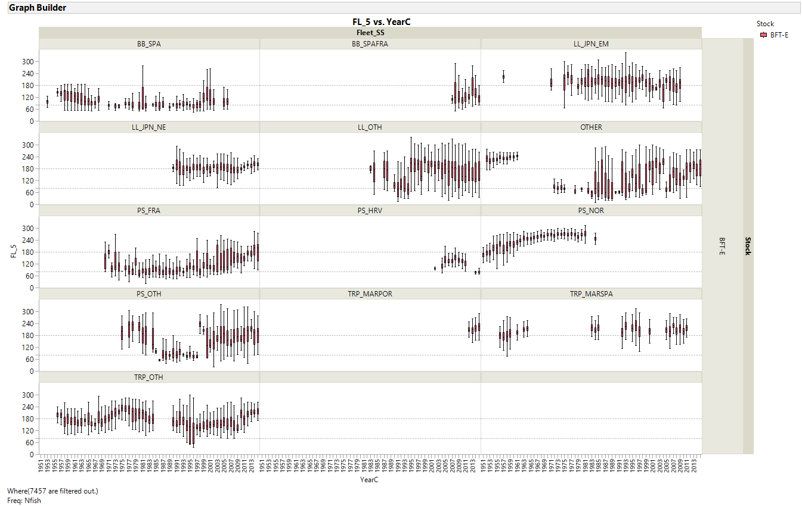

Green: OK to use, Red: Not Use (ignore length comp), and Orange (other trap: see above 4-3).

