INTERNATIONAL COMMISSION FOR THE CONSERVATION
OF ATLANTIC TUNAS

COMMISSION INTERNATIONALE POUR LA CONSERVATION
DES THONIDES DE L´ATLANTIQUE

COMISION INTERNACIONAL PARA LA CONSERVACION
DEL ATUN ATLANTICO


ASSESSMENT PROGRAM DOCUMENTATION

Program: FSIM (ver. 3.00)
A general purpose fish population simulator designed to simulate many forms of fisheries data routinely collected from real fisheries.

Current Catalog Entry: December 2003
First Cataloged by ICCAT: December 2003

Catalogue Committee
External: Jaime Mejuto (IEO, Spain)
Olivier Maury (IRD, France)
Yukio Takeuchi (NRIFSF, Japan)
Alejandro Anganuzzi (IOTC)
ICCAT Secretariat: Victor Restrepo

__________
NOTE: As part of its efforts to carry out Quality Management, ICCAT´s Standing Committee on Research and Statistics is developing a catalog of stock assessment applications. The purpose of the catalog is not to evaluate the relative merits of various assessment methods, but rather whether the software implementing the method works as intended and is adequately documented.

1. PROGRAM NAME

FSIM

2. VERSION (DATE)

Version 3.00, dated July 2003

3. LANGUAGE

FORTRAN 90
VISUAL BASIC 6

4. PROGRAMMER / CONTACT PERSON

C. Phillip Goodyear
1214 N Lakeshore Drive
Niceville, FL 32578, USA
philgoodyear@cox.net

5. DISTRIBUTION LIMITATIONS

Only executable code can routinely be distributed, along with manual and sample files. However, source code is available from the author upon written request and with agreement to certain restrictions.

6. COMPILER NEEDS / STAND-ALONE

Does not require other software, except operating system, but a good ASCII file editor is recommended. Some of the graphics require either 1024x768 or 1280x1024 pixel resolution for best results. The program is presently available from author for 32-bit Windows. It was developed on a Windows 2000 platform and should also work with Windows 9x, Windows ME, Windows NT, and Windows XP.

7. PURPOSE

A general purpose fish population simulator designed to simulate many forms of fisheries data routinely collected from real fisheries. Analyses of these “known” simulated datasets facilitate studies of the robustness of alternative assessment methodologies. The model is also useful for exploring the implications of uncertainty about the dynamics of fish populations, forecasting consequences of management alternatives, and predicting future trends in population sizes and catches for a wide assortment of possible biological attributes under different management alternatives.

8. DESCRIPTION

Program Overview
The FSIM program suite consists of several interrelated computer programs that are manipulated via the FSIM Control Window.exe. These include fsim.exe, msy.exe, pma.exe, ypr.exe, plotlog.exe, plotpma.exe, and plotypr.exe). Fsim.exe is used to simulate the population abundance in time, and to generate time series of population and catch statistics. Msy.exe computes Maximum Sustainable Yield (MSY) for the biological characteristics of the population given the selectivities in a particular year. Pma.exe determines equilibrium production at 100 levels of fishing mortality between F=0 and F=F_{extinction} given the biological characteristics of the population and the selectivities in a particular year. Plotpma.exe is used to plot the output of pma.exe. Ypr.exe computes yield per recruit (YPR) for the biological characteristics of the population and fishery selectivities in a particular year, and plotypr.exe is used to plot YPR. The programs plotlog.exe, plotpma.exe, plotypr.exe, and FSIM Control Window.exe are written in Microsoft Visual Basic 6. FSIM Control Window.exe provides a graphical interface to the programs fsim.exe, msy.exe, pma.exe, and ypr.exe, and is used to edit the input data for each program. These latter four programs are written in Fortran 90 and have the same core representation of the population and fisheries.

Population Structure and Catch
The simulation time step is seasonal with a maximum number of seasons per year of 12 (monthly). The population (N) is stratified by sex (S), age (A), and growth morph (R) so that the entire population is represented by aggregating over N_{SAR}. Each growth morph is a subunit of the cohort of individuals spawned during the same reproductive period that share the same growth characteristics (are of the same length). Mean lengths by sex and age are read from an input file. The length distributions around these means are assumed to be normal (at least initially) and are represented by dividing the cumulative range of ± 3 standard deviations from the mean into an arbitrary number of intervals (maximum=101) of equal length increments (the morphs). The growth for the year is estimated from the change in individual biomass based on the change in weight (W) that occurs from one age to the next, i.e..
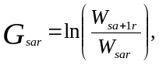

where the W_{sar} are estimated from the lengths at age using length-weight equations that are specified in an input file. The seasonal fractions (λ) of the annual growth are also read from an input file and are used to calculate weights during the year such that the initial weight at the beginning of season p is given by
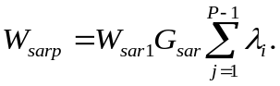

The L_{sarp} are calculated from the W_{sarp} using the length-weight equations for the appropriate sex. However, the lengths at the beginning of the each season for the first year of life are read from an input file rather than computed in this manner.
Initial recruitment to each morph is based on the proportion of the cumulative normal distribution within the length range represented by that morph. Growth within the year is seasonal. Each morph is modeled separately and population attributes are derived by summing across sexes, ages, and morphs. The number of survivors of sex s and morph r at age a and season p (N_{sarp}) is
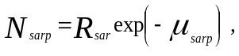

where R_{sar} is the initial recruitment of age a of sex s represented by morph r, and μ_{sarp} is the cumulative total mortality suffered by morph r of sex s from recruitment to season p at age a, or

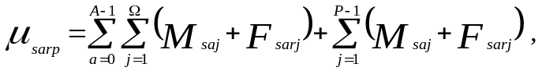
where Ω is the number of seasons within a year (maximum=12). The seasonal natural mortality by sex and age (M_{saj}) is the annual assumed rate divided by the number of seasons. The F_{sarj} is the instantaneous fishing mortality for sex s, morph r during season j when it was age a. A maximum of 10 fisheries can operate simultaneously during a simulation, and since the size of each morph of each sex and age is known each season, the fishing selectivities can be a function of either age or size. The fishing mortality rates by year, season, sex, fishery and age (or size if they are size dependent for the fishery) are read in from a file along with minimum and maximum legal sizes and total allowable catches for each fishery. In addition, if the selectivity pattern is age specific, a size at first vulnerability to the fishery may also be specified. The fishing mortality of sex s, age a, morph r, during season j is the sum of the partial fishing mortalities (h) from each fishery i, or
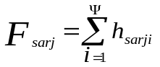

where Ψ is the number of fisheries (maximum=10). If the selectivity of fishery i is a function of size, then the mid-season length of the morph points to the element of an array of fishing mortalities at length which is then employed as the h_{sarji}, otherwise the h_{sarji} are specified directly from an input file. For ages and seasons when the morph is below a minimum or above a maximum legal size limit for the fishery, the fishing mortality is reduced to dh_{sarji} where d is the fraction of the discarded catch which dies.
All sources of mortality within a season are assumed to operate concurrently so that the catch in number and biomass from the morph for each fishery during a season is determined as the fraction of total deaths (A) suffered by the morph during the season attributable and that fishery i.e.,

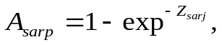

where the total mortality, Z_{sarj}, is given by

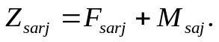

The catch in numbers of fish (C) from the morph for fishery i is
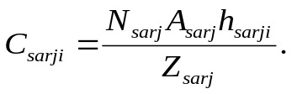

The catch in biomass (B) from the morph for fishery i is

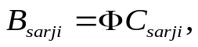

Where Φ is the mean weight of the morph during the season and is computed as

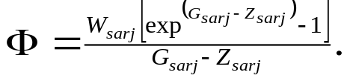

The total catch in biomass and numbers for a season or year are obtained by summing the catches for each fishery.

Reproduction
Total population fecundity, or spawning biomass, is computed from the number of females of each growth morph and age at the beginning of a season specified to be the spawning season in an input file. The fecundity can be either a function of age or size.

Recruitment
Recruitment can be read from an input file or predicted from the simulated population fecundity. It is added to the population at the beginning of a season specified as the recruitment season in an input file. If the year-class strength is defined by a value read in from an input data file, that value is used to set the strength of the recruiting year class in the model population. If the year-class strength is not defined, then one of five options specified in an input file is employed to estimate recruitment.

Option 0: Recruitment is set equal to a constant (=mean recruitment) read from an input file.

Option 1: Recruitment is not estimated. In this case recruitment is set to zero and the model population will begin to reflect missing year classes.

Option 2: Recruitment is estimated as the product of mean egg to recruit survival and the present year's estimate of total population fecundity. The mean survival is calculated as the mean of the ratios of recruitment to simulated population fecundity for previous years in the simulation where annual recruitment was read from an input file.

Options 3 and 4: Recruitment (R) is estimated from a spawner-recruit curve which may be either a standard Ricker model (Option 3) or a Beverton-Holt curve (Option 4). In both cases, the density-dependent mortality is keyed to the size of the annual fecundity estimate; i.e., the value of parental stock size (P) in the standard notation for both equations is set equal to the total population fecundity. In terms of the present model notation, the Ricker model would be:

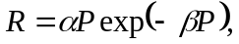

and the Beverton-Holt model would be:

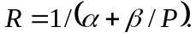
The parameters of the stock-recruitment relation are internally computed by the program from input values for recruitment at MSY and the slope of the spawner-recruit curve at the origin.

If desired, stochastic variability can be added to the recruitment time series by specifying a value for the coefficient of variation of recruitment greater than zero. This is accomplished by multiplying the predicted (mean) recruitment from the stock-recruitment relationship by exp(R*CV – 0.5*CV ²), where R is a random normal deviate with mean of zero and a variance of 1.0; and CV is the coefficient of variation of the log of the random multiplier and is read from an input file.

Indices
The program provides the ability to generate indices of abundance based on simulated fishery-independent samples of the population or samples of the fisheries catch with or without error. The indices may be in units of numbers of individuals or biomass. Trends in catchability can be introduced, and if samples are drawn from the population, the selectivity of the sampling gear can be varied by sex, age, season and year. Indices drawn from the catch by a fishery are simply the product of the catch in number or biomass and scalar (index catchability or Q) which may be varied by year. Indices drawn from the population use selectivity algorithms identical to those of a fishery but do not remove fish from the population. These selectivity patterns must be specified in an input file.

Length and age samples
The program provides the ability to sample the simulated population or catch by the fisheries to obtain individual observations of lengths and age with or without error. This feature is useful for generating simulated size data that is very similar to size frequency data collected from actual fisheries. For example, such data could be used to examine the robustness of cohort slicing as a technique for aging catches as prelude to sequential population analysis. The user specifies the number of samples to be taken by season. These samples can be drawn from all fisheries in proportion to their catches, or from individual fisheries and/or the population through the index feature of the program. The simulated sampling procedure involves constructing an array based on all sex-age-morphs in the sampled population or catch. This array contains the season catch or sampled abundance from each morph (depending on the user’s sample specifications). The array is then normalized by dividing the value of each member by the array maximum. A uniformly-distributed random number drawn within the range of 1 to the number of array elements picks a trial cell in the array. If that cell’s value is greater than or equal to a second random number drawn from a uniform distribution between 0 and 1.0, the morph corresponding to that array element is selected for the sample. If the cell is selected, the sex, age and/or length of the morph corresponding to the cell is saved as a simulated observation (with added error). This process produces a sample probability for each cell that is proportional to its relative abundance. The process is repeated until the number of observations specified by the user has been satisfied.

9. REQUIRED INPUTS

Several input files are required to run FSIM. These are generally created and edited with the program “FSIM Control Window.exe”, which provides a graphical interface to maintain and manipulate the files and associated data required to run each of the simulation modules. These include files that contain the biological profiles of the species, its recruitment history, information about the characteristics of the fishery(ies), and the kinds of output data to generate.

Run configuration
The program requires specification of the number of sexes, ages, and growth morphs that are to be considered in the simulation. In addition, the beginning and ending year for output, number of seasons per year, the number of fisheries must be specified. Other factors such as the number of population indices that will be simulated, the number of length and age samples to be taken, and/or the number of replications must also be specified, depending on the purpose of the simulation experiment. Each of the four programs of the simulator (fsim.exe, msy.exe, pma.exe, and ypr.exe) reads a file that specifies the filenames for files containing the biological data, recruitment time series, fisheries data, and/or data defining the indices to be simulated. All of these are manipulated by the “FSIM Control Window” but can also be edited with a text editor.

Biological data
The biological data are contained in a file with the extension “.bio”. This file provides the mean lengths of the individuals in the population at the beginning of the year by age and sex, seasonal proportions of the annual growth, the CV of size at age about the mean for each sex, and the length-weight equations for each sex included. Other required inputs include the reproductive value of females by age or size, the seasons for spawning and recruitment, and natural mortality by sex and age. For many applications, the form of the stock-recruit relation, its slope at the origin, and recruitment at MSY must be also be specified.

Recruitment
Data defining the recruitment by year are contained in files with the extension “.yoy”. This file specifies mean recruitment and annual realized recruitments by year. For years where the recruitment value is 0.0, recruitment will be calculated from spawning biomass according to the recruitment option specified in the *.bio file described in the recruitment section of item 8.

Fisheries
Data defining the fisheries are contained in files with the extension “.fst”. This file identifies the number of fisheries to be simulated. For each fishery, it contains the annual values of the partial fishing mortalities for fully available morphs by sex, minimum and maximum size limits, discard mortality rates and TACs. The file also contains the seasonal fractions of the annual fishing mortalities, and the selectivities for each sex by length or age for each fishery each year. Prior to running a simulation, “FSIM Control Window.exe” must processes the data in the “.fst” file to produce a management data file (*.mgt) which is the actual fisheries input file for the simulator.

Indices
Data defining the indices to be simulated are contained in files with the extension “.ndf”. This file identifies the number of indices to be collected, the annual catchabilities, whether each is based on numbers or biomass, and whether it is to be associated with a fishery or the population. If an index is associated with the population, the file also contains data that specifies whether the index selectivities are size or age determined. As with fisheries, the selectivities are specified by year, season, sex, and either age or length and are included in this file. Other data contained in this file include the magnitude of the measurement error for the index catch and effort, the number of length and age samples to be taken, and the measurement error associated with each. The name of the file to receive the index data for each index is also specified. [Note: if one of the filenames is “ASPIC” all indices will be written to a file in a format that is compatible with ASPIC (Prager 1994)].

10. PROGRAM OUTPUTS

Fsim.exe
Log file (*.log) Recruitment, SPR, spawning biomass, average stock biomass during the year, biomass harvested, fishing mortality (catch/average biomass), mean length, mean weight, and mean age for each year. The data in this file can be plotted with the program plotlog.exe. Examples are presented in Figures 1-6.

Stock statistics (*.txt) - Standing stock in numbers of fish by age, sex and season for each year.

Catch statistics(*.txt) - Catches in biomass and numbers, and standing crop in numbers by sex, age for each season, each year.

Landings (*.txt) - Simulated biomass landed by season and fishery for each year.

Index (*.txt) – One file for each index. If length and age data are included in the index definition then there will be 2 record types in the file. Type 1 records are simulated observations and have the following data: record type, year, season, fishery, sex, length and may also have the age of the “observed” fish. Type 2 records have the following data: record type, year, season, fishery, catch and effort.

Lengths (*.txt) - Simulated length observations with the following data: year, season, fishery, sex, length and may also have the age of the “observed” fish.

Initial conditions (*.txt) - State variables at the end of a simulation. These data may be read at the beginning of a simulation to define the initial condition of the stock for subsequent runs.

Msy.exe
This program produces a text output file that gives the realized selectivities, fishing mortality rates, and catch in numbers by age at MSY in numbers and MSY in biomass. It also contains the yield in numbers and biomass, stock biomass, spawning stock biomass, fishing mortality on the stock as a whole (catch/biomass), fishing mortality on the fully selected ages, recruitment, and SPR at MSY in numbers and MSY in biomass.

Pma.exe
This program produces a text output file (*.pmo) containing for each year of selectivities specified the following data: Fishing mortality (catch/stock biomass), recruitment, SPR, stock biomass, and catch in biomass. The program estimates F_{extinction} and estimates equilibrium yields for 100 equally spaced graduations between F=0 and F= F_{extinction}. The program Plotpma.exe is used to plot the results in the output file. An example is given in Figure 7.

Ypr.exe
This program produces a text output file (*.yro) containing for each year of selectivities specified, the following data: First line: year, yield per recruit at F_{0.1}, F_{catch/biomass} at F_{0.1}, F_{fully selected} at F_{0.1}, SPR at F_{max}, yield per recruit at F_{max}, F (catch/biomass) at F_{max}, F for fully selected ages at F_{max}, and SPR at F_{fmax}. Second line: column labels. Third line: F_{fully selected}, F_{catch/biomass}, Biomass yield, and SPR. The program Plotypr.exe is used to plot the results in the output file. An example is given in Figure 8.

11. DIAGNOSTICS

None

12. OTHER FEATURES

The program “FSIM Control Window.exe” is used to manipulate the input data. Many of the input functions can be graphically manipulated by dragging the cursor in an input window with the left button on the mouse depressed. These windows are exited with a right click of the mouse. These plots can be saved by double clicking on the left side of the left axis. An example for a selectivity curve is given in Figure 9.

13. HISTORY OF METHOD PEER REVIEW

The first version of FSIM was written in Microsoft FORTRAN for DOS in the early 1980s in support of investigations of management alternatives for striped bass (Morone saxatilis) on the US Atlantic Coast and the methods were reviewed by various working groups during the development of the management plan for the stock. This code was used to evaluate yield per recruit for striped bass (Goodyear, 1984). The author reprogrammed a second version of FSIM in Microsoft QuickBasic in 1988 which provided more flexible control over the input/output data. Tests demonstrated that both codes provided the same results with the same input. This version was distributed as part of the application package, LSIM (Goodyear 1989). This version was extensively used with red drum, red snapper and other stock assessments in the Gulf of Mexico and the model and results were reviewed several times by various stock assessment panels and committees, and industry representatives. Core elements of this version of the programs were applied to many different problems resulting in several peer reviewed journal articles (Schirripa and Goodyear. 1992; Goodyear 1995, 1996a, 1996b, 1997; and Prager et al. 1996). The present version of the software was developed over several years beginning in the late 1990s, and is being released as Version 3.0. The simulation modules are again written in FORTRAN (current compilations are with Compaq Visual Fortran Version 6.6) while support programs have been written in Microsoft Visual Basic 6.0. Tests showed that output among the various versions was the same for the same input. However, the current version is much more flexible than previous versions, so not all possible scenarios could be compared. The recent version of the code has been used in the evaluation of several more problems and resulted in additional peer reviewed publications (Goodyear 2001, 2002, in press; Prager and Goodyear 2001).

14. STEPS TAKEN BY PROGRAMMER FOR VALIDATION
The author has subjected numerous different simulated datasets to various analyses in the conduct of evaluations of various methods such sequential population analyses, age-length sampling to estimate growth rates, production model estimation, etc. In each of these applications preliminary analyses were conducted without adding error to the simulated data to verify that correct answers were obtained. However, because of the complexity of the implementation there are combinations of alternatives which may have never been tested. As a consequence, users should examine output carefully when executing complicated simulations. However, nearly all results which seemed counterintuitive to the author in the last several years were found to be unanticipated consequences of the relationships among the input data, and not a problem with the program code.

15. TESTS CONDUCTED BY OTHERS

16. NOTES BY ICCAT

(in prep)

17. SOURCES CITED

Goodyear, C. P.1984. Analysis of potential yield per recruit for striped bass produced in Chesapeake Bay. North American Journal of Fisheries Management 4:488-496.
Goodyear, C. P. 1989. LSIM-a length-based fish population simulation model. NOAA (National Oceanic and Atmospheric Administration) Technical Memorandum NMFS (National Marine Fisheries Service), SEFC (Southeast Fisheries Center) 219, Miami.
Goodyear, C. P. 1995. Mean size at age: an evaluation of sampling strategies using simulated red grouper data. Transactions of the American Fisheries Society 124:746-755.
Goodyear, C. P. 1996a. Variability of fishing mortality by age: Consequences for MSY. North American Journal of Fisheries Management. 16:8–13.
Goodyear, C. P. 1996b. Minimum sizes for red grouper: consequences of considering variable size at age. North American Journal of Fisheries Management 16:505-511.
Goodyear, C. P. 1997. Fish age determined from length: an evaluation of three methods using simulated red snapper data. Fishery Bulletin 95:39-46.
Goodyear, C. P. 2001. Atlantic blue marlin and yellowfin tuna: comparative population vulnerability to fishing mortality. American Fisheries Society Symposium 25:219-224.
Goodyear, C. P. 2002. Negative Implications of large minimum size regulations on future mean size at age: An evaluation using simulated striped bass data. American Fisheries Society Symposium 30:212-229.
Goodyear, C. P. Blue marlin mean length: simulated response to increasing fishing mortality. Marine and Freshwater Research. Manuscript accepted
Prager, M. H., C. P. Goodyear, and G. P. Scott. 1996. Application of a surplus production model to a swordfish-like simulated stock with time-changing gear selectivity. Transactions of the American Fisheries Society 125:729--740.
Prager, M. H. and C. P. Goodyear. 2001. Effects of Mixed-Metric Data on Production Model Estimation: Simulation Study of a Blue-Marlin-Like Stock. Transactions of the American Fisheries Society: Vol. 130, No. 5, pp. 927–939.
Prager, M. H. 1994. A suite of extensions to a nonequilibrium surplus-production model. Fishery Bulletin 92:374-389.
Schirripa, M. J. and C. P. Goodyear. 1992. Simulation modeling and conservation standards for spotted seatrout (Cynoscion nebulosa ) in Everglades National Park. Bulletin of Marine Science. 54: 1019-1035.

18. AUTHOR’S NOTES

Program Installation
The program should be installed on the user’s computer in the folder “C:\Program Files\FSIM\”. This is the default installation path for the setup package. At the user’s discretion, it may be installed in a different directory, but if this is done and environment variable “CPGFSIM” must be created which points to the installation directory for the program.

Running the application
Each of the executables can be run from Windows or from the command mode. However, the application is designed to use the FSIM control window to manipulate the input files and execute the simulator programs. This is best accomplished by creating file associations with certain input and output files so that the appropriate module is loaded when an input or output file is clicked.

File associations
The following file associations should be enabled for best results.

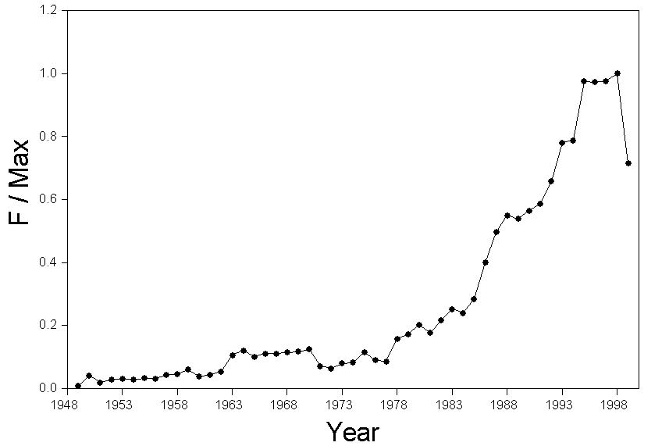
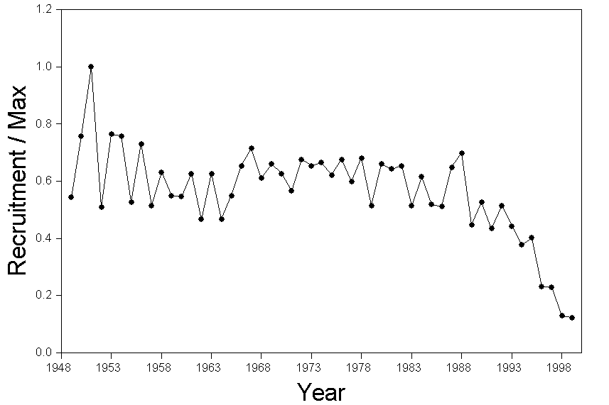
File Associations
File Extension | Program to open | Function
.run | Fsim control window | Executes FSIM.EXE
.msy | Fsim control window | Executes MSY.exe and PMA.EXE
.ypr | Fsim control window | Executes YPR.EXE
.bio | Fsim control window | Manages the biological profile
.fst | Fsim control window | Manages the fisheries to be simulated
.ndf | Fsim control window | Manages the index file to be simulated
.yoy | Fsim control window | Manages the recruitment file
.log | plotlog | Plots the FSIM output log file
.pmo | plotpma | Plots the PMA output file
.yro | plotypr | Plots the YPR output file
Figure 2..Plot of realized recruitment for a sample simulation with FSIM.
Figure 1.Plot t of realized fishing mortality for a sample simulation with FSIM.

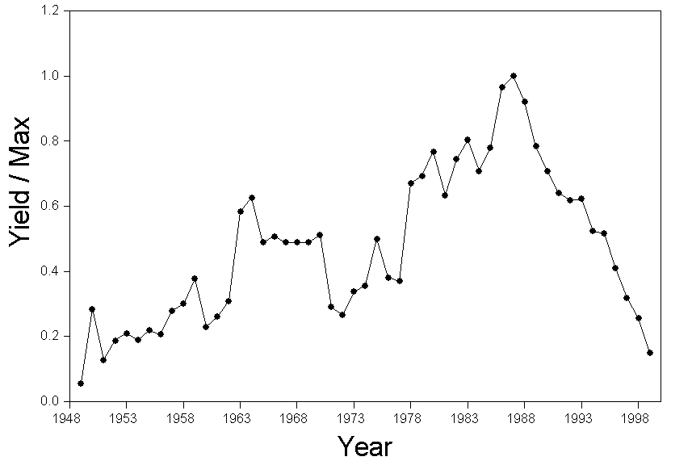
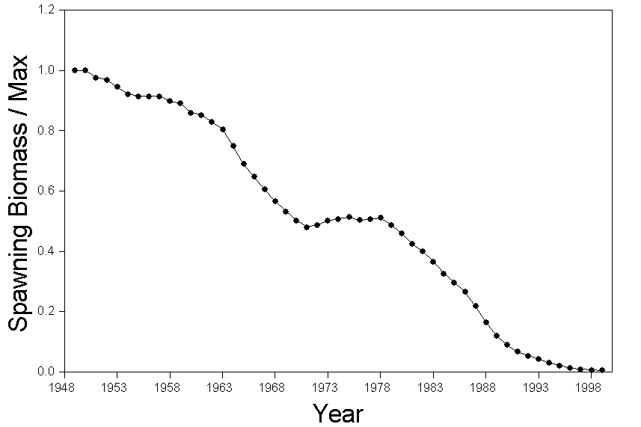

Figure 4..Plot of spawning biomass for a sample simulation with FSIM.

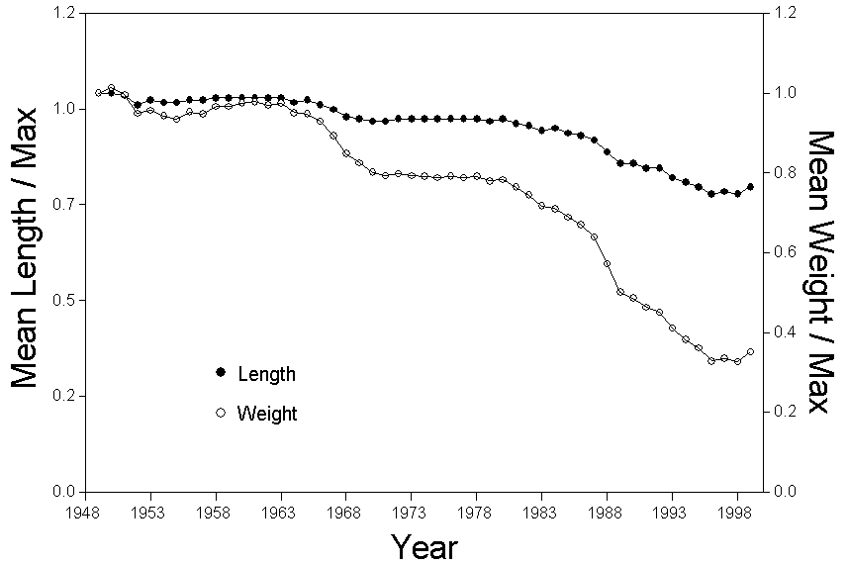
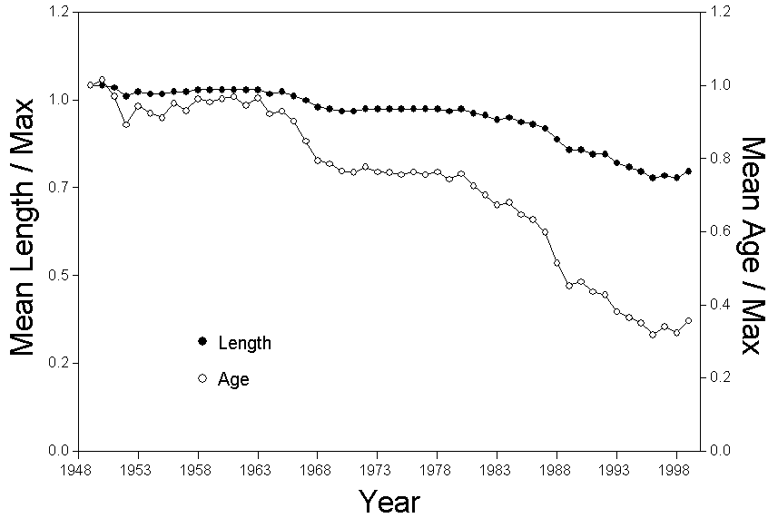

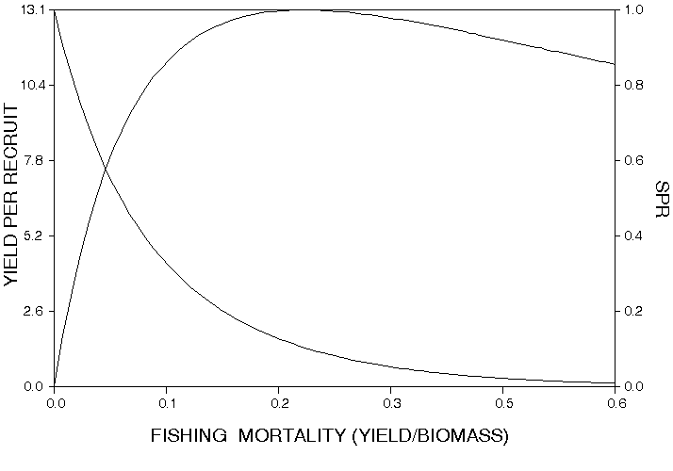

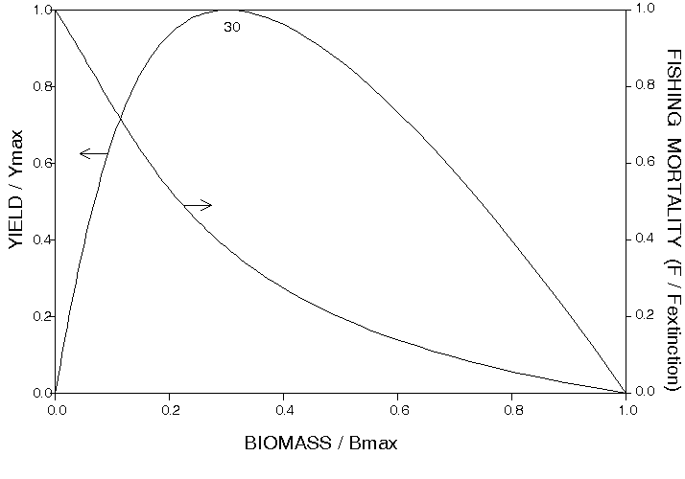
Figure 3..Plot of total yield for a sample simulation with FSIM.
Figure 5..Plot of mean lengths and weights for a sample simulation with FSIM.
Figure 6..Plot of mean lengths and ages for a sample simulation with FSIM.

Figure 7. Plot of yield per recruit for the biological profile and fishery selectivities specified for one year of a sample FSIM simulation

Figure 8. Equilibrium production for the biological profile and fishery selectivities specified for one year of a sample FSIM simulation

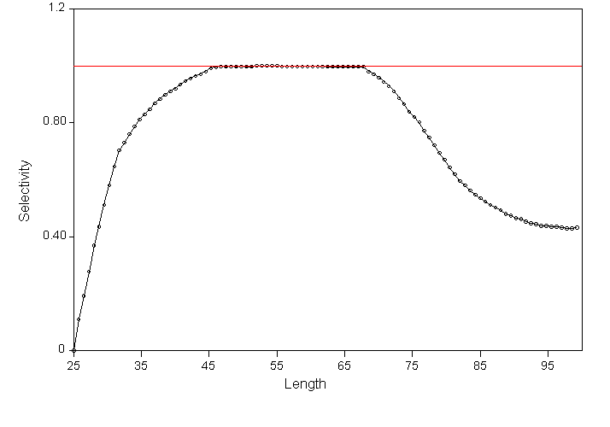

User’s Manual
Figure 9. Example of a selectivity curve edited and plot saved by the program FSIM control window.exe. Data can be edited by positioning the cursor at the desired value and depressing the left mouse button. The edit window is closed when the right mouse button is depressed, and the image may be saved by double clicking the left mouse button to the left of the left axis when running the program.
The user’s manual is supplied as a separate document: FSIM 3.0 Users Manual.pdf

Sample Applications

Sample files for a red-snapper-like species and a swordfish-like species are supplied in separate directories. See program installation in the user’s guide.

Source Code

A copy of the entire source code has been filed with the Secretariat and the full source code is available from the author on request.

