**SparkFaultBench**

**User Document**

**2016.9**

Contents

1. Prepare system and environment 2

1.1 Prepare the cluster 2

1.2 Configure network 3

1.3 Create a user “hadoop” 4

1.4 Configure ssh 4

1.5 Install jdk 5

2. Install and configure the Yarn cluster 5

2.1 Configurate hadoop 5

2.2 Install Scala and Spark 8

3. Start Cluster 10

3.1 Start hadoop and yarn 10

3.2 Bulid a path /sparklogs on hdfs to save logs: 11

3.3 Upload the test file to hdfs and Jar to master. 11

4. Generate test data 11

4.1 Choose Spark Application 11

4.2 Select algorithm 12

4.3 Configure parameters for application 12

4.4 Generate test file 13

4.5 Upload data to HDFS 13

5. Test execution 13

5.1 Set parameter information for running 13

5.2 Fill execution parameters 14

5.3 Run Application 14

5.4 Form and view test report 14

5.5 View details: 15

# 1. Prepare system and environment

## 1.1 Prepare the cluster

Prepare 6 machines with system of CentOS-6.7-x86_64-minimal. One of them has 6 cores, 6GB RAM and 60G disk, edit the host name of this machine to “Master”:

$ vi /etc/sysconfig/network

See the following drawing:



The others have 6 cores, 6GB RAM and 100G disk, edit the host name of these machine to “Slave1”, “Slave2”, “Slave3”, “Slave4”, “Slave5”.



Restart the machines so that the host name can be changed.

## 1.2 Configure network

Edit the IP of machines in the cluster to a same segment:

$ vi /etc/sysconfig/network-scripts/ifcfg-eth0

The following drawing shows network configuration of one of the machines in this manual , the IP of the others are

“133.133.134.121”,

“133.133.134.149”,

“133.133.134.92”,

“133.133.134.94”,

“133.133.134.143”.

And set “BOOTPROTO” to “static” in case of IP changing.

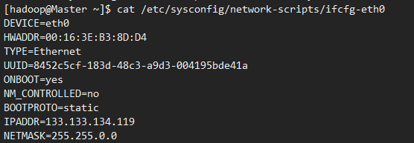

Then restart network on each machine:

$ service network restart

Modify /etc/hosts on each machine to mapping relation of host name and IP in the cluster:

$ vi /etc/hosts

As the following drawing:

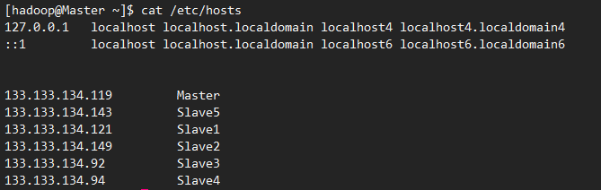

Try to ping each other on each machine to see if it works, for examples, on Master:

$ ping Slave1 -c 3

$ ping Slave2 -c 3

$ ping Slave3 -c 3

$ ping Slave4 -c 3

$ ping Slave5 -c 3

## 1.3 Create a user “hadoop”

On each machine in the cluster, create a new user named “hadoop”:

$ useradd -m hadoop -s /bin/bash

$ passwd hadoop

Add administrator privileges for user “hadoop”:

$ visudo

Add a line like this:



Then change account to “hadoop”:

$ su hadoop

## 1.4 Configure ssh

SSH has been installed on CentOS as default. Run the following command on Master:

$ ssh localhost

$ cd ~/.ssh

$ rm ./id_rsa*

$ ssh-keygen -t rsa

$ cat ./id_rsa.pub >> ./authorized_keys

$ sudo chmod 644 ./authorized_keys

Then deliver the public key on Slave1 to Slave5:

$ scp ~/.ssh/id_rsa.pub hadoop@Slave1:/home/hadoop/

On Slave1 to Slave5, add public key to authorized_keys:

$ ssh localhost

$ cat ~/id_rsa.pub >> ~/.ssh/authorized_keys

$ rm ~/id_rsa.pub

$ sudo chmod 644 ~/.ssh/authorized_keys

Restart sshd on Master and check if Master can ssh to each Slave without password successfully:

$ sudo service sshd restart

$ ssh slave1

## 1.5 Install jdk

Install open-JDK 1.7 on each machine with yum:

$ sudo yum install java-1.7.0-openjdk java-1.7.0-openjdk-devel

# 2. Install and configure the Yarn cluster

## 2.1 Configure Hadoop

On Master, download hadoop-2.7.1.tar.gz from

http://mirror.bit.edu.cn/apache/hadoop/common/hadoop-2.7.1/. install Hadoop in /usr/local:

$ sudo tar -zxf hadoop-2.7.1.tar.gz -C /usr/local

$ cd /usr/local/

$ sudo mv ./hadoop-2.7.1/ ./hadoop

$ sudo chown -R hadoop:hadoop ./hadoop

Run the following command to check if Hadoop is correctly installed:

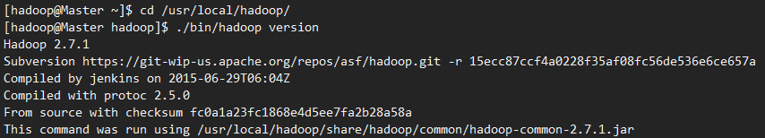

Edit following 5 files in /usr/local/hadoop/etc/hadoop on the Master:

Slaves:

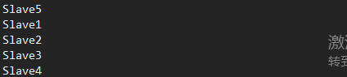

Core-site.xml:

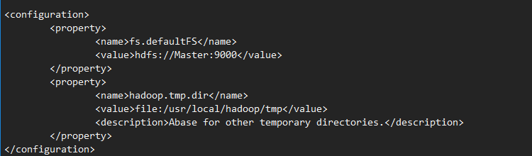

 hdfs-site.xml:

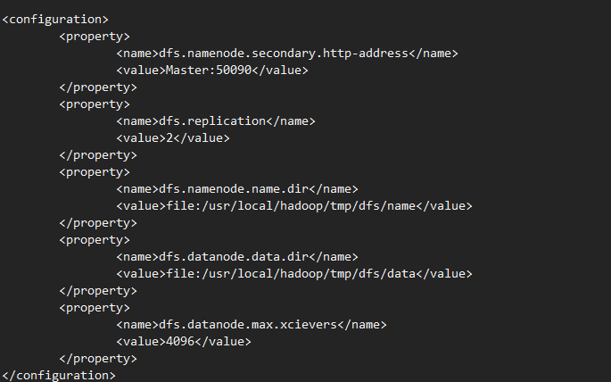

mapred-site.xml:

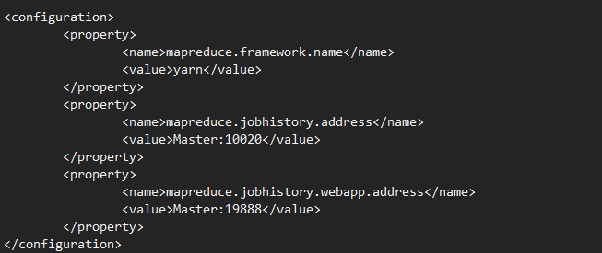

 yarn-site.xml:

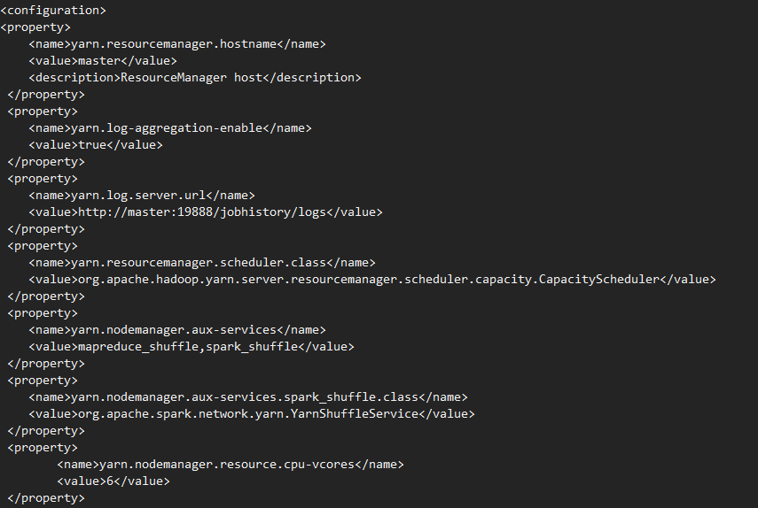

Then copy the / usr / local / Hadoop file on to each node :

$ cd /usr/local

$ tar -zcf ~/hadoop.master.tar.gz ./hadoop

$ scp ~/hadoop.master.tar.gz Slave1:/home/hadoop

Execute the following command on each slave node:

$ sudo tar -zxf ~/hadoop.master.tar.gz -C /usr/local

$ sudo chown -R hadoop /usr/local/hadoop

Performs formatting of NameNode on master:

$ hdfs namenode -format

## 2.2 Install Scala and Spark

Download scala 2.11.8 from <http://www.scala-lang.org/download/2.11.8.html>:

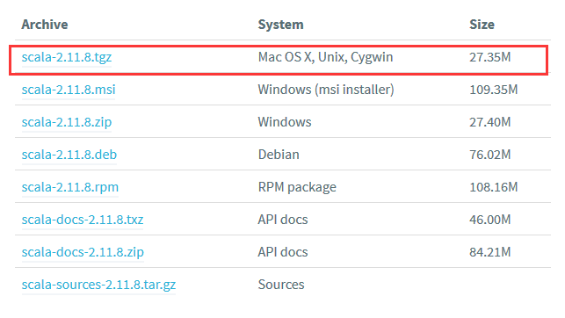

$ sudo tar -zxf scala-2.11.8.tgz -C /usr/local/

$ cd /usr/local

$ sudo mv ./scala-2.11.8.tgz/ ./scala

$ sudo chown -R hadoop:hadoop ./scala

Download spark-2.0.0-bin-hadoop2.7.tgz:

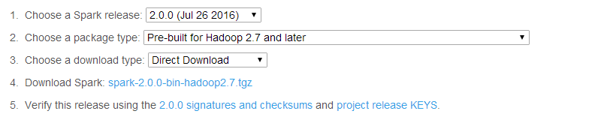

$ sudo tar -zxf spark-2.0.0-bin-hadoop2.7.tgz -C /usr/local/

$ cd /usr/local

$ sudo mv ./spark-1.6.0-bin-without-hadoop/ ./spark

$ sudo chown -R hadoop:hadoop ./spark

Edit /usr/local/spark/conf/spark-env.sh:

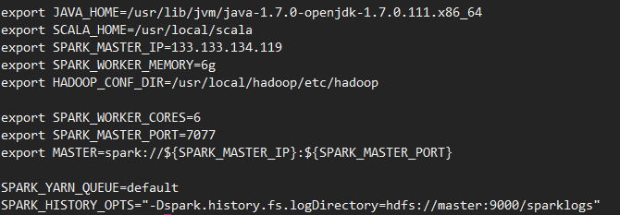

Edit /usr/local/spark/conf/spark-defaults.conf:

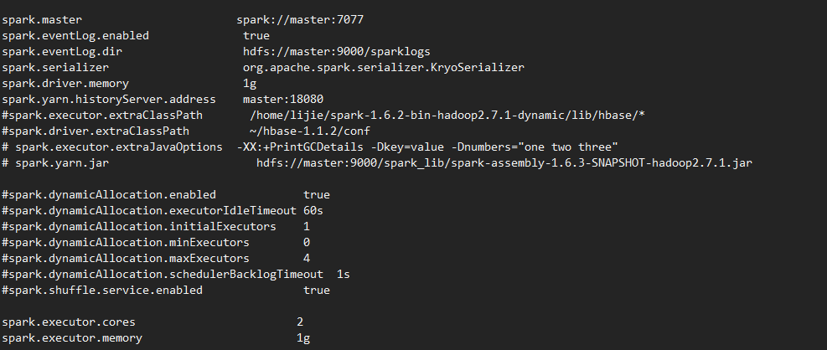

Edit /usr/local/spark/conf/slaves：

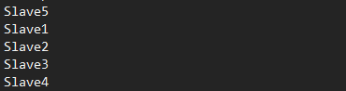

**2.3 Configure environment variable**

Run this command :

$ vi ~/.bashrc

Add lines like this:

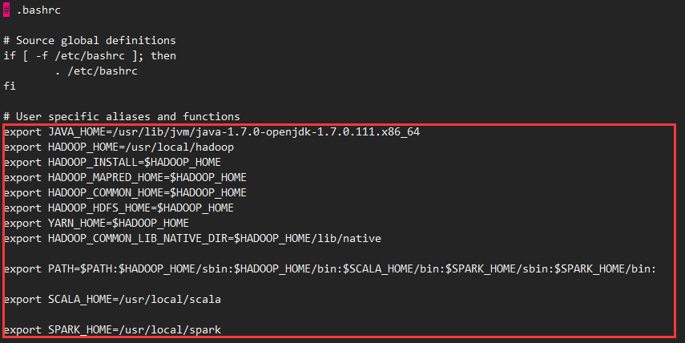

Save and run the following command to validate the configuration:

$ source ~/.bashrc

# 3. Start Cluster

## 3.1 Start hadoop and yarn

Start hadoop and yarn:

$ start-all.sh

Start hadoop historyserver and spark history server:

$ mr-jobhistory-daemon.sh start historyserver

$ $SPARK_HOME/sbin/start-hisory-server.sh

start-historyserver.sh

Run “jps” to check out if everything is opened correctly:

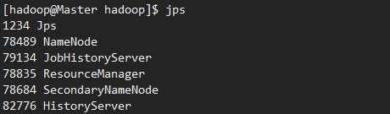

## 3.2 Bulid a path /sparklogs on hdfs to save logs:

$ hdfs dfs -mkdir /sparklogs

## 3.3 Upload the test file to hdfs and Jar to master.

Bulid a path to place test file on HDFS:

$ hdfs dfs -mkdir -p data

Upload test file “test.txt” to path “data”

$ hdfs dfs -put test.txt data/

Then upload Jar to Master using “scp” command.

# 4. Generate test data

Open the benchmark, fill the test name, select the Spark application and different types of applications , you can configure the required parameters, and then generate the data to local , and finally uploaded to the HDFS . Details as follows:

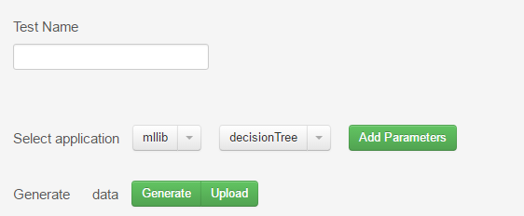

## 4.1 Choose Spark Application

For example, choose application mllib:

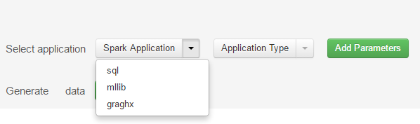

## 4.2 Select algorithm

Select the algorithm of mllib，for example, decisionTree:

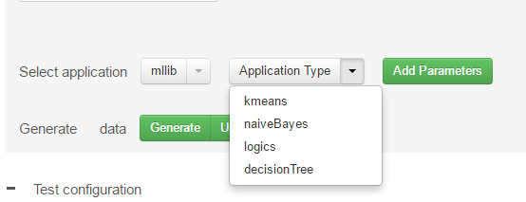

## 4.3 Configure parameters for application

Click “Add Parameters”, configure parameters for the application:

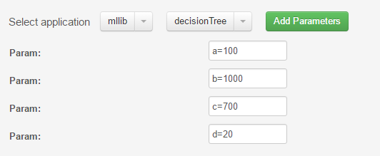

## 4.4 Generate test file

Click “Generate”，and generate .txt form test file in local:



## 4.5 Upload data to HDFS

Click “Upload” button, upload data to HDFS:



# 5. Test execution

On the benchmark, configurate parameters information during test execution , and run tests . After running , you can check the test report . Test report describes the test application type , data scale, cluster scale, application descriptions , test goal, the way of data generated. In addition , you can also link to Hadoop testing page , view the specific test conditions.

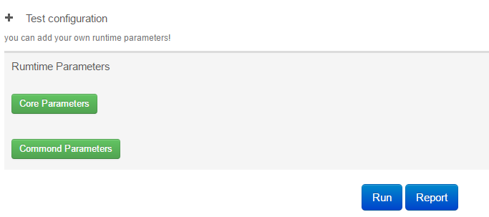

## 5.1 Set parameter information for running

Fill in the parameter information needed to run, Including driver-memory，executor-memory，executor-core, class information and so on:

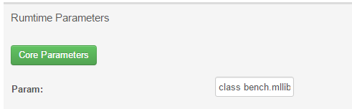

## 5.2 Fill execution parameters

Fill execution parameters specific class need when running, including the required jar package , etc:

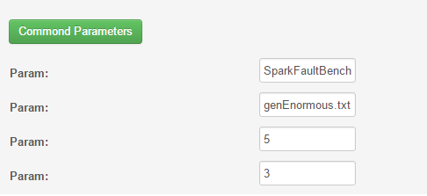

## 5.3 Run Application

Click the “Run” button, you can run the application with information configured before:



## 5.4 Form and view test report

Click the “Report” button, a test report would be formed and showed at the end of running:



Test report:

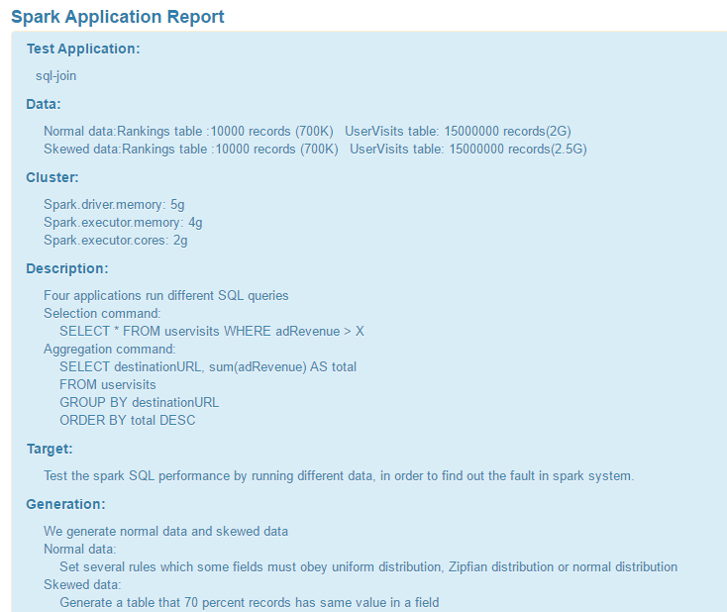

## 5.5 View details:

Click the “details” button below , you can connect to Hadoop monitor screen and view details:

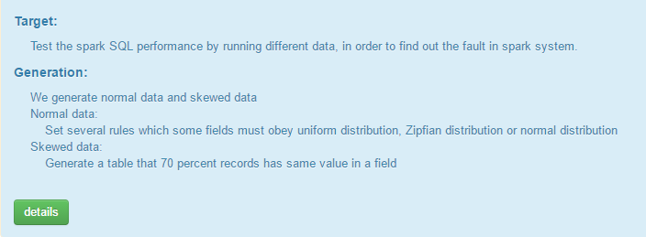

Details:



