基于Flutter的卡片笔记软件

系统设计报告
162130117-傅锦龙
目录
基于Flutter的卡片笔记软件 1
系统设计报告 1
1引言 3
编写目的 3
背景 3
定义 3
参考资料 4
2界面设计 4
BookMarks类 4
Card类 5
Category类 6
Filemanager类 7
CardManager类 8
3事务逻辑设计 10
类图 10
顺序图 11
BookMarks类 12
Category类 14
Card类 15
Filemanager类 18
Cardmanager 22
4数据库设计 36
ER图 36
Bookmark数据 37
Category数据 37
Card数据 37
第三方编辑数据 38
软件运行数据 38

软件设计说明书

1引言

编写目的
经过面向对象分析阶段，得到了系统的类图，细化的属性表和操作表，及三层精化类图；设计阶段的任务是给出各个类每层分解的实现方案，即界面显示方式、事务处理逻辑、数据库设计，不同任务的程序员可据此进行方案的实现。
预期读者为：软件开发的人员，项目评审人员，及软件测试人员。

背景
说明：
- 待开发软件系统的名称：基于Flutter的卡片笔记软件；
- 本项目的任务提出者：傅锦龙；
- 本项目的任务开发者：傅锦龙；
- 用户及实现该软件的计算中心或计算机网络：待定；

定义
卡片：包含标题、分类、书签等必要内容，卡片笔记内容可为空
书签、分类信息：存放在一个数据库表中，用以展示所有信息或查找对应卡片；
第三方编辑：用户需选定卡片保存的位置和第三方编辑器的位置，通过将卡片保存为相应位置的markdown文件并通过第三方编辑器打开，从而实现第三方编辑；
全局导入导出：笔记软件将所有卡片数据导出为json文件，可被重新导入；
创建新对象：用户通过点击导航栏上的加号键，可在不同界面可创建不同对象，如在卡片界面创建新卡片，在类型界面创建新类型；
卡片细节：用户在卡片细节界面既可查看卡片内容，也可选定第三方编辑或导出。
结果显示：当用户操作成功或失败时，出现提示框；
显示屏：是用户与计算机系统进行交互的显示渠道。

参考资料
编号 | 参考资料 | 作者
1 | 《软件工程（第三版）》，高等教育出版社，2012 | 齐治昌等
2 | 《构建之法（第二版）》，人民邮电出版社，2015 | 邹欣
3 | 《Test-Driven Development with Python》，O'Reilly，2014 | Harry J. W

2界面设计

BookMarks类
Book_page.dart | BookMarks界面

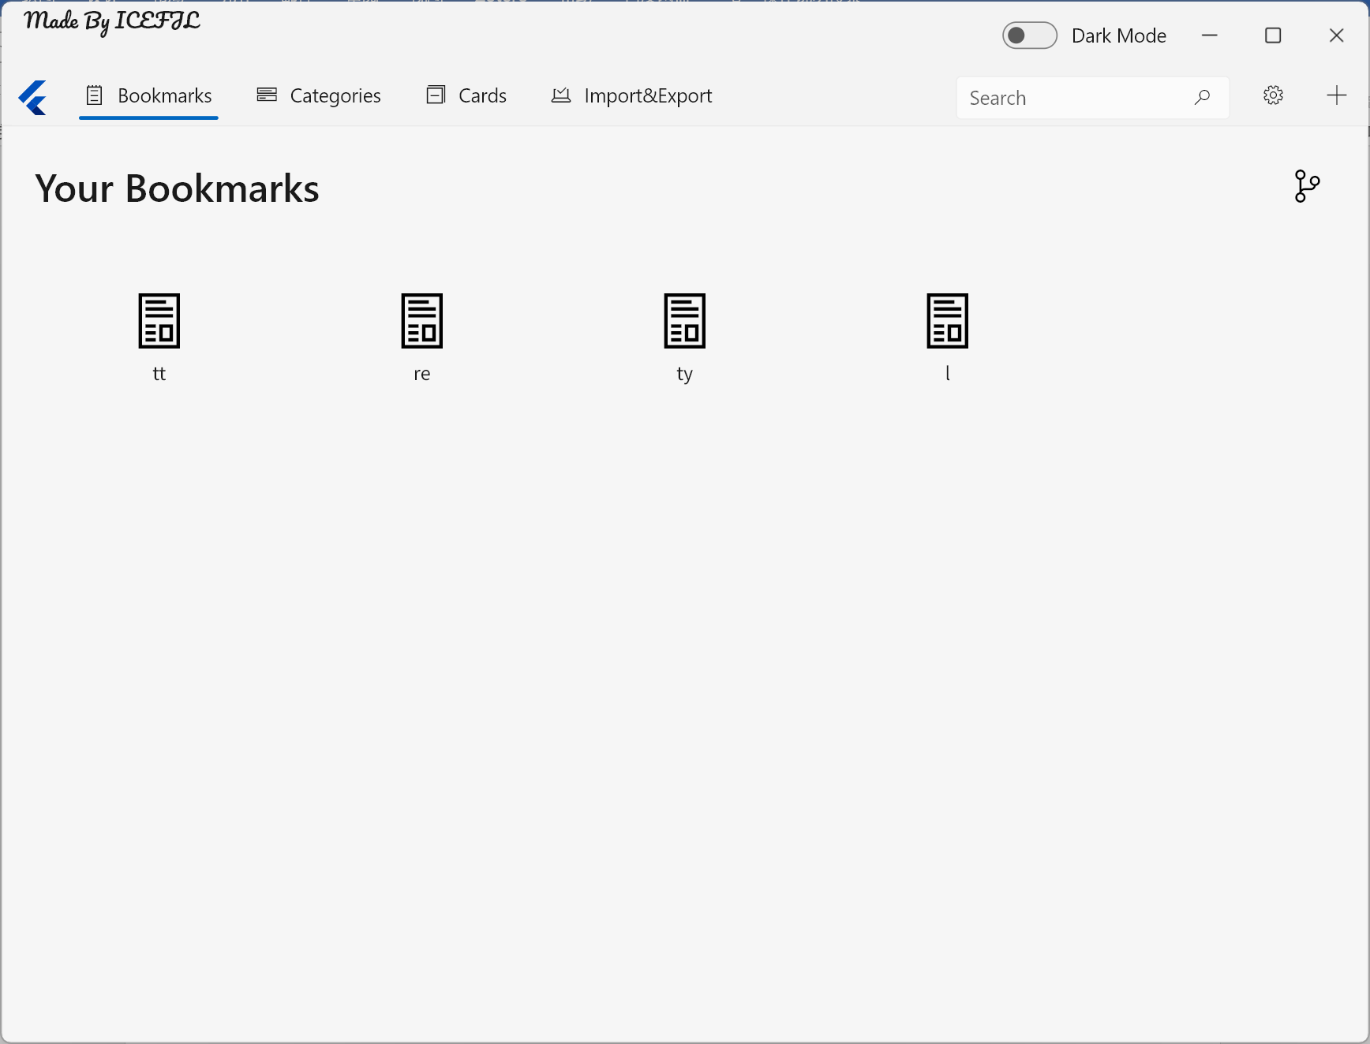

Card类
Card_page.dart | Card界面

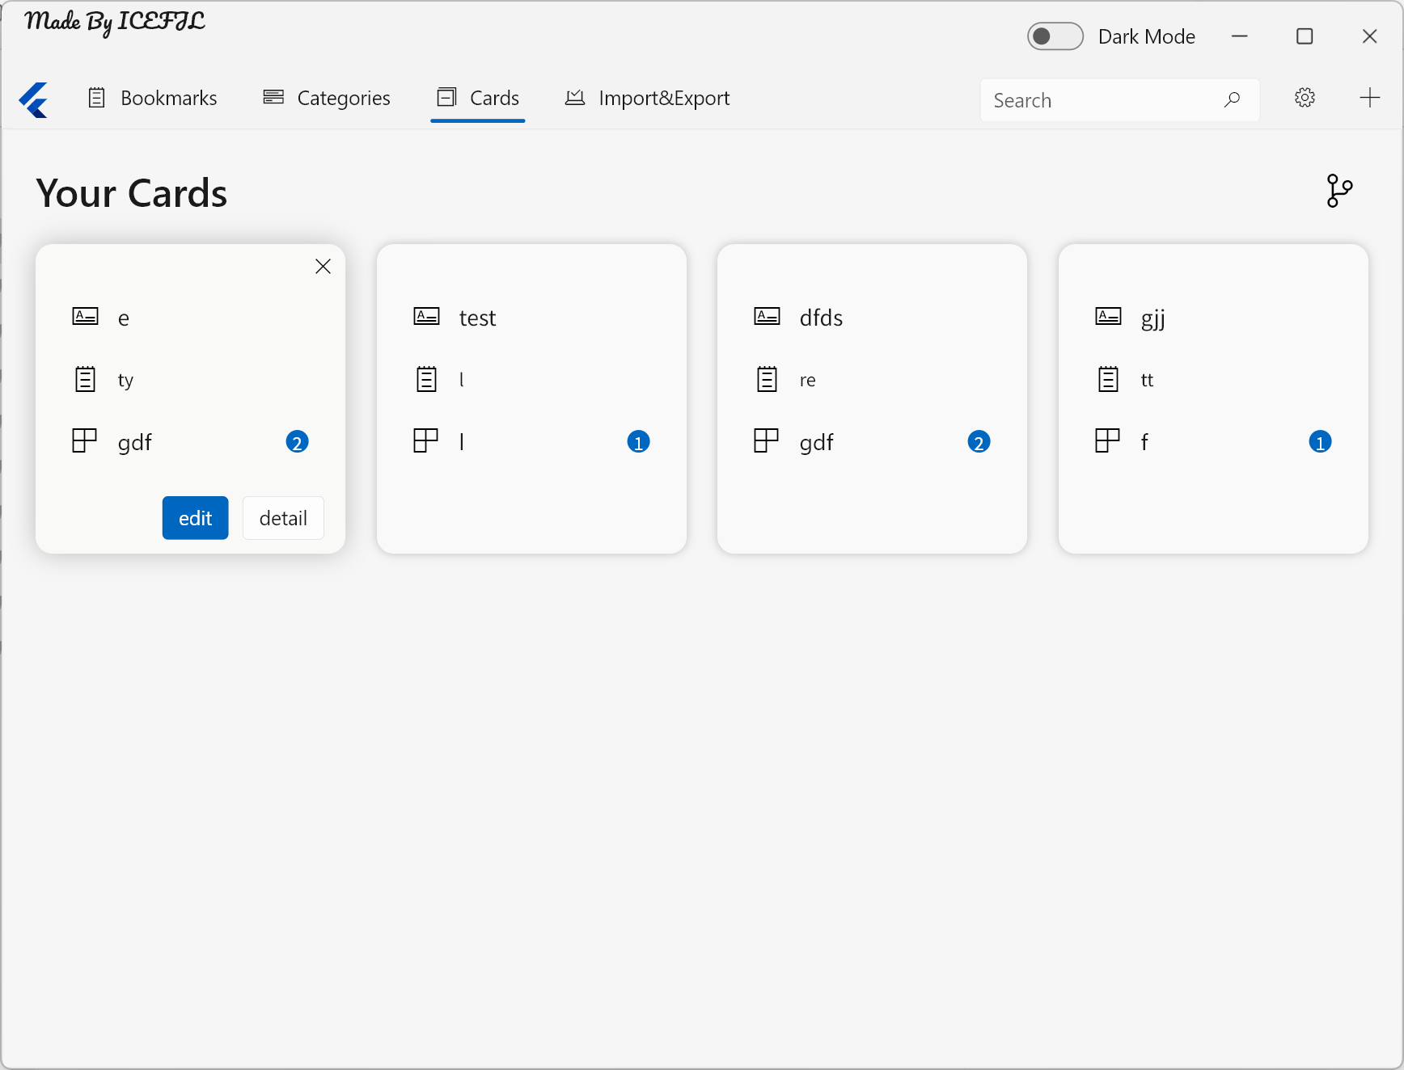

Category类
category_page.dart | Category界面

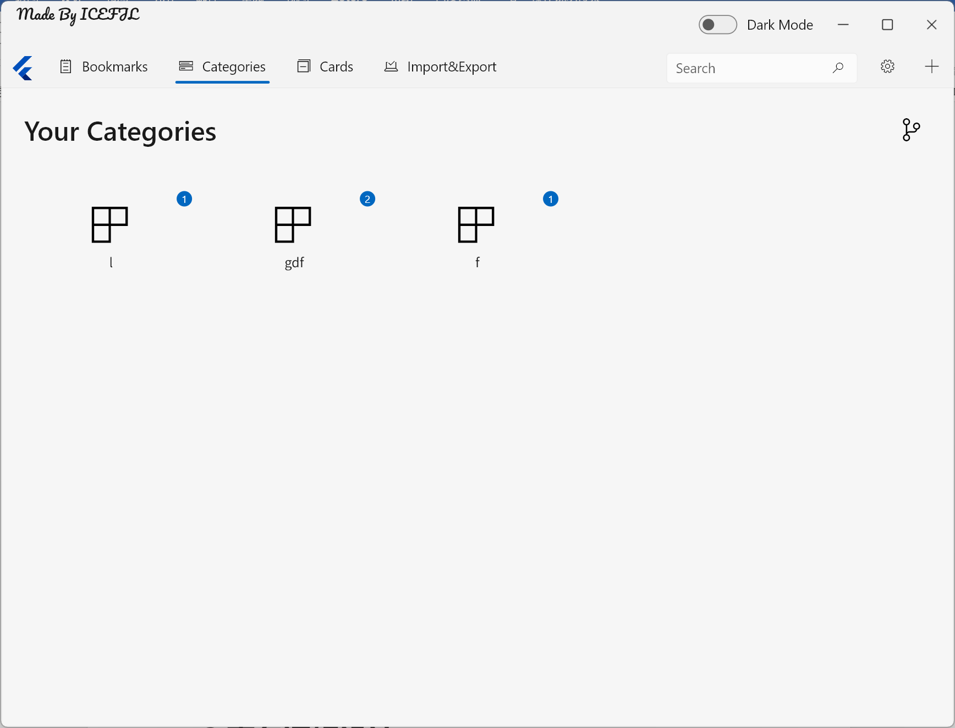

Filemanager类
save_page.dart | 全局数据导入和导出

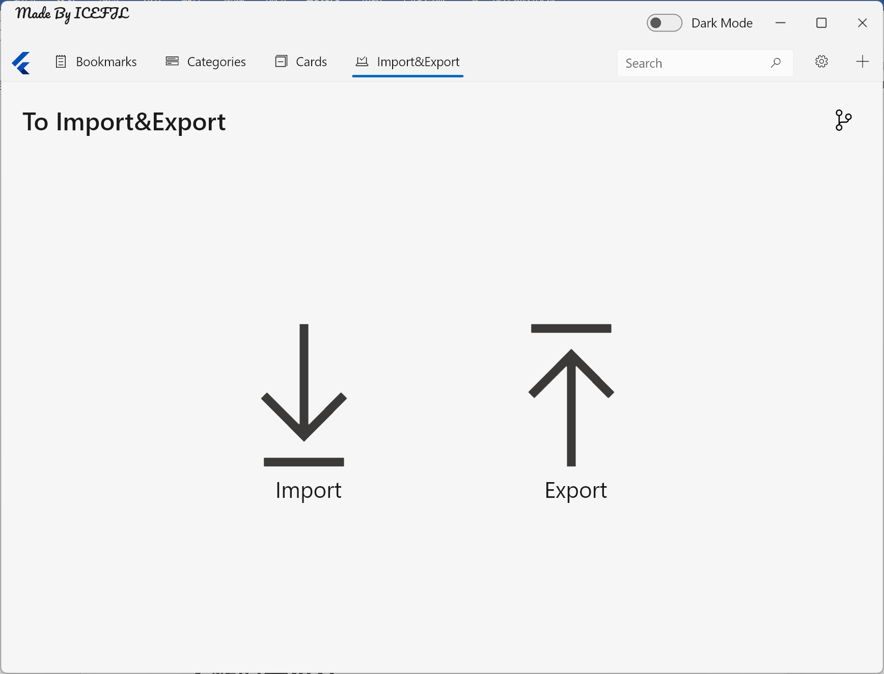

CardManager类
cardmanager.dart | 编辑或创建卡片，可在bookmark或category界面选择并创建带有选择类型的卡片
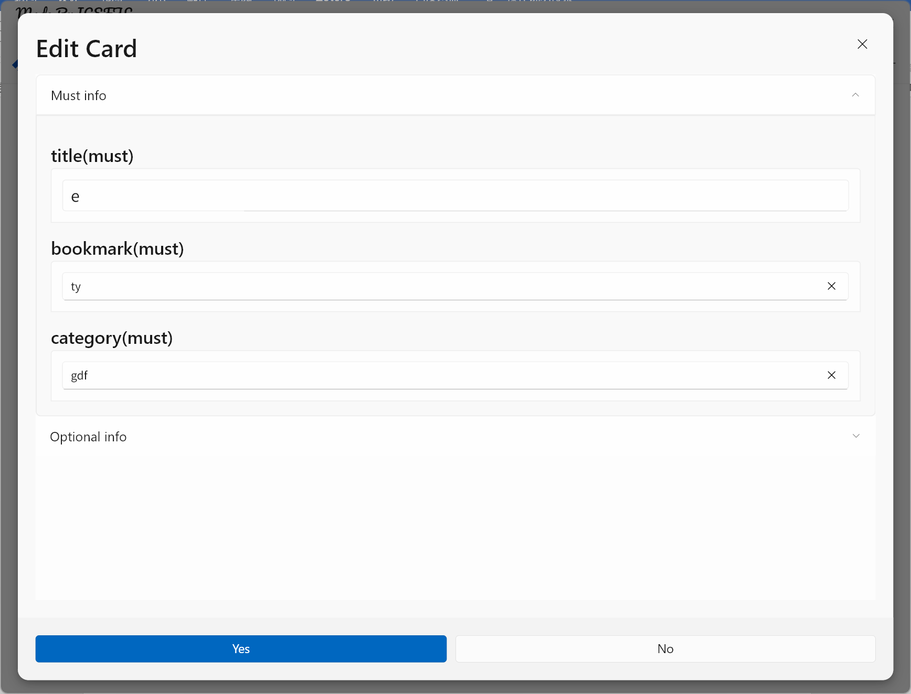
cardmanager.dart | 展示卡片内容，并可将卡片保存为markdown文件或通过第三方编辑器打开
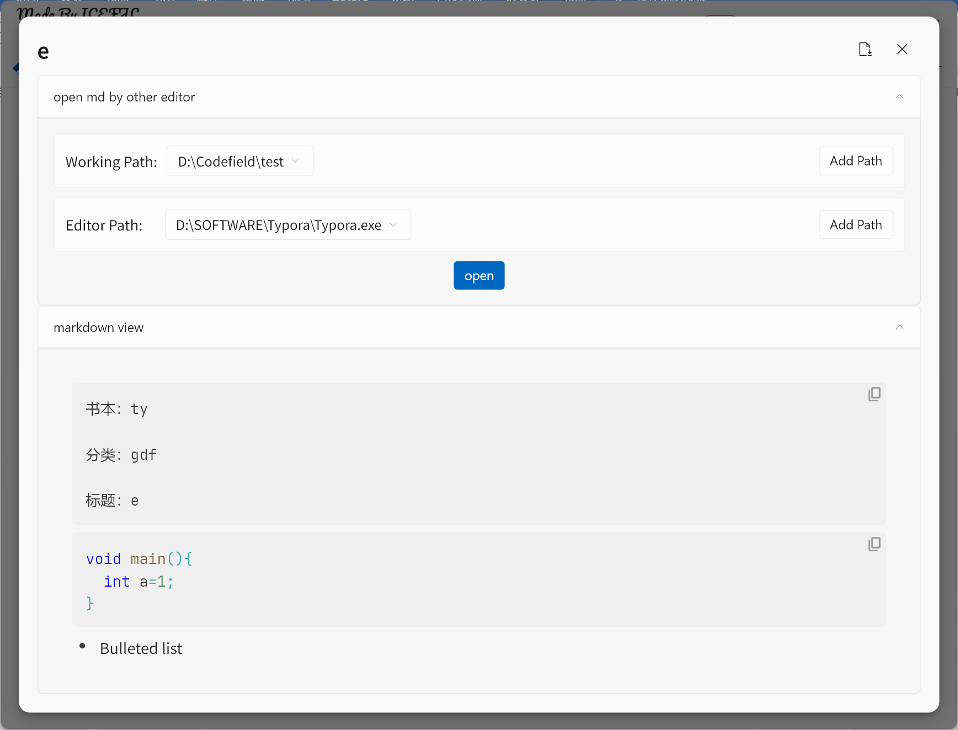

3事务逻辑设计

类图
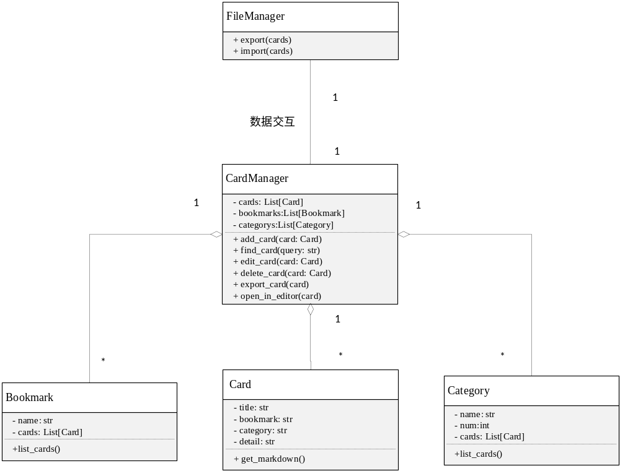

顺序图

创建卡片和查找卡片
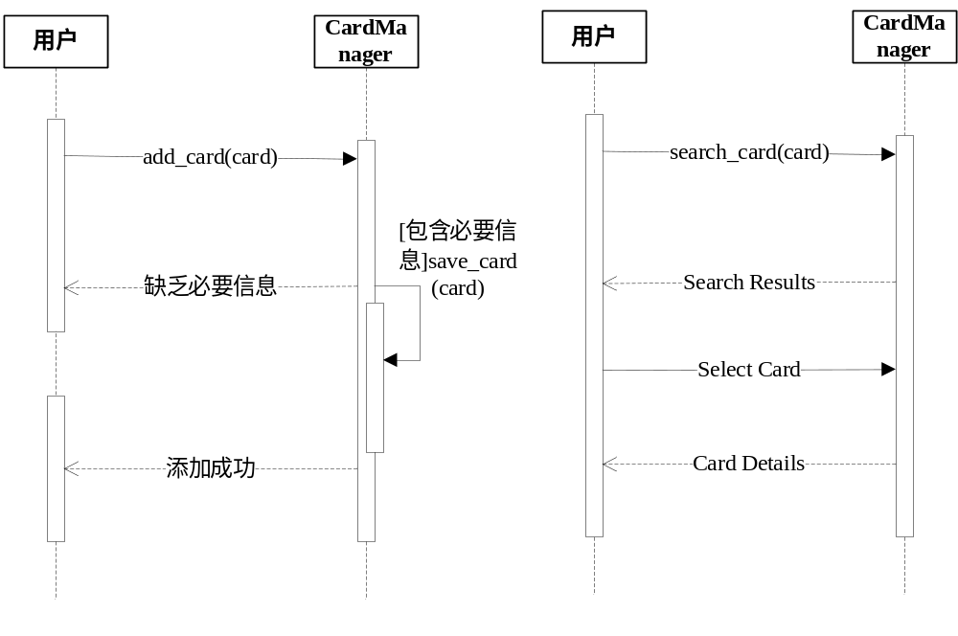

修改卡片和删除卡片
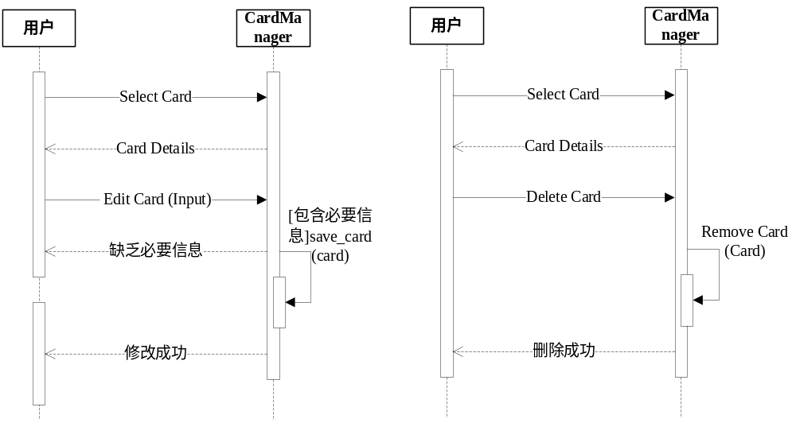

全局导入和导出
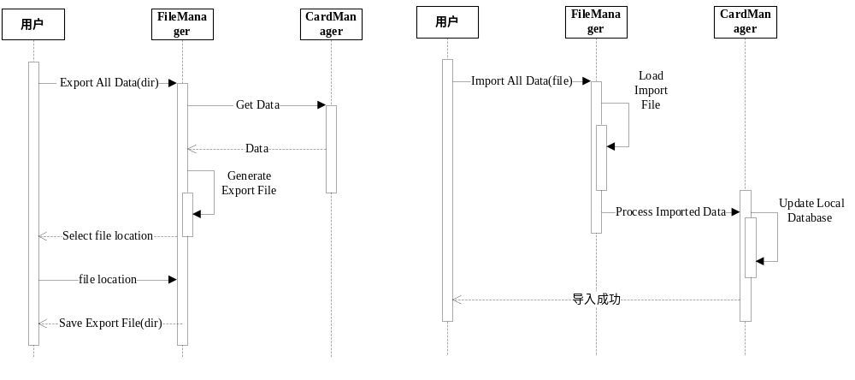

单文件导出、第三方编辑
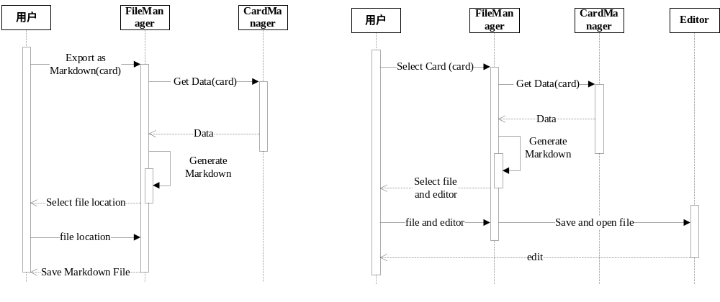

BookMarks类
class Book {
@jsonIgnore
Id id = Isar.autoIncrement;
String name = "";

static Future<List<Book>> allBooks() async {
final List<Book> books = [];
final ret = await isar.bookModels.where().findAll();
for (final v in ret) {
books.add(Book()
..id = v.id
..name = v.name);
}
return books;
}

static Future<BookModel?> get(int id) async {
assert(id != Isar.autoIncrement);
final ret = await isar.bookModels.get(id);
return ret;
}

static Future<bool> delete(int id) async {
return await isar.writeTxn(() async {
return isar.bookModels.delete(id);
});
}

static Future<BookModel?> getByName(String name) async {
final ret = await isar.bookModels.where().nameEqualTo(name).findFirst();
return ret;
}

static Future<List<Content>> allContents(Book book) async {
assert(book.id != Isar.autoIncrement);

final List<Content> contents = [];
final ret =
await isar.contentModels.filter().bookIdEqualTo(book.id).findAll();
for (final v in ret) {
final book = await Book.get(v.bookId);
final category = await Category.get(v.categoryId);

contents.add(Content()
..id = v.id
..title = v.title
..detail = v.detail
..book.id = v.bookId
..category.id = v.categoryId
..book.name = book!.name
..category.name = category!.name
..category.count = category.count);
}
return contents;
}

static Future<int> newBook(Book book) async {
return await isar.writeTxn(() async {
return isar.bookModels.put(BookModel()
..name = book.name
..id = book.id);
});
}
}

Category类
class Category {
@jsonIgnore
Id id = Isar.autoIncrement;
String name = "";
int count = 0;

static Future<List<Category>> allCategory() async {
final List<Category> category = [];
final ret = await isar.categoryModels.where().findAll();
for (final v in ret) {
category.add(Category()
..id = v.id
..name = v.name
..count = v.count);
}
return category;
}

static Future<CategoryModel?> get(int id) async {
assert(id != Isar.autoIncrement);
return await isar.categoryModels.get(id);
}

static Future<bool> delete(int id) async {
return await isar.writeTxn(() async {
return await isar.categoryModels.delete(id);
});
}

static Future<CategoryModel?> getByName(String name) async {
return await isar.categoryModels.where().nameEqualTo(name).findFirst();
}

static Future<int> newCategory(Category category) async {
return isar.writeTxn(() async {
return await isar.categoryModels.put(CategoryModel()
..name = category.name
..id = category.id
..count = category.count);
});
}

static Future<List<Content>> allContents(Category category) async {
assert(category.id != Isar.autoIncrement);

final List<Content> contents = [];
final ret = await isar.contentModels
.filter()
.categoryIdEqualTo(category.id)
.findAll();
for (final v in ret) {
final book = await Book.get(v.bookId);
final category = await get(v.categoryId);
final con = Content()
..id = v.id
..title = v.title
..detail = v.detail
..book.id = v.bookId
..category.id = v.categoryId
..book.name = book!.name
..category.name = category!.name
..category.count = category.count;

contents.add(con);
}
return contents;
}
}

Card类
class Content {
@jsonIgnore
Id id = Isar.autoIncrement;
String title = "";
Category category = Category();
Book book = Book();
String? detail;

@override
String toString() {
return 'id:$id title:$title category:${category.name} book:${book.name}';
}

Content clone() {
final ret = Content();
ret.book = Book();
ret.category = Category();
ret.title = title;
ret.detail = detail;
ret.id = id;
ret.book.name = book.name;
ret.category.name = category.name;
ret.category.count = category.count;
return ret;
}

static Future<bool> delete(int id) async {
return await isar.writeTxn(() async {
return await isar.contentModels.delete(id);
});
}

static Future<int> deleteByCategoryId(int id) async {
return await isar.writeTxn(() async {
return await isar.contentModels
.filter()
.categoryIdEqualTo(id)
.deleteAll();
});
}

static Future<int> deleteByBookId(int id) async {
final list = await isar.contentModels.filter().bookIdEqualTo(id).findAll();
for (final v in list) {
final cate = await Category.get(v.categoryId);
if (cate != null && cate.count > 0) {
cate.count--;
Category.newCategory(Category()
..id = cate.id
..name = cate.name
..count = cate.count);
}
}
final ret = await isar.writeTxn(() async {
return await isar.contentModels.filter().bookIdEqualTo(id).deleteAll();
});

return ret;
}

static Future<int> newContent(Content content, {needPlus = true}) async {
//check if exsit
if (content.book.id == Isar.autoIncrement) {
final b = await Book.getByName(content.book.name);
if (b != null) {
content.book.id = b.id;
}
}
if (content.category.id == Isar.autoIncrement) {
final b = await Category.getByName(content.category.name);
if (b != null) {
content.category.id = b.id;
content.category.count = b.count;
}
}
if (needPlus) content.category.count++;

//add book or category
final bid = await Book.newBook(content.book);
final cid = await Category.newCategory(content.category);
final id = await isar.writeTxn(() async {
return await isar.contentModels.put(ContentModel()
..id = content.id
..bookId = bid
..categoryId = cid
..title = content.title
..detail = content.detail);
});

return id;
}

static Future<List<Content>> allContent() async {
final List<Content> contents = [];
final ret = await isar.contentModels.where().findAll();
for (final v in ret) {
final book = await Book.get(v.bookId);
final category = await Category.get(v.categoryId);
final content = Content()
..id = v.id
..title = v.title
..book.id = v.bookId
..category.id = v.categoryId
..book.name = book!.name
..category.name = category!.name
..category.count = category.count
..detail = v.detail;
contents.add(content);
}
logger.d('len:${contents.length} $contents');
return contents;
}

static Future<List<Content>> titleStartWith(String pattern) async {
final searchContents = <Content>[];
final ret = await allContent();
for (final v in ret) {
if (!v.title.startsWith(pattern)) {
continue;
}
searchContents.add(v);
if (searchContents.length > 10) {
break;
}
}

logger.d('len:${searchContents.length} $searchContents');

return searchContents;
}
}

Filemanager类
class SavePage extends StatefulWidget {
const SavePage({Key? key}) : super(key: key);

@override
State<SavePage> createState() => _SavePageState();
}

class _SavePageState extends State<SavePage> {
@override
Widget build(BuildContext context) {
return ScaffoldPage(
header: PageHeader(
title: const Text('To Import&Export'),
commandBar: Row(mainAxisAlignment: MainAxisAlignment.end, children: [
Link(
uri: Uri.parse('https://github.com/ICEFJL'),
builder: (context, open) => Tooltip(
message: 'About author',
child: IconButton(
icon: const Icon(FluentIcons.open_source, size: 24.0),
onPressed: open,
),
),
),
]),
),
content: Row(
mainAxisAlignment: MainAxisAlignment.center,
children: getImportAndExportButton()));
}

Widget getHoverButton(
{required IconData icon,
required VoidCallback onPressed,
required String text,
double? iconSize,
double? fontSize,
double? width,
double? height}) {
return HoverButton(
onPressed: onPressed,
cursor: SystemMouseCursors.copy,
builder: (context, states) {
return FocusBorder(
focused: states.isFocused,
renderOutside: false,
child: RepaintBoundary(
child: AnimatedContainer(
width: width,
height: height,
duration: FluentTheme.of(context).slowAnimationDuration,
decoration: BoxDecoration(
color: ButtonThemeData.uncheckedInputColor(
FluentTheme.of(context),
states,
transparentWhenNone: true,
),
borderRadius: BorderRadius.circular(20.0),
),
padding: const EdgeInsets.all(6.0),
child: Column(
mainAxisAlignment: MainAxisAlignment.center,
mainAxisSize: MainAxisSize.min,
children: [
const SizedBox(
height: 20.0,
),
Icon(
icon,
size: iconSize,
color: FluentTheme.of(context).brightness.isDark
? Colors.white.withRed(495)
: Colors.grey[150],
),
Padding(
padding: const EdgeInsetsDirectional.only(top: 8.0),
child: Text(
text,
style: TextStyle(fontSize: fontSize),
textAlign: TextAlign.center,
overflow: TextOverflow.fade,
),
),
const SizedBox(
height: 20.0,
)
],
),
),
),
);
},
);
}

List<Widget> getImportAndExportButton() {
return [
Builder(builder: (context) {
return getHoverButton(
icon: FluentIcons.download,
iconSize: 160.0,
width: 250.0,
fontSize: 25.0,
onPressed: () async {
final res = await FilePicker.platform.pickFiles(
type: FileType.custom,
allowedExtensions: ["json"],
);
if (res != null) {
final file = File(res.paths.first!);
final crimson = Crimson(await file.readAsBytes());
final contents = crimson.readContentOrNullList();
contentBase64Decode(contents);
int count = 0;
for (final content in contents) {
if (content != null) {
final id = await Content.newContent(content);
if (id > 0) ++count;
}
}
final appData = context.read<AppData>();
await appData.loadAsync();

// ignore: use_build_context_synchronously
await showInfoBar(context,
title: Text(
'提示:',
style: getFontStyle(size: 14.0),
),
content: Text(
'成功导入$count条数据',
style: getFontStyle(size: 14.0),
));
}
},
text: 'Import');
}),
const SizedBox(
width: 50.0,
),
getHoverButton(
icon: FluentIcons.upload,
iconSize: 160.0,
width: 250.0,
fontSize: 25.0,
onPressed: () async {
final res = await FilePicker.platform.getDirectoryPath(
dialogTitle: 'Please select an output dir:',
);
if (res != null) {
final writer = CrimsonWriter();
final contents = await Content.allContent();
contentBase64Encode(contents);
writer.writeContentOrNullList(contents);
File('$res/note_with_cards.json')
.writeAsBytesSync(writer.toBytes(), flush: true);
// ignore: use_build_context_synchronously
await showInfoBar(context,
title: Text(
'提示:',
style: getFontStyle(size: 14.0),
),
content: Text(
'成功导出${contents.length}条数据',
style: getFontStyle(size: 14.0),
));
}
},
text: 'Export'),
];
}
}

Cardmanager
class CardManager {
static final _titleController = TextEditingController();
static final _bookContorller = TextEditingController();
static final _categoryController = TextEditingController();
static final _markdownController = TextEditingController();
static final _markdownFocusNode = FocusNode();
static final textScrollController = ScrollController();
static final scrollController = ScrollController();

static bool isListenMarkdown = false;

static Widget _mainPage(Content? content, BuildContext context,
{bool fixedBook = false, bool fixedCate = false}) {
if (content != null) {
_titleController.value = TextEditingValue(text: content.title);
_bookContorller.value = TextEditingValue(text: content.book.name);
_categoryController.value = TextEditingValue(text: content.category.name);
_markdownController.value = TextEditingValue(text: content.detail ?? "");
}
final appData = context.read<AppData>();
final commonData = context.read<CommonData>();
if (!isListenMarkdown) {
_markdownController.addListener(() {
commonData.setMarkdownTxt(_markdownController.text);
});
}

return mt.Scaffold(
body: SingleChildScrollView(
controller: scrollController,
child: FocusTraversalGroup(
policy: OrderedTraversalPolicy(),
child: Column(
children: [
Expander(
initiallyExpanded: true,
header: const Text('Must info'),
content: Column(
crossAxisAlignment: CrossAxisAlignment.start,
children: [
subtitle(content: const Text("title(must)")),
Card(
borderRadius: const BorderRadius.vertical(
top: Radius.circular(4.0)),
child: TextBox(
style: getFontStyle(
size: 20.0, fontWeight: FontWeight.w500),
controller: _titleController,
maxLines: null,
),
),
subtitle(content: const Text("bookmark(must)")),
Card(
borderRadius: const BorderRadius.vertical(
top: Radius.circular(4.0)),
child: AutoSuggestBox<Book>(
placeholder: _getBookmark(content),
enabled: !fixedBook,
style: getFontStyle(
size: 14.0, fontWeight: FontWeight.w500),
controller: _bookContorller,
items: appData.books
.map<AutoSuggestBoxItem<Book>>(
(e) => AutoSuggestBoxItem(
label: e.name,
value: e,
onFocusChange: (focused) {
if (focused) print("focus $e");
}))
.toList()),
),
subtitle(content: const Text("category(must)")),
Card(
borderRadius: const BorderRadius.vertical(
top: Radius.circular(4.0)),
child: AutoSuggestBox<Category>(
placeholder: _getCategory(content),
enabled: !fixedCate,
style: getFontStyle(
size: 14.0, fontWeight: FontWeight.w500),
controller: _categoryController,
items: appData.category
.map<AutoSuggestBoxItem<Category>>((e) =>
AutoSuggestBoxItem(
label: e.name, value: e))
.toList()),
),
],
)),
Expander(
headerShape: (open) => const RoundedRectangleBorder(
borderRadius: BorderRadius.zero,
),
header: const Text('Optional info'),
content: Row(
crossAxisAlignment: CrossAxisAlignment.start,
children: [
Expanded(
flex: 2,
child: mt.Padding(
padding: const EdgeInsets.fromLTRB(
2.0, 10.0, 15.0, 2.0),
child: Column(
children: [
MarkdownToolbar(
width: 45.0,
height: 32.0,
useIncludedTextField: false,
controller: _markdownController,
focusNode: _markdownFocusNode,
),
const mt.Divider(),
RawKeyboardListener(
focusNode: FocusNode(),
onKey: (RawKeyEvent event) {
if (event.logicalKey ==
LogicalKeyboardKey.tab) {
// 插入tab字符到文本框中
final TextEditingValue value =
_markdownController.value;
final int start =
value.selection.baseOffset;
final int end =
value.selection.extentOffset;
final TextEditingValue text =
TextEditingValue(
text:
'${value.text.substring(0, start)}\t\t${value.text.substring(end)}',
selection: TextSelection.collapsed(
offset: start + 1),
);
_markdownController.value = text;
}
},
child: mt.TextField(
scrollController: textScrollController,
controller: _markdownController,
focusNode: _markdownFocusNode,
textInputAction:
TextInputAction.newline,
minLines: 5,
maxLines: null,
style: getFontStyle(size: 18.0),
decoration: mt.InputDecoration(
hintText: '输入...',
hintStyle: getFontStyle(
size: 18.0,
),
labelText: 'detail text',
border:
const mt.OutlineInputBorder(),
enabledBorder:
const mt.OutlineInputBorder()),
),
)
],
)),
),
Expanded(
flex: 2,
child: Padding(
padding: const EdgeInsets.fromLTRB(
2.0, 10.0, 15.0, 2.0),
child: Column(
children: [
Text(
'MarkDown Preview',
style: getFontStyle(size: 25.0),
),
const SizedBox(
height: 20.0,
),
Consumer(
builder:
(context, CommonData value, child) {
return MyMarkdownView(
text: value.markdownTxt,
);
},
),
],
),
),
),
],
)),
],
),
)));
}

static Future<Content?> _newContent(
{Content? content,
required BuildContext context,
bool fixedBook = false,
bool fixedCate = false}) async {
Content ret = content ?? Content();
bool status = true;
if (content == null) _titleController.clear();
await showDialog(
context: context,
builder: (context) {
return ContentDialog(
title: Stack(
children: [
const DragToMoveArea(
child: Row(
children: [
Text('Edit Card'),
Expanded(child: SizedBox()),
],
),
),
Align(
alignment: Alignment.topRight,
child: IconButton(
icon: const Icon(FluentIcons.cancel),
onPressed: () {
Navigator.pop(context);
status = false;
}),
),
],
),
constraints: const BoxConstraints(
maxHeight: 1280.0,
maxWidth: 1920.0,
),
content: _mainPage(content, context,
fixedBook: fixedBook, fixedCate: fixedCate),
actions: [
FilledButton(
child: const Text('Yes'),
onPressed: () async {
final commonData = context.read<CommonData>();
ret.title = _titleController.text;
if (_titleController.text.isEmpty) {
await showCheckFieldError(context, '标题未填写');
return;
}
if (!fixedBook) {
if (_bookContorller.text.isEmpty) {
await showCheckFieldError(context, '书本名未填写');
return;
}
ret.book.name = _bookContorller.text;
}
if (!fixedCate) {
if (_categoryController.text.isEmpty) {
// ignore: use_build_context_synchronously
await showCheckFieldError(context, '分类未填写');
return;
}
ret.category.name = _categoryController.text;
}
ret.detail = commonData.markdownTxt;
// ignore: use_build_context_synchronously
Navigator.pop(context);
status = true;
},
),
Button(
child: const Text('No'),
onPressed: () {
Navigator.pop(context);
status = false;
},
),
],
);
});
return status ? ret : null;
}

static showCheckFieldError(BuildContext context, String errorInfo) async {
await displayInfoBar(context, builder: (context, close) {
return InfoBar(
title: const Text('未填写字段:'),
content: Text(errorInfo),
action: IconButton(
icon: const Icon(FluentIcons.clear),
onPressed: close,
),
severity: InfoBarSeverity.error,
);
});
}

static editContent(Content content, BuildContext context,
{bool fixedBook = false,
bool fixedCate = false,
bool onlyEdit = false}) async {
Content? old;

if (onlyEdit) {
old = content.clone();
}

final ret = await _newContent(
content: content,
context: context,
fixedBook: fixedBook,
fixedCate: fixedCate);
if (ret == null) return;

// ignore: use_build_context_synchronously
final appData = Provider.of<AppData>(context, listen: false);
int id;
bool needPlus = true;
if (onlyEdit) {
needPlus = false;
if (old!.book.name != ret.book.name) {
final n = await Book.getByName(ret.book.name);
ret.book.id = n == null ? Isar.autoIncrement : n.id;
}
if (old.category.name != ret.category.name) {
final n = await Category.getByName(ret.category.name);
//把修改前的分类对应的数量-1
old.category.count -= 1;
old.category.id = ret.category.id;
id = await appData.addCategory(old.category);
//修改后的对应的分类需要+1
needPlus = true;
if (n == null) {
ret.category.id = Isar.autoIncrement;
ret.category.count = 0;
} else {
ret.category.id = n.id;
ret.category.count = n.count;
}
}
}
id = await appData.addContent(ret, needPlus: needPlus);
// ignore: use_build_context_synchronously
await displayInfoBar(context, builder: (context, close) {
return InfoBar(
title: const Text('结果:'),
content: Text(id == content.id ? '成功编辑内容' : '成功创建内容'),
action: IconButton(
icon: const Icon(FluentIcons.clear),
onPressed: close,
),
severity: InfoBarSeverity.info,
);
});
}

static Widget getComboBoxWidget(
{required String keyName,
required String title,
required void Function(String?) call,
required VoidCallback addCall}) {
return Row(
children: [
Text(
title,
style: getFontStyle(size: 17.0),
),
const SizedBox(
width: 10.0,
),
Consumer2(builder: (context, AppData value, CommonData value2, child) {
final list = value.getValuesByKey(keyName);
return list == null
? Button(
onPressed: null,
child: Text(
'please add a path',
style: getFontStyle(size: 16.0),
))
: ComboBox<String>(
value:
keyName == 'work' ? value2.workPath : value2.editorPath,
items: list
.map((e) => ComboBoxItem(
value: e,
child: Text(
e,
style: getFontStyle(size: 16.0),
),
))
.toList(),
onChanged: (v) {
logger.d(v);
call(v);
},
);
}),
const Expanded(child: SizedBox()),
Button(onPressed: addCall, child: const Text('Add Path'))
],
);
}

static showContent(Content content, BuildContext context) async {
final text = '''
```
书本：${content.book.name}

分类：${content.category.name}

标题：${content.title}
```
${content.detail ?? ""}''';
await showDialog(
context: context,
builder: (ctx) {
return ContentDialog(
constraints: const BoxConstraints(
maxHeight: 1080,
maxWidth: 1920,
),
title: Stack(
children: [
DragToMoveArea(
child: Row(
children: [
Text(
content.title,
style: getFontStyle(size: 25.0),
),
const Expanded(child: SizedBox()),
],
),
),
Builder(builder: (context) {
return Positioned(
right: 45.0,
child: Tooltip(
message: 'save as markdown file',
child: IconButton(
icon: const Icon(FluentIcons.download_document),
onPressed: () async {
final ret = await FilePicker.platform.saveFile(
fileName: '${content.title}.md',
type: FileType.custom,
allowedExtensions: ['md']);
if (ret != null) {
logger.d(ret);
final file = File(ret);
await file.writeAsString(text, flush: true);
// ignore: use_build_context_synchronously
await showInfoBar(context,
title: Text(
'提示:',
style: getFontStyle(size: 14.0),
),
content: Text(
'导出文件成功',
style: getFontStyle(size: 14.0),
));
}
}),
),
);
}),
Positioned(
right: 5.0,
child: IconButton(
icon: const Icon(FluentIcons.cancel),
onPressed: () {
Navigator.pop(ctx);
}),
),
],
),
content: SingleChildScrollView(
child: Column(
children: [
Expander(
header: const Text('open md by other editor'),
content: Column(
children: [
Card(
child: getComboBoxWidget(
keyName: 'work',
title: 'Working Path:',
call: (v) {
if (v == null) return;
final data = context.read<CommonData>();
data.setWorkPath(v);
},
addCall: () async {
final path = await getDirctoryPath();
if (path == null) return;
// ignore: use_build_context_synchronously
final data = context.read<AppData>();
await data.addKeyValue('work', path);
data.loadValues();
}),
),
const SizedBox(
height: 10.0,
),
Card(
child: getComboBoxWidget(
keyName: 'editor',
title: 'Editor Path: ',
call: (v) {
if (v == null) return;
final data = context.read<CommonData>();
data.setEditorPath(v);
},
addCall: () async {
final paths = await getFilePaths();
if (paths == null) return;
// ignore: use_build_context_synchronously
final data = context.read<AppData>();
for (final path in paths) {
if (path == null) continue;
await data.addKeyValue('editor', path);
}
data.loadValues();
}),
),
const SizedBox(
height: 10.0,
),
Builder(builder: (context) {
return FilledButton(
child: const Text('open'),
onPressed: () async {
final data = context.read<CommonData>();
if (data.workPath.isEmpty) {
await showInfoBar(context,
title: const Text('Work path is empty!'),
severity: InfoBarSeverity.error);
return;
}
if (data.editorPath.isEmpty) {
await showInfoBar(context,
title:
const Text('Editor path is empty!'),
severity: InfoBarSeverity.error);
return;
}
final savePath =
'${data.workPath}/${content.title}.md';
final file = File(savePath);
await file.writeAsString(text, flush: true);
// ignore: use_build_context_synchronously
await showInfoBar(context,
title: Text(
'tip:',
style: getFontStyle(size: 16.0),
),
content: Text(
'Save file successful!',
style: getFontStyle(size: 18.0),
));
final process = await Process.start(
data.editorPath, [savePath]);
process.stdout
.transform(utf8.decoder)
.listen((event) {
logger.d('stdout:$event');
});
process.stderr
.transform(utf8.decoder)
.listen((event) {
logger.d('stderr:$event');
});
final code = await process.exitCode;
logger.d('exit_code:$code');
},
);
}),
],
)),
Expander(
initiallyExpanded: true,
header: const Text('markdown view'),
content: Padding(
padding: const EdgeInsets.all(20.0),
child: MyMarkdownView(
text: text,
),
),
),
],
),
),
);
});
}
}

4数据库设计

ER图
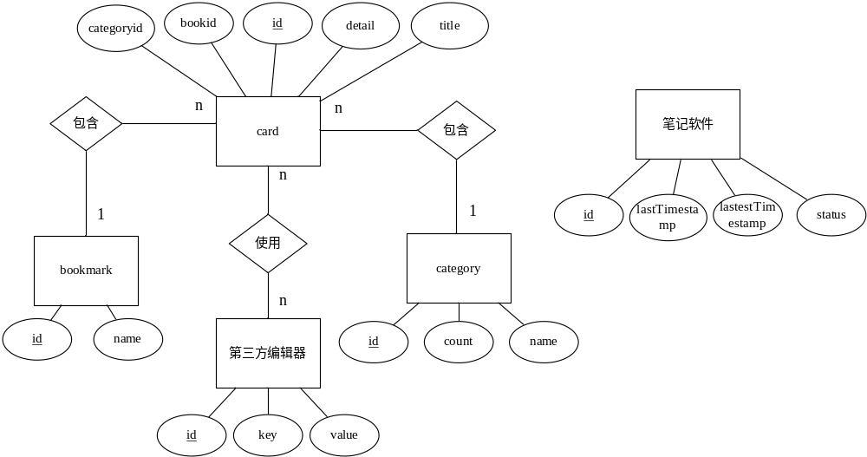

Bookmark数据
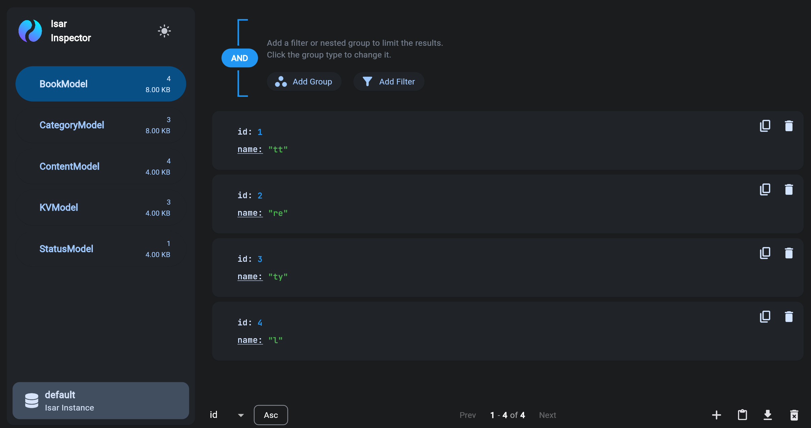

Category数据
Count代表该类型中包含的卡片数
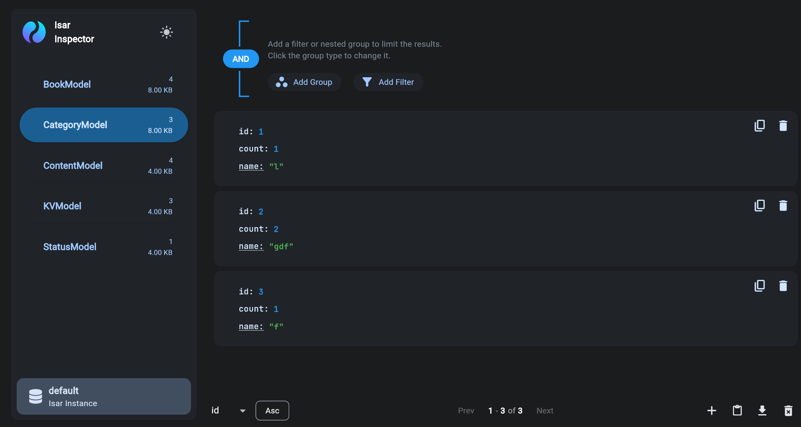

Card数据

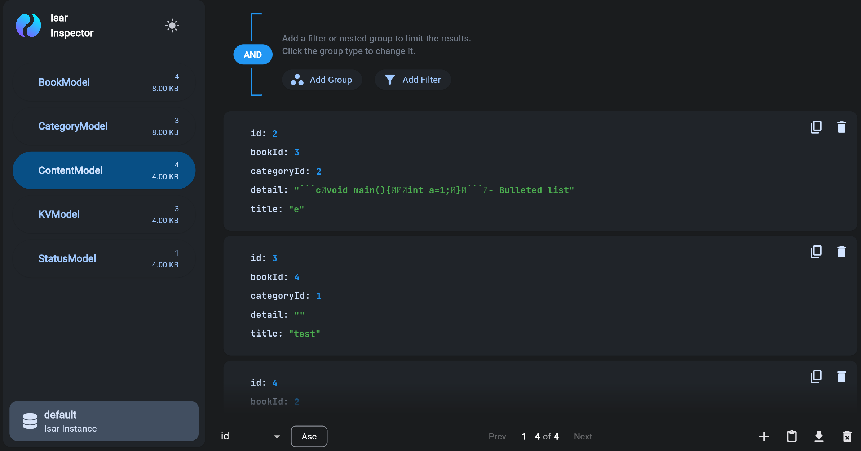

第三方编辑数据
Work代表卡片被保存为markdown文件的文件夹路径，editor代表第三方编辑器路径
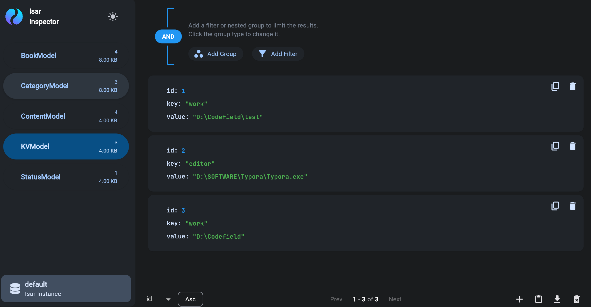

软件运行数据
Status代表当前软件运行的进程id,用来防止打开多个进程, LastTimestamp代表上次运行的时间戳
