**Quality control of ISH_assessment 2020 assessment**

**Martin Pastoors1**

25/03/2020 16:49

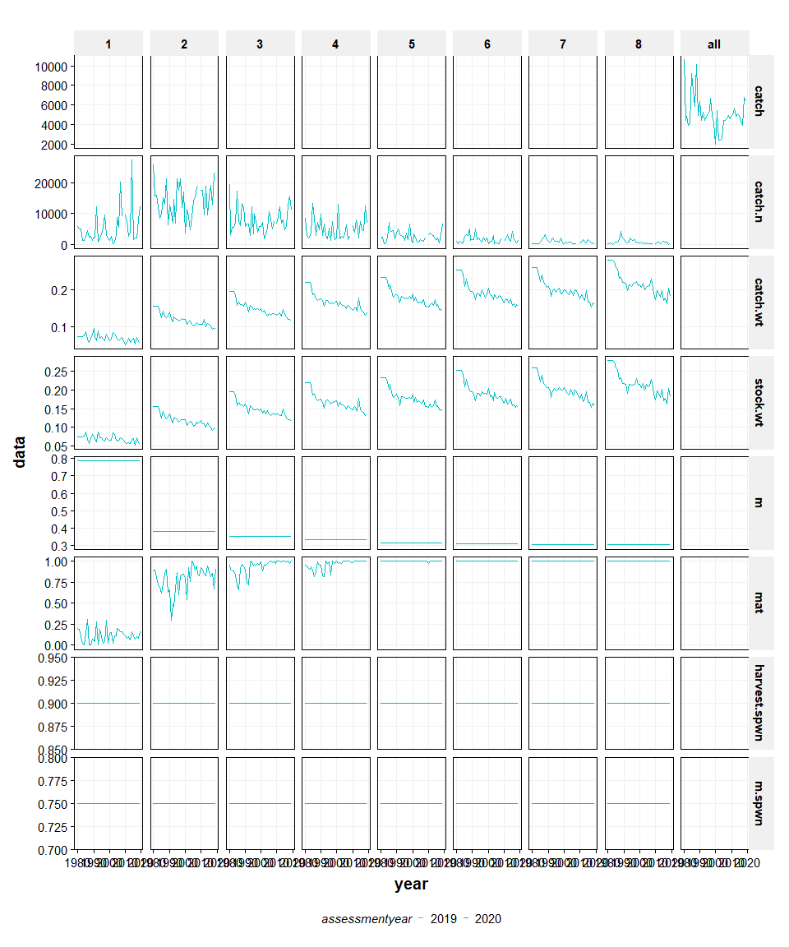

**Figure 2.2.4.x1. Irish Sea Herring. Data check on biological input data, comparing data of the 2019 and 2020 assessments.**

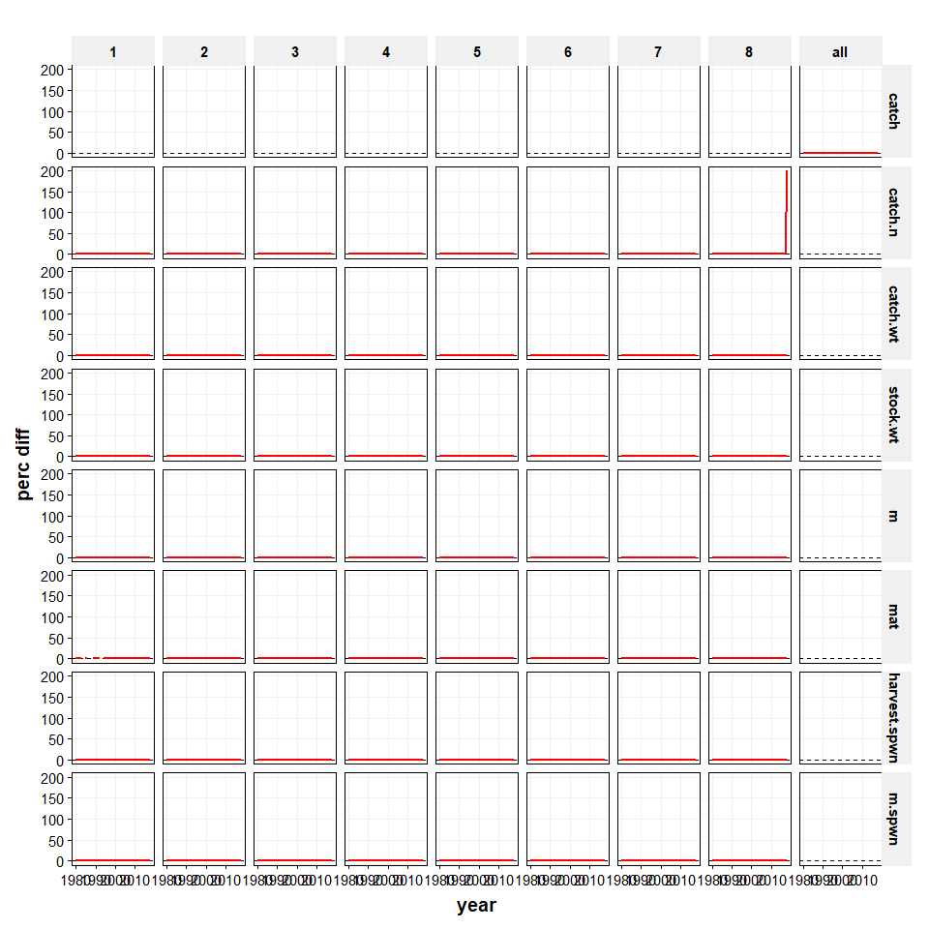

**Figure 2.2.4.x2. Irish Sea Herring. Data check on biological input data, relative difference between the 2019 and 2020 assessments.**

##### page break

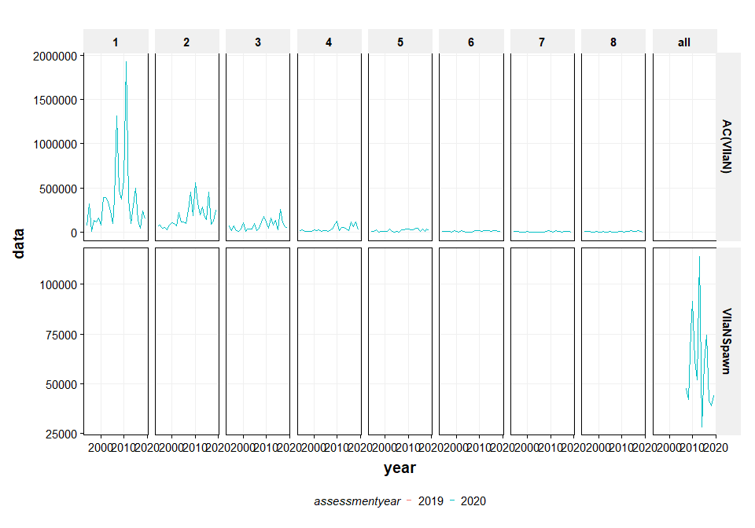

**Figure 2.2.4.x4. Irish Sea Herring. Data check on survey input data, relative difference between the 2019 and 2020 assessments.**

##### page break

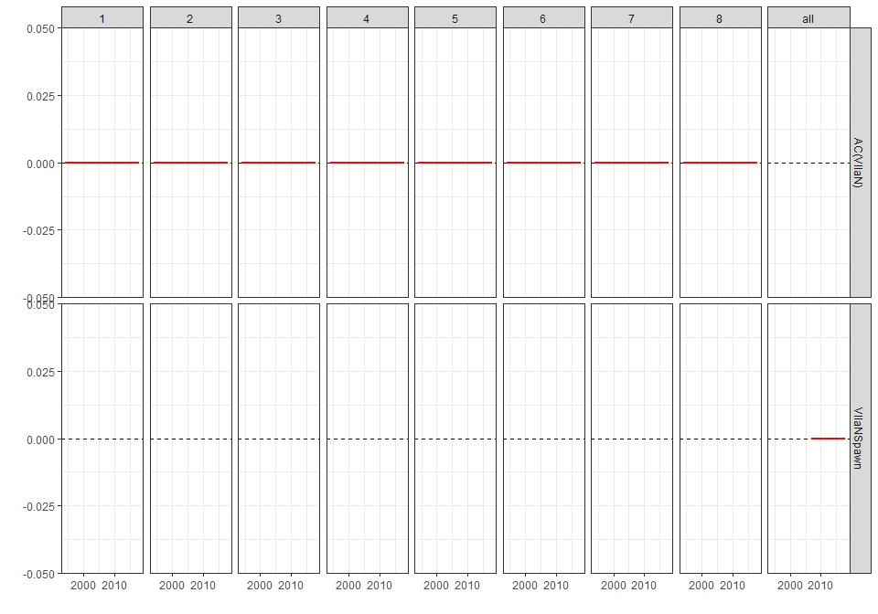

**Figure 2.2.4.x4. Irish Sea Herring. Data check on survey input data, comparing data of the 2019 and 2020 assessments.**

##### page break

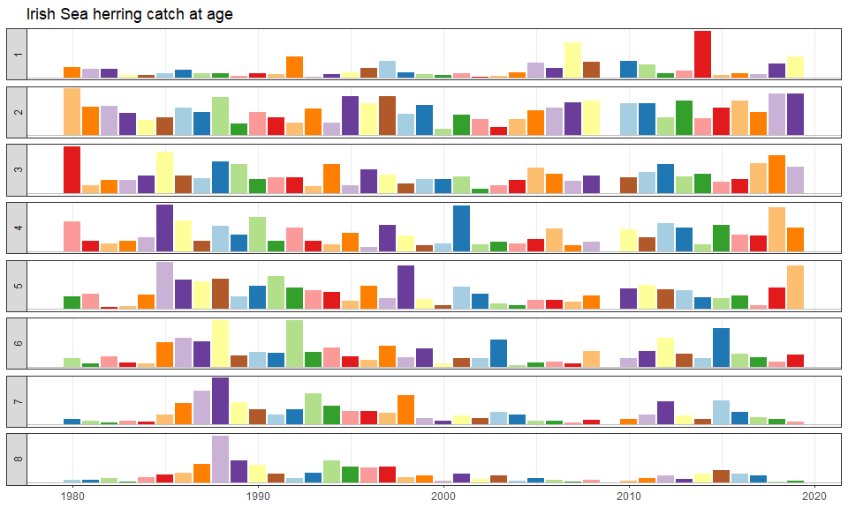

NULL

**Figure 2.6.1.2. Irish Sea Herring. Time series of catch-at-age proportion at age as used in the Irish Sea herring assessment. Colours indicate year-classes. All ages are scaled independently and therefore the size of the bars can only be compared within an age.**

##### page break

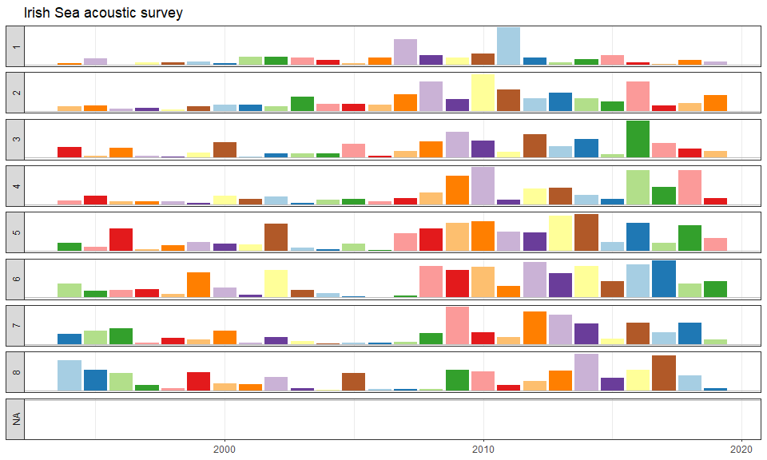

NULL

**Figure 2.6.1.4. Irish Sea Herring. Time series of the Irish Sea acoustic index by age. Colours indicate year-classes. All ages are scaled independently and cannot be compared between ages.**