**Quality control of NSH_HAWG2020_sf assessment**

**Martin Pastoors1**

23/03/2020 14:59

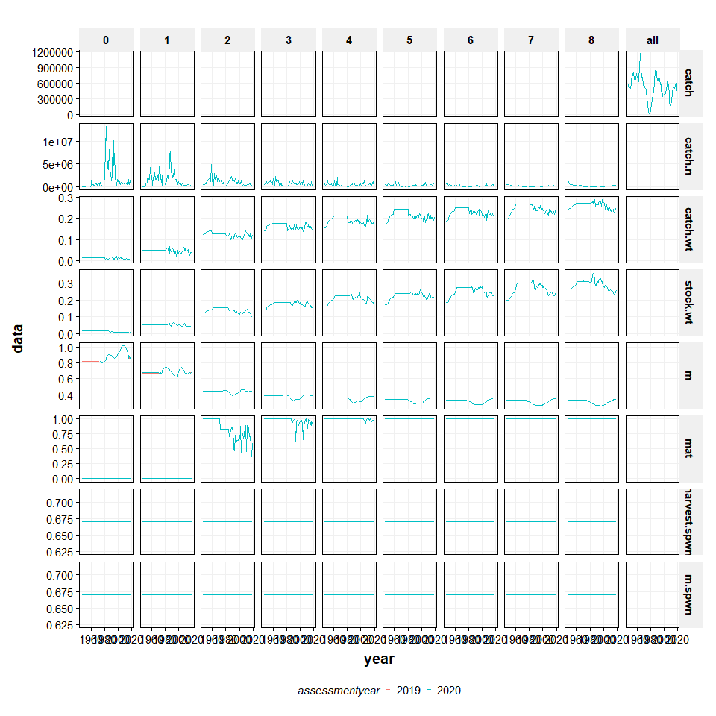

**Figure 2.2.4.x1. North Sea Herring. Data check on biological input data, comparing data of the 2019 and 2020 assessments.**

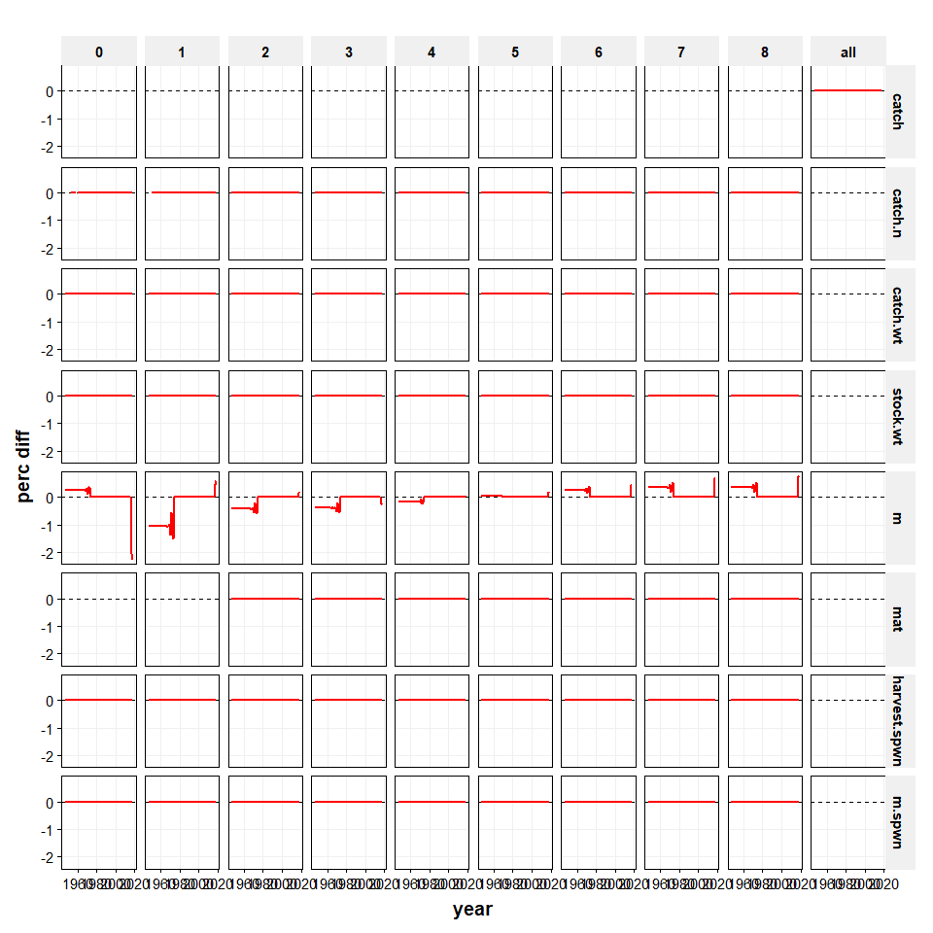

**Figure 2.2.4.x2. North Sea Herring. Data check on biological input data, relative difference between the 2019 and 2020 assessments.**

##### page break

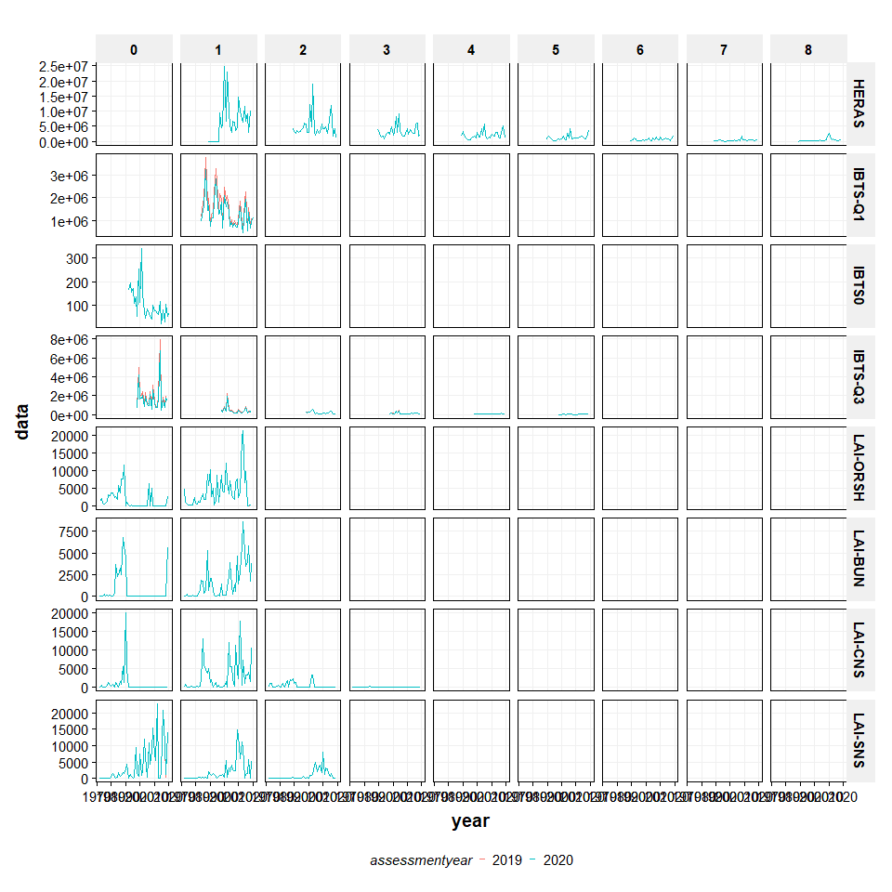

**Figure 2.2.4.x4. North Sea Herring. Data check on survey input data, relative difference between the 2019 and 2020 assessments.**

##### page break

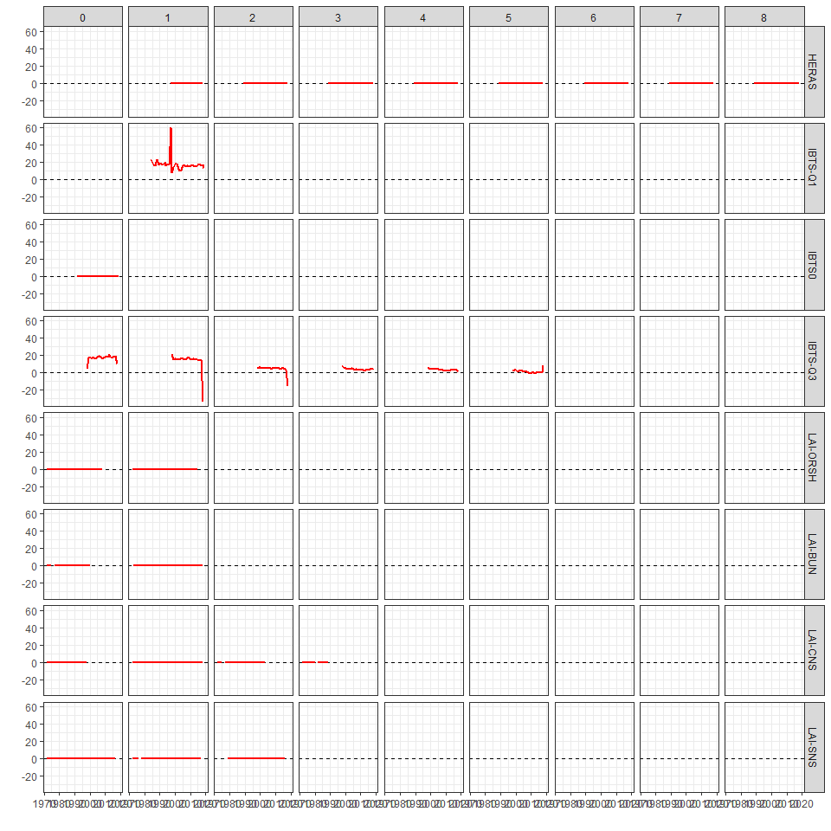

**Figure 2.2.4.x4. North Sea Herring. Data check on survey input data, comparing data of the 2019 and 2020 assessments.**

##### page break

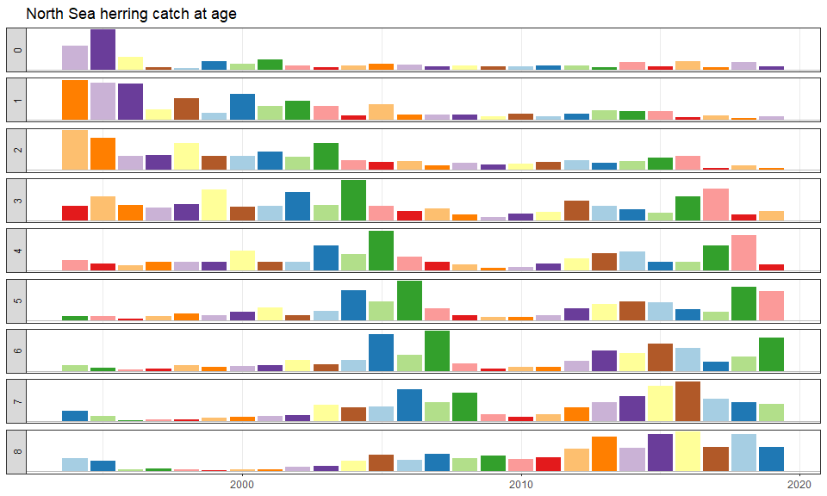

NULL

**Figure 2.6.1.2. North Sea Herring. Time series of catch-at-age proportion at ages 0–8+ as used in the North Sea herring assessment. Colours indicate year-classes. All ages are scaled independently and therefore the size of the bars can only be compared within an age.**

##### page break

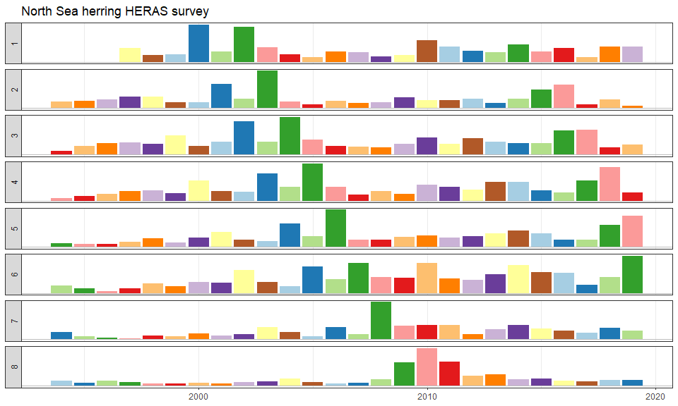

NULL

**Figure 2.6.1.4. North Sea Herring. Time series of the HERAS acoustic index by age 1–8+. Colours indicate year-classes. All ages are scaled independently and cannot be compared between ages.**

##### page break

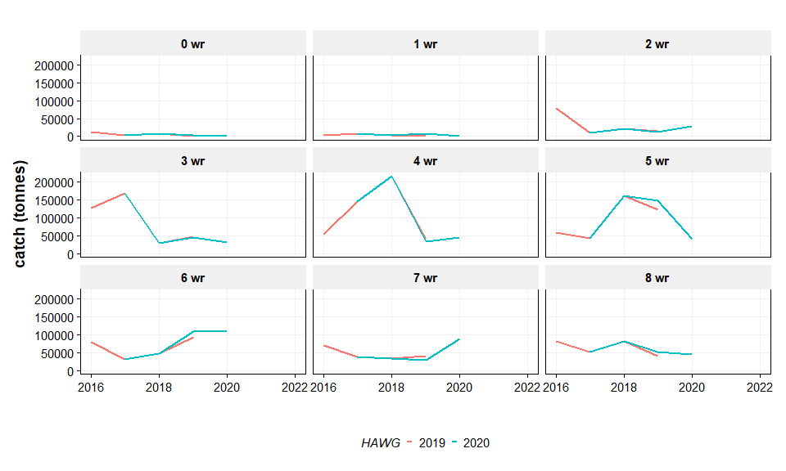

**Figure 2.7.2.1. North Sea Herring. Predicted and projected catch (in weight) between 2019 assessment (2020 as forecast year) and 2020 assessment (2021 as forecast year).**

##### page break

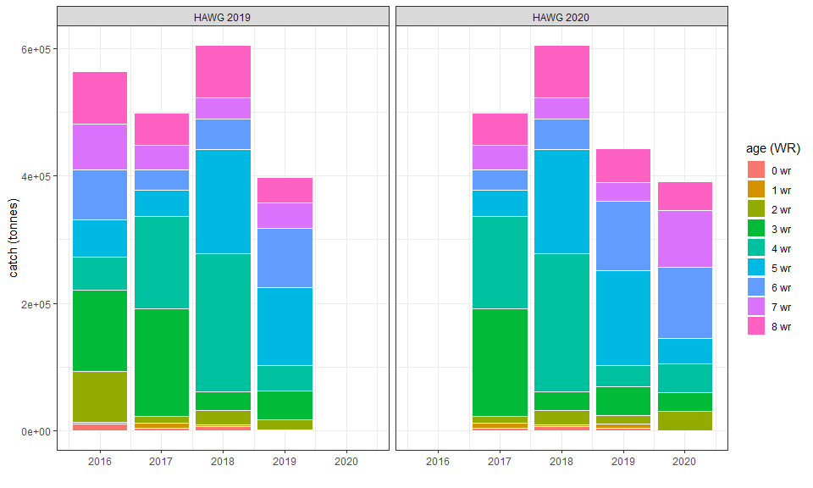

**Figure 2.7.2.2. North Sea Herring. Catch proportions for the different ages between the 2019 assessment (2020 as forecast year) and 2020 assessment (2021 as forecast year).**

##### page break

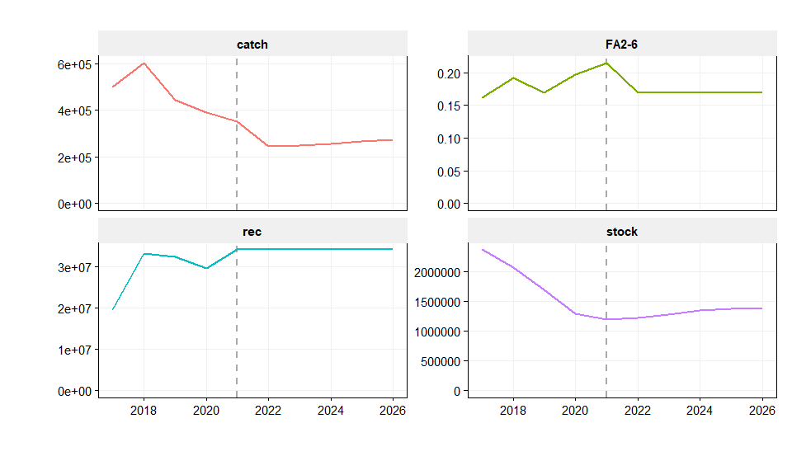

**Figure 2.7.2.3. North Sea Herring. Longer term short-term projections using an F status quo F from TAC year (i.e. advice year). Intermediate year is 2020 and the TAC year is 2021.**