**Evaluation of alternative harvest control rules for Western Baltic Herring**

**Martin Pastoors1**

15/08/2018 22:06

**Abstract**

The ICES advice for Western Baltic Spring Spawning herring (WBSS) in 2019 is for a zero TAC. The rationale behind this advice is "There are no catch scenarios that will rebuild the stock above Blim by 2020. ICES advises zero catch under such circumstances". This means that the standard interpretation of the ICES advice rule is that a zero advice will be issued if the stock cannot be rebuilt above Blim within a period of one year. However, this interpretation has not been informed by an analysis of consequences of allowing for longer periods of rebuilding to above Blim.

In this document, a variant of the standard ICES advice rule has been evaluated using a slightly modified version of the EQSIM software. The HCR variant is that below Blim, fishing mortality will be strongly reduced. This is achieved by introducing a third biomass reference point (Blim2) which is the biomass at which fishing mortality will be set to zero. The evaluations are based on the agreed reference points for WBSS herring (i.e. Fmsy, Blim, MSY Btrigger) and evaluated the consequences of different choices for Blim2. The most extreme cases are Blim2 = Blim, which means that F is set to zero when the stock is below Blim and Blim2 = 0 which means a linear reduction of F from F at Blim down to the origin.

[ Results here ]

1 [mpastoors@pelagicfish.eu](mailto:mpastoors@pelagicfish.eu)

##### Page break

# Introduction

The ICES advice for Western Baltic Spring Spawning herring (WBSS) in 2019 is for a zero TAC. The rationale behind this advice is "There are no catch scenarios that will rebuild the stock above Blim by 2020. ICES advises zero catch under such circumstances". This means that the standard interpretation of the ICES advice rule is that a zero advice will be issued if the stock cannot be rebuilt above Blim within a period of one year. However, this interpretation has not been informed by an analysis of consequences of allowing for longer periods of rebuilding to above Blim.

In this document, a variant of the standard ICES advice rule has been evaluated using a slightly modified version of the EQSIM software. The HCR variant is that below Blim, fishing mortality will be strongly reduced. This is achieved by introducing a third biomass reference point (Blim2) which is the biomass at which fishing mortality will be set to zero. The evaluations are based on the agreed reference points for WBSS herring (i.e. Fmsy, Blim, MSY Btrigger) and evaluated the consequences of different choices for Blim2. The most extreme cases are Blim2 = Blim, which means that F is set to zero when the stock is below Blim and Blim2 = 0 which means a linear reduction of F from F at Blim down to the origin Figure 1.

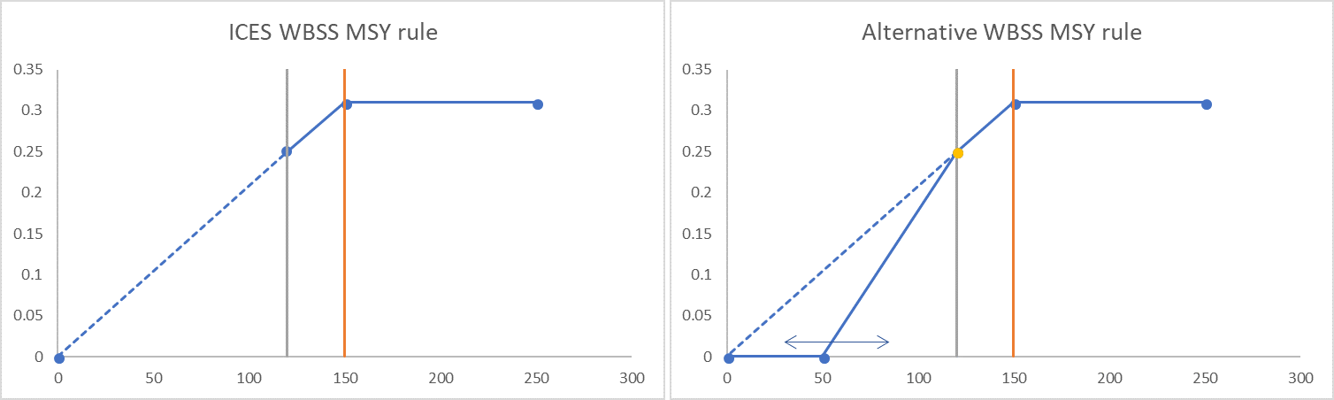

*Figure 1: ICES WBSS MSY rule (left) and Alternative WBSS MSY rules (right)*

# Material and methods

The EQSIM code available at <https://github.com/ices-tools-prod/msy/blob/master/R/eqsim_run.R> was primarily modified for the section where the harvest control rule is being coded, although smaller changes were also introduced for the scanning and the handling of results. The alternative HCR was coded as follows:

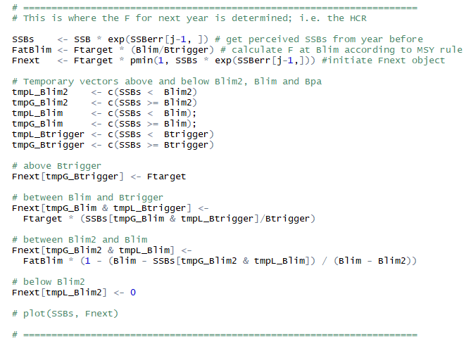

# Results

The WBSS EQSIM run at HAWG 2018 was carried out with a combined stock recruitment curve which was largely dominated by the segmented regression:

fig_nums(name = "srr1", display = FALSE,   
 caption = "ICES WBSS SRR curve as estimated by HAWG 2018" )  
  
#### recruitment with multi-model estimation  
noSims <- 999  
appModels <- c("Segreg","Ricker","Bevholt")   
rmSRRYrs <- c()   
FIT_All <- eqsr_fit(stk,nsamp=noSims, models = appModels, remove.years=rmSRRYrs)  
eqsr_plot(FIT_All,n=2e4)

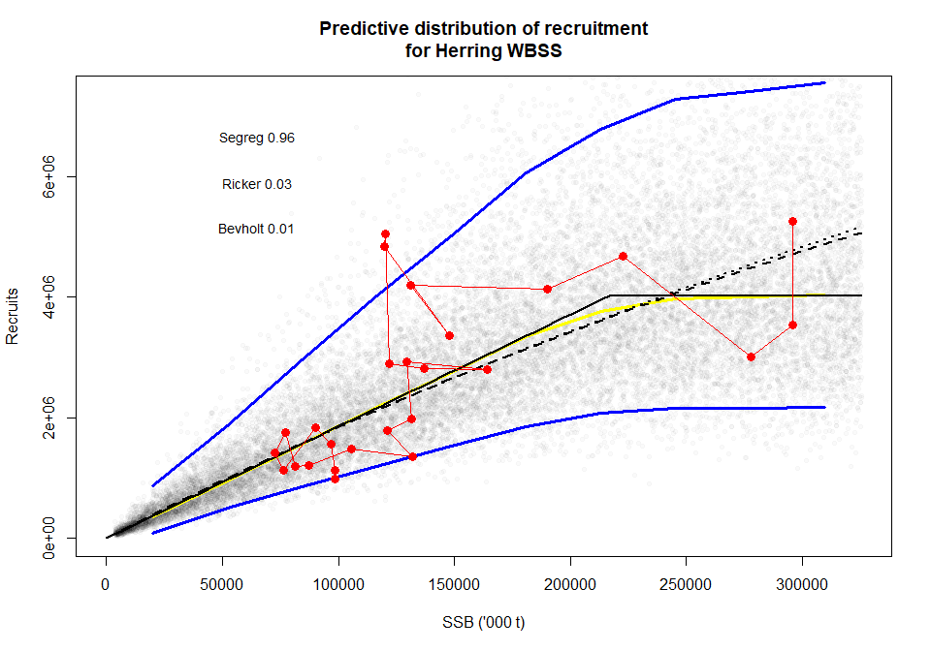

*Figure 2: ICES WBSS SRR curve as estimated by HAWG 2018*

Here we used a more pessimistic recruitment curve based on the most recent recruitments (that is also the basis of Blim) and a segmented regression that is forced through Blim.

fig_nums(name = "srr2", display = FALSE,   
 caption = "ICES WBSS SRR curve using SegregBlim and short time series" )  
  
noSims <- 999  
blim <- 120000  
rmSRRYrs <- c(1991:1999) # years to remove for SRR estimation  
stk.sr <- trim(stk, year=(max(rmSRRYrs)+1):dims(stk)$maxyear)  
FIT_segregBlim <- eqsr_fit(stk.sr,nsamp=noSims, models = "SegregBlim")  
eqsr_plot(FIT_segregBlim,n=2e4)

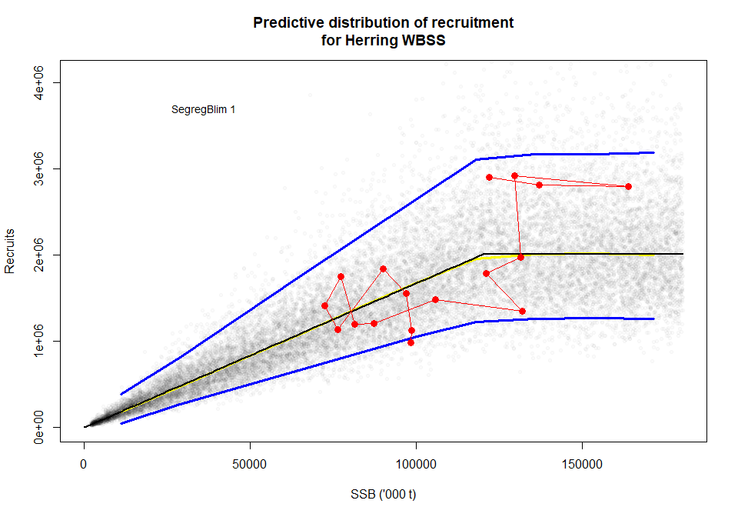

*Figure 3: ICES WBSS SRR curve using SegregBlim and short time series*

In the plots below the facets refer to Blim2 (i.e. Blim2=0 is the ICES MSY rule extended down to the origin, Blim2=120000 is the de facto ICES rule with an F=0 if stock is below Blim). Plots below are mostly worm plots (20 iterations). They all indicate that recovey to MSY Btrigger will take until around 2020, also with the zero catch option (Blim2 = 120000t).

# Simulations; no output yet  
  
fit = FIT_segregBlim  
bio.years = c(2012, 2016)  
bio.const = FALSE  
sel.years = c(2012, 2016)  
sel.const = FALSE  
Fmsy = 0.31  
Fcv = 0.212  
Fphi = 0.423  
SSBcv = 0.0  
SSBphi = 0.0  
# Fcv = 0.23  
# Fphi = 0.24  
# SSBcv = 0.31  
rhologRec = FALSE  
Blim = 120000  
Bpa = 150000  
Btrigger = 150000  
Blim2 = 60000  
Blim2.scan= seq(0, Blim, by = 20000)  
Nyear = 15  
Nits = 500  
process.error = FALSE  
verbose = TRUE  
recruitment.trim = c(3, -3)  
CatchInFirstYear = 50740  
rmSRRYrs <- c(1991:1999) # years to remove for SRR estimation  
  
# initial checks  
if (abs(Fphi) >= 1)  
 stop("Fphi, the autocorelation parameter for log F should be between (-1, 1)")  
if ((recruitment.trim[1] + recruitment.trim[2]) > 0)  
 stop("recruitment truncation must be between a high - low range")  
  
# set year ranges  
btyr1 <- bio.years[1]  
btyr2 <- bio.years[2]  
slyr1 <- sel.years[1]  
slyr2 <- sel.years[2]  
  
# Number of years to keep (= all)  
keep <- Nyear  
  
# Define simulation start and end year  
simstartyear <- max(sel.years)+1  
simendyear <- simstartyear + Nyear - 1  
  
  
# Resample SR parameters for each of the iterations  
SR <- fit$sr.sto[sample(1:dim(fit$sr.sto)[1] , Nits , replace = F),]  
  
# historical data on stock and recruitment (only for the years used to estimate the SR curve)  
data <-   
 fit$rby[, c("rec", "ssb", "year")] %>%   
 filter (year > max(rmSRRYrs)) # make sure to only use the years that were used to estimate SR  
  
# stock object and subsets for bioyears and selectionyears  
stk <- fit$stk  
stk.win <- FLCore::window(stk, start = btyr1, end = btyr2)  
stk.winsel <- FLCore::window(stk, start = slyr1, end = slyr2)  
  
# Function to replace zero by NA  
ReplaceZeroByNA <- function(x, i) {  
 x2 <- x  
 x2[i] <- NA # replace x2 with NA for i = TRUE  
 x2[] <- apply(x2, 1, mean, na.rm = TRUE) # calculate the average for each age  
 x[i] <- x2[i] # replace missing values with the average for that age  
 return(x)  
}  
  
west <- matrix(FLCore::stock.wt(stk.win), ncol = btyr2 - btyr1 + 1)  
i <- (west == 0) # make vector of i as TRUE when west == 0  
if (any(i)) west <- ReplaceZeroByNA(west, i) # if any west == 0, apply the replace by NA function  
  
weca <- matrix(FLCore::catch.wt(stk.win), ncol = btyr2 - btyr1 + 1)  
i <- weca == 0  
if (any(i)) weca <- ReplaceZeroByNA(weca, i)  
  
wela <- matrix(FLCore::landings.wt(stk.win), ncol = btyr2 - btyr1 + 1)  
i <- wela == 0  
if (any(i)) wela <- ReplaceZeroByNA(wela, i)  
  
Mat <- matrix(FLCore::mat(stk.win) , ncol = btyr2 - btyr1 + 1)  
M <- matrix(FLCore::m(stk.win) , ncol = btyr2 - btyr1 + 1)  
landings <- matrix(FLCore::landings.n(stk.winsel), ncol = slyr2 - slyr1 + 1)  
catch <- matrix(FLCore::catch.n(stk.winsel) , ncol = slyr2 - slyr1 + 1)  
sel <- matrix(FLCore::harvest(stk.winsel) , ncol = slyr2 - slyr1 + 1)  
Fbar <- matrix(FLCore::fbar(stk.winsel) , ncol = slyr2 - slyr1 + 1)  
  
# Calculate selection by dividing F at age by Fbar  
sel <- sweep(sel, 2, Fbar, "/")  
  
if (sel.const == TRUE) {  
 sel[] <- apply(sel, 1, mean)  
 landings[] <- apply(landings, 1, mean)  
 catch[] <- apply(catch, 1, mean)  
}  
  
if (bio.const == TRUE) {  
 west[] <- apply(west, 1, mean)  
 weca[] <- apply(weca, 1, mean)  
 wela[] <- apply(wela, 1, mean)  
 Mat[] <- apply(Mat, 1, mean)  
 M[] <- apply(M, 1, mean)  
}  
  
# ratio of number of landings to catch  
land.cat <- landings/catch  
i <- is.na(land.cat)  
if (any(i)) land.cat[i] <- 1  
  
# Set Fprop and Mprop  
Fprop <- apply(FLCore::harvest.spwn(stk.winsel), 1, mean)[drop = TRUE]  
Mprop <- apply(FLCore::m.spwn(stk.win), 1, mean)[drop = TRUE]  
  
# Create empty objects for storing Operating model ('real') simulation results  
ages <- FLCore::dims(stk)$age  
  
ssbreal <- Fbarreal <- Ferr <- catchreal <- landingsreal <-  
 array(0, c(Nyear, Nits), dimnames = list(year = simstartyear:simendyear, iter = 1:Nits))  
  
Nreal <- Freal <- CNreal <- WSreal <- WCreal <- WLreal <- Rreal <-   
 array(0, c(ages, Nyear, Nits),   
 dimnames = list(age = (range(stk)[1]:range(stk)[2]),  
 year = simstartyear:simendyear,   
 iter = 1:Nits))  
  
ssbperc <- Fbarperc <- catchperc <- landingsperc <-  
 array(0, c(Nyear, Nits), dimnames = list(year = simstartyear:simendyear, iter = 1:Nits))  
  
# Filling the first year with F errors for each of the iterations  
Ferr[1, ] <- stats::rnorm(n = Nits, mean = 0, sd = 1) * Fcv/sqrt(1 - Fphi^2)  
  
# Calculating the F errors for the subsequent years taking into account the error the year before  
for (j in 2:Nyear) {  
 Ferr[j, ] <- Fphi * Ferr[j - 1, ] + Fcv * stats::rnorm(n = Nits, mean = 0, sd = 1)  
}  
  
# SSB errors  
SSBerr <- matrix(stats::rnorm(n = Nyear * Nits, mean = 0, sd = 1),   
 ncol = Nits,  
 dimnames = list(year = simstartyear:simendyear, iter = 1:Nits)) * SSBcv  
  
# creat matrix of random vectors to be used for weight in each year / iteration  
rsam <- array(sample(1:ncol(weca), Nyear * Nits, TRUE),   
 c(Nyear, Nits),  
 dimnames = list(year = simstartyear:simendyear, iter = 1:Nits))  
  
# create matrix of random vectors for selectivity in each year / iteration  
rsamsel <- array(sample(1:ncol(sel), Nyear * Nits, TRUE),   
 c(Nyear, Nits),  
 dimnames = list(year = simstartyear:simendyear, iter = 1:Nits))  
  
# Generate random weights  
WCreal[] <- c(weca[, c(rsam)]) # WCreal[,,1]  
WLreal[] <- c(wela[, c(rsam)])  
  
# Generate random ratio of landings to catch (Why ??)  
Rreal[] <- c(land.cat[, c(rsamsel)]) # Rreal[,,1]   
  
# Initial recruitment  
R <- mean(data$rec)  
  
# Number of scans over Blim2  
NBlim2 <- length(Blim2.scan)  
  
# Set up objects for storing summary of simulated results (why 7?)  
ssbs <- cats <- lans <- recs <- array(0, c(7, NBlim2))  
  
# Set up objects for storing a data  
# ferr <- ssbsa <- catsa <- lansa <- recsa <-   
# array(0, c(NBlim2, keep, Nits))  
  
# first year to keep results  
begin <- Nyear - keep + 1  
  
# Generate matrix of residuals for SR (one residual for each iteration, each year)  
resids = array(stats::rnorm(Nits * (Nyear + 1), 0, SR$cv), c(Nits, Nyear + 1))  
  
# Autocorrelation in Recruitment Residuals:  
if (rhologRec) {  
   
 # Explain ....  
 fittedlogRec <- do.call(cbind, lapply(c(1:nrow(fit$sr.sto)),  
 function(i) {  
 FUN <- match.fun(fit$sr.sto$model[i])  
 FUN(fit$sr.sto[i, ], fit$rby$ssb)  
 }))  
   
 # Calculate lag 1 autocorrelation of residuals:  
 rhologRec <- apply(log(fit$rby$rec) - fittedlogRec, 2,  
 function(x) {  
 stats::cor(x[-length(x)], x[-1])  
 })  
   
 # Draw residuals according to AR(1) process:  
 for (j in 2:(Nyear + 1)) {  
 resids[, j] <- rhologRec * resids[, j - 1] + resids[,  
 j] * sqrt(1 - rhologRec^2)  
 } # end of AR(1) loop  
} # end of if rhologRec  
  
# Limit how extreme the Rec residuals can get:  
lims = t(array(SR$cv, c(Nits, 2))) * recruitment.trim  
for (k in 1:Nits) {  
 resids[k, resids[k, ] > lims[1, k]] = lims[1, k]  
}  
for (k in 1:Nits) {  
 resids[k, resids[k, ] < lims[2, k]] = lims[2, k]  
}  
  
# calculate F at Blim according to ICES MSY rule  
FatBlim <- Fmsy * (Blim/Btrigger)   
  
# set up an FLStock object with the appropriate dimensions (alternative to all the matrices)  
stk.all <- FLCore::window(stk, start = 1990, end = simendyear)  
stk.all <- propagate(stk.all, Nits)  
  
# ----- SCANS ------------------------------------------------------  
  
# Create dataframe for storing loop information   
loop.df <- data.frame()  
  
# initialize empty data.frames for individual scans over Blim2  
Cwy.df <- Fbarreal.df <- Freal.df <- Nreal.df <- WCreal.df <- ssbreal.df <- data.frame()  
  
# Loop over NBlim2 (number of scans for Blim2)  
# i <- 1  
for (i in 1:NBlim2) {  
   
 # Set Blim2 value  
 Blim2 <- Blim2.scan[i]  
   
 # --------------------------------------  
 # Population in simulation year 1 (the intermediate or current year)  
 # --------------------------------------  
   
 # Zpre: Z that occurs before spawning (matrix)  
 Zpre <- (sel[, rsamsel[1, ]] * Fmsy * Fprop + M[, rsam[1,]] * Mprop)  
   
 # compute survivors after the last assessment year (FLQuant)  
 N <- stock.n(stk)[,ac(max(sel.years))] * exp (-(harvest(stk)[,ac(max(sel.years))] +   
 m(stk)[,ac(max(sel.years))]))  
   
 # add year to the dimnames (last year + 1)  
 dimnames(N)$year <- max(sel.years) + 1  
   
 # plus group  
 N[dim(N)[1], ] <- N[dim(N)[1]-1 , ] + N[dim(N)[1] , ]   
 # N[dim(N)[1]-1 , ] <- N[dim(N)[1]-1 , ] + N[dim(N)[1] , ] # Note: this was wrong; changed max age - 1  
   
 # shift all one age down (except plus group)  
 N[c(-1, -dim(N)[1])] <- N[1:(dim(N)[1]-2)] # N[-dim(N)[1] , ]  
  
 # add recruitment  
 N[1] <- R  
  
 # set Nreal for the first simulation year  
 Nreal[, 1, ] <- c(N@.Data)  
  
 # set real SSB for the first simulation year  
 ssbreal[1, ] <- colSums(Mat[, rsam[1, ]] * Nreal[, 1, ] * west[, rsam[1, ]]/exp(Zpre)[])  
   
 # set perceived SSB, catch and F for the first simulation year  
 ssbperc[1,] <- ssbreal[1, ] * exp(SSBerr[1, ])   
   
 # calculate catchnumber in first year  
 # Use CatchInFirstYear and selection pattern to calculate F at age and catch at age  
 # stk.all@stock.n[,ac(simstartyear),,,] <- N  
 # TACS <- FLQuant(CatchInFirstYear,  
 # dimnames=list(age="all",year=ac(simstartyear),unit=NA,  
 # season="all",area=1,iter=1))  
 # fleet.harvest(stk,iYr=2017,TACS)  
   
 # Temporary fix: set F in the intermediate year equal to the last year of assessment, scaled by the catch  
   
   
 # update the loop data.frame  
 loop.df <-  
 bind_rows(loop.df,   
 data.frame(year = simstartyear,  
 iter = an(unlist(dimnames(ssbreal)["iter"])),   
 Fnext = an(NA),   
 Ferr = an(NA),  
 ssbs = ssbreal[1,] * exp(SSBerr[1, ]),   
 SSBerr =SSBerr[1,],   
 Blim2, Blim, Btrigger, Fmsy, FatBlim,  
 catch = CatchInFirstYear) )  
   
   
   
 # --------------------------------------  
 # simulation of year 2 until the end  
 # --------------------------------------  
   
 for (j in 2:Nyear) {  
 # j <- 2  
   
 y <- simstartyear + j -1  
 # SSB <- ssbreal[j - 1, ]  
   
 if (process.error) {  
 allrecs <-   
 sapply(unique(SR$mod), function(mod) exp(match.fun(mod)(SR, ssbreal[j-1, ]) + resids[, j]))  
 } else {  
 allrecs <-   
 sapply(unique(SR$mod), function(mod) exp(match.fun(mod)(SR, ssbreal[j - 1, ])))  
 }  
  
 # select which recruitment model to use (if more than 1)  
 select <- cbind(seq(Nits), as.numeric(factor(SR$mod, levels = unique(SR$mod))))  
 Nreal[1, j, ] <- allrecs[select]  
   
 # ======================================================================  
 # This is where the F for the current year is determined; i.e. the HCR  
   
 # Tester  
 # SSBs <- seq(from=0, to=50000, length.out = 500)  
   
 # get perceived SSBs from year before  
 SSBs <- ssbreal[j - 1, ] * exp(SSBerr[j-1, ])   
   
 #initiate empty Fnext object  
 Fnext <- SSBs; Fnext[] <- NA  
   
 # Temporary vectors above and below Blim2, Blim and Bpa  
 tmpL_Blim2 <- c(SSBs < Blim2)  
 tmpG_Blim2 <- c(SSBs >= Blim2)  
 tmpL_Blim <- c(SSBs < Blim);   
 tmpG_Blim <- c(SSBs >= Blim);   
 tmpL_Btrigger <- c(SSBs < Btrigger)  
 tmpG_Btrigger <- c(SSBs >= Btrigger)  
   
 # above Btrigger  
 Fnext[tmpG_Btrigger] <- Fmsy  
   
 # between Blim and Btrigger  
 Fnext[tmpG_Blim & tmpL_Btrigger] <-   
 Fmsy * (SSBs[tmpG_Blim & tmpL_Btrigger]/Btrigger)  
   
 # between Blim2 and Blim  
 Fnext[tmpG_Blim2 & tmpL_Blim] <-   
 FatBlim * (1 - (Blim - SSBs[tmpG_Blim2 & tmpL_Blim]) / (Blim - Blim2))  
   
 # below Blim2  
 Fnext[tmpL_Blim2] <- 0  
   
 # plot(SSBs, Fnext)  
   
 # ======================================================================  
   
 # Is this right? Apply the F error after going through the HCR??  
 Fnext <- exp(Ferr[j, ]) * Fnext  
   
 # get a selection pattern for each simulation and apply this to get N  
 Zpre <- rep(Fnext,   
 each = length(Fprop)) * Fprop * sel[, rsamsel[j, ]] + M[, rsam[j, ]] * Mprop  
   
 # MP: Why is this the F in the year before??  
 Freal[, j-1, ] <- rep(Fnext,   
 each = ages) * sel[, rsamsel[j - 1, ]]  
   
 # Calculate stock numbers given F  
 Nreal[-1, j, ] <- Nreal[1:(ages - 1), j - 1, ] *   
 exp(-Freal[1:(ages - 1), j - 1, ] - M[1:(ages - 1), rsam[j - 1, ]])  
   
 # plus group  
 Nreal[ages, j, ] <- Nreal[ages,j,] +   
 Nreal[ages,j-1,] * exp(-Freal[ages, j-1, ] - M[ages, rsam[j-1, ]])  
   
 # calculate SSB  
 ssbreal[j, ] <- apply(array(Mat[, rsam[j, ]] *   
 Nreal[, j, ] *   
 west[, rsam[j, ]]/exp(Zpre), c(ages, Nits)), 2, sum)  
   
 # calculate catch numbers  
 CNreal[, j, ] <- Nreal[, j-1, ] * Freal[, j-1, ]/  
 (Freal[, j-1, ] + M[, rsam[j-1, ]]) *   
 (1 - exp(-Freal[,j-1, ] - M[,rsam[j-1, ]]))  
   
 # calculate catch weight  
 catchreal[j, ] <- apply(CNreal[,j,] * WCreal[,j,],2,sum)  
   
 # update the loop data.frame for the previous year (i.e. for F)  
 loop.df <-  
 bind_rows(loop.df,   
 data.frame(year = j + max(an(dimnames(ssb(stk))$year)) - 1,  
 iter = an(names(tmpG_Blim)),  
 Fnext= Fnext, Ferr = Ferr[j,],  
 Blim2, Blim, Btrigger, Fmsy, FatBlim ) )  
   
 # update the loop data.frame for the current year (i.e. for other than F)  
 loop.df <-  
 bind_rows(loop.df,   
 data.frame(year = j + max(an(dimnames(ssb(stk))$year)),  
 iter = an(names(tmpG_Blim)),   
 SSBs=ssbreal[j,] * exp(SSBerr[j, ]), SSBerr=SSBerr[j,],   
 tmpL_Blim2, tmpG_Blim2, tmpL_Blim, tmpG_Blim, tmpL_Btrigger, tmpG_Btrigger,   
 Blim2, Blim, Btrigger, Fmsy, FatBlim,  
 catch = catchreal[j,] ))  
   
 } # end of run over j (years) =========================  
   
 # Create worm data.frames for storing results  
 WCreal.df <-   
 as.data.frame(t(as.data.frame(WCreal))) %>%  
 setNames(paste0("age", unlist(dimnames(WCreal)[1]))) %>%   
 rownames_to_column(., "rowname") %>%   
 separate(rowname, into=c("year","iter"), sep="\\.") %>%   
 mutate(  
 variable = "WCreal",  
 iter = as.numeric(iter),   
 Blim2 = Blim2  
 ) %>%   
 gather(key="age", value="value",   
 colnames(.)[3:((length(colnames(.)))-1)]) %>%   
 mutate(  
 age = gsub("age", "", age)  
 ) %>%   
 bind_rows(WCreal.df, .)  
   
 Nreal.df <-   
 as.data.frame(t(as.data.frame(Nreal))) %>%  
 setNames(paste0("age", unlist(dimnames(Nreal)[1]))) %>%   
 rownames_to_column(., "rowname") %>%   
 separate(rowname, into=c("year","iter"), sep="\\.") %>%   
 mutate(  
 variable = "Nreal",  
 year = as.numeric(year) + max(an(dimnames(ssb(stk))$year)) - 1,  
 iter = as.numeric(iter),   
 Blim2 = Blim2  
 ) %>%   
 gather(key="age", value="value",   
 colnames(.)[3:((length(colnames(.)))-1)]) %>%   
 mutate(  
 age = gsub("age", "", age)  
 ) %>%   
 bind_rows(Nreal.df, .)  
   
 Cwy.df <-   
 as.data.frame(t(as.data.frame(CNreal * WCreal))) %>%   
 setNames(paste0("age", unlist(dimnames(CNreal)[1]))) %>%   
 rownames_to_column(., "rowname") %>%   
 separate(rowname, into=c("year","iter"), sep="\\.") %>%   
 mutate(  
 variable = "Cwy",  
 iter = as.numeric(iter),   
 Blim2 = Blim2  
 ) %>%   
 gather(key="age", value="value",   
 colnames(.)[3:((length(colnames(.)))-2)]) %>%   
 group_by(year, iter, Blim2, variable) %>%   
 dplyr::summarize(value = sum(value)) %>%   
 bind_rows(Cwy.df, .)  
   
 Freal.df <-   
 as.data.frame(t(as.data.frame(Freal))) %>%  
 setNames(paste0("age", unlist(dimnames(Freal)[1]))) %>%   
 rownames_to_column(., "rowname") %>%   
 separate(rowname, into=c("year","iter"), sep="\\.") %>%   
 mutate(  
 variable = "Freal",  
 iter = as.numeric(iter),   
 Blim2 = Blim2  
 ) %>%   
 gather(key="age", value="value",   
 colnames(.)[3:((length(colnames(.)))-1)]) %>%   
 mutate(  
 age = gsub("age", "", age),  
 value = an(value)  
 ) %>%   
 bind_rows(Freal.df, .)  
   
 Fbarreal.df <-  
 Freal.df %>%   
 filter(age %in% an(stk@range["minfbar"]): an(stk@range["maxfbar"])) %>%   
 group_by(iter, year, Blim2) %>%   
 dplyr::summarize(value = mean(value, na.rm=TRUE)) %>%   
 mutate(variable = "fbary") %>%   
 bind_rows(Fbarreal.df, .) %>%   
 group_by(year, iter, Blim2, variable) %>%   
 filter(row_number() == 1)  
   
 ssbreal.df <-   
 as.data.frame(t(as.data.frame(ssbreal))) %>%  
 rownames_to_column(., "iter") %>%   
 gather(key="year", value="value",   
 colnames(.)[2:(length(colnames(.)))]) %>%   
 mutate(  
 variable = "ssbreal",  
 age = "all",  
 Blim2 = Blim2  
 ) %>%   
 mutate_at(c("iter","year"), funs(as.integer)) %>%   
 bind_rows(ssbreal.df, .)  
   
} # End of loop over i (scans for Blim2) -----------------------------------------  
  
ssbs.df <-   
 select(loop.df, year, iter, Blim2, value=SSBs) %>%   
 filter(!is.na(value)) %>%   
 mutate_at(c("iter","year", "Blim2"), funs(as.integer)) %>%   
 mutate(variable="ssbs", age="all") %>%   
 mutate(Blim2 = factor(Blim2, levels=as.integer(Blim2.scan)))  
  
Fs.df <-  
 select(loop.df, year, iter, Blim2, value=Fnext) %>%   
 filter(!is.na(value)) %>%   
 mutate_at(c("iter","year","Blim2"), funs(as.integer)) %>%   
 mutate(variable="fs", age="all") %>%   
 mutate(Blim2 = factor(Blim2, levels=as.integer(Blim2.scan)))  
  
catch.df <-  
 select(loop.df, year, iter, Blim2, value=catch) %>%   
 filter(!is.na(value)) %>%   
 filter(!is.na(Blim2)) %>%   
 mutate_at(c("iter","year","Blim2"), funs(as.integer)) %>%   
 mutate(variable="catch", age="all") %>%   
 mutate(Blim2 = factor(Blim2, levels=as.integer(Blim2.scan)))  
  
ssbs2.df <-  
 ssbs.df %>%   
 group_by(year, Blim2, variable, age) %>%   
 dplyr::summarize(mean = mean(value, na.rm=TRUE),  
 sd = sd(value, na.rm=TRUE),  
 n = n()) %>%   
 mutate(se = sd / sqrt(n),  
 lower.ci = mean - qt(1 - (0.05 / 2), n - 1) * se,  
 upper.ci = mean + qt(1 - (0.05 / 2), n - 1) * se)  
  
catch2.df <-  
 catch.df %>%   
 group_by(year, Blim2, variable, age) %>%   
 dplyr::summarize(mean = mean(value, na.rm=TRUE),  
 sd = sd(value, na.rm=TRUE),  
 n = n()) %>%   
 mutate(se = sd / sqrt(n),  
 lower.ci = mean - qt(1 - (0.05 / 2), n - 1) * se,  
 upper.ci = mean + qt(1 - (0.05 / 2), n - 1) * se)  
  
probbelowBlim.df <-  
 ssbs.df %>%   
 group_by(year, Blim2, variable) %>%   
 mutate(percbelowBlim = (value<Blim)/(!is.na(value)) ) %>%   
 summarize(percbelowBlim = mean(percbelowBlim, na.rm=TRUE)) %>%   
 ungroup() %>%   
 mutate(Blim2 = factor(Blim2, levels=as.integer(Blim2.scan)))

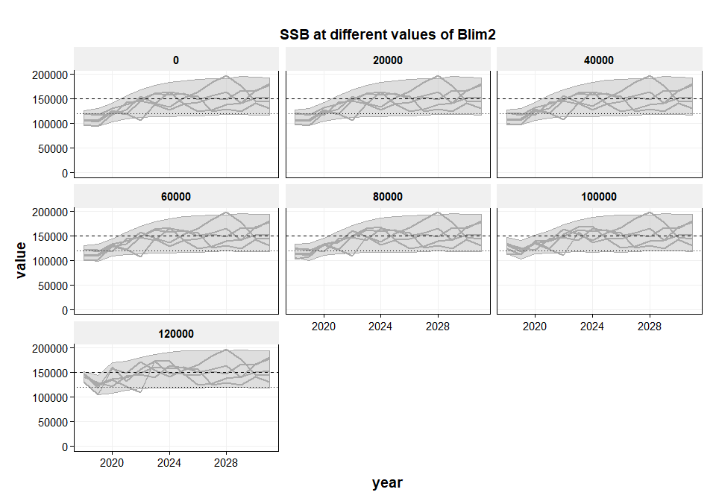

*Figure 2: ICES WBSS SRR curve as estimated by HAWG 2018*

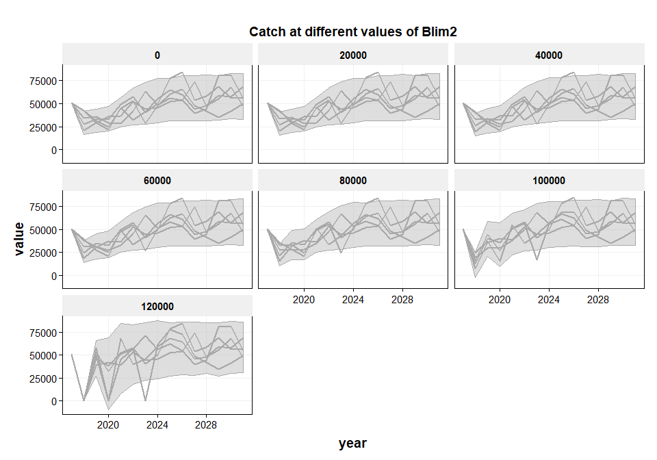

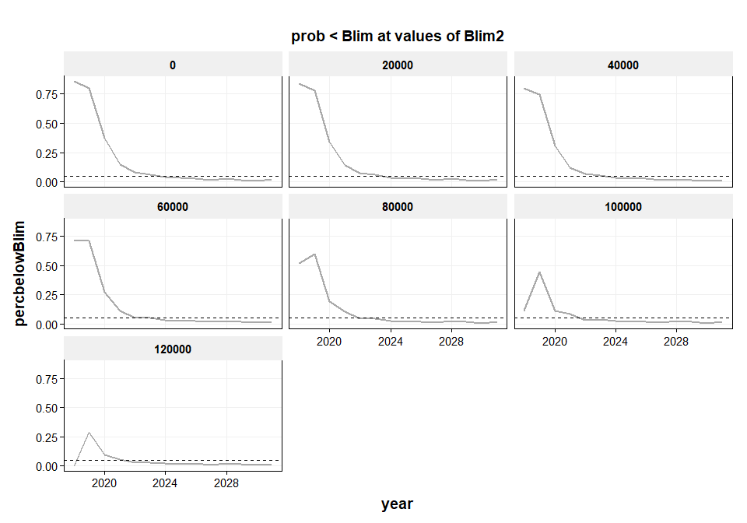

# Discussion

# References