**HAWG 2020 overviews**

**Martin Pastoors1**

27/03/2020 12:12

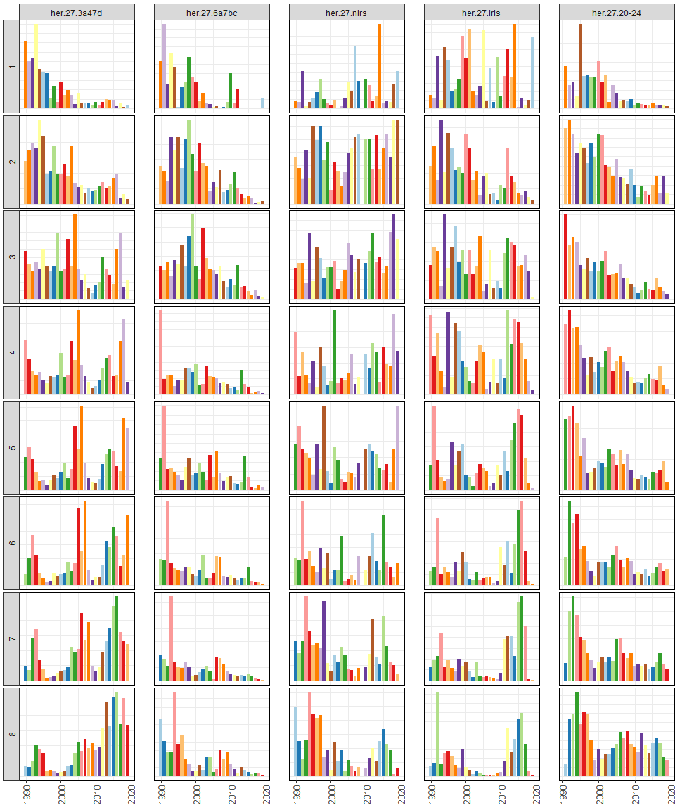

**Figure x. Overview of catch at age.**

##### page break

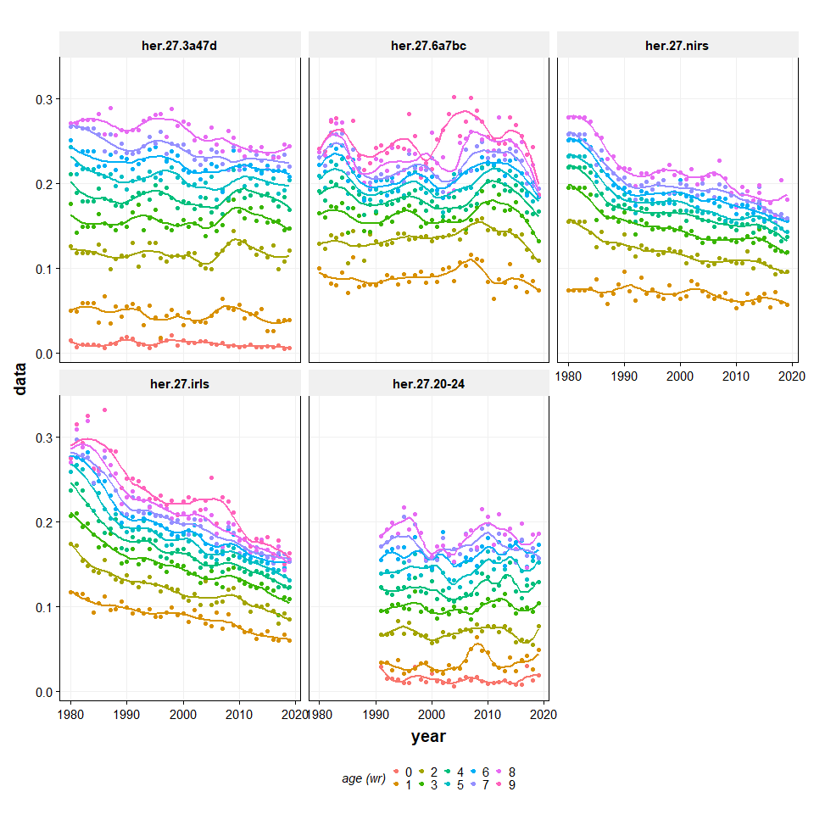

**Figure x Catch weight at age**

##### page break

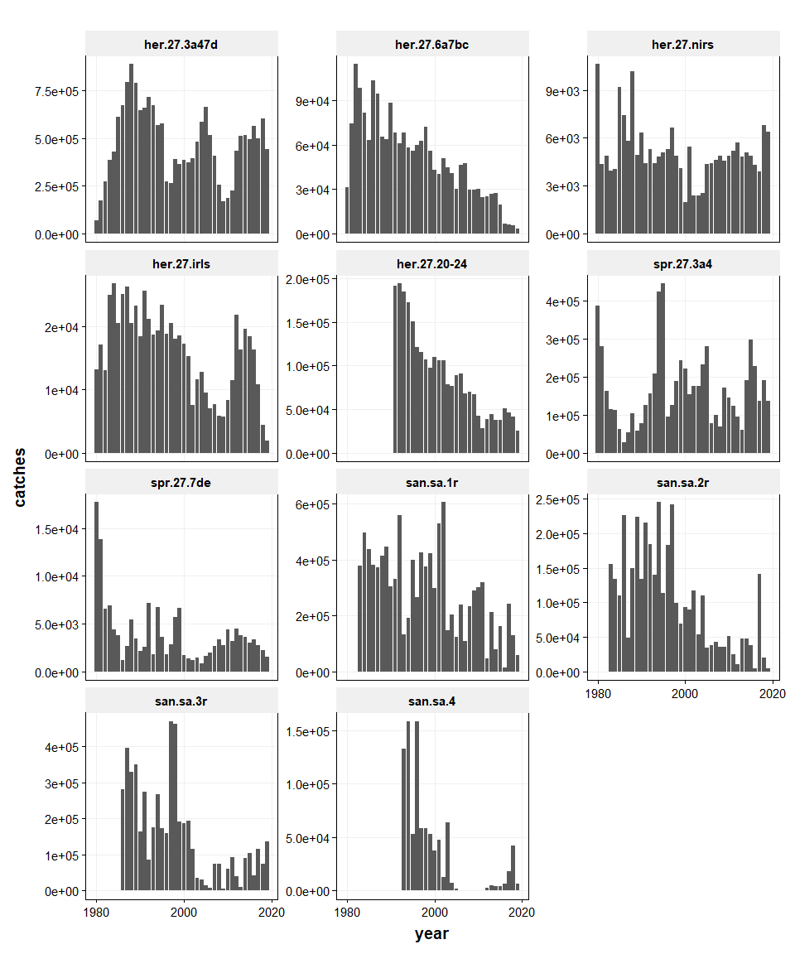

**Figure x Trends in catch.**

##### page break

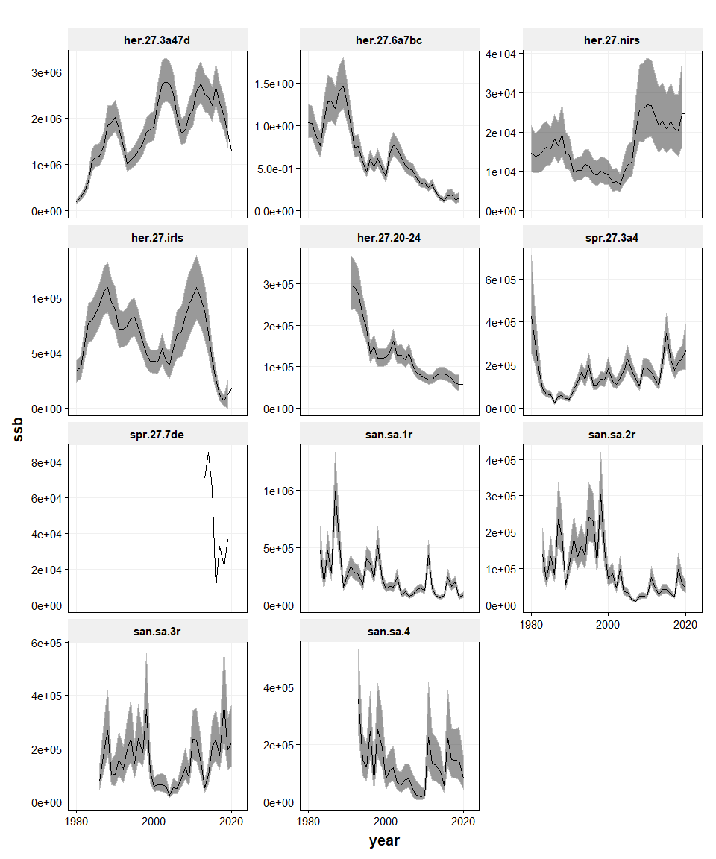

**Figure x Trends in SSB.**

##### page break

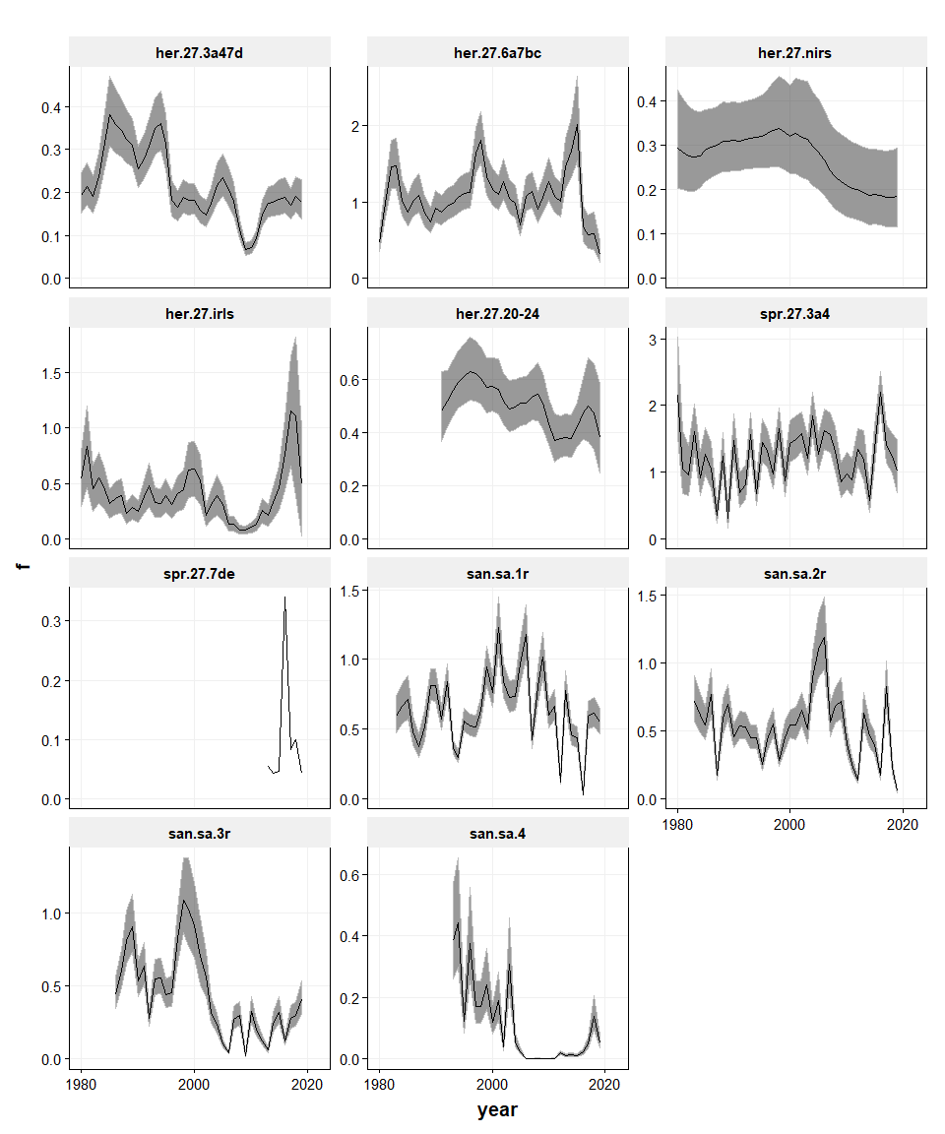

**Figure x Trends in F.**

##### page break

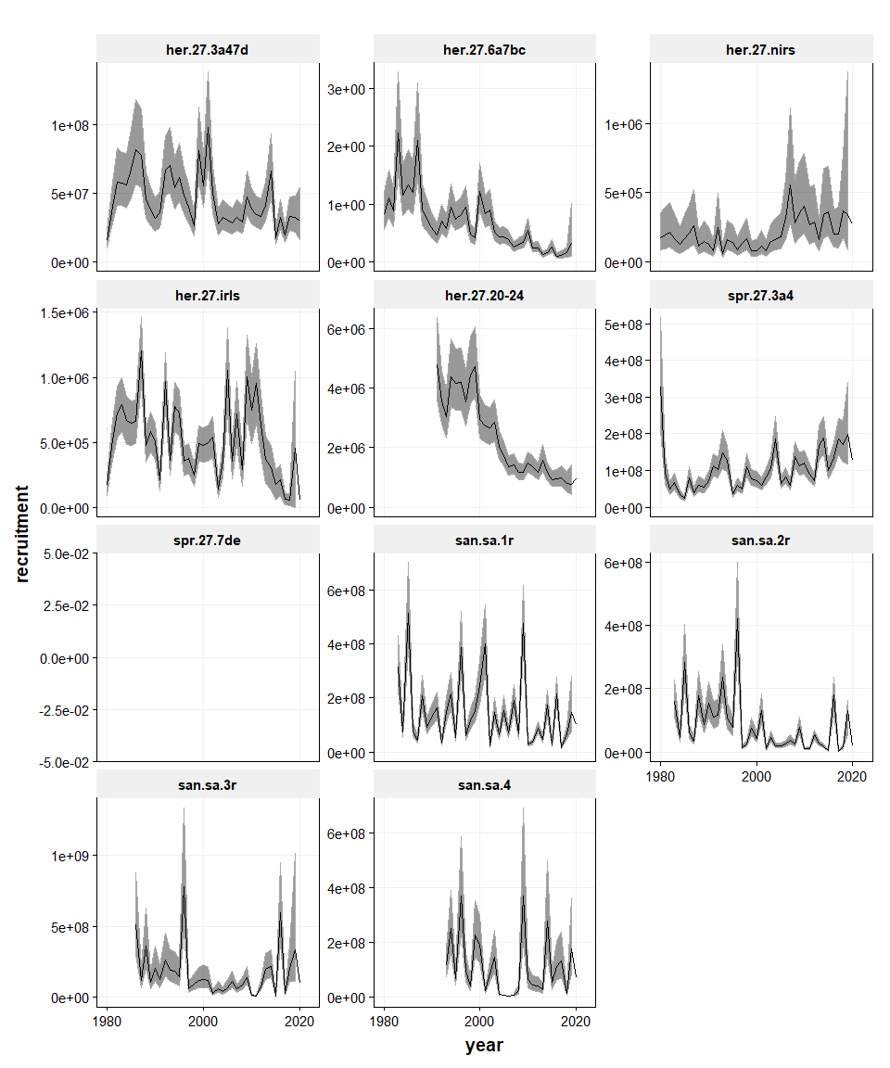

**Figure x Trends in recruitment.**