Working document xx, HAWG 2021

**Utilizing the full time-series of herring catch by rectangle**

Martin Pastoors, 16/03/2021

**Introduction**

HAWG has been publishing catch per rectangle plots in the working group reports for many years already. Catch by rectangle has been compiled by WG members and generally provide a WG estimate of catch per rectangle. So far, the catch by rectangle has only been presented for one single year in the WG reports. Here, we collated all the catch by rectangle data for herring catches in all areas (excluding subarea 27.2).

**Results**

An overview of the summed catches by division and year is shown in the text tables below.

division 2004 2005 2006 2007 2008 2009 2010 2011 (all)  
---------- --------- --------- --------- --------- --------- --------- --------- --------- -----------  
 3A 26,691 30,932 22,611 16,488 4,374 21,292 16,756 8,604 147,748  
 4A 368,963 458,759 436,860 265,128 158,577 81,143 118,534 139,882 2,027,846  
 4B 99,466 95,662 92,981 67,204 54,840 60,689 29,540 51,860 552,242  
 4C 7,937 6,521 7,025 1,004 1,549 2,501 3,689 2,786 33,012  
 5B 420 500 0 0 0 0 36 0 956  
 6A 22,385 13,398 12,678 29,291 15,185 12,900 19,572 17,402 142,811  
 7A 1,782 3,522 3,234 4,628 4,895 0 87 5,204 23,352  
 7B 64 0 0 0 0 0 0 0 64  
 7D 60,526 53,913 53,498 30,927 28,060 19,421 22,831 23,857 293,033  
 7E 693 507 630 602 949 2,385 1,084 671 7,521  
 7F 47 198 76 115 29 8 23 38 534  
 7G 1 1 5 0 0 135 180 4 326  
 7H 289 150 150 829 502 364 1,060 809 4,153  
 7J 653 238 238 63 191 0 0 7 1,390  
 (all) 589,917 664,301 629,986 416,279 269,151 200,838 213,392 251,124 3,234,988

division 2012 2013 2014 2015 2016 2017 2018 2019 (all) TOTAL  
---------- --------- --------- --------- --------- --------- --------- --------- --------- ----------- -----------  
 3A 9,488 11,686 12,828 10,614 9,866 3,627 2,261 2,064 62,434 210,182  
 4A 284,144 333,728 356,962 367,032 427,911 386,903 449,072 319,548 2,925,300 4,953,146  
 4B 99,770 119,242 108,790 72,491 85,251 65,714 107,794 86,318 745,370 1,297,612  
 4C 3,937 2,800 3,181 743 2,736 1,572 2,189 1,754 18,912 51,924  
 6A 19,171 16,690 23,147 19,894 6,595 6,176 5,521 3,384 100,578 243,389  
 7A 6,716 6,566 5,085 5,750 1,735 1,318 7,688 6,889 41,747 65,099  
 7B 0 9 0 6 340 0 25 1 381 445  
 7D 33,133 41,907 35,036 40,315 43,023 33,573 43,127 37,137 307,251 600,284  
 7E 436 255 732 380 191 21 57 8 2,080 9,601  
 7F 116 154 35 124 239 28 3 9 708 1,242  
 7G 1 12,553 1,319 15,991 13,175 8,813 3,353 1,329 56,534 56,860  
 7H 1,166 1,040 578 569 121 471 183 0 4,128 8,281  
 7J 2,722 349 0 161 325 0 0 0 3,557 4,947  
 (all) 460,800 546,979 547,693 534,070 591,508 508,216 621,273 458,441 4,268,980 7,503,968

##### page break

**Herring catch by rectangle in the whole area**

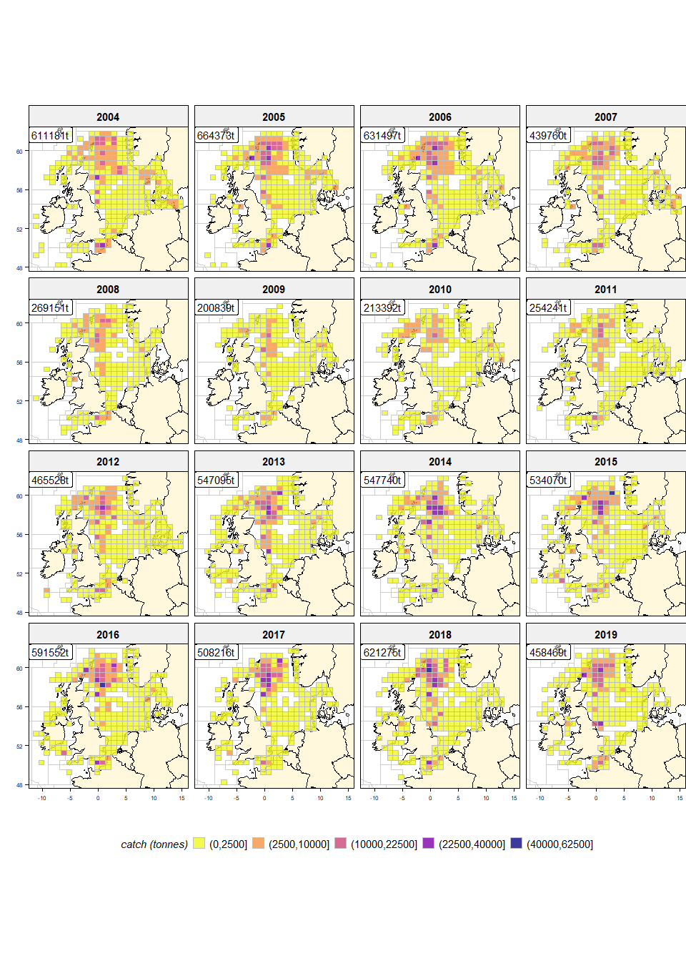

*Figure 1: Catch of herring (tonnes) by year and rectangle*

##### page break

**Herring catch by rectangle in the North Sea, Skagerrak and Eastern Channel**

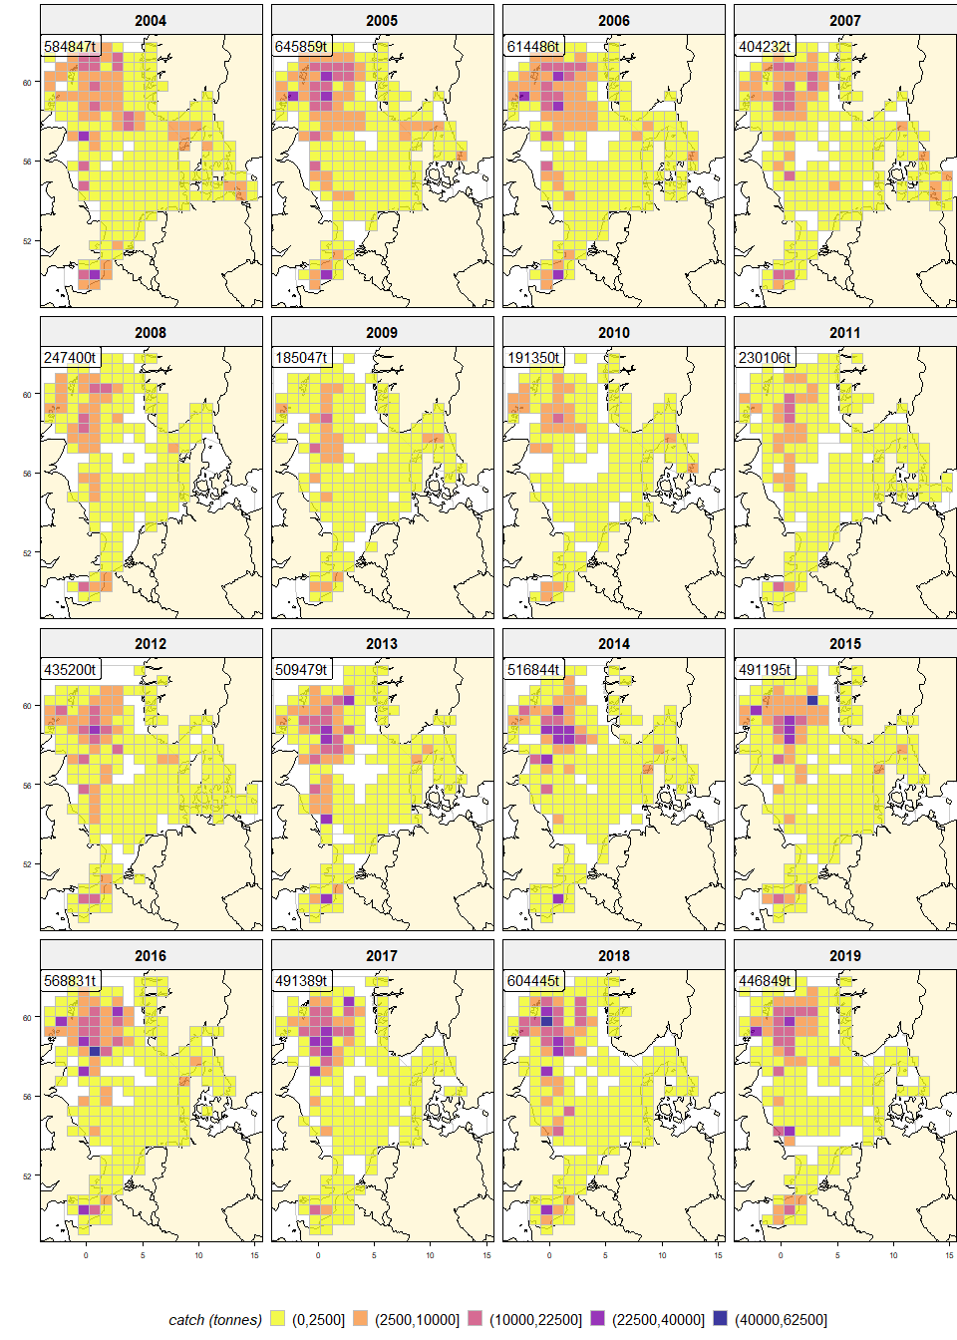

*Figure 2: Catch of herring (tonnes) in subareas 27.3, 27.4 and division 27.7.d*

##### page break

**Herring catch by rectangle in the western area**

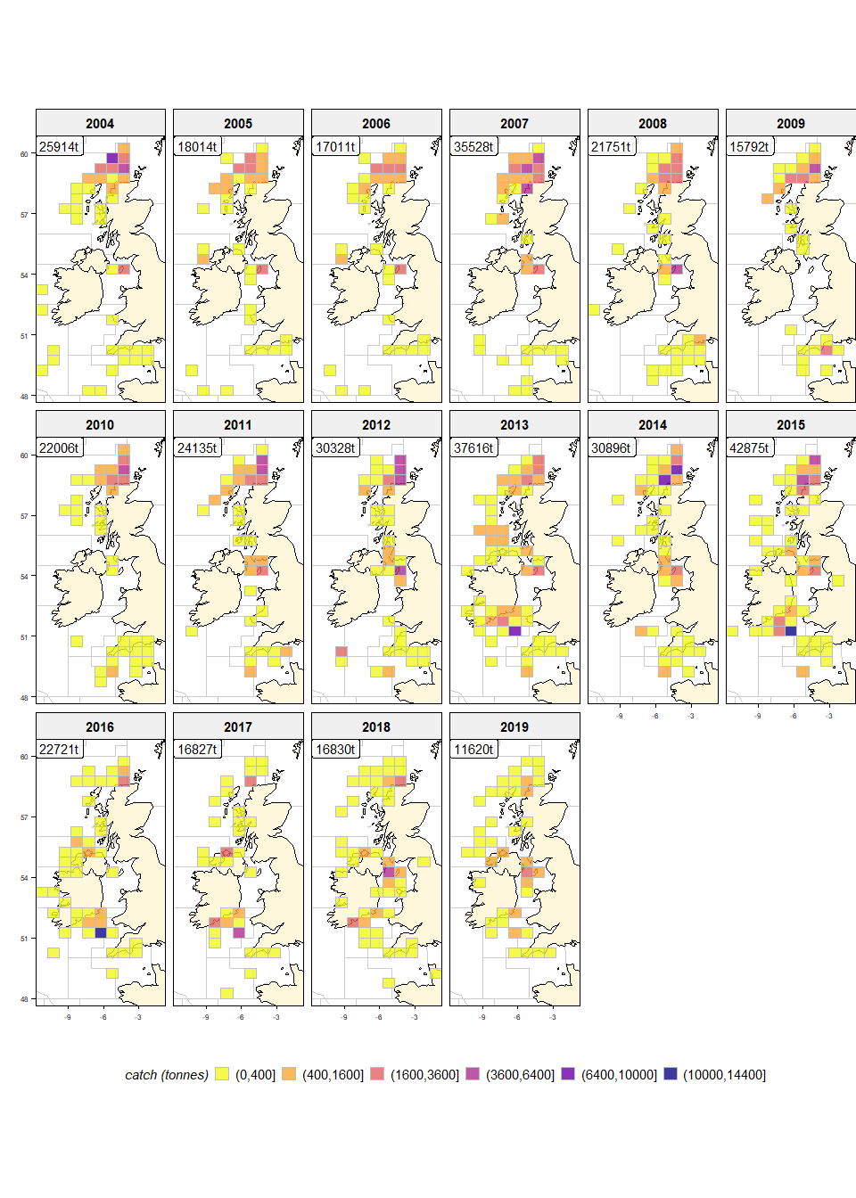

*Figure 3: Catch of herring (tonnes) in subareas 27.6 and 27.7 (excluding 27.7.d)*

**Discussion**

While the aggregation and presentation of the catch per rectangle data does not constitute rocket-science, it does provide us with meaningful insights into the changes of catching areas over time. This could be relevant in understanding the fluctuations of stock and impacts of climate change on fisheries. As such, these graphical representations of catching areas provide a useful addition to the WG report.

One important check that still needs to be carried out is the check on data availability by country and year that may not be consistent over the time series. Making the time-series complete would improve the useability of the information.

##### page break