|  |
| --- |
|  |
| Assignment01 |
|  |

|  |
| --- |
| josh brooks  9-4-2017 |

1. Cubin Compilation and Output:

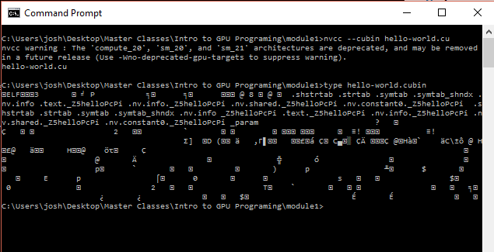

1. PTX Compile and Output:

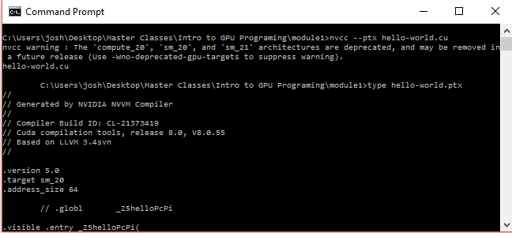

1. 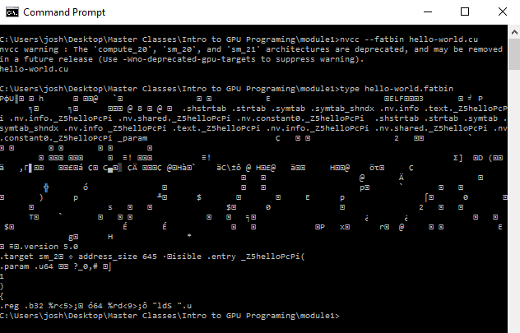Fatbin Compile and OutPut:
2. Exe Compilation and Output:

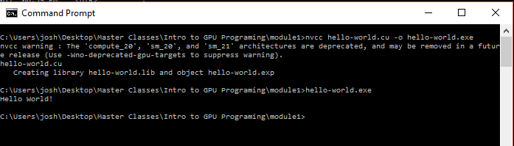

1. GPU Compilation and Output:

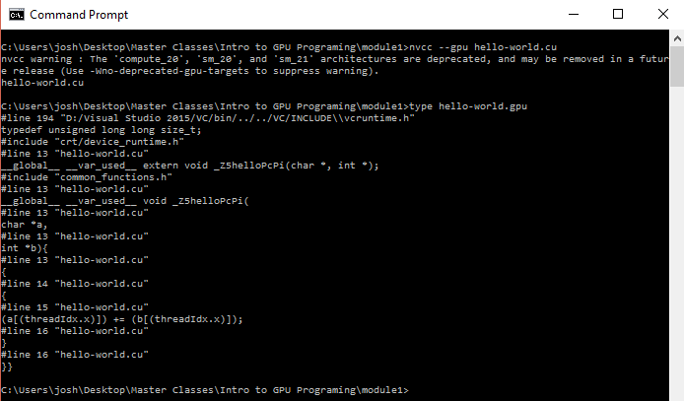

1. Lib Compilation and Output:

