# MedCheck.gov– Section 508 Audit

|  |  |
| --- | --- |
| **Name of Application:** | MedCheck.gov |
| **Testing URLs:** | <https://ads18f-alpha.herokuapp.com/> and <http://icfcreative.com/icf-gsa-agile/> |
| **Review Requested By:** | Jeremy Vanderlan |
| **Department, Agency or other Client** | HHS/FDA |
| **Review Participants:** | Dona Patrick |
| **Date(s) of Review:** | July 1 - 2, 2015 |
| **Testing Tools Used:** | JAWS 14 and 15, Internet Explorer 10, Firefox, Chrome, Web Accessibility Toolbar for IE, Firefox Developer Extension, Firefox WAVE Toolbar, Windows 7, Chrome WAVE app. |
| **Expectation:** | If one instance of the Section 508 standards fails, the site fails for that standard. |

## Method and Scope

The site was tested with tools such as Internet Explorer’s Accessibility Toolbar and Firefox’s WAVE toolbar and JAWS screen reader. When an issue was encountered the code was examined.

## Report

This report is divided into several sections:

* Results: A table listing the passes, failures, not-applicable results and a brief summary of the issue for the current Section 508 standards.
* Extended Remarks: More information regarding Section 508 failures.
* Other Accessibility Issues: These are issues that are not part of the current Section 508 standards but will likely be part of the updated Section 508 standards which are currently under review and could be implemented within a year. HHS may require some of these for compliance.
* Enhancements for Better Accessibility: These are issues that are not part of the current or future Section 508 Standards, but have an impact on accessibility.
* Other Issues: These are issues that are not necessarily accessibility issues, but were found during the audit such as typos, discrepancies and grammatical errors.

## Results:

### SECTION 508 STANDARDS §1194.21 (a) and (c) and 1194.22 (a) through (p)

| **508 Standard** | **Pass, Fail or NA** | **Remarks  (See extended remarks for items that fail)** |
| --- | --- | --- |
| §1194.21 (a) When software is designed to run on a system that has a keyboard, product functions shall be executable from a keyboard where the function itself or the result of performing a function can be discerned textually. | Fail | Not all buttons can be activated with a keyboard. (medcheck)  Pop-up chart information only available with mouse over. (medcheck)  Photograph mouse over information not available to keyboard-only user. (ICF page) |
| §1194.21 (c) A well-defined on-screen indication of the current focus shall be provided that moves among interactive interface elements as the input focus changes. The focus shall be programmatically exposed so that assistive technology can track focus and focus changes. | Fail | Visual focus disappears when tabbing through photos. (ICF page) |
| §1194.22 (a) A text equivalent for every non-text element shall be provided (e.g., via "alt", "longdesc", or in element content). | Fail | SVG graphics do not provide equivalent information to screen reader users. (medcheck) |
| §1194.22 (b) Equivalent alternatives for any multimedia presentation shall be synchronized with the presentation. | NA |  |
| §1194.22 (c) Web pages shall be designed so that all information conveyed with color is also available without color, for example from context or markup. | Possible Fail | Graphs use color as the only means of conveying information. (medcheck) |
| §1194.22 (d) Documents shall be organized so they are readable without requiring an associated style sheet. | Fail | Graphs appear as black boxes when CSS is disabled.  Some images are CSS images which disappear when CSS images are removed. |
| §1194.22 (e) Redundant text links shall be provided for each active region of a server-side image map. | NA |  |
| §1194.22 (f) Client-side image maps shall be provided instead of server-side image maps except where the regions cannot be defined with an available geometric shape. | NA |  |
| §1194.22 (g) Row and column headers shall be identified for data tables. | NA |  |
| §1194.22 (h) Markup shall be used to associate data cells and header cells for data tables that have two or more logical levels of row or column headers. | NA |  |
| §1194.22 (i) Frames shall be titled with text that facilitates frame identification and navigation. | NA |  |
| §1194.22 (j) Pages shall be designed to avoid causing the screen to flicker with a frequency greater than 2 Hz and lower than 55 Hz. | Pass |  |
| §1194.22 (k) A text-only page, with equivalent information or functionality, shall be provided to make a web site comply with the provisions of this part, when compliance cannot be accomplished in any other way. The content of the text only page shall be updated whenever the primary page changes. | NA |  |
| §1194.22 (l) When pages utilize scripting languages to display content, or to create interface elements, the information provided by the script shall be identified with functional text that can be read by assistive technology. | Pass |  |
| §1194.22 (m) When a web page requires that an applet, plug-in or other application be present on the client system to interpret page content, the page must provide a link to a plug-in or applet that complies with §1194.21(a) through (l). | NA |  |
| §1194.22 (n) When electronic forms are designed to be completed on-line, the form shall allow people using assistive technology to access the information, field elements, and functionality required for completion and submission of the form, including all directions and cues. | Fail | Form fields not associated with label. |
| §1194.22 (o) A method shall be provided that permits users to skip repetitive navigation links. | Possible fail | No skip navigation link exists, but there is also no repeated naviation. |
| §1194.22 (p) When a timed response is required, the user shall be alerted and given sufficient time to indicate more time is required. | NA |  |

## Extended remarks

### **§1194.21** (a) When software is designed to run on a system that has a keyboard, product functions shall be executable from a keyboard where the function itself or the result of performing a function can be discerned textually.

This also violates **WCAG 2.0 success criterion 2.1.1 Keyboard**: All functionality of the content is operable through a keyboard interface without requiring specific timings for individual keystrokes, except where the underlying function requires input that depends on the path of the user's movement and not just the endpoints. (Level A).

#### Problem

Not all interactive content is operable using only a keyboard.

The Search More Side Effects can be tabbed to using a keyboard, but pressing enter does not trigger it. Using a mouse takes the user back to the form fields at the top of the page.

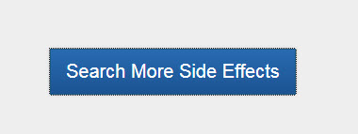

Figure 1 Search More Side effects button

#### Recommendation

Modify button to trigger when enter key is pressed.

#### Problem

When side effects are mentioned, a graph appears. This graph can be moused-over to reveal more information – especially when the smaller segments of the graph are not large enough to contain the percentage. A keyboard-only user will not have access to the mouse-over information.

|  |  |
| --- | --- |
| Figure 2 As seen by keyboard-only user | Figure 3 As seen by mouse user |

#### Recommendation

Modify graphs so keyboard-only users receive the same information as mouse users.

#### Problem

On the "Human-Centered Design Showcase" section of the ICF page each photograph reveals text when moused over. This same information does not appear when a keyboard-only user tabs to the photograph.

|  |
| --- |
| Figure 4 As seen by keyboard-only user |
| Figure 5 As seen by mouse user |

#### Recommendation

Modify photographs so keyboard-only users receive the same information as mouse users.

#### Resources

<http://www.w3.org/TR/WCAG20/#keyboard-operation>  
<http://www.w3.org/WAI/WCAG20/quickref/#qr-keyboard-operation-keyboard-operable>  
<http://www.w3.org/TR/UNDERSTANDING-WCAG20/keyboard-operation-keyboard-operable.html>

### **§1194.21** (c) A well-defined on-screen indication of the current focus shall be provided that moves among interactive interface elements as the input focus changes. The focus shall be programmatically exposed so that assistive technology can track focus and focus changes.

This also violates **WCAG 2.0 success criterion 2.4.7 Focus Visible**: Any keyboard operable user interface has a mode of operation where the keyboard focus indicator is visible. (Level AA)

#### Problem

When a keyboard-only user tabs through the photographs in the "Human-Centered Design Showcase" section of the ICF page visual focus disappears after each photograph. Pressing enter brings up a modal dialog window, but a keyboard only user may be confused about what will happen when enter is pressed because there is no visual indication of focus.

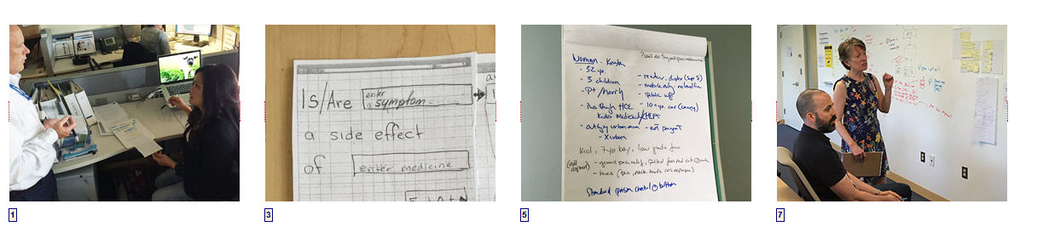

Figure 6 Tabbing seem to go nowhere in between photos

#### Recommendation

Modify modal dialog box trigger so it does not create invisible focus.

#### Problem

When a visitor selects an image in the "Human-Centered Design Showcase" section of the ICF page a modal dialog box opens. While focus is placed on the close button in the dialog box, there is no visual indication of focus on the close button. A sighted keyboard-only user could be confused.

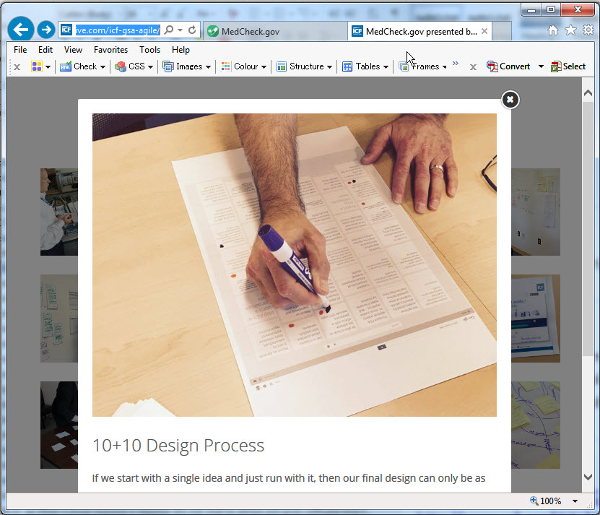

Figure 7 No visual indication of focus on X

#### Recommendation

Ensure a visual indication of focus appears on all interactive elements.

#### Resources

<http://www.w3.org/TR/WCAG20/#navigation-mechanisms>   
<http://www.w3.org/WAI/WCAG20/quickref/#qr-navigation-mechanisms-focus-visible>  
<http://www.w3.org/TR/UNDERSTANDING-WCAG20/navigation-mechanisms-focus-visible.html>

### **§1194.22** (a) A text equivalent for every non-text element shall be provided (e.g., via "alt", "longdesc", or in element content).

This is also a violation of **WCAG 2.0 success criterion 1.1.1 Non-text Content**: All non-text content that is presented to the user has a text alternative that serves the equivalent purpose, except for the situations listed below. (Level A)

* Controls, Input: If non-text content is a control or accepts user input, then it has a name that describes its purpose. (Refer to Guideline 4.1 for additional requirements for controls and content that accepts user input.)
* Time-Based Media: If non-text content is time-based media, then text alternatives at least provide descriptive identification of the non-text content. (Refer to Guideline 1.2 for additional requirements for media.)
* Test: If non-text content is a test or exercise that would be invalid if presented in text, then text alternatives at least provide descriptive identification of the non-text content.
* Sensory: If non-text content is primarily intended to create a specific sensory experience, then text alternatives at least provide descriptive identification of the non-text content.
* CAPTCHA: If the purpose of non-text content is to confirm that content is being accessed by a person rather than a computer, then text alternatives that identify and describe the purpose of the non-text content are provided, and alternative forms of CAPTCHA using output modes for different types of sensory perception are provided to accommodate different disabilities.
* Decoration, Formatting, Invisible: If non-text content is pure decoration, is used only for visual formatting, or is not presented to users, then it is implemented in a way that it can be ignored by assistive technology.

#### Problem

When a visitor searches symptoms of a drug and a match is found, two graphs appear in the results area. Neither of these graphs have appropriate text equivalents available to screen reader users. JAWS announces the percentage that appears on the orange area (incorrectly sometimes), but does not announce the percentage if it does not show (blue area). JAWS' announcement of the graphic is inconsistent. Sometimes it is announced as "Graphic 98.1 (or other percentage), Graphic 0, Graphic 0, Graphic 10 [through Graphic 80)". Other times it is read as a series of seemingly random numbers with lots of zeros.

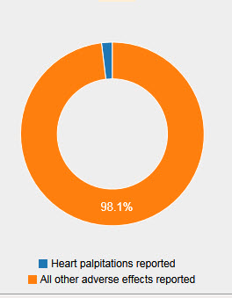

Figure 8 No text equivalent for graphs

#### Recommendation

Provide a text equivalent for the graphs that is available to screen reader users.

#### Problem

The back to top, Facebook, Twitter and Google Plus Icons on the ICF page have no text equivalents. Because they are links they must have text equivalents. They are announced by JAWS as part of the link:

| **Icon** | **JAWS announces** |
| --- | --- |
| Figure 9 Back to top button | icf-gsa-agile same page link |
| Figure 10 Facebook button | ICFInternational |
| Figure 11 Twitter button | icfi |
| Figure 12 Google Plus button | Plus ICFInternational |

#### Recommendation

Provide text equivalents that make sense to a screen reader user.

#### **References**

<http://webaim.org/techniques/images/alt_text>  
<http://www.jimthatcher.com/webcourse2.htm>  
<http://www.jimthatcher.com/webcourse5.htm>  
<http://www.w3.org/TR/WCAG20/#text-equiv>  
<http://webaim.org/standards/wcag/checklist#sc2.4.4>  
<http://www.sitepoint.com/tips-accessible-svg/>

### **§1194.22** (b) Equivalent alternatives for any multimedia presentation shall be synchronized with the presentation.

#### Problem

#### Recommendation

#### Resources

<http://www.hhs.gov/web/socialmedia/getting_started/youtube_guidance.html#accessibility>  
<http://www.access-board.gov/sec508/guide/1194.24.htm#(c)>  
<http://www.w3.org/TR/WCAG20/#media-equiv>

### **§1194.22** (c) Web pages shall be designed so that all information conveyed with color is also available without color, for example from context or markup.

This is also a violation of **WCAG 2.0 success criterion 1.4.1 Use of Color**: Color is not used as the only visual means of conveying information, indicating an action, prompting a response, or distinguishing a visual element. (Level A).

#### Problem

The graphs use colors to display information: Symptom reported = blue, Other adverse effects reported = orange. While the percentage is available on the graph section large enough to hold it, it is not displayed (without mouse-over) on the section too small to display it. A sighted, but color blind, visitor may have trouble distinguishing the differences in the colors.

#### Recommendation

Do not use color as the only means of conveying information.

On second inspection, the title of the graph reports the percentage of the symptom (rounded) – this may be enough, along with the percentage on the orange (fix contrast though).

#### Resources

<http://www.w3.org/TR/WCAG20/#visual-audio-contrast>  
<http://www.w3.org/WAI/WCAG20/quickref/#qr-visual-audio-contrast-without-color>  
<http://www.w3.org/TR/UNDERSTANDING-WCAG20/visual-audio-contrast-without-color.html>

### **§1194.22** (d) Documents shall be organized so they are readable without requiring an associated style sheet.

#### Problem

The graphs appear as black boxes when CSS is disabled.

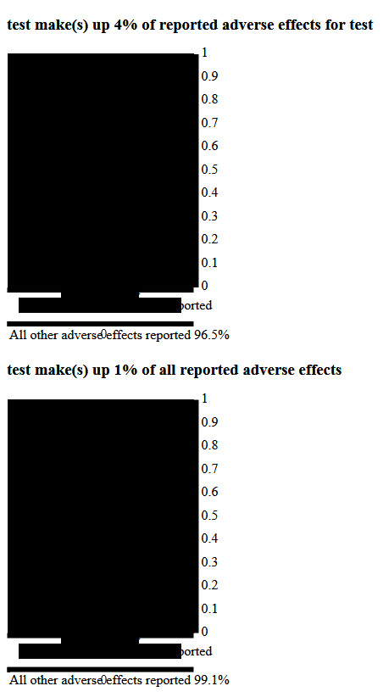

Figure 13 Graphs do not display properly with CSS disabled.

#### Recommendation

Make sure all information is visible with CSS disabled.

#### Problem

Some images, such as the Title image of the page, OpenFDA and ICF logos, are CSS images and when CSS images are removed, nothing shows. This may or may not be a problem.

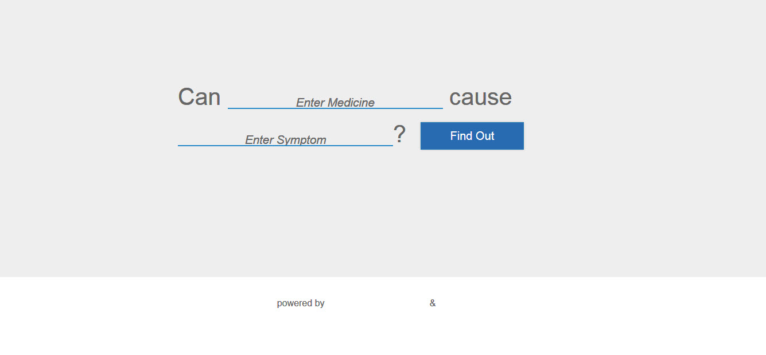

Figure 14 CSS images disabled

#### Recommendation

Use real images instead of CSS images.

#### Resources

<http://www.jimthatcher.com/webcourseb.htm>

### **§1194.22** (e) Redundant text links shall be provided for each active region of a server-side image map.

#### Problem

#### Recommendation

#### Resources

<http://www.jimthatcher.com/webcourse5.htm>

### **§1194.22** (f) Client-side image maps shall be provided instead of server-side image maps except where the regions cannot be defined with an available geometric shape.

#### Problem

#### Recommendation

#### Resources

<http://www.jimthatcher.com/webcourse5.htm>

### **§1194.22** (g) Row and column headers shall be identified for data tables.

#### Problem

#### Recommendation

#### Resources

<http://webaim.org/techniques/tables/data>  
<http://www.w3schools.com/tags/tag_tbody.asp>  
<http://www.w3.org/TR/WCAG20-TECHS/H43>

### **§1194.22** (h) Markup shall be used to associate data cells and header cells for data tables that have two or more logical levels of row or column headers.

#### Problem

#### Recommendation

#### Resources

<http://www.w3.org/TR/WCAG20-TECHS/H39.html>  
<http://webaim.org/techniques/tables/data#id>

### **§1194.22** (i) Frames shall be titled with text that facilitates frame identification and navigation.

#### Problem

#### Recommendation

#### Resources

<http://www.w3.org/TR/WCAG20-TECHS/H64.html>

### **§1194.22** (j) Pages shall be designed to avoid causing the screen to flicker with a frequency greater than 2 Hz and lower than 55 Hz.

#### Problem

#### Recommendation

#### Resources

<http://webaim.org/articles/seizure/>

### **§1194.22** (k) A text-only page, with equivalent information or functionality, shall be provided to make a web site comply with the provisions of this part, when compliance cannot be accomplished in any other way. The content of the text only page shall be updated whenever the primary page changes.

#### Problem

#### Recommendation

#### Resources

### **§1194.22** (l) When pages utilize scripting languages to display content, or to create interface elements, the information provided by the script shall be identified with functional text that can be read by assistive technology.

#### Problem

#### Recommendation

#### Resources

<http://webaim.org/techniques/javascript/>  
<http://www.jimthatcher.com/webcoursea.htm>

### **§1194.22** (m) When a web page requires that an applet, plug-in or other application be present on the client system to interpret page content, the page must provide a link to a plug-in or applet that complies with §1194.21(a) through (l).

#### Problem

#### Recommendation

#### Resources

<http://www.jimthatcher.com/webcoursea.htm>

### **§1194.22** (n) When electronic forms are designed to be completed on-line, the form shall allow people using assistive technology to access the information, field elements, and functionality required for completion and submission of the form, including all directions and cues.

#### Problem

The input elements for the medicine and symptom are enclosed in <label> tags but they are not associated with the labels.

<label><span class="blank-label ng-binding">Enter Medicine</span> <input autocorrect="off" type="text" required="required" data-ng-model="theBlank" class="ng-pristine ng-invalid ng-invalid-required ng-touched" tabindex="0" autocomplete="off" aria-required="true" aria-invalid="true"></label>

<label><span class="blank-label ng-binding">Enter Symptom</span> <input autocorrect="off" type="text" required="required" data-ng-model="theBlank" class="ng-pristine ng-invalid ng-invalid-required ng-touched" tabindex="0" autocomplete="off" aria-required="true" aria-invalid="true"></label>

#### Recommendation

In order of preference, do one of the following:

* Associate the label with the input element by using the "for" attribute in the label tag whose value matches the ID attribute value in the input element tag (note the input elements do not have id attributes at present.) This is the best solution because the label is present.
* Use titles attributes in the input elements to describe what should go in the form fields.
* Use aria-labelledby in the input element to describe what should go in the form fields.

#### Problem

Three input elements on the Contact Us section of the ICF page have labels with "for" attributes but they are not properly associated with the input elements. Instead of having identical value as the id attribute, the "for" value matches the name attribute.

The fourth input element on the Contact Us section of the ICF page has no label, but does have an id attribute.

<label class="sr-only" for="message">Message</label><textarea name="message" class="form-control" placeholder="Message" style="height: 181px" rows="6" required=""></textarea>

<label class="sr-only" for="name">Name</label><input name="name" type="text" class="form-control input-lg" placeholder="Name" required="">

<label class="sr-only" for="email">Email</label><input name="email" type="email" class="form-control input-lg" placeholder="Email" required="">

<input name="verify" type="text" id="verify" class="form-control input-lg" placeholder="Type the code shown" required=""> <img src="image.php" alt="Image verification" class="captcha-image">

#### Recommendation

Provide id attributes for the first three input elements that match the "for" attribute of the label tag.

Provide a "for" attribute for the last form field that matches the id attribute of the input element.

#### Resources

<http://www.jimthatcher.com/webcourse8.htm>  
<http://www.w3.org/TR/WCAG20-TECHS/H65.html>  
<http://webaim.org/techniques/forms/>

### **§1194.22** (o) A method shall be provided that permits users to skip repetitive navigation links.

#### Problem

While there is no navigation links over which to skip, HHS may require a skip nav link anyway.

#### Recommendation

Not sure about this – the page uses proper nesting of headings, so it may be okay without a skip nav link.

#### Resources

<http://webaim.org/techniques/skipnav/>

### **§1194.22** (p) When a timed response is required, the user shall be alerted and given sufficient time to indicate more time is required.

#### Problem

#### Recommendation

#### Resources

<http://www.ssa.gov/accessibility/bpl/bps/forms/timeout/default.htm>

## Other accessibility issues

### Focus order

This violates **WCAG 2.0 success criterion 2.4.3 Focus Order**: If a Web page can be navigated sequentially and the navigation sequences affect meaning or operation, focusable components receive focus in an order that preserves meaning and operability. (Level A)

#### Problem

When a visitor selects an image in the "Human-Centered Design Showcase" section of the ICF page a modal dialog box opens. While focus is placed on the close button in the dialog box, further tabbing goes off the modal window onto the address bar of the web page.



Figure 15 Modal window

#### Recommendation

Ensure focus remains in the modal window until the window is closed.

#### Resources

<http://accessibility.oit.ncsu.edu/training/aria/modal-window/>   
<http://www.w3.org/TR/WCAG20/#navigation-mechanisms>  
<http://www.w3.org/WAI/WCAG20/quickref/#qr-navigation-mechanisms-focus-order>  
<http://www.w3.org/TR/UNDERSTANDING-WCAG20/navigation-mechanisms-focus-order.html>

### Color Contrast

This violates **WCAG 2.0 success criterion 1.4.3 Contrast (Minimum)**: The visual presentation of text and images of text has a contrast ratio of at least 4.5:1, except for the following: (Level AA)

* Large Text: Large-scale text and images of large-scale text have a contrast ratio of at least 3:1;
* Incidental: Text or images of text that are part of an inactive user interface component, that are pure decoration, that are not visible to anyone, or that are part of a picture that contains significant other visual content, have no contrast requirement.
* Logotypes: Text that is part of a logo or brand name has no minimum contrast requirement.

#### Problem

The white text on orange background (medcheck) on the graphs fails for color contrast at 2.53:1. Contrast must be at least 4.5:1.

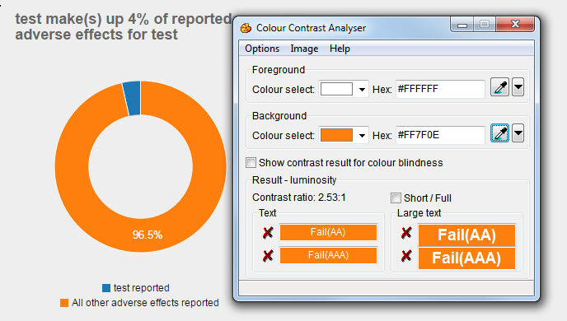

Figure 16 Color contrast ratio fails at 2.53:1

#### Recommendation

Increase the contrast ratio by making the orange darker.

#### Problem

The gray text on white background in the form fields of the "Contact Us" Section of the ICF page fails for color contrast at 2.85:1. Contrast ratio must be at least 4.5:1.

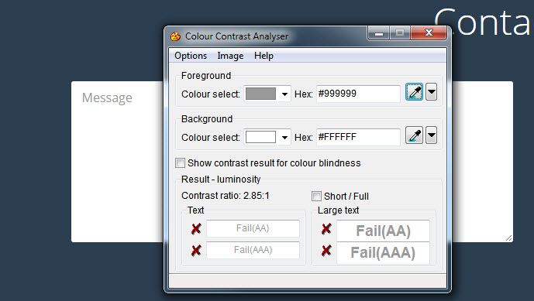

Figure 17 Color contrast fails at 2.85:1

#### Recommendation

Increase the contrast ratio by making the gray darker.

#### Resources

<http://www.w3.org/TR/WCAG20/#visual-audio-contrast>  
<http://www.w3.org/WAI/WCAG20/quickref/#qr-visual-audio-contrast-contrast>  
<http://www.w3.org/TR/UNDERSTANDING-WCAG20/visual-audio-contrast-contrast.html>

### Captcha not accessible

#### Problem

The ICF page features a captcha in the form field that is inaccessible to screen reader users. A screen reader user will be unable to submit the form.

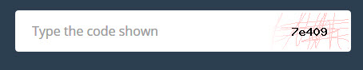

Figure 18 Captcha image

#### Recommendation

Use an alternative method to prove the visitor is a human.

#### Resources

<http://www.w3.org/TR/turingtest/>   
<http://webaim.org/blog/spam_free_accessible_forms/>

## Enhancements for better accessiblity

### Unnecessary alt text

#### Problem

Many of the images on the ICF page are decorative but have alt text. Decorative images do not need, and should not have, a text equivalent.

These include:

* mouse.png (mouse scrolling icon)
* phone-screen.jpg (MedCheck.gov screen)
* team.png (Assembled the team icon)
* thought-leaders.png (Sought out thought leaders icon)
* understand-users.png (Worked to understand the user icon)
* tested-prototypes.png (Tested prototypes with users icon)
* incorporate-feedback.png (Incorporated user feedback icon)
* agile.png (Ran iterative agile sprints icon)
* All staff photos

#### Recommendation

Give decorative images null alt text (alt="").

#### Resources

<http://webaim.org/techniques/alttext/#decorative>

### Incorrect alt text

#### Problem

The photographs in the Human-Centered Design Showcase section of the ICF page have alt text contain the words "Thumbnail photo". Because these photos are links, they need alt text, but "thumbnail photo" is unnecessary.

#### Recommendation

Remove "thumbnail photo" from the alt text of the images.

#### Resources

<http://webaim.org/techniques/alttext/#context>

## Other Issues