SGDE

**QUEUES**



School of Mathematical Sciences

The University of Adelaide

Authors:

Riris A Silalahi (A1750682)

I-Chun Lin (A1745127)

Rumeenabanu Babi (A1756994)

Semester 1, 2018

# **Executive Summary**

Delay is a crucial issue for service providers like stores. Many research has revealed that the length of waiting time has a significant influence on consumer’s satisfaction. However, many stores including Eeylops Owl Emporium store, a retail store which sells owls and other owl-related supplies such as food and cages, are still struggling with excessive waiting time for customer checkouts. This paper illustrates the use of a queue modelling approach in the analysis of two different types of checkout systems which are regular counter service and self-service. We present an analytical study of a finite-state Markov chain model to capture the dynamics of customer queue. Furthermore, we validate the results of our modelling task by using Matlab simulations. The aim of this paper is to support Eeylops Owl Emporium management team to get a better understanding of the optimum checkouts system that can be applied in their store in order to enhance the quality of their services.

In this project, the two checkout systems are assumed to be independent each other. In order to make a clear comparison between these two systems, we decided to pick up two necessary cases(the best case and the worst case) for each system. The worst case means that this queue has highest increasing probability and lowest decreasing probability. In contrast, the best case means that this queue has lowest increasing probability and highest decreasing probability. We generate a simulation of 100 steps by using three different starting length of the queue which are n = 60 (it means queue is full), n =30 (it means queue is half full) and n=0 (it means queue is empty). The simulation then shows that no matter what the first situation is, when the increasing probability is greater than the decreasing probability, the number of people in this queue will increase easily. In contrast, if the decreasing probability is greater than the decreasing probability, the number of people in this queue will decrease easily. Moreover, the value of probability has a significant effect on the increasing rate and decreasing rate.

In the next analysis, we tried to generate a simulation for 10000 steps to calculate the times of this system staying in each state. The simulation shows that the proportion of times of the system staying in state i is equal to the probability of this system staying state i. Based on the comparison for both the worst case and the best case between two systems, we can derive a conclusion that the regular system is obviously better than the self-service system. Thus, the simulation result indicates that in terms of the number of people waiting in the queue, the regular system is a better solution for shop’s owner. To confirm the current result that we have, then we make a comparison between equilibrium probability distribution π generated by mathematic model and simulation results. It shows that there is a high similarity between the state distribution of our simulation result and the equilibrium probability distribution π generated by a mathematic model. And based on this high similarity, we can conclude that our simulation is really closed to our mathematic model. Moreover, if our simulation is closed to reality, so in the future, we could just use our mathematic model to simulate problem in reality.

# **Table of Content**

Executive Summary i

Table of Content ii

Introduction 1

List of Assumptions 1

Mathematical Formulations 1

Markov Chain 1

Equilibrium Behaviour of Markov Chain 2

Queue Problem 2

Modelling Process 3

Basic concepts of Simulation 3

How Increasing Probability and Decreasing Probability Effect the Queue System 4

Comparison of the Result Of 10000 Times Simulation Between Two Systems 6

Comparison between Simulation Result and Equilibrium Probability Distribution 7

Infinite State Situation 9

Result 9

Appendices 10

# **Introduction**

A successful retail business not only has good inventory and management systems, but also has good customer services. One of the most crucial factors contributing to customer's satisfaction is their experience in the checkout line. Eeylops Owl Emporium, a retail store sells owls and owls-related supplies such as food and cages, has two types of checkout counters one is self-service counter and another is checkout counter with people. There are some issues with checkout counters, self-service counters save money of the store, however, some of the people are not familiar to use it, and some of them need a long time to scan the items which cause other people wait in the queue which results in dissatisfaction.

This report simulates a comparison between two types of checkout counters that will help the store management team to analyse the difference between two of them. This comparison is mainly focused on behaviour of the queue. Due to safety regulation, this store allows for maximum 60 people in a queue at a time. To simulate the queue for both systems we are using the concept of Markov chain. Markov chain is a simple concept which can easily explain most complicated real-time processes. Markov chain is based on the principle of "memoryless" property. In other words, the next state of the process only depends on the previous state, not on the history of states. This memoryless property is very similar to the behaviour of the queue. Therefore, by using the concept of Markov chain we can compare both systems and derive a conclusion to help the management team in determining the better option to their store.

# **List of Assumptions**

The assumptions used in this project listed below:

1. The two checkout systems (self-service and regular service) are assumed to be independent each other.
2. Random number used in Matlab simulation is a true random variable.
3. Maximum number of the people in a queue is 60,

# **Mathematical Formulations**

## **Markov Chain**

A Markov chain is a stochastic model describing a sequence of events in where the probability of next event depends only on what just occurred. This property is often known as being memoryless, where the next state depends only the current state not all the history of the states.

***Definition 1: Discrete Time Markov Chain (DTMC)***

A discrete time random process $X_{n}, n ∈N$, is a discrete-time Markov chain if it satisfies

$P\left(X_{n}=s \right| X_{0}=x_{0}, { X}_{1}=x_{1}, . . . , { X}_{n-1}=x_{n-1})$ = $P\left(X_{n}=s \right| { X}_{n-1}=x_{n-1})$

for all $n≥1$ and all $s, x_{0}, x_{1}, …, x_{n-1}∈S$

If moreover

$$P\left(X_{n+1}=j \right| X_{n}=i)=P\left(X_{1}=j \right| X_{0}=i)$$

is independent of n, then $X_{n}$ is said to be a *time-homogeneous* Markov chain.

***Definition 2: Transition Matrix***

The transition matrix P of a discrete-time time-homogeneous Markov chain is the |S| × |S| matrix of transition probabilities

$$p_{ij}=P\left(X_{n+1}=j \right| X_{n}=i)$$

On the other word, can be said that $p_{ij}$ is the probability of transitioning from state *i* to state *j* in one time state.

Transition matrix has two main properties which are

* $0≤p_{ij}≤1$, for all $i,j∈S$
* $\sum_{j∈S}{p_{ij}=1, }$ for all $i∈S$

***Definition 3: m-step Transition Matrix***

The m-step transition matrix $p^{(m)}=\left[{p_{ij}}^{(m)}\right]$ of time-homogeneous Markov chain is the |S| × |S| matrix of transition probabilities

$${p_{ij}}^{(m)}=P\left(X_{n+m}=j \right| X_{n}=i)$$

On the other word, it can be said that ${p_{ij}}^{(m)}$ is the probability of transitioning from state *i* in step n to state *j* in the (*n+m)th* step.

## **Equilibrium Behaviour of Markov Chain**

Assume that

${p_{ij}}^{(m)}⟶π_{j}$ As m → ∞

That is, the probability of being in state *j* after many steps converges to some constant value and hence is independent of the initial state *i*. A stationary distribution **π** is a (row) vector, whose entries are non-negative and sum to 1, is unchanged by the operation of transition matrix **P** on it and so is defined by

$$πP= π$$

## **Queue Problem**

Suppose that a queueing system is observed every minute and the number of customers in the system will follow these assumptions:

* Increases by 1, between observations, with probability.
* Decreases by 1, between observations, with probability $μ$,
* Stays in the same length with probability 1-($+μ)$.

As an exception, when the queue is empty, it

* Increases by 1, with probability.
* Stays empty with probability 1 −.

Base on the problem statement above we can establish transition probabilities for a DTMC which model this queue on the infinite state space $S=\{0, 1, 2, 3, …\}$.

$$P=\left(\begin{matrix}1- & & 0 & 0 & … \\ μ & 1--μ & & 0 & … \\ 0 & μ & 1--μ & & … \\ 0 & 0 & μ & 0 & … \\ ⋮ & ⋮ & ⋮ & ⋮ & ⋱\end{matrix}\right)$$

# **Modelling Process**

In this section, the concepts, the process and the result of our simulation will be clearly explained in following parts.

1. The basic concepts about simulation for one step transition of the Markov chain.
2. 100 steps simulation of the worst case and the best case of two systems to show how the decreasing probability and increasing probability affect the queue.
3. The result of 10000 steps simulation for two systems to make a comparison about the permanent situation of two systems.
4. Comparison between simulation result and Equilibrium probability distribution π generated by the mathematic model.

## **Basic concepts of Simulation**

As what is mentioned above, this simulation uses Markov Chain to simulate the process of the queue. The mechanism about how to determine the next state of the queue are mainly three parts, first is to know the recent state. Second, to select probability density function (pdf) to determine the probability to go to other states. Third, to calculate cumulative distribution function (cdf) from previous pdf function and use a random number in [0, 1] to determine the next state of this system.

The following is a very simple flow to illustrate how we simulate this process with defined increasing probability and defined decreasing probability. Assuming that increasing probability is 0.6 and decreasing probability is 0.2, and transition matrix is like this [0.4, 0.6, 0, 0, 0, 0, 0…,

0.2, 0.2, 0.6, 0, 0, 0, 0…,

…

]

Assuming initial states is S1

0.2

0.2

0.6

8

Because current state is state 1, then the probability about transition in next step could be obtained from transition matrix in Row 1.

1. Probability of transferring from S1 to S0 in next step is 0.2,
2. Probability of staying S1 in next step is 0.2
3. Probability of transferring from S1 to S2 in next step is 0.6;

Those probability is used to calculate the cdf function just like the following line graph

And a number from (0 1) is rand,

0.2~0.4

0.0~0.2

0.4~1.0

1. if this random number is in [0.0~0.2), then next state is S0
2. if this random number is in [0.2~0.4), then next state is S1
3. if this random number is in [0.4~1.0), then next state is S2

If we continue running the above step 10000 times, then we can simulate the process of this queue in next 10000 steps and also calculate the times of this system staying each state to obtain the probability of staying in each state of this system.

## **How Increasing Probability and Decreasing Probability Effect the Queue System**

In our project, there are two checkout system we should simulate and compare. The following table shows the possible increasing probability and decreasing probability range of two systems:

|  |  |  |
| --- | --- | --- |
|  | Self Service | Regular |
| Increasing probability | [0.1, 0.8] | [0,0.6] |
| Decreasing probability | [0, 0.8] | [0.2,0.8] |

In one system, there are two situations which should be taken into consideration, the worst situation and best situation, because other situations are considered to be between the worst case and the best case. The worst case means that this queue has highest increasing probability and lowest decreasing probability. In contrast, the best case means that this queue has lowest increasing probability and highest decreasing probability. Thus, for these two systems, we can assume the best and worst case as the following table:

|  |  |  |
| --- | --- | --- |
|  | Self Service | Regular |
| Best Case | Increasing probability = 0.1  Decreasing probability = 0.8 | Increasing probability = 0  Decreasing probability = 0.8 |
| Worst Case | Increasing probability = 0.8  Decreasing probability = 0 | Increasing probability = 0.6  Decreasing probability = 0.2 |

To know how increasing probability and decreasing probability affect this queue, we simulate 100 steps of the queue among four situations above with different starting state. For efficiency, we use Matlab to simulate it.

In following figures, is the increasing probability and $μ$ is the decreasing probability.

1. Figure 1: The initial state is state 0 (the queue is empty in the beginning)
2. Figure 2: The initial state is state 60 (the queue is full in the beginning )
3. Figure 3: The initial state is state 30 (the queue is half full in the beginning)

**Figure 1**. Process of The Queue with Initial State is State 60

**Figure 2**. Process of The Queue with Initial State is State 0

**Figure 3**. Process of The Queue with Initial State is State 30

There is a common phenomenon in those three graphs above. No matter what is the first situation when the increasing probability is greater than the decreasing probability, then the number of people in this queue will increase easily. In contrast, if the decreasing probability is greater than the decreasing probability, then the number of people in this queue will decrease easily.

Moreover, the value of probability has a significant effect on the increasing rate and decreasing rate. Take Figure 3 for example, we can observe that the increasing speed of the number of people between orange line (the worst case of the regular system) and yellow line (the worst case of the self-serve system) is very different. Because the increasing probability of the worst case of the self-service system is higher than the increasing probability of the worst case of the self-service system, the increasing speed of orange line (the worst case of the regular system) is greater than the increasing speed of yellow line (the worst case of self-serve system).

## **Comparison of the Result Of 10000 Times Simulation Between Two Systems**

While repeating this simulation for 10000 times, the times of this system staying in each state can be calculated. At the end of this simulation, the proportion of times of this system staying in state i is equal to the probability of this system staying state i.

To clearly explain the result, the histograms for states distribution of the best cases are used. From figure 4 and 5, it is obviously observed that the probability of the regular system staying in state zero is greater than the probability of the self-service system staying in state zero. Therefore, when it comes to the comparison between two best cases of both systems, the regular system is better than the self-service system.

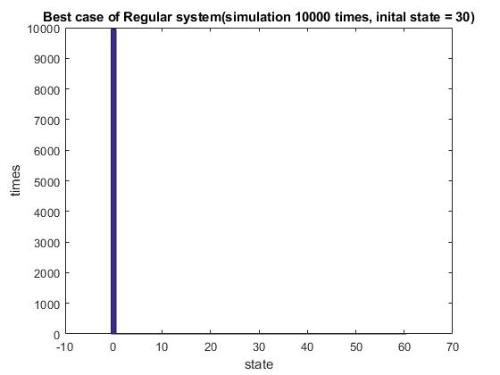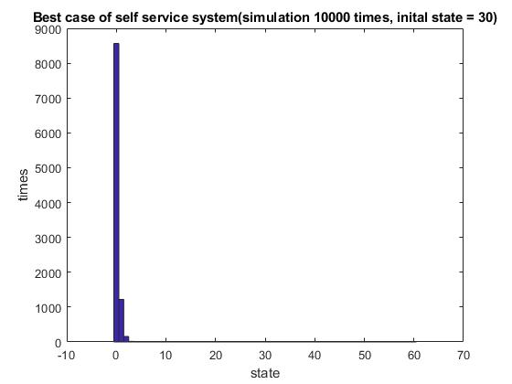

**Figure 5**. Best Case for Self Service System System

**Figure 4**. Best Case for Regular System

When it comes to the comparison of two worst situations between the two systems, the following figures also show a clear difference.

It is clear that the times of regular system staying in state 60 is lower than the times of self-service system staying state 60. It means that the average number of people in the queue of the worst case of the regular system is lower than the number of people in the queue of the worst case of the self-service system. Thus, in term of comparison between the worst cases of the two systems, the regular system is better than the self-service system.

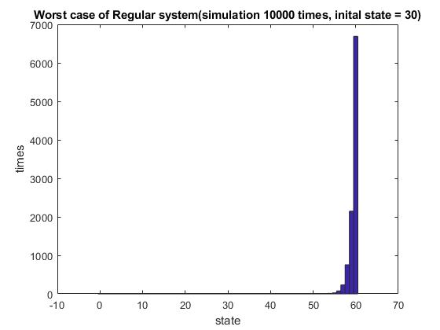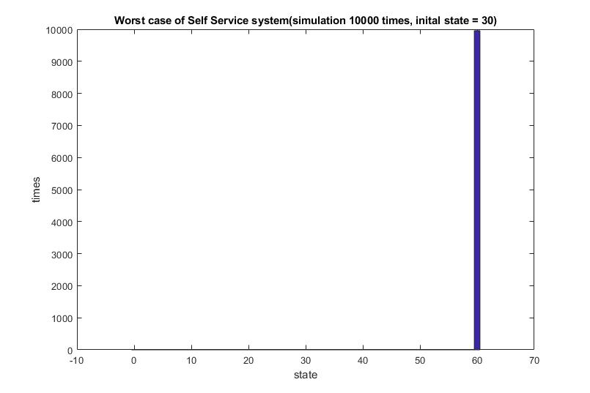

**Figure 7**. Worst Case for Self Service System

**Figure 6**. Worst Case for Regular System

In summary, when we consider the simulation for the worst case comparison and the best case comparison between two systems, the result of the regular system is obviously better than the result of the self-service system. Thus, the simulation result indicates that in terms of the number of people waiting in the queue, the regular system is a better solution for shop’s owner.

## **Comparison between Simulation Result and Equilibrium Probability Distribution**

This section is for comparison between equilibrium probability distribution π generated by mathematic model (Equation 4) and simulation results. The following table shows the comparison result. The left side of the following table are histograms showing the distribution of our simulation result. The right side of the table are histograms showing the equilibrium probability distribution π generated by the mathematic model.

The table shows, there is a high similarity between the state distribution of our simulation result and the equilibrium probability distribution π generated by the mathematic model. And based on this high similarity, we can conclude that our simulation is much closed to our mathematic model. Moreover, if our simulation is closed to reality, in the future, we could just use our mathematic model to simulate problem in reality.

|  |  |
| --- | --- |
| Simulation results of our experiment | Equilibrium probability distribution π generated by mathematic model |
|  |  |
|  |  |
|  |  |
|  |  |

## **Infinite State Situation**

This section is for the prediction of the behaviour of the queue while the length of this queue is unlimited. As it is discussed in mathematic model section. There are three situations needed to be discussed. Because we cannot really set the length of the queue infinite in Matlab. In this section, we just use a mathematical model as has been proofed in appendices 1 to illustrate three possible cases.The increasing probability () is smaller than the decreasing probability ($μ$)

1. There is an equilibrium distribution for this queue. It means that this queue will finally reach a stable state.
2. The increasing probability () is greater than the decreasing probability ($μ$): There is no stable state for this queue and the length of this queue will be grow forever.
3. The increasing probability () is equal to the decreasing probability ($μ$): There is no stable state for the queue

# **Result**

In order to make a clear comparison between two systems, in our analysis, we take two cases that will be observed closely, which are the worst and the best case for each system. The worst situation means that queue has highest increasing probability and lowest decreasing probability. In this case, the number of people in the queue has a tendency to increase continuously. In contrast, the best situation means the queue has lowest increasing probability and highest decreasing probability. In this case, the number of people in the queue has a tendency to decrease continuously.

From our simulation, we can calculate the times of the queue remaining in each state. Here for the worst case in the self-service system, we observed the times that the queue remains in state 60 (queue is full) is greater than the regular system. In another word, it means that the average number of people staying in the queue of the self-service system is greater than the average number of people in the queue of the regular system. However, for the best case, the times of the regular system queue remain in state zero is greater than the self-service system. In the other word. This simulation gives us a clear difference between both systems, from which we can derive a conclusion that regular checkout system is better than the self-service system for the shop owner.

We compared our simulation model and mathematical model, this comparison gives us the result that there is a high similarity between them. If this simulation model is closed to reality then in the future we can use our mathematical model to simulate the reality. Since our experiment shows a high similarity between our mathematical model and our simulation. To extend this model to an infinite queue, the mathematical model is a reasonable way to predict the behaviour of the infinite queue. The queue can only reach a stable state if the decreasing probability is higher than increasing probability.

As a recommendation, if the shop owner wants to increase the quality of their self-service checkout, they can increase the number of machines, so it will increase the decreasing probability of the queue. It means that there will be more people served at the same time.

# **Appendices**

1. **Mathematical Proof**

**Equilibrium Distribution for Finite States**

If the process has a finite number of states N, then the equilibrium equations are a system of N

$$π=Pπ$$

$$\left(\begin{matrix}π_{0} & π_{1} & π_{2} & … & π_{n}\end{matrix}\right)=\left(\begin{matrix}π_{0} & π_{1} & π_{2} & … & π_{n}\end{matrix}\right)\left(\begin{matrix}1- & & 0 & 0 & … \\ μ & 1--μ & & 0 & … \\ 0 & μ & 1--μ & & … \\ 0 & 0 & μ & 0 & … \\ ⋮ & ⋮ & ⋮ & ⋮ & ⋱\end{matrix}\right)$$

From the equation above we can get boundary equations:

$$π_{0}=(1-) π_{0}+μ π_{1}$$

$$π_{1}=π_{0}+ (1--μ) π_{1}+μ π_{2}$$

$$π_{2}=π_{1}+ (1--μ) π_{2}+μ π_{3}$$

By looking to the pattern from three equations above we can take generalisation for equilibrium equation:

$π_{i}=π_{i-1}+ (1--μ) π_{1i}+μ π_{i+1}$, for $i≥1$.

By using the boundary equation we can get the relationship between $π_{0}$ and $π_{1}$

$π_{0}=(1-) π_{0}+μ π_{1}$, we have

$$π_{0}=π_{0}-π_{0}+μ π_{1}$$

$$π_{0}=μ{ π}_{1}$$

$π_{1}=\frac{}{μ}π_{0}$ (1)

By using the general equation for $1≤i≤N$, letting $i=1$, we have

$π_{1}=π_{0}+ (1--μ) π_{1}+μ π_{2}$ (2)

By substituting equation (1) to equation (2), then we can get

$$π_{1}=μπ_{1}+ π_{1}-π_{1}-μ π_{1}+μ π_{2}$$

$$μ π_{2}=π_{1}$$

$$π_{2}=\frac{}{μ}π_{1}= \frac{}{μ} . \frac{}{μ} π_{0}= {\left(\frac{}{μ}\right)}^{2} π_{0}$$

Similarly, we can get

$π_{i}={\left(\frac{}{μ}\right)}^{i} π_{0}$ for $0≤i≤N-1$ (3)

By using the normalising equation $\sum_{i∈S}{π_{i}=1,}$ we have

$$\sum_{i∈S}{π_{i}=1}$$

$⟺$ $\sum_{i=0}^{N}{{\left(\frac{}{μ}\right)}^{i} π_{0}}=1$

$⟺$ $π_{0}\left(\sum_{i=0}^{N}{{\left(\frac{}{μ}\right)}^{i} }\right)=1$

By using the form of arithmetic sequence $\sum_{i=0}^{N}{{\left(\frac{}{μ}\right)}^{i} }=\frac{1-{\left(\frac{}{μ}\right)}^{N+1}}{1-\frac{}{μ}}$.

$⟺$ $π_{0}={\left(\frac{1-{\left(\frac{}{μ}\right)}^{N+1}}{1-\frac{}{μ}}\right)}^{-1}$

In summary we can write that

$π_{i}={\left(\frac{1-{\left(\frac{}{μ}\right)}^{n+1}}{1-\frac{}{μ}}\right)}^{-1}{\left(\frac{}{μ}\right)}^{i}$, for $0≤i≤n$ (4)

This equation then will be used to calculate the equilibrium distribution for our queue problem.

**Equilibrium Distribution for Infinite States**

If the process has an infinite number of states and transition probability $p_{jk}$ do not depend on the actual value of *j* for $j≥J$, but just the difference $k-j.$

By multiplying our vector $π$ and the matrix p, we know our boundary equilibrium equations were:

$$π_{0}=(1-) π_{0}+μ π_{1}$$

$π_{n}={ π}_{n-1}+\left(1--μ\right)π_{n}+μ π_{n+1}$, $n≥1$ (5)

and we also have property of

$$\sum_{i∈S}{π_{i}=1,}$$

Equation (5) can be rewritten as

$\left(+μ\right)π_{n}={ π}_{n-1}+μ π_{n+1}$ (6)

To get a characteristic equation of equation (6) we subtitute ${ π}_{n}=m^{n}$, for some $m$ and $n≥1.$

$\left(+μ\right)π_{n}={ π}_{n-1}+μ π_{n+1}$, for $n≥1$

$⟺$ $\left(+μ\right)m^{n}=m^{n-1}+μ m^{n+1}$, for $n≥1$

by dividing both side by $m^{n-1}$, we can get:

$⟺$ $\left(+μ\right)m=+μ m^{2}$

$⟺$ $μ m^{2}-\left(+μ\right)m+=0$

$⟺$ $μ m^{2}- m- μ m+=0$

$⟺$ $μ m(m-1)- (m-1) =0$

$⟺$ $(μ m- )(m-1) =0$

$⟺$ $m=\frac{}{μ}$ or $m=1$

So, we get two solution which are $m=\frac{}{μ}$ or $m=1$.

**If $≠μ ;$**  then we have two distinct roots for the characteristic $m=\frac{}{μ}$ and $m=1$, then the general solution is of the form

$π_{n}=A{\left(\frac{}{μ}\right)}^{n}+B{(1)}^{n}$, for $n≥0$

where A and B can be any constant in for $R$.

By using boundary equation

$$π_{0}=μ{ π}_{1}$$

we have that,

$$\left(A{\left(\frac{}{μ}\right)}^{o}+B{(1)}^{0}\right)=μ \left(A{\left(\frac{}{μ}\right)}^{1}+B{(1)}^{1}\right)$$

$$⟺\left(A+B\right)= A+ μB$$

$⟺$ $B= μB$

$⟺$ $B(- μ)=0$

$⟹$ $B=0$, because we assume that $≠μ$.

To determine the constant A, we use the normalising equation $\sum_{i∈S}{π_{i}=1,}$ so we get:

$$\sum_{n=0}^{∞}{A}{\left(\frac{}{μ}\right)}^{n}=1$$

$⟺$ $A= {\left(\frac{1}{1-\frac{}{μ}}\right)}^{-1}$ if and only if $\left|\frac{}{μ}\right|<1$

$⟹$ $π_{n}=A{\left(\frac{}{μ}\right)}^{n}={\left(\frac{1}{1-\frac{}{μ}}\right)}^{-1}{\left(\frac{}{μ}\right)}^{n}$, for $n≥0$

$⟺$ $π_{n}=\left(1-\frac{}{μ}\right){\left(\frac{}{μ}\right)}^{n}$, for $n≥0$ and for $≥μ$.

**If $>μ$;** then,

$\sum_{n=0}^{∞}{A}{\left(\frac{}{μ}\right)}^{n}$ diverges for all $A≠0$,

Therefore, $π_{n}=0$, for all $n≥0$.

It means that the equilibrium probability does not exist.

Intuitively, the queue size will go to infinity ($n⟶∞$). The long term average probability of being in any state equals to 0. In the other word, the length of the queue will increase forever.

**When $=μ$;** then the characteristic equation has repeated root $(m=\frac{}{μ}=1)$.

So the equilibrium equation become

$\left(+\right)π_{n}={ π}_{n-1}+ π_{n+1}$, $n≥1$

$$π_{0}={ π}_{1}$$

it means that $π_{0}={ π}_{1}$, for all $i≥0$.

So there is no solution to the normalising equation

$$\sum_{i∈S}{π_{i}=1,}$$

Therefore, no equilibrium probability distribution.

1. Coding Part
2. Data
3. SDGE Individual Report