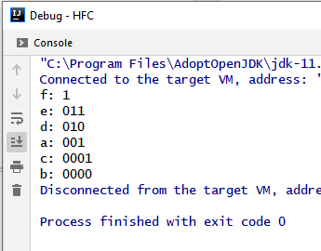

Test case of Huffman Coding example given in class.

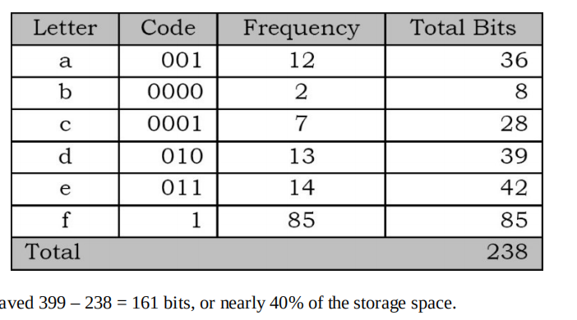

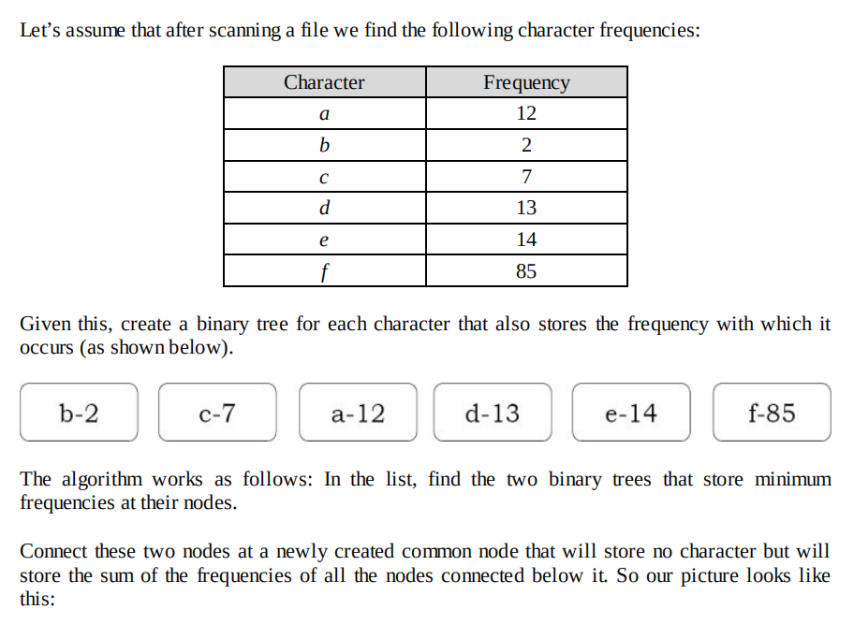

# Discussion

This program uses priority queue(PQ) ADT to ensure minimal selection. In order to achieve ordering by frequency, I tried implementing “comparator” as according to usage, however it did not work. Given comparable is a compulsory interface to implement, but did not help the ordering either. It is found that PQ by default uses the first attribute for natural ordering. I then shifted the object ordering of attributes as a temporary measure.

My implementation is also different from the pseudocode by a lot. At least I cannot directly insert sub-trees into the Binary Tree using Java PQ.

For the display() section, It is a pre-order traversal algorithm.

