/\*

\* p2 : construct an RE that specifies each of the following

\* a. All binary Strings except 11 or 111

\* b. Bin Strings with 1 in every odd-number bit pos

\* c. Bin Strings with at least 2 zeros and at most 1 one

\* d. Bin Strings with no two consecutive 1s

\*/

a.

^(1|1{4,}|[10]\*0+[01]\*)$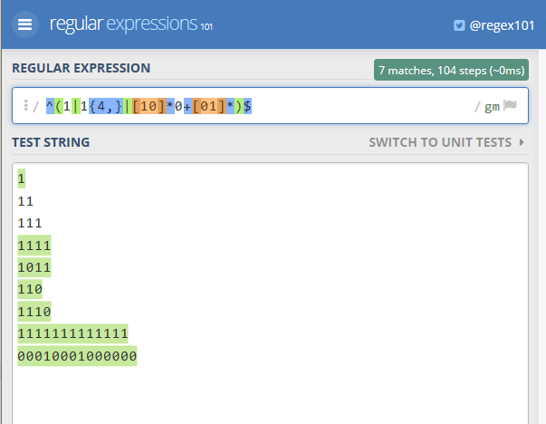

b. ^([10]?(1[10])\*1)$

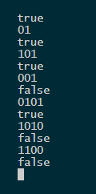

c. ^(0+10+|10{2,}|0{2,}1?)$

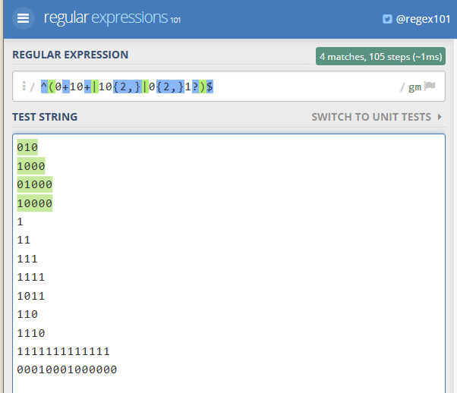

d. ^1?(01?)\*$

