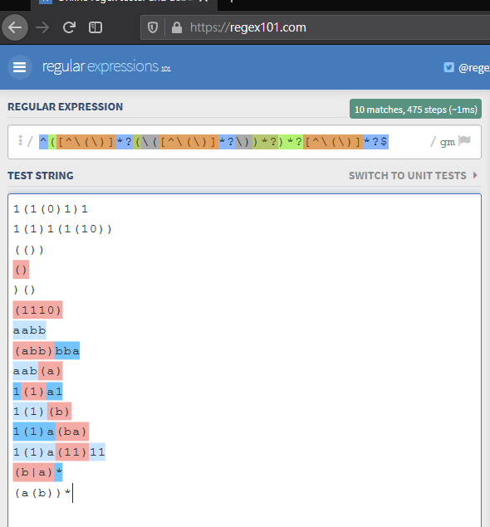^[^\(.*\)]*$

Figure 1 Combined Constructors

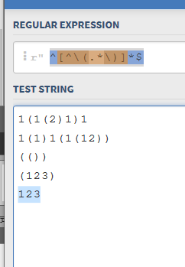

Figure 2 draft construction

^([^\(\)]*?(\([^\(\)]*?\))*?)\***?**[^\(\)]*?$

[^\(\)] = anything but parenthesis

Grey portion:

case 1: To match anything(anything) for infinite times lazily

case 2: Including …(anything)(anything)

Yellow portion:

In case there is anything behind (not ending with parenthesis)

Lazy quantifiers may be used.

That is *? instead of *.

While this increases the amount of computation, this can distinguish between matches better.

When the green ? is removed, the program treat multiline as one match, which could be undesirable.

Testing environment: https://regex101.com/