Hdu1016a
Time in msec:
47168,31178,47242
AVG: 41863
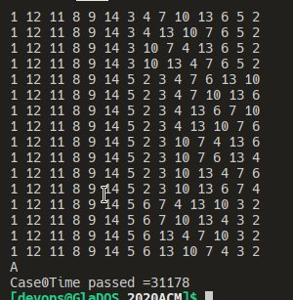

hdu1016b
Time in msec:
51287,51119,51900
AVG: 51435
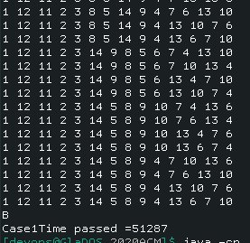

Results and Observation
The test case involved n=6,10 and 14, counted in total.
While A algorithm appears faster than B for about 10 seconds on average, both program are consider slow compared with my written C program. Further more searching on the internet suggested it might be due to the exhausted usage of the printf function. The function in turns would flush the buffer for each line, suggested to use log to write a large amount of output instead.
However, I find this non-explanatory to my C counterpart performance, which was also utilized a lot of printf calls.

Moreover, after disabling all printf calls, the function did not improve much in return.
Case0Time passed =40978
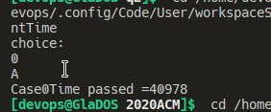

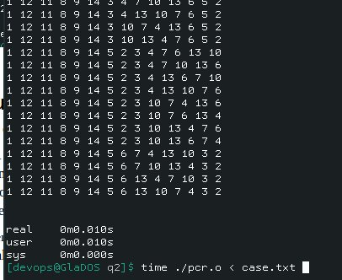
My C Program for reference:
Assume the java algorithms are efficient, there might be unknown bottleneck in the Java setup(which is using default settings).

Tests without Using test driver:
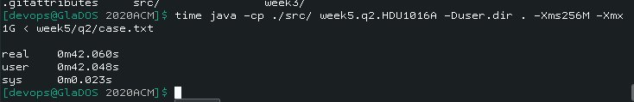
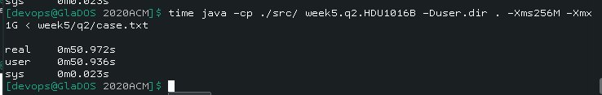
Still, no improvement.

Why A is faster than B?
B is recursive while A is iterative, this potentially eliminated a lot of overheads when the stack calls are large.
Also, what if A and B are inherently slow?
Both A and B does try all possible permutation before checking for bond-primeness at once while in my design ring I add elements one by one into a ring with faulty bond checked every time. Once faulty bond are founded, the whole branch is discarded and backtracked immediately. The approach seems to be very different from A and B.

