# DFS

I have get used to DFS using Adj-list. This trial aims to implement DFS using stack and adjacency matrix only. After testing, the traversal process to find out edge proved itself to be tedious and repetitive, thus the higher T(N) of O(n^2). Every path traversal requires scanning through a row of the current vertex.

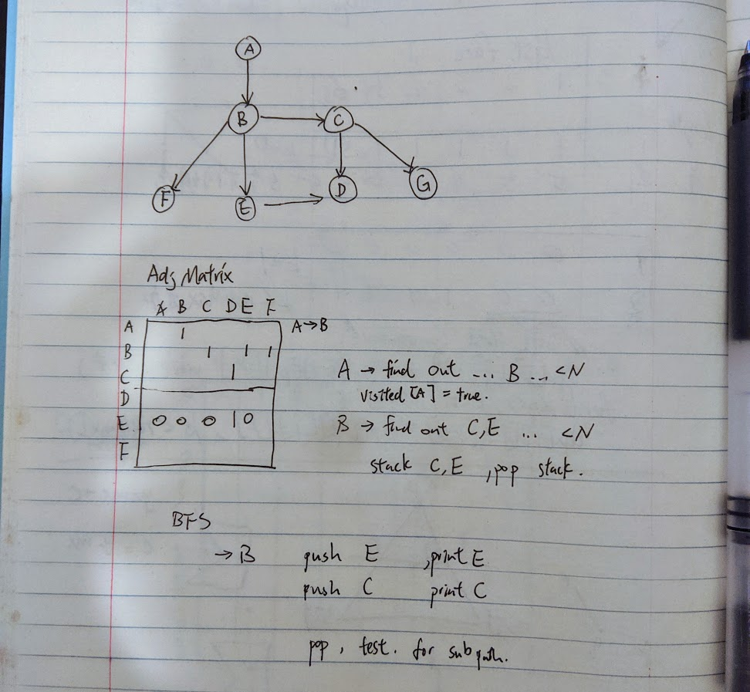

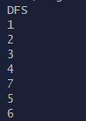

# BFS

BFS traverse layer by layer, by storing items in queue which is FIFO.

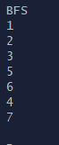

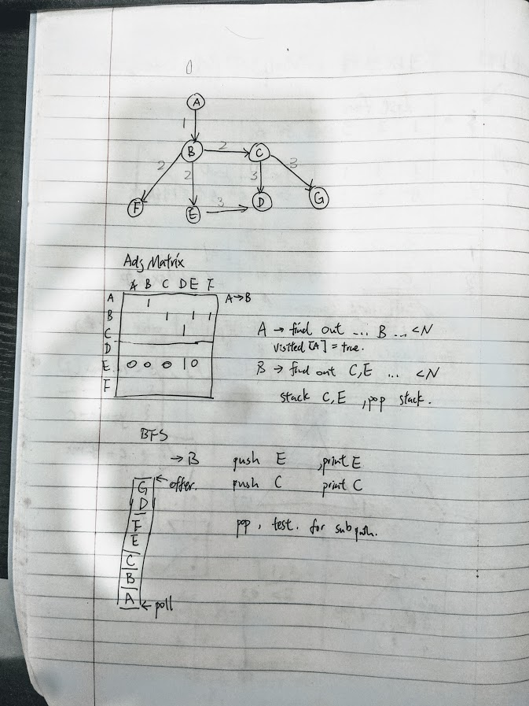

# Cycle

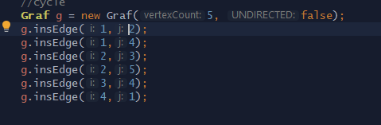

When treated with cyclic graph, both algorithm can perform a tree traversal. Since visited nodes are no longer visited again.

**Result**

