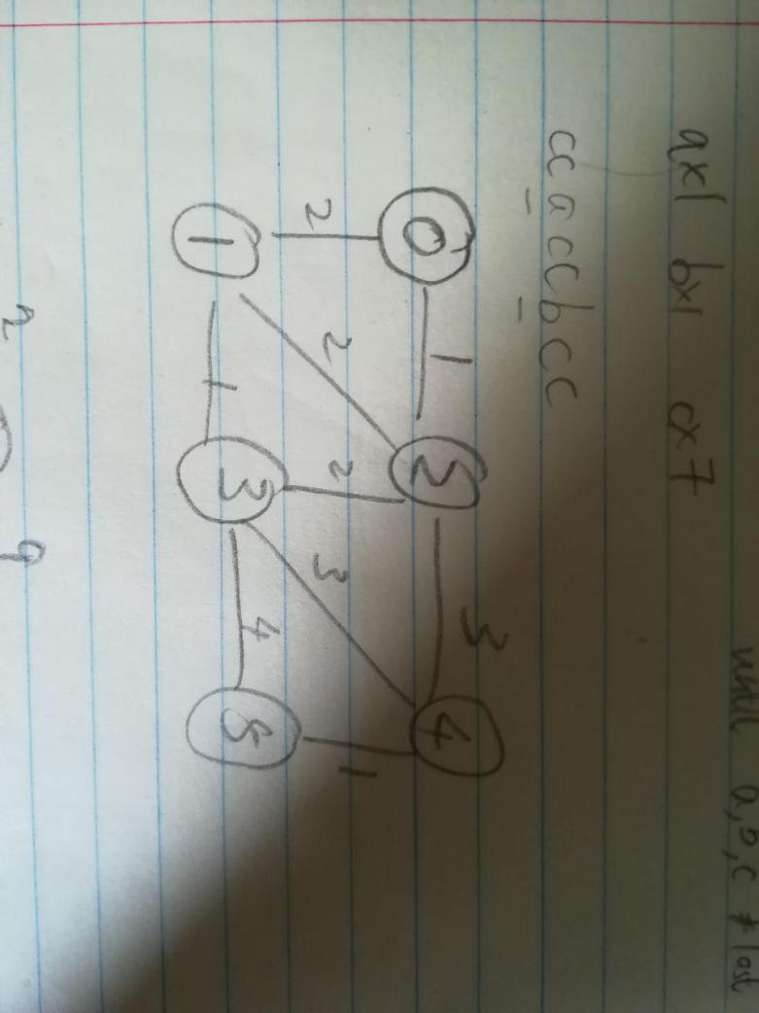

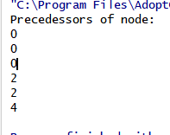

Discussion:

Example pseudocode given in ppt did not find the shortest edge for node 5. Instead of using weight[][] to relax edge, I used distance d.