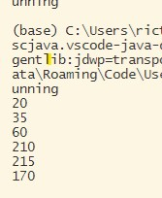

At first my algorithm had problem with the fifth case, which 65,50,50 only return 215 instead of 230.

dp[i] = Math.max(n[i]\*2, n[i] + dp[i + 1]);

After investigating, I found I omitted the fact that accelerating more than once is allowed.

Then I added the if statement.

if(i+2<cnt){

dp[i] = Math.max(n[i] \*2 + dp[i+2], n[i] + dp[i + 1]);

}else{

dp[i] = Math.max(n[i]\*2, n[i] + dp[i + 1]);}

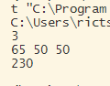

Now every case is correct.

