Case:

GeneA = “GAATC”

GeneB = “CATAC”

1. Finish tabling algorithm 5/3/2020

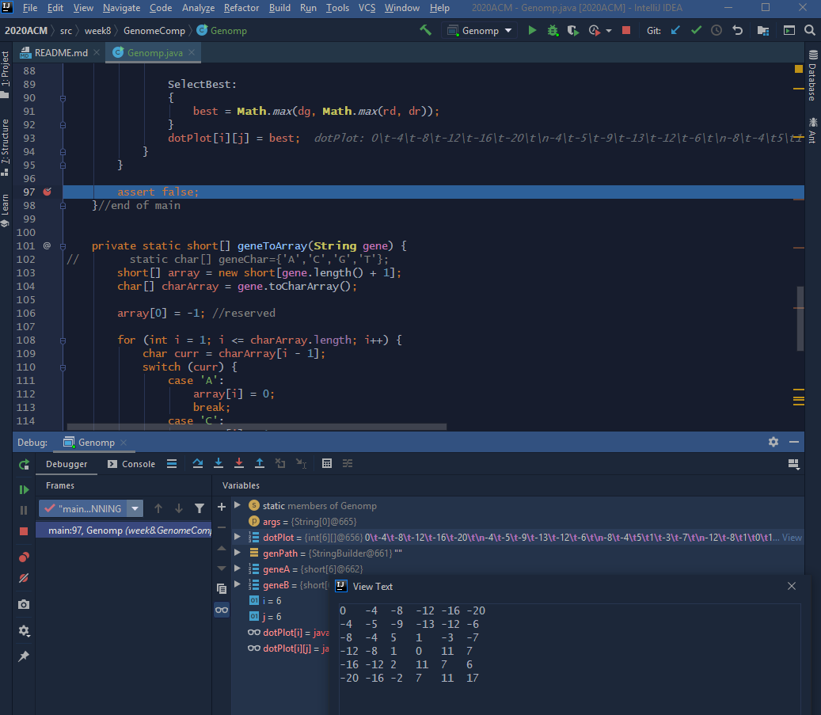

1. Find solution

Trying to establish backtrack by building an array of in-edges in byte[][] dotLink.

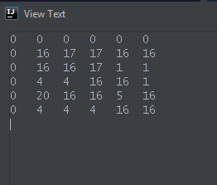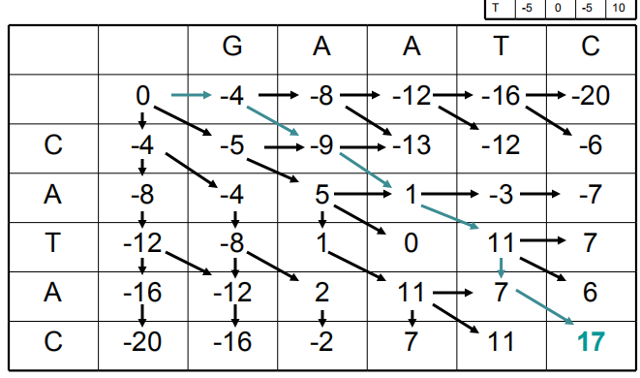

Pair Matching : Stored in reverse order.

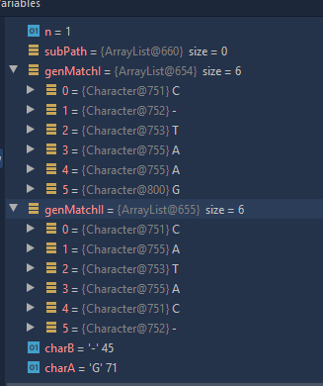

Finish: 5/4/2020

