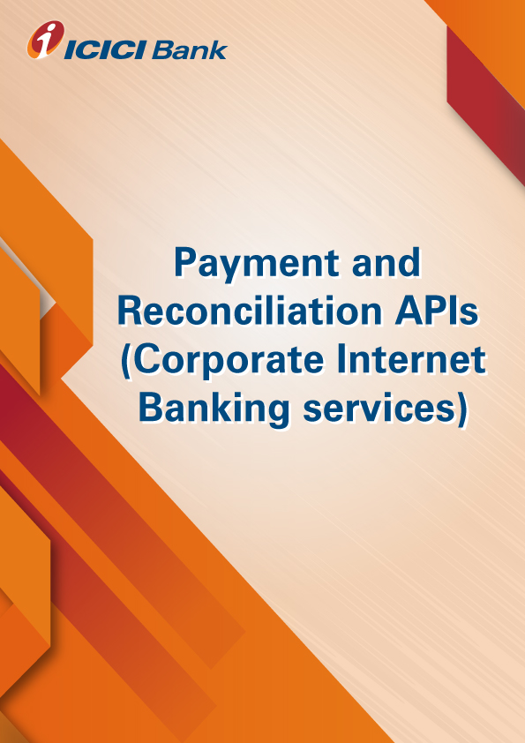

**Product-Process document for the UPI API**

1. **Why UPI API:** The Unified Payments Interface (UPI) offers architecture and a set of standard Application Programming Interface (API) specifications to facilitate online payments. It aims to simplify and provide a single interface across all NPCI systems besides creating interoperability and superior customer experience.
2. **How does it work:**

* Merchant will send Collect Pay request on collect pay API. Merchant will send customer’s VPA and other transaction details.
* On receiving request in correct format, ICICI bank will send collect pay response as transaction initiated successfully.
* At the same time UPI request will be sent to customer’s PSP(based on his VPA) mobile app. (E.g. xyz@icici VPA request on iMobile App and for other banks VPA i.e. xyz@axisbank on their respective mobile app)
* Once Customer accepts or rejects the request from his mobile app, ICICI bank will send call back response to merchant stating Success or Reject.
* When customer accepts the request from his mobile, transaction will be completed and amount will be credited to merchant’s account.
* At any given time merchant can check the status of transaction by calling Transaction status API.
* (Note- For testing purpose, we will provide merchant, an UAT iMobile app/UAT pockets app, where merchant can create test VPA which will be consider as customer or payer’s VPA. In UAT app merchants can complete the transactions on the behalf of customer)

1. **What are the use cases:** vendor payment, Vendor Collection, Ecommerce refund

Ecommerce payment, Fee Collection, Subscription Collection, POS collection, P2P fund transfer, travel booking, movie booking

1. **How to apply for the UPI API services:**

* Please validate and virtually test the standard request response parameters available on developers’ portal.
* Contact your RM / CMS solution manager at your ICICI Bank branch for documentation and commercials
* Complete development and sandbox testing and request for production credentials to go live

1. **What are the commercials of UPI API:** Contact your RM / CMS solution manager at your ICICI Bank branch as the final commercials will depend upon the transaction volumes and value of transaction processed through UPI API.
2. **Whom to contact in case interested or for any help: write to us on** [**apiservicing@icicibank.com**](mailto:apiservicing@icicibank.com)