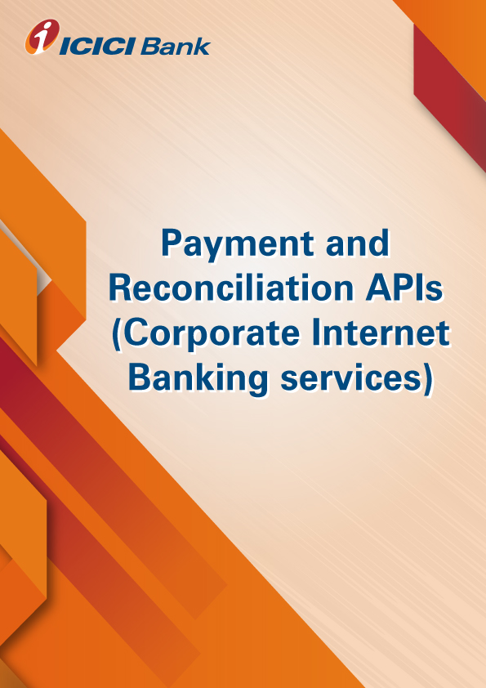

**Product-Process document for the CDM API**

**A. Why CDM API:** Cash Deposit Machine (CDM) offers complete automated solution for cash deposit. Client’s authorized personnel/agents can deposit cash by visiting the nearest ICICI Bank CDM facility. After real-time authentication of the depositor and automated cash counting and validation, the Corporate account is instantly credited and transaction confirmation is sent in real-time to Client’s internal financial system.

**B. How does it work:**

* Client’s Authorized Personnel (depositor) shall visit ICICI Bank’s Designated location with CDM facility and shall select “cardless deposit transaction” option on the CDM for deposit of cash.
* The depositor shall be prompted to enter an account number for deposit of the cash. The depositor shall be required to enter the 12-digit Identifier Code. a. This 12-digit identifier code is a dummy account number made up of client code (e.g.: 9988) followed by depositor code (agent id maintained at client’s end for authentication)
* CDM shall send the deposit request to Client’s back-end system to validate the depositor.
* Upon authentication of the Identifier Code, the CDM will display the dynamic text returned from Client including depositor’s name, the minimum expected/actual outstanding balance amount to be deposited (Screen text can be customizable as per Client’s needs).
* The depositor shall deposit the requisite cash in the CDM as specified on the CDM screen. In case of any mismatch, the depositor has an option to change the account number by canceling the existing transaction and initiating a fresh transaction.
* On confirmation by the depositor, the Machine shall evaluate if the cash being deposited is greater than or equal to the minimum expected cash deposit (as per the instructions received from Client’s back end system). The cash will be processed.

**C. What are the use cases:** Fee deposit, Premium deposit, Agent collection, subscription collection, Bill collection, Service delivery basis payment confirmation etc

**D. How to apply for the CDM API services:**

* Please validate and virtually test the standard request response parameters available on developers’ portal.
* Contact your RM / CMS solution manager at your ICICI Bank branch for documentation and commercials
* Complete development and sandbox testing and request for production credentials to go live

**E. What are the commercials of CDM API:** Contact your RM / CMS solution manager at your ICICI Bank branch as the final commercials will depend upon the transaction volumes and value of transaction processed through CDM

**F. Whom to contact in case interested or for any help ?: write to us on** [**apiservicing@icicibank.com**](mailto:apiservicing@icicibank.com)