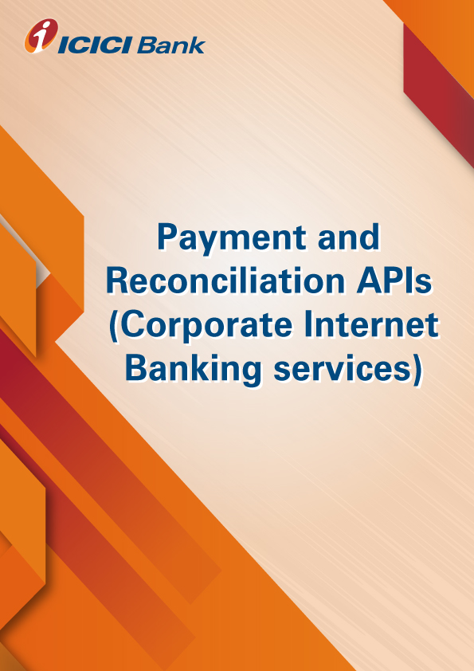

**Product-Process document for the CIB PAYMENT API**

1. **Why CIB API**: CIB Payment API offers to initiate NEFT/RTGS/IMPS/FT by client server to CIB. Based on the defined workflow of corporate, the payments are either processed automatically or are processes up to the point of manual authentication in CIB. Building web interface with the client for accepting payment instructions and Sproviding the reverse feed.
2. **How does it work:**

* Client Onboarding On API for CIB Payment, balance fetch, and statement
* Customer will integrate ICICI bank APIs with his in premises ERP system for using banking services
* Handshake between client and Bank. Client to Provide static IP, Public Certificate, URL, SSL certificate for UAT.
* Bank will configure the Clients UAT detail and provide the UAT credential to the client.
* Client will do testing under UAT and after successful testing, client will provide UAT signoff.
* Client will provide Production details –
* Bank will configure client details for transaction under live production.
* After configuration Bank will provide below live credential to the client to start transactions such as API end point URL, API key, Banks public certificate, headers, testing Credential (Aggr ID, Aggr Name, Corp ID, User ID & Account Number)
* Client will do the pilot transactions and after successful transactions client can start using the services.

1. **What are the use cases:** Salary Payment, vendor payment, all other payments etc.
2. **How to apply for the CIB API services:**

* Please validate and virtually test the standard request response parameters available on developers’ portal.
* Contact your RM / CMS solution manager at your ICICI Bank branch for documentation and commercials
* Complete development and sandbox testing and request for production credentials to go live

1. **What are the commercials of CIB API:** Contact your RM / CMS solution manager at your ICICI Bank branch as the final commercials will depend upon the transaction volumes and value of transaction processed through CIB API.
2. **Whom to contact in case interested or for any help: write to us on** [**apiservicing@icicibank.com**](mailto:apiservicing@icicibank.com)