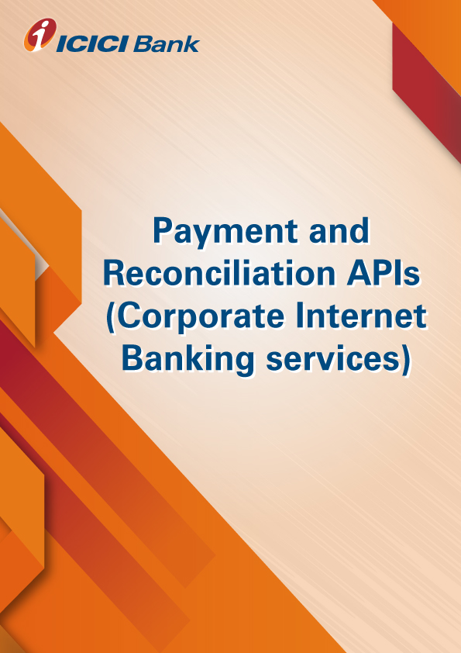

**Product-Process document for the ISUREPAY APIs**

1. **Why Isurepay:** ISUREPAY offers complete automated solution for cash deposit. Client’s authorized personnel/agents can deposit cash by visiting the nearest ICICI Bank Branch. After real-time authentication of the depositor the Corporate account is instantly credited and transaction confirmation is sent in real-time to Client’s internal financial system.
2. **How does it work:**

* Payer can walk down to any branch and tender the cash/ Cheque / DD to the corporate/ institution client code in ISUREPAY module of cash deposit at branches
* ICICI Teller will enter the payers “*Payer id “*and ICICI system will trigger the API call for the acceptance of payer id and amount
* On successful validation & confirmation of the *payer id* by the corporate/ institution teller will process the transaction
* On successful transaction processed, corporate/ institution will get the instant credit and confirmation API call with “unique transaction reference number”
* All the transaction processed during the day will be sent to corporate/ institution on email next day morning in forma of report bearing the “unique transaction reference number” which was passed in the conformation API call

1. **What are the use cases:** Fee deposit, Premium deposit,agent collection, subscription collection, Bill collection, Service delivery basis payment confirmation etc
2. **How to apply for the Isurepay services:**

* Please validate and virtually test the standard request response parameters available on developers’ portal.
* Contact your RM / CMS solution manager at your ICICI Bank branch for documentation and commercials
* Complete development and sandbox testing and request for production credentials to go live

1. **What are the commercials of Isurepay:** Contact your RM / CMS solution manager at your ICICI Bank branch as the final commercials will depend upon the transaction volumes and value of transaction processed through Isurepay.
2. **Whom to contact in case interested or for any help: write to us on** [**apiservicing@icicibank.com**](mailto:apiservicing@icicibank.com)