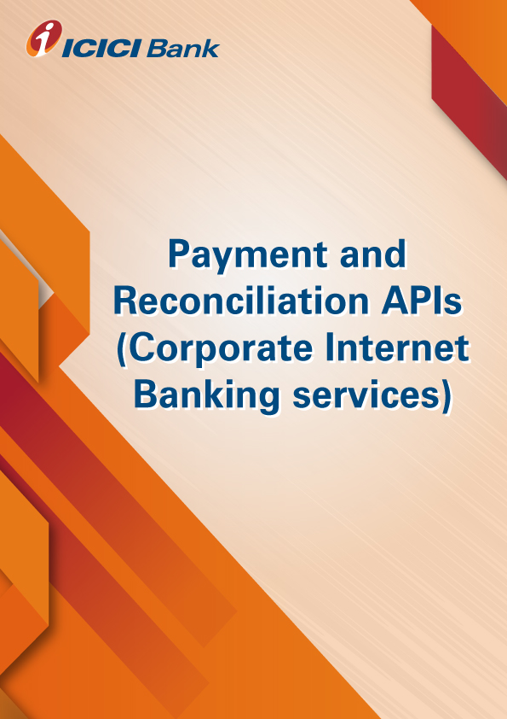

**Product-Process document for the IMPS API**

1. **Why CIB API:** IMPS API offers upload payment files containing bulk/ single transaction via IMPS. Used for bulk payments such as Vendor payments/ salary payments etc. Building web interface with the client for accepting payment instructions and providing the reverse feed.
2. **How does it work:**

**Client’s ERP calls Bank’s IMPS API with beneficiary account and IFSC code**

* Client’s current account held in ICICI Bank is debited and Beneficiary bank’s account is credited
* Bank passes the transaction confirmation along with reference number in the same API call session
* Client’s ERP records the confirmation of payment with the details
* Bank provide an eod report to client for each transaction
* Client ERP reconciles the payment details with eod report
* Failed transactions can be reinitiated post correcting the details through same mode or alternate modes.

1. **What are the use cases:** Salary Payment, vendor payment, all other payments etc .
2. **How to apply for the IMPS API services:**

* Please validate and virtually test the standard request response parameters available on developers’ portal.
* Contact your RM / CMS solution manager at your ICICI Bank branch for documentation and commercials
* Complete development and sandbox testing and request for production credentials to go live

1. **What are the commercials of IMPS API: Contact your RM / CMS solution manager at your ICICI Bank branch as the final commercials will depend upon** the transaction volumes and value of transaction processed through IMPS API .

* **Whom to contact in case interested or for any help: write to us on** [**apiservicing@icicibank.com**](mailto:apiservicing@icicibank.com)