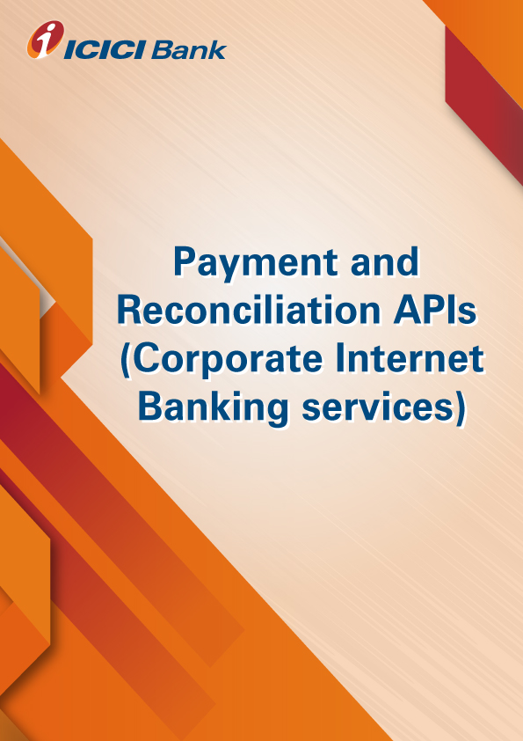

**Product-Process document for the IPS PAYMENT API**

1. **Why CIB API:** IPS Payment API offers upload payment files containing bulk txn via NEFT/RTGS/FT/IMPS. Used for bulk payments such as Vendor payments/ salary payments etc. Building web interface with the client for accepting payment instructions and providing the reverse feed.
2. **How does it work:**

* Prerequisite:
* Client to share the UAT and production IP and port for conducting the feasibility
* Whitelisting of connecting configuration (IP & Port) at both end.
* Client to build for web service as per the XML structure defined below in the document with mandatory tags.
* Client Setup:
* Client have to be on boarded on IPS with end to end mapping of upload & download FC as per the standard configuration defined in the document.
* Web service tags to be configured by client as per the payment file format configuration in IPS
* Payment work flow to be defined on Payment portal (IPS)
* Payment Process Flow:
* Client will initiate payment request & generate XML Encoded Payment String
* The string will be pushed to bank on predefined secured address
* Cordys/ICICI server provide acknowledgement response to client server with status and description
* Cordys/ICICI server to convert XML packet into txt/csv file and push it IPS for debit
* IPS to process the txn and push the status to cordys in csv/txt file
* Cordys to convert the file into XML packet & send the response to client for any rejection or success

1. **What are the use cases:** Salary Payment, vendor payment, all other payments etc.
2. **How to apply for the IPS Payment API services:**

* Please validate and virtually test the standard request response parameters available on developers’ portal.
* Contact your RM / CMS solution manager at your ICICI Bank branch for documentation and commercials
* Complete development and sandbox testing and request for production credentials to go live

1. **What are the commercials of IPS Payment API:** Contact your RM / CMS solution manager at your ICICI Bank branch as the final commercials will depend upon the transaction volumes and value of transaction processed through IPS Payment API .
2. **Whom to contact in case interested or for any help: write to us on** [**apiservicing@icicibank.com**](mailto:apiservicing@icicibank.com)