Illinois' Multiyear Strategy to Control
Drug and Violent Crime
FFY2004



Rod Blagojevich, Governor

Pat Quinn, Lt. Governor

April 2004

Illinois Criminal Justice Information Authority
Sheldon Sorosky, Chairman
Lori G. Levin, Executive Director
TABLE OF CONTENTS

- Executive Summary………………………………………………………………….3

- Data and Analysis……………………………………………………………………9

- Resource Needs………………………………………………………………..…….76

- Priorities and the National Drug Control Strategy………………..……………...82

- Selected Programs…………………………………………………………………..83

- Coordination Efforts………………………………………………………………..86

- Data Sources………………………………………………………………………...87

- EXECUTIVE SUMMARY

Introduction

In June 2000, the Authority convened a Criminal Justice Planning Assembly in which policy makers, service providers, researchers, practitioners, and elected officials participated. The goals and objectives for the criminal justice system, which came out of the Assembly, were refined in the following months and recommended action steps to address identified priorities were developed. This work resulted in a Criminal Justice Plan for the State of Illinois. A primary purpose of the Plan was the development of a framework for a comprehensive statewide approach to coordinating the allocation and expenditure of all federal and state funds appropriated to the Authority and made available for juvenile and criminal justice purposes.

The Plan as well as past funding initiatives, the latest data on drug and violent crime in Illinois, and new criminal justice issues that have arisen in the last several years were taken into account in the development of this strategy. The strategy describes the role that Illinois’ Anti-Drug Abuse Act Edward Byrne Memorial Fund award plays in the larger plan for Illinois, coordinating research, policy, and legislative activities with funding initiatives.

Drug and Violent Crime Issues in Illinois

The strategy provides an overview of the latest data on drug and violent crime in Illinois. From this data, the following trends emerge.

- Drug crime in Illinois has increased more than violent crime.

Drug arrest rates grew more than arrest rates for violent crimes in all regions. The rate of Illinois Department of Corrections (IDOC) commitments for violent Index crimes decreased statewide, in Cook County and the collar counties, and increased only slightly in the urban and rural counties, whereas the rate of commitments for drug crimes nearly doubled in all regions.

- Methamphetamine poses an increasing drug threat to Illinois.

Although methamphetamine admissions accounted for a small percentage of illicit drug admissions (three percent) to substance abuse treatment facilities in Illinois in 2002, methamphetamine admissions increased over 22 times between 1994 and 2002, more than any other drug. Between 1994, the first year data was collected, and 2002, the rate of methamphetamine seizures in the state increased nearly eight times, and the rate of methamphetamine seizures in all regions increased to the greatest degree of any drug.

- Crack cocaine is overshadowing powder cocaine as a drug threat in some areas.

Powder cocaine admissions to substance abuse treatment facilities in Illinois decreased 14 percent while crack cocaine admissions doubled between 1994 and 2002, and crack accounted for 64 percent of drug treatment admissions for cocaine in 2002.

- The use and availability of marijuana are increasing in Illinois.

Cannabis arrests grew threefold statewide, while the rate of controlled substances arrests grew only 18 percent between 1992 and 2002. Controlled substances arrests accounted for the largest percentage of drug arrests (45 percent) in the state in 2002, but arrests for cannabis were not far behind, accounting for 41 percent of all drug arrests that year. According to MEG and task force surveys, in rural areas, cannabis was the most widely available drug.

Admissions to substance abuse treatment facilities in Illinois for marijuana abuse increased more than four times between 1994 and 2002, and treatment admissions for marijuana comprised about one-third of illicit drug admissions in 2002. The 2002 Illinois Household Survey reported that marijuana was the most widely used drug among survey respondents. About one-third of residents in all but one region of Illinois admitted to using marijuana at least once during their lifetime. Finally, according to the Adverse Pregnancy Outcomes Reporting System there were decreases in the number of positive tests for each individual drug except cannabis; positive tests for cannabis increased nearly four times between 1991 and 2001.

- Cocaine and heroin continue to pose significant drug threats to Illinois.

According to the Adverse Pregnancy Outcomes Reporting System (APORS), of the 22,706 infants who tested positive for illegal drugs between 1991 and 2001, 63 percent had traces of cocaine in their system.

Between 1992 and 2002, the rate of cocaine seizures in Chicago increased 11 times, and violations of the Controlled Substances Act account for the largest percentage of drug arrests in Illinois. Also, cocaine and heroin each accounted for about one-third of illicit drug admissions to substance abuse treatment centers in Illinois in 2002.

- Drug and violent crime remain a significant public safety challenge.

According to the Authority’s 2000 Illinois Adult Probation Outcome Study a majority of those on probation for a violent offense (60 percent) had a current or prior substance abuse problem, and probationers with a current substance abuse problem were more than twice as likely as their counterparts on probation of being rearrested while on probation. The study also found that previous drug abusers are more likely to be rearrested while on probation. Finally, the completion of substance abuse treatment by a probationer was associated with a reduction in the likelihood of rearrest in one study. These facts also support the need for more substance abuse treatment programs for offenders.

The Illinois Drug Threat Assessment Update by the National Drug Intelligence Center reports that cocaine, particularly crack, is the drug most often associated with violent criminal behavior according to law enforcement officials in Illinois since retail distributors frequently carry firearms and are linked to drive-by shootings, assaults and murder.

The Authority’s Chicago Women’s Health Risk Study found that intimate partner homicides were more likely to involve drug or alcohol intoxication than non-fatal incidents of intimate partner abuse against women. An intimate partner’s drinking or drug use was a factor in cases involving the homicide of a woman who had not previously experienced violence at the hands of her partner.

- Crime increased more in the rural counties than in any other region of the state.

For example, the rate of violent Index offenses doubled in rural counties between 1992 and 2002, but decreased in all other regions of the state. Likewise, the violent Index arrest rate in the rural counties grew between 1992 and 2002 but decreased in all other regions except for the collar counties. Furthermore, the percent increase in the rural counties’ violent Index arrest rate was five times greater than the collar counties’ rate increase.

Finally, the drug arrest rate for the rural counties grew six times between 1992 and 2002. The collar counties had the next highest percent increase among the regions in its drug arrest rate, yet the increase in the drug arrest rate for the collar counties was less than half the increase experienced by the rural counties.

- Law enforcement efforts increased more in the rural counties than in any other region.

Not only are the increases in the violent Index and drug arrest rates in the rural counties higher than in all other regions of the state, but increases in the rates of new court commitments to IDOC and felony case filings are also higher in the rural counties than in any other region.

- Chicago continues to account for the majority of drug and violent crime in Illinois.

For example, 68 percent of all murders, 33 percent of the criminal sexual assaults, 73 percent of the robberies and 52 percent of the aggravated assaults in Illinois occurred in Chicago in 2002. That year, about 50 percent of Illinois’ cannabis arrests and 70 percent of the state’s arrests for controlled substances occurred in Chicago. In 2002, Chicago’s drug arrest rate, and violent Index arrest and offense rates were twice as high as the statewide rates.

- Crimes involving firearms are a persistent threat in Illinois.

In 2001, according to the National Center for Injury Prevention and Control at the Centers for Disease Control, homicide was the second leading cause of death for Illinois residents age 15 to 34 years. Eighty-three percent of these homicides involved firearms. Fifty-eight percent of firearm deaths in Illinois in 2002 were homicides. In 2002, the Chicago Police Department reported that firearms were used in 79 percent of the reported homicides, a ten percent increase from 1992.

Based on these drug and violent crime issues, the input received and its discussion, the Authority has identified seven priorities for FFY2004. These priorities, which are consistent with and supportive of the National Drug Control Strategy, are not significantly different from those identified in previous strategies. They are the following:

Priority 1: Support prevention programs that help youth recognize risks associated with violent crime and drug use and target youth to reduce their use of violence, illicit drugs, alcohol, and tobacco products.

Priority 2: Support programs statewide that target prevention and early intervention for juveniles, with particular emphasis on the principals of balanced and restorative justice.

Priority 3: Support programs that enhance treatment effectiveness, quality, and services so that those who need treatment can receive it.

Priority 4: Support research that identifies what works in drug treatment and the prevention of drug use, violent crime, and their consequences.

Priority 5: Support programs that promote the efficiency and effectiveness of the criminal justice system.

Priority 6: Support efforts to implement an integrated justice system in Illinois that includes all components of the criminal justice system and includes every jurisdiction within the state.
Priority 7: Support efforts with law enforcement, prosecution, and probation to combat, disrupt, and test drug users.

The Authority has also taken into account past funding allocations and the likely future of federal grant programs. On average, nearly 45% of Byrne funds from the past four years have been dedicated to multi-jurisdictional efforts (MEGs, task forces, drug prosecution units). Almost 13.5% of these awards have been designated to information systems (includes the 5% set-aside for criminal history record improvement). Corrections programs have received nearly 9% of these funds. Between 5% and 7% of the funds have gone to defense initiatives, evaluation, and alternatives to detention. Lesser amounts have been made available for community crime prevention, training, prosecution initiatives (other than multi-jurisdictional drug prosecution units), innovative programs, system response to victims, and gang enforcement and prevention.

In consequence of the various federal budget proposals and their potential effect, in determining funding priorities for the FFY04 Byrne Strategy, Authority members have considered the fact that there might not be future Byrne, LLEBG, or JABG funding. In addition, $85.88 million of the proposed JAG appropriation is currently earmarked for specific projects ($19.96 million for NIJ to assist local units to identify, develop, and purchase new technologies for use by law enforcement, $60 million is for Boys and Girls Clubs, and $5.92 million for the Tribal Courts Initiative). Since details of the JAG program are not available at this time, it is impossible to speculate as to how much Illinois may receive under this initiative.

The priorities are also based on the Authority’s findings regarding current and future resource gaps and needs:

- There continues to be a need to for preventive programs that help youth recognize risks associated with violent crime and drug use and target youth to reduce their use of violence, illicit drugs, alcohol, and tobacco products;
- There continues to be a need for programs throughout the state that target prevention and early intervention for juveniles, with particular emphasis on the principals of balanced and restorative justice.
- There continues to be a need for programs that enhance treatment effectiveness, quality, and services so that those who need treatment can receive it.
- There continues to be a need to emphasize and support research that identifies what works in drug treatment and the prevention of drug use, violent crime, and their consequences.
- There remains a need to support programs that promote the efficiency and effectiveness of the criminal justice system. These include programs such as the multijurisdictional law enforcement and prosecutorial programs focusing on drug and violent crime.
- There is a critical need to support efforts to implement an integrated justice system in Illinois that includes all components of the criminal justice system and includes every jurisdiction within the state.

The Authority has also found that any FFY04 funds available for new projects should be focused in four areas:

- Treatment for sex offender parolees from the Illinois Department of Corrections.
- A special DNA prosecution unit at the Cook County State’s Attorney’s Office.
- Balanced and Restorative Justice (BARJ) projects; and,
- Other public policy initiatives from the Governor, Authority members, and staff.

Each of the first three areas represents efforts in which work by both staff and potential sub-grantees is already underway or specifically projected, and consequently anticipates plans for projects which can realistically be structured and achieved with the timing and funds projected to become available. Additionally, each of the first three areas of focus relate to larger sets of state priorities and needs. The fourth area allows the Authority to maintain maximum flexibility and responsiveness in view of the potentially significant funding restraints, which may be experienced in the very near future, and to respond to emerging needs identified in the course of the funds’ life.

Conclusion

Much progress has been made in combating drug and violent crime in the State. However, these problems remain significant challenges to public safety and security in Illinois. This strategy lays a solid and comprehensive course for using Byrne funds to address them, and is the result of a collaborative and thoughtful planning process.

II. DATA AND ANALYSIS

Introduction

Due to the fact that no single, comprehensive, complete and accurate measure of drug and violent crime exist, numerous sources of information were examined to draw some general conclusions about the extent and nature of the problem.

Many sources were examined in order to accurately analyze the prevalence of drug abuse in Illinois. Also, surveys of Metropolitan Enforcement Groups (MEGs) and Drug Enforcement Task Forces (TFs) regarding drug price and availability in the state, drug seizure data from the Illinois State Police and the Illinois Drug Threat Assessment Update by the National Drug Intelligence Center were analyzed in order to draw some general conclusions about the availability of drugs in Illinois.

Drug arrest data collected by the Illinois State Police (ISP) and the Chicago Police Department (CPD), as well as arrest information gleaned from surveys of MEGs and TFs, are used to characterize drug crime in Illinois. Due to the dramatic growth in the prevalence of methamphetamine in Illinois, this report also includes a special section on methamphetamine based on the Authority study Methamphetamine in Illinois: An Examination of an Emerging Drug.

Violent crime in Illinois was examined by looking at arrests and offenses from Uniform Crime Reports collected by the ISP, as well as data from the CPD. This section also analyzed firearm data from the Illinois Department of Public Health, and elder abuse data from the Illinois Department on Aging (IDOA).

Another section exploring violent crime in Illinois scrutinizes adult offenders in court and on probation who are tracked by the Administrative Office of Illinois Courts (AOIC) and in the jail and prison population monitored by the Illinois Department of Corrections (IDOC). The next section on violent crime in Illinois describes domestic violence and crime victims using data from ISP on domestic crimes, orders of protection and petitioners entered into the Law Enforcement Agencies Data System (LEADS), the Illinois Criminal Justice Information Authority’s (Authority’s) Chicago Women’s Health Risk Study and 2002 Illinois Crime Victimization Survey, and child sexual and physical abuse and neglect are discussed using data from the Illinois DCFS, supplemented by data on crimes against children reported to ISP.

The final section exploring violent crime in Illinois looks at juvenile justice, specifically delinquency petitions, juvenile probation, juveniles in prison, the Juvenile Justice Reform Provisions of 1998 and female delinquents. Information on delinquency petitions and juvenile probation comes from AOIC, while data on juvenile new court commitments to prison comes from the IDOC. Discussion of the Juvenile Justice Reform Provisions of 1998 and female delinquents stems from two reports conducted by the Authority, the Implementation Evaluation of the Juvenile Justice Reform Provisions of 1998 and Female Delinquents Committed to the Illinois Department of Corrections: A Profile.

In all cases, analysis covered changes in the rates of various measures of drug and violent crime over a ten-year period: The latest year for which data were available and the nine previous years. Also, data were organized by region in order to compare crime across different types of jurisdictions in Illinois. The regions discussed in this report are: the City of Chicago and suburban Cook County (where data were available) which together comprise Cook County; the collar counties including DuPage, Kane, Lake, McHenry, and Will counties; the urban counties including Boone, Grundy, Kendall, Menard, Rock Island, Winnebago, Champaign, Henry, Macon, Monroe, Sangamon, Woodford, Clinton, Jersey, Madison, Ogle, St. Clair, DeKalb, Kankakee, McLean, Peoria, and Tazewell counties; and the rural counties including Adams, Coles, Fulton, JoDaviess, Mason, Pulaski, Vermilion, Alexander, Crawford, Gallatin, Johnson, Massac, Putnam, Wabash, Bond, Cumberland, Greene, Knox, McDonough, Randolph, Warren, Brown, DeWitt, Hamilton, LaSalle, Mercer, Richland, Washington, Bureau, Douglas, Hancock, Lawrence, Montgomery, Saline, Wayne, Calhoun, Edgar, Hardin, Lee, Morgan, Schuyler, White, Carroll, Edwards, Henderson, Livingston, Moultrie, Scott, Whiteside, Cass, Effingham, Iroquois, Logan, Perry, Shelby, Williamson, Christian, Fayette, Jackson, Macoupin, Piatt, Stark, Clark, Ford, Jasper, Marion, Pike, Stephenson, Clay, Franklin, Jefferson, Marshall, Pope, and Union counties.

Counties are considered urban if their population consists of at least 50,000 residents or if they contribute at least 50,000 residents to a total Metropolitan Statistical Area (MSA) of 100,000. An area qualifies for recognition as an MSA in one of two ways: (1) if it includes a city of at least 50,000 population, or (2) if it includes an urbanized area of at least 50,000 population with a total metropolitan population of 100,000. In addition to the county containing the main city or urbanized area, an MSA may include additional counties having strong economic and social ties to the central county. Those that are not part of an MSA are rural counties.

Chicago and the collar counties each accounted for 23 percent of Illinois’ population in 2002, suburban Cook County and the urban counties each accounted for 20 percent and the rural counties for 15 percent of the statewide population.

These analyses come to a number of general conclusions about drug and violent crime in Illinois, discussed in-depth at the end of this section. First, drug crime in Illinois increased more than violent crime, although there are connections between the two. Cocaine and heroin continue to pose significant drug threats to Illinois, and marijuana and methamphetamine are increasing in prevalence when factors such as drug use and availability are considered. Crime and law enforcement efforts increased more in the rural counties than in any other region of the state, but Chicago still accounts for the majority of drug and violent crime in Illinois. Finally, crimes involving firearms are a continuing threat in Illinois.

Illicit Drugs in Illinois

Drug Abuse in Illinois

The following sources were examined in order to draw some general conclusions about the prevalence of drug abuse in Illinois: Admissions to substance abuse treatment centers collected by the Illinois Department of Health and Human Services’ OASA, data on substance-exposed infants collected by the Illinois DCFS, the Illinois Department of Public Health’s APORS, data from the Substance Abuse and Mental Health Services Administration’s DAWN on drug mentions and deaths in Chicago-area emergency departments, the Authority report Results from the 2000 Illinois Adult Probation Outcome Study, and the 2002 Illinois Household Survey conducted by OASA.

Drug Treatment Admissions

OASA, under the aegis of the Illinois Department of Human Services, reports that in Illinois in 2002, there were almost 139,000 drug treatment admissions. Total drug treatment admissions increased 66 percent between 1994 and 2002. In 2002, 60 percent of admissions to substance abuse treatment programs in Illinois were for illicit drugs. There were more admissions from Chicago than any other region of the state. In 2002, Chicago accounted for 44 percent of illicit drug admissions to substance abuse treatment programs. The urban counties also accounted for a significant portion of illicit drug admissions to substance abuse treatment facilities (19 percent). Suburban Cook County and the rural and collar counties each accounted for around ten percent of illicit drug treatment admissions in Illinois in 2002.

Between 1994 and 2002, heroin admissions in the state increased twofold, and marijuana admissions increased fourfold. Although treatment admissions for powder cocaine decreased 14 percent between 1994 and 2002, admissions for crack cocaine doubled during that time. However, overall cocaine admissions increased only 16 percent from 1994 to 2002 (Figure 1).

Although methamphetamine admissions accounted for a small percentage of total illicit drug admissions (three percent) in 2002, methamphetamine admissions grew more between 1994 and 2002 than any other drug. During that time, methamphetamine admissions increased 22 times (Figure 1).
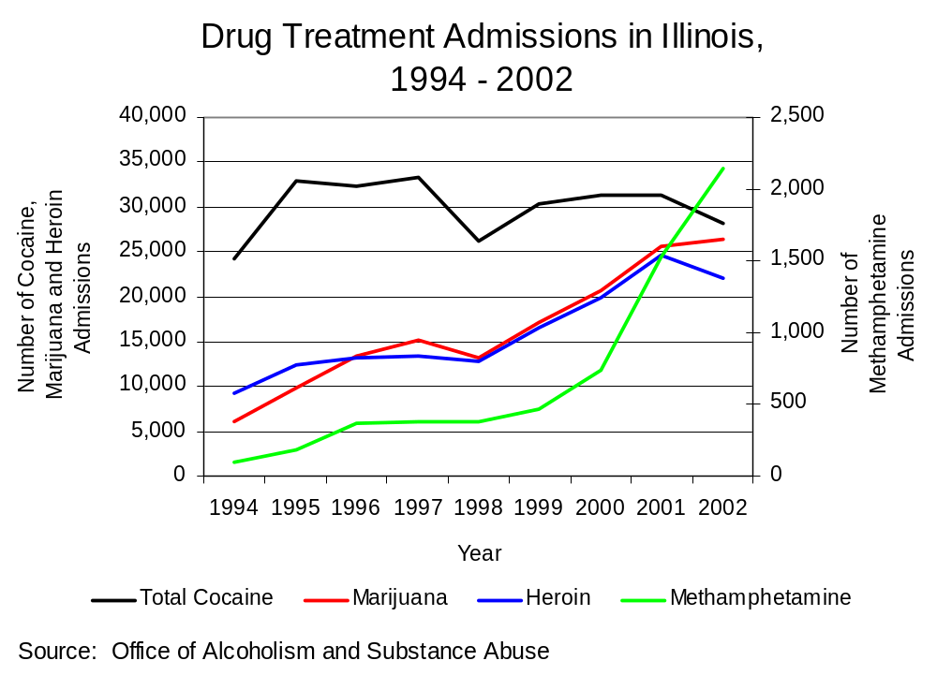
Figure 1

Substance abuse treatment admissions for cocaine, marijuana and heroin each accounted for about 33 percent of illicit drug admissions in 2002. Cocaine, including powder, base and crack, accounted for 34 percent of illicit drug admissions in 2002, and crack accounted for 64 percent of drug treatment admissions for cocaine that year. Marijuana, including hashish, accounted for 32 percent of illicit drug admissions in 2002, and heroin accounted for 27 percent of illicit drug admissions that year.

APORS and DCFS – Substance-Exposed Infants

According to the Illinois DCFS, 1,272 cases of substance-exposed infants were reported in Illinois in 2002. The rate of reported cases of substance-exposed infants in Illinois decreased 58 percent between state fiscal years 1992 and 2002. The rate of reported cases of substance-exposed infants that were verified decreased by virtually the same amount during that time (59 percent).

Seventeen percent of the reported cases of substance-exposed infants in Illinois occurred in suburban Cook County, 53 percent occurred in Chicago, 13 percent occurred in the urban counties, and less than ten percent each occurred in the collar and rural counties of Illinois in 2002. The percentages of verified substance-exposed infant cases for each of the regions in Illinois followed the same pattern in 2002.

Because population data for suburban Cook County and Chicago were not available, rate changes were not calculated separately, and Cook County as a whole was considered instead. In Cook County, the rates of reported and verified cases of substance-exposed infants fell 65 percent, while in the urban counties both rates fell about 45 percent, and in the collar counties both rates decreased about 33 percent between 1992 and 2002. The only region to experience an increase in the rates of reported and verified cases of substance-exposed infants was in the rural counties of Illinois. In the rural counties, the rate of reported cases doubled, and the verified cases quadrupled.

Another source of information on substance-exposed births is the Illinois Department of Public Health's (IDPH) APORS. APORS data are particularly important because they identify through blood tests the illegal drugs to which newborns were exposed. Of the 22,706 infants who tested positive for illegal drugs between 1991 and 2001, the majority (63 percent) had traces of cocaine in their system (Figure 2). Between 1991 and 2001 the number of positive tests through APORS fell 37 percent, with decreases in the number of positive tests for each individual drug except cannabis; positive tests for cannabis increased nearly four times between 1991 and 2001. The decrease in positive cocaine tests was the most dramatic of any of the individual drugs with a 57 percent reduction.
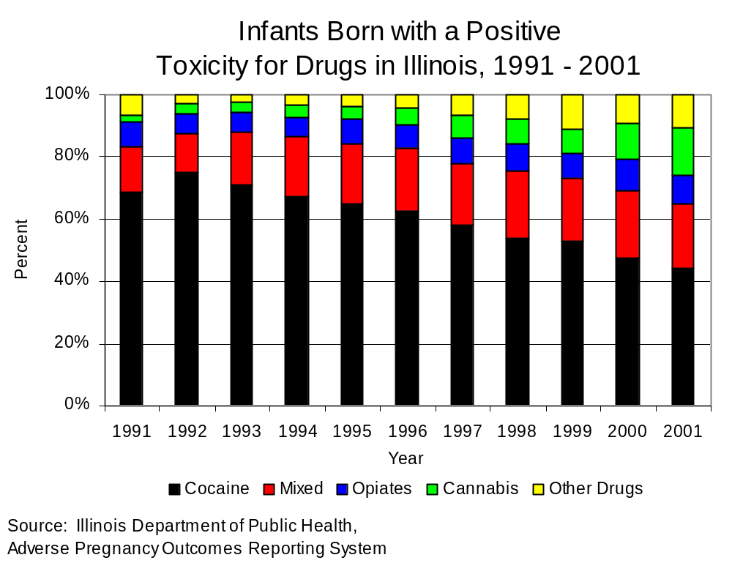
Figure 2

Drug-Related Emergency Department Mentions and Deaths

DAWN, administered by the Substance Abuse and Mental Health Services Administration, is a voluntary data collection system for hospitals meeting set criteria. Data from hospitals enrolled in the Network are used to estimate drug-related episodes, mentions, and visits in the United States (excluding Alaska and Hawaii), and DAWN also tabulates the number of drug mention cases resulting in death and drug-induced or related deaths. DAWN defines drug episodes as emergency department (ED) visits induced by or related to the use of an illegal drug or the non-medical use of a legal drug for patients age 6 to 97 years, and drug mentions as substances recorded during a drug-related death or ED visit by patients within that same age range. DAWN data must be used with caution since up to four drugs per patient may be recorded by physicians and some mentions reflect multiple visits by the same individual. Also note that DAWN includes crack cocaine along with cocaine’s other forms in the “cocaine” category. DAWN’s goal is to highlight the health risks of drug use as reflected in visits to EDs and deaths.
In 2002, Chicago had the third highest rate of ED drug episodes among the 21 cities for which DAWN collects data. Among the ten metropolitan areas with at least 100 PCP mentions in 2001 or 2002, Chicago was the only city showing a significant decrease (48 percent) between those years. Among the 21 cities in DAWN’s network, Chicago had the highest rate of ED mentions for cocaine and heroin in 2002. That year, Chicago’s cocaine mentions were almost four times the national rate, and its heroin mentions were just over six times the national rate.

In 2002, ED mentions for cocaine comprised 36 percent of all emergency room mentions for major substances of abuse in Chicago. Heroin accounted for 29 percent of ED mentions, and marijuana for ten percent. Overall mentions of major substances of abuse increased 71 percent between 1994 and 2002, while mentions for cocaine increased 51 percent, mentions of heroin increased nearly threefold, and mentions of marijuana doubled (Figure 3).
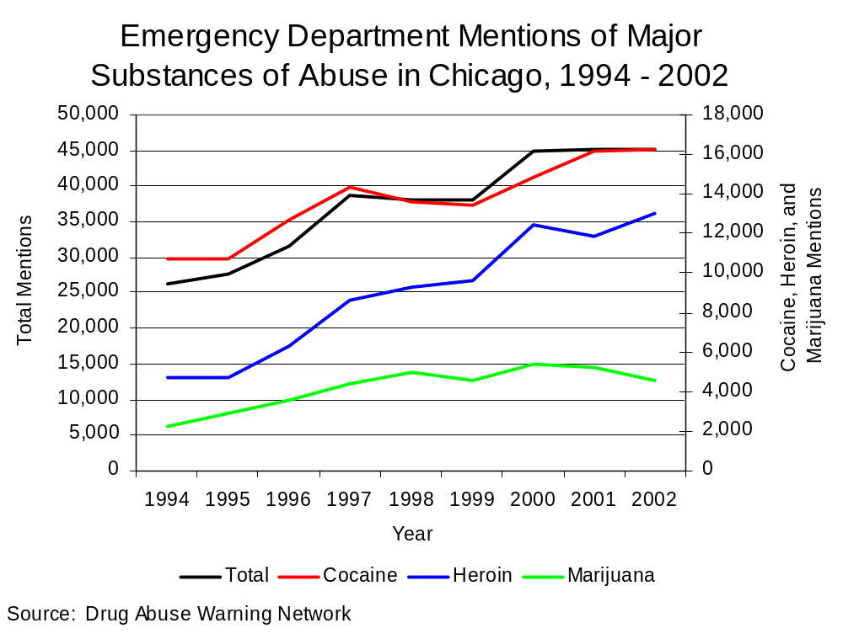
Figure 3

Although not comprising a large percentage of total mentions of major substances of abuse in 2002 (one percent or less), mentions for amphetamines increased almost six times between 1994 and 2002, methamphetamine mentions nearly doubled, and mentions for ecstasy (MDMA) increased nearly nine times (Figure 4).

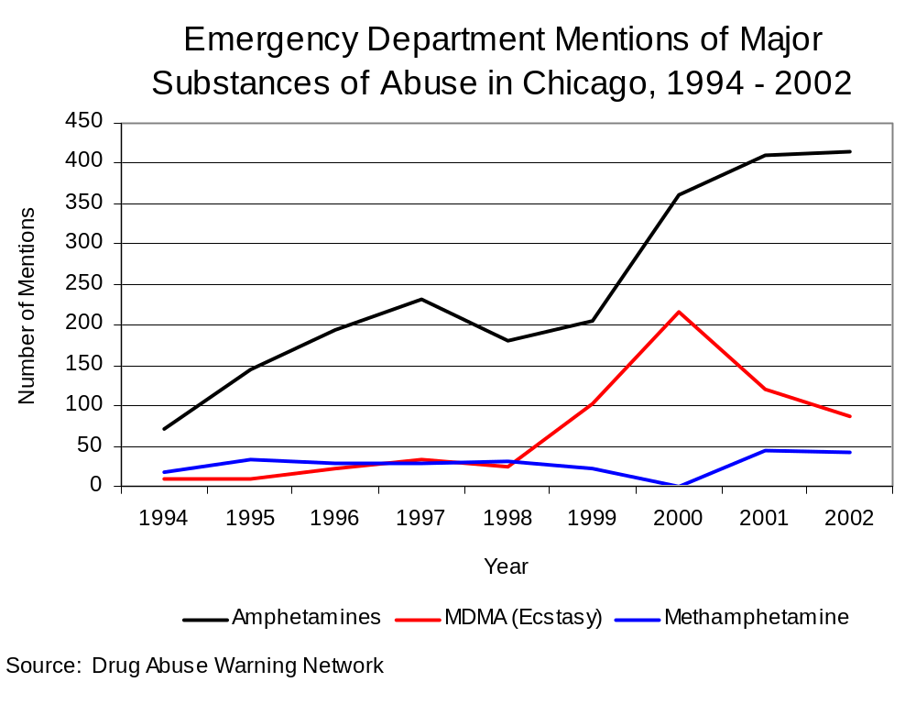
Figure 4

In participating hospitals in metropolitan Chicago in 2001, 854 drug-related or induced deaths occurred and 1,612 drug mentions where death occurred were reported. Overall drug mentions where death occurs have remained stable over the last couple of years in the metropolitan Chicago area. Among drug mentions where death occurred, 32 percent involved cocaine and 22 percent involved heroin. Also, the number of cocaine mentions where death results increased and the number of heroin mentions resulting in death decreased between 1994 and 2002.

Drug Use Among Probationers

At the end of the year 2000 in the state of Illinois, almost twice as many offenders convicted of a crime received probation as received a sentence involving incarceration. The Authority partnered with the Administrative Office of Illinois Courts to survey this large and growing segment of the correctional population. According to the Authority’s 2000 Illinois Adult Probation Outcome Study, 24 percent of probationers surveyed were on probation for a drug offense (the largest single group of probationers relative to those on probation for other types of offenses) while almost 40 percent of adult probation cases involved drug law violations and driving under the influence. Seventy-one percent of probationers were identified as having a current or prior substance abuse problem. This percentage was higher among offenders on probation for a drug offense (82 percent), yet a majority of those on probation for a violent offense (60 percent) also had a current or prior drug abuse problem. Of probationers with a current drug abuse problem or a history of drug abuse, 77 percent abused cannabis, 40 percent abused cocaine and 13 percent abused heroin.

Nearly 60 percent of all probationers were referred to some form of substance abuse treatment by probation officers or as a condition of their parole, and the completion of substance abuse treatment by a probationer was associated with a reduction in the likelihood of rearrest. Probationers with a current substance abuse problem were more than twice as likely as their counterparts on probation of getting rearrested while on probation, and previous drug abusers are more likely to be rearrested while on probation.

Overall, 28 percent of adult probationers surveyed were ordered to undergo urinalysis as a condition of their parole. Forty percent of juveniles on probation were ordered to submit to urinalysis. Of the probationers who were ordered to undergo urinalysis and who were subsequently tested (22 percent), more than half tested positive for illegal drug use at least once during the term of their probation.

2002 Illinois Household Survey

Preliminary results from the 2002 Illinois Household Survey conducted by the Office of Alcoholism and Substance Abuse (OASA) are divided by region: Chicago, suburban Cook County, northwest Illinois, north and south collar counties, east and west central Illinois and southern Illinois. In all other sections of this report the State of Illinois is divided into four to six regions depending upon the availability of data: Chicago, Cook County, Suburban Cook County, and rural, urban and collar counties. It is impossible to satisfactorily reconcile these two different ways of dividing the state, but generally, southern Illinois is overwhelmingly comprised of what the Authority identifies as rural counties, east and west central Illinois are each comprised of a majority of rural counties, and about half the counties in northwest Illinois are rural and half are defined as urban. Chicago, suburban Cook County, and the north and south collar counties are all comprised exclusively of urban counties. Rather than considering the north and south collar counties and the east and west central counties separately, a range is given in the analysis below, where the values are similar, to represent the prevalence of drug use in the collar counties and central Illinois as a whole.

Generally, a higher percentage of respondents in suburban Cook County as compared to Chicago reported using marijuana, crack and powder cocaine, heroin and hallucinogens at least once during their lifetime. The lifetime use of inhalants by respondents in Chicago was three percent higher than in suburban Cook County, while the use of club drugs in Chicago was only slightly higher than survey respondents in suburban Cook County reported. More respondents in east central Illinois relative to west central Illinois reported using marijuana, heroin, hallucinogens and club drugs at least once during their lifetimes. More respondents in west central as opposed to east central Illinois used crack or powder cocaine once during their lifetimes, while the same percentage of respondents in both areas reported using inhalants. More respondents in the north collar counties relative to south collar counties reported using marijuana, inhalants and club drugs, while more survey respondents living in the south collar counties reported using crack or powder cocaine, heroin and hallucinogens once during their lifetimes.

Table 1 depicts the regions where the highest percentage and lowest percentage of survey respondents reported lifetime drug use.

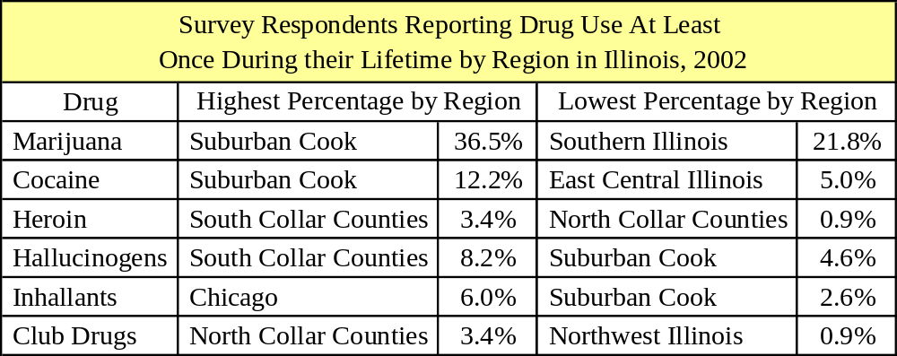
Table 1
Source: Office of Alcoholism and Substance Abuse

The highest percentage of respondents reporting the use of marijuana at least once during their lifetime was in suburban Cook County (37 percent). About 33 percent of surveyed residents in all of the remaining areas except Southern Illinois admitted to using marijuana one time. About 20 percent of surveyed residents in southern Illinois admitted to using marijuana once in their lives.

The percentages of respondents reporting marijuana use within the past month were similar to the percentages of respondents reporting the use of the other drugs during their lifetime. Four percent of survey respondents in Chicago reported that they had used marijuana within the past month, the highest percentage of any region. The lowest percentage of respondents who had used marijuana within the past month lived in northwest Illinois (one percent). Two percent of respondents in southern Illinois reported using marijuana within the past month. The percentage was higher among respondents in central Illinois (three percent), the collar counties (three to four percent) and suburban Cook County (three percent).

Overall, the percentage of surveyed Illinois residents in the various regions of the state reporting the use of cocaine, heroin and club drugs at least once during their lifetime was low. Suburban Cook County showed the highest percentage of respondents who had used crack or powder cocaine in their lifetime (12 percent). Ten percent of respondents in Chicago used crack or powder cocaine in their lifetime, five to six percent of survey respondents in central and southern Illinois reported the use of crack or powder cocaine within their lifetime, whereas about eight percent of those surveyed in northwest Illinois and eight to 11 percent of those in the collar counties reported using crack or powder cocaine at least once in their lifetime.

Three percent of survey respondents in suburban Cook County and southern Illinois reported using heroin at least once during their lives. Here the north and south collar counties are considered separately because the percentages were markedly different: In the north collar counties, one percent of survey respondents reported using heroin at least one time in their lives while three percent, the highest percentage of any region, in the south collar counties reported trying heroin at least once during their lifetime. In central Illinois two percent of respondents admitted trying heroin at least once, while in northwest Illinois, one percent of those surveyed reported using heroin at least once in their lives. Barely two percent of respondents in Chicago reported trying heroin at least once during their lifetime.

Three percent of surveyed residents in Chicago reported using club drugs once during their lifetime. Between two and three percent of respondents in central Illinois and the collar counties reported using club drugs at least one time in their lives. Two percent of survey respondents in suburban Cook County and southern Illinois reported using club drugs at least once during their lifetime, and one percent of surveyed residents in northwest Illinois reported using club drugs at least once.

Drug Availability

Surveys of Metropolitan Enforcement Groups (MEGs) and Drug Enforcement Task Forces (TFs) regarding drug price and availability in the state, drug seizure data from the Illinois State Police and the Illinois Drug Threat Assessment Update by the National Drug Intelligence Center were analyzed in order to draw some general conclusions about the availability of drugs in Illinois.

Metropolitan Enforcement Group and Drug Enforcement Task Force Surveys

In 1995, 1996, 1998 and 2000, the Authority conducted a survey of each of MEGs and TFs in Illinois to gauge the perceived price and availability of drugs in the areas they cover. Currently, there are 20 of these units across 61 counties covering 30 percent of the statewide population. Results from the 2000 survey are presented below.

Based on the survey data, cannabis was more readily available in Illinois than any other drug, and increased in availability between 1995 and 2000. Crack was more readily available than cocaine, although both increased in availability between 1995 and 2002. Methamphetamine availability increased to the greatest degree during that time, and LSD was the only drug to decrease in availability between 1995 and 2002 (Figure 5).

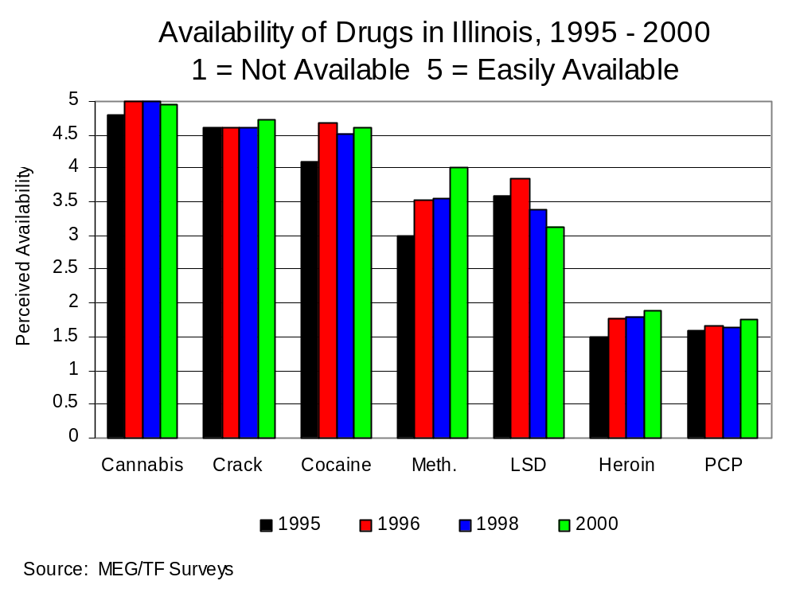
Figure 5

Between 1995 and 2000 statewide, the price of cocaine and crack decreased, the price of cannabis remained the same, and the price of heroin increased. Since 1996, the first year survey data was available, the price of methamphetamine increased.

Cannabis, crack and cocaine were all equally available according to MEGs and TFs that operated in mostly urban areas in 2000. Heroin was the least readily available drug in these areas that year, and was less prevalent than PCP or LSD. PCP and heroin were more widely available in urban areas than in rural regions and regions with a mix of urban and rural areas (Figure 6).

For MEGs and TFs that operate in regions that are a mix of urban and rural areas, crack was more readily available than either cannabis or cocaine, although all three of these drugs were readily available. Methamphetamine was most readily available in rural regions relative to urban regions or regions with a mix of rural and urban areas. LSD was more readily available in mixed urban and rural areas than was true among areas that were exclusively rural or urban, and PCP had the lowest availability in urban and rural mixed areas of any drug in 2000. In rural areas, cannabis was the most widely available drug, and methamphetamine was more readily available than either crack or cocaine (Figure 6).
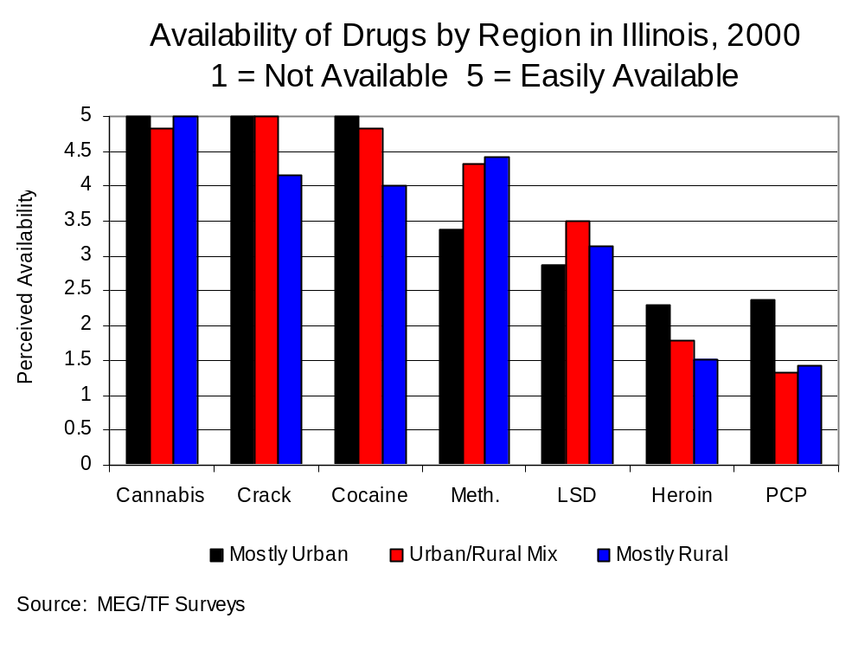
Figure 6

Drug Seizures

The number of grams of drugs seized by police departments in Illinois and submitted to the Illinois State Police (ISP) for analysis, over five million grams in 2002, was examined to determine the availability of drugs in the state. For this analysis, only cannabis, cocaine, crack, heroin and methamphetamine were considered; seizures of other types of drugs were not examined.

In 2002 in Illinois, cannabis and cocaine each comprised about half of all drug seizures. Crack accounted for about six percent of drugs seized, while heroin and methamphetamine accounted for less than one percent each. Between 1992 and 2002, the rate of cannabis and heroin seizures in the state decreased 44 percent while the rate of cocaine seizures increased almost five times. Between 1996, the first year data from Chicago and suburban Cook County were included in the statewide total, and 2002, the crack seizure rate in Illinois increased seven percent. Between 1994, the first year data was collected, and 2002, the rate of methamphetamine seizures in the state increased nearly eight times.

In 2002, Chicago accounted for 70 percent of the drugs seized and submitted to ISP labs. Suburban Cook County accounted for four percent of statewide drug seizures, while the urban counties accounted for 13 percent, and the collar and rural counties accounted for fewer than ten percent each of statewide drug seizures.

In Chicago in 2002, 60 percent of the drugs seized were cocaine and about 33 percent of drug seizures were cannabis. In suburban Cook County that year, 85 percent of drug seizures were cannabis, and 14 percent of drug seizures were cocaine. In the urban, collar and rural counties, the overwhelming majority of drug seizures were comprised of cannabis. In the urban counties cannabis accounted for 89 percent of drugs seized, in the collar counties 75 percent of drugs seized were cannabis, and in the rural counties 86 percent of drugs seized in 2002 were cannabis. Cocaine seizures accounted for about 25 percent of drug seizures in the collar counties in 2002. In the rural counties, less than ten percent of drug seizures were accounted for by cocaine and methamphetamine (nine and five percent respectively), and in the urban counties about ten percent of drug seizures were accounted for by cocaine.

Although cannabis accounted for the majority of drugs seized in the collar and rural counties in 2002, the rate of cannabis seizures in these regions decreased 43 and 88 percent respectively between 1992 and 2002. In the urban counties, the rate of cannabis seizures decreased four percent between 1992 and 2002. In urban and rural counties, the cocaine seizure rate decreased 51 and 77 percent respectively, but increased 71 percent in the collar counties during this time. The rate of crack seizures increased 12 times in the collar counties, five times in the rural counties, while decreasing slightly in the urban counties during this time. The rate of heroin seizures in the urban and collar counties decreased about 33 percent and 80 percent respectively and increased just over ten percent in the rural counties between 1992 and 2002.

Between 1992 and 2002, the rate of cannabis seizures in Chicago increased about 30 percent, while the rate of cocaine seizures increased 11 times, and the rate of heroin seizures decreased 40 percent. Between 1996, the first year data were available for Chicago, and 2002, crack seizures increased 12 percent. The cannabis seizure rate in suburban Cook County increased 43 percent, while the rate of cocaine seizures decreased eight percent, and the rate of heroin seizures decreased 75 percent. The rate of crack seizures in suburban Cook County decreased 92 percent between 1996, the first year data were available, and 2002.

The rate of methamphetamine seizures in all regions increased to the greatest degree of any drug. Between 1994, the first year data were collected for the urban and rural counties, and 2002, the methamphetamine seizure rate increased ten times and five times respectively. The methamphetamine seizure rate in the collar counties increased nearly 11 times between 1995, the first year reliable data were collected, and 2002. Between 1997, the first year data were available for suburban Cook County and Chicago, and 2002, the methamphetamine seizure rate in Chicago increased about 35 times, and decreased almost 50 percent in suburban Cook County.

The overall drug seizure rate including cannabis, cocaine, crack, heroin and methamphetamine, was highest in Chicago and lowest in suburban Cook County in 2002. The drug seizure rate in Chicago in 2002 was about three times higher than the statewide rate.

Illinois Drug Threat Assessment Update

According to the Illinois Drug Threat Assessment Update published by the National Drug Intelligence Center (NDIC) in 2002, cocaine poses the greatest drug threat in the state. Cocaine, particularly crack, is the drug most often associated with violent criminal behavior. Retail cocaine distributors frequently carry firearms and are linked to drive-by shootings, assaults and murder. Criminal groups from Mexico and Columbia are primarily responsible for the wholesale distribution and transportation of crack and cocaine into and out of Illinois.

South American and Southeast Asian are the most prevalent types of heroin in the state. The supply of South American heroin is increasing dramatically and may be surpassing Southeast Asian as the most readily available type of heroin in Illinois. Criminal groups in Columbia directly smuggle heroin into Chicago and are the wholesale distributors of South American heroin in the state, although some Mexican criminal enterprises bring the drug into the city on behalf of Columbian criminal organizations. Nigerian crime organizations are responsible for the supply and wholesale distribution of Southwest Asian heroin into Chicago. Chicago is a distribution hub for heroin into other states.

Most marijuana available in Illinois is from Mexico, and Mexican criminal organizations supply marijuana to Mexican midlevel dealers who distribute the drug in Illinois. The MDMA or ecstasy available in Illinois is produced mainly in the Netherlands or Belgium. Asian, Eastern European and Israeli criminal enterprises are primarily responsible for the ecstasy supply and wholesale distribution in Illinois. These groups bring the drug into the state via New York City or bring it directly into Chicago, although Canada is a growing source of MDMA in Illinois.

Chicago-based street gangs are responsible for most retail sales of cocaine (both powder and crack), heroin and marijuana in Illinois. Retail sales of ecstasy are attributed to ethnic criminal groups or independent white dealers who typically buy large quantities of the drug.

Production and abuse of methamphetamine is growing in Illinois, particularly in rural areas, although methamphetamine is not as great a threat to Illinois as either heroin or cocaine. Methamphetamine is produced locally, in Mexico or in southwestern states. Locally produced methamphetamine is the type most widely available in rural areas of Illinois, but the type produced in Mexico and the southwestern states are most readily available in the Chicago area. Statewide, local independent dealers distribute the locally produced methamphetamine. Mexican criminal groups are the primary wholesale distributors of methamphetamine produced in Mexico, but rather than distributing methamphetamine at the retail level here, Mexican criminal enterprises use Illinois as a hub for the distribution of Mexican methamphetamine into other states.

Drug Crime

Drug arrest data collected by the Illinois State Police (ISP) and the Chicago Police Department (CPD), as well as arrest information gleaned from surveys of Metropolitan Enforcement Groups (MEGs) and Drug Enforcement Task Forces (TFs), are used to characterize drug crime in Illinois.

Drug Arrests

In Illinois, there are currently four sets of state laws designed to address the illegal possession, sale, and production of drugs and drug paraphernalia. The Cannabis Control Act (720 ILCS 570), which prohibits growing, dealing or possessing marijuana, the Controlled Substances Act (720 ILCS 550), which prohibits manufacturing, possessing or selling other illegal drugs, such as cocaine, heroin, phencyclidine (PCP), and LSD, the Hypodermic Syringes and Needles Act (HSNA) (720 ILCS 635) and the Drug Paraphernalia Control Act (DPCA) (720 ILCS 600) which was expanded in 1994. The HSNA and DPCA prohibit the illegal possession, sale or delivery of instruments frequently used to facilitate drug use. The following is an analysis of arrests for violations of these drug acts statewide and by region.

Between 1992 and 2002 in the State of Illinois, the rate of drug arrests increased 86 percent. The cannabis arrest rate increased nearly three times, while the HSNA arrest rate increased 80 percent, and the rate of controlled substances arrests increased 18 percent. Because the DPCA was expanded in 1994, this report examines changes in the DPCA arrest rate between 1994 and 2002. During that time, the DPCA arrest rate increased more than nine times (Figures 7 and 8).

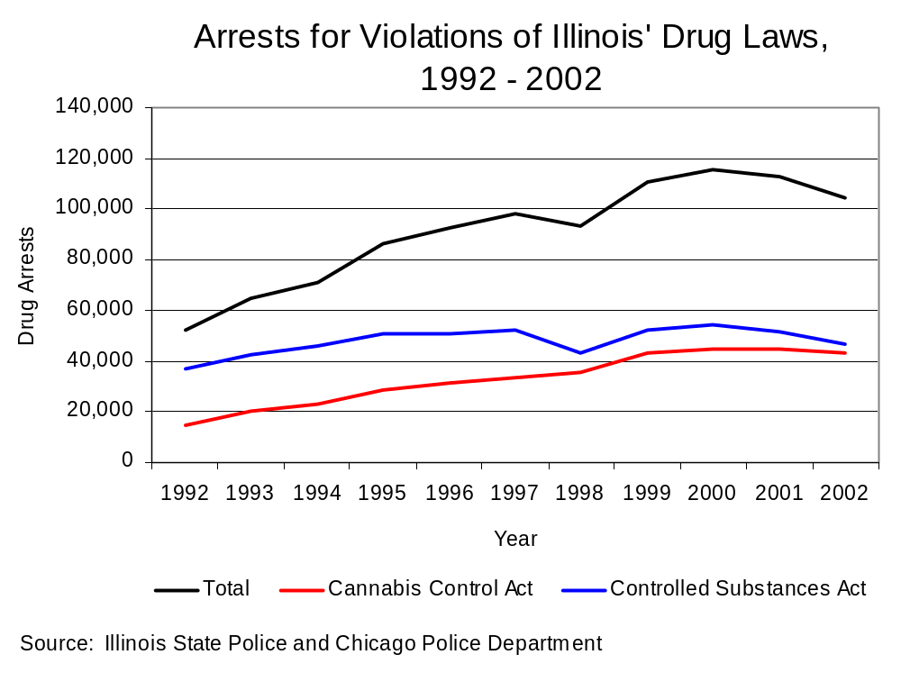
Figure 7

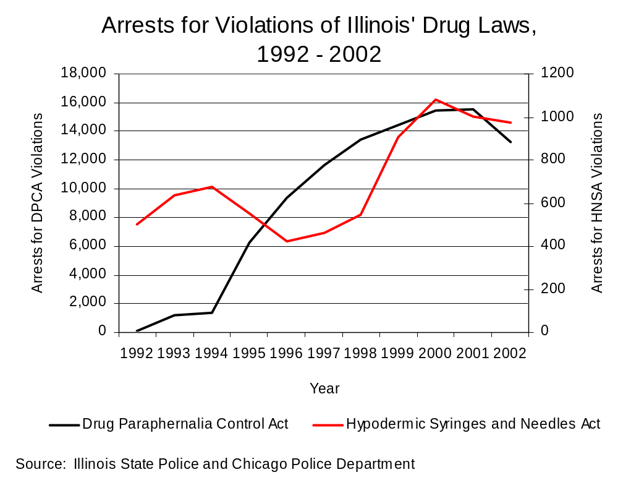
Figure 8

Controlled substances arrests, which grew least of any drug act between 1992 and 2002, account for the largest percentage of drug arrests (45 percent) in the state. Arrests for cannabis account for 41 percent of all drug arrests, DPCA violations account for 13 percent of drug arrests, and HSNA violations account for one percent of drug arrests in Illinois.

The rural counties showed the greatest increase relative to other regions of Illinois in its drug arrest rate, which increased six times between 1992 and 2002. The drug arrest rate in the collar counties increased almost four times, and the rate in the urban counties increased three times. The drug arrest rate in Chicago increased nearly 50 percent, while suburban Cook County’s drug arrest rate almost tripled between 1992 and 2002.

The cannabis arrest rate in all regions of the state more than doubled between 1992 and 2002. The cannabis arrest rate increase in rural counties was greater than in any other region during that time, tripling between 1992 and 2002, although cannabis arrests in rural counties comprised only ten percent all cannabis arrests statewide in 2002. Cannabis arrests in Chicago accounted for the largest percentage (50 percent) of cannabis arrests in the state in 2002.

The rate of controlled substances arrests in Chicago and the urban counties showed relatively small increases between 1992 and 2002. These areas account for the vast majority of controlled substances arrests in Illinois. Although controlled substances arrests in rural areas comprised only six percent of all controlled substances arrests in the state in 2002, the arrest rate in these areas increased more than seven times between 1992 and 2002. Similarly, although controlled substances arrests in the collar counties and suburban Cook County each accounted for a small proportion of all controlled substances arrests in Illinois in 2002 (six and 11 percent respectively), the arrest rate for controlled substances in the collar counties increased almost 80 percent, and the controlled substances arrest rate in suburban Cook County doubled.

The rate of arrests for HSNA violations in rural counties again showed the largest increase between 1992 and 2002. The HSNA arrest rate in rural counties during that time increased more than 13 times, and in 2002, HSNA arrests in rural areas comprised a larger percentage of the state’s HSNA arrests (about 25 percent) of any area. The HSNA arrest rate in the urban and collar counties showed modest gains (30 to 40 percent) during that time, and HSNA arrests in the urban and collar counties each accounted for just over 15 percent of HSNA arrests statewide. Data for Chicago only reliably extends as far back as 1999. Between 1999 and 2002, the HSNA arrest rate in Chicago decreased 61 percent. Suburban Cook County accounted for 20 percent of Illinois’ HSNA arrests in 2002, the same percentage as Chicago. Between 1992 and 2002, the HSNA arrest rate in suburban Cook County decreased 30 percent.

As a relatively new law, arrests for DPCA violations predictably showed dramatic increases in all areas of the state except Chicago between 1994 and 2002. DPCA drug arrests in 2002 for Illinois were comprised of nearly equal numbers of arrests in the rural (24 percent), urban (30 percent), and collar counties (25 percent). Suburban Cook County accounted for 15 percent of DPCA arrests statewide, while Chicago accounted for only six percent.

The rate of DPCA arrests in rural counties increased more than the rate in any other region of the state (16 times) between 1994 and 2002. The DPCA arrest rate in urban counties increased 11 times between 1994 and 2002, while the DPCA arrest rate in the collar counties increased more than 14 times. The DPCA arrest rate in suburban Cook County increased threefold between 1994 and 2002. Data for Chicago only extends as far back as 1999; between 1999 and 2002, the DPCA arrest rate in Chicago decreased 19 percent.

Arrests by Metropolitan Enforcement Groups and Task Force Units

Based on the Authority’s analysis of MEG units and Drug Task Forces, it was found that:

- Although MEGs and task forces accounted for 14 percent or one out of every seven drug arrests made in the covered regions between 1993 and 2002, these arrests were accomplished by a small work force; officers assigned to MEGs and task forces accounted for less than two percent of the total number of sworn police officers working for agencies participating in a MEG or task force. Thus, while non-MEG and task force personnel made an average of nearly 18 drug arrests per officer, those in the MEGs and task forces made nearly 105 drug arrests per officer.

- Unlike arrests by participating and non-participating agencies in 2002, arrests by MEGs and task forces tended to involve the substances considered most serious and the substances for which a large proportion of community residents were seeking and receiving substance abuse treatment, i.e., controlled substances; violations of the Controlled Substances Act are generally felony-level offenses.

- Between 1993 and 2002, the proportion of total drug arrests accounted for by controlled substance arrests increased across all MEGs and task forces.

- Rural MEGs and task forces play a more extensive role in drug law enforcement in the areas they cover than units in urban areas. Estimates show that rural MEGs and task forces account for a significantly larger proportion of cannabis, controlled substances and total drug arrests reported in their regions than is true of urban and mixed urban/rural MEGs and task forces.

- Between 1991 and 2002, nearly all drug arrests by MEGs and task forces resulted in prosecution. Sixty-two percent were for violations of the Controlled Substances Act. During this time 73 percent of all drug offenders who were prosecuted as a result of MEG and task force activity were convicted.

- Among MEG and task force drug offenders convicted and sentenced in 2002, most were sent to prison (45 percent). Forty-three percent were sentenced to probation, and 12 percent to jail.

- Between state fiscal years 1991 and 2002, prison sentences resulting from MEG and task force cases accounted for 32 percent of all drug-law violators sent to prison from the regions where MEGs and task forces operate. MEGs and task forces operating in urban areas accounted for 24 percent of drug-law violators sent to prison from the covered regions, mixed urban/rural MEGs and task forces accounted for 34 percent, and rural MEGs and task forces accounted for 78 percent.

- Almost 75 percent of all drug arrests for violations of the Cannabis Control Act and the Controlled Substances Act reported by MEGs and task forces between 1993 and 2002 involved drug sale or delivery. These types of arrests generally account for a relatively small proportion of drug arrests by local agencies.

Special Section - Methamphetamine in Illinois: An Examination of an Emerging Drug

Up until the last decade, methamphetamine was limited to rather isolated regions of the West and Southwest. That is no longer the case. Methamphetamine is now spreading through the Midwest and becoming an emerging and significant new drug problem in previously unaffected rural and urban areas. The study Methamphetamine in Illinois: An Examination of an Emerging Drug was developed by Authority staff to demonstrate how key indicators can be used to measure, monitor, and evaluate the extent and nature of methamphetamine use and abuse in Illinois. Using aggregate data at the local and national level, the research sought to gauge the migratory characteristics of methamphetamine as an emerging drug by examining prevalence indicators, such as drug arrests, lab seizures, and quantity of drugs seized, relative to consequence indicators, such as admissions to treatment for methamphetamine abuse and other health data.

When reading this report, it is important to view it as a whole. Statistical measures can be open to different interpretations, and no single indicator can accurately reflect the complexity of the problems associated with methamphetamine activity. But multiple indicators, taken together, provide at least a rough indication of patterns and trends in the spread of methamphetamine use and abuse in Illinois. Methamphetamine in Illinois: An Examination of an Emerging Drug employed a general approach to answering questions regarding the extent and nature of methamphetamine activity in Illinois. It also looked at how specific prevalence and consequence indicators reflect the use and abuse of methamphetamine in Illinois, and the extent to which those indicators relate to each other. The prevalence indicators used in this study were arrests for violations of Illinois’ Controlled Substances Act, clandestine methamphetamine laboratory seizures, and the number and weight of methamphetamine drug seizures submitted to Illinois State Police (ISP) crime laboratories for analysis. The consequence indicators were treatment admissions for methamphetamine abuse.

Many of the analyses presented in this report were structured to provide an overview of methamphetamine activity across the state. In addition to examining statewide trends, the report also examined methamphetamine activities across regions of Illinois: Cook County, collar counties (five counties that share a contiguous border with Cook County), urban counties (22 counties outside of Cook County and the collar counties that lie within a Metropolitan Statistical Area), and rural counties (the 74 remaining counties that do not lie within a Metropolitan Statistical Area).

Arrests for violations of drug laws are indicators of the extent and nature of the drug problem in Illinois. Statewide arrest data were obtained through the Uniform Crime Reporting (UCR) program. The data has one major limitation in that the only distinction provided between types of drug arrests is between arrests involving cannabis (identified as violations of the Illinois Cannabis Control Act) and arrests for all other illegal substances (identified as violations of the Illinois Controlled Substances Act). Arrests for drugs such as cocaine, crack cocaine, heroin, and methamphetamine, are reported together as violations of the Controlled Substances Act.

Between 1994 and 2001, the statewide arrest rate per 100,000 population for violations of the Illinois Controlled Substances Act increased six percent. Similar to statewide trends, the controlled substances arrest rate per 100,000 population increased in the collar counties and urban counties. Although the Cook County controlled substances arrest rate increased three percent during the period, its arrest rate in 2001 was the lowest since 1994. Rural counties, on the other hand, experienced the greatest rate increase, more than tripling between 1994 and 2001. Thus, by 2001, the arrest rate in rural counties was nearly equal to or greater than the rates in the collar and urban regions.

While statewide methamphetamine arrest data are not currently available, reports from multi-jurisdictional drug task forces operating in Illinois do specifically identify methamphetamine arrests and can provide a limited picture of arrest activity for the drug. The number of methamphetamine arrests made by multi-jurisdictional drug enforcement units in Illinois offers some insight on the extent and nature of arrests for methamphetamine in the state. The 21 metropolitan enforcement groups (MEGs) and task forces that operate in Illinois did not begin to make a significant number of methamphetamine arrests until after 1997, when they made six. The number of methamphetamine arrests by MEGs and task forces increased rapidly after that, reaching 1,000 arrests in state fiscal year 2002.

MEGs and task forces are classified as being either mostly urban, mixed urban/rural, or mostly rural, based on the classification of the county or counties that each unit covers. While methamphetamine arrests increased across all regions covered by a MEG or task force, between state fiscal years 1997 and 2002, mostly rural units experienced the greatest increase in methamphetamine arrests, increasing from three to 714 arrests, followed by mixed urban/rural units and mostly urban units, which increased from three to 219 arrests and zero to 67 arrests, respectively. In 2002, mostly rural units accounted for more than 71 percent of all methamphetamine arrests by MEGs and task forces.

Drugs seized by law enforcement agencies are another indicator of the extent and nature of illegal drug trade in a jurisdiction. When illegal drugs are seized by Illinois law enforcement agencies, all or a portion of the total amount seized is submitted to a crime lab for identification and analysis. Because most agencies submit drugs to one of the ISP crime labs, data on drugs that were seized and submitted to ISP labs were analyzed. The quantity of methamphetamine seized and submitted to ISP labs jumped from 3,433 grams in 1994 to 19,576 grams in 2001, and number of methamphetamine submissions to Illinois State Police crime labs for analysis more than tripled between 1994 and 2001.

While all regions reported increases in methamphetamine seizures during that period, rural counties accounted for 57 percent of all methamphetamine seized. The statewide methamphetamine seizure rate per 100,000 population increased more than four times between 1994 and 2001. While Cook County had the greatest percentage increase in seizure rates during that period, the rural counties accounted for the highest methamphetamine seizure rate throughout most of the period analyzed. Indeed, methamphetamine is the only drug for which rural counties experienced higher seizure rates than more urban counties in the state. In 2001, heroin seizure rates were 90 percent lower in rural counties than the rest of the state, cocaine seizure rates were 77 percent lower, and cannabis seizures were 13 percent lower. When methamphetamine seizure rates are compared regionally, however, the rate of 597 grams per 100,000 population in Illinois’ rural counties was more than four times the methamphetamine seizure rate experienced in the rest of Illinois. In 1994, methamphetamine was seized in 61 of Illinois’ 102 counties. By 2001, methamphetamine had been seized in 91 counties, 68 of which were rural.

Drug treatment admissions also help depict the nature and extent of the methamphetamine problem. National-level consequence indicators produced by the Drug Abuse Warning Network (DAWN) and the Treatment Episode Data Set (TEDS), indicate rising admissions to treatment facilities and increasing visits to hospital emergency departments associated with methamphetamine, suggesting increases in the use of methamphetamine. DAWN is an ongoing, national drug abuse surveillance system that monitors visits to hospital emergency departments and deaths reviewed by medical examiners and coroners that are attributable to drug abuse. DAWN showed an 18 percent increase in the number of emergency department mentions for methamphetamine between 1998 and 2000. In 1999, methamphetamine was the primary form of amphetamine seen in the United States, making up 94 percent of all treatment admissions for amphetamines.

The number of admissions for treatment for methamphetamine abuse from rural counties increased from 46 to 1,122 between 1994 and 2001. Rural counties accounted for 73 percent of methamphetamine treatment admissions in Illinois in state fiscal year 2001.

Although the characteristics and substances abused by those admitted to treatment may not be reflective of general drug use patterns within a region, one can interpret treatment admissions as reflective of more serious substance abusers. TEDS is a data set that tallies admissions to publicly funded substance abuse treatment programs in most of the 50 states. The most current TEDS data indicate that publicly-funded treatment admissions for methamphetamine rose from 20,771 in 1993 to 55,745 in 1998.

TEDS data were examined to determine the extent to which methamphetamine abuse has changed in Illinois, as well. The number of admissions for treatment where methamphetamine was identified as the primary substance of abuse rose from 97 in 1994 to 1,528 in 2001. This increase was largely driven by treatment admissions from rural areas, where admissions surged from 46 in 1994 to 1,122 in 2001. Admissions from rural counties accounted for 73 percent of all methamphetamine treatment admissions in Illinois in 2001. During the same period, admissions for treatment also increased in other regions of the state, but in much smaller numbers. Between 1994 and 2001, admissions from Cook County increased from 11 to 17, admissions from urban counties increased from 34 to 207, and admissions from collar counties rose from six to 31.

The statewide methamphetamine treatment admission rate rose from 0.8 admissions per 100,000 population in 1994 to 12 admissions per 100,000 population in 2001. The admission rate in Cook County and the urban and collar counties remained relatively low during this period. The rate in the rural counties, however, increased from two to nearly 60 admissions per 100,000 residents, a rate nearly five times greater than the rate for the entire state. In 1994, admissions for treatment of methamphetamine abuse were reported in 34 counties, 18 of which were rural. However, by 2001, rural counties accounted for 58 of the 81 counties in which methamphetamine treatment admissions were reported. Rural counties accounted for the majority of counties experiencing the highest treatment admission rates in 2001.

Methamphetamine treatment admissions also accounted for an increasing proportion of total illicit drug abuse treatment admissions. Similar to national trends, the proportion of treatment admissions for methamphetamine abuse in Illinois increased slightly, from 0.2 percent in 1994 to nearly two percent in 2001. Although the proportion of methamphetamine treatment admissions in both the collar and urban county regions increased between 1994 and 2001, the increase was slight, increasing from 0.2 to 0.4 percent and 0.4 to one percent, respectively. However, during the same time period, the proportion of treatment admissions in rural counties accounted for by methamphetamine increased significantly, from slightly more than one percent to 12 percent of all illicit drug treatment admissions.

In addition to collecting data on the quantities of drugs seized and submitted to ISP crime labs, ISP also collects and reports data on the actual number of submissions and the types of drugs submitted regardless of the amount of drugs involved in each submission. Statewide, between 1998 and 2001, the number of methamphetamine submissions for analysis to ISP crime labs more than tripled, from 628 to 2,148. Rural counties accounted for 76 percent of all methamphetamine submissions in 2001. In 2001, the statewide methamphetamine submission rate was 17 submissions per 100,000 population, compared to five submissions per 100,000 population in 1998. Rural counties experienced a nearly fourfold increase, rising from 19 submissions per 100,000 population in 1998 to a rate of nearly 87 submissions in 2001. The methamphetamine submission rate for rural counties was more than five times greater than the rate for the entire state in 2001.

Clandestine laboratory seizures are another means for measuring the spread of methamphetamine in Illinois. As a result of the growing number of small methamphetamine producers who began operating local laboratories in more regions of the country, the number of labs seized in the U.S. by the DEA increased more than eightfold between 1994 and 2000, rising from 263 to 1,815. These independent distributors are producing small quantities of methamphetamine for retail distribution in their local areas or possibly to surrounding areas. Despite law enforcement pressure and regulation of the chemical ingredients, individuals and groups continue to manufacture bulk quantities of methamphetamine. According to the National Drug Intelligence Center, law enforcement reporting indicates that local independent lab operators account for as much as 80 percent of retail methamphetamine distribution in some areas of the country.

In Illinois, methamphetamine labs that have been detected by police are reported to, and tracked by, ISP’s Strategic Information and Analysis Group. The state data on labs were aggregated at the county level and subsequently aggregated into their respective geographic regions. The number of clandestine methamphetamine labs seized in Illinois increased from 24 in 1997 to 666 in 2001. During that period, only three labs were seized in the collar counties, and the first methamphetamine lab was seized in Cook County in 2001. In urban counties one lab was seized in 1997, and 104 were seized in 2001. In rural counties, 23 labs were seized in 1997, and 561 were seized in 2001. Rural counties accounted for 87 percent of labs seized in Illinois during that period. The statewide methamphetamine lab seizure rate in 2001 was five labs seized per 100,000 population, compared to 0.2 labs seized per 100,000 population in 1997. Rural counties experienced the greatest seizure rate increase during this period, nearly six times greater than the rate for the entire state.

In 1997, clandestine methamphetamine labs were seized in ten Illinois counties, nine of which were rural counties. By 2001, however, rural counties accounted for 53 of the 67 counties in which methamphetamine labs were seized, further demonstrating how rural counties accounted for the highest lab seizure rates in 2001.

Overall, the report Methamphetamine in Illinois: An Examination of an Emerging Drug concludes that an examination of national-level data regarding the prevalence of methamphetamine shows that methamphetamine is no longer confined to isolated areas of the West and Southwest. Methamphetamine can be seen rapidly spreading across the country and it appears that no region will be left unaffected. High rates of prevalence and consequence indicators of methamphetamine use and abuse indicate that methamphetamine has migrated predominantly into urban and rural counties in the south and central regions of Illinois. While the rates of these indicators have all experienced increases during the periods analyzed, controlled substance arrest rates have remained relatively stable. Statewide, the findings indicate that during the periods analyzed, the relationships between prevalence and consequence indicators examined in this report were significantly correlated across most variables. Most notably, there were strong relationships between methamphetamine drug submission rates and the rates of methamphetamine seizures and treatment admissions.

In addition, there were moderate relationships between methamphetamine treatment admission rates and methamphetamine seizure rates as well as between rates of methamphetamine drug submissions and methamphetamine lab seizure rates. It is also clear that there is no fixed relationship between specific rates of methamphetamine laboratory seizures and specific rates of controlled substance arrests.

When specific regions were examined, however, rural counties are seen to have experienced the greatest impact from methamphetamine. Historically, rural counties have had little opportunity to impact statewide crime trends in Illinois. That has changed with methamphetamine. As can be seen in Figure 5, activities in rural counties are responsible for driving the escalating statewide levels of methamphetamine drug seizures, clandestine lab seizures and methamphetamine submissions to ISP crime laboratories. They are also leading the state in methamphetamine treatment admissions. As a result the data indicate that rural counties are contributing significantly to the overall controlled substance arrest rate.

The expansion of methamphetamine trafficking and the growth of independent clandestine laboratories have dramatically increased the availability and abuse of methamphetamine in Illinois. Over the past decade, as demonstrated in this report, methamphetamine has quickly gained a firm foothold in the heartland of Illinois.

Violent Crime in Illinois: Victims and Offenders
and the Criminal Justice System’s Response

Arrests and Offenses

Illinois Uniform Crime Reports (I-UCR) maintained by the Illinois State Police (ISP) contain information on the number of violent crimes reported to the police, arrests made for violent crime, and incidents of hate crime. The following is an analysis of UCR data submitted to ISP specifically hate crime and violent Index offenses and arrests, supplemented by data from the Chicago Police Department (CPD), data on firearm deaths from the Illinois Department of Public Health, and elder abuse data from the Illinois Department on Aging (IDOA).

Violent Index Offenses Reported to the Police and Violent Index Arrests

In Illinois in 2002, violent Index offenses, murder, criminal sexual assault, robbery, and aggravated assault, accounted for 13 percent of all Index offenses (which include the violent Index offenses plus the property Index offenses, burglary, theft, motor vehicle theft and arson). In 2002, 80,076 violent Index offenses were reported to the police in Illinois. In suburban Cook County, only seven percent of all Index offenses were violent crimes. In Chicago, however, 24 percent of all Index offenses were violent offenses. In both urban and rural counties, 13 percent of all Index offenses were violent offenses. Eight percent of Index offenses reported in the collar counties were violent offenses (Table 2).

Suburban Cook County and the collar and rural counties each accounted for less than ten percent of the violent Index offenses reported in Illinois in 2002, while Chicago accounted for 57 percent of the violent Index offenses statewide. The urban counties accounted for 17 percent of the violent Index offenses reported in the state that year (Table 2).

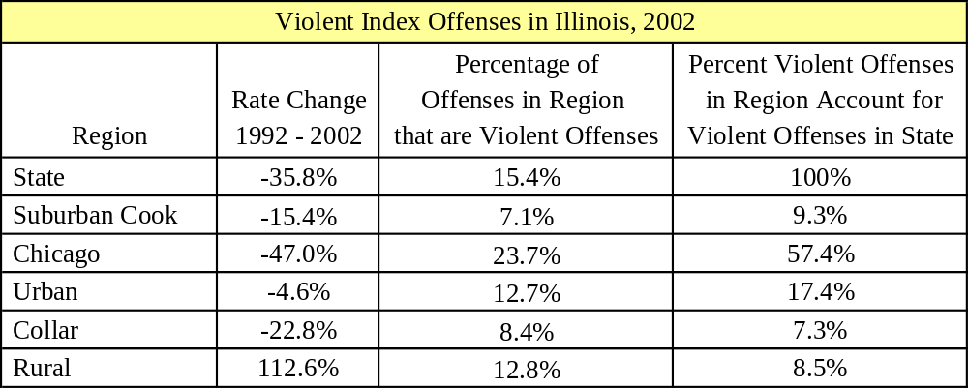
Table 2
Source: Illinois State Police and Chicago Police Department

In 2002, 80,076 violent Index offenses were reported to police in Illinois. Between 1992 and 2002, the violent Index offense rate in Illinois decreased 36 percent, while the reported violent Index offense rate in suburban Cook County decreased 15 percent, and Chicago saw a 47 percent decrease in its violent Index offense rate. The collar counties experienced a 23 percent decrease in the violent Index offense rate between 1992 and 2002. The urban counties experienced a small decrease (five percent) in their violent Index offense rate between 1992 and 2002, and the reported violent Index offense rate in the rural counties doubled during that time (Figures 9 and 10).

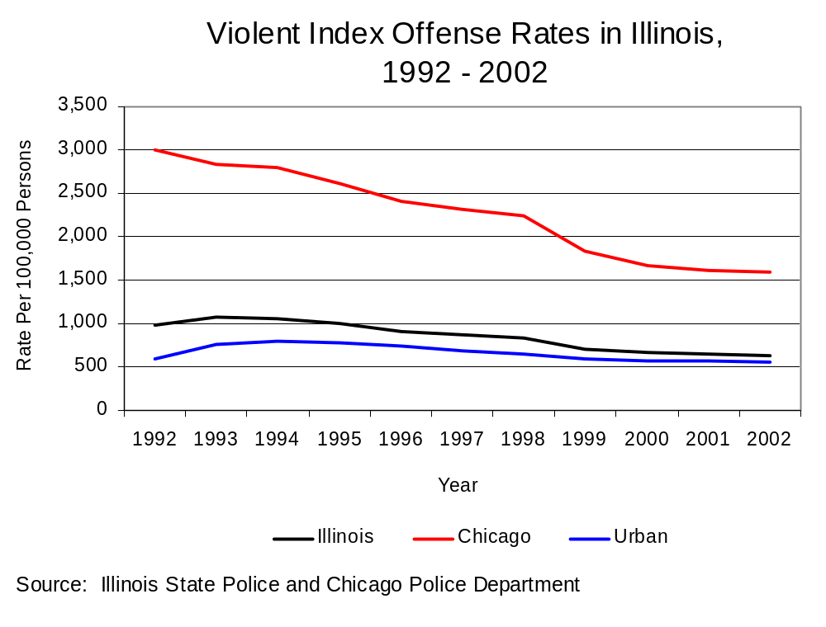
Figure 9

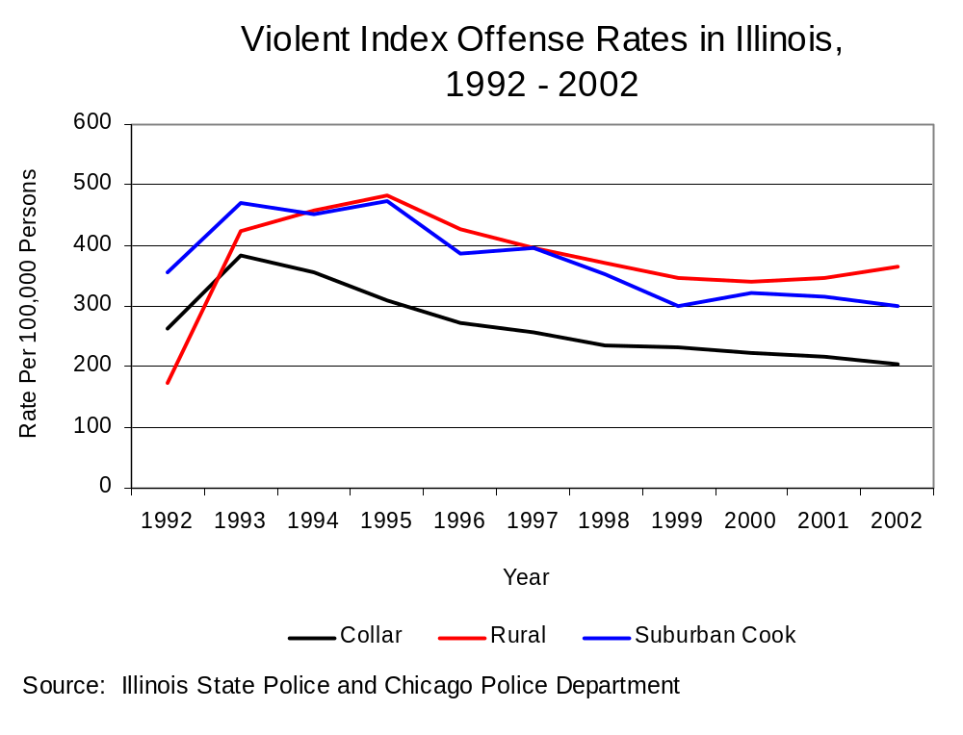
Figure 10

Although the violent Index offense rate for Chicago dwarfs the statewide rate (Figure 9), the decrease in the violent Index offense rate for Chicago was greater between 1992 and 2002 than the decrease in the rate of any other region of the state.

In 2002, law enforcement agencies in Illinois made 26,081 arrests for violent Index offenses. The violent Index arrest rate in Illinois decreased 20 percent between 1992 and 2002. Statewide, the violent Index arrest rate decreased less than the violent Index offense rate between 1992 and 2002. In Chicago, the decreases in the arrest and offense rates were virtually identical, while in suburban Cook County and the collar counties, the rate of offenses decreased but the rate of arrests increased during that time. In the rural counties, the increase in the arrest rate was nearly twice the increase in the offense rate, and in the urban counties, the arrest rate decreased more than the offense rate, although both showed only slight decreases (Table 3).

The rural counties had the highest percentage of violent Index arrests relative to all Index arrests (33 percent) in 2002, and Chicago accounted for the highest percentage of violent Index arrests (38 percent) compared to other regions in Illinois that year (Table 3).

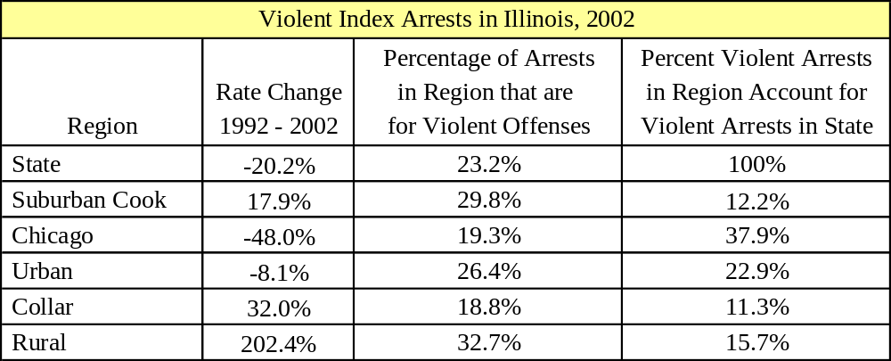
Table 3
Source: Illinois State Police and Chicago Police Department

“Clearance rates” were examined by dividing the number of violent Index arrests by the total number of violent Index offenses reported. It is important to note that the proportion of violent Index offenses that result in an arrest varies considerably depending upon the proportion of individual offenses that comprise the total number of violent offense in a region. Robbery is the violent offense least likely to result in an arrest, thus when a region experiences a high number of robberies, the overall clearance rate will be lower there than in regions that experience a higher number of more solvable crimes like aggravated assaults. In Chicago where a considerable portion of violent crimes are accounted for by robberies, therefore, the clearance rate is lower than in other parts of Illinois, such as rural areas, where a relatively large portion of violent crimes are aggravated assaults. Furthermore, arrests in any given year may outpace offenses because an arrest may occur long after an offense was committed. Also, more than one offender may be arrested for one offense or numerous offenses may result in the arrest of a single offender. This explains why the number of arrests one year may be greater than the number of offenses.

In 2002, Illinois’ clearance rate of violent Index crimes was 33 percent, compared to a rate of 26 percent in 1992. The rural counties had the highest clearance rate of any region of Illinois in 2002 (60 percent), while at 21 percent Chicago had the lowest clearance rate of any region (Table 4).

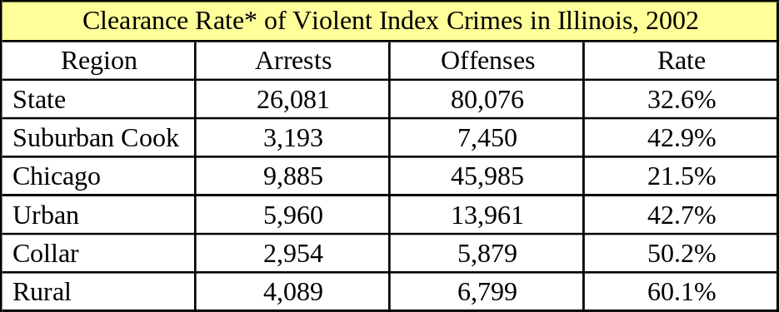
Table 4
Source: Illinois State Police and Chicago Police Department
*Rate = Number of arrests divided by the number of offenses

Between 1992 and 2002, every region except Chicago and the urban counties experienced an increase in the clearance rate. The decreases in Chicago and the urban counties were slight, however. The increase in the rural counties’ and suburban Cook County’s clearance rates were substantial (42 percent and 39 percent, respectively), but the collar counties showed the largest increase of any region in their clearance rate (71 percent increase) between 1992 and 2002.

Most violent crime arrests and offenses in each region of Illinois are for aggravated assault and robbery. Still, some variation by region of the state exists with respect to these two Index crimes, while the percentages murder and criminal sexual assault comprise of all Index offenses occurring in each region is uniform throughout all regions of Illinois (Table 5).

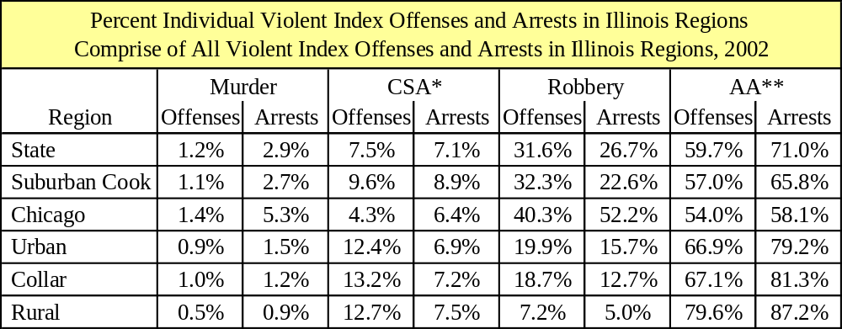
Table 5
Source: Illinois State Police and Chicago Police Department
*Criminal Sexual Assault
**Aggravated Assault

Murder

In general, murder accounts for the smallest percentage of violent Index offenses relative to all other individual offenses that comprise the violent Index. In 2002, there were 949 murders in Illinois. That year, murder comprised a similar proportion of violent Index offenses, about one percent, in all regions of the state (Table 5). The murder rate decreased about 33 percent statewide (Figure 11), in Chicago, and in the collar and urban counties in Illinois between 1992 and 2002. The murder rate decreased 25 percent in rural Illinois counties during that time, and only five percent in suburban Cook County.

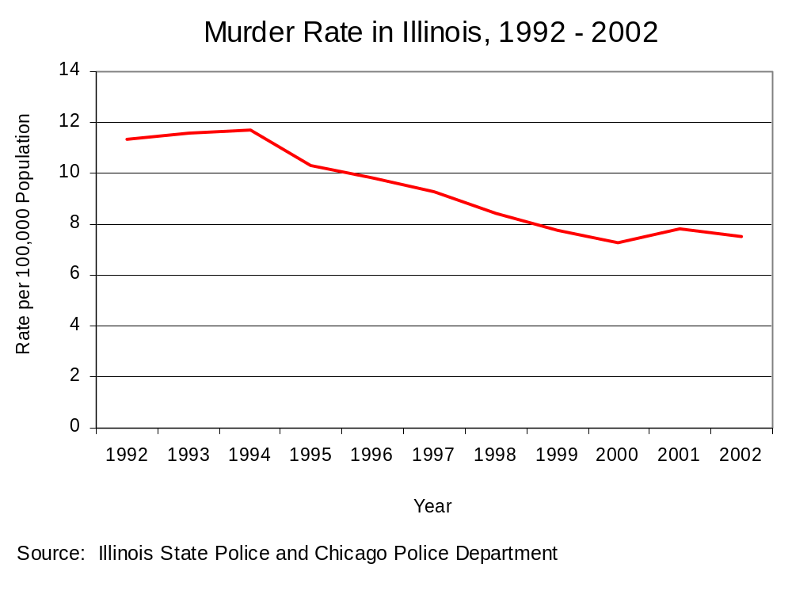
Figure 11

In 2002, the murder rate in Chicago was three times as high as the murder rate statewide. The murder rate in Chicago, the third largest city in the United States, was higher in 2003 than in any other city in the nation. Chicago homicide totals for 2002 are used elsewhere in this analysis for comparison with statewide and regional numbers because 2003 totals for these other areas are not yet available. New York City, with three times Chicago’s population, reported three fewer murders in 2003, and Los Angeles estimates that fewer than 500 murders were reported in that city in 2003. Despite this, the number of murders in Chicago is the lowest in the city since 1967.

Sixty-eight percent of Illinois’ murders occurred in Chicago in 2002, and suburban Cook County accounted for nine percent of the murders committed in the State. Thirteen percent of Illinois’ murders were reported in urban counties in 2002, and the rural and collar counties accounted for about five percent of Illinois’ murders (Table 5).

Figure 12 shows that the rate of murder arrests per 100 offenses reported is quite high in the regions where most murders occur, indicating that the majority of murders in Illinois result in arrest. The rate of murder arrests per 100 offenses declined between 1992 and 2002 in all regions in Illinois except for the collar and rural county regions, and suburban Cook County. The rate of murder arrests per 100 offenses increased 25 percent in rural counties during this time period and 29 percent in suburban Cook County, comparable to the declines statewide and in all other regions in the state (except the collar counties) where decreases in the number of murders were between 27 and 31 percent. However, the number of arrests for murder in the rural counties increased 58 percent and the number of arrests in suburban Cook County increased 26 percent, where declines in the number of arrests were apparent in every other region of the state between 1992 and 2002. The rate of murder arrests to offenses in the collar counties between 1992 and 2002 is virtually unchanged because the decline in the number of offenses and arrests during that time kept pace with one another. Between 1992 and 2002 in the collar counties, arrests for murder declined 11 percent and the number of murder offenses decreased 15 percent.

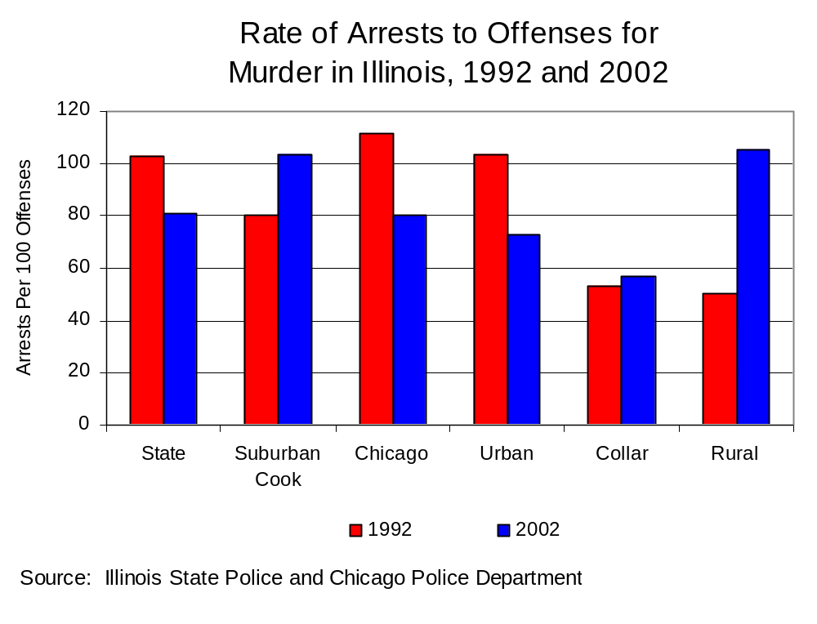
Figure 12

Criminal Sexual Assault

Criminal Sexual Assault accounts for a relatively small percentage of all violent Index offenses. In 2002, there were 6,037 criminal sexual assaults in the state, and that year criminal sexual assaults accounted for eight percent of all violent Index offenses in Illinois. The rate of criminal sexual assaults decreased almost 20 percent statewide between 1992 and 2002 (Figure 14). The greatest decrease in the criminal sexual assault rate for any region in Illinois occurred in Chicago between 1992 and 2002 (42 percent). The rate of reported criminal sexual assaults decreased in suburban Cook County only two percent, and 22 percent in the collar counties. However, the rate of criminal sexual assaults in the urban and rural counties increased seven and 66 percent respectively.
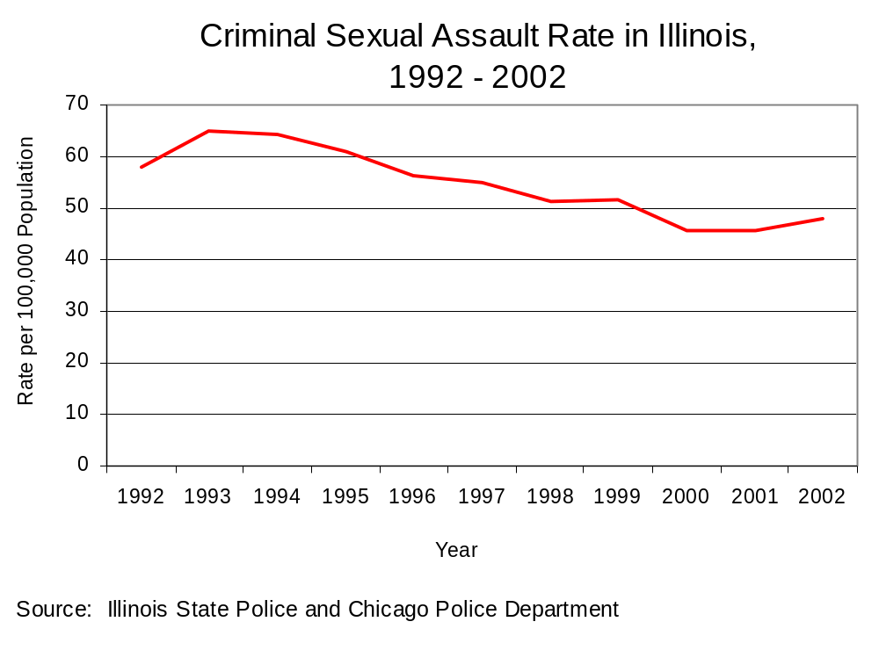
Figure 13

Although the rate of criminal sexual assaults increased only seven percent in urban areas between 1992 and 2002, the criminal sexual assault rate in urban areas in 2002 was higher than in anywhere else in the state. The rate in Chicago was nearly as high as the urban counties’ rate. The collar counties had the lowest criminal sexual assault rate of any area in the state in 2002.

Fourteen percent of criminal sexual assaults in Illinois were reported in rural areas in 2002, where the largest increase in the criminal sexual assault rate was seen. Twelve percent occurred in suburban Cook County in 2002, 34 percent occurred in Chicago, and about 33 percent occurred in urban counties. In 2002, the collar counties accounted for about 13 percent of the state total.

In Chicago, criminal sexual assaults accounted for around five percent of all violent Index offenses reported, and accounted for ten percent of violent Index offenses reported in suburban Cook County. Statewide, criminal sexual assaults accounted for eight percent of all reported violent Index offenses. In the urban, rural and collar counties, criminal sexual assaults accounted for about 13 percent of violent Index crimes reported in these areas in 2002.

The rate of arrests to offenses in Illinois in 2002 was about 30 percent, indicating a relatively low percentage of cases cleared through arrest. In general, the change in the number of arrests kept pace with changes in the number of offenses in Illinois, Chicago and the rural counties between 1992 and 2002. The clearance rates in the collar counties and suburban Cook County increased, and the significant decrease in the clearance rate in urban regions in Illinois between 1992 and 2002 is due to the fact that the number of sexual assaults increased 29 percent while the number of arrests decreased 20 percent. Overall, the rural counties have the highest rate of any region of arrests per 100 criminal sexual assaults (Figure 14).

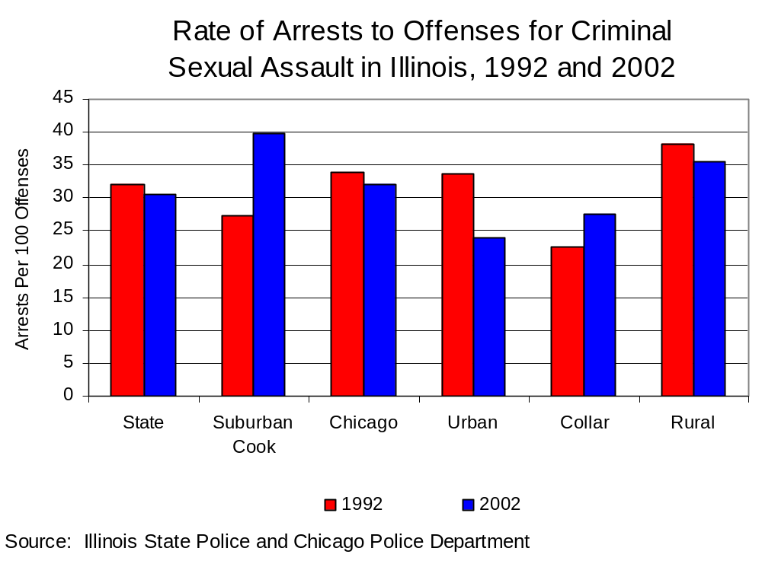
Figure 14

Robbery

Between 1992 and 2002 in Illinois, the robbery rate in Illinois decreased 51 percent (Figure 15). In Illinois in 2002, there were 25,305 robberies, and robbery accounted for 32 percent of all violent Index offenses.

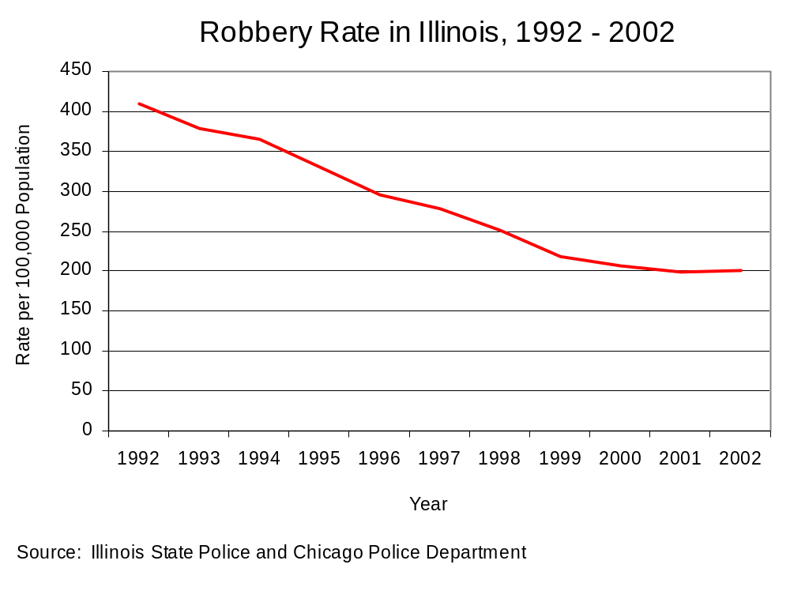
Figure 15

In 2002, suburban Cook County accounted for ten percent of all robberies reported in Illinois, and Chicago accounted for about 75 percent of all robberies. The urban counties accounted for 11 percent of the robberies reported in Illinois in 2002, while the collar and rural counties each accounted for less than five percent of robberies reported statewide.

In Chicago the robbery rate declined to the greatest degree, by 54 percent between 1992 and 2002, driving the statewide decrease. The rate of robberies in urban counties and suburban Cook County decreased about 30 percent, and in the collar counties the robbery rate decreased almost half between 1992 and 2002. The robbery rate in the rural counties decreased to the smallest degree, 11 percent, during that time. The robbery rate in Chicago was more than three times the statewide rate in 2002, and the robbery rate in Chicago was 24 times the rate in the rural counties that year.

Robbery accounted for 40 percent of all violent Index offenses reported in Chicago, and for 32 percent of the violent Index offenses reported in suburban Cook County that year, while robberies accounted for about 20 percent of violent Index offenses in the urban and collar counties. In 2002, only seven percent of reported violent Index offenses in rural counties were robberies.

Figure 17 shows that the rate of arrests for robbery per 100 reported offenses was relatively low in both 1992 and 2002 in all regions of the state and in Illinois as a whole. Clearance rates increased in all areas except for the urban counties, where changes in the number of robbery arrests kept basically apace of changes in the number of robbery offenses. The most significant change from 1992 to 2002 is in the rural regions of Illinois. Although the number of offenses in rural counties increased 11 percent between 1992 and 2002, arrests increased 55 percent. Even so, robbery in rural areas accounts for only two percent of all robberies that occur statewide.

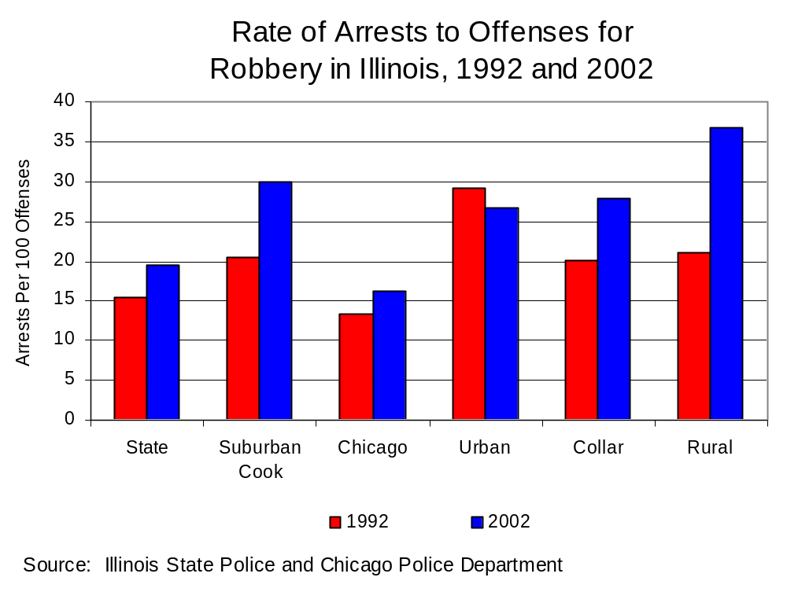
Figure 16

Aggravated Assault

Between 1992 and 2002 in Illinois, the rate of aggravated assaults decreased 26 percent (Figure 17). In Illinois, aggravated assaults comprised 60 percent of all violent Index offenses in 2002. In Illinois in 2002, there were 47,785 reported aggravated assaults.
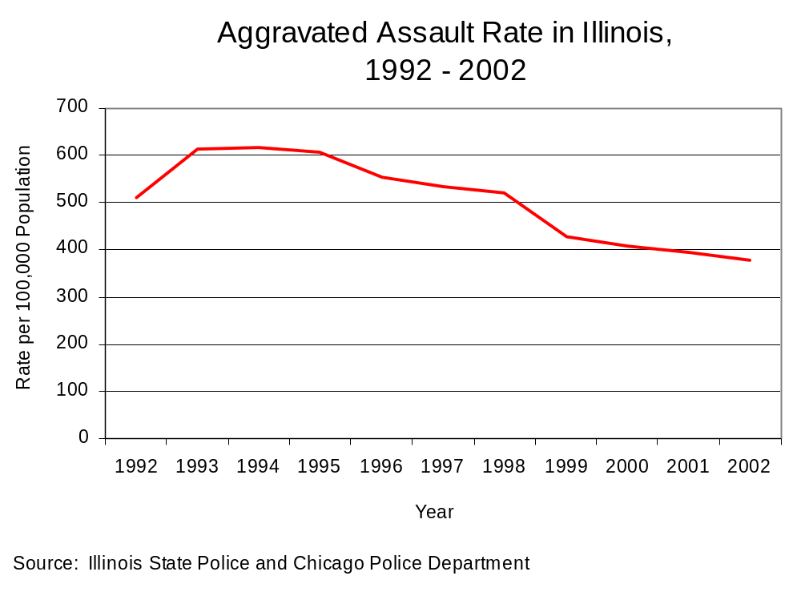
Figure 17

In 2002, suburban Cook County accounted for nine percent of aggravated assaults reported in the state, and Chicago accounted for a little over half of the aggravated assaults reported statewide. Urban counties accounted for 20 percent of the total number of aggravated assaults reported in Illinois in 2002. The collar counties accounted for less than ten percent of aggravated assaults reported in Illinois, while rural areas accounted for just over ten percent in 2002.

Between 1992 and 2002, the aggravated assault rate in Chicago decreased 42 percent, and Chicago’s aggravated assault rate was 75 percent higher than the statewide rate. Suburban Cook County’s rate decreased seven percent between 1992 and 2002, while the rate in the collar counties decreased 11 percent during that time. The aggravated assault rate in the urban counties increased six percent and almost tripled in the rural counties between 1992 and 2002.

Fifty-four percent of all reported violent Index offenses in Chicago were aggravated assaults, and 57 percent of violent offenses in suburban Cook County were aggravated assaults in 2002. Sixty-seven percent of violent Index offenses in the urban and collar counties that year were aggravated assaults, while 80 percent of violent Index offenses in rural counties were aggravated assaults.

Figure 18 shows that the rate of arrests for aggravated assaults per 100 reported offenses was approximately 39 arrests per 100 offenses statewide in 2002. In Illinois, Cook County, and in the urban counties, the change in the number of aggravated assault offenses kept pace with changes in the number of arrests between 1992 and 2002. In suburban Cook County and the collar and rural counties, the clearance rate increased between 1992 and 2002, due mainly to increases in the number of arrests. Arrests for aggravated assault in suburban Cook County increased 24 percent, arrests in the collar counties doubled, and arrests in rural counties increased almost four times, while the number of offenses in these regions increased nine, eight and 11 percent respectively.

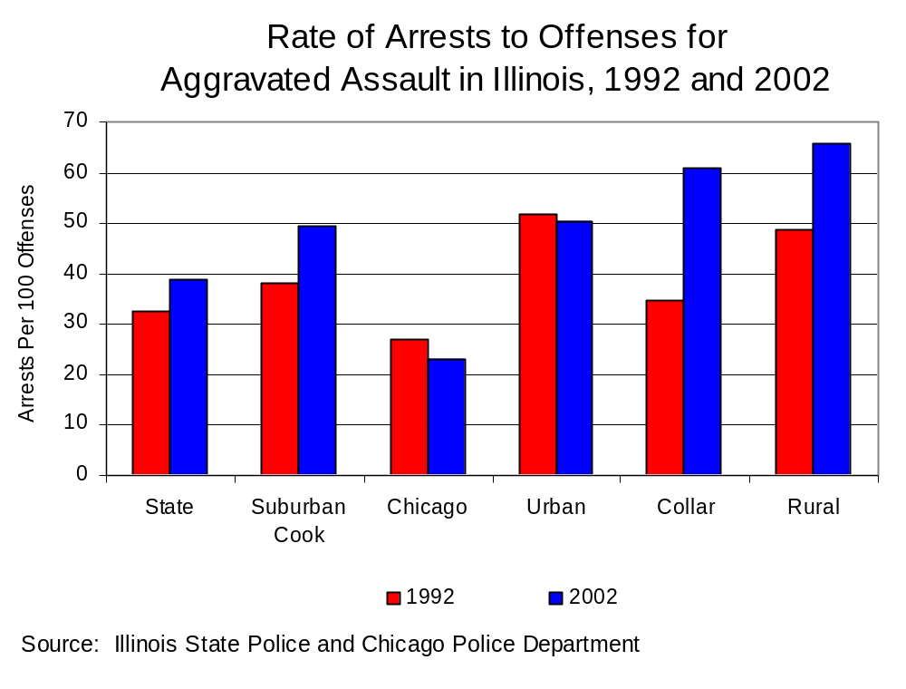
Figure 18

Firearm-Related Homicides and Deaths and Prevalence of Firearm Use

Firearms continue to play a major role in Illinois’ homicides and violent crime. According to the National Center for Injury Prevention and Control at the Centers for Disease Control, in the year 2001 homicide was the second leading cause of death for Illinois residents age 15 to 34 years. Eighty-three percent of these homicides involved firearms. The Illinois Department of Public Health reports that firearm deaths in Illinois decreased 18 percent between 1991 and 2001. Fifty-eight percent of firearm deaths in Illinois in 2002 were homicides, and firearm homicides in Illinois decreased 23 percent between 1991 and 2001. In 2002, the Chicago Police Department reported that firearms were used in 79 percent of the reported homicides, a ten percent increase from 1992, but also that firearm recoveries decreased more than half from 21,090 in 1992 to 10,182 in 2002.

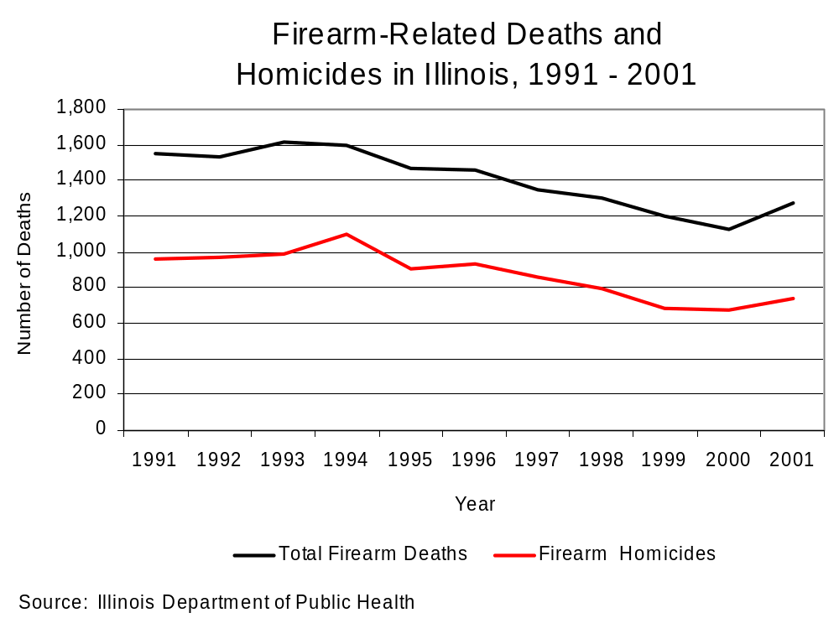
Figure 19

Hate Crime

A hate crime is defined under Illinois statute (720 ILCS 5/12-7.1) as the commission of a specified illegal act based on an actual or perceived race, color, creed, religion, ancestry, gender, sexual orientation, or ethnicity of another individual. There are two basic elements of a hate crime: 1) a criminal act which is an offense in and of itself; and 2) a motive generated by a specific characteristic of a victim. Hate crimes are not separate and distinct from other crimes. Rather, they are offenses motivated by the offender’s personal bias. Therefore, crimes in which no offender is identified or situations in which the offender’s motivation cannot be identified are not reported as hate crimes.

In Illinois, law enforcement agencies are required by law to report all bias-motivated crimes to the Illinois State Police (ISP) on a quarterly basis. Although ISP began collecting bias crime data using the FBI’s Hate Crime Incident Report form in 1991, the reporting of hate crime information to the state police was voluntary for local police departments until April of 1996 when hate crime data collection and submission became mandatory and systematic. Because the actual process of data collection was new in 1996 and did not begin until April, the numbers found in this analysis for that year may under-represent the actual occurrence of hate crimes across the state.

Between 1997, the first full year of reporting, and 2001, the latest year for which regional hate crime totals are available, the rate of reported hate crimes in Illinois decreased 24 percent. The greatest decrease in the state during that time was in Cook County, where the rate of reported hate crimes decreased 37 percent. The change in the rate of reported hate crimes in the collar counties was also substantial, a 33 percent decrease between 1997 and 2001. Only in the rural counties did the rate of reported hate crimes increase, 14 percent between 1997 and 2001. Cook County and the urban counties each accounted for close to 40 percent of reported hate crimes in Illinois in 2001.

In 2002, the most recent year for which statewide data is available, 54 percent of reported hate crimes were racially motivated. Twenty-one percent were motivated by the victims' sexual orientation, and 18 percent were religiously motivated. Sixty-two percent of racially motivated hate crimes in 2002 were committed against African-Americans and 31 percent targeted white victims, while 46 percent of offenders who committed hates crimes in 2002 were white and 35 percent were African-American. Ninety-five percent of attacks motivated by the victims' sexual orientation were against homosexual males, and 92 percent of religiously motivated hate crimes were against Jews. While only a small percentage of hate crimes were motivated by the victims' ethnicity (seven percent), over half of these types of hate crimes were against those of Arab descent (54 percent, seven offenses total).

In 2002, most hate crimes occurred in a residence (27 percent) or on the street (23 percent). Twenty-eight percent of hate crimes in Illinois in 2002 involved simple assault, 24 percent consisted of intimidation and aggravated assault, and 21 percent involved vandalism. Ninety-one percent of hate crimes were aimed at an individual as opposed to an attack against a business or religious organization.

All of these patterns were evident in 2001 except that 23 percent of hate crimes that year were motivated by the victims' ethnicity, and of these, the majority of victims were of Arab descent (61 percent, 49 offenses total). According to the Illinois State Police, in 2002 one percent of all hate crimes in Illinois were committed against the elderly (two incidents).

Elder Abuse

The abuse and neglect of elderly persons by family or household members is becoming a more widely recognized form of domestic violence in Illinois. The Illinois Department on Aging (IDOA) administers the statewide Elder Abuse and Neglect Program to respond to allegations of abuse or mistreatment of any Illinois citizen 60 years or older. The rate of reported cases of elder abuse has nearly doubled from 1993 to 2002. Additionally, the number of reported cases of abuse of long-term care residents by employees has increased more than three-fold since 1994. Most victims of elder abuse in Illinois are female and are most likely to have been abused by family members.

In Illinois in 2002, approximately 40 percent of elder abuse offenders were children of their victims, 12 percent of the offenders were spouses of their victims, and an additional 20 percent of the offenders were “other” relatives. Although more than 40 counties in Illinois have experienced notable increases in the rate of elder abuse from 1993 to 2002, aside from the services that might be available from victim specialists who work in state’s attorney’s office, only 35 agencies in Illinois provide services to victims of elder abuse.

Illinois statutes specifically targeting crimes against the elderly fall under three broad categories: 1) violent crimes, 2) abuse and neglect, and 3) financial exploitation. Although these specific statutes are available, in 2001, police and prosecutors infrequently used them compared to other charges. For example, statewide, more than 9,500 aggravated battery arrest charges were reported, compared to only 127 charges of aggravated battery of a senior citizen.

Of the 162 court cases in Illinois where the crimes against the elderly statutes were applied in 2001, and for which an outcome was reported, 65 percent were prosecuted in Cook County. As baby boomers age, the percentage of the total population age 60 and over is expected to increase. The potential for this increase is illustrated by data showing that from 1990 to 2000 there was a 30 percent increase in the number of Illinois citizens 40-49 and a 31 percent increase in the number of Illinois citizens 50-59. Sadly, elder abuse is one crime where increases can be safely predicted and where added attention to the victims and their offenders must be placed.

Adult Offenders in Illinois Courts, on Probation, and in Jail and Prison

This section discusses data on the response of the State to criminal offenders, specifically felony filing rates, court sentences imposed and adult felony probation in Illinois reported by the Administrative Office of Illinois Courts (AOIC). Information on jail and prison populations is posted by the Illinois Department of Corrections.

Felony Filings

Every court case involving a felony offense that enters the criminal justice system is prosecuted, downgraded, diverted or dismissed. Regardless of the prosecutorial course of action, each alleged offender is defended (with a few pro se exceptions) and each disposition (how a case concludes) is entered by the court.

The felony filing rate in the rural counties increased to the greatest degree, 39 percent, between 1991 and 2001, and the felony filing rate in Cook County increased the smallest degree of any region in the state, 11 percent, during the same time period. In the urban and collar counties, felony filing rates increased just under 30 percent, and Illinois’ felony filing rate increased 20 percent between 1991 and 2001.

In 2001, the collar counties had the lowest felony filing rate statewide, and urban counties the highest. The state, Cook County and the rural counties had similar felony filing rates in 2001.

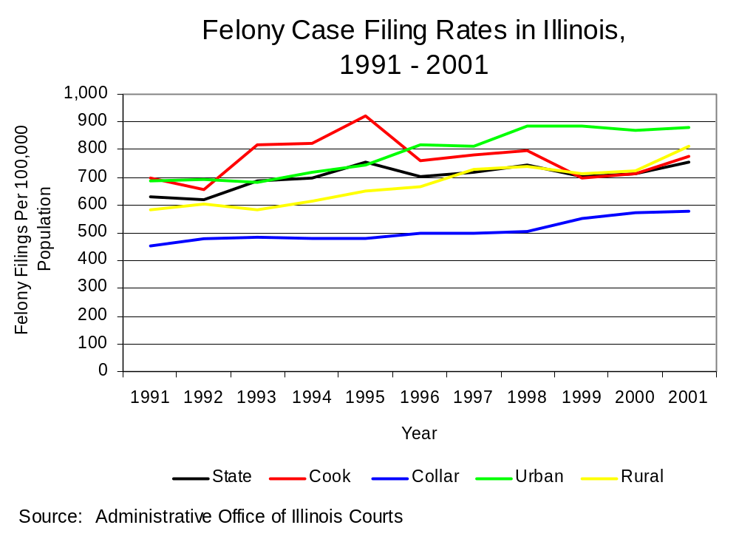
Figure 20

Court Sentences Imposed

In 2001, nearly 61,500 convicted felons were sentenced in Illinois’ Circuit Courts. The rate of felony sentences in Illinois increased four percent between 1991 and 2001.

Cook County accounted for over half of the felony sentences statewide in 2001 (53 percent), while almost a quarter of the felony sentences in the state were handed down in the urban counties. The collar and rural counties each accounted for about 13 percent of felony sentences in Illinois in 2001. Between 1991 and 2001, the rate of felony sentences increased about 33 percent in the urban counties, 38 percent in the rural counties, and 13 percent in the collar counties. The only region of the state in which the rate of felony sentences decreased was in Cook County (eight percent decrease).

The rate of felony prison sentences decreased in Cook County alone between 1991 and 2001 (eight percent decline). Between 1991 and 2001, the rate of felony prison sentences increased 30 percent in the urban and collar counties. The rate of felony prison sentences in the rural counties increased to the greatest degree, almost four times between 1991 and 2001.

Statewide, the rate of felony prison sentences increased three percent between 1991 and 2001, while the rate of felony probation sentences decreased the same amount during that time. The rate of felony probation sentences in Cook County and the collar counties decreased 14 and ten percent respectively, while rates in the urban and rural counties increased just over 25 percent in 2001.

In 2001, the number of prison sentences outnumbered probation sentences in Cook County alone but only slightly, three percent in 2001. The urban and rural counties showed the greatest disparity between the number of felony probation and prison sentences. In each region, probation sentences were 40 percent higher than prison sentences. Statewide, 12 percent more felony sentences for probation were handed down compared to prison sentences, and in the collar counties, probation sentences outnumbered prison sentences four percent in 2001.

In 2001, Cook County accounted for 58 percent of felony prison sentences in the state, and for 50 percent of the felony probation sentences in the state. The urban counties accounted for 17 percent of the state’s felony prison sentences, and for about 25 percent of the state’s felony probation sentences. The collar counties comprised 14 percent and 12 percent of statewide felony prison and probation sentences in 2001, and the rural counties accounted for 11 and 15 percent of prison and probation sentences.

Felony Adult Probation Caseload

The felony adult probation caseload in Illinois increased 20 percent between 1991 and 2001. In 2001, about 53,500 adult felons were on probation in Illinois. Cook County accounted for just over half of the caseload, while the urban counties comprised 21 percent of the caseload, the collar counties accounted for 11 percent of the caseload, and the rural counties accounted for 17 percent of the caseload.

The rate of adult felons on probation increased to the greatest degree in the rural and urban counties (35 percent each) between 1991 and 2001, while the rate increased 23 percent in Cook County and 20 percent in the state. The rate in the collar counties was the only one to decline, 14 percent between 1991 and 2001 (Figure 21).

The collar counties had the highest percentage of adult felons on probation as opposed to adults on probation for a misdemeanor or other offense (67 percent) in 2001. Adult felons comprised 64 percent of Cook County’s probationers, 65 percent of the state’s and urban counties’ probationers, and 45 percent of probationers in rural areas that year (Figure 22).

The rate of adult felons on probation in the collar counties was lower than anywhere else in Illinois, although the statewide rate fell below the rate for Cook County and the urban and rural counties beginning in 1997.

The rate of adult felons on probation increased statewide, in Cook County, and in the urban and rural counties between 1991 and 2001, whereas the rate of adult felony probation sentences decreased or increased to a lesser degree in these same areas between 1991 and 2002. This may indicate that the probation sentences are becoming longer causing the caseload to grow from year to year. In the collar counties, the rate of adult felony probation sentences and the rate of adult felons on probation decreased to a similar degree.

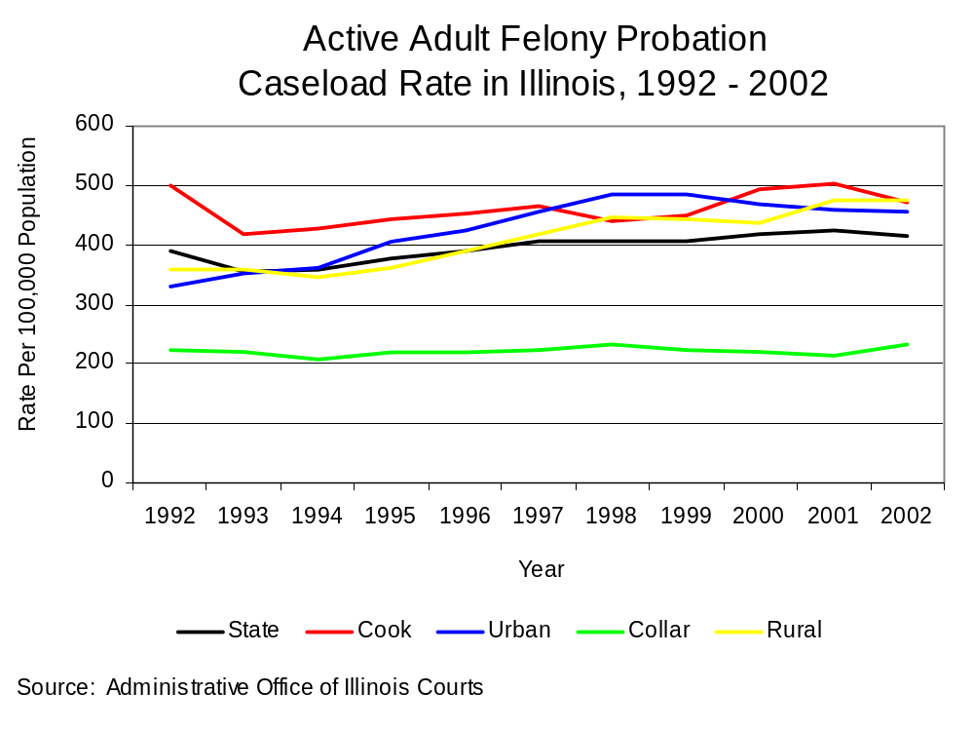
Figure 21

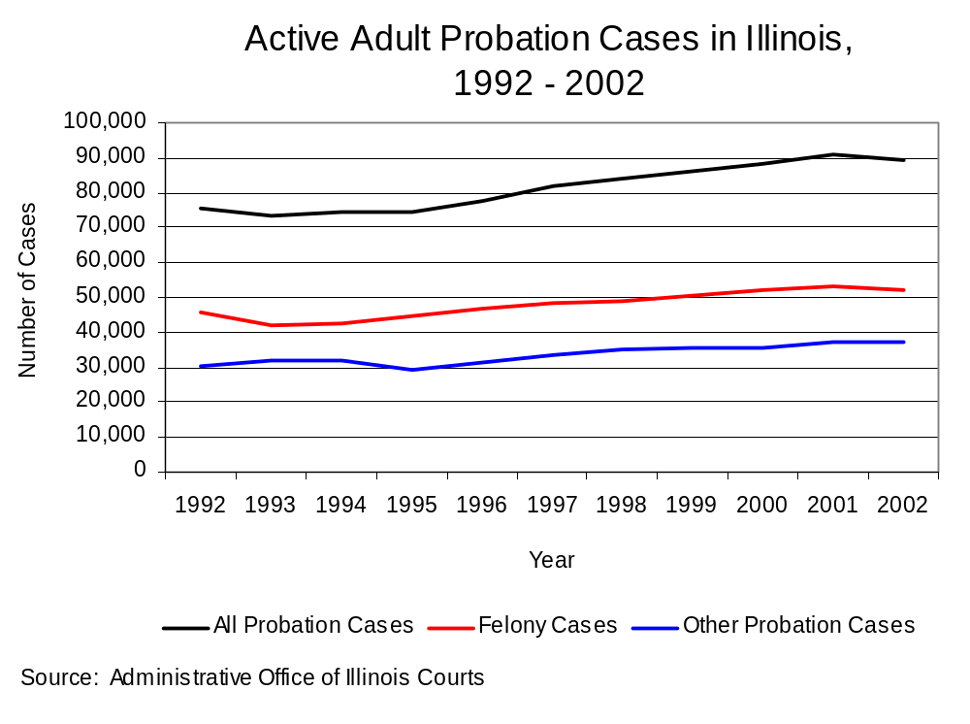
Figure 22

Data are limited regarding the specific characteristics of probation sentences in the state, but an increasing proportion of probation sentences, just as with prison sentences, may be accounted for by drug law violators.

Jail Populations

The average daily jail population rate in Illinois county jails showed an overall increase of nearly 47 percent between 1991 and 2001. The average daily population rate in jails in the rural counties increased to the largest extent relative to jails in other regions (71 percent increase). In Cook County, the average daily jail population rate increased around 55 percent, the collar counties’ rate increased 44 percent, while the urban counties showed the smallest increase of any region between 1991 and 2001 (23 percent).

Prison Commitments and Population

In 2003, 27,339 adults were committed to the Illinois Department of Corrections (IDOC) for new offenses. The majority of these IDOC commitments were accounted for by Cook County (57 percent), however the urban counties contributed a significant proportion to the overall total (18 percent). The rate of commitments from Cook County and the urban counties regions increased to a lesser degree than commitments from other regions in the state. Cook County’s new court commitment rate during this time increased modestly (25 percent), the rate of commitments from urban counties increased more than 50 percent, while the rate of commitments in the rural counties increased 80 percent and the rate in the collar counties increased almost 67 percent.

Statewide, the rate of new court commitments to IDOC increased 37 percent between 1993 and 2003, while the admission rate for drug crimes more than doubled between 1993 and 2003, and the rate of admission for violent crimes decreased one percent in Illinois (Figure 23).

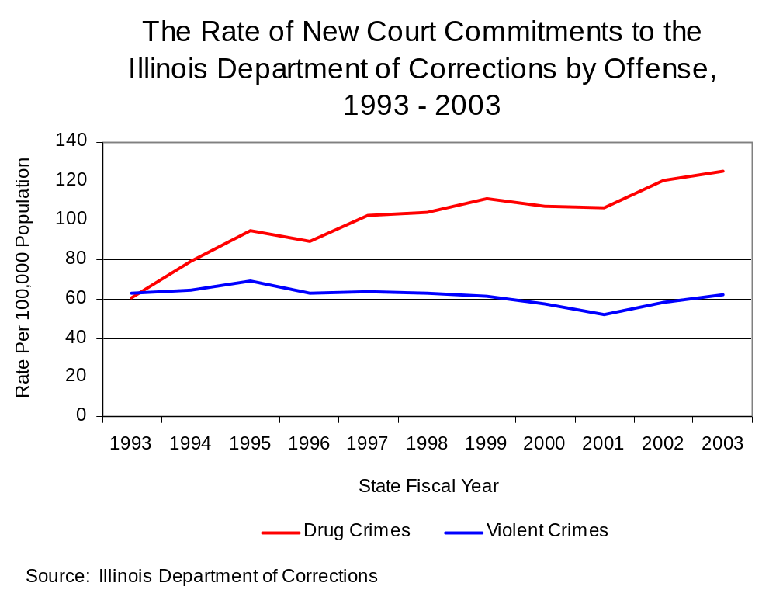
Figure 23

In 2003 in Illinois and Cook County, more IDOC new court admissions were for drug crimes than for any other type of crime (41 and 48 percent respectively of all new court commitments to IDOC). In the rural and collar counties, commitments for drug crimes accounted for about 35 percent of all admissions, and in the urban counties, 28 percent of new court commitments to IDOC were drug offenders. The urban counties had the highest percentage of offenders admitted to IDOC for violent crimes (23 percent), though about 20 percent of IDOC admissions in all regions were for violent crimes, and admissions for violent crimes comprised the smallest percentage of new court commitments to IDOC for any crime in all regions. In the urban and collar counties, more offenders were newly admitted to IDOC for property crimes than for any other crimes, and in the rural counties, the same percentage of new court commitments to IDOC were for property and drug crimes.

In Cook County, the rates of admission for violent crimes decreased more than 20 percent between 1993 and 2003, while the rates of admission for drug crimes increased over 90 percent. The rate of new court commitments to IDOC from the urban counties for violent crimes increased almost 50 percent between 1993 and 2003, while the admission rate for drug crimes doubled. As for the collar counties, the rates of admission for violent crimes increased almost 90 percent, while the admission rate for drug crimes increased nearly threefold. The admission rate for violent crimes in the rural counties increased 80 percent, while the admission rate for drug crimes increased almost three times.

Domestic Violence and Victims of Crime

This section provides a description of domestic violence and criminal victimization in Illinois. Data from the Illinois State Police (ISP) on domestic violence offenses reported to police, orders of protection and petitioners entered into the Law Enforcement Agencies Data System (LEADS) by local police agencies help give an account of domestic violence in Illinois. The summary of the Chicago Women’s Health Risk Study spearheaded by researchers from the Authority illustrates risk factors for domestic violence victims, and the synopsis of the 2002 Illinois Crime Victimization Survey (IL-CVS) helps depict the types and prevalence of criminal victimization in Illinois. Finally, child sexual and physical abuse and neglect are discussed using data from the Illinois Department of Children and Family Services (DCFS), supplemented by data on crimes against children reported to Illinois State Police.

Domestic Violence Offenses

A relatively new indicator of domestic violence in the state is the number of domestic offenses reported to the Illinois State Police (ISP) by local law enforcement through a supplemental reporting requirement to Illinois’ Uniform Crime Reporting (I-UCR) Program. Since April 1, 1996, this new reporting system has been mandated by the Criminal Identification Act (20 ILCS 2630/5.1). The statute mandates the reporting of all offenses of abuse, neglect, or exploitation that occur between family or household members to the ISP.

Between 1997, the first full year of data collection, and 2001, the rate of domestic crimes reported to ISP decreased seven percent. In 2001, Cook County accounted for 65 percent of domestic crimes statewide. Although domestic crimes reported in rural counties accounted for just below ten percent of domestic crimes statewide in 2001, rural counties in Illinois comprised the only area of the state for which domestic crimes increased between 1997 and 2001 (nine percent increase). The rate of reported domestic crimes decreased to the largest degree in the collar counties, 17 percent between 1997 and 2001.

The rate of reported domestic crimes involving intimate partners in Illinois increased 16 percent between 1997 and 2001. It was not possible to include Cook County in a comparative analysis of reported intimate partner domestic crimes because non-intimate and intimate partner domestic crimes were reported to ISP together in 2000 and 2001. This reporting issue likely accounts for the increase in the rate of domestic crimes involving intimate partners in Illinois. The rate of intimate partner domestic crimes in the urban, collar and rural counties decreased about 15 percent between 1997 and 2001.

In 2001 in Illinois, 49 percent of family-related domestic crimes were between spouses, ex-spouses or common-law spouses. Thirty-three percent was between a caregiver, parent, stepparent, grandparent, etc., and child. Seventy-six percent of non-family-related domestic crimes were between a girlfriend and boyfriend, and seven percent were between a victim and offender who had a child together.

The Chicago Police Department (CPD) stopped differentiating domestic violence calls for service and domestic crimes in 1998, so statewide and regional comparisons were impossible. However, in 2001 CPD reported that 210,998 domestic violence calls for service were placed in Chicago, a 12 percent decrease from 1996, the first year such information was published. Domestic violence calls for service comprised four percent of all calls for service. Almost 75 percent of the calls for service in 2001 were classified as domestic disturbances, 25 percent were domestic battery reports, and three percent were reports of a violation of an Order of Protection.

CPD arrested over 13,000 offenders for domestic-related crimes in 2001, a 32 percent decrease from 1996. In 2001, 90 percent of these arrests were for domestic battery and just fewer than ten percent were for a violation of an Order of Protection. In 2001, six percent of all homicides in Chicago were attributed to domestic violence, down two percent from 1996. Statewide arrest data for domestic crimes and data on domestic-related homicide was not available from the Illinois State Police.

Orders of Protection

Data regarding the number of orders of protection issued in Illinois and then entered into the Law Enforcement Agencies Data System (LEADS) has been a primary indicator of domestic violence for the past several years. LEADS is a live database maintained by the Illinois State Police, and is accessible to police officers responding to incidents that require immediate knowledge of current orders of protection. By law, orders of protection are entered into LEADS no later than 24 hours after they are issued. It is important to remember that one petitioner may request more than one order of protection per year, thus both orders of protection and petitioners are examined in this section. Also, because of the similarity of names or the possibility that a name is truncated from one entry to the next (Nancy Lynn Smith and Nancy L. Smith) it was impossible to remove all duplicates in the data. The likelihood of duplicates increases in urban areas because the likelihood that multiple persons share a name increases.

Orders of protection entered into LEADS in Illinois increased 25 percent between 1994 and 2003 (Figure 24), yet the number of those petitioning for an order of protection in Illinois only increased 12 percent, suggesting that petitioners are requesting multiple petitions (Figure 25).

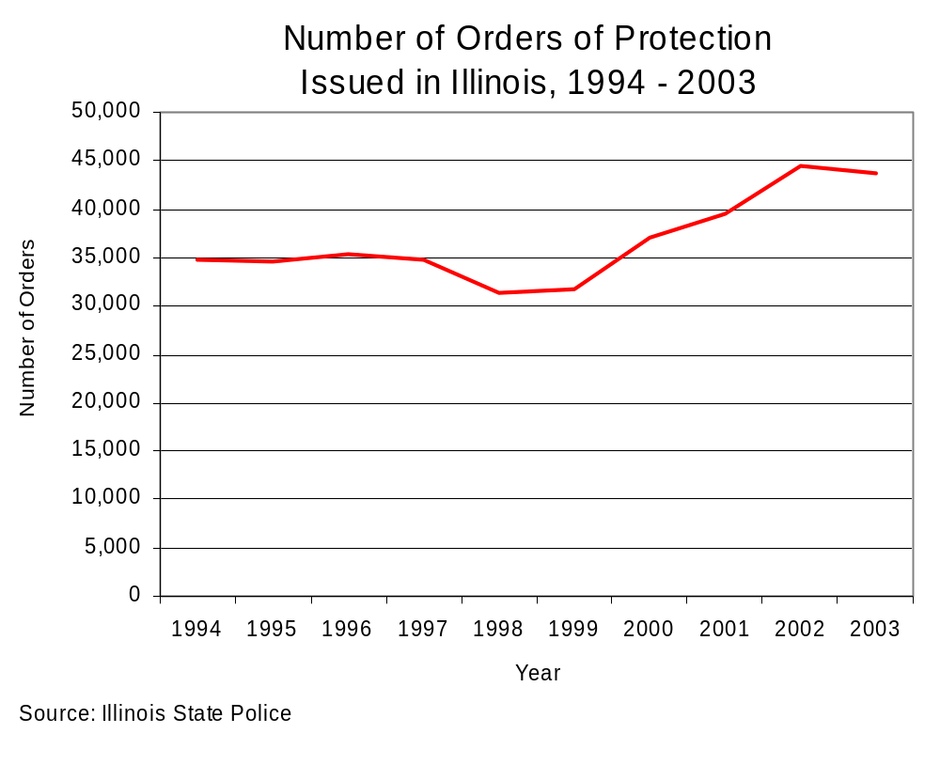
Figure 24

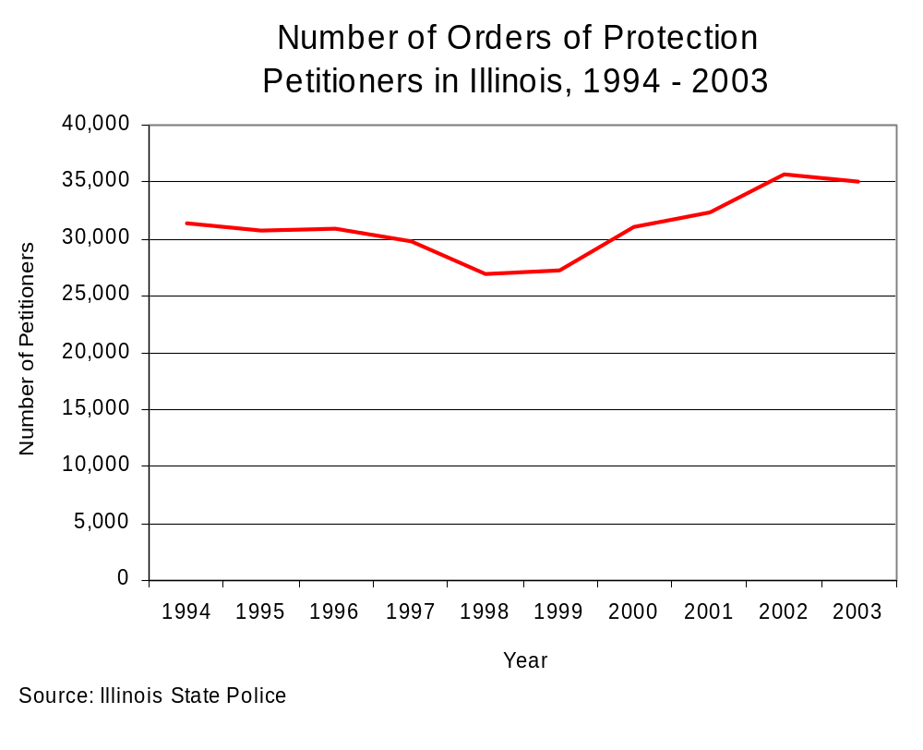
Figure 25

Orders of protection increased 37 percent in urban counties and 20 percent in the collar counties. Orders of protection in rural counties increased more than in any other region of Illinois between 1994 and 2003 (55 percent). Orders of protection increased least in Cook County during that time (nine percent). Petitioners in the urban counties increased 18 percent and petitioners in the collar counties increased five percent between 1994 and 2003. During that time, petitioners increased most relative to all other regions in the rural counties (33 percent) and least in Cook County (two percent).

In 2003, orders of protection and petitioners in Cook County accounted for 35 and 37 percent respectively of orders and petitioners in Illinois. The urban counties accounted for almost 30 percent of all orders and petitioners in the state in 2003. Orders of protection and petitioners in the collar counties accounted for 15 percent of orders and petitioners entered into LEADS in Illinois in 2003, and the rural counties accounted for about 20 percent of orders and petitioners in the state.

Chicago Women’s Health Risk Study

In 1997, the Authority began a study to identify factors that indicate significant danger of a life-threatening injury or death in situations in which a woman is abused by an intimate partner. The Chicago Women’s Health Risk Study (CWHRS) was completed in 1999 with support from the Chicago Department of Public Health, Erie Family Health Center, Cook County Hospital, the City of Chicago Mayor’s Office on Domestic Violence, the Cook County Medical Examiner’s Office, and the Chicago Police Department, and funding from the National Institute of Justice. The CWHRS relied upon a sample of intimate partner homicides involving women in Chicago and interviews with as many prescreened women as possible seeking any type of treatment at a hospital or health care clinic that participated in the study. Women seeking treatment who were 18 years or older and in a relationship were asked a series of questions: Are you a current victim of violence or sexual abuse, and are you afraid to go home? The CWHRS attempted to question further all of the women who fit the criteria and answered “yes” to one of more of the prescreening questions, and 30 percent of those who answered “no” to all questions. Just over 700 women were surveyed further.

Selected CWHRS findings, especially those linked to substance abuse and the use of firearms, include:

- In 40 percent of the intimate partner homicides involving women, the woman’s attempt to leave or end the relationship was an immediate precipitating factor in the violence.

- Eighty-five percent of female victims of intimate partner homicide experienced violence at the hands of their intimate partners within the past year.

- Half of the women who experienced severe violence and left or attempted to end the abusive relationship did not experience further incidents of abuse upon follow-up by interviewers.

- Offenders who murdered a female intimate partner using a firearm were more likely to commit suicide than was true for murderers using other types of weapons.

- Substance use was more likely to be involved in intimate partner murder-suicides than was true for incidents involving only murder.

- Intimate partner homicides were more likely to involve drug or alcohol intoxication than was true for non-fatal incidents of intimate partner abuse against women.

- An intimate partner’s drinking or drug use was a factor in cases involving the homicide of a woman who had not previously experienced violence at the hands of her partner.

- Intimate partner violence resulting in homicide was more likely than non-fatal incidents of abuse to involve drinking or drug use, and these incidents were no more likely to involve alcohol use than to involve drug use.

- For the women who experienced only one abusive incident within the past year, that incident was severe or life-threatening and drug use by the intimate partner was a strong risk factor.

Illinois Crime Victimization Survey

The Illinois Criminal Justice Information Authority (ICJIA) recently conducted, for the first time, a statewide crime victimization survey. The 2002 Illinois Crime Victimization Survey (IL-CVS) was mailed to nearly 7,500 adult residents of Illinois, asking them about experiences with crime ranging from theft to violent sexual assaults during 2002. The project aimed to shed light on the true nature and extent of crime victimization in Illinois, including incidents that go unreported to police. The most recent findings from the U.S. Department of Justice’s National Crime Victimization Survey (NCVS) indicated that less than half of all crime is actually reported to police.

The questionnaire was modeled after the NCVS, which has been conducted annually by the U.S. Department of Justice since 1973. The names and addresses of about 7,500 individuals age 18 or older were randomly selected from the Illinois Secretary of State’s Office’s databases of driver’s licenses and state identification cards. About 1,800 of these subjects could not be surveyed for reasons such as the person was not an Illinois resident in 2002, they no longer lived at that address, or they were deceased. ICJIA received a total of 1,602 completed surveys after five mailings to each non-responding individual in the sample, rendering a response rate of just over 28 percent. Although the number of completed surveys allowed for estimates with low sampling errors (estimated rates of victimization are within standard errors of + or – five percent), the potential was high for non-response error and therefore, impossible to measure precisely. For this reason, estimates provided should be interpreted with consideration to the potentially large differences between those who responded to the survey and those who did not.

An estimated 38 percent of Illinois residents aged 18 and older were victims of crime during 2002. This estimate included 15 percent of residents who were victims of personal crime (robbery, assault, and completed or attempted sex crime). The most common personal crime experienced was assault; more than eight percent of Illinoisans were victims of assault during 2002. About 23 percent of residents statewide were property crime victims (attempted and completed motor vehicle theft, theft, and burglary, and completed vandalism). The most common property crime during 2002 was theft (attempted or completed), experienced by more than 14 percent of Illinois’ adult population.

The most prevalent type of victimization was computer crime, as this occurred to about 25 percent of adult residents that used a computer in 2002. About three percent of Illinoisans were victimized by someone in their family or a relative during 2002, while eight percent knew the offender(s) who victimized them. About 1 percent of residents were victims of sex crime during 2002. And just over one percent of residents were victims of hate crime in Illinois during 2002.

When victimization was examined at the regional level, Chicago had the highest estimated rate for overall victimization in 2002 at 47 percent of adult residents. The other four regions in Illinois (suburban Cook, collar, urban, and rural counties) had victimization rates between 35 and 37 percent of adult residents. Chicago also had the highest victimization rates in all sub-categories of victimization except for sex crime, and hate crime, motor vehicle theft, and computer crime.

Urban counties had the highest rate of sex crime at two percent of adult residents, whereas other regions’ rates ranged between .5 and two percent. Rural counties led all regions for hate crime at just over one percent of residents, although only slightly. The other regions had rates of about one percent. Motor vehicle theft was most prevalent among suburban Cook County residents; three percent were victims of motor vehicle theft in 2002. This rate surpassed all other regions at least 200 percent. Rural counties also had the highest rate of computer crime at 27 percent of residents that used a computer in 2002. Other regions had rates between 24 and 25 percent.

Additional variables were examined to determine whether crime victimization in 2002 was more prevalent among demographic subgroups of Illinois’ adult population. Respondents with one or more of the following characteristics had higher rates of victimization: those under the age of 35, Hispanic and black respondents, single and divorced persons, those with an annual household income of $10,000 or less, respondents reporting a disability, residents of larger cities, residents who live in duplexes, townhouses, or apartment buildings, and residents who do not own a home.

Some questions on the IL-CVS provided insight about the nature and impact of the victimization experiences reported during 2002. Of 587 victimizations for which respondents gave weapons information, ten percent involved a weapon. Of these 57 incidents, more than 25 percent (16 incidents) involved firearms. Of the nearly 600 incidents for which injury information was reported, ten percent resulted in a physical injury(ies). Respondents reported that the offender(s) was a gang member for four percent of victimizations; however, respondents did not know whether the offender(s) was a gang member or not for most of the victimizations (67 percent). Respondents were also asked if the offender(s) was drinking or on drugs for over 600 victimizations. They reported that nearly 11 percent of these victimizations occurred while the offender was drinking, on drugs, or both. Again, respondents did not know this information for most of the victimizations (78 percent).

Of the nearly 600 victimizations for which respondents indicated whether or not they reported the incident to police, they did so for only 28 percent of victimizations. However, they also reported that the police found out about the incident through other means for an additional ten percent of victimizations. Thus, police were informed about 38 percent of the victimizations reported during 2002. The three most common reasons provided by respondents for reporting the victimization to police were: to stop the offender from committing more crimes against anyone (71 percent of those who reported to police); to stop the offender from committing more crimes against the victim or anyone else in their household (57 percent); and to stop or prevent the incident from happening (57 percent). The three most common reasons cited for not reporting the victimization to police were: the incident was a minor or unsuccessful crime, small or no loss, recovered property (37 percent of those who did not report to police); could not recover or identify property (23 percent); and that police would not have enough evidence to arrest an offender (21 percent).

Finally, respondents were asked whether they were aware of certain resources available for crime victims. Furthermore, those that did report victimization were asked during 2002 to disclose whether they utilized these resources, and whether or not they found them helpful. Nearly 21 percent of respondents were aware of crime victims compensation; 60 percent knew of domestic violence services; about half knew about rape/sexual assault services; 53 percent were aware of services available for child abuse victims; 41 percent had knowledge of services for violent crime victims, and only 35 percent knew of elder abuse services available. Of the 607 respondents who reported victimization. Utilization of crime victim services was scarce, for the 579 victimizations for which this information was reported, respondents used victim services from the criminal justice system for only three percent of them. Of the 18 victimizations for which these services were utilized, ten were described as “helpful” and another two were “somewhat helpful.” Respondents used victim services from private, non-profit agencies outside of the criminal justice system for just 15 of the 579 victimizations. Of these, services were “helpful” for four of these victimizations and “somewhat helpful” for another six.

Child Abuse and Neglect and Sexual Abuse

Some of the most pervasive and damaging types of domestic violence are child abuse and neglect, and child sexual abuse. Child sexual and physical abuse are linked to juvenile involvement in the criminal justice system. The Illinois Department of Children and Family Services (DCFS) is charged with responding to and investigating reports of suspected child abuse and neglect and sexual abuse.

In 2003, 97,426 cases of child abuse and neglect were reported to DCFS. The rate of child abuse and neglect statewide dropped 25 percent between 1993 and 2003 (Figure 26). In 2003, 28 percent of these reported abuse and neglect cases were indicated, defined as incidents of abuse that were investigated and determined to be actual instances of abuse. The rate of indicated cases of child abuse and neglect in Illinois decreased 38 percent between 1993 and 2003.

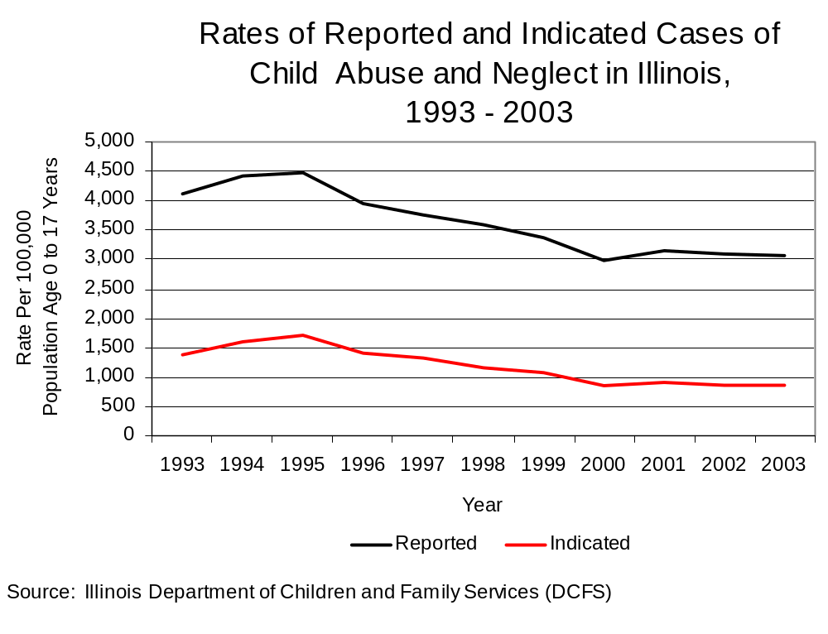
Figure 26

In 2003, 8,239 cases of child sexual abuse were reported in Illinois. In 2003, 33 percent of child sexual abuse cases were indicated. The rate of reported and indicated cases of child sexual abuse in Illinois decreased 36 and 51 percent respectively (Figure 27).

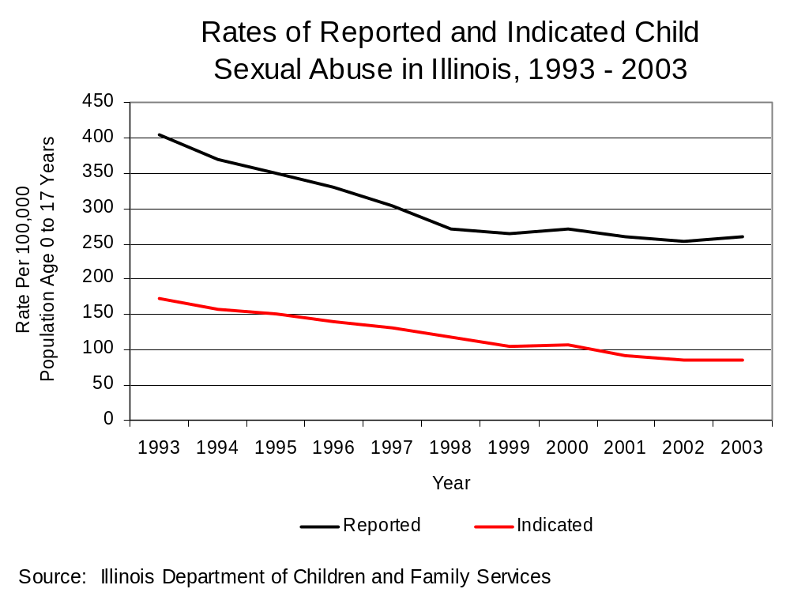
Figure 27

The rate of reported cases of child abuse and neglect in Chicago decreased by the widest margin between 1993 and 2003 (48 percent decrease), and the rural counties comprised the only region of Illinois to experience an increase in the rate of reported cases (four percent increase). The rate of indicated cases of child abuse and neglect likewise decreased to the largest extent in Chicago (60 percent decrease). Although the rate of indicated cases in the rural counties decreased, the rate decreased to the smallest degree of any region examined (nine percent).

Chicago, the urban and rural counties each accounted for about one quarter of the reported and indicated cases of child abuse and neglect in Illinois in 2003. Suburban Cook County and the collar counties accounted for fewer than 15 percent of reported and indicated cases of child abuse and neglect in Illinois in 2003.

The rate of reported cases of child sexual abuse decreased 42 percent in Chicago, 48 percent in the urban counties, and 43 percent in the collar counties between 1993 and 2003. The rate of reported cases of child sexual abuse decreased 31 percent in suburban Cook County, and least in the rural counties (nine percent) between 1993 and 2003. The rate of indicated child sexual abuse cases decreased over 50 percent in Chicago and suburban Cook County, and by nearly 60 percent in the urban and collar counties. The rural counties again showed the smallest decrease of any region in the rate of indicated child sexual abuse cases, although the rate decreased 32 percent between 1993 and 2003.

Chicago accounted for 20 percent of Illinois’ reported and indicated child sexual abuse cases in 2003, and suburban Cook County accounted for around ten percent. The rural counties comprised about 30 percent of the reported and indicated cases of child sexual abuse in the state in 2003, while the urban counties accounted for about 20 percent of the cases and the collar counties accounted for about 15 percent of both the reported and indicated cases.

Crimes Against Children

In 2002, 37,896 crimes against children age 16 years and younger were reported in Illinois, a 30 percent increase from 1996, the first year the Illinois State Police (ISP) began publishing these numbers. Police agencies in Illinois are not required by statute to report the number of crimes committed against children to ISP. Thus, this analysis only includes the number crimes of any type committed against children age 16 years or younger as reported to ISP on a voluntary basis by local police departments. In 2002, 55 percent of crimes committed against children were simple assaults or batteries, 11 percent were aggravated assaults or batteries; no other offense was committed against more that seven percent of crime victims under the age of 16. Forty-two percent of crimes against children were committed by family members, 41 percent of the crimes were perpetrated by someone known to the child victim but outside the family, and 17 percent of the crimes were committed by an offender not known to the victim.

Generally, the percentage of child victims of each age drops incrementally with the year-by-year decrease in age, although there is a marked decrease in the number of victims age ten and the number age nine years, and a slight increase occurs in the number of victims age one year and younger compared to the number of victims age two years. Thus, in general, the largest percentage of child victims of any age is 16 years. The year 2002 was no exception; that year, 19 percent of child victims were age 16 years.

Juvenile Justice

This section discusses components of the juvenile justice system including delinquency petitions, juvenile probation, juveniles in prison, the Juvenile Justice Reform Provisions of 1998 and female delinquents. Information on delinquency petitions and juvenile probation comes from the Administration Office of Illinois Courts (AOIC), while data on juvenile new court commitments to prison is from the Illinois Department of Corrections. Discussion of the Juvenile Justice Reform Provisions of 1998 and female delinquents stems from two reports conducted by the Authority, the Implementation Evaluation of the Juvenile Justice Reform Provisions of 1998 and Female Delinquents Committed to the Illinois Department of Corrections: A Profile.

Delinquency Petition Filings

Delinquency petitions are formal filings in juvenile court for a delinquent offense. “Delinquency adjudication” indicates that a juvenile has been tried in court and found guilty. About 22,500 delinquency petitions were filed in Illinois in 2001, a 14 percent decrease from 1991. Cook County accounted for 44 percent of delinquency petitions filed in the state, the urban and rural counties accounted for 21 percent each, and the collar counties accounted for 15 percent of the petitions filed in Illinois in 2001. Delinquency petition filings fell almost half in Cook County between 1991 and 2001 but increased about 50 percent in the urban counties. Petition filings in the collar counties doubled between 1991 and 2002, and the rural counties saw a 66 percent increase. In 2001, the AOIC recorded 8,417 adjudications for delinquency petitions, thus 37 percent of delinquency petitions filed resulted in an adjudication of delinquency. In 1991, 31 percent of petitions filed resulted in a finding of delinquency.

Juvenile Probation Caseloads

In 2001, nearly 18,300 juveniles were on probation in Illinois. Thirty-five percent of the juveniles were on probation in Cook County, the rural counties accounted for 22 percent of the statewide caseload, the urban counties accounted for 27 percent, and the collar counties comprised 15 percent of Illinois’ juvenile probation caseload in 2001.

The rate of juveniles on probation in Illinois decreased one percent between 1991 and 2001. Cook County’s rate decreased about 33 percent during that time, while the collar and rural counties’ rates increased by the same percentage. The rate of juveniles on probation increased to the greatest degree in the urban counties, 52 percent.

The rate of juveniles on probation in rural counties was higher than the statewide rate and the rates for any of the regions examined from 1992 to 2001, although the urban counties’ rate was just below the rural counties’ rate in 2000 and 2001. The rate of juveniles on probation in the collar counties was lower than anywhere else in the state between 1991 and 2001 (Figure 28).

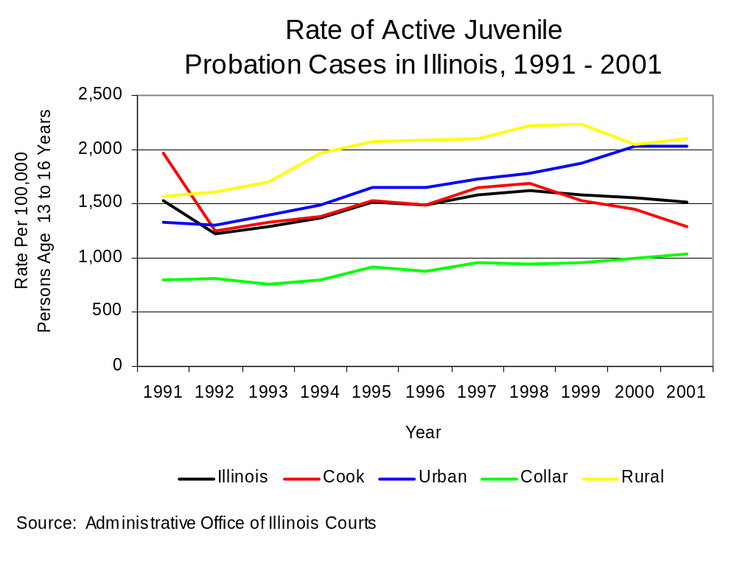
Figure 28

Juvenile Offenders in Corrections

Although this report focuses on drug and violent crime, when contrasting juvenile and adult new court commitments to the Illinois Department of Corrections (IDOC), it becomes necessary to discuss property crimes. Statewide, more juveniles were newly committed to the IDOC for property offenses in 2003 than for any other crime. Contrast this with adult new court commissions to IDOC, where the highest percentage of new admissions had committed a drug crime. In Cook County that year, more juveniles were sent to IDOC for a violent crime relative to other crimes, whereas the highest percentage of adult new court commitments in Cook County were sentenced for a drug crime. In the urban counties, the highest percentage of juvenile and adult new court commitments to IDOC were institutionalized for property crimes. In the collar counties, the majority of juvenile new court commitments were in IDOC for a violent crime, yet the highest percentage of adult new court commitments to IDOC were sentenced for a property offense. In the rural counties, more juvenile new court commitments to IDOC committed property crimes relative to all other crimes, while more adults were sentenced to IDOC for drug crimes compared with other types of offenses (Figure 29).
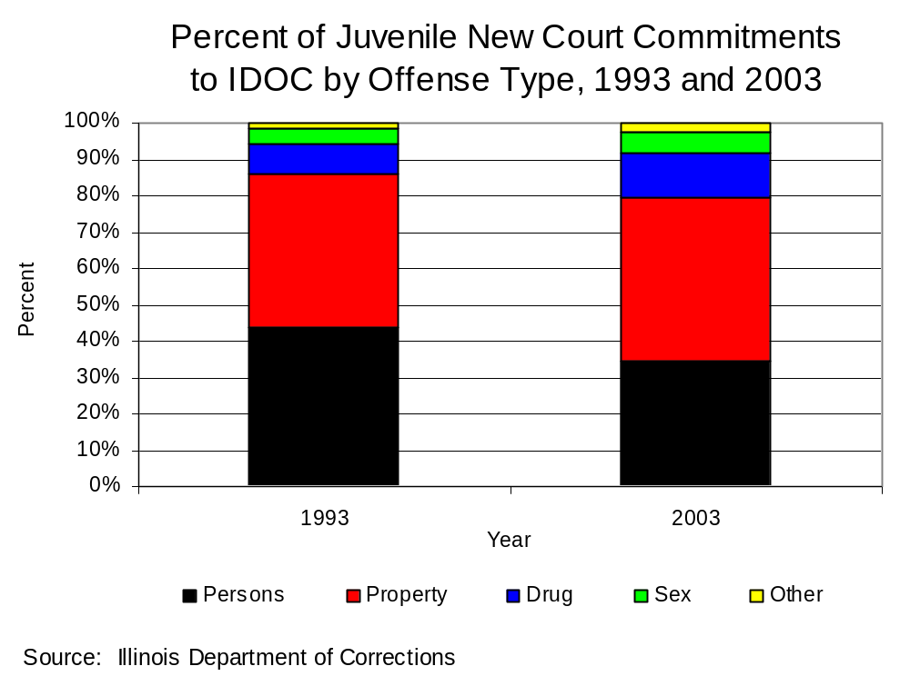
Figure 29

Statewide, the rate of juvenile new court commitments to IDOC increased 35 percent between 1993 and 2003 (Figure 30). The rate of drug crime admissions doubled statewide during that time, but the rate of admissions for violent offenses only increased 11 percent. The overall rate of juvenile admissions to IDOC as well as the rate of admissions for all individual offenses except drug crimes decreased in Cook County between 1993 and 2003. Overall admissions in Cook County decreased 14 percent during that time, the rate of violent crimes admissions decreased almost 40 percent, but the rate of drug crime admissions almost doubled.

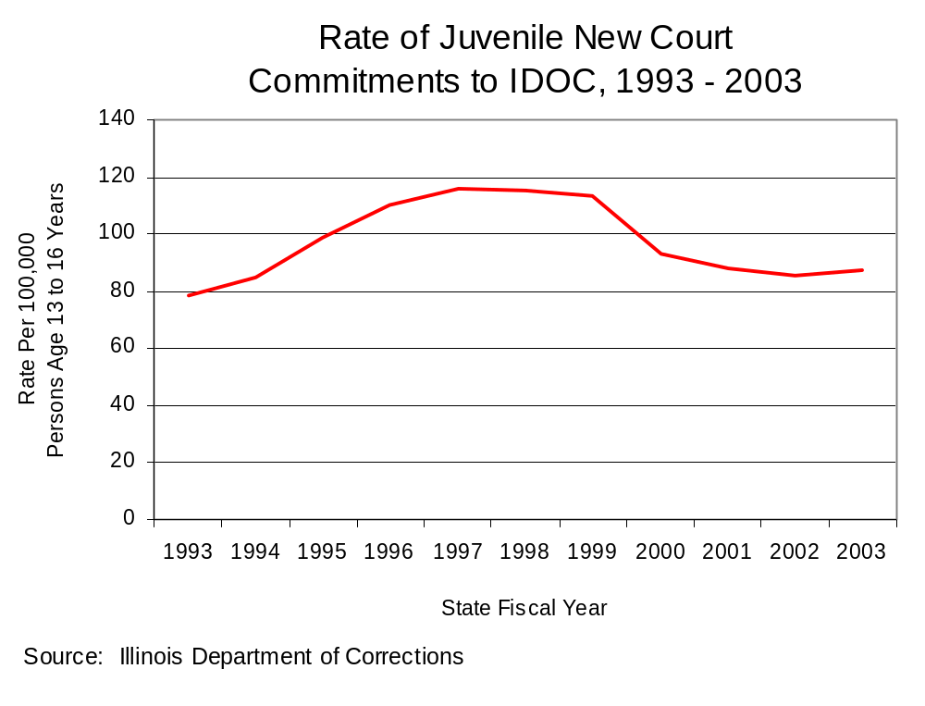
Figure 30

The rates of admission for each individual offense increased greatly in the urban counties between 1993 and 2003. Specifically, the overall rate of admission for juvenile new court commitments to IDOC increased 93 percent in the urban counties, while the rate of admission for drug crimes doubled, and the rate of admission for violent crimes increased 75 percent. The rate of admissions to IDOC for drug crimes in the collar counties decreased 41 percent, while the overall admission rate increased to nearly the same degree. The admission rate for violent crimes increased 75 percent in the collar counties. The overall IDOC admission rate for juveniles from rural counties as well as the rate for individual offense types doubled between 1993 and 2003. More specifically, the overall rate of admission as well as the rate of admission for violent crimes in the rural counties nearly tripled. The juvenile admission rate for drug crimes between 1994, the first year the rural counties reported admissions for this offense type, and 2003 increased nearly 21 times.

More juveniles were committed to IDOC from the urban counties relative to other regions in the state in 2003 (40 percent). Cook County and the rural counties each accounted for about 25 percent of all juvenile new court commitments to IDOC in Illinois, while the collar counties accounted for about ten percent.

Juvenile Justice Reform

In 1998, the Illinois General Assembly and the Governor of Illinois passed Public Act 90-590, or the Juvenile Justice Reform Provisions of 1998, which took effect on January 1, 1999. The Reform Provisions included a new purpose and policy statement that adopted Balanced and Restorative Justice (BARJ) as a guiding philosophy. The BARJ philosophy seeks to balance the needs of juvenile offenders, juvenile crime victims, and the community. In addition to the new purpose and policy statement, the Reform Provisions also made a number of other changes to the Illinois juvenile justice system.

The Illinois Criminal Justice Information Authority examined a number of BARJ-related and non-BARJ-related changes that the Reform Provisions made to the Illinois juvenile justice system. The goals of the evaluation were: (1) to learn the extent to which juvenile justice professionals in Illinois are implementing the BARJ-related and non-BARJ-related changes, and (2) to learn the extent to which juvenile justice professionals understand BARJ and are implementing the BARJ philosophy in their everyday professional activities.

One of the three components to the evaluation is the statewide evaluation component. Surveys were distributed to the following types of juvenile justice professionals in each of Illinois’ 102 counties: state’s attorneys with juvenile caseloads, public defenders with juvenile caseloads, juvenile probation officers, juvenile intake officers, juvenile police officers, juvenile court judges who hear delinquency cases, and circuit court clerks. The statewide evaluation component was intended to provide a broad, comprehensive view of statewide Reform Provision implementation. The key findings are detailed below.

Responses to questions asking juvenile justice professionals for their definitions of competency and accountability indicate that these terms are defined in a manner that is consistent with BARJ. This suggests that some juvenile justice professionals have an implicit understanding of BARJ, even though juvenile justice professionals reported relatively low levels of BARJ knowledge and training.

All juvenile justice professionals tended to report fairly low levels of knowledge regarding BARJ. No more than approximately 55% of any profession strongly agreed or agreed with the statement “I consider myself knowledgeable about Balanced and Restorative Justice”.

Additional research by Illinois Criminal Justice Information Authority research staff indicated that, there were 29 juvenile justice councils in Illinois. Few juvenile justice councils have completed important council tasks, such as developing a juvenile justice plan or a local juvenile resource guide.

The Reform Provisions added new sections to the Illinois Juvenile Court Act encouraging counties or jurisdictions to develop community mediation panel programs and teen court programs. Few counties or jurisdictions have developed community mediation panel programs. Teen court programs seem to be somewhat more prevalent than community mediation panel programs. Few community mediation panel programs or teen court programs have been developed directly as a result of the Reform Provisions.

The Reform Provisions added a new parental responsibility section to the Illinois Juvenile Court Act granting courts increased leeway to involve parents or guardians in the juvenile court process. However, overall, parental involvement in the juvenile justice system has not increased. This may, in part, be because juvenile justice professionals believed that parents already played a large role in juvenile court processes and juvenile sentences.

The Reform Provisions changed the section in the Illinois Juvenile Court Act that describes how station adjustments are to be handled. Juvenile police officers are required to distinguish between two types of station adjustments: formal and informal. Approximately half of the juvenile police officers who responded to the survey (35 of 69) reported that they are distinguishing between formal and informal station adjustments.

The guidelines for formal station adjustments in the Illinois Juvenile Court Act indicate that, in order for a juvenile police officer to issue a formal station adjustment, the minor and the minor’s parent(s) must sign a written form that describes, among other information, the station adjustment conditions. Only approximately two-thirds of the juvenile police officers who reported that they distinguish between formal and informal station adjustments (23 of 35) use written forms for formal station adjustments.

The Reform Provisions added a new section to the Illinois Juvenile Court Act which enables state’s attorneys to petition the court for an EJJ prosecution if there is probable cause to believe that a minor 13 years of age or older has committed an offense that would be a felony if committed by an adult. Minors who are found guilty in an EJJ prosecution are given both an adult and a juvenile sentence. The adult sentence is not imposed unless the minor violates the conditions of the juvenile sentence. Survey results suggest that EJJ is being used sparingly throughout Illinois. Very few state’s attorneys, juvenile court judges, or public defenders who responded to the survey reported having been involved in an EJJ prosecution.

Female Delinquents

What is known about female juvenile offenders in Illinois is limited. There are no state-level data available on the number of females arrested or the number of females entering and moving through the juvenile justice system in Illinois, nor are there state-level data available on the specific characteristics of female delinquents. Without such information it is difficult to determine the needs of this population. In 2003, Illinois Criminal Justice Authority staff completed the report Female Delinquents Committed to the Illinois Department of Corrections: A Profile, in order to repair these knowledge gaps so that practitioners, policymakers, and correctional administrators can better serve the needs of female delinquents. The report also sought to describe the experiences of practitioners working with female delinquents.

Authority staff examined the trends in female and male admissions to Illinois Youth Centers. Based on the admission data to these centers from state fiscal year (SFY) 1993 to SFY 2002, it was found that the female new court admission rate to Illinois Youth Centers was much lower than the rate for males. While both rates increased during the time period analyzed, the female admission rate increased at a much greater magnitude than the male admission rate. It was also found that the demographic and offense characteristics of females differed from males admitted to Illinois Youth Centers. A greater percentage of females than males were white, admitted for court evaluations, and committed from rural or urban counties. Moreover, a greater percentage of females than males were admitted for property and person offenses; assaults and batteries; and Class 3 felony and misdemeanor offenses.

Females committed to the Illinois Youth Center in Warrenville were analyzed in order to ascertain characteristics of female delinquents. Over 75 percent of the females in our sample were committed to the Department of Corrections after being tried and adjudicated delinquent in juvenile court. Forty-four percent of the females in our sample were dually involved in the child welfare and juvenile justice systems. Over half of these females had experienced either physical and/or sexual abuse at least once in their lifetime. Over 95 percent of the females who reported physical, emotional, or verbal abuse and nearly 75 percent of the females reporting past sexual abuse reportedly knew their victimizers (e.g., family members, boyfriends, other relatives, etc.).

Many of the females in our sample were reportedly having difficulty in school. Almost 70 percent had missed school due to truancy, 45 percent had been suspended at least once, ten percent had been expelled, and 21 percent had dropped out of school or had been dropped from the school’s roster due to not attending. Also, nearly 75 percent of the females in our sample had been diagnosed with a mental health disorder or problem. Thirty-eight percent had reported suicidal thoughts and over 25 percent had attempted suicide at least once.

Nearly all of the females in our sample had tried alcohol and/or drugs - the most frequently cited drug being marijuana. Many of the females entering the Department of Corrections had extensive arrest histories; the average was five prior arrests (not including arrests for status offenses). Nearly 75 percent had been arrested for a violent offense. For those females in which information about their victims were available, it was found that family members, authority figures (e.g., police, school personnel, etc.), acquaintances (e.g., school mates, etc.), and store owners or businesses were the most frequently identified victims.

Focus group participants reported experiencing four main barriers while working with female delinquents: (1) the family and neighborhood environments, (2) females’ sexual relationships, (3) the juvenile justice system and other agencies, and (4) the institutional environment. Focus group participants reported filling various roles staff reported engaging in while working with females. The most frequently cited role was that of a surrogate parent. A few participants, however, felt taking on the parental role was difficult because it could create situations in which the youth gets attached to staff and does not want to leave the institution or the staff member disciplines the youth and she feels rejected and hurt.

Staff participating in the focus groups made several recommendations for improving the correctional system. These include creating more mental health options for the seriously ill, more training on issues particular to working with females, better screening of staff, and more communication between staff (including administrative personnel). Parole officers cited the need for transitional living centers for female delinquents, and all three focus groups identified the need for aftercare services.

Authority staff recommended developing more programming for female delinquents. More programming should be developed to specifically address the needs of females engaged in the juvenile justice system. Programs recommended include mentoring and tutoring programs, anger management and conflict resolution programs, sex education classes, and parenting classes. Programs also should be developed that teach and model healthy relationships. Additionally, it was recommended that more community-based mental health programs be developed to specifically address the mental health needs of females at risk for or entering the juvenile justice system. Finally, programs should be created that work specifically with females and their families.

Improving the information available in the social history reports was another area Authority staff deemed important. While reviewing social history reports, it was realized that the social history reports varied greatly in terms of the amount and detail of the information provided. Although it is recognized that some counties are limited in what they are able to produce during the time available to conduct a pre-sentence social history investigation, officials should at minimum consider revisiting what information is being collected, particularly in those counties in which a limited amount of information is being collected and reported to juvenile court.

The report determined that more research on female delinquents should be conducted on female delinquents in general, not just those committed to the Department of Corrections. Research is needed to determine if indeed there has been an increase in the number of female juveniles arrested in Illinois, and if so, why this increase has occurred; map the flow of female delinquents through the juvenile justice system to identify how females move through the juvenile justice system and what factors predict their movement; and how the Department of Corrections is being used by local juvenile justice systems.

Based on the information shared by focus group participants, Authority staff recommended that the Department of Corrections consider revisiting institutional policies to determine if some policies conflict with institutional rules, and if so, what actions can be taken to remedy such situations. Additionally, several participants described working with female delinquents as emotionally draining, difficult, and frustrating. It was suggested that the Department of Corrections should provide staff with the opportunity to openly discuss their concerns or frustrations.

It was also recommended that the Department of Corrections develop more intensive mental health services for the females in their care. Such services may include the development of a separate wing devoted specifically to females with more severe mental health problems.

The report suggests that a greater focus on education within the Department of Corrections is needed. Based on the findings from the focus groups, it was recommended that there should be a greater focus on the education of females in the Illinois Youth Center – Warrenville. Also, aftercare services should be developed to supplement the supervision provided through parole. Such aftercare services could link females to additional programming and crisis intervention services. It was also suggested that aftercare services should be made available to youth as they transition off parole. Transition centers should be created to provide temporary placements for youth while alternative placements are identified.

III. RESOURCE NEEDS

This section is intended to generally describe the resources that are currently being used in Illinois to address the problems that have been identified, as well as the gaps in resources that need to be filled as part of this multi-year strategy.

In past Byrne strategies, the Authority set seven priorities. These priorities were:

- Support prevention programs that help youth recognize risks associated with violent crime and drug use and target youth to reduce their use of violence, illicit drugs, alcohol, and tobacco products;

- Support programs that strengthen multi-agency linkages at the community level among prevention, treatment, and criminal justice programs, as well as other supportive services, to better address drug abuse;

- Support programs that enhance treatment effectiveness, quality, and services so that those who need treatment can receive it;

- Support programs that reduce drug-related crime and violence;

- Support research that identifies what works in drug treatment and the prevention of drug use, violent crime, and their consequences;

- Support programs that promote the efficiency and effectiveness of the criminal justice system; and
- Support programs statewide that target prevention and early intervention for juveniles, with particular emphasis on the principals of balanced and restorative justice.

Under these priorities, the Authority funded a variety of programs including multi-jurisdictional task forces and prosecution units, prevention programs, training programs, public defense initiatives, treatment programs in the state correctional system and in probation departments, and evaluation efforts to determine what works.

The amount of Byrne funds designated to various purposes has fluctuated over the years. Following is a summary of the percent (and dollar amount) of each year’s award designated to specific purpose areas for the past four years, as well as the average percent for each purpose area.
 | FFY00 | FFY01 | FFY02 | FFY03 | Average
Multi-Jurisdictional Task Forces | 41.8%  ($7,729,826) | 40.2%  ($7,397,837) | 54.7%  ($9,952,557) | 42.5%  ($7,637,987) | 44.78%  ($32,718,207)
Community Crime Prevention | 0.3%  ($58,776) | 2.7%  ($500,000) | 0  ($0) | 3.3%  ($600,000) | 1.59%  ($1,158,776)
Training | 7.1%  (1,313,262) | 3.1%  ($570,900) | 3.1%  ($570,900) | 0.9%  ($164,050) | 3.58%  ($2,619,112)
Prosecution Initiatives | 4.4%  ($816,223) | 6.3%  ($1,152,258) | 2.0%  ($355,350) | 2.0%  ($355,350) | 3.67%  ($2,679,181)
Defense Initiatives | 3.5%  ($645,814) | 5.7%  ($1,057,350) | 4.5%  ($823,447) | 7.5%  ($1,349,684) | 5.30%  ($3,876,295)
Corrections | 8.1%  ($1,502,575) | 10.3%  ($1,894,053) | 8.7%  ($1,587,719 | 8.5%  ($1,531,024) | 8.92%  ($6,515,371)
Information Systems * | 15.1%  ($2,790,033) | 12.6%  ($2,324.579) | 11.5%  ($2,087,687) | 14.7%  ($2,633,366) | 13.46%  ($9,835,665)
Innovative Programs | 4.7%  ($876,974) | 2.6%  ($472,160) | 0.5%  ($85,086) | 2.8%  ($500,000) | 2.65%  ($1,934,220)
System Response to Victims | 1.0%  ($181,664) | 1.0%  ($189,639) | 0.5%  ($98,880) | 0  ($0) | 0.64%  ($470,183)
Evaluation | 6.8%  ($1,250,000) | 6.9%  ($1,265,000) | 7.0%  ($1,265,000) | 7.0%  ($1,265,000) | 6.90%  ($5,045,000)
Alternatives to Detention | 7.2%  ($1,327,905) | 8.6%  ($1584,850) | 3.8%  ($684,850) | 7.0%  ($1,258,575) | 6.65%  ($4,856,180)
Gang Enforcement and Prevention | 0.1%  ($11,872) | 0  ($0) | 0  ($0) | 0  ($0) | 0.02%  ($11,872)
Unallocated | 0  ($0) | 0  ($0) | 3.8%  ($684,067) | 3.7%  ($666,270) | 1.85%  ($1,350,337)

* Includes 5% set-aside for criminal history record improvement.

On average, nearly 45% of Byrne funds from the past four years has been dedicated to multi-jurisdictional efforts (MEGs, task forces, drug prosecution units). Almost 13.5% of these awards have been designated to information systems (includes the 5% set-aside for criminal history record improvement). Corrections programs have received nearly 9% of these funds. Between 5% and 7% of the funds have gone to defense initiatives, evaluation, and alternatives to detention. Lesser amounts have been made available for community crime prevention, training, prosecution initiatives (other than multi-jurisdictional drug prosecution units), innovative programs, system response to victims, and gang enforcement and prevention.

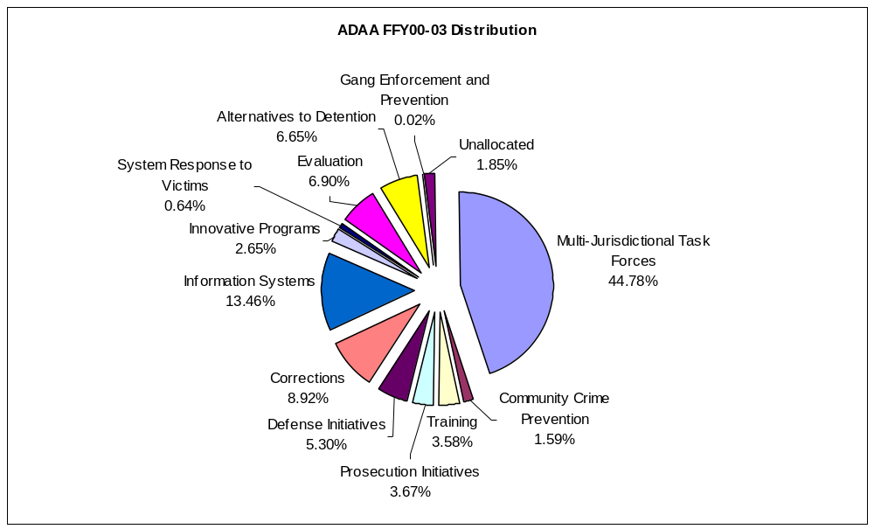
If currently funded Byrne projects that have not reached the end of their 48-month funding cycle with FFY03 funds and all multi-jurisdictional efforts are continued, about $7 million of the Authority’s FFY04 award would be available for new initiatives. However, the President’s proposed FFY05 budget eliminates the Byrne formula program and the Local Law Enforcement Block Grants (LLEBG) program and consolidates both into the Justice Assistance Grant (JAG). In addition, the President’s FFY05 budget eliminates another Authority administered grant—the Juvenile Accountability Block Grant (JAIBG or JABG).

The following chart compares the FFY02 through FFY04 federal appropriations and Illinois awards as well as the President’s FFY05 budget proposal for the Byrne Formula, LLEBG, JAG and JAIBG.

 | Designation | FFY02 | FFY03 | FFY04 | FFY05 *
Byrne Formula  (ADAA) | Federal  Appropriation | $500 million | $500 million | $500 million | $0
Byrne Formula  (ADAA) | Illinois  Award | $19,460,474 | $19,209,953 | $18,800,637 | $0
LLEBG | Federal  Appropriation | $400 million | $400 million | $225 million | $0
LLEBG | Illinois  Award | $984,700 | $1,009,362 | **$560,000 | $0
Justice Assistance Grant (JAG) Program | Federal  Appropriation | $0 | $0 | $0 | $508.94 million
JAIBG - JABG | Federal  Appropriation | $249.5 million | $190 million | $60 million | $0
JAIBG - JABG | Illinois  Award | $7,079,600 | $5,531,842 | $1,830,200 | $0
*President’s budget proposal
**Estimate

In consequence of the budget proposals and their potential effect, in determining funding priorities for the FFY04 Byrne Strategy, Authority members have considered the fact that there might not be future Byrne, LLEBG, or JABG funding. In addition, $85.88 million of the proposed JAG appropriation is currently earmarked for specific projects ($19.96 million for NIJ to assist local units to identify, develop, and purchase new technologies for use by law enforcement, $60 million is for Boys and Girls Clubs, and $5.92 million for the Tribal Courts Initiative). Since details of the JAG program are not available at this time, it is impossible to speculate as to how much Illinois may receive under this initiative.

With these things in mind, the Authority has identified several current and/or future resource gaps and needs:

- There continues to be a need to for preventive programs that help youth recognize risks associated with violent crime and drug use and target youth to reduce their use of violence, illicit drugs, alcohol, and tobacco products;
- There continues to be a need for programs throughout the state that target prevention and early intervention for juveniles, with particular emphasis on the principals of balanced and restorative justice.
- There continues to be a need for programs that enhance treatment effectiveness, quality, and services so that those who need treatment can receive it.
- There continues to be a need to emphasize and support research that identifies what works in drug treatment and the prevention of drug use, violent crime, and their consequences.
- There remains a need to support programs that promote the efficiency and effectiveness of the criminal justice system. These include programs such as the multijurisdictional law enforcement and prosecutorial programs focusing on drug and violent crime.
- There is a critical need to support efforts to implement an integrated justice system in Illinois that includes all components of the criminal justice system and includes every jurisdiction within the state.

The Authority has also found that any FFY04 funds available for new projects should be focused in four areas:

- Treatment for sex offender parolees from the Illinois Department of Corrections. Legislation passed last year that took effect January 1, 2004 (Public Act 93-0616) requires that “each sex offender placed on parole or mandatory supervised release by the Prisoner Review Board shall be required as a condition of parole to undergo treatment based upon any evaluation or subsequent reevaluation regarding such offender during the offender’s incarceration or any period of parole.” This legislation is an unfunded mandate. Providing funding for this treatment would fit under the priority of supporting programs that enhance treatment effectiveness, quality, and services so that those who need treatment can receive it.
- A special DNA prosecution unit at the Cook County State’s Attorney’s Office. The Cook County State’s Attorney’s Office would like to develop a new unit within the office that will not only carry its own load of cases involving DNA evidence, but also to act as in-house experts who will consult on cases in other areas of the office to make better use of DNA evidence, expedite cases, act as a liaison with the crime lab and provide training to support assistant state’s attorneys within the office as well as throughout the state on issues relating to DNA evidence. By having in-house DNA experts who can provide the support and information frequently requested in calls to the state crime lab, the time of the forensic scientists could be better used to focus on DNA analysis. Providing funding for such a project would fit under the priority of supporting programs that promote the efficiency and effectiveness of the criminal justice system.
- Balanced and Restorative Justice (BARJ) projects. BARJ projects have been a focus under the JAIBG, now JABG program, and BARJ principles are part of the Juvenile Justice Reform Act. As JABG funding has been reduced and may be cut entirely, a main source of support for these types of programs is being lost. Funding BARJ related projects would fit under the priority to support programs statewide that target prevention and early intervention for juveniles, with particular emphasis on the principals of balanced and restorative justice.
- Other public policy initiatives from the Governor, Authority members, and staff. Each of the first three areas represents efforts in which work by both staff and potential sub-grantees is already underway or specifically projected, and consequently anticipates plans for projects which can realistically be structured and achieved with the timing and funds projected to become available. Additionally, each of the first three areas of focus relate to larger sets of state priorities and needs. The fourth area is recommended so as to maintain maximum flexibility and responsiveness in view of the potentially significant funding restraints, which may be experienced in the very near future, and to address emerging needs identified in the course of the funds’ life.

PRIORITIES AND THE NATIONAL DRUG CONTROL STRATEGY

The Authority has identified seven priorities for FFY2004. These priorities are consistent with and build on the National Drug Control Strategy.

Priority 1: Support prevention programs that help youth recognize risks associated with violent crime and drug use and target youth to reduce their use of violence, illicit drugs, alcohol, and tobacco products. (National Drug Control Strategy Priority #1.)

Priority 2: Support programs statewide that target prevention and early intervention for juveniles, with particular emphasis on the principals of balanced and restorative justice. (National Drug Control Strategy Priority #1.)

Priority 3: Support programs that enhance treatment effectiveness, quality, and services so that those who need treatment can receive it. (National Drug Control Strategy Priority #2.)

Priority 4: Support research that identifies what works in drug treatment and the prevention of drug use, violent crime, and their consequences. (National Drug Control Strategy Priority #’s 1 & 2.)

Priority 5: Support programs that promote the efficiency and effectiveness of the criminal justice system. (National Drug Control Strategy Priority #3.)

Priority 6: Support efforts to implement an integrated justice system in Illinois that includes all components of the criminal justice system and includes every jurisdiction within the state. (National Drug Control Strategy Priority #3.)

Priority 7: Support efforts with law enforcement, prosecution, and probation to combat, disrupt, and test drug users. (National Drug Control Strategy Priority #3.)

V. SELECTED PROGRAMS

- Multi-Jurisdictional Narcotic Units
- Approved 1989
- Ties to national priority 3—Disrupting the Market
- Purpose Area 2
- Twenty multi-jurisdictional narcotic units exist across the state. They are made up of law enforcement agencies within one county or within multiple counties. The units conduct primarily covert operations to stop the flow of illegal drugs in Illinois by targeting drug distributors and dealers.
- Performance Measures: 1) Number of offenders arrested, 2) Number of drug seizures, 3) Quantity by weight and drug type, 4) Total value of funds and assets forfeited
- Evaluation: An evaluation of the multi-jurisdictional enforcement groups (MEGs) and task forces was completed in 1995. In January 2002 a report entitled “A Summary of Drug Enforcement Activities across Illinois’ MEGs and Task Forces” was completed. A report entitled “New Approaches and Techniques for Examining and Evaluating Multi-jurisdictional Drug Task Forces in Illinois” was completed in December 2002. In February 2003 a report was completed entitled “Comparison of Local and Multi-jurisdictional Drug Enforcement Efforts in Illinois.” Also, comprehensive profiles of each of the units were prepared in March 2004.

- Multi-Jurisdictional Drug Prosecution Programs
- Approved 1989
- Ties to national priority 3—Disrupting the Market
- Purpose Area 2
- Seven multi-jurisdictional drug prosecution programs are funded to support the prosecution of offenders arrested by the multi-jurisdictional narcotics units.
- Performance Measures: 1) Number of offenders prosecuted
- Evaluation: An evaluation of the multi-jurisdictional drug prosecution units was completed in 1999.

- Evaluation--Drug Strategy Impact Evaluation
- Approved 1990
- Purpose Area 19
- This project funds staff and other resources for both internal and external evaluations of Byrne funded projects and for data collection, research and other activities supporting the administration of Byrne funds.
- Performance Measures: 1) Number of evaluations conducted/in-progress
- Evaluation: Not applicable

- Probation Initiatives--Juvenile Reporting Centers
- Approved 1991
- Ties to national priority 2—Healing America’s Drug Users
- Purpose Area 20
- The Juvenile Reporting Centers address the supervision and treatment needs of at-risk juveniles. The goal of the day/evening reporting center programs is to provide community-based intensive intervention programming for juvenile probationers at risk of placement in detention.
- Performance Measures: 1) Number of alternative programs created, 2) Number of offenders participating in programs
- Evaluation: No evaluation planned. The Authority requests a waiver.

- Probation Initiatives--Innovative Probation Initiatives
- Approved 1991
- Ties to national priority 2—Healing America’s Drug Users
- Purpose Area 20
- As a result of the Innovative Probation Initiative request for proposals, four counties and two judicial circuits were chosen to receive funding for innovative probation projects. These programs affect 18 counties in Illinois and bring research-based best practices to areas of the state not able to implement these programs on their own. Additionally, four of the six programs aim to implement the recommendations of the Illinois Attorney General’s Sex Offender Management Board. Without exception, all the programs are designed with new and innovative components that elevate and enhance the practice of probation in the county or circuit in which they will be implemented.
- Performance Measures: 1) Number of alternative programs created, 2) Number of offenders participating in programs
- Evaluation: Being considered for evaluation, but no evaluation planned at this date.

- Probation Initiatives--Community-based Transitional Services for Female Offenders
- Approved 1991
- Ties to national priority 2—Healing America’s Drug Users
- Purpose Area 20
- Three community-based transitional services for female offenders programs exist, based in probation departments. The programs provide gender specific services to address substance abuse and the trauma of sexual and physical abuse. The focus is to promote health and independence and to reduce arrest rates and technical violations.
- Performance Measures: 1) Number of alternative programs created, 2) Number of offenders participating in programs
- Evaluation: An evaluation of the project in Lake County is underway. Evaluation completion is targeted for June 2005.

- Correctional Initiatives--Sex Offender Parolee Treatment
- Approved 1992
- Purpose Area 11
- Illinois legislation passed last year requires that “each sex offender placed on parole or mandatory supervised release by the Prisoner Review Board shall be required as a condition of parole to undergo treatment based upon any evaluation or subsequent reevaluation regarding such offender during the offender’s incarceration or any period of parole.” This program will provide some of the funding needed to carry out this mandate.
- Performance Measures: 1) Number of offenders in community-based programs, 2) number of community-based programs
- Evaluation: Being considered for evaluation, but no evaluation planned at this date.

- Innovative Prosecution Initiatives--DNA Prosecution Unit
- Approved 1993
- Purpose Area 16
This project within the Cook County State’s Attorney’s Office will not only carry its own load of cases involving DNA evidence, but also to act as in-house experts who will consult on cases in other areas of the office to make better use of DNA evidence, expedite cases, act as liaison with the crime lab and provide training to support assistant state’s attorneys within the office as well as throughout the state on issues relating to DNA evidence.
- Performance Measures: 1) Number of offenders prosecuted
- Evaluation: No evaluation planned. The Authority requests a waiver.

VI. COORDINATION EFFORTS

Coordination is an integral and increasingly intentional part of the Illinois crime prevention strategy. It is pursued and achieved through a number of methodologies and structural interfaces.

The Authority is a statutorily created and independent state agency charged with improvement of the administration of justice within the state. Its Board brings together representatives of the major stakeholders in criminal justice administration, policy and planning, including the courts, prosecution, defense, victim advocacy, corrections, research and law enforcement communities, and members of the public at large. Through its meetings as a whole and through its committees, both general priorities and specific initiatives are reviewed, analyzed and discussed as an essential part of both strategic and short term planning.

The Authority, through its Federal and State Grants Unit, oversees many of the principal federal and state assistance programs in Illinois, which relate to the administration of justice. The Authority administers nine federal programs including the Anti-Drug Abuse Act (Byrne Formula) Grant Program, Juvenile Accountability Block Grants Program, Local Law Enforcement Block Grants Program, National Criminal History Improvement Program, National Forensic Sciences Improvement Act Program, Residential Substance Abuse Treatment Program, Violence Against Women Act Program, Victims of Crime Act Program, and the Violent Offender Incarceration/Truth in Sentencing Program.

The Authority’s Budget Committee oversees the grant award procedures of the Authority and through this committee and its oversight, applications, awards and administration are coordinated. Coordination efforts are supported by the participation of the same members in funding and program decisions across a number of otherwise distinct programs. Funds from different programs can be used to ensure that the entire spectrum of the criminal justice system receives funding that is complementary, rather than duplicative, and can also be concentrated where tactically or strategically desirable to achieve specific goals or address critical problems.

The Authority is additionally responsible for a leading role in the area of integration of criminal justice information systems across the state, and also functions as a principal planning and research entity.

Strategic coordination of programs, resources and information in the context of cooperative and interdependent relationships are thus not only a critical part of the Illinois strategic but are a part of its process of development and implementation by structural design and operational choice.

VII. DATA SOURCES

Administrative Office of Illinois Courts; Annual Report to the Supreme Court of Illinois

Chicago Police Department; Annual Report and Homicide Report

Illinois Criminal Justice Information Authority:

Results from the 2000 Illinois Adult Probation Outcome Study, March 2002;

Methamphetamine in Illinois: An Examination of an Emerging Drug, January 2003;
Chicago Women’s Health Risk Study, June 2000;
2002 Illinois Crime Victimization Survey, upcoming;
Surveys of Metropolitan Enforcement Groups (MEGs) and Drug Enforcement Task Forces (TFs), 1995, 1996, 1998, 2000;
Implementation Evaluation of the Juvenile Justice Reform Provisions of 1998, March 2002;

Female Delinquents Committed to the Illinois Department of Corrections: A Profile, December 2003

Illinois Department of Corrections; Human Services Plan, Statistical Presentation and Statistical Summary of the Juvenile Division

Illinois Department of Human Services, Illinois Department of Children and Family Services; Annual Report

Illinois Department of Human Services, Office of Alcoholism and Substance Abuse; 2002 Illinois Household Survey and additional data on substance abuse treatment admissions

Illinois Department of Public Health, Adverse Pregnancy Outcomes Reporting System

Illinois Department of Public Health; data on firearm deaths

Illinois Department on Aging; elder abuse data

Illinois State Police; Crime in Illinois

Illinois State Police; Law Enforcement Agencies Data System; data on orders of protection and petitioners

U.S. Department of Health and Human Services, Substance Abuse and Mental Health Services Administration, Drug Abuse Warning Network

U.S. Department of Justice, National Drug Intelligence Center; Illinois Drug Threat Assessment Update

DAWN reports that rates as used here are not drug use prevalence rates for the population using EDs, but are indicators of the number of ED drug abuse episodes or mentions per 100,000 population.
The data maintained by the Illinois State Police do not represent 100 percent of Illinois’ total resident population. It is unknown whether non-reporting agencies had no hate crime in their jurisdictions, or if they failed to report.
Rennison, C. and Rand, M. Criminal Victimization, 2002, National Crime Victimization Survey, Washington, DC: U.S. Department of Justice, Bureau of Justice Statistics, August 2003, NCJ 199994.
Standard errors for all statewide estimates do not exceed +/- 2.4 percentage points at the 95 percent confidence level.
Robbery includes pick-pocketing and purse snatching.
Includes aggravated assault.
Includes sexual assault and other forced or coerced unwanted sexual activity.
Computer crime rates were calculated using only the number of respondents who reported using a computer for personal use during 2002. Computer crime included fraud in purchasing something over the Internet, threats of harm or attack made while on-line or through e-mail, software copyright violations, and virus attacks (excluding violations and attacks at a respondent’s occupation unless they were self-employed).
The section on weapons did not include an option for hands, feet and fists.

