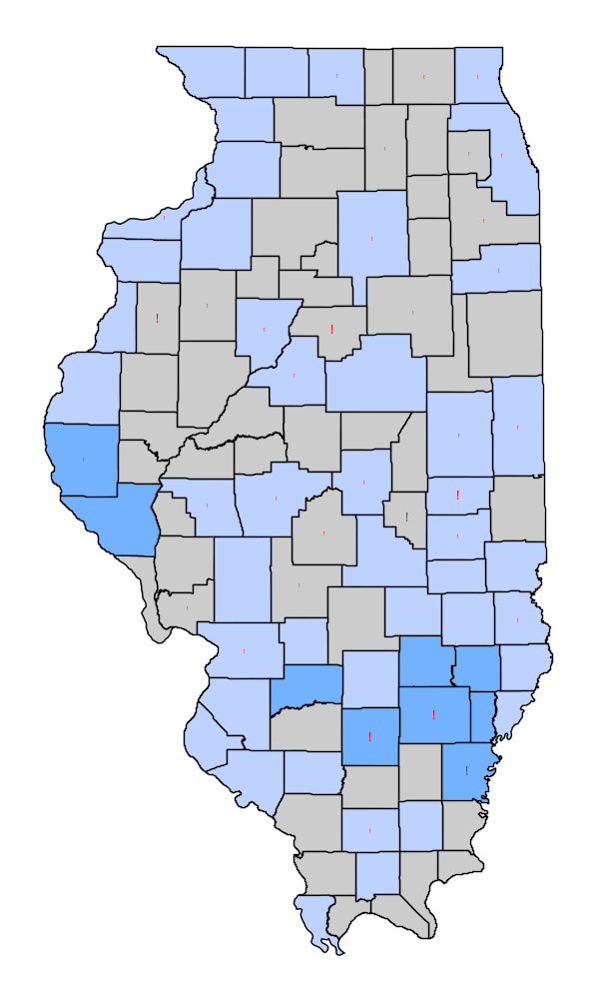
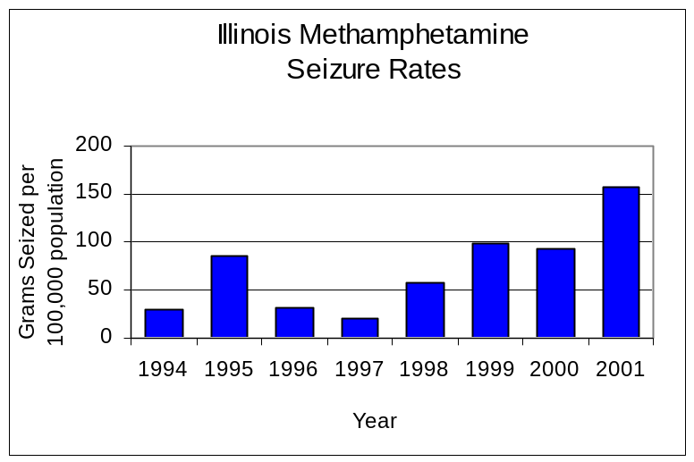
Trends in Methamphetamine Use and Abuse in Illinois

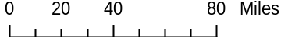
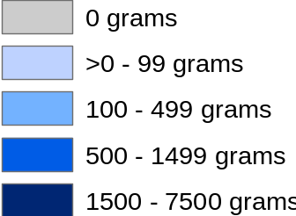
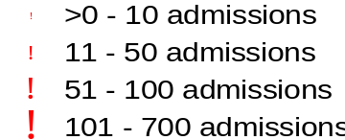
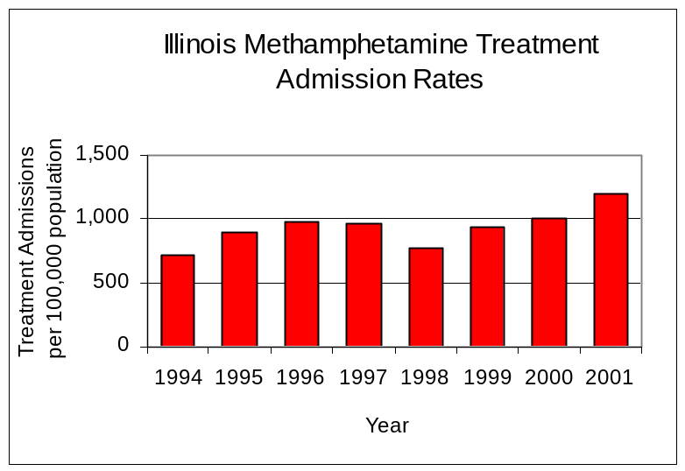
1994
1997
2001

Methamphetamine Treatment Rate
(Treatment admissions per 100,000 population)
Methamphetamine Seizure Rates
(Grams seized per 100,00 population)

Methamphetamine: An Examination of an Emerging Drug
According to the U.S. Department of Justice’s National Drug Intelligence Center (NDIC), methamphetamine is widely available throughout most regions of the United States. Such prevalence indicators as increasing methamphetamine drug and clandestine laboratory seizures, arrests, indictments and sentences illustrate this widespread availability. Methamphetamine is now spreading through the Midwest and becoming an emerging and significant new drug problem in previously unaffected rural and urban areas. A study by the National Center on Addiction and Substance Abuse found higher rates of methamphetamine use in rural areas than in urban areas. Using 1999 data, researchers found that eighth-graders in rural America were more than twice as likely than those in urban centers to use methamphetamine.

Through the use of existing local and national-level aggregate data, research has been done to determine the migratory characteristics of methamphetamine as an emerging drug by examining prevalence indicators (efforts undertaken by law enforcement, e.g., the quantity of methamphetamine seized) relative to consequence indicators (admissions to treatment for methamphetamine abuse and Drug Abuse Warning Network [DAWN] data).

Nationally, the Drug Enforcement Administration (DEA) reported that domestic seizures of methamphetamine, between 1990 and 2000, more than tripled, from 221 kilograms to 3,163. In Illinois, law enforcement agencies submit seized drugs to Illinois State Police crime laboratories for identification and analysis. The quantity of methamphetamine seized and submitted to the Illinois State Police increased dramatically between 1994 and 2001, jumping considerably from 3,433 grams to 19,576 grams. While all regions reported increases in methamphetamine seizures, rural counties accounted for more than one-half (57 percent) of all methamphetamine seized from 1994 to 2001. Illinois’ methamphetamine seizure rate increased more than four-fold, from 29 to 157 grams per 100,000 population between 1994 and 2001. In 1994, methamphetamine was seized in 61 of Illinois’ 102 counties. However, by 2001, methamphetamine had been seized in 85 Illinois counties. Rural counties accounted for three-quarters (64) of those counties where methamphetamine was seized and submitted to the Illinois State Police.

National-level consequence indicators produced by the Drug Abuse Warning Network DAWN suggest that the uses of, and adverse consequences of methamphetamine use, are increasing as evidenced by rising treatment admissions and emergency department visits. DAWN reporting indicated an 18 percent increase in the number of emergency department mentions for methamphetamine between 1998 and 2000. In Illinois, the aggregate number of individuals admitted to drug treatment for methamphetamine abuse was obtained for each county from the Illinois Department of Human Services’ Office of Alcoholism and Substance Abuse (OASA). The number of admissions to treatment where methamphetamine was identified as the primary substance of abuse increased dramatically, more than 15-fold, between 1994 and 2001, from 97 to 1,528 admissions, and more than doubled over the last two years. Rural counties accounted for nearly three-quarters (73 percent) of all methamphetamine treatment admissions in Illinois in 2001. The statewide methamphetamine treatment admission rate in 2001 was 12 admissions per 100,000 population, compared to 0.8 admissions per 100,000 population in 1994. In 1994, admissions for treatment of methamphetamine abuse were reported in 34 of Illinois’ 102 counties, 18 of which were rural counties. However, by 2001, rural counties accounted for 58 of the 81 counties where methamphetamine treatment admissions were reported.
Sources: Illinois Criminal Justice Information Authority calculations using Illinois State Police and U.S. Bureau of the Census data
Sources: Illinois Criminal Justice Information Authority calculations using Illinois Department of Human Services’ Office of Alcoholism and Substance Abuse and U.S. Bureau of the Census data

Illinois Criminal Justice Information Authority

