
Integration Architectures: The Range of Possibilities for Justice Information Systems Integration in Illinois
by Steve Prisoc
Abstract
This paper examines the various conceptual architectures for integrating justice information systems in Illinois. The term “architecture” in this context refers to the underlying structure of systems that facilitate the sharing of information between various justice agencies. The choice of an integration architecture or architectures does not necessarily limit the way a system will look and feel to its users, or what technologies may be used to build the system(s). Because integration architecture decisions have the potential to significantly affect fundamental integration issues surrounding system security, privacy, ownership, administration and governance, an early understanding of integration architectures needs to be had by policy makers directing the integration process in order that they have sufficient background to develop polices that will best shape and scale integration in a particular state, county, or locality.

© 2002 Illinois Criminal Justice Information Authority. All rights reserved.
120 S. Riverside Plaza • Chicago, Illinois, 6060
T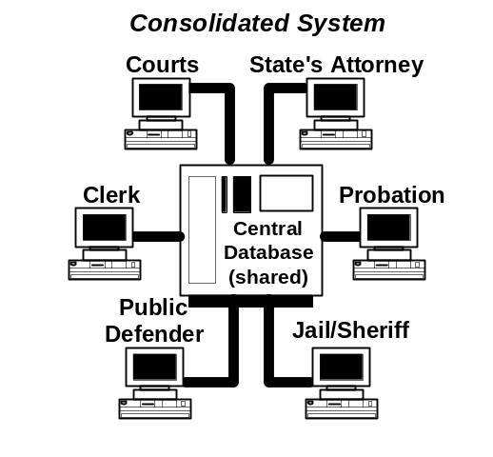he purpose of this paper is to examine the various architectures for integration of justice information systems in Illinois. The term “architecture” refers to the underlying structure of systems that facilitate the sharing of information between various justice agencies. For example, the McLean County, Illinois system is designed to allow all justice agencies to share one system on one computer. At the opposite end of the integration spectrum, the Colorado integrated system is designed to allow agencies to maintain and control their own separate systems, which reside on different computing platforms. Exchange of information between systems is enabled by software called “middleware,” which routes data between systems. The choice of a particular architecture for a jurisdiction or state is both a policy and a technical decision since it has ramifications for individual agencies in terms of how directly they control the systems and data that contribute to their daily operations.

Introduction
The choice of an integration architecture or architectures does not necessarily limit the way a system will look and feel to its users, but is rather a choice made based on a number of factors in place in a particular jurisdiction. These include the current level of automation, the current level investment in justice information systems, the continued viability of these existing systems, the centralization or decentralization of information technology services, the geographic distribution of users and systems, and the need for individual agencies to physically manage their own data stores. It is unwise to commit to particular technologies too early in the integration process, particularly before sufficient analysis has been performed, but integration architecture decisions have the potential to significantly affect fundamental issues surrounding system security, privacy, ownership, administration and governance, and should be considered as the scope of an integration project is being discussed. As such, an understanding of integration architectures needs to be had by policy makers directing the integration process in order that they have sufficient background to make the best decisions affecting the long-term shape of integration in a particular state, county, or locality.

Integration Schemes: One Size Does Not Fit All
Integrated justice information systems can take many forms. At present, there are almost as many possible configurations as there are installed integrated systems. One reason for this might be the differences between various jurisdictions in terms of needs, financial resources, and information infrastructure in each. Another factor might be different political realities facing each jurisdiction. Needless to say, if just one important justice entity refuses to participate in a justice integration scheme, then the configuration of the final system will be very different, if the system is implemented at all. Even if all justice entities agree to participate, the larger agencies—particular those with “custody” of the most valuable data elements—can greatly influence the types of data exchanges that take place. The types of exchanges will then greatly influence the final integrated system architecture.
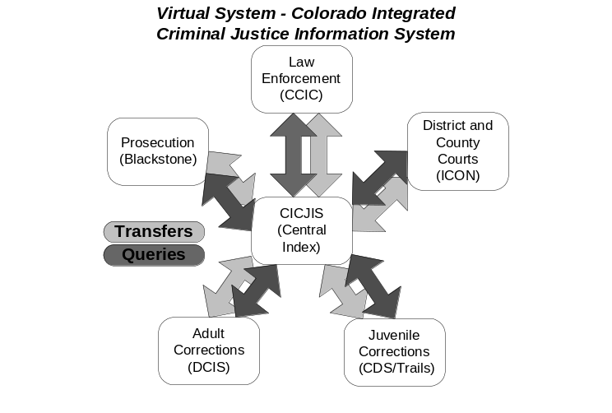The ideal integrated system should make information generated by the justice process “potentially” accessible to any authorized user, from a single computer interface. The key word here is “potentially” since not all information should be available to all those who make up the justice enterprise. For instance, information that should be accessible to a particular criminal justice agency can be made available only to certain authorized individuals within that agency. Additionally, even for information that should be accessible to a particular individual in the system, that person may have a need to receive that information at a particular point in the process and not before. One obvious example might be intelligence information gathered on a particular offender that has no bearing on the immediate court proceeding but may be useful in the future. Such information should probably only be available to those people actually involved in the investigation. That information might appropriately be available to a wider audience at a later date—say after an indictment is returned—but which must remain absolutely confidential until that key event occurs. So, this ideal system must have dependable means of securing information so that only appropriate users can view or manipulate the information. The system should also have a means by which information will automatically become available to a larger audience once a key event—say an indictment—has occurred.
What should integration do?
Within agreed-upon security constraints, users of the system may want information delivered in one or more of the following ways:
System Inquiry – The user makes a request for information on an individual or a particular case. This request could be in the form of a query or an indexed search.
Subscription – The user wants to be automatically notified when a particular event occurs. For example, a probation or parole officer will want to be notified if a probationer or parolee on their caseload is rearrested.
Notification – The user wants to be automatically notified of all instances of a particular event—once again, say an arrest—has occurred since the last notification. An example of this might be when a pre-trial services officer wants to be notified of all defendants arrested the previous night. This type of notification can be triggered by a particular event and would be helpful to any user who is “upstream” in the justice process and needs to prepare for the next step in the process.
In order for the above-listed features to be useful, justice information must be accurate, timely and complete. Data errors or data not available due to slow information transfer processes severely compromise its value, even if the system provides effective information delivery mechanisms to system users. Data accuracy, therefore, must be a prime goal of any integration effort. This means that repeated re-entry of data from one agency system to another, which occurs when justice agencies successively interact with offenders as part of the justice process, must be minimized. Transcription errors caused by successive re-keying of data from one system to another impacts negatively not only upon accuracy but also the completeness and timeliness of essential justice information.
One of the most important benefits of an integrated system is elimination of redundant data entry. Redundant data entry is inevitable when systems such as prosecutor systems, court systems, and police systems are separately funded and implemented to address operational problems within particular agencies. Because of the separation of powers and the adversarial nature of the justice system, such discrete operational systems tend to grow quite naturally unless oversight and planning occurs in the earliest stages of automation. Because of the separate funding streams for the various justice entities, it is unlikely that systems will be coordinated or consolidated at an early stage unless funding providers such as a county’s board of directors dictate that cooperation will take place before funding of automation can occur. In practice, this rarely occurs.
Redundant data entry by itself is very expensive due to duplication of labor, but perhaps more important, the repeated re-keying of data as cases move through the justice process introduces data inaccuracies on an epic scale. As a result, linking simple events like dispositions, which occur (usually) at the end of the process, to arrests, which usually occur at the beginning, becomes impossible in many instances because of errors introduced while transcribing key identifiers. The cost of these inaccuracies is also very high in terms of both the ad hoc information-gathering efforts that must occur to compensate for the inaccuracies, and the overall cost of inaccurate data to a process that relies on accurate information to function correctly.

Integration system architecture should be tailored to meet needs of the particular jurisdiction

An effective integration effort must then not only develop mechanisms for delivering information to end users, but must eliminate redundant data entry between agencies. The system must be designed to accurately capture data entry at its origination point and facilitate electronic transfer of that information from agency to agency. Data should never be re-entered, but rather should be reused at each step in the process. The only data entry that should occur at the agency level is that which enhances data originating earlier in the justice process. One example of such enhancement might be when the prosecutor modified charges against a defendant that the police originally entered at the time of arrest and booking.
The architecture chosen for a particular jurisdiction, region or state should take into consideration unique needs and should not simply be chosen just because it works for another state or locality. Every new project should carefully inventory the existing system infrastructure and choose a solution that will take advantage of existing resources. Information technology projects can be very expensive and integration projects usually combine several information technology projects under the umbrella of one integration effort so it is likely that the project will be very expensive unless existing systems are incorporated rather than replaced all at once.
Only recently have the technologies become available to enable robust data exchange between disparate systems in a way that will convert these systems into a working whole. In the not so distant past, any integration project had to consolidate any participating systems into one central computer. Today, hardware and software products exist that can transform a group of non-communicating computer systems into a “virtual” system that has most of the benefits of a single consolidated system. When compared to consolidated systems, these virtual systems also have the added benefit of allowing individual agencies a greater degree of control over their own physical systems and data stores.
Integration Architectures: Range of Possibilities

While most integrated justice schemes fit into either a consolidated or a virtual system approach, within these two classifications, there are several sub-classifications for various types of integration architectures. In a recent paper by Larry Webster and Kelly Harris of SEARCH, they developed an elaborate system of classification for various integration schemes and architectures. These are as follows:
Anarchy model – This model basically represents “pre-integration” and is “characterized by lack of central planning and coordination of efforts to connect systems.” This results from agencies meeting their operational needs by developing systems with little or no consideration for how those systems affect or interact with the entire justice enterprise. This is the natural course of development in most jurisdictions and is primarily a consequence of funding justice information projects through single agencies rather than through an oversight body. Recently, this trend has reversed and many jurisdictions are beginning to consider how agency systems will impact the entire justice enterprise. This approach to justice information systems is expensive and inefficient and is the root cause of the difficulties faced by those who wish to enhance the quality of justice systems information sharing.
Network model – This model of a consolidated system “focuses on the ability to inquire into systems maintained by organizations in other justice disciplines, rather than on data exchange between these entities.” An example of such an approach might be a circuit court clerk’s system that makes available docket information to the prosecutor, public defender, the courts, probation and law enforcement. Real-life implementations are in place in many Illinois counties including Cook, DuPage and Lake. This model usually fails to eliminate paper data exchanges and thus results in information that is less accurate, complete and timely than it would be if it were exchanged electronically and in “real time.” Some of these “network” systems have evolved into workable integration schemes, with all justice entities working on a single computer system.
Centralized model – This approach is “characterized by a single application that supports the entire justice system in a jurisdiction.” One example of this is the courts-operated system in Harris County, Texas, which was implemented in 1978 and is the earliest model of a completely integrated county-level system. The McLean County, Illinois system is another example of the centralized approach.
Many integration experts say that this approach is now outmoded due to the availability of technology that enables real-time data exchange between disparate systems, yet this is still a good approach for counties that don’t have viable information systems in place, and can start pretty much from scratch. A centralized system will typically be the most efficient and cost-effective when used in small to medium sized county-level jurisdictions and is not typically workable for large counties, and is even less workable for all but the smallest states. Some might assume that Cook County, Illinois uses a centralized approach since many of its agencies use common software on the county mainframe; however, because these agency applications are completely separate and have different data dictionaries, this is not truly a centralized approach to information sharing.
Umbrella model – Uses a master index to link information stored on systems maintained by different justice entities. “The master index is used to access information from the disparate systems through a single inquiry.” Such an approach is used by the FBI Interstate Identification Index system. Rather than gather criminal history information and store it centrally, the FBI chose to link to state criminal history systems through an master index, and point users to the particular state repository containing the information requested. This is a good example of the umbrella model. This index approach has some similarities to the middleware approach described below since most middleware uses a central index to route requests and to push or pull information from various disparate justice agency systems.
Data Warehouse – Data warehouses containing extensive justice information are in use in some states and more are planning to adopt this approach. Usually, the data warehouse supplements other integration initiatives. As an example, Colorado is planning to implement a data warehouse to supplement its middleware-based (see Middleware model, below) integration system. One of the important aspects of the data warehouse is that stored information can be cleansed and optimized for reports and queries. On the other hand, individual agencies’ operational systems are usually optimized for necessary business transactions but not for reports and queries. In fact, excessive report and query activity can adversely affect performance of these systems since reports and queries can quickly consume needed processing power and have the potential to slow overall system performance, especially during peak use periods. Creating a data warehouse takes the reporting load off of operational systems and also provides superior reporting and querying capabilities. Some states are creating data warehouses that will be used as the data stores for enterprise portals that can be accessed by authorized users. These portals provide web browser-based access to justice information supplied by many agencies. These portals may also offer subscription features to users. For example, if a probation or parole officer wishes to subscribe to information on particular clients, they can register the client’s state ID number with the system and they’ll be notified if the client is rearrested. In Kansas and Pennsylvania, authorized subscribers can be notified through Internet e-mail and can generate reports and queries over the Internet—though over a secure connection.
Middleware model – This approach uses special software to translate information—“United Nations” style— from one system to another. The middleware model creates a “virtual” system by linking many disparate systems that can appear to the user as one centralized system. While this approach can effectively link several independent agency systems, the work needed to implement such an approach is extensive as each data element and all of its allowable values must be identified and stored as a part of the middleware’s translation table; those who have worked with cross-agency data dictionary development know just how difficult this work can be.
Statewide model – This approach integrates state-level justice agencies—criminal history repositories, corrections, state appellate and supreme courts—and then allows local agencies to participate in this integration scheme at some point when they are ready. This allows the state to develop data and communications standards that locals can then adopt. The strength of this approach is that it reduces integration—at least initially—to a smaller subset of agencies under the direct influence of a governor and a legislature. The weakness is that since the bulk of law enforcement and court activity occurs at the local level the overall effectiveness of the system will be compromised by the lack of local agency participation. After all, most of the business of justice—arrest to disposition—takes place at the local agency or county level. If information can’t be efficiently and effectively gathered at this level then the overall system benefit will be compromised. According to SEARCH, “This approach obviously works best where automation for key players is provided and maintained at the state level.” In Illinois, key players include local law enforcement as well as county-level courts, prosecution agencies and other essential county-level justice agencies.
Standardized Interface Model – This model develops system specifications and data standards for use by all justice agencies. If an agency wishes to participate, that agency would tailor its system to the specification and would then be able to transmit and receive data from other agencies using the same specification. This model eliminates the need to continually rewrite system interface specifications for each new interface. A new interface is developed once and, except for occasional updates, an agency won’t have to rewrite the interface every time it wishes to transmit to, or receive data from a different agency. According to Webster and Harris, “this [method] provides maximum flexibility to individual organizations; they are free to do whatever they like in their internal systems so long as they can translate their data to meet the standard.”
Because of the extreme diversity of existing justice systems in Illinois and the disparity between the various counties in terms of systems infrastructure, the most workable solution is a hybrid solution that adopts characteristics from several models and combines these into a plan for a phased adoption of a statewide integration scheme.
The Current Illinois Justice Information Environment and the need for a hybrid approach to integration
Illinois now has several in-process efforts, which when completed, will concentrate information from many different justice agencies into data warehouses. So far, these planned data warehouses concentrate on individual aspects of the justice enterprise like courts, probation, law enforcement or criminal history. Brief descriptions of these efforts follow:
State Police ECHO System – This system, when completed, will replace the current state criminal history system (CHRI). While the computing platform and architecture has not been finalized as of this writing, the system will be both a transactional and an analytical system and will thus have data warehouse and operational system aspects.
Administrative Office of Illinois Courts (AOIC) Polaris System – This system will concentrate information acquired from probation agencies across the state into a single data warehouse that will be available to authorized users. This system is also in the planning phase and is being developed by the Administrative Office of Illinois Courts with the assistance of staff from the University of Illinois, Springfield.
Administrative Office of Illinois Courts (AOIC) Automated Disposition Reporting System – This system now concentrates Illinois court disposition reporting to the AOIC by Circuit Court Clerks. This system is now being enhanced to incorporate data warehousing features and once these enhancements are incorporated, the system will have much more robust reporting and querying.
Southern District U.S. Attorney System – This system will concentrate information supplied by many different local, state and federal agencies operating within the Southern District of Illinois. The system will be a data warehouse that addresses the need by law enforcement in this region to easily share operational and intelligence information. The system was inspired by the lack of information regarding methamphetamine manufacturing and distribution in the area.
Chicago Police CLEAR System - The CLEAR system is a continuation of the Chicago Police Department’s successful CHRIS system, a police records management system. This system concentrates transactional data into a data warehouse that is optimized for the types queries performed by police managers, investigators and detectives.
All of these systems will concentrate data gathered from different agencies into data stores optimized for querying and reporting. Some of the functions of these systems will overlap; however, none of these systems will have common data dictionaries or interfaces. Therefore, information exchange between the systems or between these and other agency systems will require extensive programming for interface development and data translation—unless the planners of these systems work together to create a common data and interface standards.
The need for a hybrid approach to integration that will accommodate the diversity of existing Illinois justice information systems
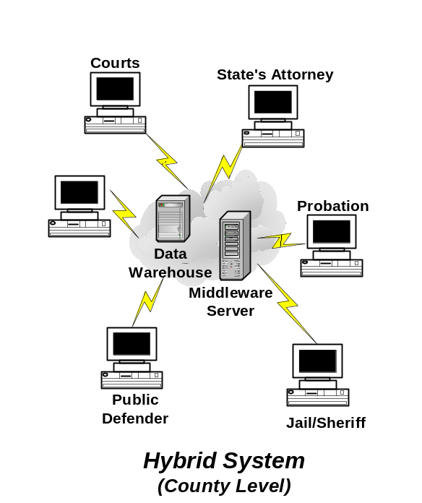In addition to these large data warehouse systems, several counties in Illinois either have operational countywide justice information systems or are in the planning stage for integration of their justice information systems. These systems range from IBM mainframe based systems to client-server systems using a small server as a central repository.
Because of the diversity of existing justice information infrastructure, Illinois must be able to either accommodate existing systems or must provide replacements for all existing systems and halt planning and implementation of any new systems. The latter alternative—replacing all existing or planned systems—is absurdly impractical, especially in light of current fiscal constraints. Therefore, some kind of a virtual system approach that allows for interaction with existing systems and future systems is the likely direction for Illinois. This type of approach is best characterized as a “hybrid” approach since no one architecture will be mandated; rather, a variety of architectures will be incorporated into the Illinois integration process.
This approach is consistent with that suggested by the report, The Global Justice Information Network: An Introductory Report on Infrastructure, issued by the Infrastructure/Standards Working Group, Global Justice Information Network Advisory Committee in June of 2000
The Committee recognized that local justice agencies—courts, law enforcement, prosecution, etc.—have primary responsibility to “support and maintain information systems within their own, individual agencies…in an effort to improve local agency automation, and thereby enhance the quality and timeliness of local agency data” These local justice agencies are also responsible to “[e]stablish and enable the sharing of the day-to-day information that serves as the operation currency of locally integrated systems…”
State-level agencies, on the other hand, are responsible for developing and maintaining “Statewide information repositories/systems that support the operational information needs of local (and state) users. They are responsible for the development and/or adoption of standards for information sharing between local agencies and state and national systems. States are also responsible for developing communications between the various justice information systems—local, state, and national, and providing basic infrastructures “that will support and enable integration of local agencies statewide. These infrastructures are the “telecommunication systems, radio systems, and programs that permit sharing of information and that support general levels of automation within justice agencies…” Lastly, states must support the development of standards “that will lay the foundation for integrated systems planning and implementation at the state and local levels.”
States may also directly fund the development of information systems for local courts, prosecution, criminal defense, etc. But there is no consistent practice for funding or supporting these systems.
Given this division of responsibilities between state- and local-level integration efforts, Illinois’ state-level effort must allow for and accommodate existing justice systems but seek to enhance the ability of these systems to robustly exchange information, and to provide the communications infrastructures and information sharing standards that will enable significant interactions between these systems. The State must also provide—as it does now—central repositories for the storage of critical justice-related information that must be made available to local Illinois as well as national justice agencies.
This hybrid architecture could take many forms and may incorporate a variety of system platforms—mainframe, client-server, and browser-based—but it must seek to enable the exchange of information between the various Illinois justice information systems and data repositories, and it should seek to eliminate or reduce the use of paper or batch electronic exchanges between these systems. The ultimate goal is to provide the multitude of Illinois justice agencies with more accurate, timely and complete justice-related information, while enhancing system security and, when appropriate, preserving agency independence.

