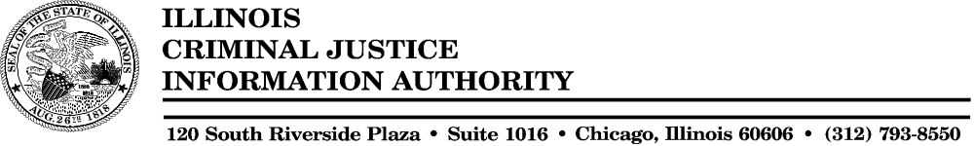

M E M O R A N D U M

To: Authority Members
From: Diane Griffin, Chief Fiscal Officer
Date: May 16, 2003
Re: Summary of Office of Fiscal Management Activities

The following highlights the work performed by the Office of Fiscal Management since the last Authority meeting.

Reports

The following reports were prepared and submitted by OFM staff:
- Quarterly Accounts Receivable Report.
- Quarterly Federal Financial Status Reports for direct and formula grant awards.
- Cost center reports for agency operations and federal grant cost centers.
- Assisted in preparation of the 2nd Quarter Performance Report.

Accounts Receivable

- Continue to receive and process payments from users. To date, received and processed approximately 85% of the billing for the second half of SFY03.
- Continued to follow-up on and reconcile outstanding balances.

Federal Grants

- Conducted preliminary budget reviews of approximately 114 interagency agreements
- Processed 106 contract obligation documents ($15,828,598) and 327 vouchers ($9,685,239) for federal grants to state and local governments and not-for-profit agencies.
- Prepared 20 payment history letters in response to requests from grantees for information for their independent audits.
- Reviewed 36 A-133 independent audit reports received from grantees for compliance with audit requirements and conducted follow-up as necessary.
- Conducted three on-site detailed monitoring reviews of Authority grantees.

General Agency Operations

- Completed obligation, expenditure and cash reconciliations for six funds.
- Began activities to research and liquidate outstanding obligations in preparation for fiscal year close.

Agency Budget

- Prepared and submitted a proposal to reserve $248,400 in General Revenue Funds and $291,500 in Criminal Justice Information Systems Trust Funds (user’s fees) in FY03 as requested by the new administration.
- Prepared a revised FY04 budget proposal in response to requests from the new administration. The revised guidance instructed us to reduce our General Revenue Funds budget by $294,400 and the Criminal Justice Information Systems Trust Fund budget by $851,700 from our FY03 appropriated levels.
- Prepared and submitted revised information for the Governor’s FY04 Budget Book.
- Completed and submitted the Illinois State Legislature (ISL) forms, which detail our FY04 budget request.
- As requested by the new administration, prepared and submitted a proposal to further reduce the Authority’s FY04 General Revenue Funds budget by $249,100, Criminal Justice Information Systems Trust Fund budget by $523,100, Motor Vehicle Theft Prevention Fund budget by $8,300 and Criminal Justice Trust Fund (federal) budget by $356,000 to comply with the Governor’s cost savings initiatives related to procurement, information technology services and elimination of salary increases and pension pick-up for employees in merit compensation positions.
- Prepared and submitted budget and other information related to the Governor’s proposed consolidation of legal, internal audit and information technology services.

Audit

- Provided informal comments to KPMG auditors conducting the FY02 State Single Audit on draft findings. Presently waiting for information from KMPG on the resolution of issues and the final report.
- Completed and submitted the annual Fiscal Control and Internal Auditing Act certification to the Office of the Auditor General.
- Provided preliminary information to audit firm contracted to conduct the Authority’s compliance audit for the two years ending 6/30/03.

Other Misc. Projects

- Researched new accounts receivable software systems, met with potential vendors for software demonstrations and selected a potential vendor. Purchase is currently on hold pending information from the Governor’s office regarding a possible consolidation of fee collection activities.

Personnel Changes

New Hires: None

Departures None

Filling of an accountant vacancy remains on hold due to hiring restrictions put in place by new administration.

