Marion Muster/First Name Surname/…

Title

Subtitle

**Keywords:** Give at least three keywords separated by semicolons; do not end the keyword list with a full stop

Revised and de-anonymized abstracts (including examples, references, tables, and figures) should have a maximum of 6,000 characters including blanks.

When preparing the revised abstract, it is recommended to write directly into this document template and to replace the model text. Please do not insert any blank lines between the different sections or paragraphs of the abstract. And do not insert any manual hyphenation in the text. Each abstract should be submitted both as a doc/docx/odt file and as an unlocked PDF file.

The basic structure of each abstract consists of the author(s), title, keywords, structured main text, references, and contact details (name, institution, e-mail).

Reviewers' comments and instructions given in the reviews should be taken into account.

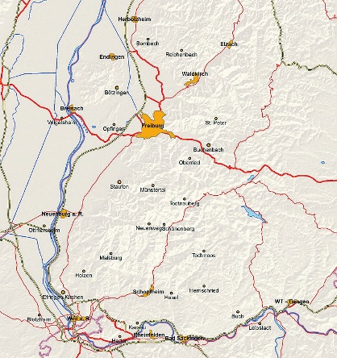Fig. 1: Colour figures are allowed. Figures should be supplied in a clean and high-quality format, using, if possible, a resolution of a minimum of 300 dpi. Figures should be numbered consecutively. Do not end the figure caption with a full stop

|  |  |  |
| --- | --- | --- |
| ****City**** | ****Country**** | ****River**** |
| Mannheim | Germany | Rhine |
| Paris | France | Seine |

Table 1: Number the tables separately from the figures, do not end the table caption with a full stop

# Examples

Examples should be numbered consecutively, as shown in (1).

1. This is an example text.

Glossed examples should follow, as far as possible, the Leipzig Glossing Rules (Bickel/Comrie/Haspelmath 2015), as exemplified in (2).

|  |  |  |  |  |  |  |
| --- | --- | --- | --- | --- | --- | --- |
| (2) | Lezgian (Haspelmath 1993, p. 207) | | | | | |
|  | *Gila* | *abur-u-n* | *ferma* | *hamišaluǧ* | *güǧüna* | *amuq’-da-č.* |
|  | now | they-obl-gen | farm | forever | behind | stay-fut-neg |
|  | ‘Now their farm will not stay behind forever.’ | | | | | |

You can achieve the glossing by using a table and making the borders invisible or simply by copying example (2) and adjusting it to your needs.

# Citing

Please consider using the official ICLC-10 Zotero style[1] to automate the creation of references and the bibliography. In any case, references in the abstract should be given in brackets and follow this convention: (Teich 2003), (Hasselgård/Johansson 2011), (Ernst 1994; Greenbaum 1996, pp. 2–3) or (Cappelle/Mostrov/Tayalati 2021, p. 82). All bibliographical references used in the abstract should be listed in alphabetical order and full detail at the end of the abstract in the references section. The following reference examples illustrate the basic format. For online sources, please state the date of access in brackets (last access: 8 March 2023). Please activate all hyperlinks.

References

Bickel, Balthasar/Comrie, Bernard/Haspelmath, Martin (2015): The Leipzig glossing rules: Conventions for interlinear morpheme-by-morpheme glosses. <https://www.eva.mpg.de/lingua/pdf/Glossing-Rules.pdf> (last access: 8 March 2023).

Cappelle, Bert/Mostrov, Vassil/Tayalati, Fayssal (2021): Temperaments, tempers, and temporality. In: Languages in Contrast, 21(1), pp. 82–111. <http://doi.org/10.1075/lic.19006.cap>.

Ernst, Pascal (1994): Meaning and Mind in Monkeys. Master’s Thesis. Department of Philosophy, Kings College, University of London.

Greenbaum, Sidney (ed.) (1996): Comparing English Worldwide: The International Corpus of English. Oxford: Clarendon Press.

Haspelmath, M. (1993): A grammar of Lezgian.(Mouton Grammar Library, 9). Berlin. In: New York [Preprint].

Hasselgård, Hilde/Johansson, Stig (2011): Learner corpora and contrastive interlanguage analysis. In: Meunier, Fanny/Paquot, Magali/Gilquin, Gaëtanelle/De Cock, Sylvie (eds.): A Taste for Corpora. Amsterdam: Benjamins (Studies in Corpus Linguistics), pp. 33–61.

Teich, Elke (2003): Cross-Linguistic Variation in System and Text: A Methodology for the Investigation of Translations and Comparable Texts. Berlin: Mouton de Gruyter.

# Contact information

Enter the name of each author, institution and email address. Please note that this information will be published. Use the format/style for reference entries.

**Marion Muster**

Leibniz-Institut für Deutsche Sprache

[muster@ids-mannheim.de](mailto:muster@ids-mannheim.de)

1. Direct download link: <https://github.com/ICLC-10/Zotero/releases/latest/download/ICLC-10.csl>