Course: COMP1643

Information and Content Management

Submission deadline: 05/10/2020

|  |  |
| --- | --- |
| Submitted to | Submitted by |
| Course leader:  Annemarie Zijlema | Username: an7104p  Banner Id: 001137503 |

Group One Members

|  |  |  |
| --- | --- | --- |
| Banner Id | User name | Team Role |
| 001139284 | Ma9978i | Scrum master |
| 001136520 | Na1987s | Analyst |
| 001137505 | Mi8438o | Developer |
| 001136698 | Ts1801x | Designer |
| 001137503 | An7104p | Tester |

Introduction:

Quality assurance is most important thing of any kind of the project. On this module I worked as a quality assurance manager on our team. Our team consists of five-member scrum master, analyst, designer, developer and myself. After completing all work of the project, it is my duty to assure the best quality of the project. For assuring the quality of the project I have done some testing on the developed website. on this section I will provide testing plans, cases and test log.

Test plan

Before launching a website, it is very important to do a proper testing of that website. A test plan is a must for doing a perfect testing. There are varies kinds of testing and on a test plan it will be described how a tester will do all those testing. On this module we are developing some features of the University of Edinburgh Website using a content management system. In the beginning of testing I will start the website testing with **unit testing** where I will test designing and each web parts. On **integration testing** I will test the interface of the website between modules. The developer is developing the website but his thoughts and understandings might be different from other developer so for verifying the modules work in unity integration testing is necessary. The main aim of **functional testing** is to the website by providing inputs and match outputs with functional requirements for doing this test I will use white box testing approach. **Usability testing** is a type of testing where I will test how easy our website is from another user perspective. This testing mainly defines how user-friendly and effectiveness of the website. As we are developing a duplicate version of university of Edinburgh so, A/B testing will be best for doing usability testing. For identifying vulnerabilities, threats and weaknesses of the website **security testing** is must. Using OWASP dependency check I will test security testing of the website. **Browser** **compatibility test** is a kind of testing where I will run the website from various browsers like Google chrome, Mozilla Firefox, internet explorer etc. for checking compatibilities among all browsers. I will also do a **responsive test** by running the website from two different device like mobile and computer.

Test case:

|  |  |  |  |  |  |  |
| --- | --- | --- | --- | --- | --- | --- |
| **Test name** | **Test serial no.** | **Title** | **Precondition** | **Steps of the test** | **Actual result** | **Expected result** |
| Unit testing | 1.1 | Enquiry  submission | Must need to be accessed on the website. | Enquiry form submission. | Form submitted successfully. | Result as expected. |
| 1.2 | Work flow | Need to fill and submit the form. | Form submission and mail checking. | Form submitted successfully. Mail received successfully. | Result as expected. |
| 1.3 | Latest news | Need to click on the latest news. | Click on the link. | Redirect to the latest news webpage. | Result as expected. |
| Functional testing | 2.1 | Enquiry | Must need to run all web parts on the page successfully. | Need to fill the field of form webpart of the page. | User successfully submitted the form. | Result as expected. |
| 2.2 | Alumni | Must need to run all web parts on the page successfully. | All the links on the page need to check. | All the links of the page worked successfully. | Result as expected |
| 2.3 | Search | Search function of the website need to work | Search anything by providing data. | Under construction | Search result shown successfully. |
| Integration testing | 3.1 | Home to study | Clickable nav item home and study. | By clicking on home nav item shows home page and clicking on study nav item shows study page. | Two nav item worked vise-versa successfully. | Result as expected |
| Usability testing | 4.1 | Button check | Clickable button. | By clicking on button, button need to work successfully. | Button works successfully. | Result as expected |
| 4.2 | Font checking | Font need to be understandable | By watching the fonts user need to understand which one is heading and which one is normal font. | Font is easily understandable. | Result as expected. |
| Browser compatibility testing | 5.1 | Using Firefox. | Need to be accessible | Website need to be fully accessible. | Website works perfectly | Result as expected. |
| 5.2 | Using google chrome | Need to be accessible | Website need to be fully accessible. | Website works perfectly | Result as expected. |
| Link testing | 6.1 | Broken link checking | Need to check links on the page by using link checker. | All the links of the page need to worked perfectly. | two links on the page is broken. | All the links of the page worked perfectly |
| responsive testing | 7.1 | Using computer | Website need to be fully responsive | Using a computer needs to check the responsiveness of the website. | Website is fully responsive using computer. | Result as expected |
| 7.2 | Using mobile phone. | Website need to be fully responsive | Using mobile phone needs to check the responsiveness of the website | Website is fully responsive using mobile phone. | Result as expected |

**Test logs:**

On this part of the testing I am going provide screenshots the testing according to the test pans and test cases.

Unit testing:

1.1

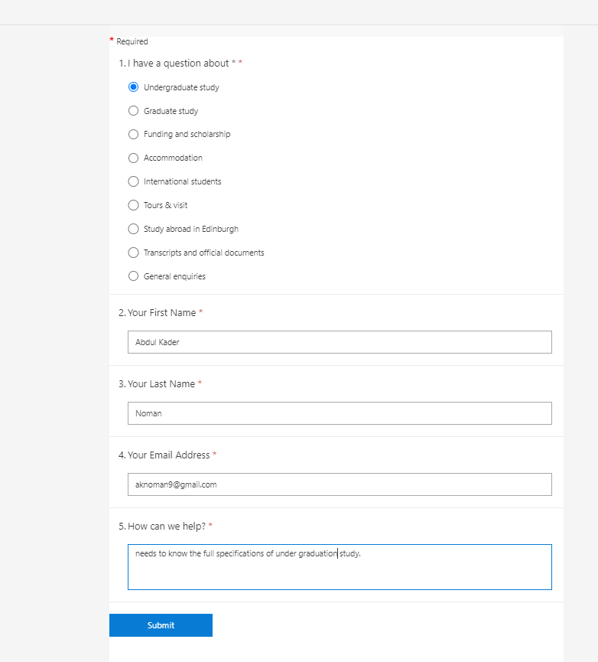

Figure 1 enquiry submission form

Comments: User have successfully filled the form of enquiry.

1.2

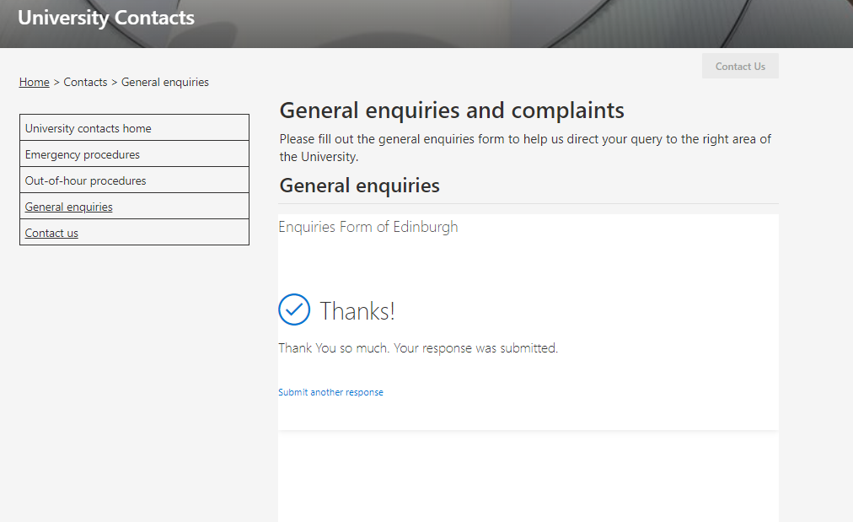

Figure 2 enquiry form submitted successfully.

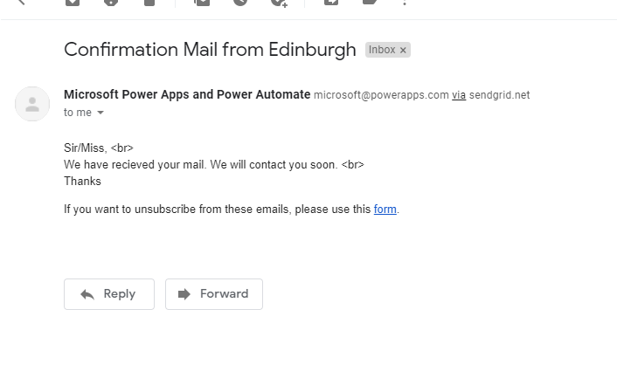

Figure 3 confirmation mail received

comments: user have successfully submitted the form and also received confirmation mail successfully.

Functional testing:

2.3

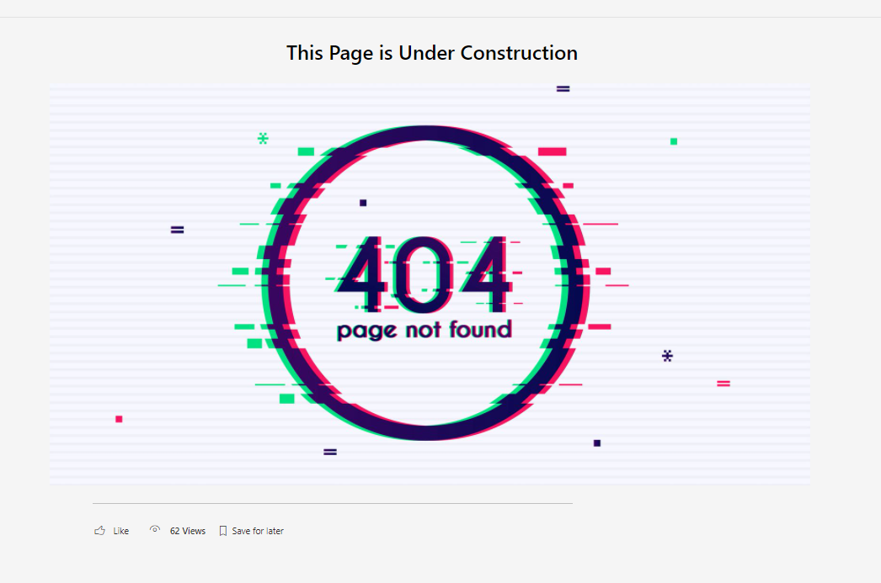

Figure 4 after clicking on the search function

Comments: The expected result is to show the search item on the page but as his page is under construction so it failed to show the actual result.

Integration testing:

3.1

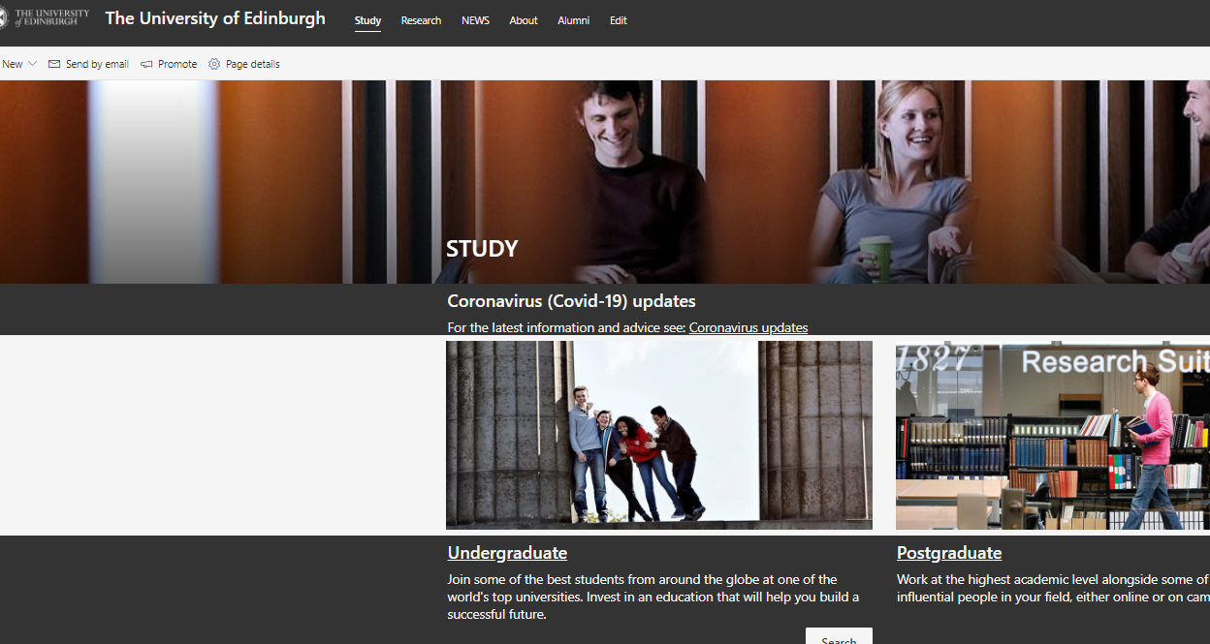

Figure 5 home page to study page

Comments: By clicking on study from the nav it takes the user to study page with describes the instigated connections between modules.

Usability testing:

4.2

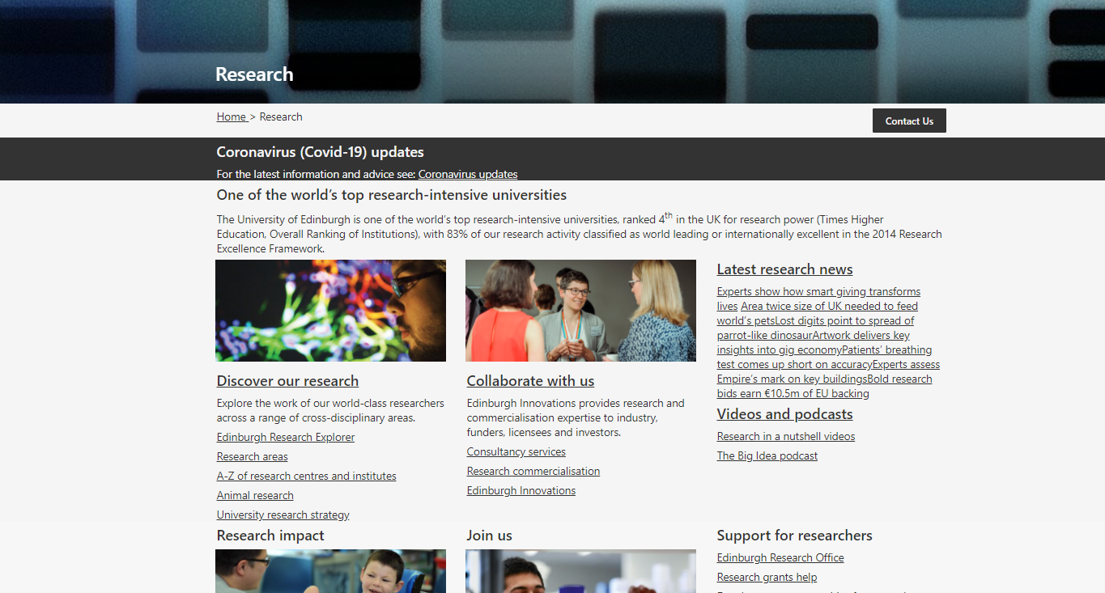

Figure 6 font checking of research page

Comments: form the above it is clearly understandable that which font is used for heading and which is normal paragraph.

Browser compatibility testing:

5.1

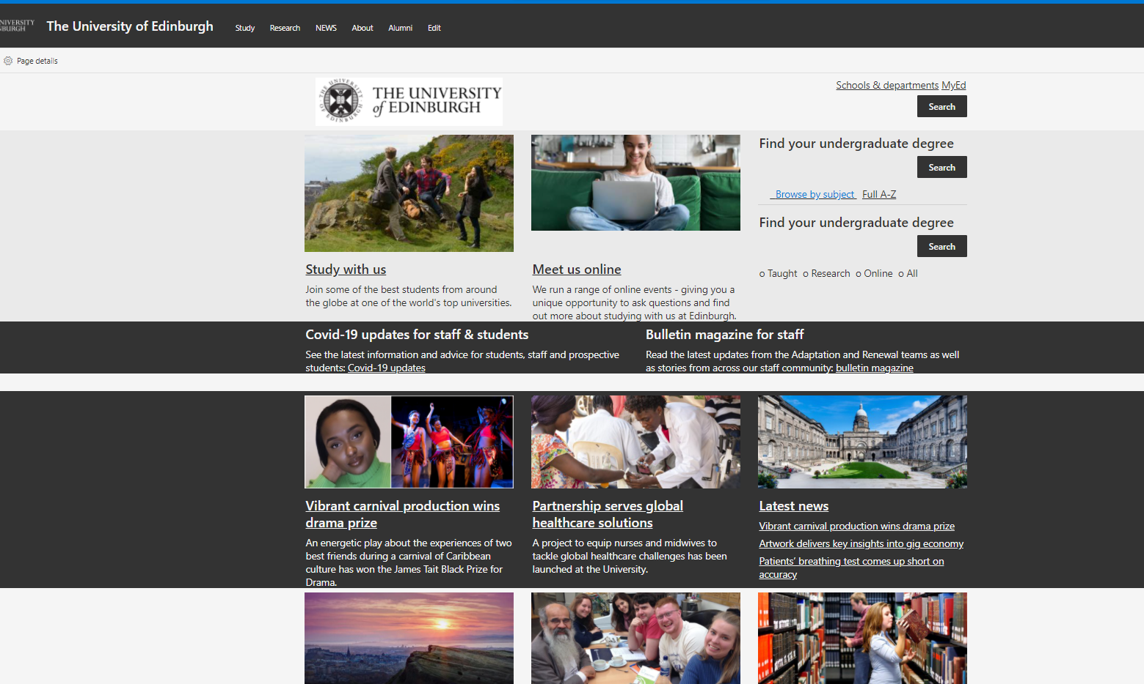

Figure 7 home page using Firefox

5.2

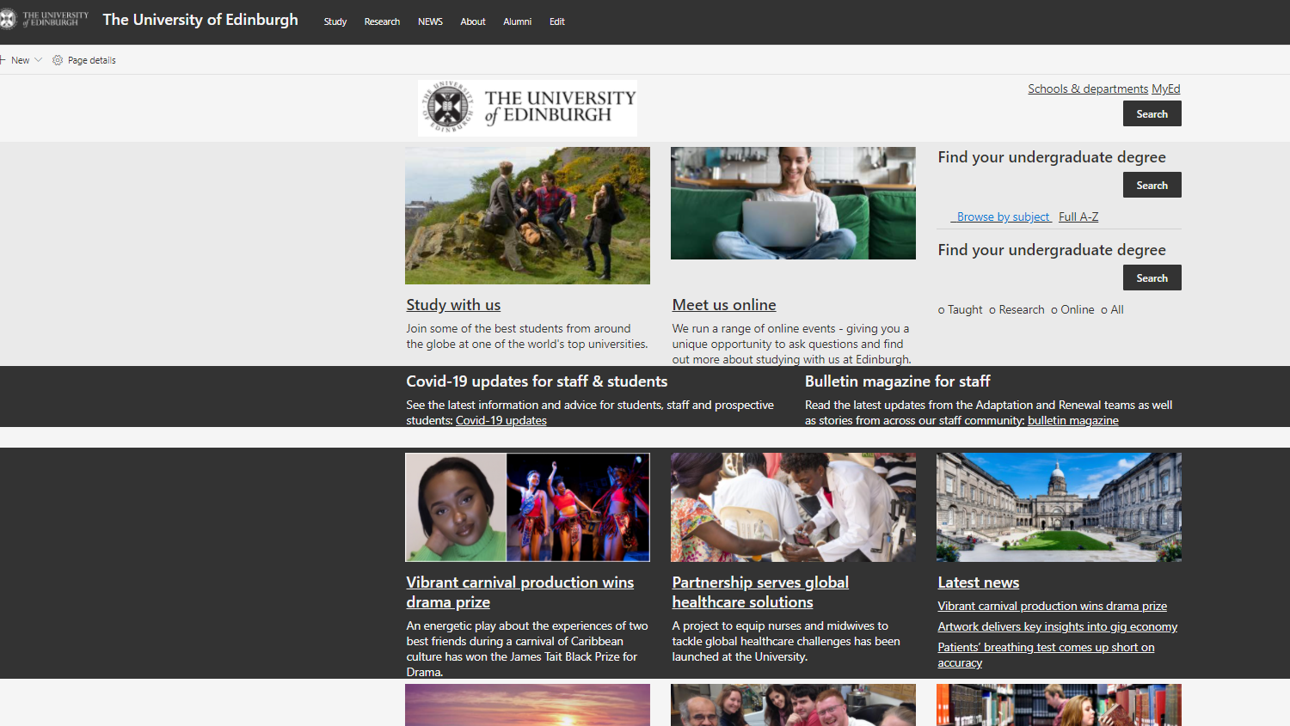

Figure 8 home page using Google Chrome

Comments: website is running successfully both on Firefox and Google Chrome.

Link testing:

6.1

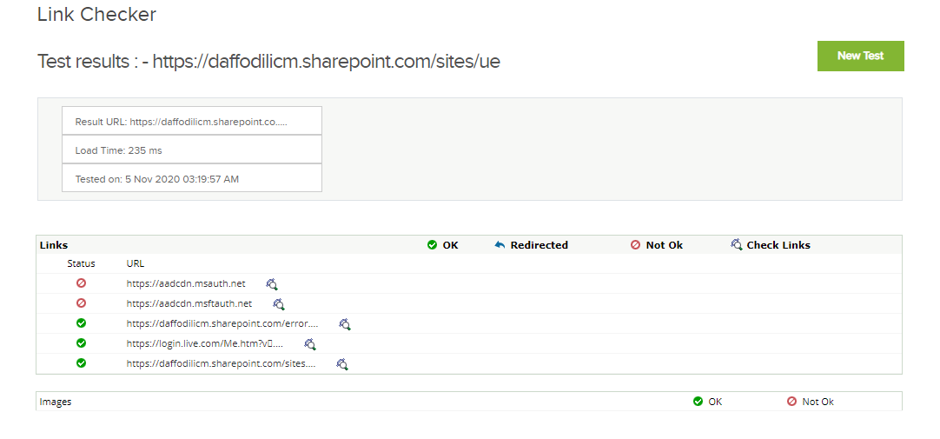

Figure 9 link checking on home page

Comments: two links on the home page is broken.

Responsive testing:

7.1

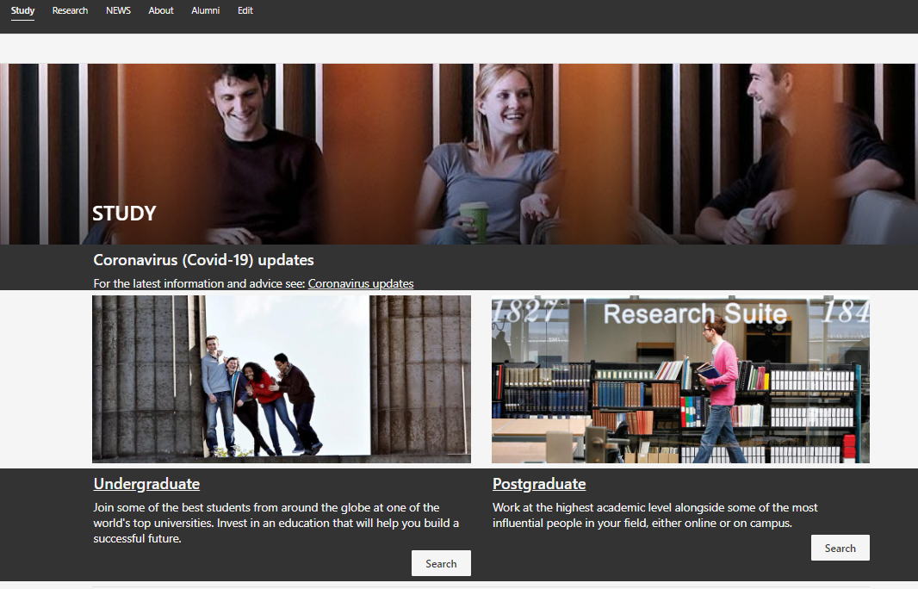

Figure 10 study page using computer.

7.2

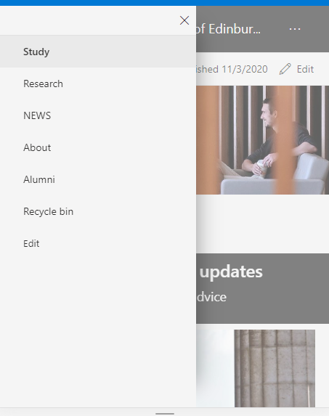

Figure 11 study page using mobile

Comments: the website is fully responsive from both mobile phone and computer.