# Appendix S1. An example of R code to perform the REST model by the MCMC method using OpenBUGS software.

Ncam<-30 #Number of camera-traps

lambda<-0.17 #Parameter of exponential distribution for staying time

actv<-0.5 #activity proportion (treated as a known constant here)

rho<-10 #Density

alpha<-1.27 #dispersion parameter

S<-2.67/1000000 #Area of a camera detection zone

day<-30 #research days

t<-24*60*60*day*actv #Research effort (sec.) per camera trap

mu<-rho*S*t/(1/lambda) #Expected number of videos per camera-trap

eff<-rep(t, Ncam)

y<-round(rpois(Ncam,mu*rgamma(Ncam,alpha,alpha)),0)

Nstay<-sum(y)

stay<-rexp(Nstay,lambda)

cens<-rep(0,Nstay)

cens[which(stay>10)]<-10

stay[which(stay>10)]<-NA

##################################################

library(R2OpenBUGS)

model.file<-"C:\\bugstemp\\density_survival\\model1.txt"

sink(model.file)

cat("model

{

for(i in 1:Nstay){

stay[i]~dexp(lambda)I(cens[i],)

}

for(i in 1:Ncam){

pcy[i]~dpois(mu.y[i])

y[i]~dpois(mu.y[i])

mu.y[i]<-mu[i]*u[i]

log(mu[i])<-log(S)+log(eff[i])+log(rho)+log(lambda)

u[i]~dgamma(alpha,alpha)

}

lambda~ dgamma(0.1,0.1)

rho~dgamma(0.1,0.1)

alpha~dunif(0,100)

}

")

sink()

datalist<-list(y=y,S=S,eff=eff,stay=stay,cens=cens,Nstay=Nstay,Ncam=Ncam)

inits<-function(){

list(lambda=1/8,rho=7,invalpha=1)

}

parameters<-c("lambda","rho","stay","mu","alpha","pcy")

res<-bugs(datalist,inits,parameters,model.file,

n.chains=3, n.iter=2000,n.burnin=1000,n.thin=20,

,working.directory="C:\\bugstemp\\density_survival",debug=F)

res

# Appendix S2. Details of installation scenarios for Monte Carlo simulations to test reliability of the REST model assuming animal movements at fine temporal scale

In ins. 4, animal movements followed the complex model of Howe *et al*. (2017). An animal started from a randomly selected location, and changed movement speed and direction every two s. Animals moved rapidly for 144 min, and moved slowly and more tortuously for 216 min. They repeated this pattern for a total of 12 h, and stopped to rest for 12 h. When moving rapidly, the movement speed (m/2 s) followed a lognormal distribution with 1.046 ± 0.103 *SD*, and the direction (in degrees) followed a normal distribution with 0.209 ± 0.004 *SD*. When moving slowly, the movement speed followed a lognormal distribution with -1.61 ± 0.3 *SD*, and the direction (in degrees) followed a normal distribution with 0.0 ± 8.0 *SD*. When an animal left the study area, it reappeared on the opposite side of the area. Data on staying time during the animals’ active period was used for density estimation.

# Appendix S3. Details of installation scenarios for Monte Carlo simulations to test the effects of sampling effort

What follows are the details of the installation scenarios used for Monte Carlo simulations to test the effects of sampling effort. Three simulations were performed:

1. The research term *H* was held constant at 10 days per camera, whereas the number of cameras was changed: 10, 20, 25, 50, and 100.
2. The total number of cameras was held constant at 20, whereas *H* varied between 5 and 50 days per camera.
3. The total amount of camera time was held constant at 500 camera days, whereas the number of unique locations sampled varied between 10 (50 days per location) and 100 (5 days per location).

In the third scenario, we assumed a situation where both the number of cameras and the amount of time available for the survey was limited, requiring a trade-off between the number of locations and time per location. Note that, unlike scenarios (1) and (2), sampling duration at each location decreased as the number of sampling locations increased in this scenario.

In all the simulations, the average density was set at 10 km-2, and the focal area (area monitored by the camera) was set at 2.67 m2. The length of stay in a focal area was generated from the exponential distribution lambda 0.17 (= 1/*E(T)*). The number of videos was then generated by drawing random numbers from a negative binomial distribution (its mean calculated from equation 1, with a dispersion parameter of 1.27). No censored data was designated. Densities were then estimated by the REST model using the same procedure used in the random walk simulations. In each scenario, 200 iterations were performed.

# Appendix S4. Details of camera installations and measurement of animals’ staying time within a focal area

The REST model was applied to an actual dataset of forest-dwelling duikers (blue and red duikers) from a field survey conducted in the Moukalaba-Doudou National Park, Gabon. The density estimates derived from the REST model were compared with those from the line-transect surveys. Blue duikers *Philantomba monticola* are small-sized ungulates (ca. 5 kg), often moving in pairs or sometimes family groups (3–5 individuals). Red duikers include three different species (*Cephalophus ogilbyi, C. callipygus*,and *C. dorsalis*), all of which are medium-sized (ca. 20 kg) and typically move alone. Distinguishing the three species in the field is very difficult; thus, we regarded them as a single taxon (simply ‘red duikers’).

Five, 2-km line-transects were established at least 2 km apart in various forest vegetation types (SW: Swamp; YS: Young secondary; GL: Gallery; PR: Primary and OS: old secondary, see Nakashima, Inoue & Akomo 2013). Conventional line-transect surveys were conducted along these transects from July 2011 to June 2012. Details of the census methods and the results are reported in Nakashima *et al.* (2013). In summary, the line-transect surveys were conducted 26–30 times at each of the five transects. During the survey, a total of 100 blue duikers and 80 red duikers were detected. The estimated mean group density (km-2) determined by the distance sampling approach (Buckland *et al.* 2001) varied considerably among transects, ranging from 7.9 km-2 to 15.0 km-2 for blue duikers, and from 0.9 km-2 to 11.4 km-2 for red duikers. Results of the line-transect survey are summarized in Table S3.

During the dry season (July–September) in 2011, 24–30 camera traps (Bushnell Trophy Cam 2010) were set up on the five transects. The cameras were installed at random coordinates within an area 2 km × 20 m along each transect. The exact coordinate points were determined using a tape measure (in cm-precision), and the nearest trees (>3 cm) from this point were selected to set up a camera. The camera was directed to the point. Cameras were placed at a height of approximately 0.3 m above ground without baits or lures; they were angled parallel to the ground. Each camera was set to ‘video mode’ and video-length was designated as 30 s during the first two weeks, but thereafter decreased to 10 s (for logistical reasons). The delay period between videos was set at 2 min to maximize the continuity of sampling, while minimizing memory wastage.

The focal area of the camera trap for estimating animal density was defined prior to the survey. A preliminary survey, following Rowcliffe *et al.* (2011), suggested that animals were filmed with the highest probability within 1.0–3.5 m of a camera trap (Y. Nakashima, unpublished data). We set two candidate focal area settings: an equilateral-triangle area (2.67 m2, Fig. 3, hereafter ‘larger focal area’) and a quarter-sized equilateral-triangle (0.67 m2, Fig. 3), whose bottom was shared with the larger focal area, was defined as the ‘smaller focal area’. To test whether certain detection was assumable in these focal areas, control trials of camera response were made using a domestic cat (male, 4.3 kg) in a laboratory in Japan, as suggested by Rowcliffe *et al.* (2011). The cat was made to pass the focal areas of a camera trap (installed at ca. 30 cm in height) on a tripod. To avoid the camera responding to a researcher, the camera sensor was covered with a wooden board (30 × 30 × 3 cm), which was removed after the researcher left the camera detection zone. The temperature of the laboratory was controlled at 25 °C, which was approximately concordant with that of the dry season at the study site. The cat was made to pass each side of the triangle (larger focal area) 15 times (45 trials in total). The results showed that detection probability in both focal areas was sufficiently high, although detection probability did not reach 1 in the larger focal area. The cat crossing the larger focal area was successfully detected in 42 out of 45 trials (93.3 %; in all the three missed detections, the cat crossed near the front of the camera). On the other hand, the cat passing within the smaller focal area was always detected (23 times). In the field survey, densities were separately estimated for the larger and smaller focal areas, admitting that density estimates based on the larger focal area may be underestimated.

Staying time in the focal area was measured as follows. In the field, the closest point of the focal area was 1.1 m away from the camera, and poles were driven in at 1.10 m and 3.25 m from the cameras and filmed by a camera trap as a reference to the larger focal area prior to the research. The poles were removed during the camera operation period, such as not to influence animal behaviour. All the obtained videos of duikers and the reference video were pasted into Microsoft PowerPoint. The larger focal area of each camera was drawn based on the reference videos, and were pasted to all the videos on the slides. The smaller focal area was then drawn based on the larger focal area. Each video was run and stopped at the time when either back paw of an animal entered the focal area, and stopped again when the same paw left the focal area. The interval between the two times was defined as the staying time (see Appendix F1). Only images of animals crossing within the focal area were used for the subsequent analyses. Owing to the much wider effective angle of the PIR (passive infrared) sensor of our camera (ca. 75 degrees), the majority of videos began before animals entered the focal areas both for blue duikers (larger 70.8 %; smaller 98.1 %) and red duikers (larger focal area: 75.6 %; smaller: 98.5 %). This enabled reliable estimation of the staying time, although it may still have been underestimated.

The result of the random walk simulation (ins. 3.2) suggested that a high proportion of censored data may bias the density estimates. If the video length was designated as 10 s, the proportion of blue duikers censored would be 24.2 % and that of red duikers 10.1 % in the larger focal areas. To avoid the bias associated with a high proportion of censored data, data collected during the first two weeks was used for the estimation of staying times in the larger focal area for both species. During this period, the proportion censored was less than 5 % for both species. The same number of videos captured during the early survey period was used for estimating trapping rates and staying time in the smaller focal area. When the sufficient number of videos were not available, additional data was obtained from the nearest camera. The proportion censored was also less than 5 % for both species. In theory, the REST model could estimate the density of individuals even when animals move in pairs or in a small group; however, the short delay period in our camera settings (see above) allowed only for the estimation of group density because the delay period resulted in later-arriving members of the group to be missed. The ‘delay period’ was subtracted from the research period. Because our preliminary survey using 10 camera traps designated with no delay period showed there was no significant difference in trapping rates using the 3 min after detections and the other period (Chi-Square Goodness of Fit Test: *P* > 0.05; Y. Nakashima, unpublished data), this treatment was valid. Activity proportion was estimated using the method of Rowcliffe *et al.* (2014) and the time records of the videos captured in the larger focal area.

Parameter estimation of the REST model was performed using the Markov chain Monte Carlo (MCMC) method. The distribution with the highest predictive power was selected from the same candidates as the random walk simulations (see above) based on their Watanabe–Akaike information criterion (WAIC) values (Watanabe 2013); the potential for overfitting is acknowledged because many observations might not be independent. Their variances and credible limits were calculated as the posterior summary. To judge whether the selected distribution adequately fit the actual data for the staying time of duikers in the focal area, the Lilliefors-corrected Kolmogorov-Smirnoff test using the R package ‘KScorrect’ (Novack-Gottshall & Wang 2016) was implemented.

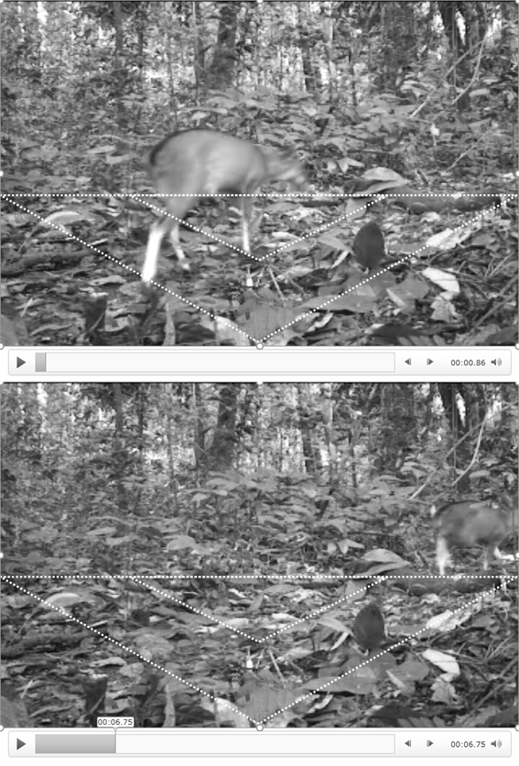

**Appendix F1.** An illustration of measuring staying time within a focal area. The video was stopped at the time an animal entered (upper) and left (lower) the larger focal area.

**References**

Nakashima, Y., Inoue, E. & Akomo, E.O. (2013) Population density and habitat preference of forest duikers in the Moukalaba-Doudou National Park, Gabon. *African Zoology,* 48, 395-399.

Novack-Gottshall, P. & Wang S.C. (2016). KScorrect: Lilliefors-Corrected Kolmogorov-Smirnoff goodness-of-fit tests. R package version 1.2.0. <https://CRAN.R-project.org/package=KScorrect>

Rowcliffe, J.M., Carbone, C., Jansen, P.A., Kays, R., & Kranstauber, B. (2011) Quantifying the sensitivity of camera traps: an adapted distance sampling approach. *Methods in Ecology and Evolution,* **2**, 464–476.

Watanabe, S. (2013) A widely applicable Bayesian information criterion. *Journal of Machine Learning Research*, **14**, 867–897.