1. Download FermiSurfer

FermiSurfer’s documentation:
https://mitsuaki1987.github.io/fermisurfer/en/_build/html/index.html

2. Open phononsurface.fs with FermiSurfer
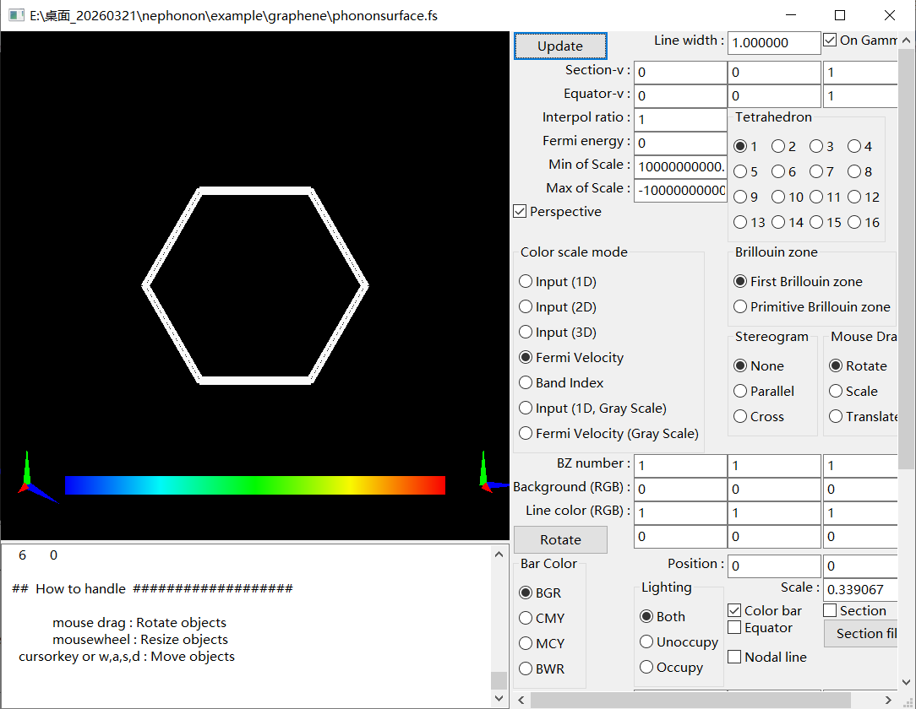
3. Set Fermi energy to 50meV and Click Updata button
