Auto-generated report from NMA

Version: 03 May, 2022

## Introduction

This is a report of a NMA using the package NMA.

## Model description

The NMA is a Fixed Effects (FE) model.

$$y∼βX$$

## Plots

The network graph is

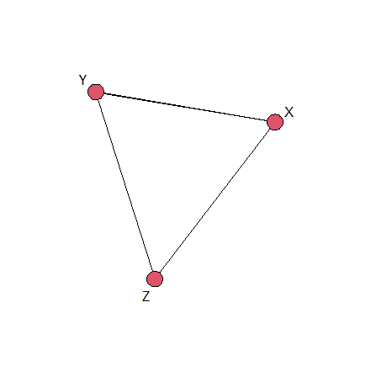

The pair-wise table is

|  | X | Y | Z |
| --- | --- | --- | --- |
| X | 1 (1,1) | 1.84 (0.95,2.73) | 3.98 (2.97,7.94) |
| Y | 0.54 (0.37,1.05) | 1 (1,1) | 3.12 (1.13,5.19) |
| Z | 0.25 (0.13,0.34) | 0.32 (0.19,0.88) | 1 (1,1) |

The treatment effect forest plot of posterior samples is

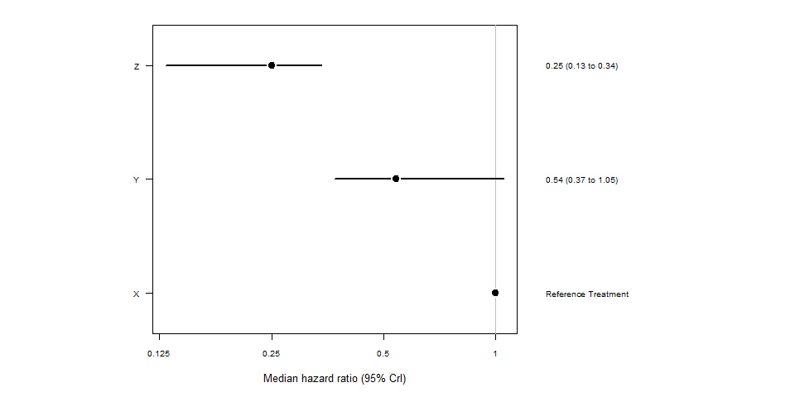

The rank probability grid is

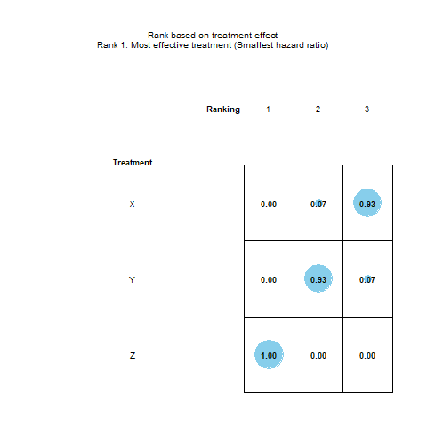

## References