**Updates station characterization 2021-01-28:**

Folder for output

Already in gui – if want to save the figures (equivalent to wanting to save a PDF also), a new folder is created with the structure 2021_01_28_07_51_27_HTM150

The folder name is also saved to the settings of the station characterization object passed to all the functions that generates the graphs.

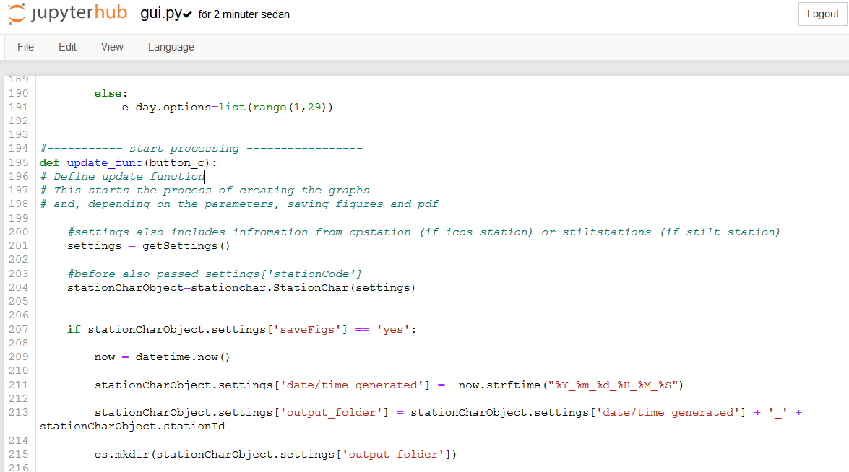

Quatile information for pop, sens and point source

In multiple_varaibles_graph function:

If want to save the figures (saveFigs==’yes’) – add three items to the settings part of the station characterization object: myStation.settings[‘Sensitivity’] and ‘Population’ and ‘Point source’.

stc_functions:

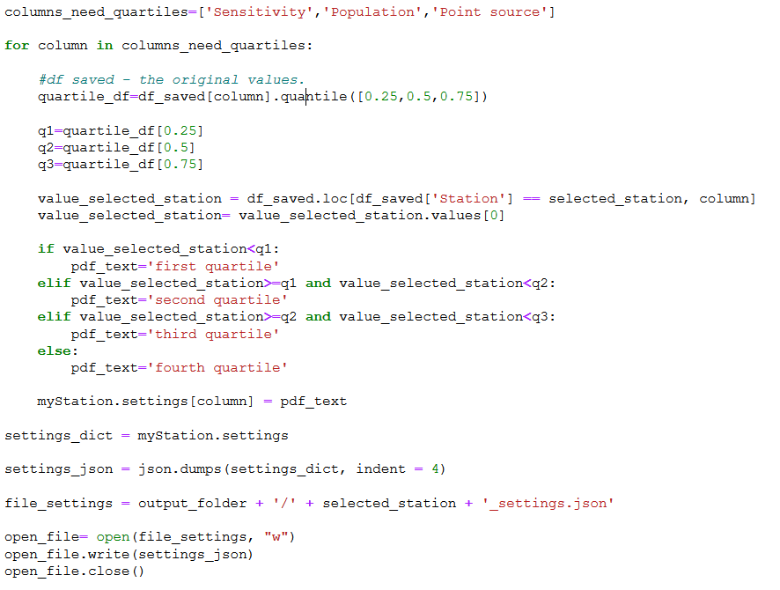

Since now all the information needed for the station characterization PDFs is in the settings of the object, I export the settings dictionary as a .json file within the multiple variables graph function. That means we don’t have to return the station characterization object back to the gui. In the meeting 2021-01-27 we did discuss how if we get any other information from the functions to generate the different output that would be good to have in the PDF, we could do the same with passing the station characterization from the functions and back to gui.py where at the end the settings would be exported to json. Easy to change to save the .json here instead.

Updates to that all output figures from other functions end up in output_folder

Get the folder name from the station characterization object (myStation.settings[‘output_folder’])

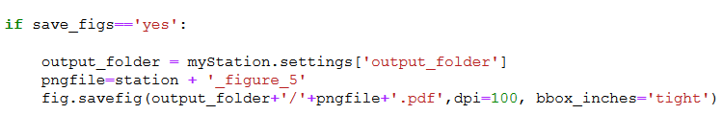

Result:

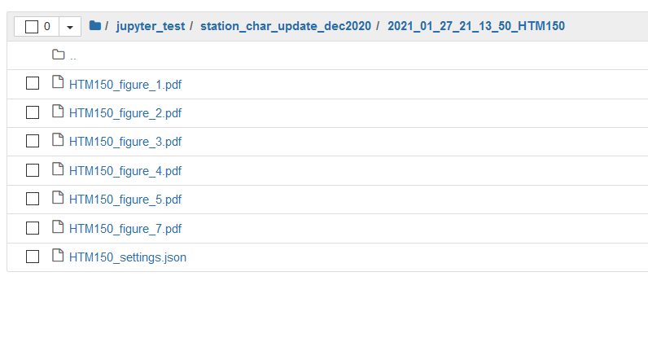

**Next steps:**

Latex file into output folder

Latex file should be generated in a function ran in gui.py if the user has selected to save the figures (option to only save the figures OR also generate an output PDF?). We have a latex file structure that currently loads individual text files for station name, lat, long, quartile etc. Now rather from saved settings file (HTM150_settings.json).

Ida will download a settings.json file and use that instead of the text files and locally generate a PDF.

Once successful, a python function that generates a .tex file will be created. I have previously done that in a loop (see uploaded notebook station_characterization_prepare_latex):

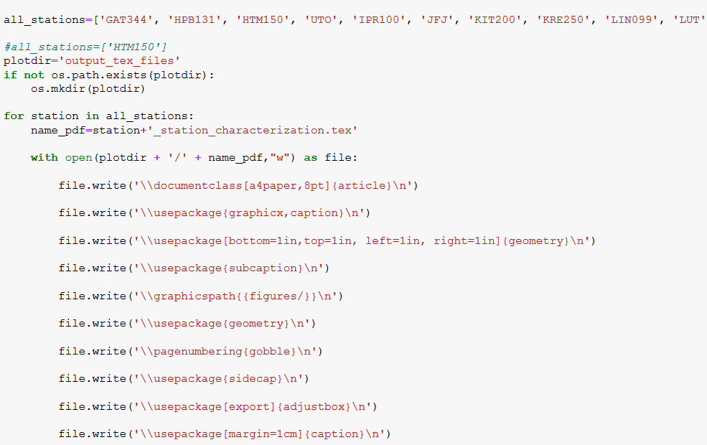

This can be used as a foundation in combination with the successfully locally ran .tex files.

It would be enough to pass the station characterization object to this function in the end after button click from user. Again, conditional (if saveFigs == ‘yes’).

Add option to upload an .json file with settings

Add first input 🡪 name of .json file. Will it need to first be uploaded by the user to the same directory as the gui.py file? Or how will the file be found?

Click button – widgets show up either like it currently does, or with all the values from the settings pre-populated.

User clicks run.

Option to generate PDFs for multiple stations

Probably Jupyter Notebook with dropdown (and choice STILT/ICOS stations). Select multiple options.

In loop generate latex files + output PDFs.

Dear all,

Earlier this week I sent an email regarding a possible PhD topic to Dominik:

We are still at early stages in thinking about the topic, gathering information and looking for a good niche where my background in GIS can best be utilized. One possible direction is optimization of sensor placement; how we can learn from cities that already have sensor networks and from that, and publish findings on optimal sensor placement, define parameters that could feed into a suitability analysis of other cities. Ideally this would also result in a service hosted at the Carbon Portal.

Dominik replied:

I would certainly see possibilities for connecting such a PhD project with our CO2 measurement activities in Zurich.

We haven't thought about sensor placement optimization, but this is certainly a relevant question, also in view of the (hopefully) upcoming PAUL project.

Dominik, you have colleagues you thought could be good to also include in the discussion. However, an initial discussion between the four of us would maybe be good for now, and once we have a clearer idea they could also be invited to discuss? If you disagree with this, I will edit the Doodle so they can also share their availability and be included in the meeting.

Best from Ida Storm

Dear all,

Thank you, Omar!

In terms of the time (Dublin / Sweden), either way is fine.

Best from Ida

Hi Omar and Zuzana,

I would apprechiate if you could provide the link, Zuzana!

Thank you both,

Ida